Easy preparation of wood-base membrane with fouling resistance in complex environments for efficient oil-water emulsion separation
Xichun Zhang, ^{a, b#} Chao Teng,^{a, c#}， Rui Zhai,ª Lulu Jiang,ª Jie Wang,ª Jiale Zhou,ª Rongfang Wang,^{b} Hui Wang,^{b} Xuyun Wang,^{b*} Xiaoyan Ma^{b*}
ª College of Materials Science and Engineering, Qingdao University of Science and Technology, Qingdao 266042, China.
^{b} College of Chemical Engineering, Qingdao University of Science and Technology, Qingdao 266042, China.
^{c} Weihai Jinhong Group Co., Ltd, Weihai, 264211, China

* Corresponding author: wangxy@qust.edu.cn; maxiaoyan@qust.edu.cn
# Xichun Zhang and Chao Teng contributed equally to this work.

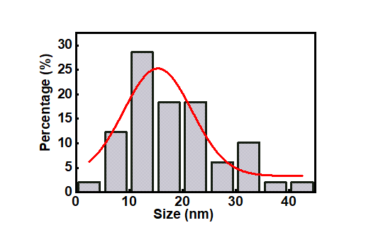
Fig. S1 Diameter statistics chart of the exfoliated ANF

Fig. S2 The mass fraction of water in wet ANF/wood membrane and wood in dry ANF/wood membrane
Fig. S3 Optical photographs of water and oil droplets on dry ANF/wood surface, exhibiting amphiphilic performance

Fig. S4 Oil contact angles underwater of wood and ANF/wood membranes

Fig. S5 Photographic images revealing the self-cleaning properties of the ANF/wood membrane

Fig. S6 From left to right are carbon tetrachloride-in-water, dichloroethane-in-water, n-hexane-in-water, n-dodecane-in-water and diesel-in-water, basically remaining the original state under long storage for 24 h

Fig. S7 Optical microscopy images of hexane-in-water emulsion before and after separation under different conditions
Fig. S8 The natural wood as separation membrane could successfully separate the different oil/water mixtures

