Table 1. Information and images of the analyzed samples.
Sample Code | Sample Type | Image of the Object | Sample Code | Sample Type | Image of the Object
AE-01 | paper | 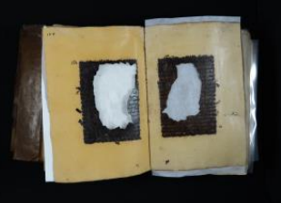 | AE-21 | leather (from the inside of the cover) | 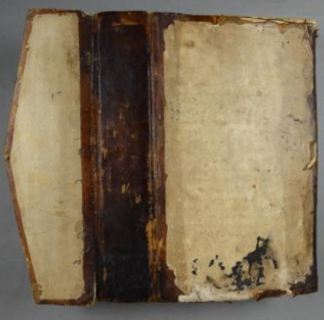
AE-02 | paper | 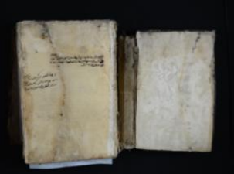 | AE-22 | leather (from binding) | 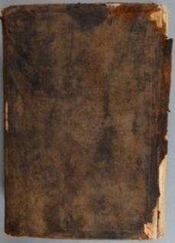
AE-03 | paper | 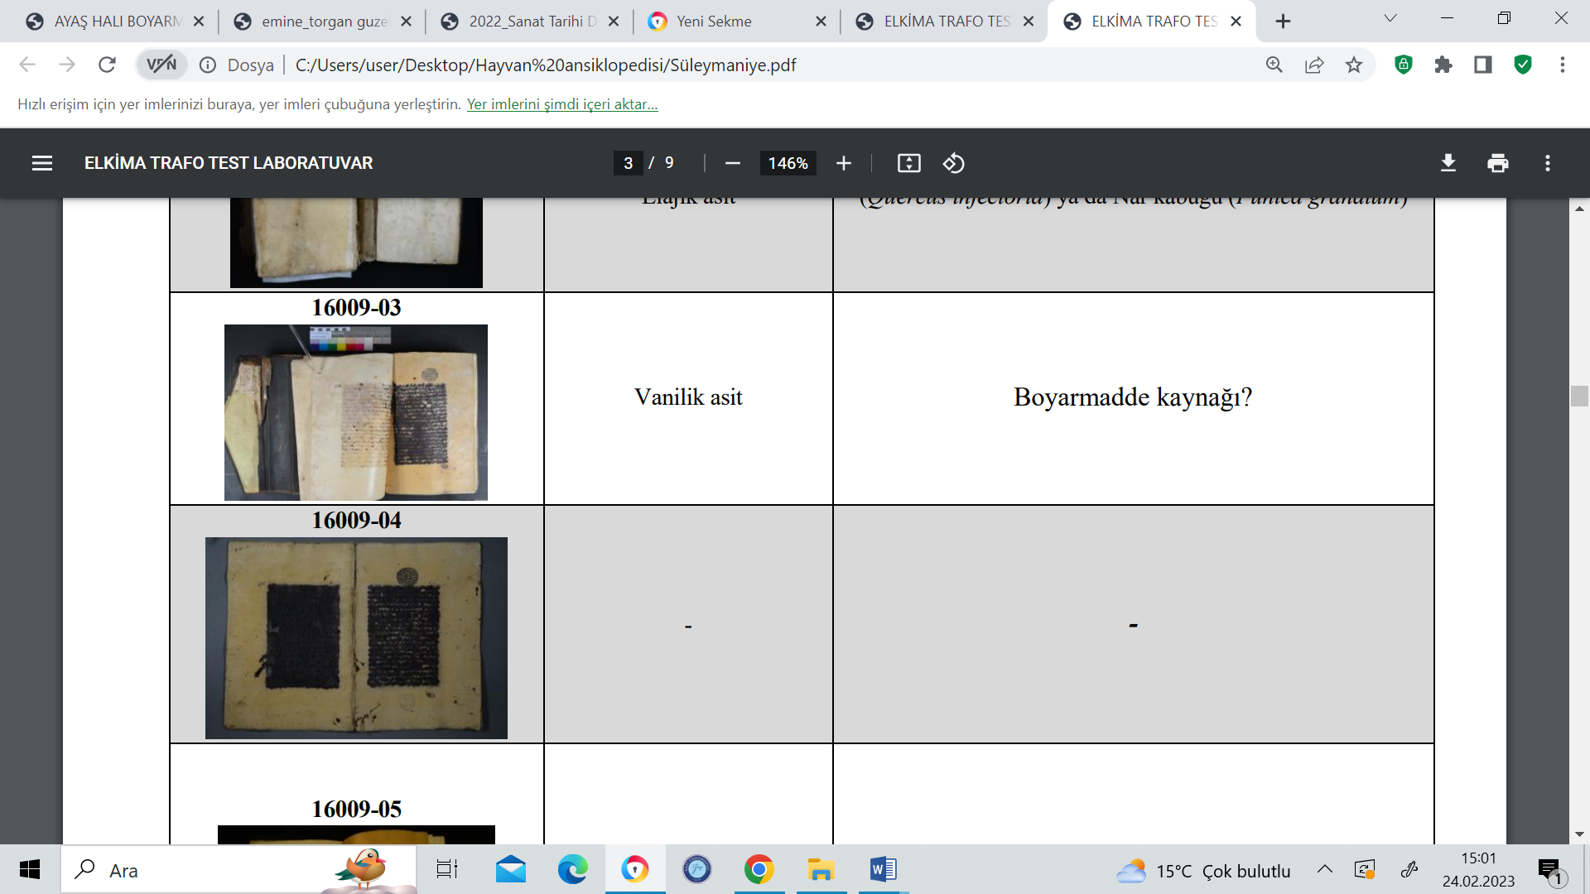 | AE-23 | leather (from binding) | 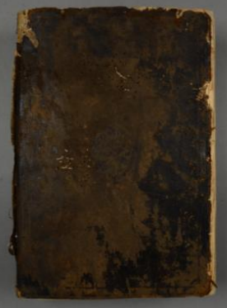
AE-04 | paper |  | AE-24 | leather (from spine) | 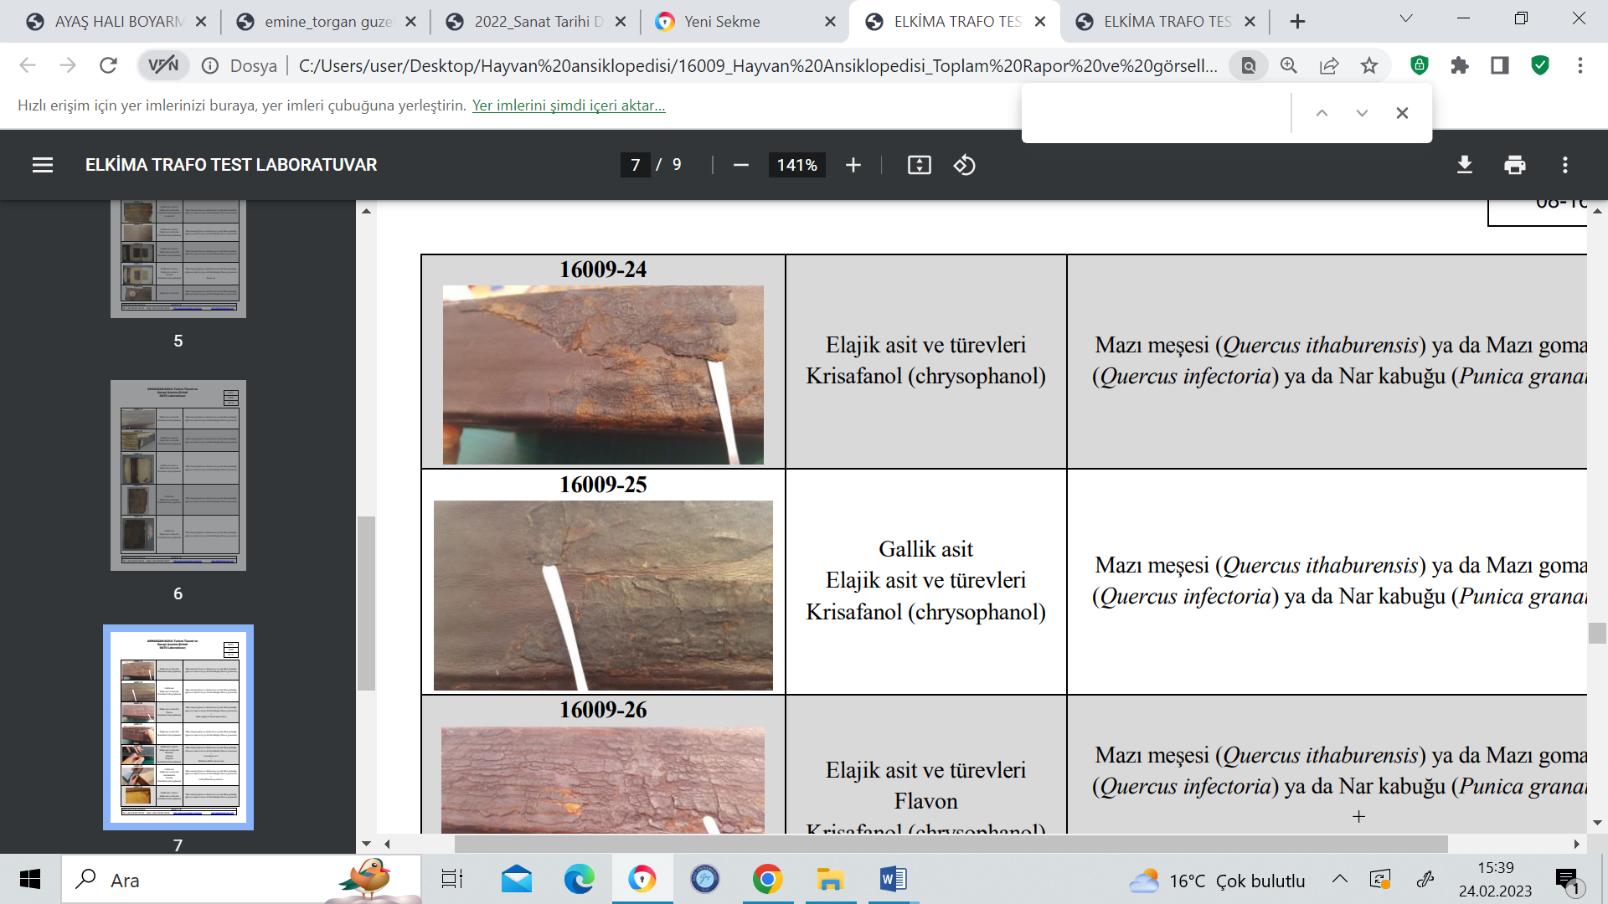
AE-05 | paper | 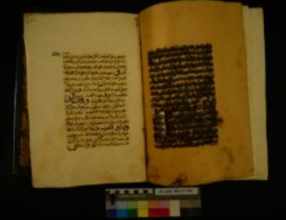 | AE-25 | leather (from spine)
AE-06 | paper+ink | 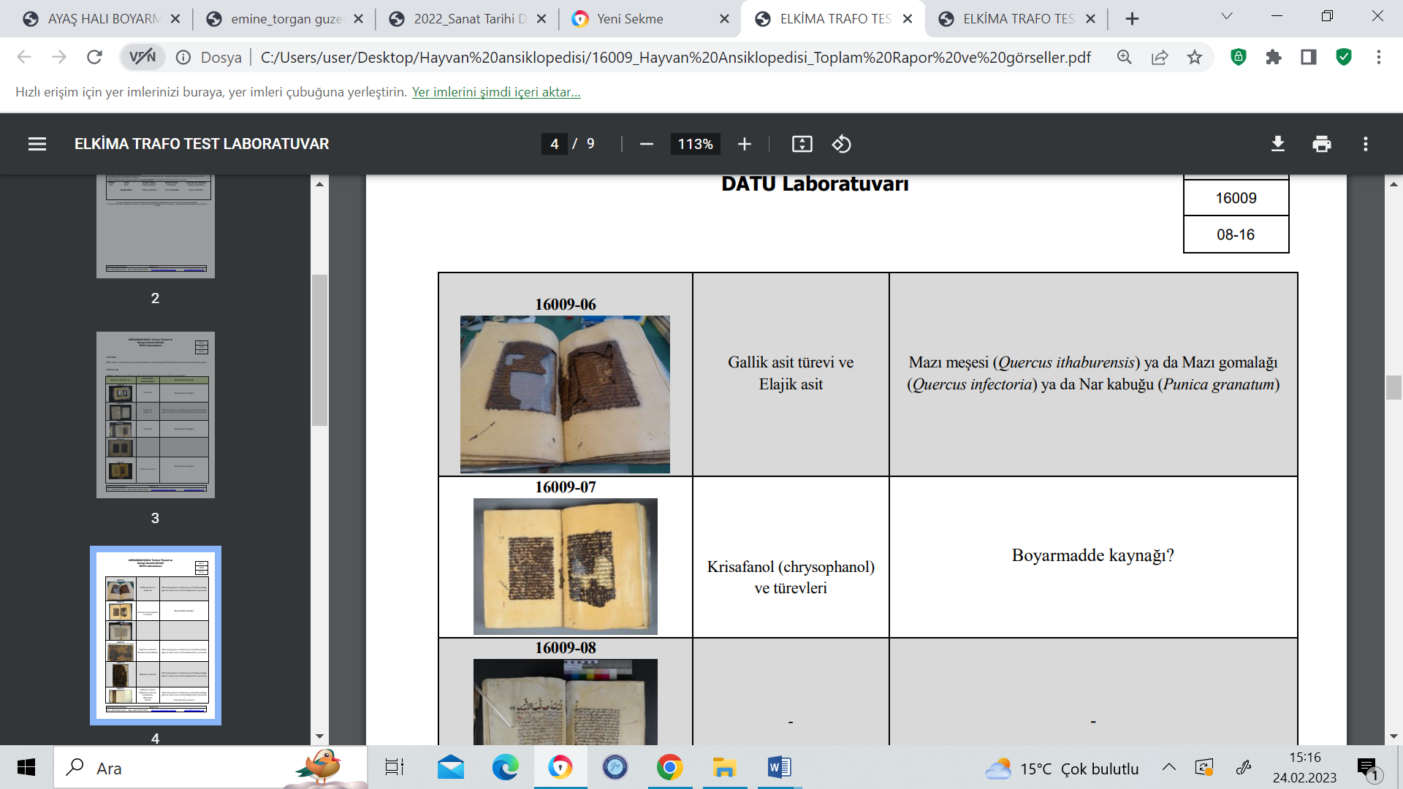 | AE-26 | leather (from spine) | 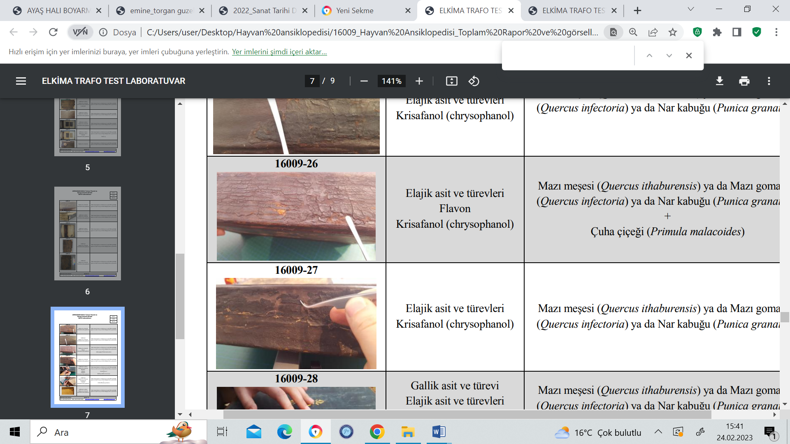
AE-07 | paper |  | AE-27 | leather (from spine)
AE-08 | paper | 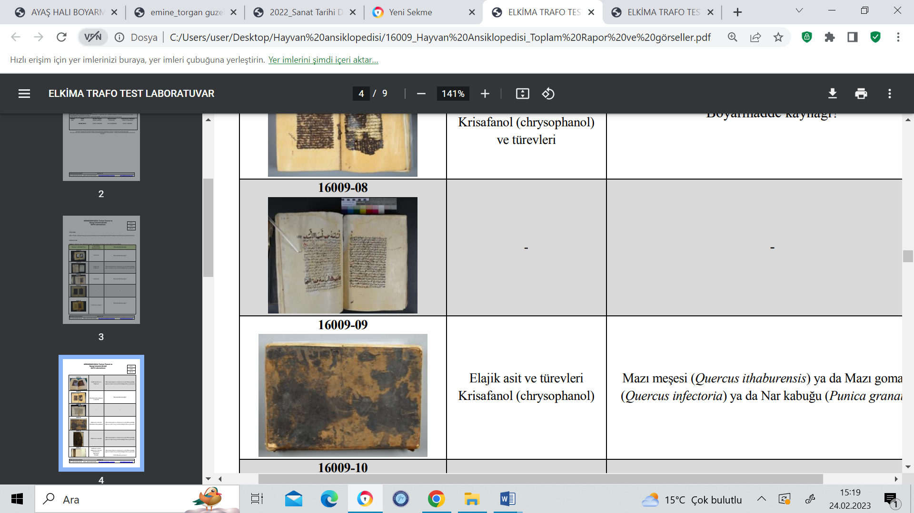 | AE-28 | paper (doublure) | 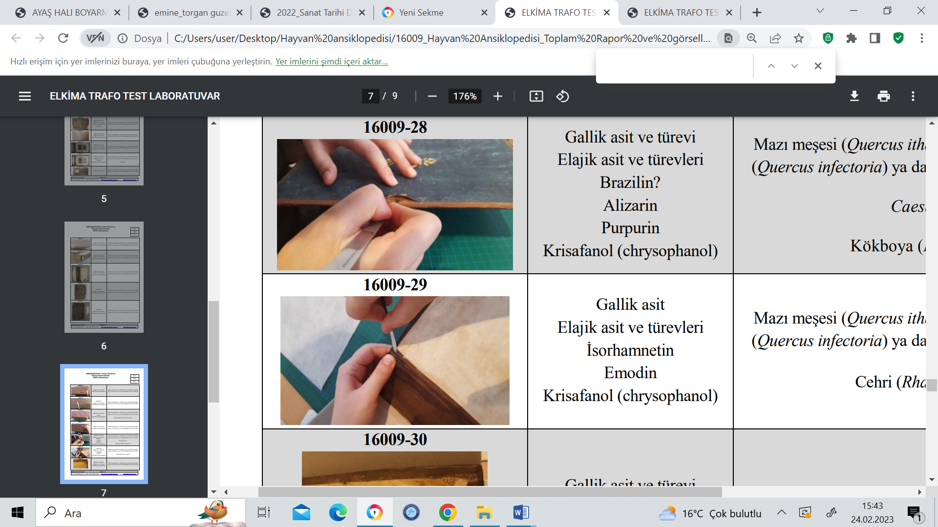
AE-09 | leather (from binding) |  | AE-29 | paper (doublure)
AE-10 | leather (from binding) | 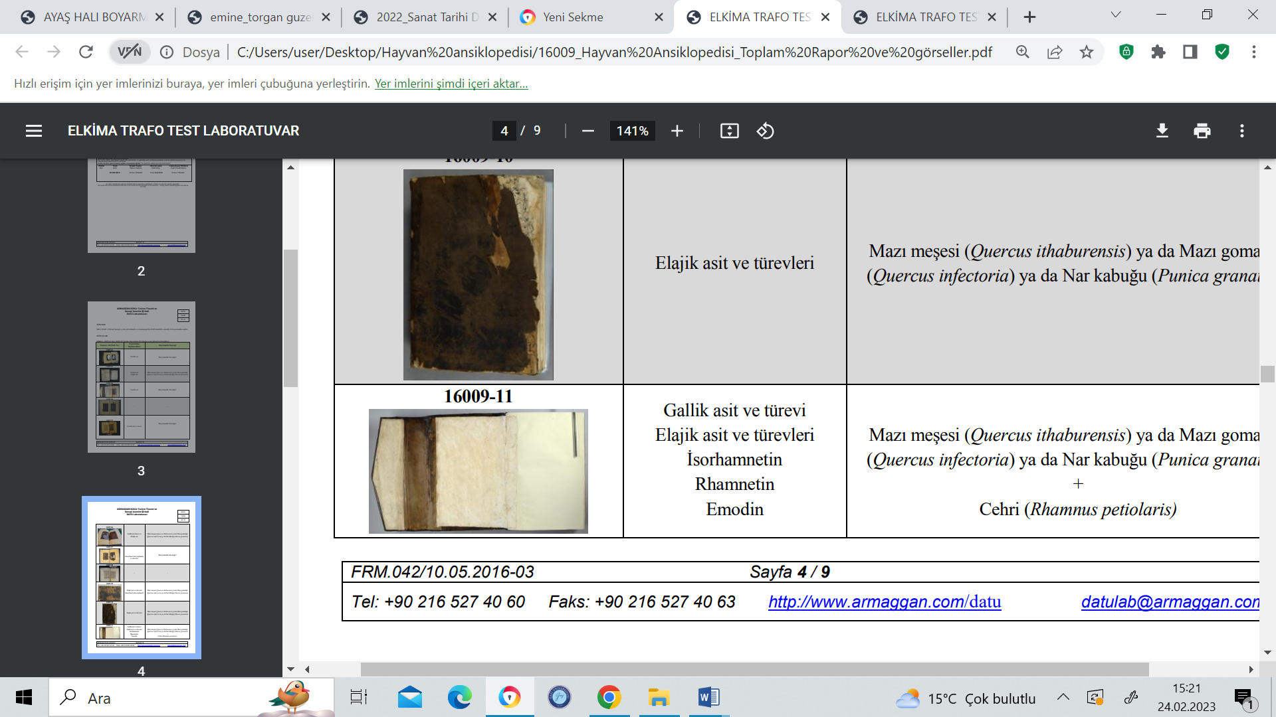 | AE-30 | paper (doublure) | 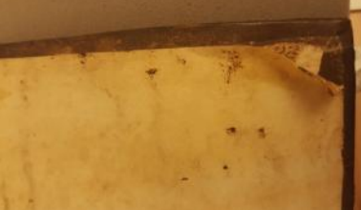
AE-11 | paper (doublure) |  | AE-31 | paper (doublure) | 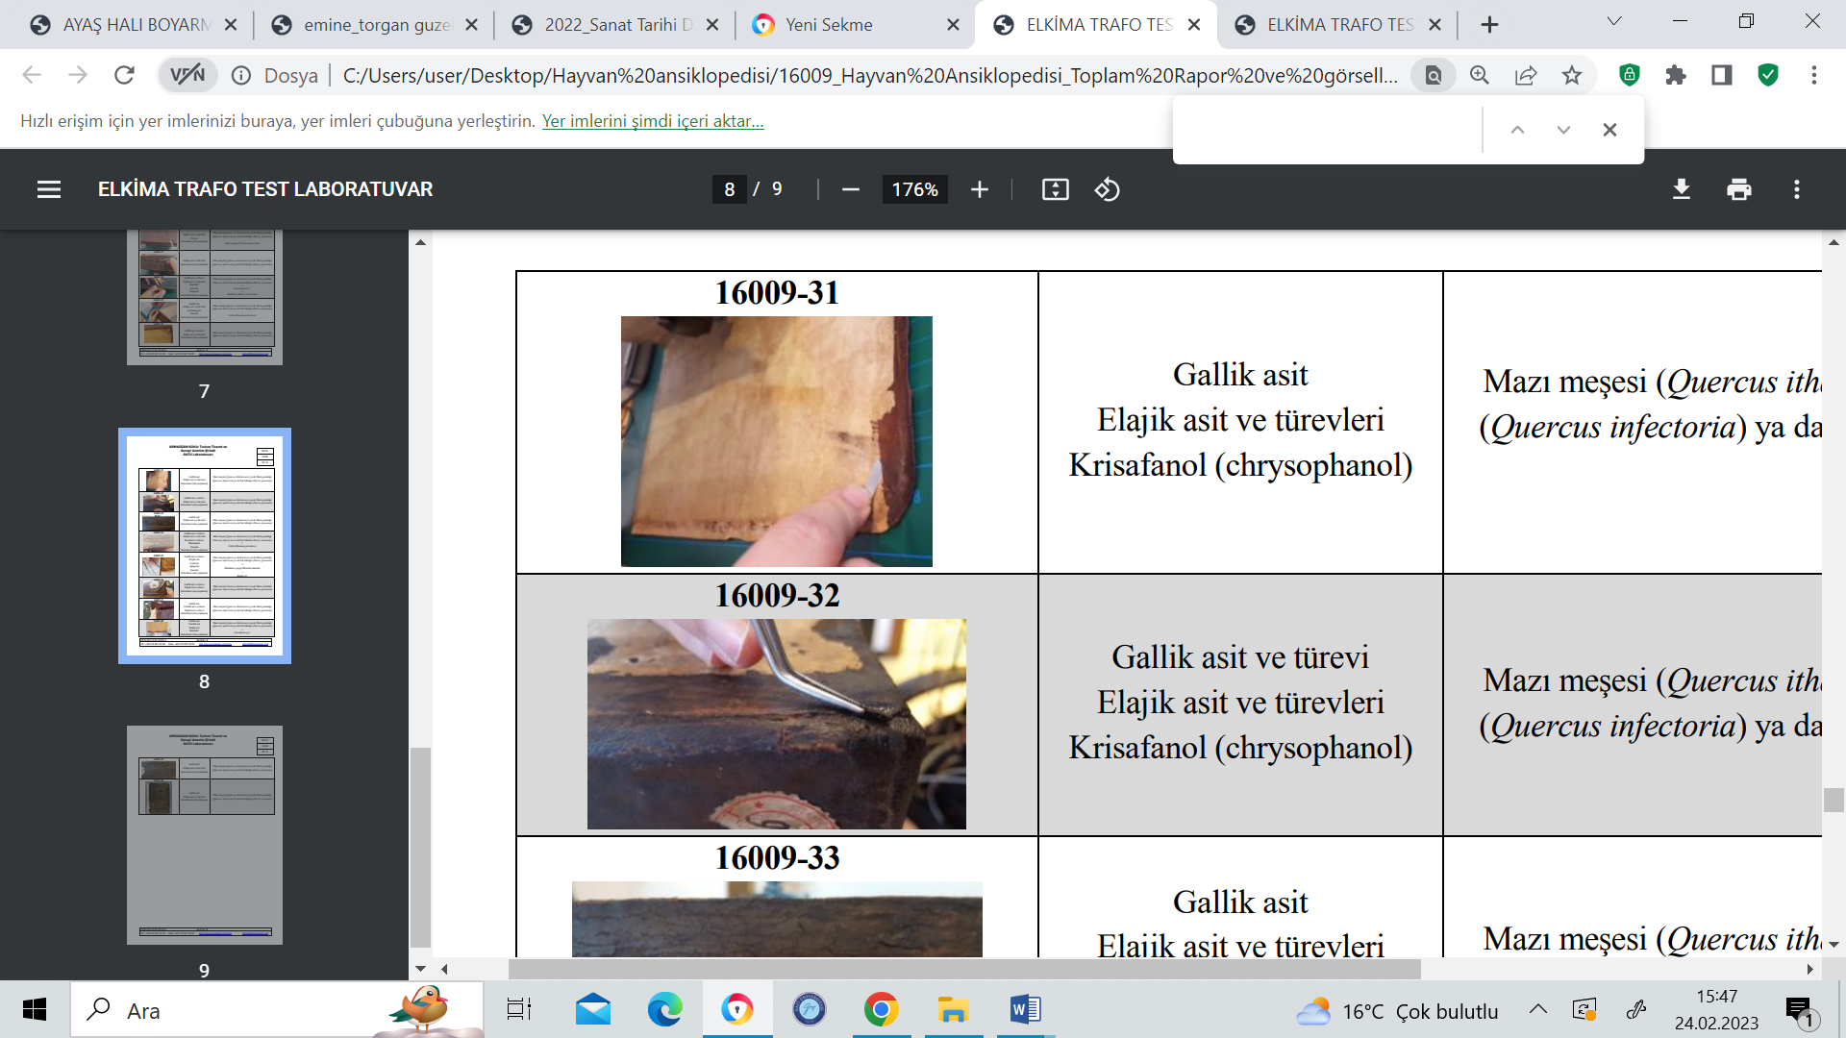
AE-12 | paper (doublure) | 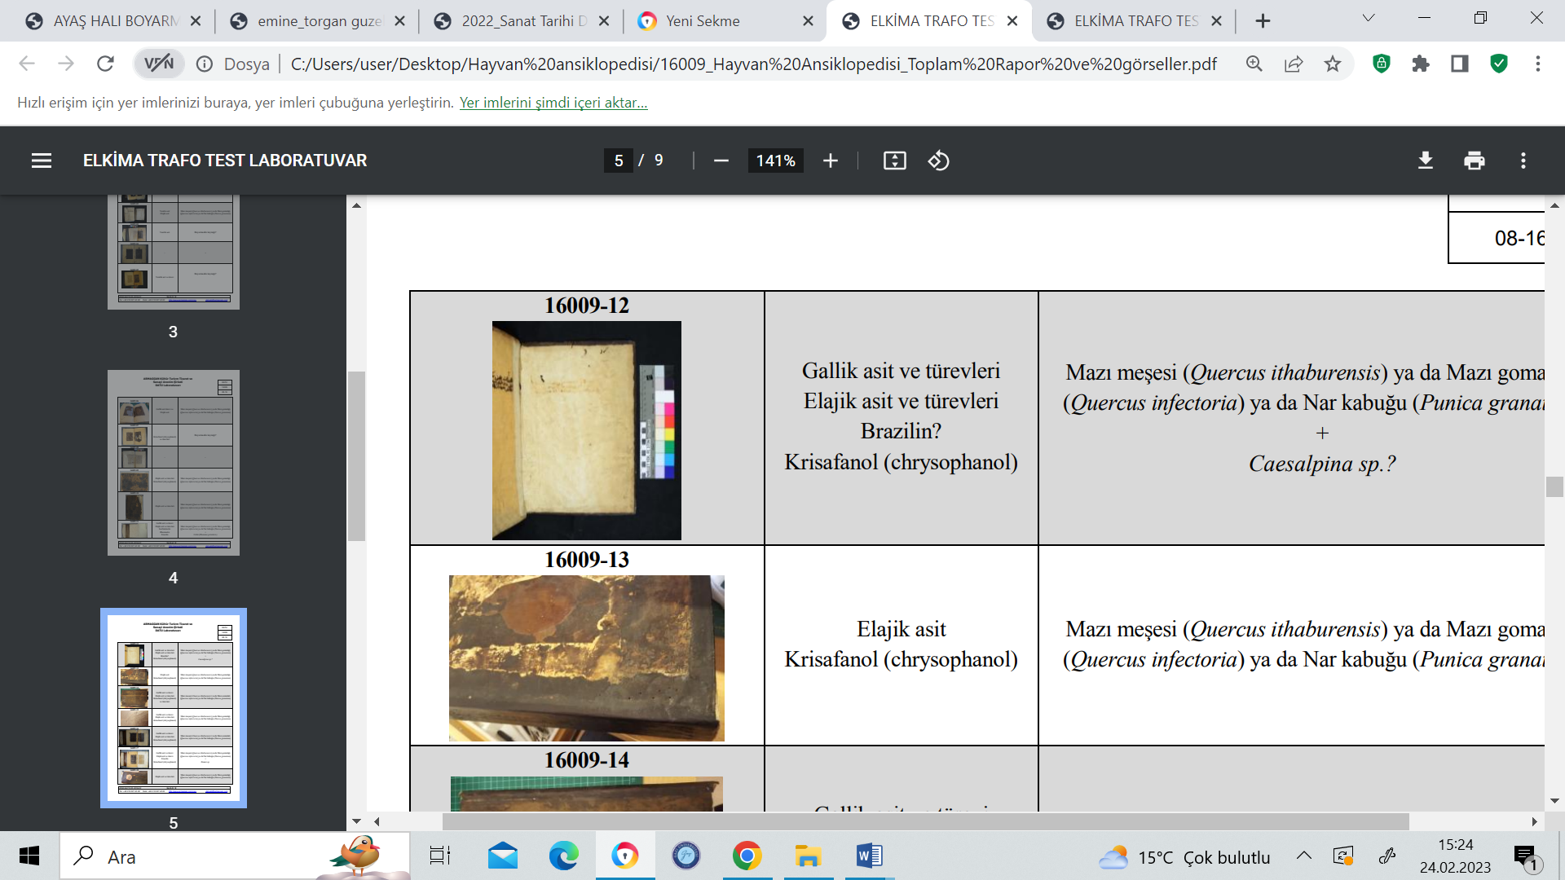 | AE-32 | leather (from spine)
AE-13 | leather (from binding) |  | AE-33 | leather (from spine) | 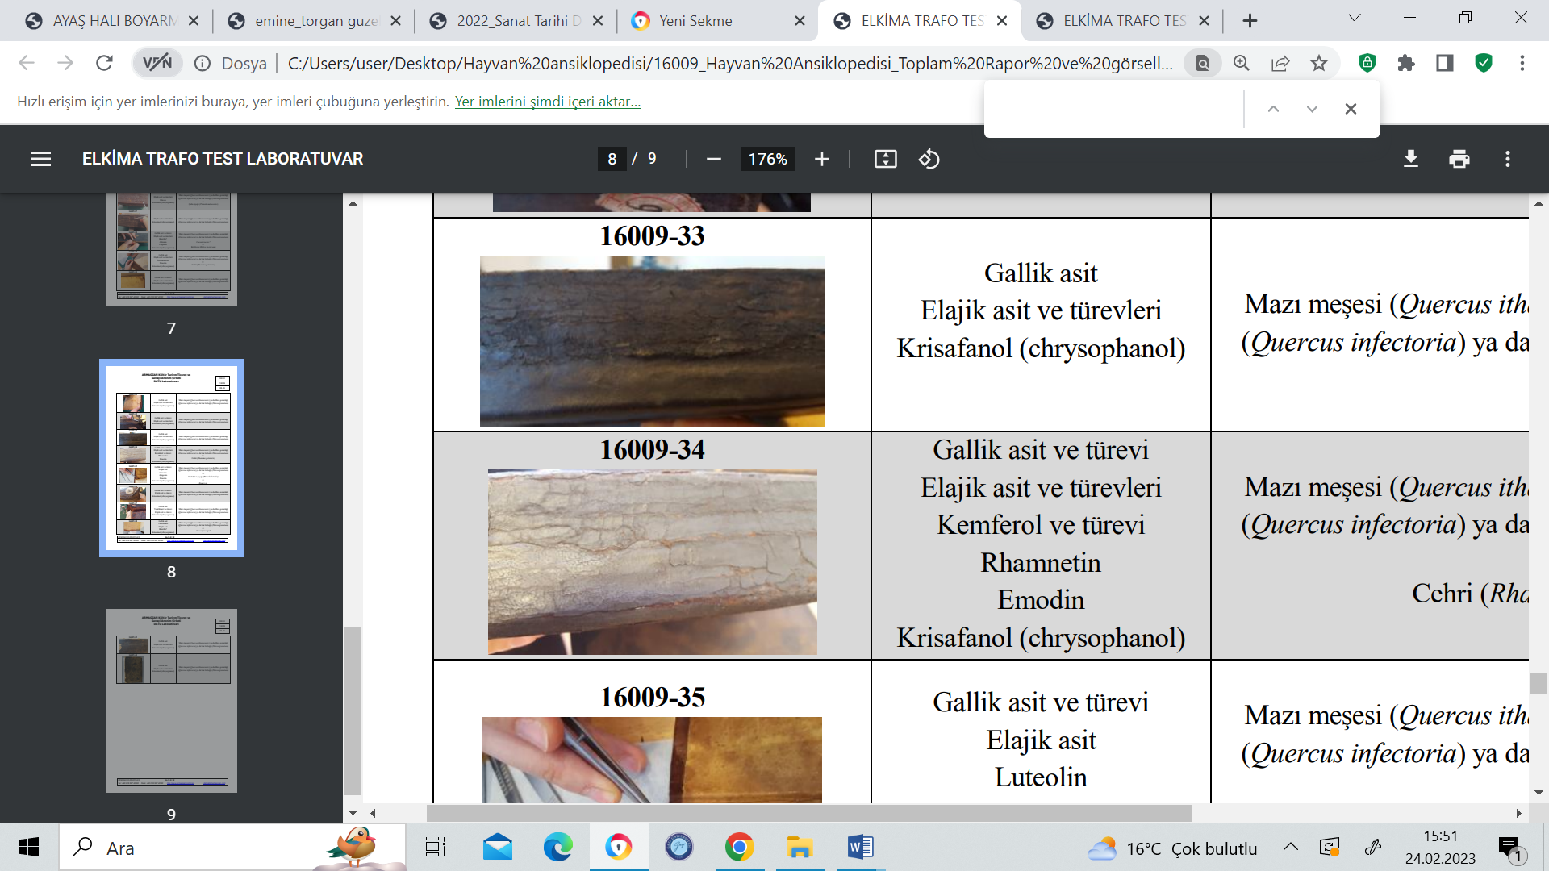
AE-14 | leather (from binding) | 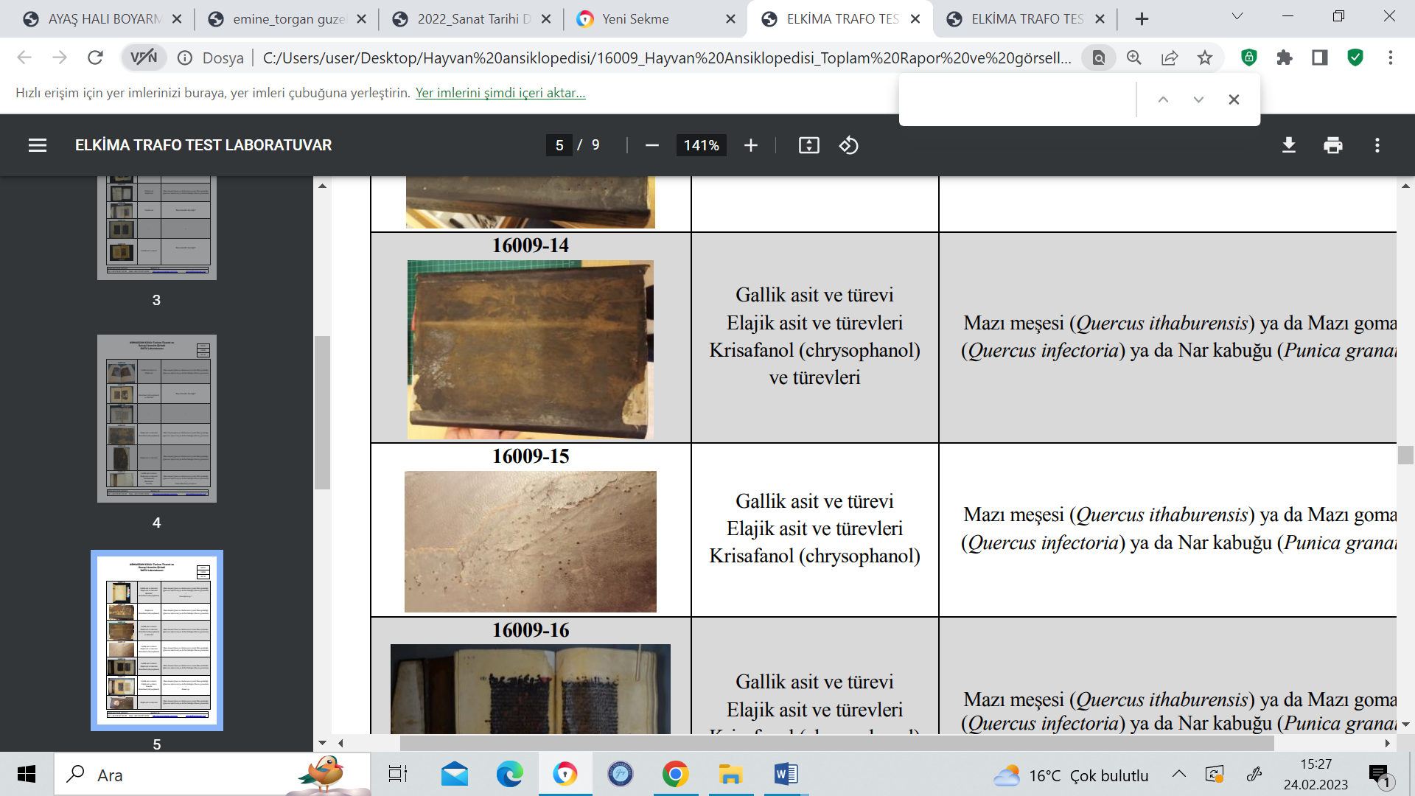 | AE-34 | leather (from spine)
AE-15 | leather (from binding) |  | AE-35 | paper (doublure) | 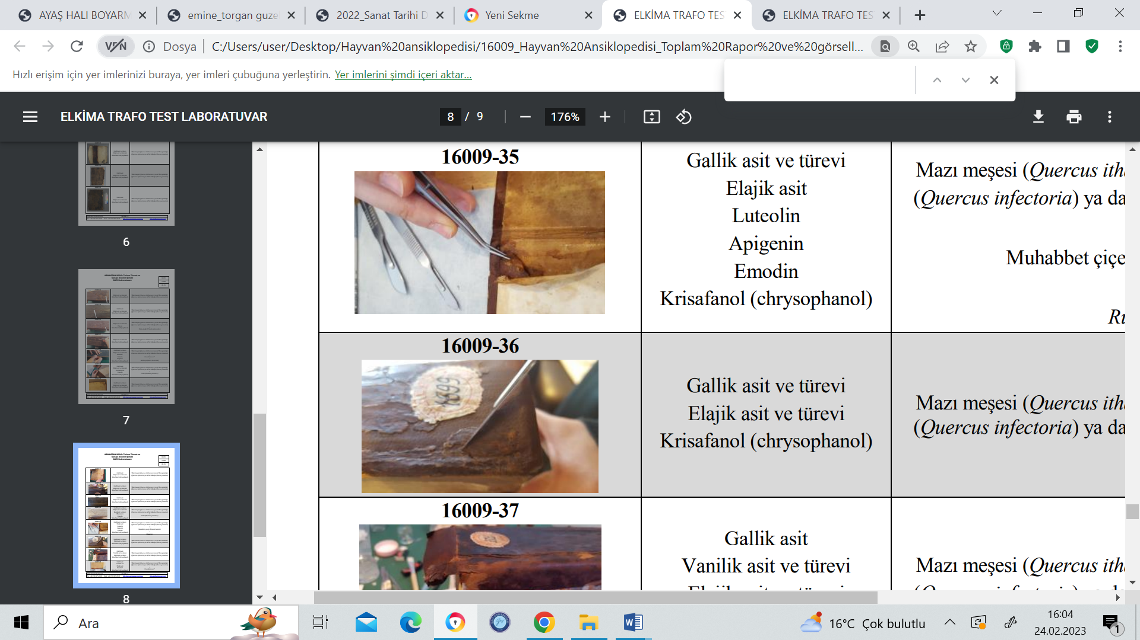
AE-16 | paper+ink | 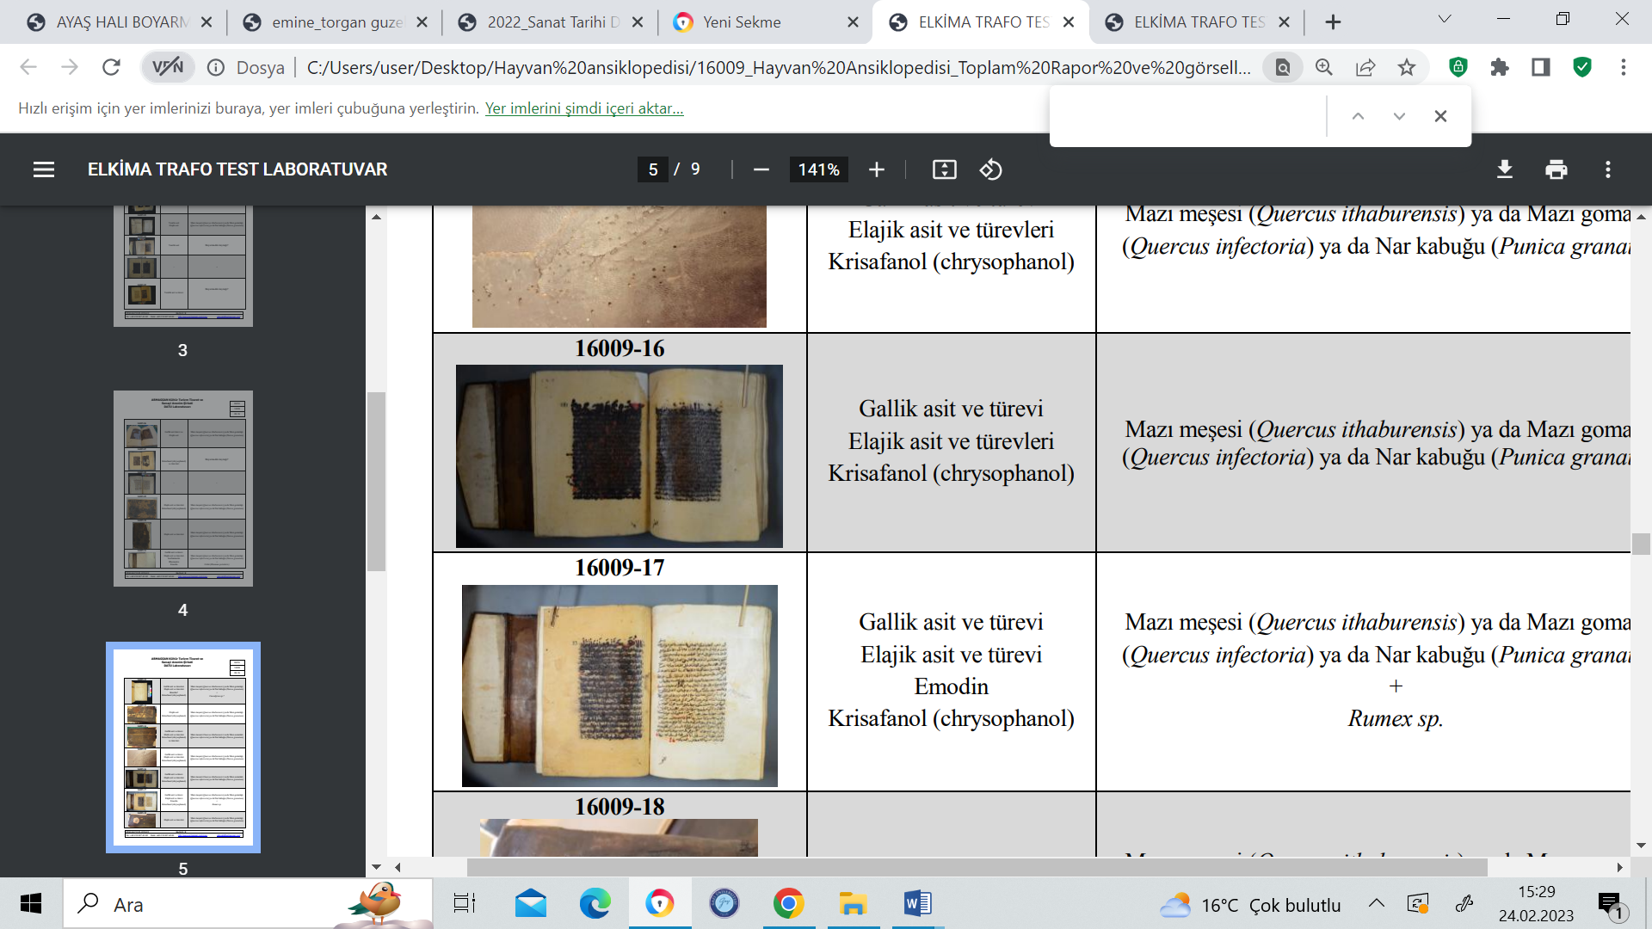 | AE-36 | leather (from spine)
AE-17 | paper+ink |  | AE-37 | paper | 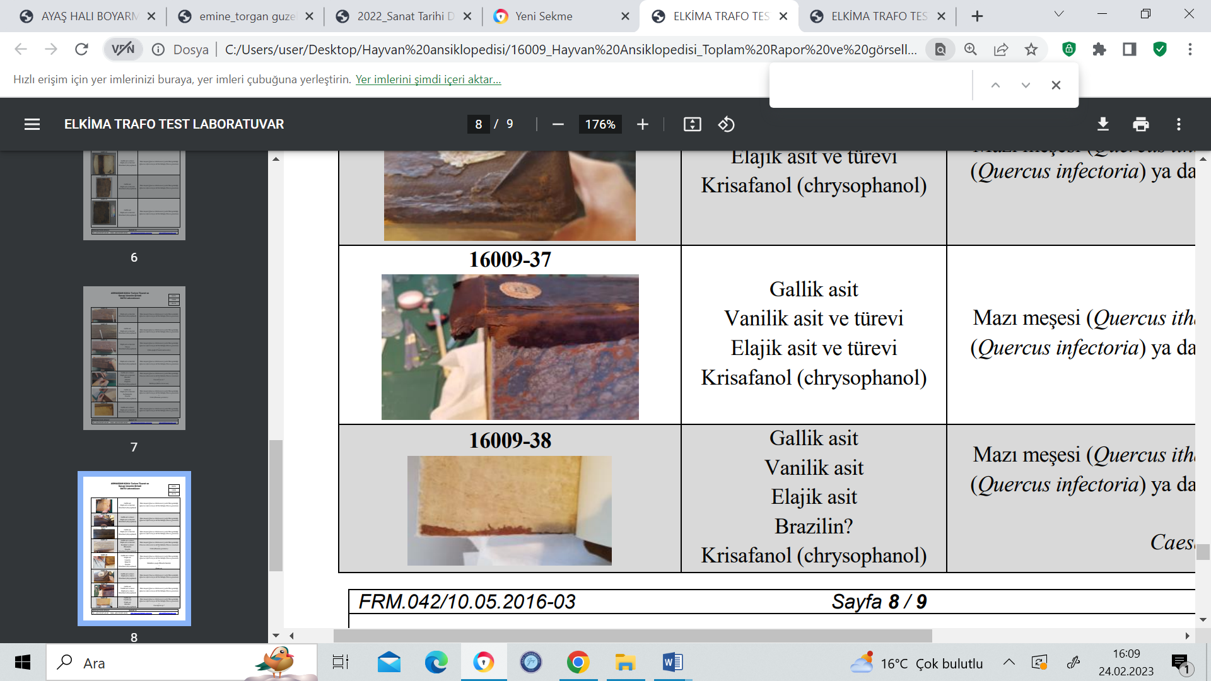
AE-18 | leather (from spine) | 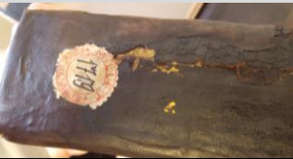 | AE-38 | paper (doublure)
AE-19 | leather (from spine) | 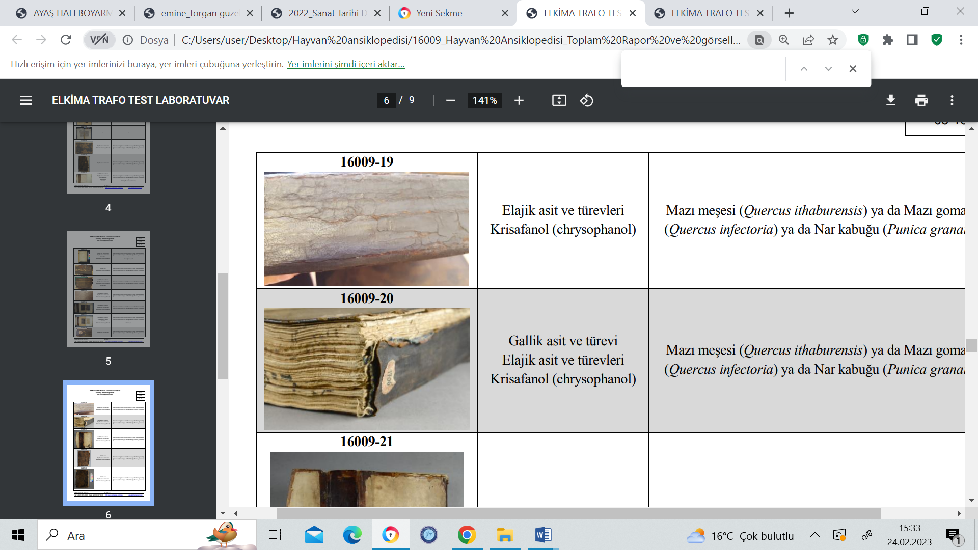 | AE-39 | leather (from spine) | 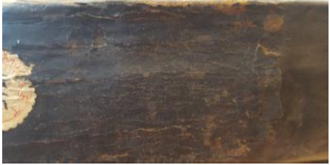
AE-20 | leather (from spine) |  | AE-40 | leather (from binding) | 