Electronic Supplemental Materials

Supplementary Figure 1. CVID-dysbiosis index. The relative abundance of the 11 main taxa in CVID patients and controls (CVID-dysbiosis index). The dysbiosis index was higher in CVID patients than in HD (OR 30.0, 95%CI 19.8 to 40.2, panel A). The dysbiosis index was inversely related to the alpha diversity (OR -1.1, 95%CI -1.3 to -0.8, panel B). Levels of significance: ****p<0.0001
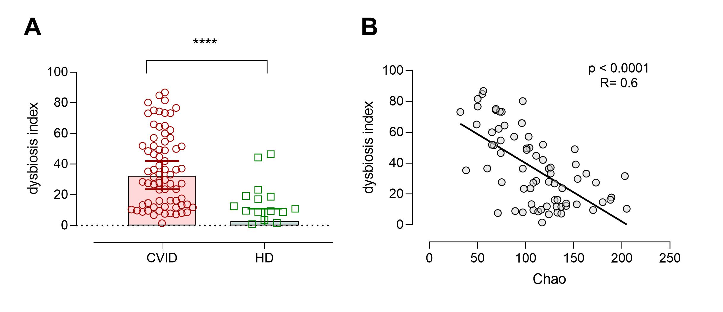
Supplementary Table 1. Bacterial taxa with different abundance in CVID and controls.
Taxon | Increased in | LDA Effect size | LEfSe  P value | t test  P value
Bacteria.Bacteroidetes | HD | 4.63 | 8.7x10⁻⁵ | 8.5 x10⁻⁴
Bacteria.Bacteroidetes.Bacteroidia | HD | 4.63 | 8.7x10⁻⁵ | 8.5 x10⁻⁴
Bacteria.Bacteroidetes.Bacteroidia.Bacteroidales | HD | 4.58 | 1.8 x10⁻⁵ | 0.0010
Bacteria.Bacteroidetes.Bacteroidia.Bacteroidales.Prevotellaceae | HD | 4.50 | 5.1 x10⁻⁴ | 0.0011
Bacteria.Bacteroidetes.Bacteroidia.Bacteroidales.Prevotellaceae.Alloprevotella | HD | 4.14 | 1.9 x10⁻⁴ | 4.1 x10⁻⁵
Bacteria.Bacteroidetes.Bacteroidia.Bacteroidales.Prevotellaceae.Prevotella | HD | 3.68 | 2.0 x10⁻⁴ | 0.0273
Bacteria.Bacteroidetes.Bacteroidia.Flavobacteriales | HD | 3.69 | 0.0046 | 0.0178
Bacteria.Bacteroidetes.Bacteroidia.Flavobacteriales.Flavobacteriaceae | HD | 3.58 | 0.0109 | 0.0326
Bacteria.Fusobacteria | HD | 4.26 | 0.0183 | 0.0062
Bacteria.Fusobacteria.Fusobacteriia | HD | 4.26 | 0.0183 | 0.0062
Bacteria.Fusobacteria.Fusobacteriia.Fusobacteriales | HD | 4.26 | 0.0183 | 0.0062
Bacteria.Fusobacteria.Fusobacteriia.Fusobacteriales.Fusobacteriaceae | HD | 3.99 | 0.0355 | 0.0042
Bacteria.Fusobacteria.Fusobacteriia.Fusobacteriales.Fusobacteriaceae.Fusobacterium | HD | 3.99 | 0.0355 | 0.0042
Bacteria.Firmicutes.Negativicutes | HD | 4.20 | 0.0402 | 0.0035
Bacteria.Firmicutes.Negativicutes.Selenomonadales | HD | 4.20 | 0.0402 | 0.0035
Bacteria.Firmicutes.Negativicutes.Selenomonadales.Veillonellaceae | HD | 4.20 | 0.0402 | 0.0035
Bacteria.Epsilonbacteraeota | HD | 3.54 | 0.0219 | 0.0284
Bacteria.Epsilonbacteraeota.Campylobacteria | HD | 3.54 | 0.0219 | 0.0284
Bacteria.Epsilonbacteraeota.Campylobacteria.Campylobacterales | HD | 3.54 | 0.0219 | 0.0250
Bacteria.Epsilonbacteraeota.Campylobacteria.Campylobacterales.Campylobacteraceae | HD | 3.54 | 0.0231 | 0.0293
Bacteria.Epsilonbacteraeota.Campylobacteria.Campylobacterales.Campylobacteraceae.Campylobacter | HD | 3.54 | 0.0231 | 0.0293
Bacteria.Firmicutes.Bacilli.Lactobacillales | CVID | 4.97 | 2.8x10⁻⁶ | 0.0042
Bacteria.Firmicutes.Bacilli.Lactobacillales.Streptococcaceae | CVID | 4.94 | 5.5x10⁻⁶ | 0.0050
Bacteria.Firmicutes.Bacilli.Lactobacillales.Streptococcaceae.Streptococcus | CVID | 4.95 | 9.3x10⁻⁵ | 0.0045

Supplementary Table 2. Dysbiosis index and CVID-related characteristics collected during the study.

Characteristics | OR | 95% CI per OR | P value
Sex | -9.7 | from 20.0 to 0.6 | 0.065
Age >=40 years | 7.0 | from -4.2 to 18.1 | 0.218
IgA < 0.01 g/L | 5.1 | from -7.7 to 17.9 | 0.431
Chronic obstructive pulmonary disease (moderate/severe) | 17.8 | from 5.1 to 30.4 | 0.006
Bronchiectasis | 1.9 | From -9.7 to 13.4 | 0.748
Antibiotic use (T0-T5) | 1.0 | From -11.4 to 13.4 | 0.873
Respiratory tract infections (T6-T12) | -1.4 | From -13.7 to 10.8 | 0.814
Corticosteroids treatment by inhaler (T0-T6) | 11.0 | From -2.4 to 24.4 | 0.105

