Súkeníková et al, Extended Data Figure 1
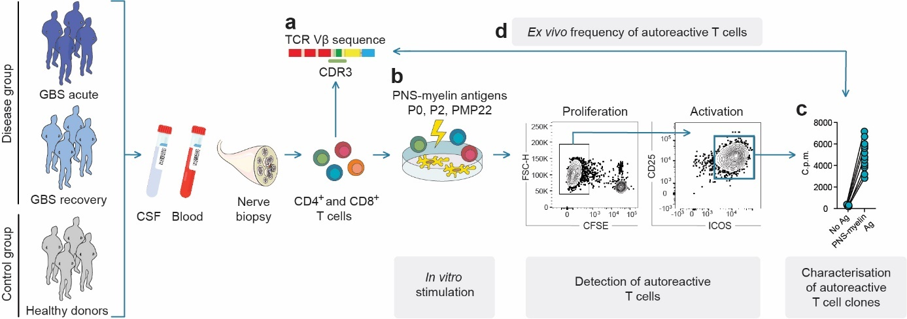
Extended Data Figure 1. Experimental approach to study autoreactive T cells in GBS patients. Peripheral blood from GBS patients (n = 16) at acute phase and/or at follow up visits during the recovery stage (Extended Data Table 1) as well as from HD (n = 15) was collected. When available, we also obtained cerebrospinal fluid (CSF, n = 3) and nerve biopsy (n = 1) samples at GBS disease onset. Memory CD4⁺ and CD8⁺ T cells ex vivo from blood or total CD4⁺ and CD8⁺ T cells, polyclonally expanded in vitro from CSF or nerve biopsy, were sorted by FACS-cytometry. (a) A fraction of cells (2 - 2.5 x10⁵ cells) was analysed by high throughput T cell receptor β-chain variable (TCR Vβ) sequencing to determinate their repertoire composition. (b) The rest of sorted T cells was in vitro screened for the presence of autoreactive T cells specific for P0, P2 and PMP22 myelin antigens of the peripheral nerves (PNS-myelin antigens). Autoreactive T cells were detected by measuring carboxyfluorescein succinimidyl ester (CFSE) dilution and expression of the activation markers CD25 and ICOS on day 6-7 by flow cytometry. (c) When identified, autoreactive T cells were further studied at the single cell resolution through the generation of single T cell clones by the characterization of their TCR Vβ sequences, MHC restriction and targeted epitope. (d) TCR Vβ repertoire of PNS-myelin-specific T cell clones was compared to the repertoire obtained from T cell populations directly isolated ex vivo from PBMCs or expanded from CSF or nerve biopsy to obtain information on their frequency in vivo in the blood and on the potential existence of shared autoreactive T cells in GBS patients.

Súkeníková et al, Extended Data Figure 2.
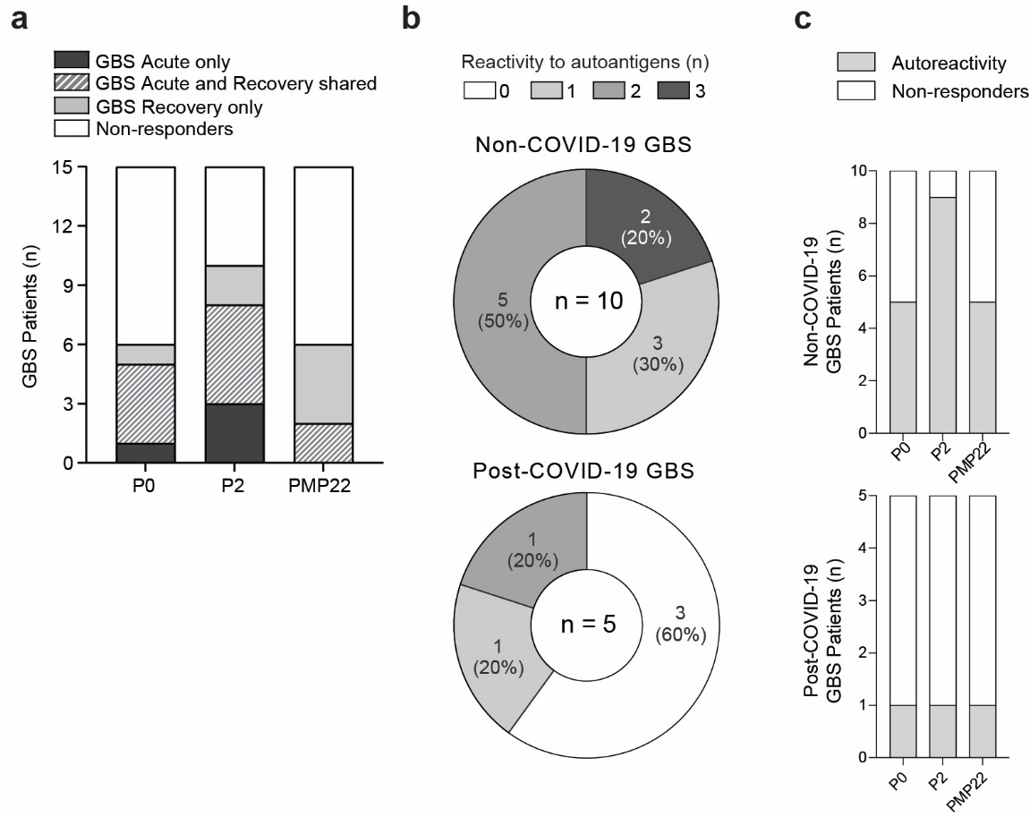
Extended Data Figure 2. Overview of autoreactive memory CD4⁺ T cell response in GBS patients with respect to disease stage and prior SARS-CoV-2 infection. (a) Graphical representation of autoreactive response detected based on total number of responding GBS patients (n = 15, y axis) to P0, P2 and PMP22 myelin antigens (x axis) and disease phase where autoreactivity was detected. (b-c) Number and percentage of GBS patients showing an autoreactive CD4⁺ T cells response divided with respect to prior SARS-CoV-2 infection (post-COVID-19, n = 5 and non-COVID-19, n = 10). (b) Reactivity to either one, two, three, or none of the PNS-myelin autoantigens tested and (c) number of responders / non-responders GBS patients are shown with respect to P0, P2 and PMP22 myelin antigens.

Súkeníková et al, Extended Data Figure 3.
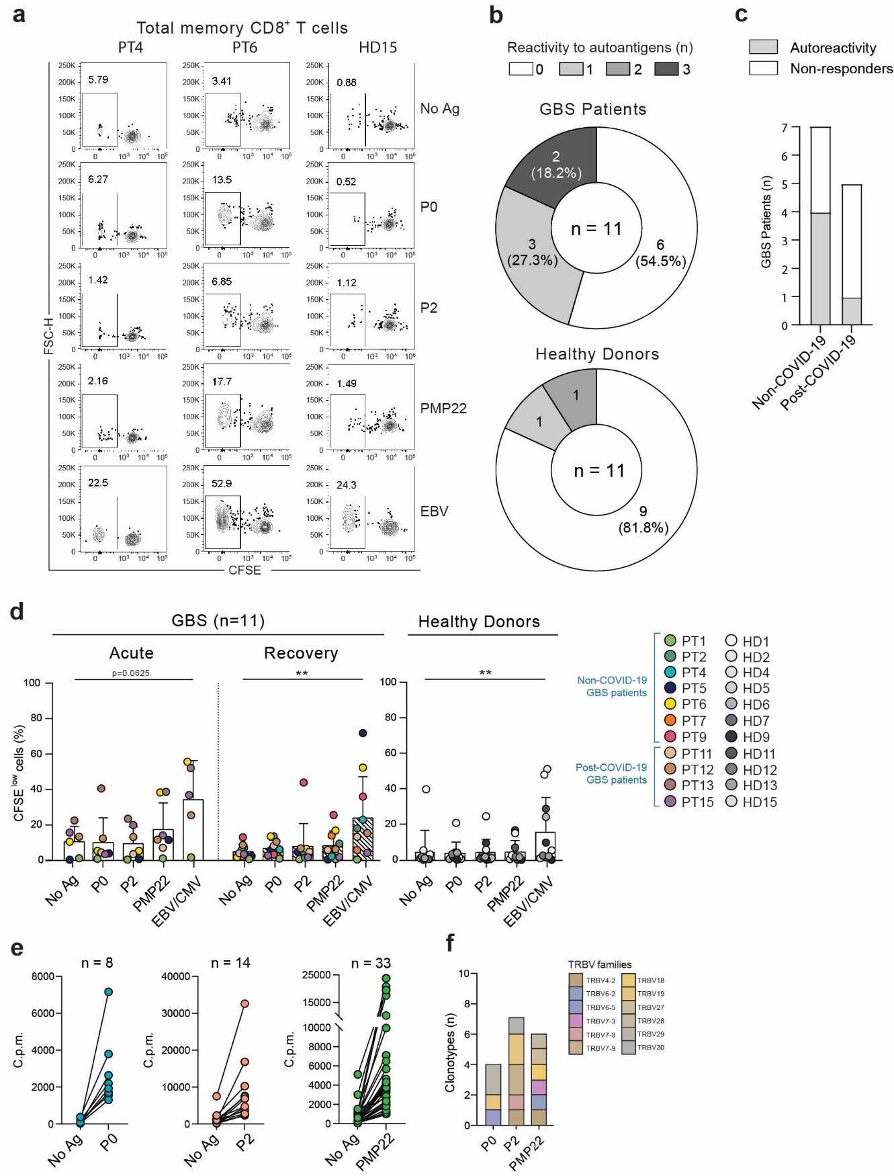
Extended Data Figure 3. Ex vivo stimulation of memory CD8⁺ T cells from blood of GBS patients and healthy donors. (a) Total memory CD8⁺ T cells from the blood of GBS patients and healthy donors were labelled with CFSE and cultured with autologous monocytes in the presence or absence of the PNS-myelin peptide pools (P0, P2, PMP22) and EBV/CMV HLA class I peptides as positive control. CFSE profiles from two representative patients (PT4, PT6) and one healthy donor (HD15) are shown. (b) Overview of the total number of screened GBS patients and HD reactive to either one, two, three, or none of the PNS-myelin autoantigens tested. Positive response was considered as stimulation index ≥ 2 and a Δ value ≥ 1.5%. (c) Total number of GBS patients showing or not autoreactive CD8⁺ T cell response divided with respect to prior SARS-CoV-2 infection. (d) Scatterplot with pooled data from the GBS patients (PT, n = 11 biologically independent samples, coloured dots) and healthy donors (HD, n = 11 biologically independent samples, white and grey dots) are shown as the percentage of proliferating CFSE^{low} cells. Each dot represents an individual donor and bar height indicates mean value with standard deviation. Data were analysed using Wilcoxon matched-pairs signed-rank test (P values are denoted: p > 0.05, *p < 0.05, **p < 0.01 and ***p < 0.001). (e) PNS-myelin specific memory CD8⁺ T cell clones were identified by individual stimulation with autologous B cells untreated (No Ag) or pulsed with the indicated PNS-myelin peptide pools (P0, P2, PMP22). Proliferation of CD8⁺ T cell clones was measured on day 3 after a 16-h pulse with [³H]-thymidine and is expressed as counts per minute (c.p.m.). Total number of PNS-myelin specific CD8⁺ T cell clones isolated from all GBS patients (n = 11) is indicated above each graph. (f) TCR Vβ gene usage of P0-, P2-, PMP22-specific CD8⁺ T cell clones isolated from GBS patients (n = 5) is shown as stacked bar chart. The y axis indicates the number of unique autoreactive clonotypes carrying different CDR3β sequences.

Súkeníková et al, Extended Data Figure 4.
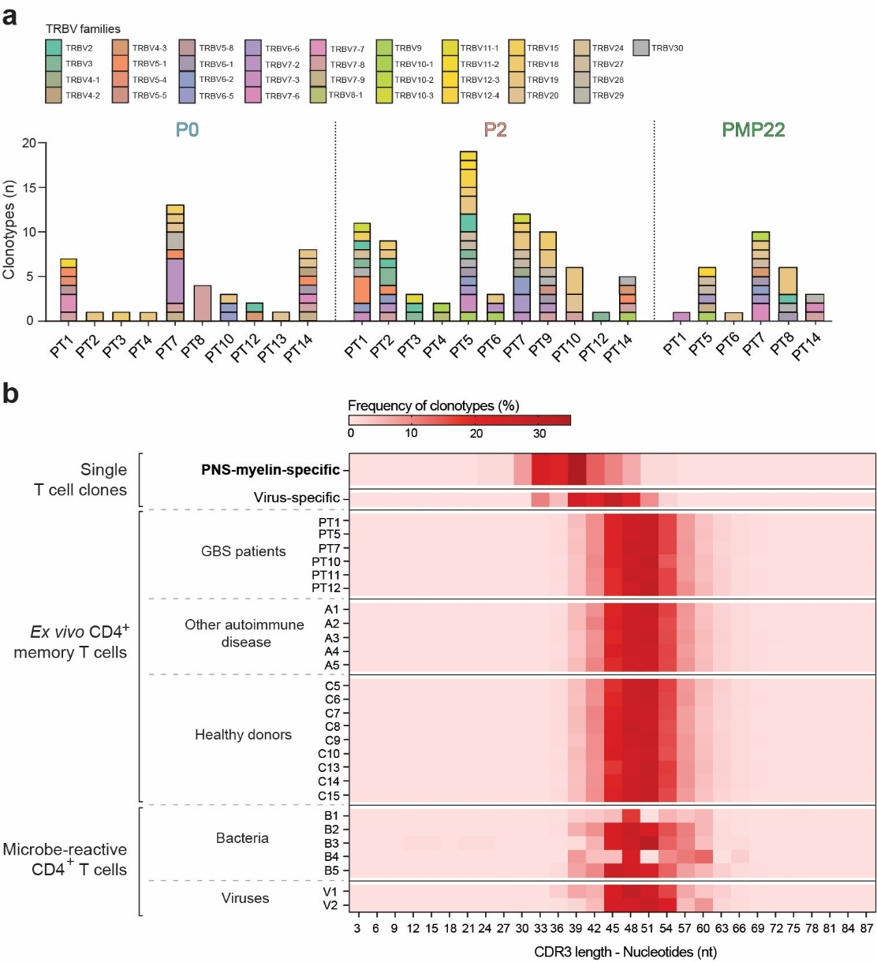
Extended Data Figure 4. Characterization of autoreactive T cell clones in GBS patients. (a) TCR Vβ gene usage of P0-, P2-, PMP22-specific clonotypes isolated from the indicated GBS patients. The y axis indicates the number of autoreactive clonotypes. (b) Heat map showing the percentage of clonotypes bearing the same CDR3β length defined by the number of nucleotides. The CDR3β lengths of PNS-myelin-specific CD4⁺ T cells isolated from GBS patients are shown in the top raw (n = 149 from 13 PT) and were compared to the CDR3β lengths of (i) SARS-CoV-2-specific CD4⁺ T cell clones (virus-specific clonotypes, n = 93 from 6 PT), (ii) ex vivo memory CD4⁺ T cells from the indicated GBS patients, or patients with other autoimmune disorders (A) or healthy donors (C) and (iv) bacteria- (B) and viruses- (V) reactive CD4⁺ T cell CFSE^{low} fractions enriched from in vitro stimulation assay.

Súkeníková et al, Extended Data Table 1.
N.A. not available; VZV, Varicella-zoster virus; CMV, Cytomegalovirus; IVIg, Intravenous immunoglobulin; PEX, Plasma Exchange; *days from disease onset
Patient ID | Gender | Age | Diagnosis | Prior  infection | Treatment | Anti-gangliosides antibody (serum) | Acute  blood sample* | Follow-up  blood sample* | CSF  sample | Nerve biopsy sample
PT1 | M | 74 | Non-COVID-19 AIDP | VZV | None | Negative | 0 | 201 | N.A. | N.A.
PT2 | M | 31 | Non-COVID-19 AIDP | CMV | None | Anti-GD1a IgG Positive  Anti-GD1b IgG Positive  Anti-GM1 IgG Positive  Anti-GM2 IgM Positive | 5 | 180 | N.A. | N.A.
PT3 | M | 52 | Non-COVID-19 AIDP | CMV | IVIg | Negative | N.A. | 136 | N.A. | N.A.
PT4 | M | 75 | Non-COVID-19 AIDP | N.A. | IVIg | Negative | 15 | 235 | N.A. | N.A.
PT5 | F | 65 | Non-COVID-19 AIDP | N.A. | None | Negative | 36 | 314 | N.A. | N.A.
PT6 | M | 30 | Non-COVID-19 AIDP | N.A. | None | Negative | 15 | 350 | N.A. | N.A.
PT7 | M | 80 | Non-COVID-19 AIDP | N.A. | IVIg | N.A. | 0 | 223 | N.A. | N.A.
PT8 | F | 61 | Non-COVID-19 AIDP | Pyelonephritis | IVIg | N.A. | 13 | 241 | N.A. | N.A.
PT9 | M | 64 | Non-COVID-19 AIDP | N.A. | IVIg | Negative | 8 | 428 | N.A. | N.A.
PT10 | F | 71 | Non-COVID-19 AIDP | N.A. | None | Negative | 4 | N.A. | Yes | N.A.
PT11 | M | 54 | Post-COVID-19 AIDP | SARS-CoV-2 | IVIg and PEX | Negative | 20 | 135 | Yes | N.A.
PT12 | M | 49 | Post-COVID-19 AIDP | SARS-CoV-2 | IVIg | Negative | 9 | 147 | Yes | N.A.
PT13 | F | 48 | Post-COVID-19 AIDP | SARS-CoV-2 | IVIg | Negative | 9 | 509 | N.A. | N.A.
PT14 | M | 49 | Post-COVID-19 AIDP | SARS-CoV-2 | None | Negative | 12 | 138 | N.A. | N.A.
PT15 | M | 53 | Post-COVID-19 AIDP | SARS-CoV-2 | None | Anti-GM2 IgM Positive | 6 | 188 | N.A. | N.A.
PT16 | M | 66 | Non-COVID-19 AIDP | VZV | PEX and IVIg | Negative | 31 | N.A. | N.A. | Yes

Súkeníková et al, Extended Data Table 2.
 | Memory CD4⁺ T cells from blood |  |  |  |  | Total CD4⁺ T cells from CFS |  | Memory CD8⁺ T cells from blood
PT (ID) | Ex vivo screening* | PNS-myelin reactivity | Isolation of PNS-myelin specific clones | High Throughput TCRβ sequencing* | High Throughput TCRβ sequencing* |  | Ex vivo screening* |  | PNS-myelin reactivity | Isolation of PNS-myelin specific clones
PT1 | AC+REC | yes | yes | AC + REC | N.D. |  | AC+REC |  | no | no
PT2 | AC+REC | yes | yes | N.D. | N.D. |  | REC |  | no | no
PT3 | REC | yes | yes | N.D. | N.D. |  | N.D. |  | N.D. | N.D.
PT4 | AC+REC | yes | yes | REC | N.D. |  | REC |  | no | no
PT5 | AC+REC | yes | yes | AC + REC | N.D. |  | AC+REC |  | yes | yes
PT6 | AC+REC | yes | yes | N.D. | N.D. |  | AC+REC |  | yes | yes
PT7 | AC+REC | yes | yes | AC + REC | N.D. |  | REC |  | yes | yes
PT8 | AC+REC | yes | yes | N.D. | N.D. |  | N.D. |  | N.D. | yes
PT9 | AC+REC | yes | yes | REC | N.D. |  | REC |  | yes | yes
PT10 | AC | yes | yes | AC | yes |  | N.D. |  | N.D. | N.D.
PT11 | REC | no | no | AC | yes |  | AC+REC |  | yes | no
PT12 | AC+REC | yes | yes | AC + REC | yes |  | AC+REC |  | no | no
PT13 | AC | no | yes | REC | N.D. |  | AC |  | no | no
PT14 | AC+REC | yes | yes | N.D. | N.D. |  | AC+REC |  | no | yes
PT15 | AC+REC | no | no | N.D. | N.D. |  | N.D. |  | N.D. | N.D.
PT16 | AC (EM + CM) | yes | no | N.D. | N.D. |  | N.D. |  | N.D. | N.D.
N.D.: not done; * disease stage.

