SUPPLEMENTARY INFORMATION

Supplementary Table S1. Interaction between smoking status and genetic predisposition on dementia risk among females

Supplementary Table S2. Interaction between smoking status and genetic predisposition on dementia risk among males

Supplementary Table S3. Interaction between smoking status and genetic predisposition on dementia risk additionally adjusted for depression status

Supplementary Table S4. Interaction between smoking status and genetic predisposition on dementia risk (excluded samples followed up less than 3 years)

Supplementary Figure S1. Flow chart of the study population

Supplementary Figure S2. Cumulative incidence of dementia in groups stratified by a. APOE-related risk, b. polygenic risk score category, and c. smoking status during follow-up years

Supplementary Figure S3. Adjusted hazard ratio of APOE genotype, polygenic risk, smoking status on dementia risk

Supplementary Figure S4. Association of genetic predisposition and smoking status with dementia risk by sex

Supplementary Figure S1. Flow chart of the study population
Total population
(n=502,505)

Excluded from population:
Age < 60 years (n=285,022)

Study population
(n=217,483)

Excluded from population:
Participants with missing ethnic background information (n=1182) and not white British (n=17,400)

Study population
(n=198,901)

Excluded from analysis:
Participants without PRS and APOE genotype information (n=5324) and with ε1 in APOE genotype (n=25)

Study population
(n=193,552)

Excluded from analysis:
Participants with unmatched self-reported sex and genetic sex (n=121) and with excessive relativesª (n=88)

Study population
(n=193,343)

Excluded from analysis:
Participants with previous dementia (n=145)

Study population included in the analysis
(n=193,198)

ªExcessive relatives: more than 10 putative third-degree relatives.
Supplementary Figure S2. Cumulative incidence of dementia in groups stratified by a. APOE-related risk, b. polygenic risk score category, and c. smoking status during follow-up years
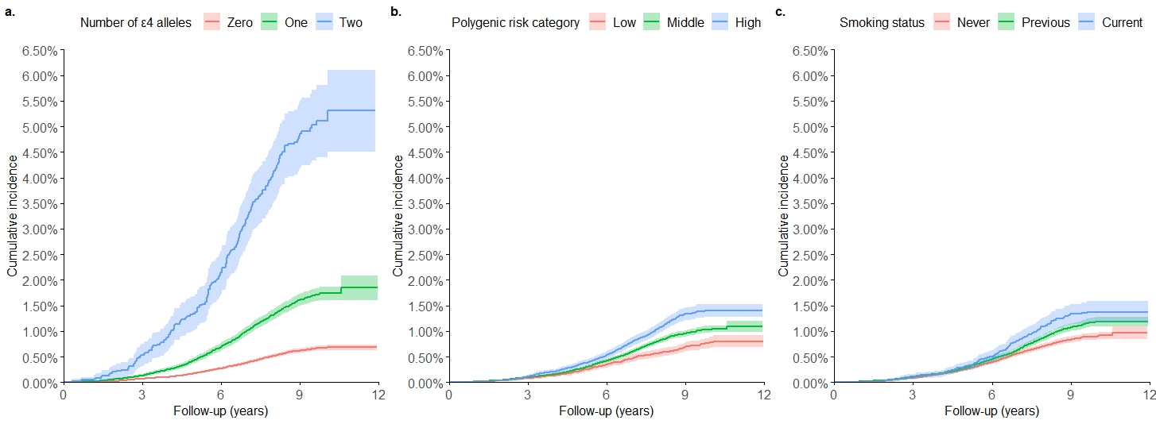

Supplementary Figure S3. Adjusted hazard ratio of APOE genotype, polygenic risk, smoking status on dementia risk
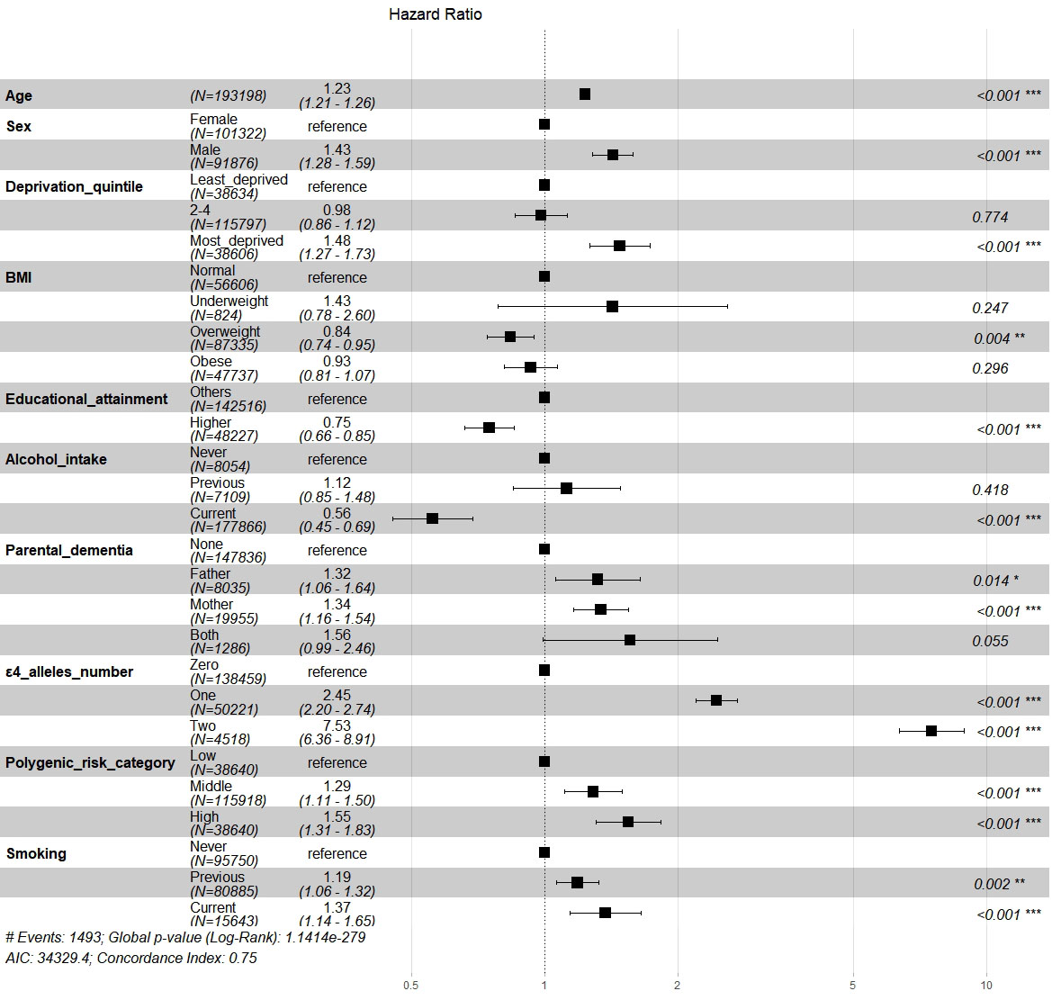
*: P<0.05; **: P<0.01; ***: P<0.001.
Adjusted for 5 principal components of ancestry.

Supplementary Figure S4. Association of genetic predisposition and smoking status with dementia risk by sex
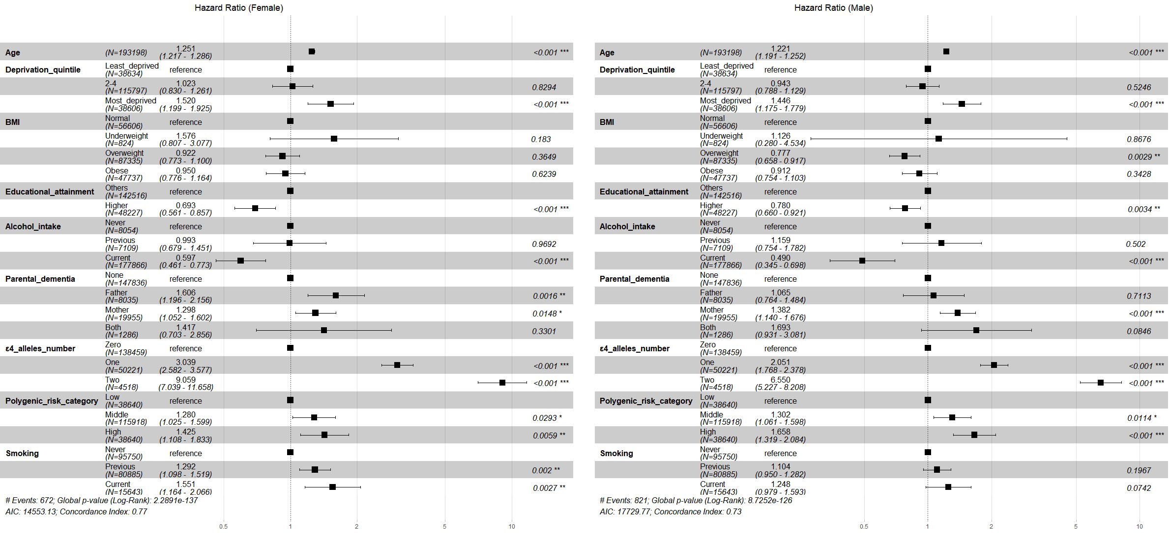
*: P<0.05; **: P<0.01; ***: P<0.001.
Both models adjusted for 5 principal components of ancestry.
Supplementary Table S1. Interaction between smoking status and genetic predisposition on dementia risk among females
Variables | Additive interaction effect |  |  |  | Multiplicative interaction effect
Variables | RERI  (95% CI) | AP  (95% CI) | S  (95% CI) |  | HR  (95% CI) | P value | P value for interaction
Smoking status * Number of APOE ε4 alleles | - | - | - |  | - | - | 0.01
Never * Zero | - | - | - |  | Reference | - | -
Previous * One | 0.60  (-0.34-1.55) | 0.14  (-0.06-0.34) | 1.22  (0.89-1.67) |  | 0.92  (0.66-1.30) | 0.64 | -
Current * One | -1.19  (-3.06-0.67) | -0.36  (-1.07-0.35) | 0.66  (0.32-1.37) |  | 0.46  (0.24-0.86) | 0.02
Previous * Two | -1.47  (-6.49-3.55) | -0.15  (-0.69-0.4) | 0.86  (0.51-1.46) |  | 0.64  (0.37-1.10) | 0.11 | -
Current * Two | 6.12  (-7.11-19.36) | 0.33  (-0.16-0.83) | 1.55  (0.7-3.42) |  | 0.77  (0.33-1.79) | 0.54 | -
Smoking status * Polygenetic risk category | - | - | - |  |  |  | 0.15
Never * Low | - | - | - |  | Reference |  | -
Previous * Middle | 0.44  (-0.04-0.92) | 0.27  (-0.04-0.58) | 3.30  (0.14-75.39) |  | 1.36  (0.85-2.19) | 0.20 | -
Current * Middle | -0.16  (-1.41-1.09) | -0.10  (-0.90-0.70) | 0.79  (0.14-4.54) |  | 0.87  (0.39-1.94) | 0.73 | -
Previous * High | 0.16  (-0.48-0.79) | 0.10  (-0.30-0.50) | 1.39  (0.29-6.6) |  | 1.10  (0.64-1.88) | 0.73 | -
Current * High | 0.50  (1.04-2.04) | 0.20  (-0.37-0.78) | 1.52  (0.38-6.17) |  | 1.13  (0.48-2.66) | 0.78 | -
Abbreviation: HR, hazard ratio; CI: confidence interval; RERI, relative excess risk due to interaction; AP, attributable proportion; S, synergy index; RERI=0; AP=0; S=1: no interaction; RERI>0; AP>0; S>1: positive interaction; RERI<0; AP<0; S<1: negative interaction. Dash “-”: not applicable. P value for interaction: results from likelihood ratio test to compare the reduced model excluding interaction term with the full model including the term.
All analyses were adjusted for age, sex, educational attainment, deprivation quantile, BMI, parental dementia status, and 5 principal components of ancestry.

Supplementary Table S2. Interaction between smoking status and genetic predisposition on dementia risk among males
Variables | Additive interaction effect |  |  |  | Multiplicative interaction effect
Variables | RERI  (95% CI) | AP  (95% CI) | S  (95% CI) |  | HR  (95% CI) | P value | P value for interaction
Smoking status * Number of APOE ε4 alleles | - | - | - |  | - | - | 0.001
Never * Zero | - | - | - |  | Reference | - | -
Previous * One | -0.35  (-0.96-0.25) | -0.16  (-0.44, 0.12) | 0.77  (0.51-1.17) |  | 0.80  (0.58-1.09) | 0.15 | -
Current * One | -0.57  (-1.65-0.51) | -0.23  (-0.74-0.28) | 0.72  (0.36-1.41) |  | 0.64  (0.38-1.05) | 0.07 | -
Previous * Two | 3.81  (0.67-6.96) | 0.40  (0.14-0.66) | 1.81  (1.09-3.01) |  | 1.49  (0.92-2.41) | 0.11
Current * Two | -3.19  (-7.18-0.80) | -1.08  (-3.53-1.37) | 0.38  (0.07-2.2) |  | 0.34  (0.10-1.15) | 0.08 | -
Smoking status * Polygenetic risk category | - | - | - |  | - | 0.60 | 0.60
Never * Low | - | - | - |  | Reference | - | -
Previous * Middle | 0.09  (-0.36-0.54) | 0.06  (-0.27-0.4) | 1.32  (0.23-7.66) |  | 1.07  (0.69-1.64) | 0.77 | -
Current * Middle | -0.02  (-0.90-0.86) | -0.01  (-0.61-0.58) | 0.96  (0.16-5.70) |  | 0.95  (0.47-1.93) | 0.46 | -
Previous * High | 0.3  (-0.27-0.88) | 0.17  (-0.15-0.49) | 1.61  (0.47-5.54) |  | 1.20  (0.74-1.94) | 0.89 | -
Current * High | 0.46  (-0.7-1.61) | 0.21  (-0.28-0.7) | 1.64  (0.4-6.76) |  | 1.19  (0.55-2.59) | 0.66 | -
Abbreviation: HR, hazard ratio; CI: confidence interval; RERI, relative excess risk due to interaction; AP, attributable proportion; S, synergy index; RERI=0; AP=0; S=1: no interaction; RERI>0; AP>0; S>1: positive interaction; RERI<0; AP<0; S<1: negative interaction. Dash “-”: not applicable. P value for interaction: results from likelihood ratio test to compare the reduced model excluding interaction term with the full model including the term.
All analyses were adjusted for age, sex, educational attainment, deprivation quantile, BMI, parental dementia status, and 5 principal components of ancestry.

Supplementary Table S3. Interaction between smoking status and genetic predisposition on dementia risk additionally adjusted for depression status
Variables | Additive interaction effect |  |  |  | Multiplicative interaction effect
Variables | RERI  (95% CI) | AP  (95% CI) | S  (95% CI) |  | HR  (95% CI) | P value | P value for interaction
Smoking status * Number of APOE ε4 alleles | - | - | - |  | - | - | 0.01
Never * Zero | - | - | - |  | Reference | Reference | -
Previous * One | -0.12  (-0.67-0.44) | -0.04  (-0.21-0.14) | 0.95  (0.74-1.21) |  | 0.79  (0.62-1.00) | 0.05 | -
Current * One | -1.02  (-2.03-0.00) | -0.37  (-0.83-0.09) | 0.63  (0.38-1.06) |  | 0.51  (0.34-0.77) | 0.001 | -
Previous * Two | 1.48  (-1.56-4.52) | 0.14  (-0.12-0.40) | 1.18  (0.84-1.67) |  | 0.88  (0.62-1.25) | 0.47 | -
Current * Two | -2.06  (-7.18-3.06) | -0.27  (-1.11-0.56) | 0.76  (0.36-1.62) |  | 0.47  (0.23-0.95) | 0.04 | -
Smoking status *  Polygenetic risk category | - | - | - |  | - | - | 0.84
Never * Low | - | - | - |  | Reference | Reference | -
Previous * Middle | 0.22  (-0.13-0.56) | 0.14  (-0.09-0.38) | 1.69  (0.48-5.97) |  | 1.15  (0.83-1.59) | 0.41 | -
Current * Middle | -0.1  (-0.85-0.65) | -0.07  (-0.57-0.43) | 0.84  (0.24-2.92) |  | 0.89  (0.51-1.54) | 0.67 | -
Previous * High | 0.26  (-0.19-0.71) | 0.14  (-0.1-0.39) | 1.47  (0.64-3.39) |  | 1.14  (0.79-1.64) | 0.49 | -
Current * High | 0.23  (-0.71-1.17) | 0.11  (-0.32-0.54) | 1.27  (0.46-3.51) |  | 1.02  (0.56-1.86) | 0.94 | -
Abbreviation: HR, hazard ratio; CI: confidence interval; RERI, relative excess risk due to interaction; AP, attributable proportion; S, synergy index; RERI=0; AP=0; S=1: no interaction; RERI>0; AP>0; S>1: positive interaction; RERI<0; AP<0; S<1: negative interaction. Dash “-”: not applicable. P value for interaction: results from likelihood ratio test to compare the reduced model excluding interaction term with the full model including the term.
All analyses were adjusted for age, sex, educational attainment, deprivation quantile, BMI, parental dementia status, and 5 principal components of ancestry.
Supplementary Table S4. Interaction between smoking status and genetic predisposition on dementia risk (excluded samples followed up less than 3 years)
Variables | Additive interaction effect |  |  |  | Multiplicative interaction effect
Variables | RERI  (95% CI) | AP  (95% CI) | S  (95% CI) |  | HR  (95% CI) | P value | P value for interaction
Smoking status * Number of APOE ε4 alleles | - | - | - |  | - | - | 0.01
Never * Zero | - | - | - |  | Reference | Reference | -
Previous * One | -0.09  (-0.64-0.47) | -0.03  (-0.21-0.15) | 0.96  (0.74-1.24) |  | 0.83  (0.65-1.05) | 0.12 | -
Current * One | -0.65  (-1.74-0.43) | -0.21  (-0.6-0.19) | 0.77  (0.48-1.23) |  | 0.57  (0.38-0.86) | 0.01 | -
Previous * Two | 1.00  (-1.94-3.95) | 0.10  (-0.18-0.39) | 1.13  (0.79-1.62) |  | 0.89  (0.62-1.28) | 0.53 | -
Current * Two | -2.03  (-7.18-3.13) | -0.28  (-1.16-0.60) | 0.75  (0.34-1.67) |  | 0.46  (0.22-0.96) | 0.04 | -
Smoking status *  Polygenetic risk category | - | - | - |  | - | - | 0.13
Never * Low | - | - | - |  | Reference | Reference | -
Previous * Middle | 0.29  (-0.04-0.62) | 0.2  (-0.04-0.44) | 2.76  (0.21-36.6) |  | 1.25  (0.89-1.75) | 0.19 | -
Current * Middle | -0.05  (-0.8-0.71) | -0.03  (-0.53-0.47) | 0.92  (0.23-3.62) |  | 0.93  (0.53-1.62) | 0.80 | -
Previous * High | 0.28  (-0.16-0.72) | 0.16  (-0.09-0.42) | 1.65  (0.57-4.78) |  | 1.20  (0.83-1.75) | 0.33 | -
Current * High | 0.65  (-0.34-1.64) | 0.26  (-0.09-0.62) | 1.79  (0.65-4.92) |  | 1.24  (0.68-2.26) | 0.48 | -
Abbreviation: HR, hazard ratio; CI: confidence interval; RERI, relative excess risk due to interaction; AP, attributable proportion; S, synergy index; RERI=0; AP=0; S=1: no interaction; RERI>0; AP>0; S>1: positive interaction; RERI<0; AP<0; S<1: negative interaction. Dash “-”: not applicable. P value for interaction: results from likelihood ratio test to compare the reduced model excluding interaction term with the full model including the term.
All analyses were adjusted for age, sex, educational attainment, deprivation quantile, BMI, parental dementia status, and 5 principal components of ancestry.

