Extended Data
Extended Data Table 1. The mean and standard deviation of net changes in tree distributions for the identified 12 species groups under past global changes from 1960 to 2019. Estimates here were based on a realistic migration rate. Order of species groups followed figures in the main text. Means in red indicate a net loss and means in green indicate a net gain (there were no mean net gain across species groups).
Cluster no. | Labels | No. species | mean | s.d.
C1 | North-western Bornean wet lowland | 77 | -0.240 | 0.108
C7 | Indo-Burmese deciduous lowland | 203 | -0.309 | 0.159
C8 | East Asian subtropical lowland | 69 | -0.176 | 0.089
C5 | Mainland SEA lowland | 124 | -0.311 | 0.125
C6 | SEA coastal & mangrove | 154 | -0.506 | 0.129
C4 | Bornean coastal & lowland | 102 | -0.582 | 0.156
C3 | Sundaic tropical lowland | 107 | -0.440 | 0.124
C9 | Mainland SEA temperate submontane | 167 | -0.163 | 0.066
C2 | Bornean tropical montane | 196 | -0.297 | 0.215
C11 | SEA temperate & tropical montane | 52 | -0.230 | 0.097
C10 | Southern Tibetan plateau | 139 | -0.104 | 0.076
C12 | Indo-Burmese semi-evergreen montane | 86 | -0.277 | 0.098

Extended Data Table 2. The mean and standard deviation of net changes in tree distributions for the identified 12 species groups under future global changes from 2019 to 2090 across four Shared Socioeconomic Pathways (SSPs). Estimates here were based on a realistic migration rate. Order of species groups followed figures in the main text. Means in red indicate a net loss and means in green indicate a net gain.
Cluster no. | Labels | No. species | SSP1-2.6 |  | SSP2-4.5 |  | SSP3-7.0 |  | SSP5-8.5
Cluster no. | Labels | No. species | mean | s.d. | mean | s.d. | mean | s.d. | mean | s.d.
C1 | North-western Bornean wet lowland | 77 | 0.525 | 0.540 | 0.402 | 0.537 | 0.362 | 0.553 | 0.485 | 0.589
C7 | Indo-Burmese deciduous lowland | 203 | 0.340 | 0.487 | 0.214 | 0.399 | 0.197 | 0.433 | 0.327 | 0.504
C8 | East Asian subtropical lowland | 69 | 0.105 | 0.263 | 0.179 | 0.334 | 0.229 | 0.387 | 0.113 | 0.437
C5 | Mainland SEA lowland | 124 | 0.167 | 0.196 | -0.038 | 0.215 | -0.050 | 0.278 | 0.064 | 0.296
C6 | SEA coastal & mangrove | 154 | 0.156 | 0.161 | -0.236 | 0.137 | -0.183 | 0.181 | 0.063 | 0.266
C4 | Bornean coastal & lowland | 102 | 0.075 | 0.428 | -0.231 | 0.370 | -0.237 | 0.378 | 0.016 | 0.490
C3 | Sundaic tropical lowland | 107 | 0.012 | 0.239 | -0.240 | 0.254 | -0.272 | 0.285 | -0.101 | 0.375
C9 | Mainland SEA temperate submontane | 167 | 0.010 | 0.143 | -0.042 | 0.188 | -0.079 | 0.245 | -0.121 | 0.314
C2 | Bornean tropical montane | 196 | -0.088 | 0.330 | -0.297 | 0.346 | -0.403 | 0.339 | -0.340 | 0.413
C11 | SEA temperate & tropical montane | 52 | -0.142 | 0.147 | -0.287 | 0.196 | -0.377 | 0.237 | -0.371 | 0.267
C10 | Southern Tibetan plateau | 139 | -0.131 | 0.187 | -0.264 | 0.257 | -0.329 | 0.312 | -0.449 | 0.358
C12 | Indo-Burmese semi-evergreen montane | 86 | -0.128 | 0.183 | -0.281 | 0.223 | -0.404 | 0.256 | -0.473 | 0.314

Extended Data Figure 1. The environmental conditions that characterised the representative distribution (as seen in Fig. S6) of each species group. For each representative distribution, environmental conditions from the 95th percentile of pixels were extracted and further weighted based on the pixel’s value (i.e., proportion of member species present) to derive the boxplots shown. Hence, the environmental characteristics described here represent the conditions of only the most suitable of sites (or where more of each cluster’s member species is present). Values here were used to inform the labels of each species group: C1 = North-western Bornean wet lowland; C2 = Bornean tropical montane; C3 = Sundaic tropical lowland; C4 = Bornean coastal & lowland; C5 = Mainland SEA lowland; C6 = SEA coastal & mangrove; C7 = Indo-Burmese deciduous lowland; C8 = East Asian subtropical lowland; C9 = Mainland SEA temperate submontane; C10 = Southern Tibetan plateau; C11 = SEA temperate & tropical montane; and C12 = Indo-Burmese semi-evergreen montane.
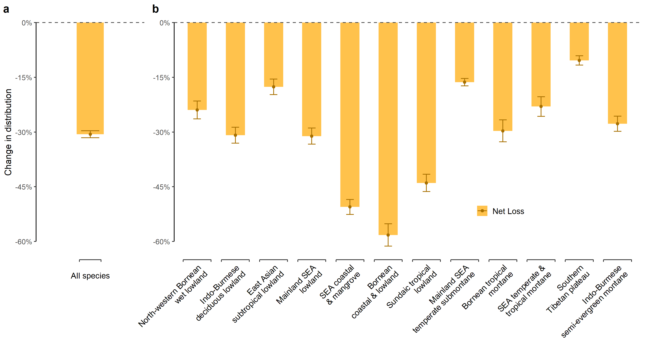

Extended Data Figure 2. The mean net changes in tree species distributions for (a) all 1476 tree species and (b) among the identified 12 species groups due to past global changes from 1960 to 2019. Error bars indicate the 95% confidence intervals. Note the especially high net loss of distribution among coastal- and lowland-distributed species groups (i.e., SEA coastal & mangrove, Bornean coastal & lowland, and Sundaic tropical lowland).
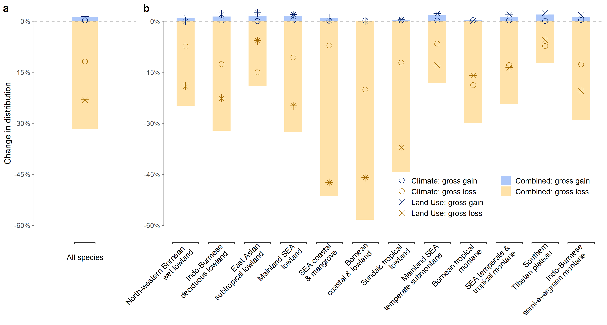

Extended Data Figure 3. The mean gross changes—as gain (blue) or loss (yellow)—in tree species distributions for (a) all 1476 tree species and (b) among the identified 12 species groups due to combined global changes (bar), climate change only (circle), or land-use change only (asterisk) from 1960 to 2019.
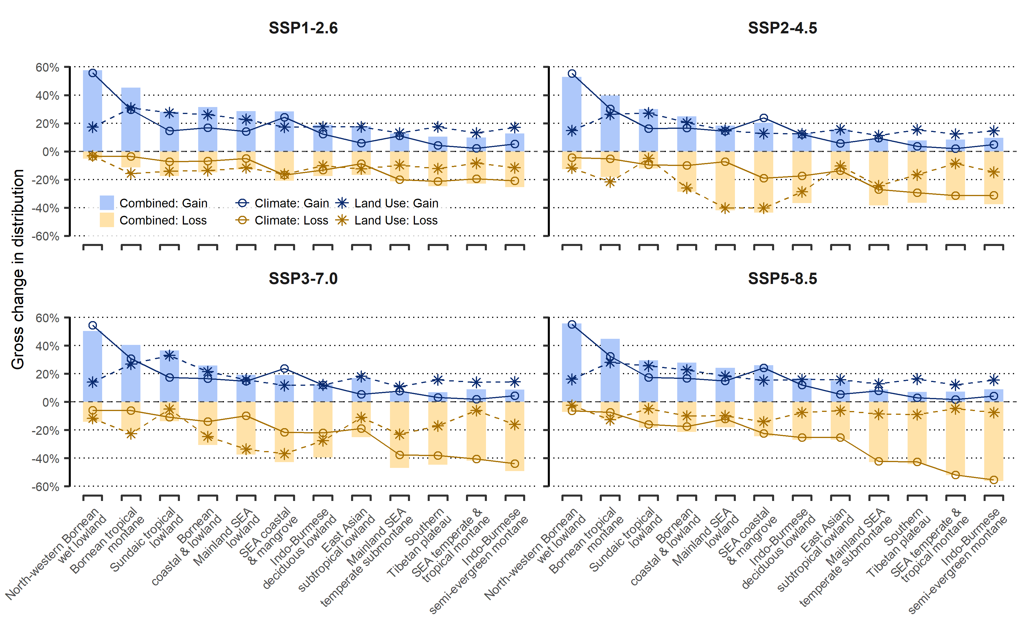

Extended Data Figure 4. The mean gross changes—as gain (blue) or loss (yellow)—in tree species distributions among the identified 12 species groups due future global changes from 2019 to 2090 under four separate SSPs: combined (bar), climate change only (circle), or land-use change only (asterisk).

