Supplementary information

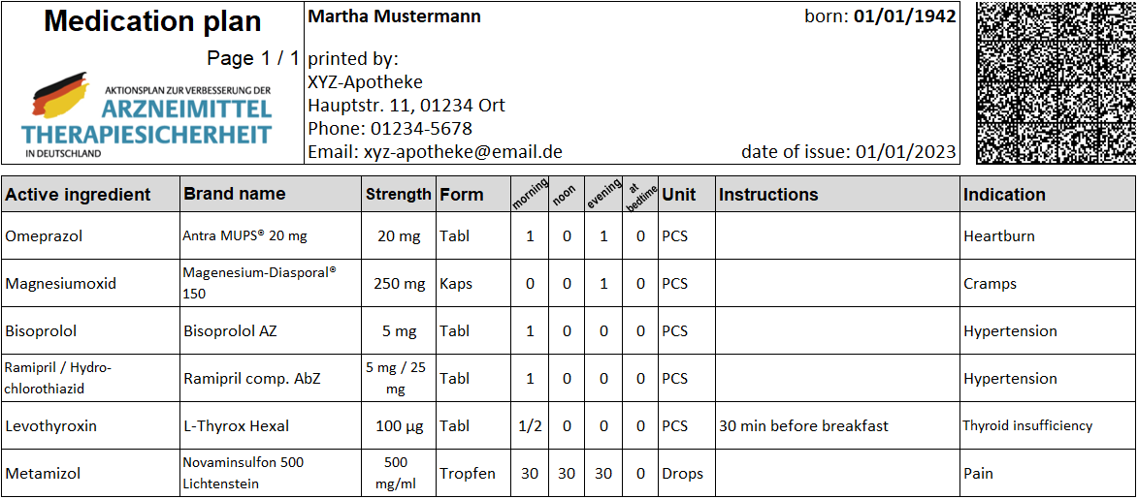
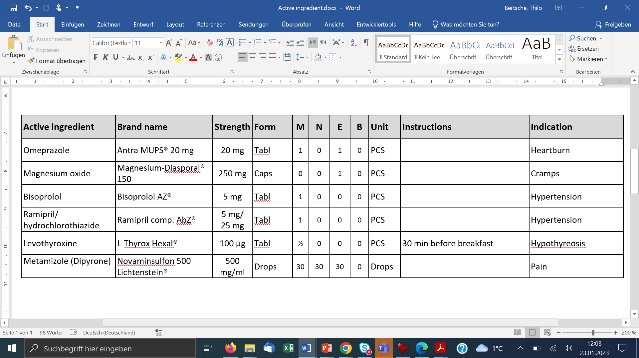
A
Printed by:
XYZ-pharmacy
Address
Phone: 01234-5678
E-mail: xyz-pharmacy@email.de

M: Morning, N: Noon, E: Evening, B: Bedtime; PCS: Pieces

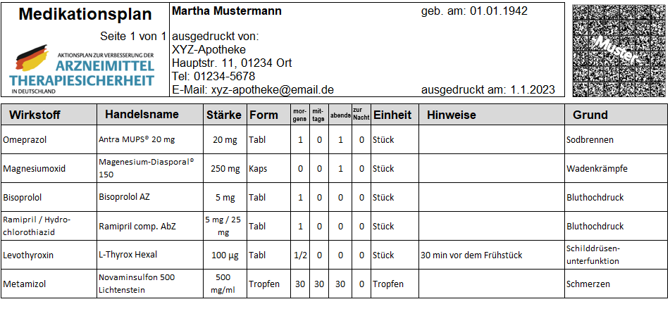
B

Fig S1 Standardized medication plan (Medikationsplan) with fictious drugs: (A) Englisch translation (not authorized); (B) German original version

