Supplementary File I.
Preliminary Protocol for Measurement of Reproducibility and Accuracy of Flow values on Digital PET/CT Systems in [¹⁵O]H₂O Myocardial Perfusion Imaging Using a Flow Phantom
Reetta Siekkinen^{1,2,3}, Heidi Partanen², Linda Kukola^{2,5}, Tuula Tolvanen^{2,3}, Andrew Fenwick⁴, Nadia A. S. Smith⁴, Mika Teräs^{3,6}, Antti Saraste^{2,7}, Jarmo Teuho^{1,2}

1 Turku PET Centre, University of Turku, Turku, Finland
2 Turku PET Centre, Turku University Hospital, Turku, Finland
3 Department of Medical Physics, Turku University Hospital, Turku, Finland
4 National Physical Laboratory, Teddington, UK
5 Department of Physics and Astronomy, University of Turku, Turku, Finland
6 Institute of Biomedicine, University of Turku, Turku, Finland
7 Heart Centre, Turku University Hospital, Turku, Finland

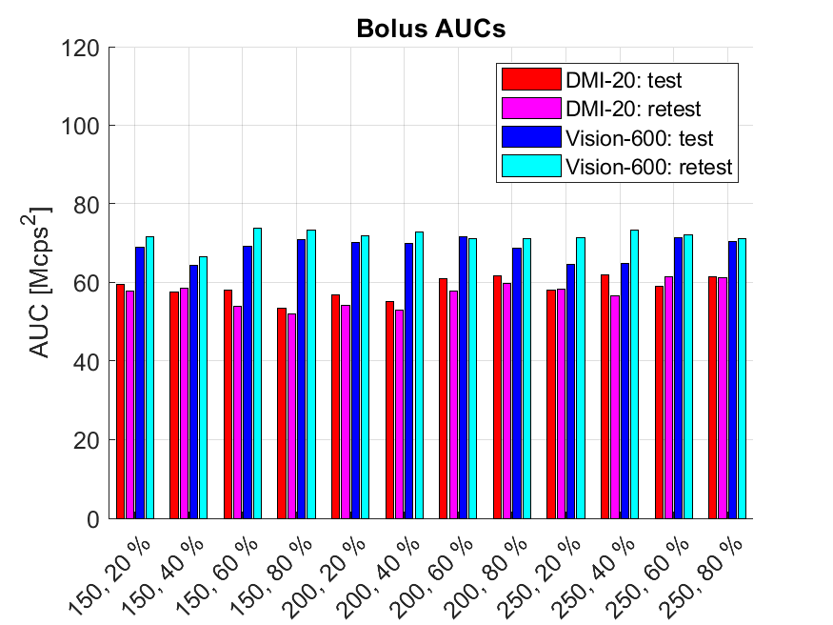
Figure 1. Areas-under-the-Curve extracted from injected bolus curves for all measurements on DMI-20 and Vision-600.

Following the variations in the bolus peaks, a similar trend was seen in the bolus AUCs (Figure 1). Overall, the retest measurements on Vision-600 system show systematically larger AUCs except for a single measurement (200-60%). Consequently, this variation is propagated to the input AUCs which follow the same trend as the bolus AUCs, indicating that the bolus delivery affects directly the input TAC and its overall AUC (Figure 2). However, after the input AUC, no similar trend cannot be clearly seen from the tissue AUCs nor the simulated tissue AUCs used for kinetic modelling (Figure 3, Figure 4).

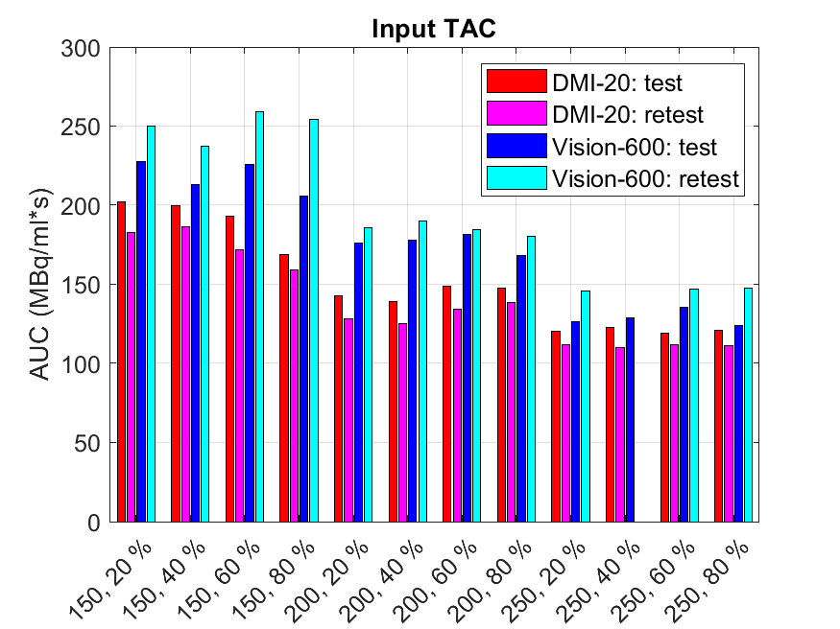
Figure 2. Areas-under-the-Curve extracted from input time-activity curves (TACs) for all measurements on DMI-20 and Vision-600.

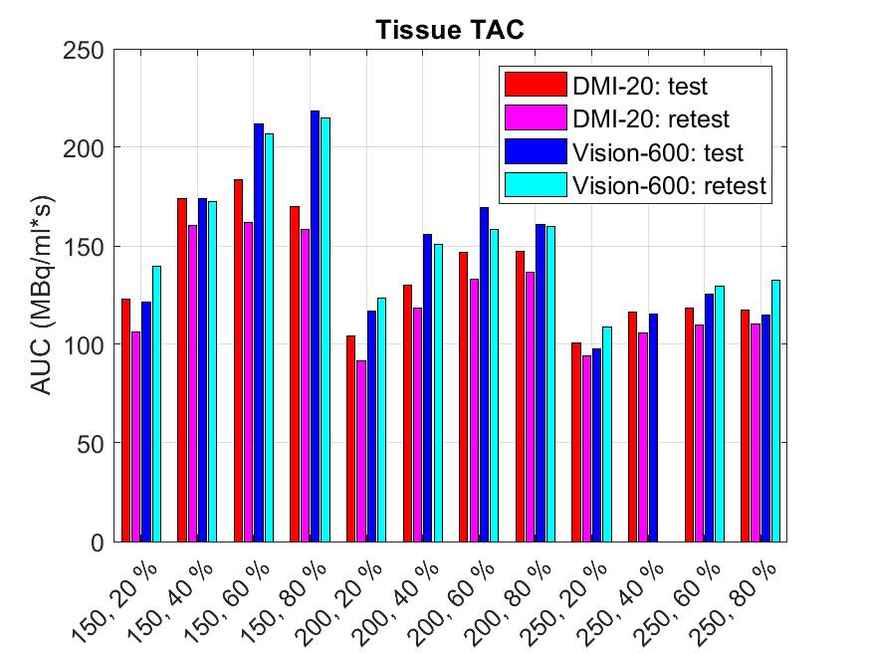
Figure 3. Areas-under-the-Curve extracted from tissue time-activity curves (TACs) for all measurements on DMI-20 and Vision-600.
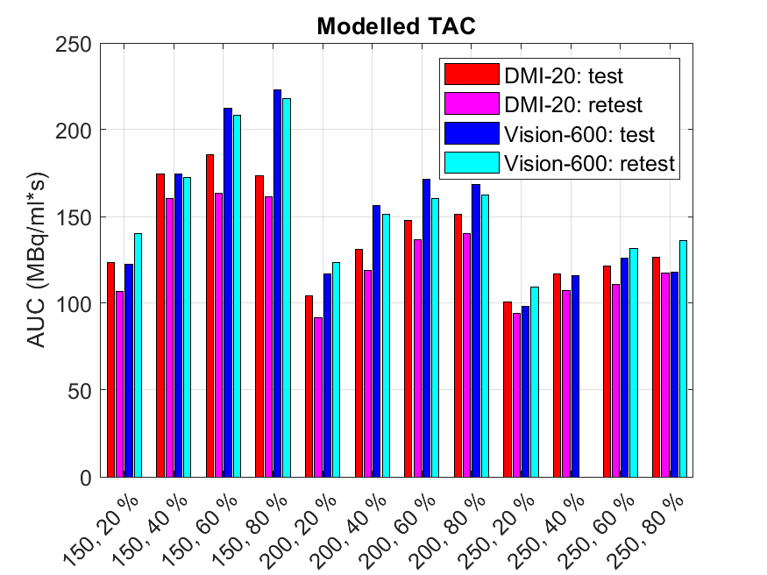
Figure 4. Areas-under-the-Curve extracted from modelled time-activity curves (TACs) for all measurements on DMI-20 and Vision-600.

