Supplementary Information for

Whisker stimulation alleviate ASD behavior of BTBR mice by regulating Piezo2 expression in DRG and neuron function in S1 and mPFC

Jinhe Zhai, Haiying Hao, Zihan Xu, Xiaoxue Li, Xinyi Zhang, Xuan Cao, Xinxin Wang, Dongxin Li, Jia Wang, Lijie Wu, Lili Fan

*Corresponding authors emails: wangjiahyd@163.com, wulijiehyd@126.com, and db2003@sina.com.

This PDF file includes:

Figures S1 to S6
Tables S1 to S2

SUPPORTING FIGURES AND TABLES
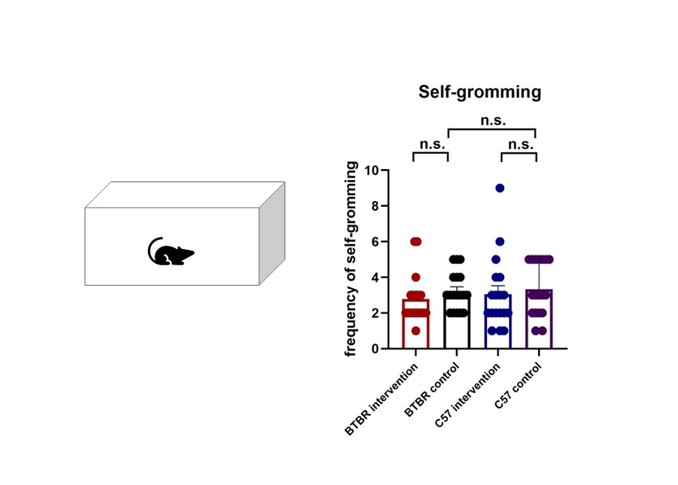
Fig. S1. Mild whisker intervention does not affect the frequency of self-grooming in mice.
N=18 mice per group. Kruskal-Wallis test of independent sample corrected by Bonferroni. n.s.=not significant. For statistical details, please see supplementary table 2.
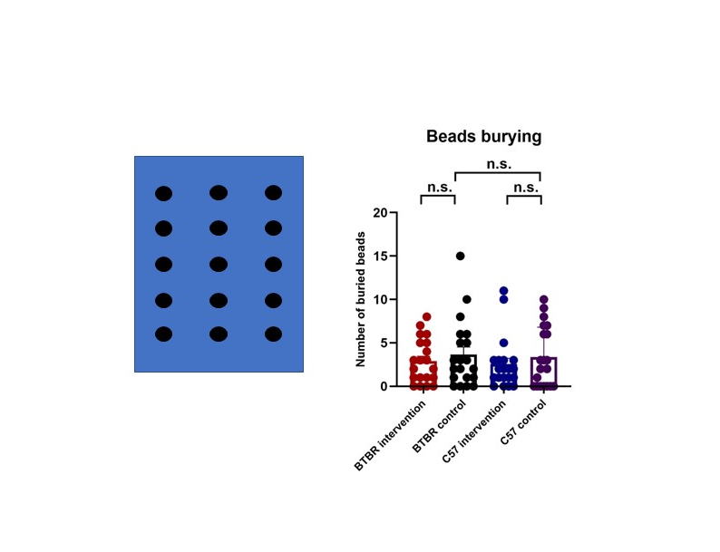
Fig. S2. Mild whisker intervention does not affect the number of buried beads in mice.
N=20 mice per group. Kruskal-Wallis test of independent sample corrected by Bonferroni. n.s.=not significant. For statistical details, please see supplementary table 2.

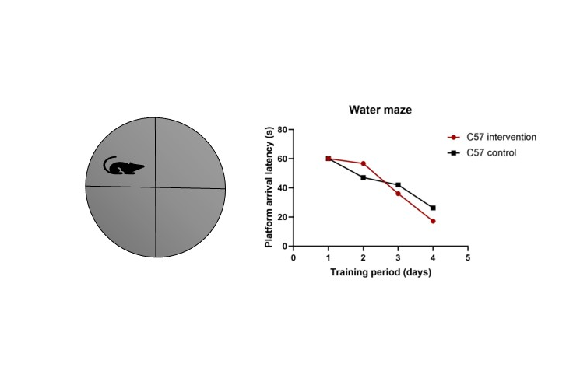
Fig. S3. Mild whisker intervention does not affect the platform latency period in C57BL/6.
N=10 mice per group. Mann-Whitney U test. n.s.=not significant. For statistical details, please see supplementary table 2.

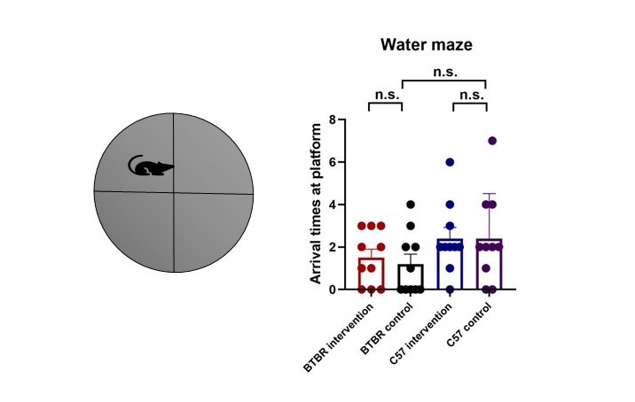
Fig. S4. Mild whisker intervention does not affect the number of platform arrivals in mice.
N=10 mice per group. Kruskal-Wallis test of independent sample corrected by Bonferroni. n.s.=not significant. For statistical details, please see supplementary table 2.

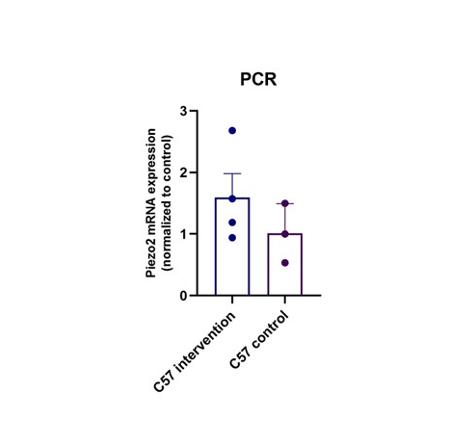
Fig. S5. Mild whisker intervention does not affect the mRNA expression of Piezo2 in C57BL/6.
N=10 mice per group. Student’s unpaired two-tailed t test. n.s.=not significant. For statistical details, please see supplementary table 2.
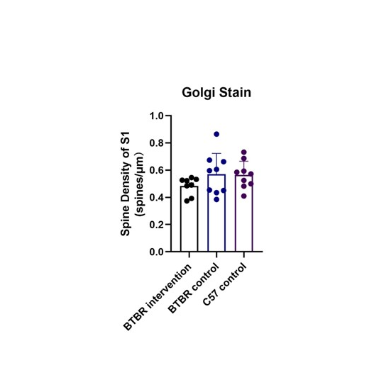
Fig. S6. Mild whisker intervention does not affect the dendritic spine density of S1 in mice.
N=10 mice per group. One-way ANOVA analysis. n.s.=not significant. For statistical details, please see supplementary table 2.

Antibody | Catalog number/manufacturer | Dilution
Rabbit anti Piezo2 | NBP1-78624, NOVUS | 1:400
Mouse anti β-actin | 4970, Cell Signaling | 1:1000
Rabbit anti | Abs20002, Absin | 1:20000
Alexa Fluor 488 goat anti-rabbit IgG | 4412, Cell Signaling | 1:1000
Table S1. Antibody information related to experimental procedures, with catalog number/manufacturer, and used dilutions.

Figure | Panel | Test | Statistic | Group-size | P value | Pair-wise  comparison | Statistic 2
1 | B | Kruskal-Wallis | H=13.109 | n=6 | P=0.004 | Bonferroni post hoc comparison | Test details H P value
BTBR intervention
vs BTBR control 11.333 0.030

BTBR vs C57BL/6 -13.083 0.007

C57BL/6 intervention
vs C57BL/6 control -2.167 ns
1 | F | Kruskal-Wallis（Interaction time with stranger 1） | H=14.673 | n=6 | P=0.002 | Bonferroni post hoc comparison | Test details H P value
BTBR intervention
vs BTBR control 15.000 0.001

BTBR vs C57BL/6 -10.833 0.048

C57BL/6 intervention
vs C57BL/6 control -4.000 ns
1 | F | Mann-Whitney U (empty vs stranger 1) | N/A | n=6 | N/A | N/A | Test details Z P value
BTBR intervention 34.000 0.009
BTBR control 18.000 ns
C57BL/6 intervention 27.000 ns
C57BL/6 control 30.000 ns
1 | G | Kruskal-Wallis | H=9.413 | n=6 | P=0.024 | Bonferroni post hoc comparison | Test details H P value
BTBR intervention
vs BTBR control 11.627 0.026

BTBR vs C57BL/6 -7.000 ns

C57BL/6 intervention
vs C57BL/6 control -4.333 ns
1 | H | Kruskal-Wallis（Interaction time with stranger 2） | H=15.327 | n=6 | P=0.002 | Bonferroni post hoc comparison | Test details H P value
BTBR intervention
vs BTBR control 14.333 0.003

BTBR vs C57BL/6 -10.000 0.014

C57BL/6 intervention
vs C57BL/6 control -7.000 ns
1 | H | Mann-Whitney U (stranger 1 vs stranger 2) | N/A | n=6 | N/A | N/A | Test details Z P value
BTBR intervention 34.000 0.009
BTBR control 17.000 ns
C57BL/6 intervention 19.000 ns
C57BL/6 control 24.000 ns
1 | I | Kruskal-Wallis | H=8.117 | n=6 | P=0.044 | Bonferroni post hoc comparison | Test details H P value
BTBR intervention
vs BTBR control 9.833 0.016

BTBR vs C57BL/6 -7.500 ns

C57BL/6 intervention
vs C57BL/6 control -6.167 ns
1 | K | Kruskal-Wallis | H=21.692 | n=18 | P<0.001 | Bonferroni post hoc comparison | Test details H P value
BTBR intervention
vs BTBR control -19.833 0.027

BTBR vs C57BL/6 27.333 0.001

C57BL/6 intervention
vs C57BL/6 control -1.500 ns
1 | M | Mann-Whitney U (BTBR intervention vs BTBR control) | N/A | n=10 | N/A | N/A | Test details Z P value
First day 10.222 0.001
Second day 270.000 ns
Third day 276.000 0.040
Fourth day 218.000 ns
2 | A | Student’s unpaired two-tailed t test | t=-2.821 | BTBR=6  C57BL/6=5 | P=0.020 | N/A | N/A
2 | B | Student’s unpaired two-tailed t test | t=3.237 | BTBR intervention=5  BTBR control=3 | P=0.028 | N/A | N/A
2 | C | One-way ANOVA | F=10.584 | n=5 | P<0.001 | Bonferroni post hoc comparison | Test details t P value
BTBR intervention
vs BTBR control -0.7098 0.001

BTBR vs C57BL/6 0.4491 0.028

C57BL/6 intervention
vs C57BL/6 control -0.5578 0.008
2 | E | Student’s unpaired two-tailed t test | t=63.000 | n=8 | P<0.001 | N/A | N/A
2 | F | One-way ANOVA | F=22.711 | n=8 | P<0.001 | Bonferroni post hoc comparison | Test details t P value
BTBR vs C57BL/6 0.2322 <0.001
C57BL/6 intervention
vs C57BL/6 control 0.0087 0.008
3 | H | One-way ANOVA | F=18.325 | n=7 | P<0.001 | Bonferroni post hoc comparison | Test details t P value
BTBR vs C57BL/6 5.951 0.007
BTBR intervention
vs BTBR control -10.046 <0.001
3 | I | One-way ANOVA | F=20.537 | n=7 | P<0.001 | Bonferroni post hoc comparison | Test details t P value
BTBR vs C57BL/6 12.193 0.011
BTBR intervention
vs BTBR control -16.640 0.002
4 | E | One-way ANOVA | F=8.041 | n=9 | P=0.002 | Bonferroni post hoc comparison | Test details t P value
BTBR vs C57BL/6 -0.1105 0.026
BTBR intervention
vs BTBR control 0.1496 0.002
S1 | N/A | Kruskal-Wallis | H=2.920 | n=18 | P=0.404 | N/A | N/A
S2 | N/A | Kruskal-Wallis | H=0.777 | n=20 | P=0.855 | N/A | N/A
S3 | N/A | Mann-Whitney U | N/A | n=10 | N/A | N/A | Test details Z P value
First day 184.000 ns
Second day 200.500 ns
Third day 200.000 ns
Fourth day 242.000 ns
S4 | N/A | Kruskal-Wallis | H=3.527 | n=10 | P=0.317 | N/A | N/A
S5 | N/A | Student’s unpaired two-tailed t test | F=0.547 | C57 intervention=4;  C57 control=3 | P=0.304 | N/A | N/A
S6 | N/A | One-way ANOVA | F=1.498 | BTBR intervention=8;  BTBR control=9;  C57BL/6=9 | P=0.245 | N/A | N/A
Table S2. Detailed statistical information.

