Supplementary file

All supplementary files are available at: https://drive.google.com/drive/folders/1TPYdYkU0pZ3bPzvFG6WhTZHF_hq4-6P9?usp=sharing

Table S1 Parameters settings for simulation scenarios

No. of Genotypes | No. of Genes | No. of Overall samples | No. of GTEx Samples | Graph density | Absolute min weight in graph
500 | 50 | 100000 | 800 | 0.05 | 0.1
500 | 50 | 100000 | 800 | 0.05 | 0.3
500 | 50 | 100000 | 800 | 0.05 | 0.5
700 | 70 | 100000 | 800 | 0.05 | 0.1
700 | 70 | 100000 | 2000 | 0.05 | 0.1
700 | 70 | 100000 | 8000 | 0.05 | 0.1
700 | 70 | 100000 | 800 | 0.05 | 0.3
700 | 70 | 100000 | 2000 | 0.05 | 0.3
700 | 70 | 100000 | 8000 | 0.05 | 0.3
700 | 70 | 100000 | 800 | 0.05 | 0.5
700 | 70 | 100000 | 800 | 0.1 | 0.1
700 | 70 | 100000 | 800 | 0.1 | 0.3
700 | 70 | 100000 | 800 | 0.1 | 0.5
700 | 70 | 100000 | 800 | 0.02 | 0.1
700 | 70 | 100000 | 800 | 0.02 | 0.3
700 | 70 | 100000 | 800 | 0.02 | 0.5
1000 | 100 | 100000 | 800 | 0.05 | 0.1
1000 | 100 | 100000 | 800 | 0.05 | 0.3
1000 | 100 | 100000 | 800 | 0.05 | 0.5
1500 | 150 | 100000 | 800 | 0.05 | 0.1
1500 | 150 | 100000 | 800 | 0.05 | 0.3
1500 | 150 | 100000 | 800 | 0.05 | 0.5
*Maximum weight in graph = abs(min weight)*1.2

Table S2 The correlation and root mean square error (RMSE) of IDA and jointIDA comparison between true and estimated value with different GTEx sample number

Note: Here GTEx refers to the sample we used for the gene-gene network inference

TableS3 The correlation and root mean square error (RMSE) of IDA and jointIDA comparison between true and estimated value with different gene number

Table S4 Sample sizes of studied traits in the UKBB dataset

Trait | Sample size | Trait | Sample size
Alanine aminotransferase | 464237 | Heart rate | 71950
Alkaline phosphatase | 464434 | Hip circumference | 486187
Anxiety* | 7284/304809 | Hypertension* | 127059/237816
Apolipoprotein A | 422746 | IGF-1 | 461898
Apolipoprotein B | 462074 | LDL | 463550
Aspartate aminotransferase | 462698 | Lipoprotein A | 371484
Atrial fibrillation* | 10486/387235 | Microalbumin in urine | 149103
BMI | 485341 | Neuroticism score | 389986
Body fat percentage | 478303 | Oestradiol | 75791
Breast cancer* | 16887/470427 | Phosphate | 424469
C-reactive protein | 463409 | Potassium in urine | 471955
CAD* | 31214/366507 | Prostate cancer* | 3389/483925
Cholesterol | 464417 | Rheumatoid factor | 40890
COVID-19-1* | 7570/451941 | SBP | 456156
COVID-19-2* | 2294/451941 | SHBG | 421180
Creatine | 464189 | Sodium in urine | 471947
Creatinine enzymatic in urine | 472949 | Stroke* | 13802/473512
Cystatin C | 464387 | Testosterone | 420618
DBP | 456169 | Total bilirubin | 462463
Depression* | 28355/285921 | Total protein | 424825
Diabetes* | 25474/459721 | Triglycerides | 464049
Direct bilirubin | 394368 | Urate | 463860
Gamma glutamyltransferase | 464178 | Urea | 464109
Glucose | 424786 | Vitamin D | 443445
Glycated haemoglobin (HbA1c) | 462976 | Weight | 485657
HDL | 425085 | WHR | 486142
Heart failure* | 2697/308608

Note: * indicates binary traits. The number before the “/” indicates the sample size for cases and the number after the “/” indicates the sample size for controls. E.g., anxiety (7284/304809), 7284 is the number of cases, 304809 is the number of controls. COVID-19-1 denotes the 1st analysis strategy, i.e., cases were defined by subjects with COVID-19 while controls were defined by subjects without COVID-19; COVID-19-2 denotes the 2nd analysis strategy, i.e., by cases were defined by the hospitalized/severe COVID-19 subjects while controls were defined by subjects without COVID-19.

Table S5 Combination of self-reported disease and ICD-10 coded diagnosis used for the definition of binary traits

Trait | Self-reported |  | ICD-10 Coding
Trait | Coding | Meaning | Coding | Meaning
Atrial fibrillation | --- | --- | I48 | Atrial fibrillation
Anxiety | 1287 | anxiety/panic attacks | F41 | Other anxiety disorder
Breast cancer | 1002 | breast cancer | C50,D05 | Breast cancer, In situ breast cancer
CAD | --- | --- | I20-I25 | Ischemic heart disease
Depression | 1286 | depression | F32-F33 | Depression
Heart failure | 1076 | Heart failure/pulmonary odema | I50 | Heart failure
Hypertension | 1065 | hypertension | I10 | Primary hypertension
Prostate cancer | 1044 | --- | --- | prostate cancer
Stroke | 1081,1082,1083,1086,1583 | stroke, subdural haemorrhage/haematoma, subarachnoid haemorrhage, ischaemic stroke, transient ischaemic attack (tia) | I60-I63 | Stroke

Table S6 Number of causally relevant genes for studied phenotypes in different tissues
Trait | No. direct | No. indirect | No. direct & indirect | No. indirect only | No. total | Prop. indirect | Prop. direct & indirect
Adipose Subcutaneous BMI | 114 | 37 | 2 | 35 | 151 | 0.245 | 0.013
Adipose Subcutaneous Body fat percentage | 66 | 16 | 0 | 16 | 82 | 0.195 | 0.000
Adipose Subcutaneous CAD | 15 | 0 | 0 | 0 | 15 | 0.000 | 0.000
Adipose Subcutaneous Cholesterol | 78 | 17 | 1 | 16 | 95 | 0.179 | 0.011
Adipose Subcutaneous Diabetes | 34 | 0 | 0 | 0 | 34 | 0.000 | 0.000
Adipose Subcutaneous HDL | 94 | 17 | 2 | 15 | 111 | 0.153 | 0.018
Adipose Subcutaneous Hip circumference | 135 | 15 | 0 | 15 | 150 | 0.100 | 0.000
Adipose Subcutaneous LDL | 49 | 32 | 2 | 30 | 81 | 0.395 | 0.025
Adipose Subcutaneous Neuroticism score | 35 | 0 | 0 | 0 | 35 | 0.000 | 0.000
Adipose Subcutaneous Triglycerides | 103 | 7 | 0 | 7 | 110 | 0.064 | 0.000
Adipose Subcutaneous Weight | 156 | 19 | 0 | 19 | 175 | 0.109 | 0.000
Adipose Subcutaneous WHR | 58 | 5 | 0 | 5 | 63 | 0.079 | 0.000
Adipose Visceral Omentum BMI | 126 | 1 | 0 | 1 | 127 | 0.008 | 0.000
Adipose Visceral Omentum Body fat percentage | 52 | 0 | 0 | 0 | 52 | 0.000 | 0.000
Adipose Visceral Omentum CAD | 18 | 4 | 0 | 4 | 22 | 0.182 | 0.000
Adipose Visceral Omentum Cholesterol | 47 | 1 | 0 | 1 | 48 | 0.021 | 0.000
Adipose Visceral Omentum Diabetes | 40 | 6 | 0 | 6 | 46 | 0.130 | 0.000
Adipose Visceral Omentum HDL | 47 | 3 | 0 | 3 | 50 | 0.060 | 0.000
Adipose Visceral Omentum Hip circumference | 111 | 0 | 0 | 0 | 111 | 0.000 | 0.000
Adipose Visceral Omentum LDL | 51 | 6 | 1 | 5 | 57 | 0.105 | 0.018
Adipose Visceral Omentum Neuroticism score | 22 | 8 | 0 | 8 | 30 | 0.267 | 0.000
Adipose Visceral Omentum Triglycerides | 97 | 4 | 0 | 4 | 101 | 0.040 | 0.000
Adipose Visceral Omentum Weight | 142 | 0 | 0 | 0 | 142 | 0.000 | 0.000
Adipose Visceral Omentum WHR | 52 | 2 | 0 | 2 | 54 | 0.037 | 0.000
Artery Coronary CAD | 17 | 0 | 0 | 0 | 17 | 0.000 | 0.000
Breast Mammary Breast cancer | 7 | 0 | 0 | 0 | 7 | 0.000 | 0.000
Cortex Anxiety | 2 | 0 | 0 | 0 | 2 | 0.000 | 0.000
Cortex BMI | 104 | 0 | 0 | 0 | 104 | 0.000 | 0.000
Cortex Body fat percentage | 50 | 0 | 0 | 0 | 50 | 0.000 | 0.000
Cortex CAD | 11 | 0 | 0 | 0 | 11 | 0.000 | 0.000
Cortex Depression | 3 | 0 | 0 | 0 | 3 | 0.000 | 0.000
Cortex Diabetes | 25 | 0 | 0 | 0 | 25 | 0.000 | 0.000
Cortex Hip circumference | 89 | 0 | 0 | 0 | 89 | 0.000 | 0.000
Cortex Stroke | 4 | 0 | 0 | 0 | 4 | 0.000 | 0.000
Cortex Weight | 114 | 0 | 0 | 0 | 114 | 0.000 | 0.000
Cortex WHR | 37 | 0 | 0 | 0 | 37 | 0.000 | 0.000
Frontal Cortex Depression | 2 | 0 | 0 | 0 | 2 | 0.000 | 0.000
Heart Left Ventricle AF | 9 | 0 | 0 | 0 | 9 | 0.000 | 0.000
Heart Left Ventricle CAD | 15 | 0 | 0 | 0 | 15 | 0.000 | 0.000
Liver Alanine aminotransferase | 38 | 0 | 0 | 0 | 38 | 0.000 | 0.000
Liver Apolipoprotein A | 11 | 0 | 0 | 0 | 11 | 0.000 | 0.000
Liver Apolipoprotein B | 31 | 0 | 0 | 0 | 31 | 0.000 | 0.000
Liver Aspartate aminotransferase | 29 | 0 | 0 | 0 | 29 | 0.000 | 0.000
Liver C-reactive protein | 26 | 0 | 0 | 0 | 26 | 0.000 | 0.000
Liver Direct bilirubin | 27 | 1 | 0 | 1 | 28 | 0.036 | 0.000
Liver Gamma glutamyltransferase | 40 | 0 | 0 | 0 | 40 | 0.000 | 0.000
Liver HDL | 29 | 5 | 0 | 5 | 34 | 0.147 | 0.000
Liver Lipoprotein A | 1 | 0 | 0 | 0 | 1 | 0.000 | 0.000
Liver Total bilirubin | 29 | 1 | 0 | 1 | 30 | 0.033 | 0.000
Liver Triglycerides | 61 | 4 | 0 | 4 | 65 | 0.062 | 0.000
Lung COVID-19-1 | 1 | 0 | 0 | 0 | 1 | 0.000 | 0.000
Lung COVID-19-2 | 1 | 0 | 0 | 0 | 1 | 0.000 | 0.000
Nucleus Accumbens Basal Ganglia Anxiety | 4 | 0 | 0 | 0 | 4 | 0.000 | 0.000
Nucleus Accumbens Basal Ganglia Depression | 3 | 0 | 0 | 0 | 3 | 0.000 | 0.000
Pancreas BMI | 126 | 2 | 0 | 2 | 128 | 0.016 | 0.000
Pancreas Body fat percentage | 49 | 0 | 0 | 0 | 49 | 0.000 | 0.000
Pancreas DBP | 32 | 0 | 0 | 0 | 32 | 0.000 | 0.000
Pancreas Diabetes | 34 | 0 | 0 | 0 | 34 | 0.000 | 0.000
Pancreas Glucose | 11 | 0 | 0 | 0 | 11 | 0.000 | 0.000
Pancreas Heart rate | 11 | 0 | 0 | 0 | 11 | 0.000 | 0.000
Pancreas Hip circumference | 104 | 6 | 1 | 5 | 110 | 0.055 | 0.009
Pancreas Neuroticism score | 22 | 0 | 0 | 0 | 22 | 0.000 | 0.000
Pancreas SBP | 52 | 0 | 0 | 0 | 52 | 0.000 | 0.000
Pancreas Weight | 123 | 2 | 0 | 2 | 125 | 0.016 | 0.000
Pancreas WHR | 45 | 0 | 0 | 0 | 45 | 0.000 | 0.000
Prostate Prostate cancer | 1 | 0 | 0 | 0 | 1 | 0.000 | 0.000
Putamen Basal Ganglia Anxiety | 1 | 0 | 0 | 0 | 1 | 0.000 | 0.000
Putamen Basal Ganglia Depression | 1 | 0 | 0 | 0 | 1 | 0.000 | 0.000
Whole Blood AF | 6 | 0 | 0 | 0 | 6 | 0.000 | 0.000
Whole Blood Alanine aminotransferase | 56 | 5 | 0 | 5 | 61 | 0.082 | 0.000
Whole Blood Alkaline phosphatase | 80 | 18 | 0 | 18 | 98 | 0.184 | 0.000
Whole Blood Anxiety | 2 | 2 | 0 | 2 | 4 | 0.500 | 0.000
Whole Blood Apolipoprotein A | 17 | 1 | 0 | 1 | 18 | 0.056 | 0.000
Whole Blood Apolipoprotein B | 53 | 17 | 1 | 16 | 70 | 0.243 | 0.014
Whole Blood Aspartate aminotransferase | 37 | 7 | 0 | 7 | 44 | 0.159 | 0.000
Whole Blood BMI | 120 | 6 | 0 | 6 | 126 | 0.048 | 0.000
Whole Blood Body fat percentage | 72 | 6 | 0 | 6 | 78 | 0.077 | 0.000
Whole Blood Breast cancer | 8 | 1 | 0 | 1 | 9 | 0.111 | 0.000
Whole Blood C-reactive protein | 44 | 17 | 2 | 15 | 61 | 0.279 | 0.033
Whole Blood CAD | 18 | 8 | 0 | 8 | 26 | 0.308 | 0.000
Whole Blood Cholesterol | 50 | 19 | 0 | 19 | 69 | 0.275 | 0.000
Whole Blood COVID-19-1 | 1 | 0 | 0 | 0 | 1 | 0.000 | 0.000
Whole Blood COVID-19-2 | 1 | 0 | 0 | 0 | 1 | 0.000 | 0.000
Whole Blood Creatine | 36 | 5 | 0 | 5 | 41 | 0.122 | 0.000
Whole Blood Creatinine (enzymatic) in urine | 19 | 1 | 0 | 1 | 20 | 0.050 | 0.000
Whole Blood Cystatin C | 39 | 10 | 1 | 9 | 49 | 0.204 | 0.020
Whole Blood DBP | 30 | 1 | 0 | 1 | 31 | 0.032 | 0.000
Whole Blood Depression | 2 | 0 | 0 | 0 | 2 | 0.000 | 0.000
Whole Blood Diabetes | 31 | 0 | 0 | 0 | 31 | 0.000 | 0.000
Whole Blood Direct bilirubin | 50 | 6 | 0 | 6 | 56 | 0.107 | 0.000
Whole Blood Gamma glutamyltransferase | 54 | 6 | 1 | 5 | 60 | 0.100 | 0.017
Whole Blood Glucose | 9 | 0 | 0 | 0 | 9 | 0.000 | 0.000
Whole Blood Glycated haemoglobin (HbA1c) | 46 | 6 | 0 | 6 | 52 | 0.115 | 0.000
Whole Blood HDL | 42 | 3 | 0 | 3 | 45 | 0.067 | 0.000
Whole Blood Heart failure | 3 | 0 | 0 | 0 | 3 | 0.000 | 0.000
Whole Blood Heart rate | 8 | 0 | 0 | 0 | 8 | 0.000 | 0.000
Whole Blood Hip circumference | 107 | 12 | 0 | 12 | 119 | 0.101 | 0.000
Whole Blood Hypertension | 75 | 3 | 0 | 3 | 78 | 0.038 | 0.000
Whole Blood IGF-1 | 92 | 0 | 0 | 0 | 92 | 0.000 | 0.000
Whole Blood LDL | 52 | 19 | 0 | 19 | 71 | 0.268 | 0.000
Whole Blood Lipoprotein A | 5 | 0 | 0 | 0 | 5 | 0.000 | 0.000
Whole Blood Microalbumin in urine | 3 | 0 | 0 | 0 | 3 | 0.000 | 0.000
Whole Blood Neuroticism score | 22 | 16 | 0 | 16 | 38 | 0.421 | 0.000
Whole Blood Oestradiol | 5 | 0 | 0 | 0 | 5 | 0.000 | 0.000
Whole Blood Phosphate | 9 | 0 | 0 | 0 | 9 | 0.000 | 0.000
Whole Blood Potassium in urine | 20 | 1 | 0 | 1 | 21 | 0.048 | 0.000
Whole Blood Prostate cancer | 2 | 1 | 0 | 1 | 3 | 0.333 | 0.000
Whole Blood Rheumatoid factor | 15 | 0 | 0 | 0 | 15 | 0.000 | 0.000
Whole Blood SBP | 30 | 1 | 0 | 1 | 31 | 0.032 | 0.000
Whole Blood SHBG | 72 | 8 | 0 | 8 | 80 | 0.100 | 0.000
Whole Blood Sodium in urine | 24 | 7 | 0 | 7 | 31 | 0.226 | 0.000
Whole Blood Stroke | 2 | 0 | 0 | 0 | 2 | 0.000 | 0.000
Whole Blood Testosterone | 20 | 0 | 0 | 0 | 20 | 0.000 | 0.000
Whole Blood Total bilirubin | 43 | 5 | 0 | 5 | 48 | 0.104 | 0.000
Whole Blood Total protein | 2 | 0 | 0 | 0 | 2 | 0.000 | 0.000
Whole Blood Triglycerides | 89 | 17 | 0 | 17 | 106 | 0.160 | 0.000
Whole Blood Urate | 40 | 10 | 0 | 10 | 50 | 0.200 | 0.000
Whole Blood Urea | 41 | 4 | 0 | 4 | 45 | 0.089 | 0.000
Whole Blood Vitamin D | 47 | 15 | 0 | 15 | 62 | 0.242 | 0.000
Whole Blood Weight | 133 | 15 | 0 | 15 | 148 | 0.101 | 0.000
Whole Blood WHR | 51 | 12 | 0 | 12 | 63 | 0.190 | 0.000

Table S7 Summary of identified causal graphs for studied traits from exploratory analysis

This supplementary table includes more than 120 csv files for all the studied tissue-trait pairs under exploratory analysis. Each csv file summarizes the identified causal graph for each tissue-specific trait and the univariate test result. In each file “Estimates” denotes the calculated effect size of each gene on the outcome by univariate analysis; “Pvalues” denotes the corresponding p-values for the estimated effect size; “IDA” indicates the calculated total causal effect for each gene on the target trait(We only estimated the total causal effects for genes directly or indirectly connects to the target, with 0 indicating no causal effects); “jointIDA” indicates the calculated direct causal effect for each gene on the target by controlling other genes(we only estimated the total causal effects for genes directly or indirectly connects to the target, with 0 indicting no causal effects); “assoc” denotes causal relationship between genes and the target; “zMin” denotes the corresponding z-score for the causal relationship; “ifmediator_gene” indicates whether the current gene is a peripheral gene with “1” denoting peripheral genes; “gene_type” denotes the relationship type between gene and target trait with “0” indicating genes that are indirect causal for the target, “1” indicating genes that are only directly causal on the target; “2” indicating genes that are both directly and indirectly causal on the targets, and “3” indicating genes that are non-causal on the targe.

Table S8 Proportion of small effect genes under different definitions

Table S9 Summary of identified causal graphs for studied traits from selective analysis
This supplementary table includes more than 120 csv files for all the studied tissue-trait pairs under selective analysis. Each csv file summarizes the identified causal graph for each tissue-specific trait and the univariate test result. In each file “Estimates” denotes the calculated effect size of each gene on the outcome by univariate analysis; “Pvalues” denotes the corresponding p-values for the estimated effect size; “IDA” indicates the calculated total causal effect for each gene on the target trait(We only estimated the total causal effects for genes directly or indirectly connects to the target, with 0 indicating no causal effects); “jointIDA” indicates the calculated direct causal effect for each gene on the target by controlling other genes(we only estimated the total causal effects for genes directly or indirectly connects to the target, with 0 indicting no causal effects); “assoc” denotes causal relationship between genes and the target; “zMin” denotes the corresponding z-score for the causal relationship; “ifmediator_gene” indicates whether the current gene is a peripheral gene with “1” denoting peripheral genes; “gene_type” denotes the relationship type between gene and target trait with “0” indicating genes that are indirect causal for the target, “1” indicating genes that are only directly causal on the target; “2” indicating genes that are both directly and indirectly causal on the targets, and “3” indicating genes that are non-causal on the targe.

Table S10 Stability selection results of inferred gene-gene networks for studied traits with selected gene set

Table S11 Open targets enrichment analysis results for overall association score under different association score cutoffs

Table S12 Comparison between our proposed method and the univariate test in identifying potential targets under 4 association scores

Table S13 Novel genes identified from our proposed method compared with the univariate test

Table S14 Comparison of survival analysis on gene sets identified from our method and the univariate test based on the cox proportional-hazard model

Tissue | Our method |  | Univariate test
Tissue | Genes | P | Genes | P
Breast Mammary | ATXN3 | 6.40E-09 | LRRC37A2 | 3.10E-12
Breast Mammary | CPNE3 | 4.10E-07 | LRRC37A4P | 1.00E+00
Breast Mammary | PTK6 | 2.00E-04 | RPS23 | 1.00E-04
Breast Mammary | GPLD1 | 7.60E-05 | XPNPEP3 | 9.10E-03
Breast Mammary | PRPH2 | 8.20E-08 | GPLD1 | 7.60E-05
Breast Mammary | FAM227B | 8.58E-01 | ATG10 | 1.10E-05
Breast Mammary | XPNPEP3 | 9.10E-03 | ATP6AP1L | 2.20E-03
Whole Blood | GDI2 | 3.00E-04 | NOTCH2 | 4.30E-03
Whole Blood | DIDO1 | 1.50E-06 | RPS23 | 1.00E-04
Whole Blood | ANGPTL6 | 1.14E-02 | LRRC37A2 | 3.10E-12
Whole Blood | NOTCH2 | 4.30E-03 | FLJ45049 | 3.00E-04
Whole Blood | ZBTB38 | 3.00E-04 | C20orf158 | 1.50E-06
Whole Blood | RPS23 | 1.00E-04 | MAPK8IP1 | 8.00E-03
Whole Blood | SLC22A5 | 2.60E-13 | LRDD | 6.20E-06
Whole Blood | LRDD | 6.20E-06 | LRRC37A | 6.00E-04
For LRRC37A4P, no available data from the reference database, so we set the p value to 1 here.

Table S15 Identified causally relevant “genes” for multiple traits analysis
Exposure trait | Outcome trait | No.  direct | No.  indirect | No. direct & indirect | No .direct only | No. total | Prop. indirect | Prop. direct & indirect
BMI | CAD | 14 | 105 | 1 | 104 | 119 | 0.882 | 0.008
BMI | COVID-19-1 | 7 | 98 | 0 | 98 | 105 | 0.933 | 0
BMI | Diabetes | 29 | 104 | 2 | 102 | 133 | 0.782 | 0.015
BMI | HbA1c | 92 | 115 | 5 | 110 | 207 | 0.556 | 0.024
HbA1c | CAD | 21 | 165 | 5 | 160 | 186 | 0.887 | 0.027
LDL | CAD | 17 | 81 | 2 | 79 | 98 | 0.827 | 0.020
BMI, Diabetes | CAD | 14 | 135 | 4 | 131 | 149 | 0.906 | 0.027
BMI, HbA1c | CAD | 15 | 105 | 1 | 104 | 120 | 0.875 | 0.008
Note: the genetically predicted risk factors were also included when counting the directly causal “genes”

Table S16 Comparison of directly causal genes identified from single trait and multiple traits analysis for the same outcome trait.
Comparison pair | No. of core genes for the 1st analysis | No. of core genes for the 2nd analysis
BMI->CAD VS CAD | 13 | 18
LDL->CAD VS CAD | 16 | 18
HbA1c->CAD VS CAD | 20 | 18
BMI-> COVID-19¹ VS COVID-19-1 | 6 | 1
BMI->Diabetes VS Diabetes | 28 | 31
BMI->HbA1c VS HbA1c | 91 | 46
BMI->Diabetes->CAD VS CAD | 12 | 18
BMI->HbA1c->CAD VS CAD | 14 | 18
Note: here “->” indicates the causal direction between traits.

Table S17 Summary of inferred causal graphs for multiple traits analysis
This supplementary table includes 8 csv files for all the studied multiple traits. Each csv file summarizes the identified causal graph for each tissue-specific trait and the univariate test result. In each file “Estimates” denotes the calculated effect size of each gene on the outcome by univariate analysis; “Pvalues” denotes the corresponding p-values for the estimated effect size; “IDA” indicates the calculated total causal effect for each gene on the target trait(We only estimated the total causal effects for genes directly or indirectly connects to the target, with 0 indicating no causal effects); “jointIDA” indicates the calculated direct causal effect for each gene on the target by controlling other genes(we only estimated the total causal effects for genes directly or indirectly connects to the target, with 0 indicting no causal effects); “assoc” denotes causal relationship between genes and the target(here 1 indicating true direct causal genes); “zMin” denotes the corresponding z-score for the causal relationship; “ifmediator_gene” indicates whether the current gene is a peripheral gene with “1” denoting peripheral genes; “gene_type” denotes the relationship type between gene and target trait with “0” indicating genes that are indirect causal for the target, “1” indicating genes that are only directly causal on the target; “2” indicating genes that are both directly and indirectly causal on the targets, and “3” indicating genes that are non-causal on the targe.

Table S18 Pathway enrichment analysis of identified core genes for studied traits

Table S19 Drug enrichment analysis results for studied binary traits based on identified core genes

Table S20 Transcription factor enrichment analysis results for studied binary traits based on identified core genes

Table S21 Number of causally relevant genes of studied phenotypes in different tissues after incorporating external knowledge from SIGNOR

Figures
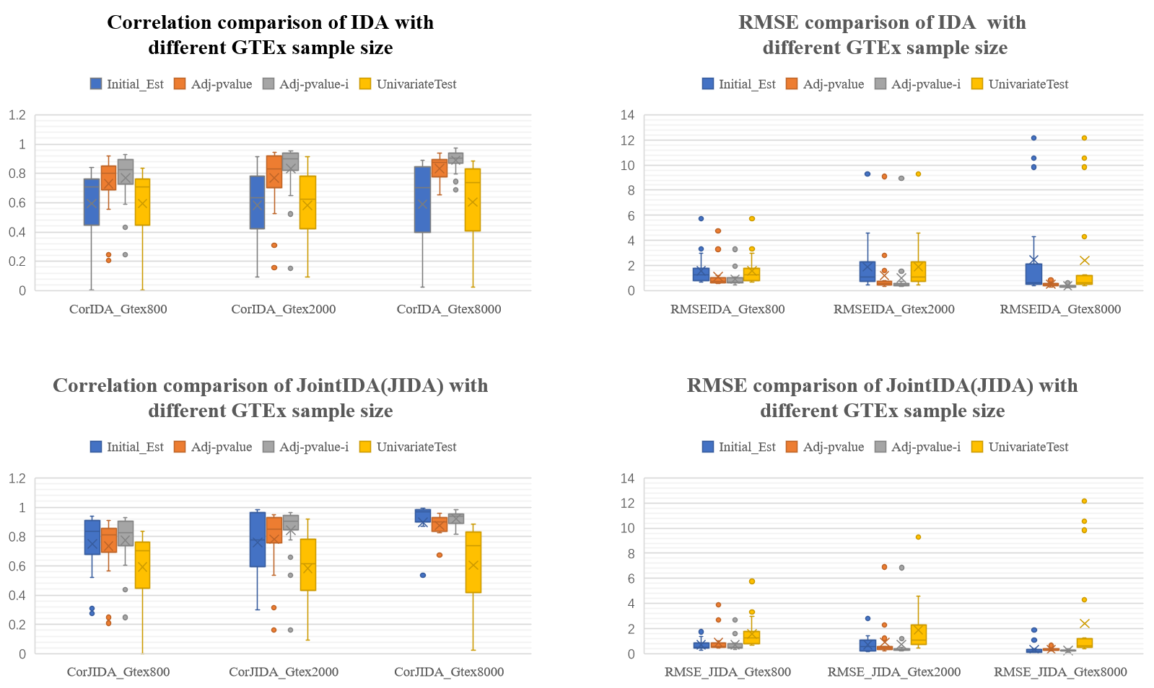
Fig.S1 The Correlation and root mean square error (RMSE) between true value and estimated value, for different GTEx sample size.
Parameter Setting: SNPs700/Genes70/OverallSamples100000/GraphDensity0.05/Abs(MinWeight)0.1

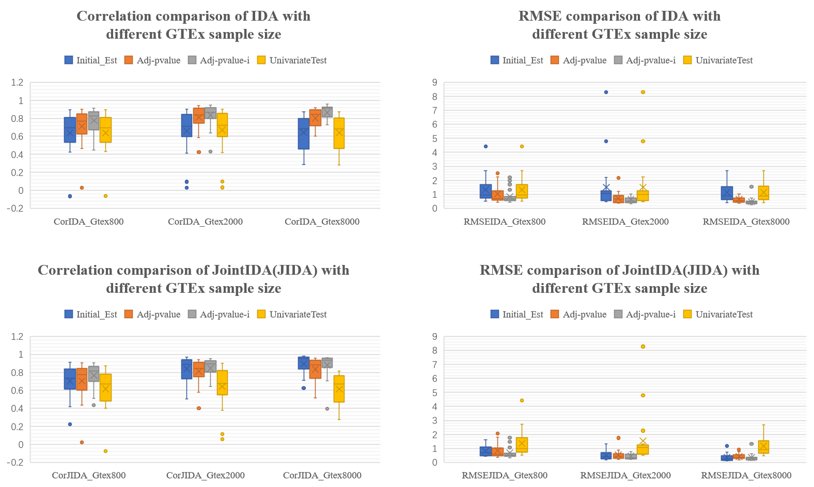
Fig.S2 The Correlation and root mean square error (RMSE) between true value and estimated value, for different GTEx number.
Parameter Setting: SNPs700/Genes70/OverallSamples100000/GraphDensity0.05/Abs(MinWeight)0.3
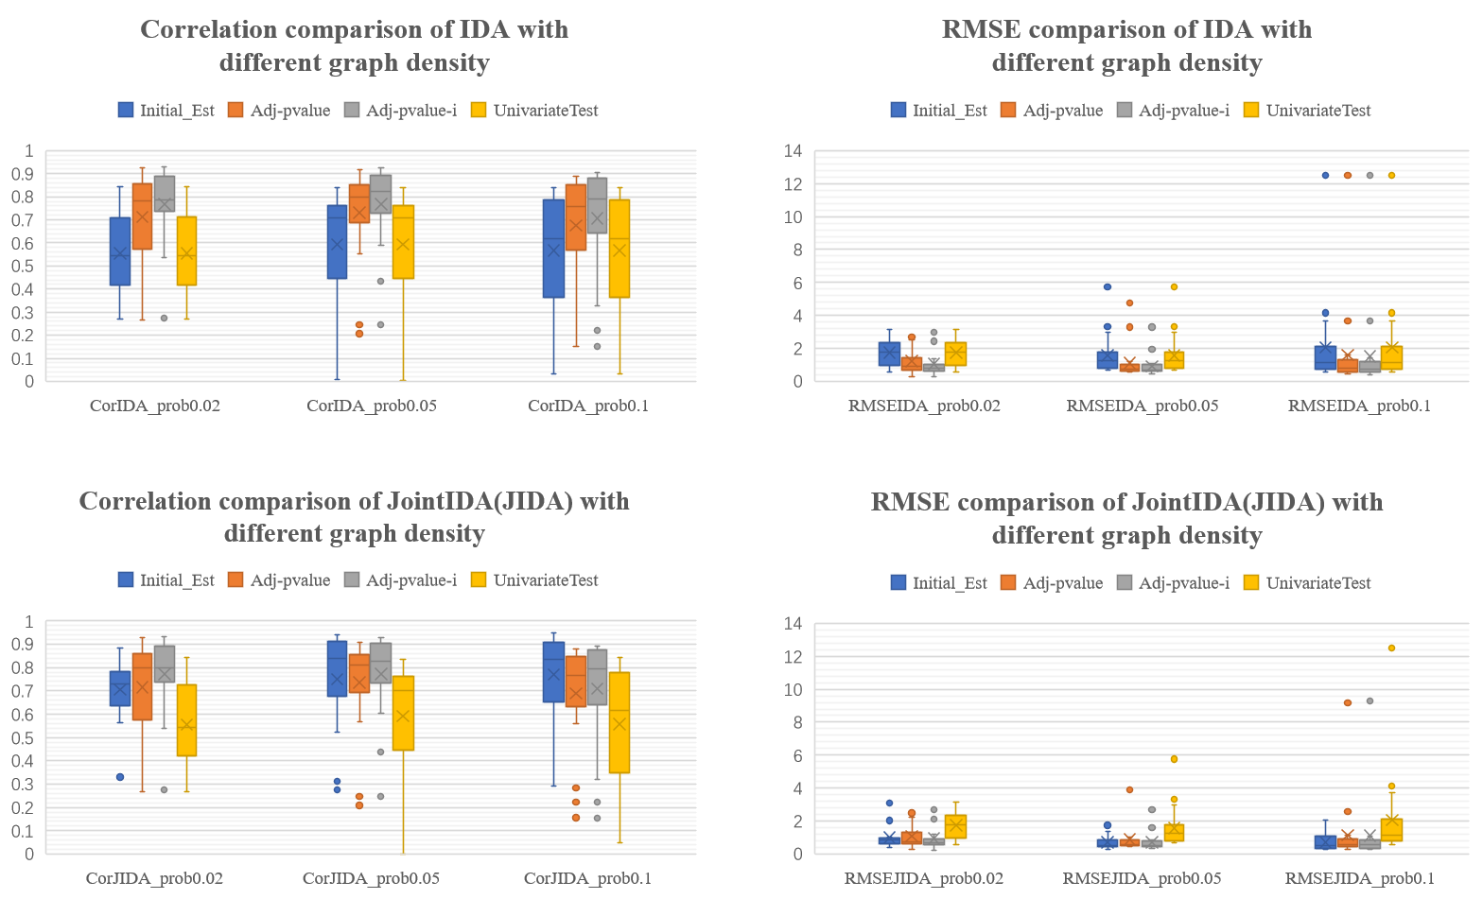
Fig.S3 The Correlation and root mean square error (RMSE) between true value and estimated value, for different graph density.
Parameter Setting: SNPs700/Genes70/OverallSamples100000/GTExSamples800/ /Abs(MinWeight)0.1
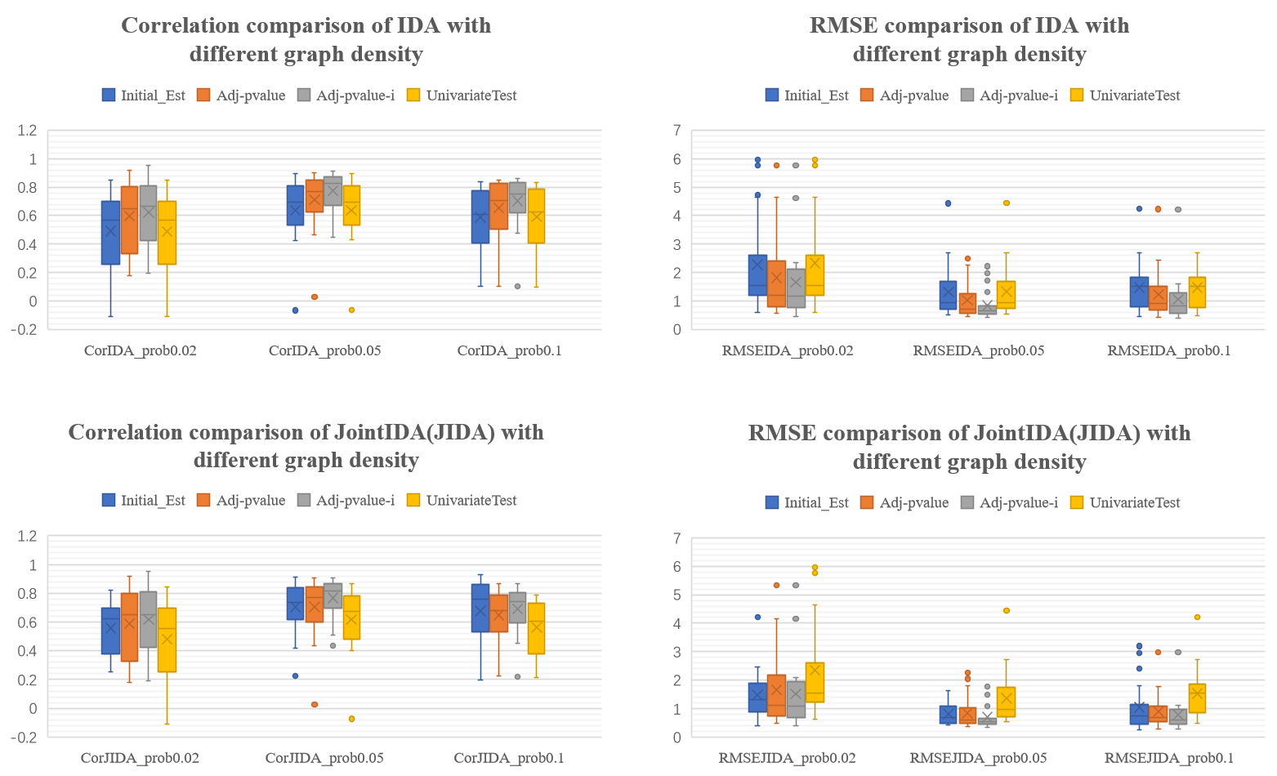
Fig.S4 The Correlation and root mean square error (RMSE) between true value and estimated value, for different graph density.
Parameter Setting: SNPs700/Genes70/OverallSamples100000/GTExSamples800/ /Abs(MinWeight)0.3

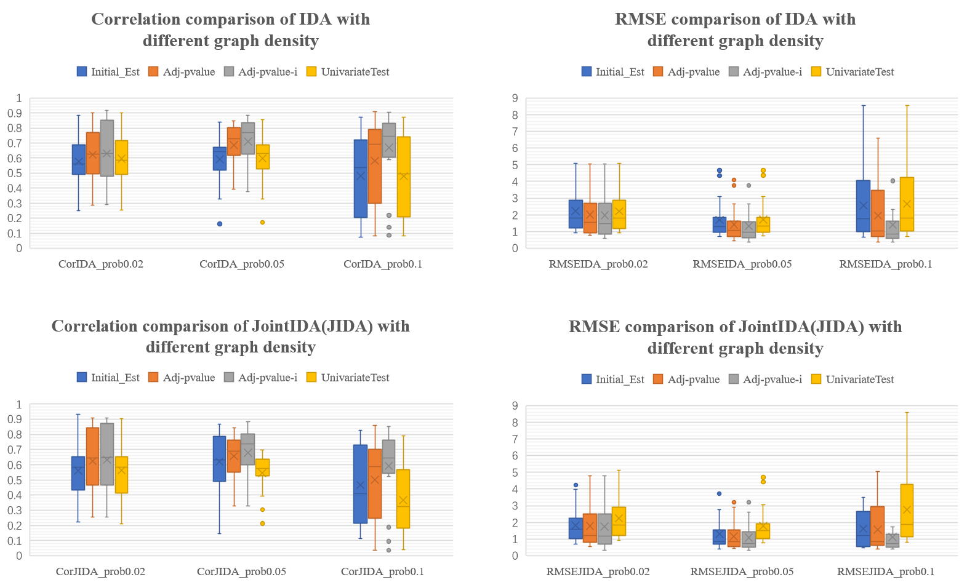
Fig.S5 The Correlation and root mean square error (RMSE) between true value and estimated value, for different graph density.
Parameter Setting: SNPs700/Genes70/OverallSamples100000/GTExSamples800/ /Abs(MinWeight)0.5
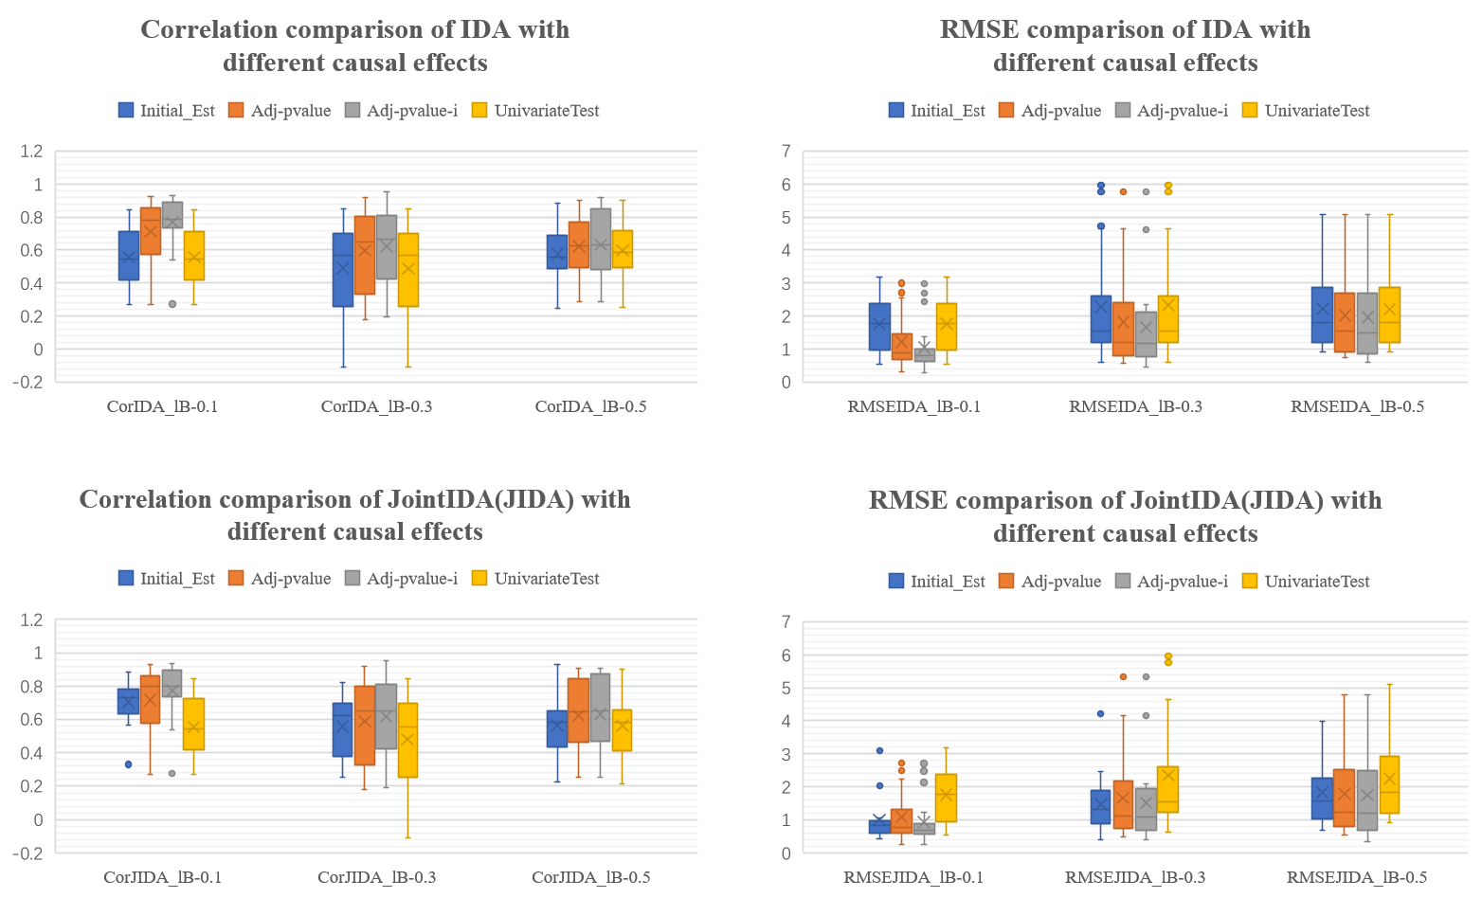
Fig.S6 The Correlation and root mean square error (RMSE) between true value and estimated value, for different causal effects.
Parameter Setting: SNPs700/Genes70/OverallSamples100000/GTExSamples800/GraphDensity0.02
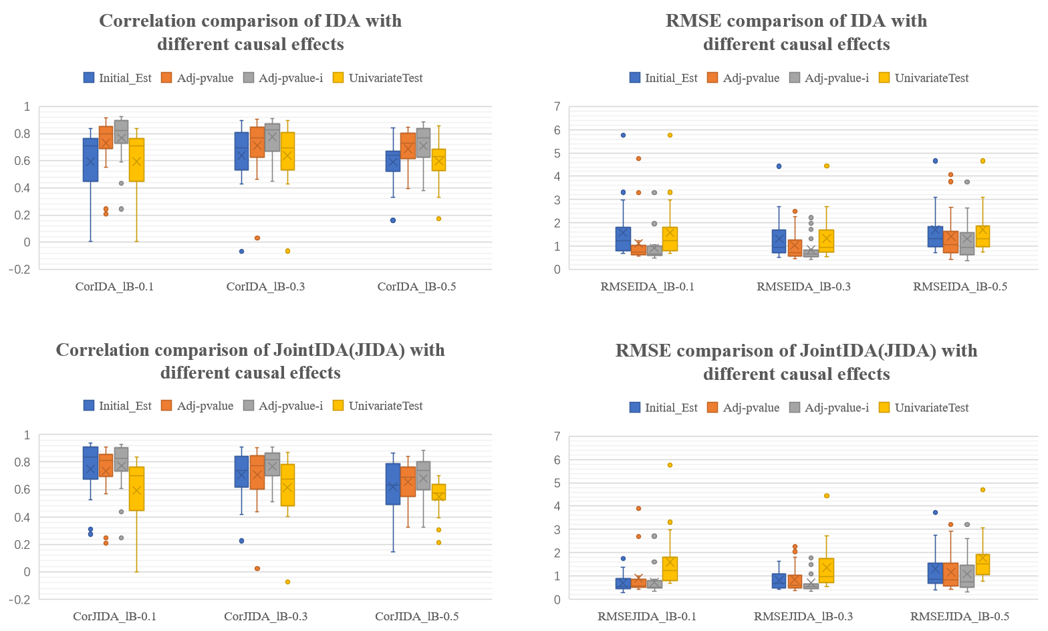
Fig.S7 The Correlation and root mean square error (RMSE) between true value and estimated value, for different causal effects.
Parameter Setting: SNPs700/Genes70/OverallSamples100000/GTExSamples800/GraphDensity0.05

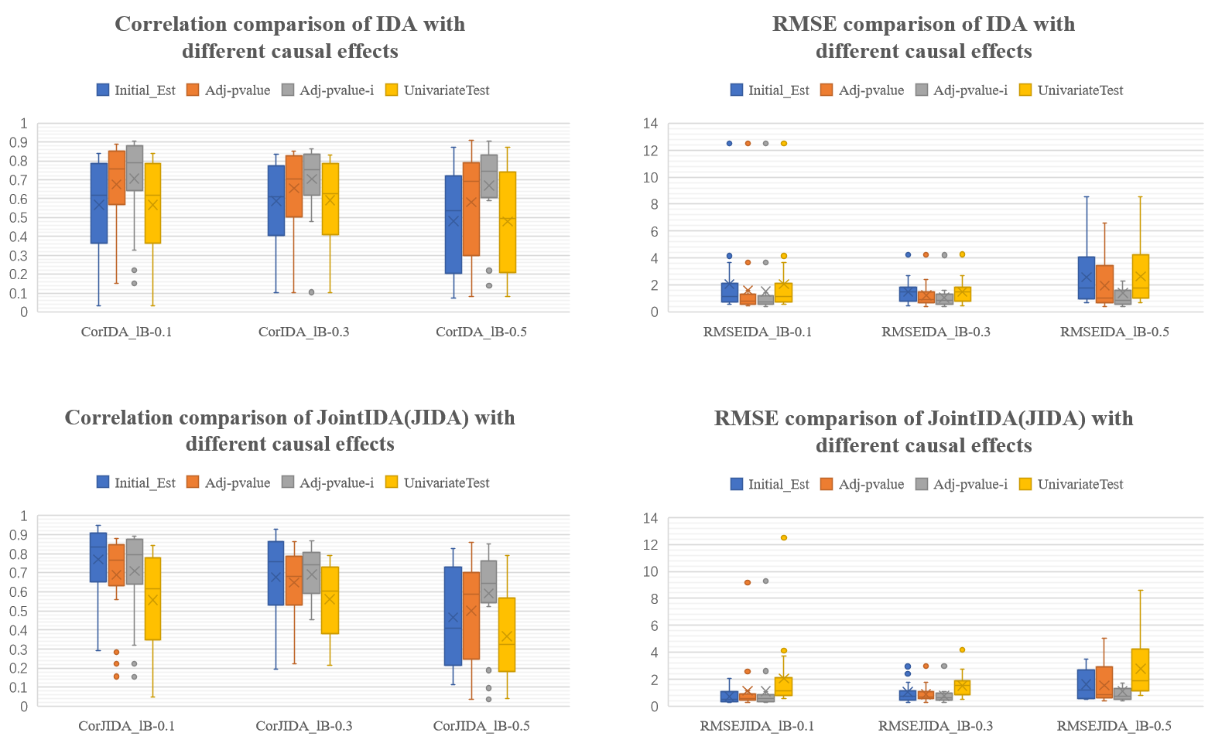
Fig.S8 The Correlation and root mean square error (RMSE) between true value and estimated value, for different causal effects.
Parameter Setting: SNPs700/Genes70/OverallSamples100000/GTExSamples800/GraphDensity0.1

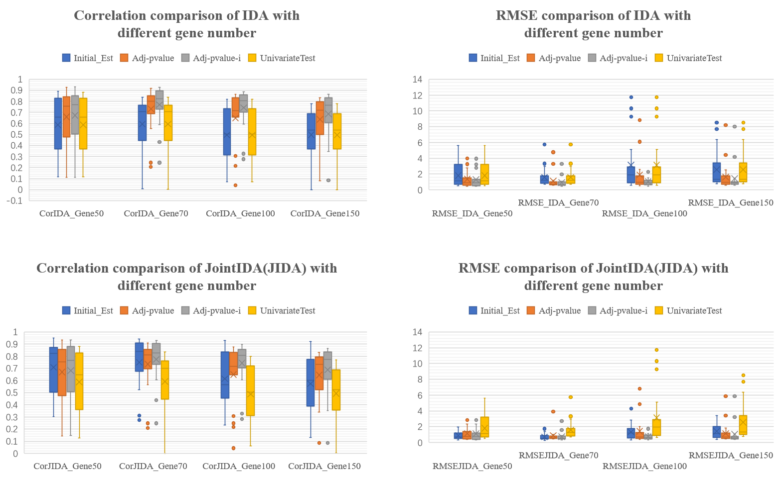
Fig.S9 The Correlation and root mean square error (RMSE) between true value and estimated value, for different gene number.
Parameter Setting: OverallSamples100000/GTExSamples800/GraphDensity0.05/Abs(MinWeight)0.1
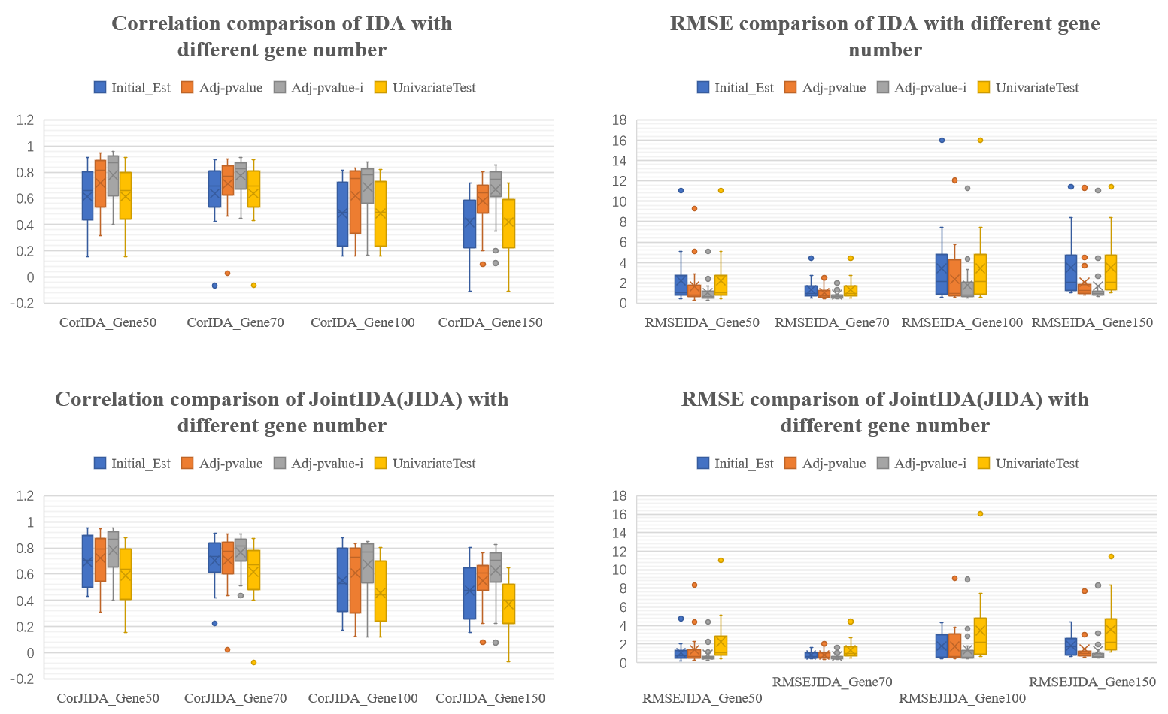
Fig.S10 The Correlation and root mean square error (RMSE) between true value and estimated value, for different gene number.
Parameter Setting: OverallSamples100000/GTExSamples800/GraphDensity0.05/Abs(MinWeight)0.3

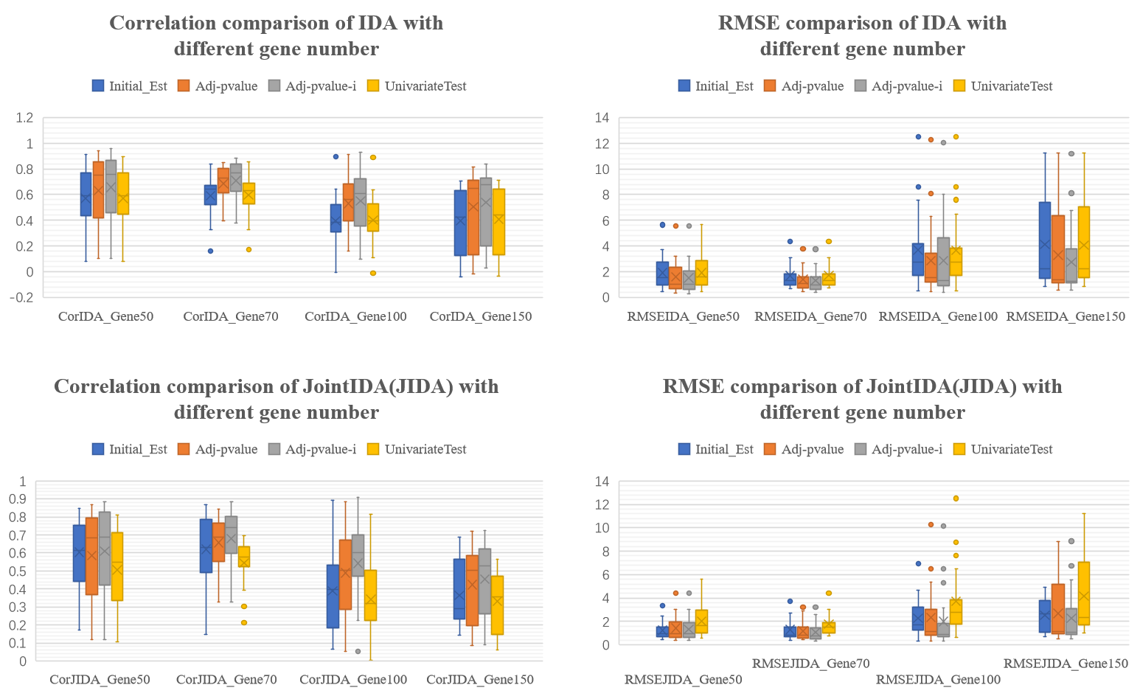
Fig.S11 The Correlation and root mean square error (RMSE) between true value and estimated value, for different gene number.
Parameter Setting: OverallSamples100000/GTExSamples800/GraphDensity0.05/Abs(MinWeight)0.5

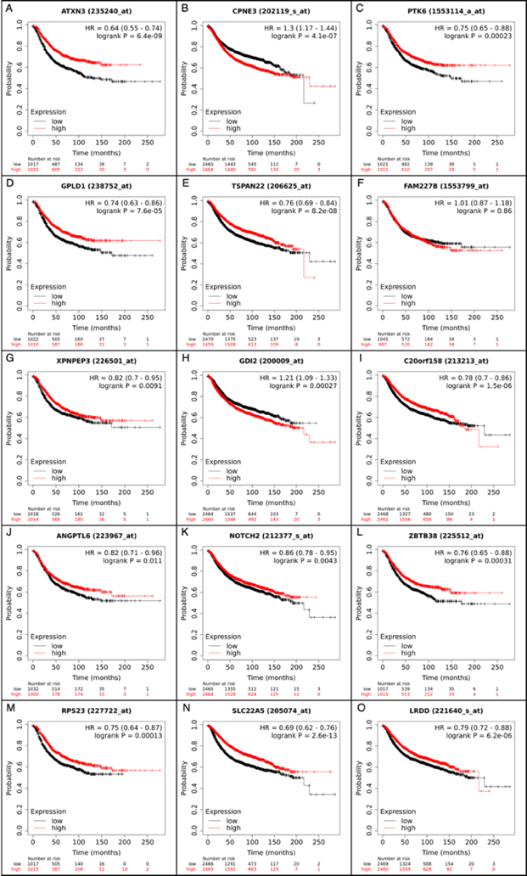

Fig S12 Survival analysis of directly causal genes identified from the breast mammary(A-G) and whole blood(H-O) for breast cancer.

