Supplementary Information

Bacterial biomass monitoring in rainbow trout
Supplementary Table 1) Real time PCR (qPCR) monitoring of bacterial 16S rRNA gene in intestinal samples of rainbow trout
Sample | Dilution | CT value | Group Average | Standard Deviation (SD)
Extraction Neg | 1:1 | 40.0 | 38.5 | 2.1
Extraction Neg | 1:1 | 37.1 | 38.5 | 2.1
RT1 | 1:1 | 33.6 | 36.3 | 2.8
RT1 | 1:10 | 34.1 | 36.3 | 2.8
RT2 | 1:1 | 40.0 | 36.3 | 2.8
RT3 | 1:1 | 34.4 | 36.3 | 2.8
RT3 | 1:10 | 34.9 | 36.3 | 2.8
RT5 | 1:1 | 40.0 | 36.3 | 2.8
RT5 | 1:10 | 37.3 | 36.3 | 2.8
PCR.Blk | 1:1 | 39.8 | 39.9 | 0.1
PCR.Blk | 1:1 | 40 | 39.9 | 0.1
Water sample 1 | 1:1 | 26.99 | 27.6 | 2.8
Water sample 2 | 1:1 | 25.12 | 27.6 | 2.8
Water sample 3 | 1:1 | 30.68 | 27.6 | 2.8

Host genomes for host filtering
Supplementary Table 2) Host genomes for host filtering

Species | NCBI Taxonomy ID | Accesion ID
Oncorhynchus mykiss | NCBI:txid8022 | GCF_002163495.1_Omyk_1.0
Salmo salar | NCBI:txid8030 | GCF_000233375.1_ICSASG_v2
Coregonus sp. | NCBI:txid861768 | GCA_902175075.1_AWG_v1

Data Generation and Quality Control

Supplementary Table 3) Shotgun sequencing output and quality control output
Sample | Host Species | No. Million Raw Reads | Paired End Length (bp) | No. Million Reads post QC & Filtering
RT1_1 | Oncorhynchus mykiss | 216.424 | 150 | 26.061
RT1_2 | Oncorhynchus mykiss | 216.424 | 150 | 31.428
RT2_1 | Oncorhynchus mykiss | 210.547 | 150 | 16.691
RT2_2 | Oncorhynchus mykiss | 210.547 | 150 | 20.406
RT3_1 | Oncorhynchus mykiss | 195.024 | 150 | 10.318
RT3_2 | Oncorhynchus mykiss | 195.024 | 150 | 12.167
RT4_1 | Oncorhynchus mykiss | 227.968 | 150 | 8.168
RT4_2 | Oncorhynchus mykiss | 227.968 | 150 | 10.838
RT5_1 | Oncorhynchus mykiss | 209.142 | 150 | 15.078
RT5_2 | Oncorhynchus mykiss | 209.142 | 150 | 16.206
AS1_1 | Salmo salar | 46.733 | 100 | 0.885
AS1_2 | Salmo salar | 46.733 | 100 | 0.885
AS3_1 | Salmo salar | 24.024 | 100 | 4.349
AS3_2 | Salmo salar | 24.024 | 100 | 4.349
AS4_1 | Salmo salar | 13.521 | 100 | 15.871
AS4_2 | Salmo salar | 13.521 | 100 | 15.871
AS5_1 | Salmo salar | 53.497 | 100 | 4.448
AS5_2 | Salmo salar | 53.497 | 100 | 4.448
AS6_1 | Salmo salar | 32.376 | 100 | 6.139
AS6_2 | Salmo salar | 32.376 | 100 | 6.139
AS7_1 | Salmo salar | 45.849 | 100 | 1.951
AS7_2 | Salmo salar | 45.849 | 100 | 1.951
AS142_1 | Salmo salar | 53.735 | 100 | 6.778
AS142_2 | Salmo salar | 53.735 | 100 | 6.778
AS391_1 | Salmo salar | 62.770 | 100 | 2.588
AS391_2 | Salmo salar | 62.770 | 100 | 2.588
WF_1 | Coregonus lavaretus | 46.429 | 100 | 21.754
WF_2 | Coregonus lavaretus | 47.398 | 100 | 22.218

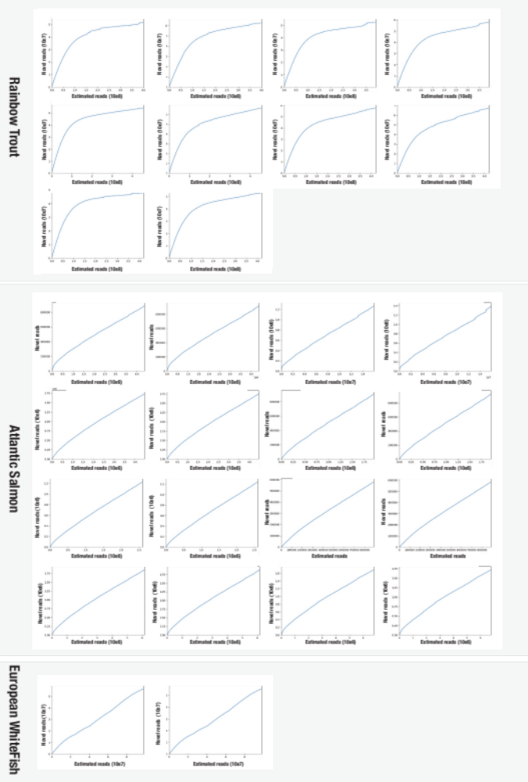
Supplementary Figure 1. Collectors curves of all paired end reads for rainbow trout, Atlantic salmon, and European whitefish, estimated using khmer. Saturation of curves indicate saturated read depth for 5X of all reads.

Saturation of read depth for 5X coverage is only fully saturated for rainbow trout. Atlantic salmon and European whitefish would need more data for fully saturated read depth, as seen for a nearly linear progression between accumulated data versus novel reads found. Taken the completion of Candidatus Mycoplasma lavaretus (>99% completion) and Candidatus Mycoplasma salmoninae salar (>85% completion) compared to Candidatus salmoninae mykiss (>95% completion), the lack of read depth is not expected to affect the investigation of dominant species, like Mycoplasma, in the metagenomes of Atlantic salmon and European whitefish.

Quality Control of Assembled Mycoplasma MAGs
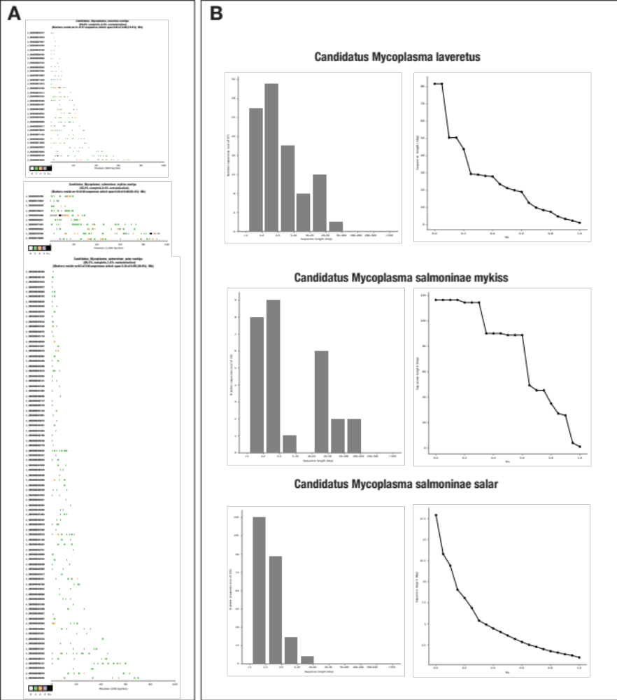
Supplementary Figure 2. Quality control of metagenomic assembled genomes (MAGs) from European whitefish (Candidatus Mycoplasma laveretus), rainbow trout (Candidatus Mycoplasma salmoninae mykiss), and Atlantic salmon (Candidatus Mycoplasma salmoninae salar), using CheckM. A) Hidden Markov Model (HMM) hits across assembled contigs for each Mycoplasma related MAG, providing information regarding the extent to which marker genes are collected. The number of marker genes within a fixed size window is indicated by different colours. Sequences without any marker genes are not shown. B) Histogram of contig length and line chart of ratio of MAG described by a given sequencing length for each Mycoplasma related MAG.

Mycoplasma isolates for comparative genetics
Supplementary Table 4) Summary of Mycoplasma genomes for comparative genomics

Please find table in provided Excel file “Supplementary_Table_4.xlsx”.

Further information of external genomes used in this study, including GenBank Accession IDs, can be found at: https://github.com/JacobAgerbo/Comparative_Mycoplasma/blob/main/Pangenome.

Comparison of novel MAGs from each host individual from of Atlantic Salmon, Rainbow Trout, Common Whitefish

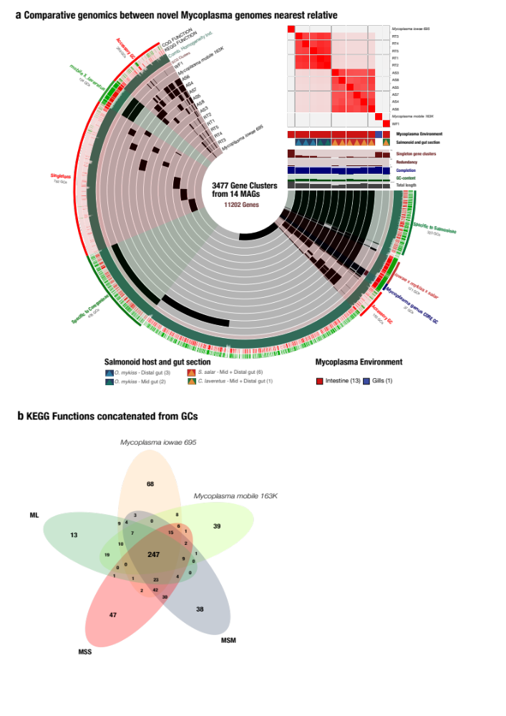
Supplementary Figure 3. Comparison of novel Mycoplasma with nearest relatives across sampled individuals. A) Comparative genomics between the novel Mycoplasma single assembled MAGs. Each one of the 3477 gene clusters (GCs) contains one or more genes contributed by one or more isolated genomes. Bars in the 14 layers indicate the occurrence of GCs in a given isolated genome, black bars indicate presence of GCs, whereas grey indicates absence. GCs are organised based on their distribution across genomes, and layers of genomes are organised based on their average nucleotide identity (ANI), using Euclidean distance and ward ordination. Heatmap indicates ANI clusters of Mycoplasma isolates, where red indicates higher similarity between genomes. The five barplots below the heatmap indicate singleton GCs (dark brown), redundancy (dark brown), completion (blue), GC-content (dark green), and length of genomes (grey). Functional annotation of GCs with KEGG and COG were visualised in outer layers with green and red. The layers are grey if no KEGG or COG annotation were found. Notations in the outer layer of co-clustering of novel genomes are visualised with different colours. Samples from Atlantic Salmon were abbreviated “AS”, samples from Rainbow Trout were abbreviated “RT”, and samples from Whitefish were abbreviated “WF”. B) Comparison of KEGG classifications of novel Mycoplasma. Venn diagram of KEGG functions concatenated from GCs from a co-assembly of the novel Mycoplasma genomes. Venn diagrams also include the nearest relative to the novel Mycoplasma genomes, including Mycoplasma mobile and Mycoplasma iowae.

Fluorescence in situ hybridization (FISH) of gut epithelia in rainbow trout
Supplementary Figure 4. Fluorescence imaging of gut epithelial in rainbow trout. Four µm rainbow trout intestine sections mounted with Vectashield with fluorescent DNA stain 4′,6-diamidino-2-phenylindole (DAPI). Panel A, B and C are confocal images captured on a Leica SPX-5. The tissue is illuminated with A) white light, B) UV light and C) white light and UV light. In panel B and C DNA appears as a blue signal. Panel D is captured with Zeiss Axioplan fluorescence microscope and DNA is visible as white light. Stars represent nuclei of the fish tissue and arrow heads represent bacteria lining the intestinal wall.

Supporting phylogenomics of unknown Mycoplasma MAGs

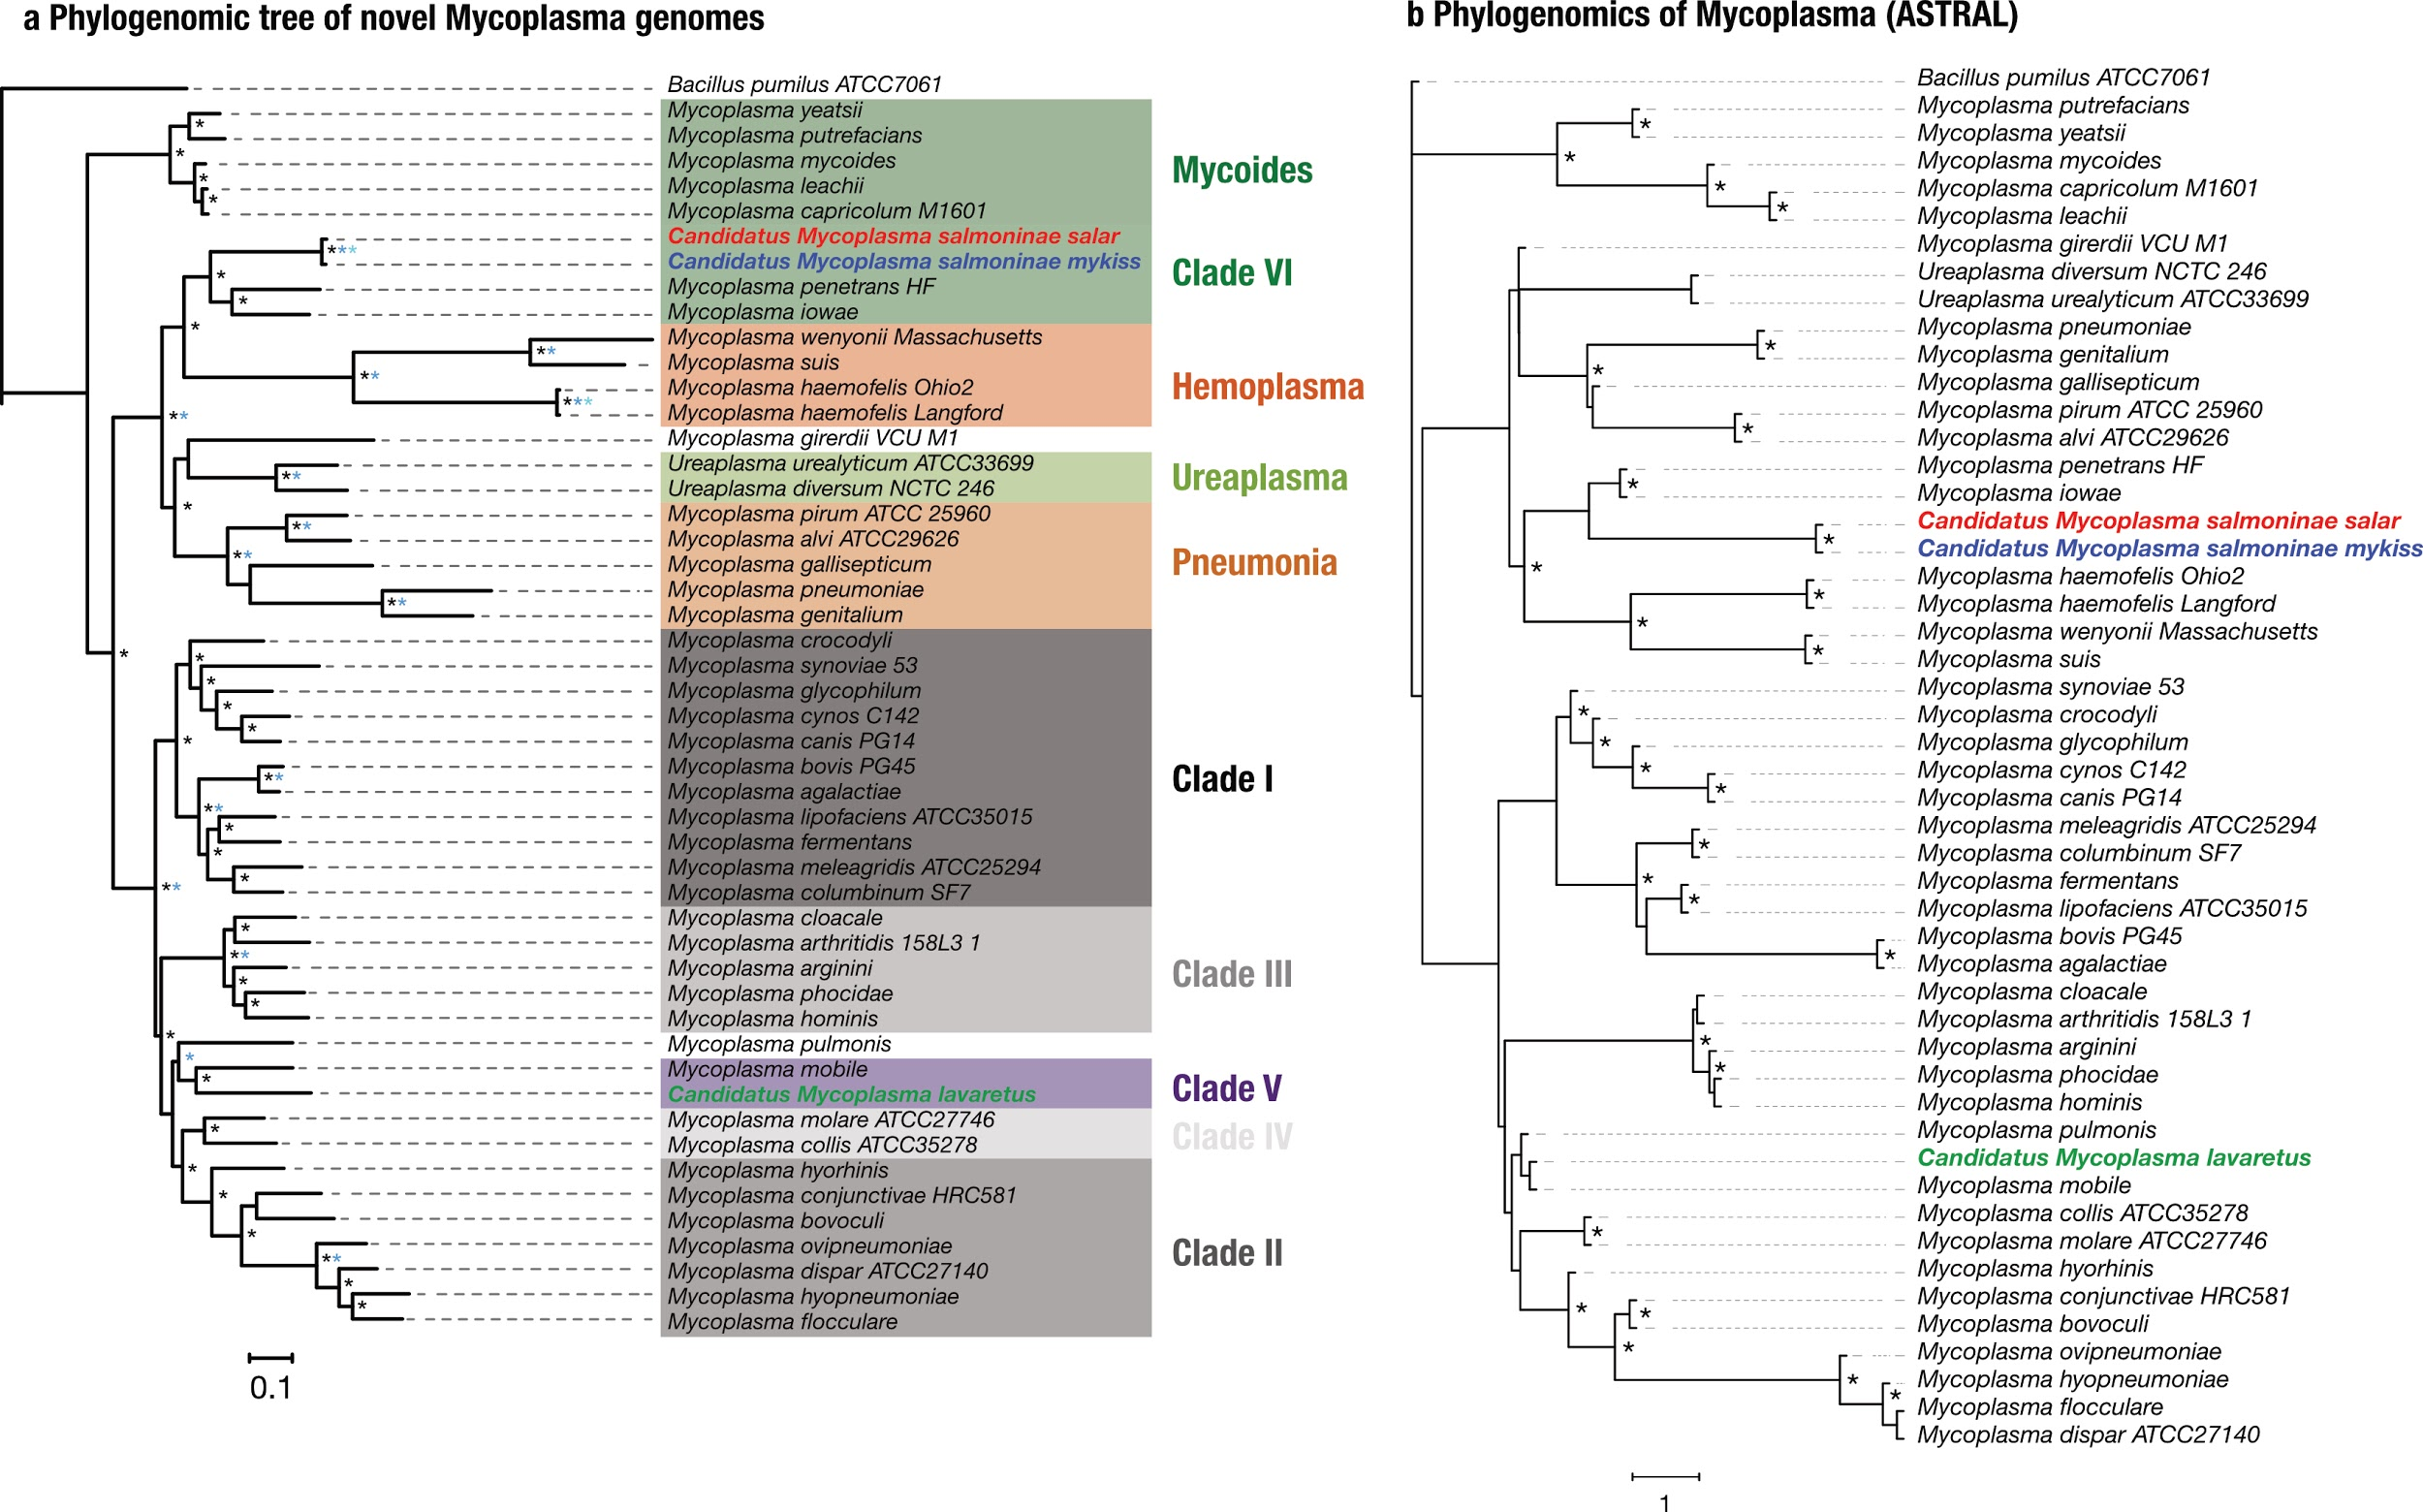
Supplementary Figure 5. Phylogenomics of unknown Mycoplasma MAGs. A. Phylogenomic tree inference from a concatenated alignment including 50 bacterial genomes (estimated in IQ-TREE). Asterisks indicate high branch supports (black: aLRT supports above 85; dark blue: gene internode certainty above 0.85; light blue: site internode certainty above 0.85). b. Phylogenomic tree estimated from ASTRAL, using the trees for core genes as input. Asterisks indicate branches with local posterior probabilities >0.85.

Metabolic reconstruction of intestinal related Mycoplasma species across multiple hosts
Supplementary Table 5) Summary of RAST annotation of Mycoplasma genomes
Please find table in provided Excel file “Supplementary_Table_5.xlsx”.

Annotation of gene clusters in pangenome
Supplementary Table 6) Summary of gene clusters in pangenome, including concatenated protein sequences.
Please find table in provided Excel file “Supplementary_Table_6.xlsx”.

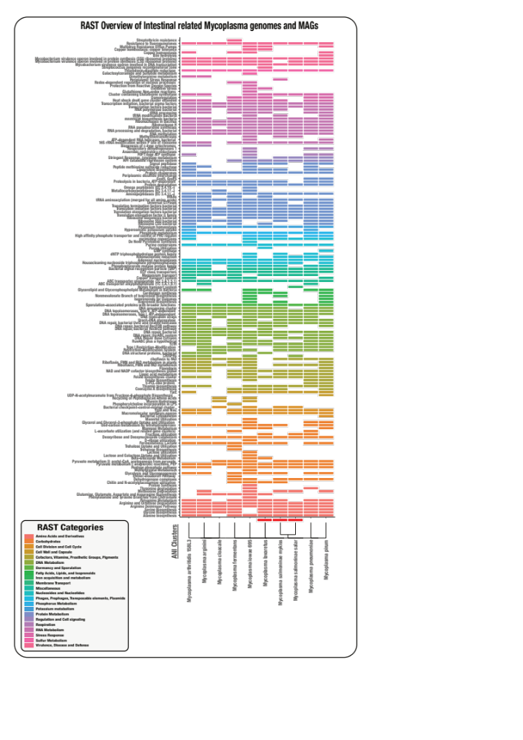
Supplementary Figure 6. Metabolic reconstruction of intestinal related Mycoplasma species across multiple known Mycoplasma clusters. RAST subsystems are visualised for each Mycoplasma genome, including novel genomes. Visualisations are based on presence/absence of completed RAST subsystems. Colours in visualisation are based on RAST categories, which is shown in the legend. Arrangement of genomes are based on average nucleotide identity (ANI) and the dendrogram is based on hierarchical clustering with maximum likelihood of ward distances of ANI. Novel MAGs from salmonids are highlighted with a red bar on the x axis.
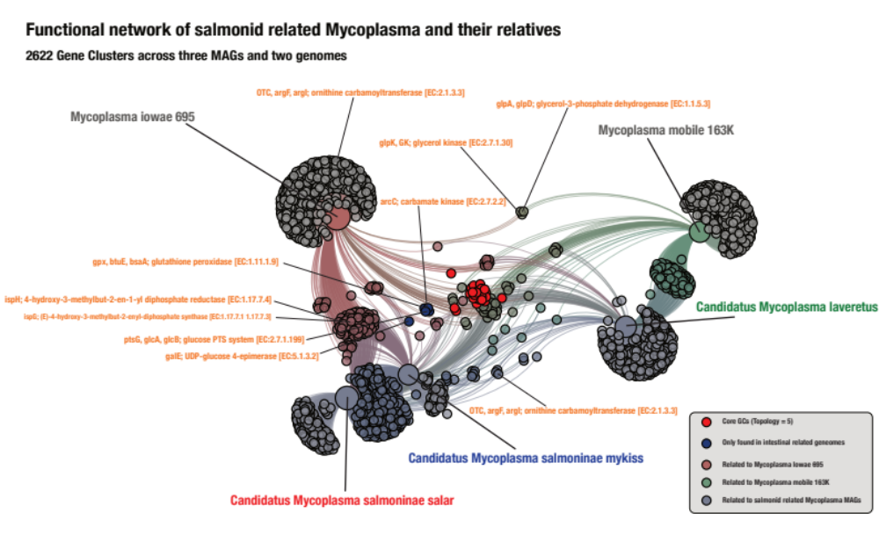
Supplementary Figure 7. Functional network of salmonid related Mycoplasma MAGs and their relatives. Functional network of the three MAGs and two genomes based on a total of 2622 identified gene clusters (GCs). Big nodes represent MAGs and genomes, whereas small nodes indicate GCs. Size and colour of genomic and MAG related nodes represent the number of related GCs and MAG taxonomy, respectively. Colours of functional nodes indicate their occurrence in the different MAGs and genomes. Name and KEGG accession number of functions of interest are highlighted in figure.

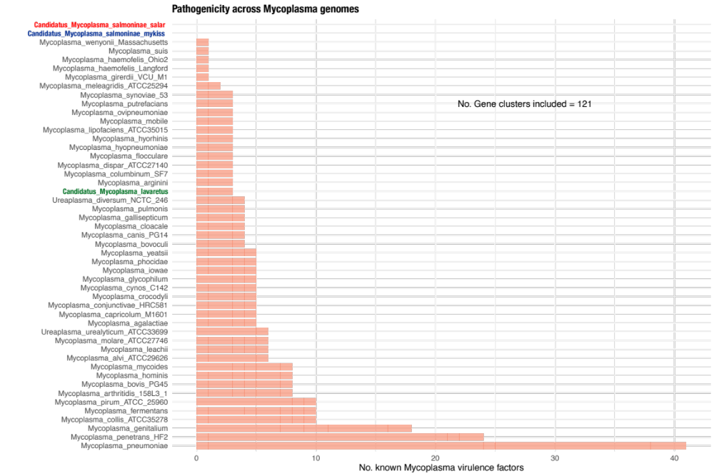
Supplementary Figure 8. Pathogenicity across Mycoplasma genomes based on known virulence factors present in Mycoplasma. Based on search for both functions, including virulence, toxins, anti-toxins, adhesion factors, Large Membrane Proteins (LMPs), and specific genes, including traG/traE, glpF, oppA, mgpA/mgpC, katE, across all gene clusters in the pangenome. Search were based on KEGG, COG, and Pfam.

Enrichment analysis between intestinal related and non-intestinal related Mycoplasma species across multiple hosts
Supplementary Table 7) Summary of Enrichment Analysis of KEGG annotations between intestinal and non-intestinal related Mycoplasma
Please find table in provided Excel file “Supplementary_Table_7.xlsx”.

