Online resource 1

Location of the sampling site. A: University; B: industrial parks; C: farms; D: residences. Red triangles represent sampling site.

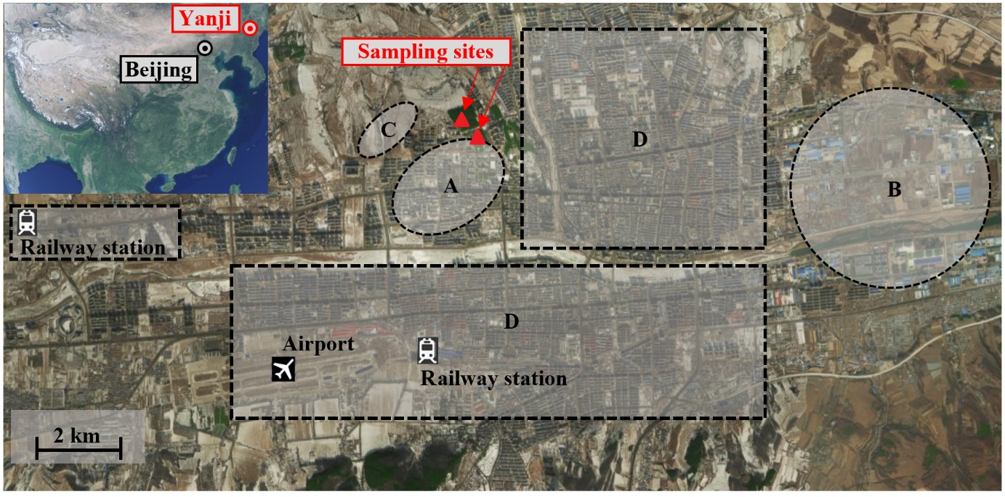
The main wind flowing to the sampling site is the westerly and northwesterly winds in the spring, autumn, and winter season and the southeasterly and southwesterly winds in the summer season. The Annual wind direction is mainly northwest wind and westerly winds.

Online resource 2

Lipid contents in dry weight information of Pinus tabulaeformis and Abies holophylla.

Species | Year | Lipid content (g g⁻¹) (n = 3)
Pinus tabulaeformis | 2015 | 0.0685 ± 0.0021
Pinus tabulaeformis | 2014 | 0.0860 ± 0.0103
Pinus tabulaeformis | 2013 | 0.0956 ± 0.0091
Pinus tabulaeformis | 2012 | 0.0779 ± 0.0211
Abies holophylla | 2016 | 0.2746 ± 0.0112
Abies holophylla | 2015 | 0.3113 ± 0.0025
Abies holophylla | 2014 | 0.3216 ± 0.0056
Abies holophylla | 2013 | 0.3100 ± 0.0113
Abies holophylla | 2012 | 0.2881 ± 0.0134
Abies holophylla | 2011 | 0.2747 ± 0.0137

Online resource 3

Air pollutant emission parameters registered in the period 2011 – 2016. Data from Jilin Province Statistics Bureau Data Management Center 2020.

Air pollutant emission parameters | Year
Air pollutant emission parameters | 2011 | 2012 | 2013 | 2014 | 2015 | 2016
Coal (10⁴ tons) | 1030 | 1431 | 669 | 751 | 718 | 429
Electricity consumption (MKH) | 114640 | 127800 | 100767 | 116234 | 113246 | 117746
Trucks (units) | 32095 | 29892 | 32300 | 34603 | 33491 | 34789
Industrial Sulfur Emissions (tons) | 25100 | 22840 | 23807 | 23789 | 24386 | 14599
Industrial Nitrogen Oxide Emissions (tons) |  | 28492 | 26255 | 27640 | 25917 | 9241
Vehicle number (units) | 77168 | 79867 | 60397 | 71346 | 117331 | 122320
Industrial gaseous pollutant emissions (tons) | 19900 | 18851 | 21218 | 35685 | 35744 | 24100
Generating capacity  (KWh) | 60 | 50 | 47 | 46.84 | 45.9 | 46.05

