Supporting information

Characterization of the bioactive compounds with efficacy against epilepsy from the herb pairs Polygala tenuifolia-Zizyphus jujuba by modulating CHRNA4/CaMKII signaling pathway: LC-MS/MS combined with network pharmacology analysis and experimental evidence.
Meng Nian ¹, Zefeng Zhao ^{1, ***}, Yongqi Wang ¹, Jingxuan Chen ¹, Mingcheng Qian ², Guangning Li ³, Xiaoan Li ^{4,} Haifa Qiao ^{1, **}, Xiaohang Yang ^{1, *}
¹ Shaanxi University of Chinese Medicine, Xixian New Area, Shaanxi Province 712046;
² Department of Medicinal Chemistry, School of Pharmaceutical Engineering and Life Science, Changzhou University, Changzhou, 213164, Jiangsu, P. R. China;
³ SCIEX Ltd, Hangzhou, Peoples R China;
⁴ Ankang Inspection and Testing Center for Food and Drug, Ankang, P. R. China;
* Correspondence: zzf598155752@sina.com, 1511006@sntcm.edu.cn and yxh1.0@163.com.

Methods description in detail

2.2. HPLC-QTOF-MS/MS conditions and Data analysis
Both the positive and negative ion modes were selected for MS data acquisition of PZE. The separation of the components in PZE were conducted on a Kinetex® 2.6 μm C18 100 Å LC Column (100 × 2.1 mm), using the mobile phase consisted of solvent A (HCOOH: H₂O = 0.1:100, v/v) and solvent B (methanol) at the gradient eluting procedure optimized as follows: 0-5 min, 15% B; 6-10 min, 15-25% B; 10-30 min, 25-40% B, 31-40 min, 40-70% B, 41-45 min, 46-48 min, 95-15% B, 49-50 min, 15% B. The flow rate was set at 0.4 mL/min. The column and autosampler temperature were maintained at 40 °C and 4 °C, respectively. The inject volume for PZE and mixed standard solution was 2 µL.
HPLC-QTOF-MS/MS analyses were performed in the negative electrospray ion mode with a Duo Spray source on a Triple TOFTM 5600⁺ system (AB SCIEX, CA, USA). The MS, and MS/MS data of the compounds was acquired in the information dependent acquirement (IDA) technology mode. The optimized parameters for IDA were set as follows: ion source gas 1 (GS1): 55 psi, ion source gas 2 (GS2): 55 psi, curtain gas: 35 psi, temperature: 600 °C, and CAD gas: 7. For TOF MS: mass range of the components, m/z 100-2000, declustering potential (DP): ± 80 V, collision energy (CE): ± 35 V, and CE spread: 0 V. Data acquisition and analysis were controlled by SCIEX OS software (Ver. 1.4, AB SCIEX Co.).
The systematic information on chemical constituents isolated or identified from the PZE was collected and sorted out by retrieving the published literatures involving phytochemical studies, fingerprint of medicinal materials studies, reviews and databases including MassBank and SciFinder scholar. etc (Wei et al., 2021). As a result, a self-built components database included compound name, and chemical formulas of each compound was established for further structural elucidation.

2.3. Construction and analysis of PZE compounds-disease target interaction network
The characterized compounds from PZE were imported into the PubChem database (https://pubchem.ncbi.nlm.nih.gov/) to acquire information about SMILES. Compounds with potentially similar biological activity can be inferred from the principle of structural similarity, we obtained the predicted targets using the SMILES string in the Swiss Target Prediction database (Daina et al., 2019) (www.swisstargetprediction.ch). Herein, we used a probability ≥ 0.1 as the screening condition of the target protein to predict the components. Afterward, the obtained targets were standardized according to the gene names by searching the UniProt Database (http://www.uniprot.org) with the “Homo sapiens” species (Consortium 2018). Finally, the target library of the puffball ingredients was constructed.

2.4. Acquisition of potential anti-epilepsy targets and the Protein-Protein interaction (PPI) network construction
The database of DisGeNET (http://210.107.182.61/geneSearch/) contains information on genes and mutation sites associated with human diseases (Piero et al., 2016). Analogously, GeneCards (www.genecards.org) provides concise genomic, proteomic, transcriptional, genetic and functional information on all known and predicted human genes (Safran et al., 2013). These two databases were used to construct inﬂammation-related target libraries by performing automated search using keywords including “epilepsy” and “seizure”. The search results were then passed through other filters, with DisGeNET score gda ≥0.05 and GeneCards score ≥9.21. Bioinformatics (www.bioinformatics.com.cn) free online platform was used to identify the shared target between the composition and the target.
STRING (https://string-db.org/) database was used to predicted the protein interactions (Szklarczyk et al., 2019), which gave a certain weight to the comprehensive results of protein interactions using a scoring mechanism, and finally outputs a comprehensive evaluation score, indicating a closer relationship. We mapped the composition targets into the epilepsy targets and a PPI network was then constructed according to the information obtained from the STRING database. The background organism was set to “Homo sapiens”, a medium confidence score of 0.4 was used as the minimum required interaction score, the results were imported in the Cytoscape v3.7.2 software, and the topological parameters of the networks were analyzed using the Network Analyzer tool (Shannon et al., 2003).

2.5. GO annotation and KEGG enrichment analysis
Using the Metascape (metascape.org) web-based portal for comprehensive gene annotation and analysis resources (Delano 2002), we performed the Gene Ontology (GO) annotation and Kyoto Encyclopedia of Genes and Genomes (KEGG) pathway enrichment analysis, while setting the pre-analysis species to “Homo sapiens”. The GO analysis includes three categories: biological process (BP), cellular component (CC) and molecular function (MF). Finally, a bubble chart was plotted using the bioinformatics platform (http://www.bioinformatics.com.cn/) for bioinformatics-related data analysis.

2.6. Ingredien -target-pathway network construction
The ingredient-target-pathway network is constructed by introducing PZE targets, pathways and selected 24 kinds of active ingredients into the Cytoscape software. The nodes with different colors represented different types of clusters, while the edges represented the relationships between the nodes.

2.7. Molecular docking
The crystal structure of core target proteins used for molecular docking in the PPI network was obtained from the PDB database (www.rcsb.org) (Berman et al., 1999). The Discovery Studio Client software was used to add hydrogen and partial charges to the proteins and ligands (Morris et al., 2009). The results of the docking computations were ranked by the binding affinity (-kcal/mol). Finally, we used Discovery Studio Visualizer to visualize the conformations and interactions between the ligands and the target proteins.

2.9. Animals and group
Our experiment was authorized by the Institutional Animal Care and Use Committee of Xi’an Jiaotong University, fifty young adults male Kunming-strain mice (22-28 g). All mice were randomly divided into five groups, and each group consisted of 10 animals: (1) normal saline group (NS); (2) pentylenetetrazol group (PTZ); (3) treatment group were divided into three group, included high (PZEH 300mg/kg), medium (PZEM 100 mg/kg) and low (PZEL 30mg/kg) dose group. Sixty minutes after the last treatment, 85 mg/kg of freshly prepared solution of PTZ was administered subcutaneously (sc) to all the mice. Latent time for the onset, the percentage of incidence of tonic seizures was observed for 30 min after PTZ injection.

2.10. Establish mice epilepsy model and sc-PTZ-induced epilepsy
Intraperitoneal injection of 10 mg/kg PTZ for 20 days to induce a developmental epilepsy model (Liu et al., 2018). The treatment groups were given intraperitoneal (i.p.) injection of PTZ (10 mg/kg) after oral injection PZE 60 minutes. The Control group was only injected with saline. Sixty minutes after the last treatment, 85 mg/kg of freshly prepared solution of PTZ was administered subcutaneously (sc.) to all the mice. Latent time for the onset, the percentage of incidence of tonic seizures was observed for 30 min after PTZ injection. The latency, duration and intensity of each seizure were recorded, and the average values were calculated for statistical analysis. The mice were sacrificed with an anesthetic (1% barbital sodium, 500 mg/kg) 24h after epilepsy.

2.11. The behavioral animal tests
The fortieth day after the beginning of the experiment, four behavioral tests usually employed in studies on laboratory.

2.10.1 Elevated plus maze test (EPMT)
The EPMT is used to assess anxiety-like behavior and was conducted as described previously (Bruijnzeel et al., 2019). The test apparatus consisted of four black polypropylene arms (Coulbourn Instruments, Whitehall, PA). The two “open” arms had 1 cm ledges, and the two “closed” arms had 15 cm walls. The open arms were placed opposite of each other. The arms were 8.5 cm wide, 70.5 cm long, and were placed on 53 cm tall acrylic legs. Testing occurred in a quiet room. At the beginning of each test, the mice were placed in the center of the apparatus facing an open arm. The mice were allowed to explore the apparatus for 15 min, and their behavior was recorded with a camera mounted above the maze. The EPMT was divided into five zones (two open arms, two closed arms, and a center zone). Behavior was analyzed automatically (center-point detection) using EthoVision XT 15.0 software (Noldus InformationTechnology, Leesburg, VA). The following behavioral parameters were
automatically determined: duration and entries into the open arms,
closed arms, and center zone, and total distance traveled. The percentage of open arm entries (open arm entries/total arm entries) and percentage of time on the open arms (time on open arms/total time on the arms) were calculated.

2.10.2. open field test (OFT)
OFT test is used to assess locomotor activity and anxiety-like behavior (Liebsch et al., 1998). The test was conducted for 5 min in a dimly lit room, as described previously (Bruijnzeel et al., 2016, Qi et al., 2016, Tan et al., 2019). The OFT apparatus consisted of a large arena measuring 40 × 40 × 40 cm (L x W x H). The arena was made of black high-density polyethylene panels that were fastened together and placed on a plastic bottom plate. The mice’ behavior was recorded with a camera mounted above the arena and analyzed with EthoVision XT 15.0 software (Noldus Information Technology, Leesburg, VA). The OFT was divided into three zones: an outside zone (20 cm wide), a middle zone (20 cm wide), and a center zone (40 × 40 cm; L x W). The following behaviors were analyzed: total distance traveled, distance traveled in each zone (outside, middle, and center), number of entries into each zone, and latency to enter the middle and center zone.

2.10.3. Forced swimming test (FST)
Each animal was free to swim in a glass cylinder (6 cm for radius with height for 30 cm) filled with clean water (25 ± 1ºC). The animals had been allowed to swim for 6 min. In the end, the time of immobility has been calculated for the last 4 min. The animal was considered immobile when it stopped swimming and struggling and became motionless other than making movements to keep its head above the water (Porsalt 1977).

2.10.4. Tail suspension test (TST)
The animals were suspended by their tail at the edge of a 50 cm rod fixed above the table. The immobility time was measured by a stop watch for 6 min and the last 4 min were analyzed. When the animal stopped making any movement, it was considered immobile (Steru et al., 1985).

2.12. Histological observation of brain tissue

2.12.1. Hematoxylin and eosin (HE) staining
After the mice were anesthetized, 5 mice in each group were perfused through the heart, first with 0.9% (w/v) sodium chloride in 0.1 M phosphate buffer, pH 7.4 (200 ml), followed by 4% paraformaldehyde in the same buffer. Subsequently, the brain was removed, fixed in the same buffer and embedded in paraffin, and then, coronal sections were prepared. These hippocampal tissue slices were used for histopathological. Neuronal damage was assessed by tissue staining with hematoxylin and eosin (H & E). Images of CA1, CA3, TeA and DG in hippocampal sections were acquired with 100× magnification. Neurons were measured and quantified using OlyVIA software.

2.12.2. Immunofluorescence staining
The mice were anesthetized with 25% Urethane (350 mg/kg, i.p.)and transcardially perfused with normal saline, followed by 4% paraformaldehyde until the liver turned white. The brain tissues were removed and fixed in 4% paraformaldehyde for 24 h, and then soaked in 30% sucrose solution for dehydration. After OCT embedding, the brain tissues were cut into 5 μm thick slices on a cryostat. The tissue sections were permeabilized with 0.5% TritonX-100 at room temperature for 20 min. After blocking with 10% goat serum at room temperature for 1 h to eliminate non-specific staining, the tissue sections were incubated with primary antibodies: CHRNA4 (rabbit anti-rat 1:800) and CaMKП (rabbit anti-rat 1:3000) at 4 ◦C overnight. After washing 3 times with PBS, the tissue sections were incubated with fluorescently labeled secondary antibody (1:1000) at 37 ◦C for 2 h. After washing 3 times with PBS, the tissue sections were incubated with DAPI (1:1000) for 30 min to stain the nucleus. Finally, sections were mounted onto gelatin-coated glass slides and air-dried. The number of neurons were observed with a fluorescence microscope. Four highpower fields (×50) with the same area were randomly selected for each slice, and the number of CHRNA4 and CaMKП stained positive cells in each field were visually counted, and the average value was used for statistical analysis.

2.12.3. Western blot analysis
Western blotting was used to analyze the protein levels, all mice were administrated 25% Urethane (i.p.) and decapitated, and the bilateral hippocampus was immediately collected. Hippocampal tissue samples (20-30 mg) were lysed, the samples were centrifuged at 12500g for 12min, and then the supernatants were collected. Total tissue protein was separated by using radioimmunoprecipitation analysis (RIPA) buffer containing 1 mM PMSF. Protein extraction from hippocampal tissue and the BCA analysis kit (Xinsaimei Biotech) was used to measure protein concentration. An equal amount of protein was used for electrophoresis. Protein samples (5ul) were separated by SDS-PAGE (10% separation gel) and transferred to a PVDF membrane (Merck Millipore Ltd. Tullagreen, Carrigtwohill, Co. Cork IRELAND, Ireland) The PVDF membranes were incubated with 5% nonfat milk for 1h at room temperature
(RT). Then, the PVDF membranes were incubated overnight at 4℃, which included CHRNA4/CaMKП/ERK1/2/CREB1-related proteins, and performing secondary antibody incubation with an enhanced chemiluminescence (ECL) detection system. The use of antibodies in our research: CHRNA4 (1:800, abcam, USA), CaMKП (1:1500, proteintech, China), ERK1/2 (1:2000, proteintech, China), CREB1 (1:2500, proteintech, China), β-actin (1:3000, zhuangzhibio, China), GADPH (1:5000, proteintech, China), β-Tublin (1:2000, proteintech, China), Goat Anti-Rabbit IgG secondary antibody (1:50000, zhuanzghibio, China). Image J (version 1.46r, NIH, Bethesda, Maryland, USA) was used to detect the band brightness in images and to export the data. Bethesda, Maryland, USA) was used to detect the band brightness in images and to export the data. The data were normalized with internal parameters and plotted using the GraphPad Prism 8.0.2 software.

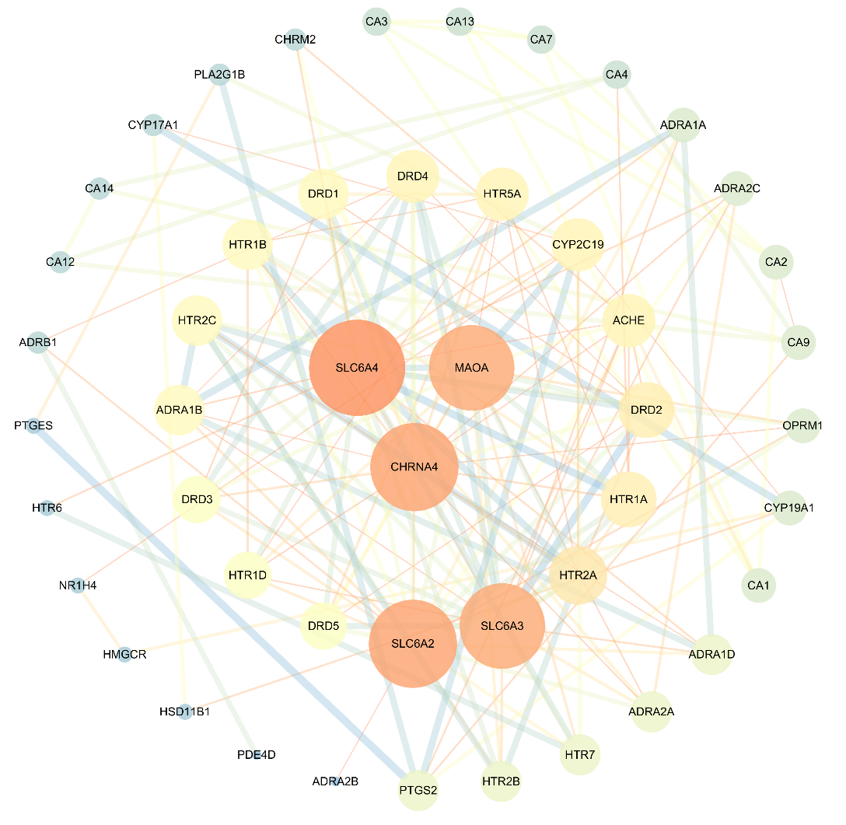
Fig. 6 PPI of the intersection targets. The size of the node represents the node degree of the target protein in the network. SLC6A4, Neuronal acetylcholine receptor subunit α-4; CHRNA4, Neuronal acetylcholine receptor subunit α-4; MAOA, Amine oxidase A; SLC6A2, Sodium-dependent noradrenaline transporter; SLC6A3, Sodium-dependent dopamine transporter; HTR2A, 5-hydroxytryptamine receptor 2A; HTR1A, 5-hydroxytryptamine receptor 1A; DRD2, D(2) dopamine receptor; ACHE, Acetylcholinesterase; CYP19A1, Aromatase; HTR5A, 5-hydroxytryptamine receptor 5A; DRD4, D(4) dopamine receptor; DRD1, D(1A) dopamine receptor; HTR1B, 5-hydroxytryptamine receptor 1B ; HTR2C, 5-hydroxytryptamine receptor 2C ; ADRA1B, Α-1B adrenergic receptor; DRD3, D(3) dopamine receptor; HTR1D, 5-hydroxytryptamine receptor 1D; DRD5, D(1B) dopamine receptor; PTGS2, Prostaglandin G/H synthase 2; HTR2B, 5-hydroxytryptamine receptor 2B; HTR7, 5-hydroxytryptamine receptor 7; ADRA2A, Α-2A adrenergic receptor; ADRA1D, Α-1D adrenergic receptor ; CA1, Carbonic anhydrase1; CYP19A1, Aromatase; OPRM1, Mu-type opioid receptor; CA9, Carbonic anhydrase 9; CA2, Carbonic anhydrase 2; ADRA2C, Α-2C adrenergic receptor; ADRA1A, Α-1A adrenergic receptor; CA4, Carbonic anhydrase 4; CA7, Carbonic anhydrase 7; CA13, Carbonic anhydrase 13; CA3, Carbonic anhydrase 3; CHRM2, Muscarinic acetylcholine receptor M2; PLA2G1B, Phospholipase A2; CYP17A1, Steroid 17-α-hydroxylase/17, 20 lyase; CA14, Carbonic anhydrase 14; CA12, Carbonic anhydrase 12; ADRB1, Beta-1 adrenergic receptor; PTGES, Prostaglandin E synthase; HTR6, 5-hydroxytryptamine receptor6; NR1H4, Bile acid receptor; HMGCR, 3-hydroxy-3-methylglutaryl-coenzyme A reductase; HSD11B1, Corticosteroid 11-beta-dehydrogenase isozyme 1; PDE4D, cAMP-specific 3',5'-cyclic phosphodiesterase 4D; ADRA2B, Α-2B adrenergic receptor. PPI network diagram was constructed via the Cytoscape platform.

References
Berman, H. M., J. Westbrook, Z. Feng, et al., 1999. The Protein Data Bank. Nucleic Acids Research. 28, 235-242.

Bruijnzeel, A. W., P. Knight, S. Panunzio, et al., 2019. Effects in rats of adolescent exposure to cannabis smoke or THC on emotional behavior and cognitive function in adulthood. Psychopharmacology. 236, 2773-2784. https://doi.org/10.1007/s00213-019-05255-7

Bruijnzeel, A. W., X. L. Qi, L. V. Guzhva, et al., 2016. Behavioral Characterization of the Effects of Cannabis Smoke and Anandamide in Rats. Plos One. 11, https://doi.org/10.1371/journal.pone.0153327

Consortium, U. P., 2018. UniProt: a worldwide hub of protein knowledge. Nucleic acids research.

Daina, A., O. Michielin and V. Zoete, 2019. SwissTargetPrediction: updated data and new features for efficient prediction of protein targets of small molecules. Nucleic Acids Res. 47, W357-w364. https://doi.org/10.1093/nar/gkz382

Delano, W. L., 2002. PyMOL: An Open-Source Molecular Graphics Tool.

Liebsch, G., A. Montkowski, F. Holsboer, et al., 1998. Behavioural profiles of two Wistar rat lines selectively bred for high or low anxiety-related behaviour. 94, 0-310.

Liu, Y. L., B. H. Hou, Y. S. Zhang, et al., 2018. Anticonvulsant agent DPP4 inhibitor sitagliptin downregulates CXCR3/RAGE pathway on seizure models. Experimental Neurology. 307, 90-98.

Morris, G., R. Huey, W. Lindstrom, et al., 2009. AutoDock4 and AutoDockTools4: Automated docking with selective receptor flexibility. Journal of Computational Chemistry. 30,

Piero, J., B. A`, N. Queralt-Rosinach , et al., 2016. DisGeNET: A comprehensive platform integrating information on human disease-associated genes and variants. Nucleic Acids Research. 45,

Porsalt, R. D., 1977. Behavioral despair in mice: a primary screening test for antidepressants. Arch Int Pharmacodyn. 229,

Qi, X., L. Guzhva, Z. Yang, et al., 2016. Overexpression of CRF in the BNST diminishes dysphoria but not anxiety-like behavior in nicotine withdrawing rats. European Neuropsychopharmacology. 26, 1378-1389.

Safran, M., I. Dalah, J. Alex, et al., 2013. Database update GeneCards Version 3: the human gene integrator.

Shannon, P., A. Markiel, O. Ozier, et al., 2003. Cytoscape: a software environment for integrated models of biomolecular interaction networks. Genome Res. 13, 2498-2504. https://doi.org/10.1101/gr.1239303

Steru, L., R. Chermat, B. Thierry, et al., 1985. The tail suspension test: a new method for screening antidepressants in mice. Psychopharmacology (Berl). 85, 367-370. https://doi.org/10.1007/bf00428203

Szklarczyk, D., A. L. Gable, D. Lyon, et al., 2019. STRING v11: protein-protein association networks with increased coverage, supporting functional discovery in genome-wide experimental datasets. Nucleic Acids Res. 47, D607-d613. https://doi.org/10.1093/nar/gky1131

Tan, S. J., S. Xue, A. Behnood-Rod, et al., 2019. Sex differences in the reward deficit and somatic signs associated with precipitated nicotine withdrawal in rats. Neuropharmacology. 160, https://doi.org/10.1016/j.neuropharm.2019.107756

Wei, W., S. Li, L. Cheng, et al., 2021. Comprehensive characterization of the chemical constituents in Yiganmingmu oral liquid and the absorbed prototypes in cynomolgus monkey plasma after oral administration by UPLC-Q-TOF-MS based on the self built components database. Chinese medicine. 16, 35. https://doi.org/10.1186/s13020-021-00443-0

