APPENDIX
Changing Worlds (US): Psychological responses to the climate crisis in young people and their agency to build the world they hope to see

A. Description of the data collection and quality assurance process

The study focuses on a subset of data collected as part of a broader survey on the psychological impacts of climate change and COVID-19, which also included questions on participation in pro-environmental behaviours, and various forms of activism. This current study focuses only on climate change experiences. For the specific aims and objectives, refer to Section 2.

The data were collected between November 2021-Jan 2022. Participants were recruited through the Qualtrics panel service. To be eligible for the study, participants had to be between 16-24 years old, and residents of the US, with sufficient English literacy. Qualtrics selected panel members to mirror ethnicity, gender, and regional population distributions according to the US census with one deviation, namely that we over-sampled explicitly from a number of regions that have been subject to recent climate-related impacts (e.g. wildfires, droughts, floods). We identified such regions at the county level as reported in the FEMA National Risk Index for Natural Hazards, National Lung Association State of the Air Report, and CDC/ATSDR Social Vulnerability Index. We sampled from a total of 620 different counties, with on average N=4 per county (N=80 could not be established)

Data
The Qualtrics Panel service returned 2883 “Good Completes”. The full set of data (as available in the Qualtrics survey interface) contains > 6000 entries. Qualtrics has marked each respondent with an embedded data called "gc" which identifies whether the response is s valid one:
- Those with a gc value equal to 1 designate the Good Completes.
- Those with a gc value equal to 2 are Screen Out responses.
- Those with a gc value equal to 3 are Over Quota responses which are complete responses that came in after the Total sample size quota was filled.
- Those with a gc value equal to 4 are those that have failed a quality check.
- Those that don't have a gc value are either responses that were gathered previously, or responses in progress that never finished the survey on their own

Inclusion and exclusion criteria
- A large number of missing values for a given participant (>50% non-responses)
- Response behaviour observed as “straight-lining” on at least half (5 or more) of the specified multi-item scales in the survey. This was taken as an indicator of a potentially dishonest or poor-quality response.
- Inconsistent responding: giving incongruent responses on two similar items in the survey; the items in question were selected from the “Trust in Government Scale” (results of this scale are not being reported in this paper). The items were “In relation to climate change I believe that my government is / other governments can be trusted” and “In relation to climate change I believe that my government is / other governments are lying about the effectiveness of the actions they are taking”. Because the two statements are incompatible, incongruent responses were taken as an indicator of a potentially dishonest or poor quality response.
- Speeding: defined as responding in less than 1/3 of the median time.

Each categorical exclusion variable was coded 1 when the respondent should be included (they met the quality criterion) and 0 when they failed the quality criterion. Participants were only excluded if they failed at least 2 criteria.
We identified N=49, or 1.7% of the total sample of “Good Completes” who failed our additional quality control checks. After screening out these respondents, the final sample is N=2834. This allows for individual missing values on certain variables, and the sample size was determined for each analysis, i.e. on a pair-wise rather than list-wise basis.

Measures included in the survey
As noted earlier, this project focuses on the psychological responses to climate change. The full survey contains additional questions; for the full survey, see https://osf.io/h237d/. To address the aims and objectives, we focused on the following questions and scales:

Mental health and subjective wellbeing
- GAD-7 total score: The GAD-7 is a brief measure for symptoms of anxiety, based on the generalised anxiety disorder diagnostic criteria described in the Diagnostic and Statistical Manual of Mental Disorders (DSM) [7 items; scale 0-3; total score: 0-21].
- K10 total score: The Kessler Psychological Distress Scale (K10) is a measure of psychological distress based on 10 questions about emotional states, used as a screen to identify levels of distress [10 items; scale 1-5; total score: 10-50].
- Current mental health diagnosis/whether the person is receiving treatment for a mental health condition [YES/NO/Undisclosed]
- Previous mental health diagnosis/whether the person has in the past received treatment for a mental health condition [YES/NO/Undisclosed]
- Overall life satisfaction [Single item scale: 0-10]

Experiences with and perceptions of climate change
  - Personal direct experiences with climate change impacts [YES/NO]
  - Direct experiences with climate change impacts in immediate circle (loved ones) [YES/NO]
  - List of specific climate impacts, e.g. flooding, droughts, wildfires, … [YES/NO]
  - Overall perceived extent of negative impacts on the respondent’s life [Single item scale: 1-5]
  - List of most important negative impacts [Select top 3]
  - Overall perceived extent of positive impacts on the respondent’s life [Single item scale: 1-5]
  - List of most important positive impacts [Select top 3]
  - Hogg Eco-anxiety Scale (HEAS-13) score: A multidimensional measure of eco-anxiety [13 items, scale 0-3; total score: 0-39; sub-scale scores for “affective symptoms”, “rumination”, “behavioural symptoms” and “anxiety about personal impact”
  - Interference with daily life: Extent to which worries about climate change affect daily functioning [Single item scale 0-5]
  - Reser’s (2012) climate distress scale: measures worry and concern over climate change [8 items; scale 0-4; total score: 0-32]
  - Self-reported emotions in relation to climate change [21 emotions; scale: 0-3; no total score]
  - Perceptions of political/government response to climate change [9 items; YES/NO/Undisclosed; total score: 0-9]
  - Whether worry/concern about climate change has changed since the pandemic [much more/a little more/the same/ a little less/much less]

Climate agency and pro-environmental behaviour
- Frequency of individual PEB/actions taken in person life [Single item scale 1-5]
- Commitment/behavioural intention towards individual PEB [YES/NO/MAYBE]
- Frequency of collective PEB/actions taken in social contexts [Single item scale 1-5]
- Commitment/behavioural intention towards collective PEB [YES/NO/MAYBE]
- Engagement in climate activism [Single item scale 1-5]
- Commitment/behavioural intention towards climate activism [YES/NO/MAYBE]
- Engagement in other forms of activism [Single item scale 1-5]
- Commitment/behavioural intention towards other forms of activism [YES/NO/MAYBE]
- Climate agency scale [9 items; scale 0-4; total score: 0-36; item scores can be transformed to between -2 and 2 for a total score of -18 to 18 with negative scores indicating an average lack of agency and positive scores a positive sense of agency]

Coping with climate change
  - Psychological Adaptation to Climate Change Scale [9 items; scale 1-6; total score 9-54]
  - “Learning to live with climate change” / Meaning-focused coping [5 items; scale 1-5; total score 5-25]
  - Economic/political System Adaptation [2 items; scale 1-6; total score 2-12]

Future thinking / planning for the future
  - Planning for the future in relation to climate change [5 items; YES/NO/MAYBE/Undisclosed; no total score]
    - Educating oneself more on climate change
    - Saving money for the future
    - Visit places before they change/disappear
    - Having children
    - Making significant lifestyle changes

  - Worry regarding 8 different factors that might affect personal future [8 items; scale 0-5; no total score]
    - Climate change
    - Financial situation
    - Work or career
    - COVID-19
    - School or studies
    - Personal relationships
    - Political issues and events
    - The economic situation

Demographic characteristics
  - Age [continuous variable]
  - Gender [categorical variable]
  - LGBTQ+ identity [categorical variable]
  - Geographic location in the US [categorical variable; transformed to urban/rural classification]
  - Ethnicity/cultural background [categorical variable]
  - Occupational status [categorical variable]
  - Level of education [categorical variable]
  - Family Affluence Scale: [scale score; 6 items; total score: 0-13]

B. Demographic characteristics of the sample

Age
 |  | Frequency | Percent | Valid Percent | Cumulative Percent
Valid | 16 | 189 | 6.7 | 6.8 | 6.8
Valid | 17 | 220 | 7.8 | 7.9 | 14.7
Valid | 18 | 402 | 14.2 | 14.4 | 29.1
Valid | 19 | 307 | 10.8 | 11.0 | 40.1
Valid | 20 | 274 | 9.7 | 9.8 | 49.9
Valid | 21 | 394 | 13.9 | 14.1 | 64.0
Valid | 22 | 315 | 11.1 | 11.3 | 75.3
Valid | 23 | 267 | 9.4 | 9.6 | 84.9
Valid | 24 | 422 | 14.9 | 15.1 | 100.0
Valid | Total | 2790 | 98.4 | 100.0
Missing | 999 | 44 | 1.6
Total |  | 2834 | 100.0

Ethnicity / cultural background
 |  | Frequency | Percent | Valid Percent | Cumulative Percent
Valid | White (non-hispanic) | 1355 | 47.8 | 48.4 | 48.4
Valid | Black / African American | 402 | 14.2 | 14.4 | 62.8
Valid | Native American /  Native Alaskan | 42 | 1.5 | 1.5 | 64.3
Valid | Asian | 184 | 6.5 | 6.6 | 70.8
Valid | Hispanic / Latinx | 585 | 20.6 | 20.9 | 91.7
Valid | Native Hawaiian /  Other Pacific Islander | 9 | .3 | .3 | 92.1
Valid | Other (self-specified) | 29 | 1.0 | 1.0 | 93.1
Valid | Mixed / multiple ethnicities | 193 | 6.8 | 6.9 | 100.0
Valid | Total | 2799 | 98.8 | 100.0
Missing | 999 | 35 | 1.2
Total |  | 2834 | 100.0

Highest level of education achieved (to date)
 |  |  | Frequency |  | Percent |  | Valid Percent |  | Cumulative Percent
Valid | Some high school /did not complete (yet) |  | 557 |  | 19.7 |  | 19.9 |  | 19.9
Valid | High school diploma or equivalent (e.g. GED) |  | 819 |  | 28.9 |  | 29.3 |  | 49.2
Valid | Some college (did not complete/no degree yet) |  | 709 |  | 25.0 |  | 25.3 |  | 74.5
Valid | Associate degree (e.g. AA, AS) |  | 259 |  | 9.1 |  | 9.3 |  | 83.8
Valid | Bachelor’s degree (e.g. BA, BS) |  | 353 |  | 12.5 |  | 12.6 |  | 96.4
Valid | Master’s degree (e.g. MA, MS, MEd) |  | 77 |  | 2.7 |  | 2.8 |  | 99.1
Valid | Professional degree (e.g. MD, DDS, DVM) |  | 19 |  | .7 |  | .7 |  | 99.8
Valid | Doctor of Philosophy (PhD) |  | 5 |  | .2 |  | .2 |  | 100.0
Valid | Total |  | 2798 |  | 98.7 |  | 100.0
Missing | 999 |  | 36 |  | 1.3
Total |  |  | 2834 |  | 100.0
Family Affluence Scale
 |  |  |  |  |  | Statistic |  | Std. Error
Total FAS score |  | Mean |  |  |  | 7.1087 |  | .04751
 |  | 95% Confidence Interval for Mean |  | Lower Bound |  | 7.0156
 |  |  |  | Upper Bound |  | 7.2019
 |  | 5% Trimmed Mean |  |  |  | 7.1033
 |  | Median |  |  |  | 7.0000
 |  | Variance |  |  |  | 6.312
 |  | Std. Deviation |  |  |  | 2.51229
 |  | Minimum |  |  |  | .00
 |  | Maximum |  |  |  | 13.00
 |  | Range |  |  |  | 13.00
 |  | Interquartile Range |  |  |  | 4.00
 |  | Skewness |  |  |  | -.005 |  | .046
 |  | Kurtosis |  |  |  | -.244 |  | .093

Urban/rural classification based on 2010 Census Tract Rural-Urban Commuting Area (RUCA)
 |  | Frequency | Percent | Valid Percent | Cumulative Percent
Valid | Metropolitan area core: primary flow within an urbanized area (UA) | 2307 | 81.4 | 83.6 | 83.6
Valid | Metropolitan area high commuting: primary flow 30% or more to a UA | 118 | 4.2 | 4.3 | 87.9
Valid | Metropolitan area low commuting: primary flow 10% to 30% to a UA | 9 | .3 | .3 | 88.3
Valid | Micropolitan area core: primary flow within an Urban Cluster of 10,000 to 49,999 (large UC) | 154 | 5.4 | 5.6 | 93.8
Valid | Micropolitan high commuting: primary flow 30% or more to a large UC | 30 | 1.1 | 1.1 | 94.9
Valid | Micropolitan low commuting: primary flow 10% to 30% to a large UC | 4 | .1 | .1 | 95.1
Valid | Small town core: primary flow within an Urban Cluster of 2,500 to 9,999 (small UC) | 83 | 2.9 | 3.0 | 98.1
Valid | Small town high commuting: primary flow 30% or more to a small UC | 10 | .4 | .4 | 98.4
Valid | Small town low commuting: primary flow 10% to 30% to a small UC | 1 | .0 | .0 | 98.5
Valid | Rural areas: primary flow to a tract outside a UA or UC | 42 | 1.5 | 1.5 | 100.0
Valid | Total | 2758 | 97.3 | 100.0
Missing | 999 | 76 | 2.7
Total |  | 2834 | 100.0

Self-reported mental health history (diagnosed/in treatment for mental health condition, in the past and/or currently)
 |  |  |  | Frequency | Percent |  | Valid Percent |  | Cumulative Percent
Valid | None reported |  |  | 1498 | 52.9 |  | 56.7 |  | 56.7
Valid | Past diagnosis/treatment (not current) |  |  | 256 | 9.0 |  | 9.7 |  | 66.4
Valid | New diagnosis/treatment (no history) |  |  | 140 | 4.9 |  | 5.3 |  | 71.7
Valid | Ongoing mental health condition |  |  | 747 | 26.4 |  | 28.3 |  | 100.0
Valid | Total |  |  | 2641 | 93.2 |  | 100.0
Missing | 999 |  |  | 193 | 6.8
Total |  |  |  | 2834 | 100.0
Mental Health * Gender cross tabulation
 |  |  | Self-reported mental health status |  |  |  |  |  |  | Total
 |  |  | No reported history of mental ill health |  |  | History of mental ill health (not current) |  | Currently experiencing mental ill health
Gender |  | Men | 732 |  |  | 105 |  | 315 |  | 1152
 |  | Women and minority genders | 733 |  |  | 147 |  | 563 |  | 1443
Total |  |  | 1465 |  |  | 252 |  | 878 |  | 2595

Chi-Square Tests for Mental Health * Gender
 | Value | df | Asymptotic Significance (2-sided)
Pearson Chi-Square | 44.984ª | 2 | <.001
Likelihood Ratio | 45.345 | 2 | <.001
Linear-by-Linear Association | 44.823 | 1 | <.001
N of Valid Cases | 2595
Mental health * Gender stacked bar graph
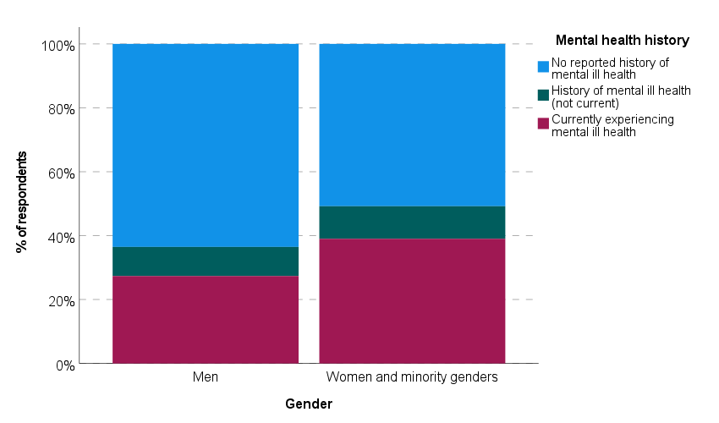

Mental Health * LGBTQI+ cross tabulation
 |  | Self-reported mental health status |  |  | Total
 |  | No reported history of mental ill health | History of mental ill health (not current) | Currently experiencing mental ill health | Total
Identifies as LGBTQI+ | Yes | 259 | 74 | 383 | 716
Identifies as LGBTQI+ | No | 1149 | 159 | 452 | 1760
Total |  | 1408 | 233 | 835 | 2476

Mental Health * Gender Chi-Square Tests
 | Value | df | Asymptotic Significance (2-sided)
Pearson Chi-Square | 193.479ª | 2 | <.001
Likelihood Ratio | 190.918 | 2 | <.001
Linear-by-Linear Association | 193.387 | 1 | <.001
N of Valid Cases | 2476
Mental Health * LGBTQI+ stacked bar graph 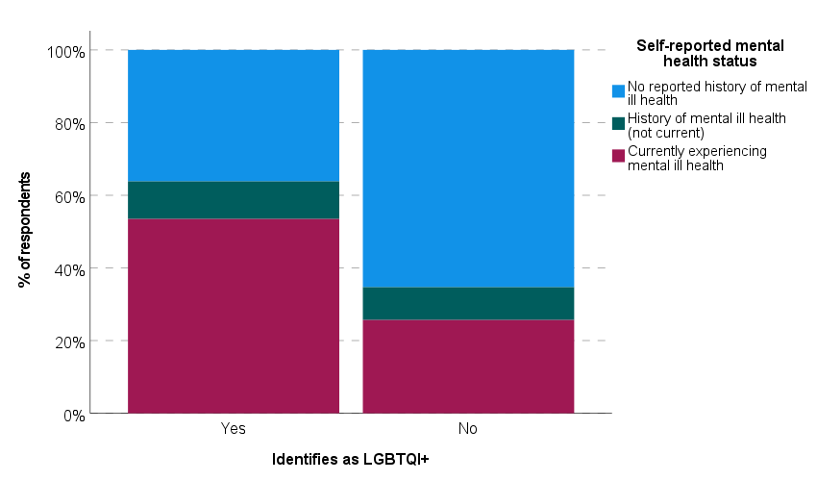
C. Descriptive data for the outcome variables

Climate distress scale

Reliability Statistics
Cronbach's Alpha | Cronbach's Alpha Based on Standardized Items | N of Items
.895 | .895 | 8

Item statistics | Mean | Std. Deviation | N
I feel distressed each time I see or read media coverage of the impacts and consequences of climate change | 2.62 | 1.193 | 2798
At times I find myself thinking and worrying about what the world will really be like in the future because of climate change | 2.84 | 1.217 | 2798
I experience some guilt over the fact that my lifestyle and behavior (e.g. consumption patterns) is in part responsible for the unfolding impacts of climate change | 2.61 | 1.234 | 2798
It upsets me that there seems to be so little that I can do to address environmental problems like climate change | 2.83 | 1.278 | 2798
At times I feel some personal responsibility for the problems and unfolding impacts of climate change | 2.65 | 1.276 | 2798
The threat of climate change is affecting my quality of life | 2.69 | 1.265 | 2798
The threat of climate change is affecting the way I think about environmental quality more generally | 2.76 | 1.244 | 2798
I feel some sense of loss because of climate change impacts that are becoming apparent in my local area | 2.63 | 1.286 | 2798

Hogg Eco-anxiety Scale

Reliability Statistics
Cronbach's Alpha | Cronbach's Alpha Based on Standardized Items | N of Items
.946 | .947 | 13

Item Statistics |  |  |  |  | Mean |  | Std. Deviation |  | N
Feeling anxious, nervous or on edge |  |  |  |  | .98 |  | .921 |  | 2798
Not being able to stop or control worrying |  |  |  |  | 1.02 |  | 1.012 |  | 2798
Worrying too much |  |  |  |  | 1.04 |  | 1.011 |  | 2798
Feeling afraid |  |  |  |  | 1.01 |  | .988 |  | 2798
Unable to stop thinking about future climate change and other global environmental problems |  |  |  |  | .97 |  | .963 |  | 2798
Unable to stop thinking about past events related to climate change |  |  |  |  | .95 |  | .979 |  | 2798
Unable to stop thinking about losses to the environment |  |  |  |  | 1.02 |  | .998 |  | 2798
Difficulty sleeping |  |  |  |  | 1.05 |  | 1.072 |  | 2798
Difficulty enjoying social situations with family and friends |  |  |  |  | .93 |  | 1.009 |  | 2798
Difficulty working and/or studying |  |  |  |  | 1.00 |  | 1.045 |  | 2798
Feeling anxious about the impact of your personal behaviors on the earth |  |  |  |  | 1.03 |  | .992 |  | 2798
Feeling anxious about your personal responsibility to help address environmental problems |  |  |  |  | .98 |  | .977 |  | 2798
Feeling anxious that your personal behaviors will do little to help fix the problem |  |  |  |  | 1.07 |  | 1.025 |  | 2798
Hogg Eco-anxiety Subscale Descriptive Statistics
 | N | Minimum | Maximum | Mean |  | Std. Deviation
Hogg Eco-anxiety - Affective mean item score | 2824 | .00 | 3.00 | 1.0134 |  | .83544
Hogg Eco-anxiety - Rumination mean item score | 2824 | .00 | 3.00 | .9765 |  | .84933
Hogg Eco-anxiety - Behavioural mean item score | 2824 | .00 | 3.00 | .9950 |  | .90762
Hogg Eco-anxiety - Impact mean item score | 2824 | .00 | 3.00 | 1.0284 |  | .87983
Valid N (listwise) | 2824

Tests of Within-Subjects Effects: Comparison between Hogg Eco-anxiety subscale scores
Measure: Mean item score
Note: Interpret Greenhouse-Geisser corrected tests as Mauchly’s test of sphericity was significant, p<.001
Source |  |  |  | Type III Sum of Squares |  | df |  | Mean Square |  | F | Sig. |  | Partial Eta Squared
Subscale |  | Sphericity Assumed |  | 4.289 |  | 3 |  | 1.430 |  | 7.431 | <.001 |  | .003
 |  | Greenhouse-Geisser |  | 4.289 |  | 2.831 |  | 1.515 |  | 7.431 | <.001 |  | .003
 |  | Huynh-Feldt |  | 4.289 |  | 2.834 |  | 1.513 |  | 7.431 | <.001 |  | .003
 |  | Lower-bound |  | 4.289 |  | 1.000 |  | 4.289 |  | 7.431 | .006 |  | .003
Error(Subscale) |  | Sphericity Assumed |  | 1629.383 |  | 8469 |  | .192
 |  | Greenhouse-Geisser |  | 1629.383 |  | 7992.419 |  | .204
 |  | Huynh-Feldt |  | 1629.383 |  | 8001.274 |  | .204
 |  | Lower-bound |  | 1629.383 |  | 2823.000 |  | .577
Pairwise Comparisons
Measure: Mean item score (subscales: 1=affective, 2=rumination, 3=behavioural, 4=impact)

(I) Subscale | (J) Subscale |  | Mean Difference (I-J) |  | Std. Error |  | Sig.^{b} |  | 95% Confidence Interval for Difference
 |  |  |  |  |  |  |  |  | Lower Bound |  |  | Upper Bound
1 | 2 |  | .037* |  | .011 |  | .004 |  | .008 |  |  | .066
1 | 3 |  | .018 |  | .012 |  | .695 |  | -.013 |  |  | .049
1 | 4 |  | -.015 |  | .011 |  | 1.000 |  | -.044 |  |  | .014
2 | 1 |  | -.037* |  | .011 |  | .004 |  | -.066 |  |  | -.008
2 | 3 |  | -.018 |  | .013 |  | .993 |  | -.054 |  |  | .017
2 | 4 |  | -.052* |  | .011 |  | <.001 |  | -.080 |  |  | -.023
3 | 1 |  | -.018 |  | .012 |  | .695 |  | -.049 |  |  | .013
3 | 2 |  | .018 |  | .013 |  | .993 |  | -.017 |  |  | .054
3 | 4 |  | -.033* |  | .012 |  | .037 |  | -.066 |  |  | -.001
4 | 1 |  | .015 |  | .011 |  | 1.000 |  | -.014 |  |  | .044
4 | 2 |  | .052* |  | .011 |  | <.001 |  | .023 |  |  | .080
4 | 3 |  | .033* |  | .012 |  | .037 |  | .001 |  |  | .066
Based on estimated marginal means
*. The mean difference is significant at the .05 level.
b. Adjustment for multiple comparisons: Bonferroni.

Climate change-related emotions
Note: pairwise deletion of cases; sorted high to low values; colours match Figure 1 in the main manuscript.

Climate emotion | N | Minimum | Maximum | Median | Mean | Std. Deviation
Concerned | 2817 | 0 | 3 | 2 | 1.55 | 1.054
Interested | 2819 | 0 | 3 | 1 | 1.46 | 1.008
Disappointed | 2819 | 0 | 3 | 1 | 1.40 | 1.062
Frustrated | 2816 | 0 | 3 | 1 | 1.36 | 1.075
Sad | 2821 | 0 | 3 | 1 | 1.34 | 1.054
Anxious | 2816 | 0 | 3 | 1 | 1.30 | 1.062
Angry | 2816 | 0 | 3 | 1 | 1.29 | 1.074
Afraid | 2816 | 0 | 3 | 1 | 1.26 | 1.046
Helpless | 2818 | 0 | 3 | 1 | 1.25 | 1.072
Outraged | 2818 | 0 | 3 | 1 | 1.23 | 1.083
Disgusted | 2817 | 0 | 3 | 1 | 1.22 | 1.067
Exhausted | 2817 | 0 | 3 | 1 | 1.21 | 1.056
Hopeful | 2818 | 0 | 3 | 1 | 1.18 | .981
Engaged | 2817 | 0 | 3 | 1 | 1.16 | .989
Ashamed | 2816 | 0 | 3 | 1 | 1.15 | 1.054
Guilty | 2820 | 0 | 3 | 1 | 1.13 | 1.024
Isolated/lonely | 2817 | 0 | 3 | 1 | 1.07 | 1.040
Courageous | 2816 | 0 | 3 | 1 | 1.04 | .992
Disconnected/apathetic | 2817 | 0 | 3 | 1 | 1.01 | 1.017
Betrayed | 2819 | 0 | 3 | 1 | 1.00 | 1.036
Cynical | 2819 | 0 | 3 | 1 | .97 | 1.024
Valid N (listwise) | 2776

Climate Change Agency Scale

Reliability Statistics
Cronbach's Alpha | Cronbach's Alpha Based on Standardized Items | N of Items
.599 | .622 | 10

Item statistics | Mean | Std. Deviation | N
I am aware of actions I can take… | .67 | .994 | 2793
I am capable of making behavioural change… | .50 | 1.027 | 2793
My actions will make a difference… | .41 | 1.080 | 2793
My actions positively affect my thinking/feeling… | .50 | 1.055 | 2793
My actions negatively affect my thinking/feeling…* | -.18 | 1.137 | 2793
My actions positively influence others… | .33 | 1.057 | 2793
People have little control…* | -.07 | 1.184 | 2793
Climate change is inevitable, actions don’t matter * | -.04 | 1.165 | 2793
I feel a sense of urgency to change my behaviour… | .37 | 1.117 | 2793
I am aware of actions I can take… | .38 | 1.094 | 2793
Note: Items marked with * were reverse coded prior to internal consistency analysis

Median and IQR for the individual agency items.
The 5-point Likert scale was scored as -2 for “completely disagree” to 2 for “completely agree”, except for items 5, 7 and 8 which were phrased negatively and thus reverse-scored. Thus, positive scores indicate high agency and negative scores low agency.

Agency domain | Median score | Interpretation | IQR
Awareness | 1 | + | 0 : 1
Capability | 1 | + | 0 : 1
Efficacy | 0 | ~ | 0 : 1
Actions positively affect thoughts | 0 | ~ | 0 : 1
Actions negatively affect thoughts * | 0 | ~ | -1 : 0
Actions influence others | 0 | ~ | 0 : 1
Lack of control * | 0 | ~ | -1 : 1
Inevitability/futility of actions * | 0 | ~ | -1 : 1
Urgency | 0 | ~ | 0 : 1
Responsibility | 0 | ~ | 0 : 1

Box plots for climate agency dimensions (10 items).
The bar indicates the median, boxes the Interquartile Range (IQR) and whiskers the minimum and maximum observed scores (not including extreme outliers); asterisks indicate extreme outliers.

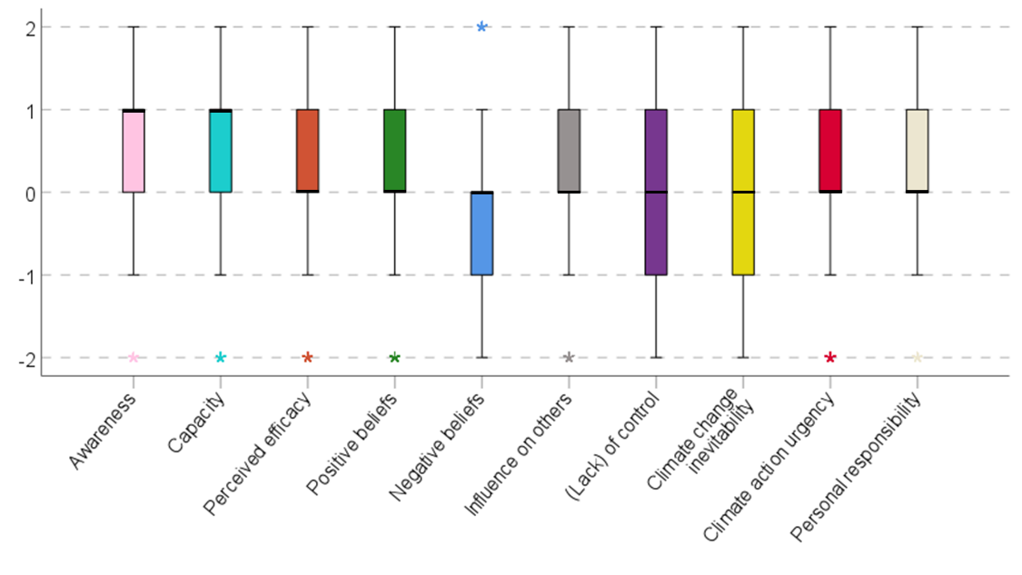

Psychological Adaptation Scale

Reliability Statistics
Cronbach's Alpha | Cronbach's Alpha Based on Standardized Items | N of Items
.858 | .858 | 9

Item Statistics | Mean | Std. Deviation | N
I have changed the way I think about the seriousness of environmental problems | 3.47 | 1.415 | 2775
Increasingly I find myself less likely to attend to media reports about climate change | 3.36 | 1.374 | 2775
I have seriously thought about alternative places to live | 3.37 | 1.457 | 2775
Climate change has forced me to change the how I think about our lifestyle and natural environment | 3.69 | 1.467 | 2775
I have often discussed climate change with others | 3.71 | 1.440 | 2775
I tend to think differently these days about sustainable consumption | 3.71 | 1.409 | 2775
Media images of climate change consequences have changed my appreciation of how soon we will experience the impacts | 3.73 | 1.400 | 2775
I have thought more about how to reduce my (family's) carbon footprint | 3.78 | 1.384 | 2775
I am increasingly aware of how my daily activities affect climate change | 3.82 | 1.374 | 2775

Meaning-focused Coping scale
For calculation of total scale scores, respondents who affirmed (strongly) that “the question did not apply to them as they had not learned to process their thoughts and feelings around climate change” were excluded.

Reliability Statistics
Cronbach's Alpha | Cronbach's Alpha Based on Standardized Items | N of Items
.808 | .808 | 4

Item Statistics | Mean | Std. Deviation | N
Helped me learn to deal better with uncertainty | 2.74 | 1.079 | 2471
Helped me become a stronger person | 3.03 | 1.150 | 2471
Makes me more willing to help others | 3.18 | 1.130 | 2471
Helped me develop a deeper sense of purpose in my life | 2.92 | 1.192 | 2471

Correlation table for all outcome variables: Pearson correlations (pairwise inclusion, N given for each bivariate correlation).

 | 1. Hogg Eco-anxiety Scale | 1a. Affective subscale | 1b. Rumination Subscale | 1c. Behavioural Subscale | 1d. Impact Subscale | 2. Climate Distress Scale | 3. Interference Item | 4. Climate Agency Scale | 5. Psychological Adaptation Scale
1a. Affective subscale | .923**
N | 2824
1b. Rumination Subscale | .889** | .765**
N | 2824 | 2824
1c. Behavioural Subscale | .877** | .747** | .677**
N | 2824 | 2824 | 2824
1d. Impact Subscale | .909** | .770** | .781** | .739**
N | 2824 | 2824 | 2824 | 2824
2. Climate Distress Scale | .565** | .528** | .503** | .487** | .512**
N | 2804 | 2804 | 2804 | 2804 | 2804
3. Interference Item | .571** | .533** | .536** | .431** | .555** | .462**
N | 2814 | 2814 | 2814 | 2814 | 2814 | 2794
4. Climate Agency Scale | 0.015 | 0.000 | .041* | -.059** | .080** | .042* | .201**
N | 2809 | 2809 | 2809 | 2809 | 2809 | 2789 | 2805
5. Psychological Adaptation Scale | .278** | .255** | .270** | .178** | .299** | .244** | .453** | .348**
N | 2792 | 2792 | 2792 | 2792 | 2792 | 2774 | 2789 | 2793
6. Meaning-focused Coping Scale | .335** | .311** | .326** | .255** | .314** | .312** | .389** | .376** | .484**
N | 2789 | 2789 | 2789 | 2789 | 2789 | 2770 | 2786 | 2790 | 2788

Note: *p<.01; **p<.01; ***p<.001
D. Direct experience of climate change impacts

Number of reported climate-related events

The perception of being directly impacted by climate change (yes/no) was significantly associated with the number of reported events the respondent had personally experienced, χ²(8)=428.27, p<.001. The list of events included floods, droughts, extreme temperatures, poor air quality/air pollution, wildfires, prolonged smoke exposure from wildfire, hurricanes/cyclones and significant local environmental change.

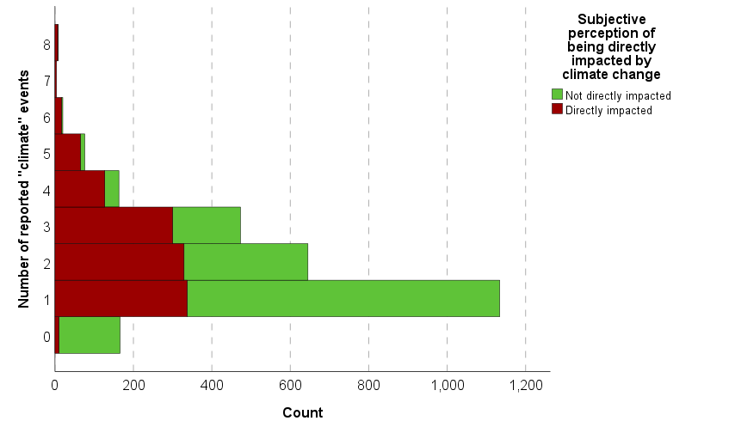

Experiencing any of the listed events (vs. not having experienced that event) was associated with the subjective perception of being impacted by climate change. We calculated φ as a measure of association between two nominal variables (0=present, 1=absent). The associations were all significant at p<.001, but the effects were small.

 | Hurricane/cyclone (0/1) | Wildfires (0/1) | Prolonged smoke exposure (0/1) | Floods (0/1) | Drought (0/1) | Extreme temperatures (0/1) | Air pollution (0/1) | Sign. environmental change (0/1)
Directly impacted or not (0/1) | .110 | .149 | .184 | .132 | .113 | .188 | .176 | .106

Differences in emotion ratings

 | Not directly  impacted |  | Directly  impacted
Emotion | N | Mean (SD) | N | Mean (SD) | Adjustedª Mean Difference (95% CI)
Concerned | 1,586 | 1.30 | 1,194 | 1.90 | 0.60 (0.52 , 0.67)***
Interested | 1,587 | 1.26 | 1,195 | 1.75 | .490 ( .415, .565)***
Disappointed | 1,588 | 1.16 | 1,194 | 1.726 | .5538 (.475, .632)***
Frustrated | 1,584 | 1.107 | 1,195 | 1.710 | .6158 (.5370, .694)***
Sad | 1,588 | 1.088 | 1,196 | 1.693 | .6021 (.524, .67992)***
Anxious | 1,587 | 1.036 | 1,192 | 1.667 | .6315 (.552, .7104)***
Angry | 1,585 | 1.015 | 1,196 | 1.655 | .6474 (.5689, .7260)***
Afraid | 1,586 | 1.0170 | 1,193 | 1.591 | .5819 (.5043, .6595)***
Helpless | 1,588 | 1.0113 | 1,193 | 1.575 | .563 (.4835, .64266)***
Outraged | 1,586 | .9590 | 1,195 | 1.595 | .6516 (.57175, .73163)***
Disgusted | 1,587 | .96786 | 1,193 | 1.5666 | .59782 (.5184, .6772)***
Exhausted | 1,587 | .9703 | 1,193 | 1.5255 | .5688 ( .4899, .6477)***
Hopeful | 1,588 | 1.0088 | 1,193 | 1.416 | .38966 (.31542, .4639)***
Engaged | 1,587 | .9382 | 1,193 | 1.4710 | .50297 (.4283, .57764)***
Ashamed | 1,587 | .92690 | 1,192 | 1.4588 | .5500 (.4709, .62914)***
Guilty | 1,588 | .8772 | 1,195 | 1.4669 | .60193 (.5258, .6780)***
Isolated/lonely | 1,586 | .8423 | 1,194 | 1.3760 | .5350 (.45707, 0.6130)***
Courageous | 1,586 | .86065 | 1,193 | 1.278 | .4127 (.338, .48729)***
Disconnected/apathetic | 1,588 | .8570 | 1,193 | 1.2179 | .3513 (.27407, .42867)***
Betrayed | 1,587 | .7504 | 1,195 | 1.3481 | .6069 (.529, .6848)***
Cynical | 1,588 | .73929 | 1,194 | 1.2730 | .54037 (.46396, .6167)***
ªLinear regression model is adjusted for age, sex, education, family affluence score (FAS), rural vs urban, and ethnicity. *** p<0.001

Differences in mental health and wellbeing indicators

In addition to the key outcomes, we also assessed whether those who had experienced climate impacts directly vs. those who had not differed on the GAD-7 (as an indicator of generalised anxiety) and self-reported overall life satisfaction. Generalised anxiety was higher among those directly impacted by climate change.

Group Statistics
 | Directly impacted? | N | Mean | Std. Deviation | Std. Error Mean
GAD-7 score | No | 1591 | 8.59 | 5.805 | .146
GAD-7 score | Yes | 1198 | 11.01 | 5.343 | .154
Life satisfaction score | No | 1587 | 6.01 | 2.491 | .063
Life satisfaction score | Yes | 1193 | 5.96 | 2.509 | .073

 |  | Levene's Test
 |  | F | Sig. | t | df | Significance |  | Mean Difference (SE) | 95% Confidence Interval of the Difference
 |  |  |  |  |  | One-Sided p | Two-Sided p |  | Lower | Upper | Effect size
GAD-7 | Equal variances assumed | 19.662 | <.001 | -11.257 | 2787 | <.001 | <.001 | -2.416 (.215) | -2.837 | -1.995
GAD-7 | Equal variances not assumed |  |  | -11.389 | 2677.757 | <.001 | <.001 | -2.416 (.212) | -2.832 | -2.000 | .53
Life satisfaction score | Equal variances assumed | .843 | .358 | .574 | 2778 | .283 | .566 | .055  (.096) | -.133 | .243 | .05
Life satisfaction score | Equal variances not assumed |  |  | .573 | 2557.356 | .283 | .567 | .055  (.096) | -.133 | .243

Interaction between direct climate change impacts and generalised anxiety on interference with daily functioning

We found that both the severity of generalised anxiety and direct experience with climate change impacts had an effect on perceived interference of climate change-related thoughts and feelings on daily functioning. Unlike the model which included self-reported mental health status (as opposed to the GAD-7 severity of anxiety categories), the interaction term was only marginally significant. This suggests that while a similar trend could be observed the effect of generalised anxiety is only slightly more pronounced in the context of direct climate change impacts.

Descriptive Statistics: Climate thoughts and feelings interfering with daily life
 | Severity of anxiety according to GAD7 | Mean | Std. Deviation | N
No direct climate impacts | Minimal anxiety | 1.80 | 1.498 | 439
No direct climate impacts | Mild anxiety | 2.12 | 1.355 | 463
No direct climate impacts | Moderate anxiety | 2.49 | 1.354 | 414
No direct climate impacts | Severe anxiety | 2.39 | 1.438 | 259
No direct climate impacts | Total | 2.17 | 1.435 | 1575
Direct climate impacts | Minimal anxiety | 2.29 | 1.437 | 141
Direct climate impacts | Mild anxiety | 2.92 | 1.254 | 318
Direct climate impacts | Moderate anxiety | 3.15 | 1.171 | 419
Direct climate impacts | Severe anxiety | 3.29 | 1.260 | 314
Direct climate impacts | Total | 3.02 | 1.285 | 1192
Total | Minimal anxiety | 1.92 | 1.497 | 580
Total | Mild anxiety | 2.44 | 1.371 | 781
Total | Moderate anxiety | 2.82 | 1.307 | 833
Total | Severe anxiety | 2.88 | 1.416 | 573
Total | Total | 2.54 | 1.435 | 2767

Tests of Between-Subjects Effects
Source | Type III Sum of Squares | df | Mean Square | F | Sig. | Partial Eta Squared
Corrected Model | 719.002ª | 7 | 102.715 | 56.898 | <.001 | .126
Intercept | 15758.861 | 1 | 15758.861 | 8729.524 | .000 | .760
Direct climate change impacts (yes vs no) | 307.179 | 1 | 307.179 | 170.160 | <.001 | .058
Severity of anxiety (minimal/mild/moderate/severe) | 210.459 | 3 | 70.153 | 38.861 | <.001 | .041
Interaction term | 12.319 | 3 | 4.106 | 2.275 | .078 | .002
Error | 4980.649 | 2759 | 1.805
Total | 23530.000 | 2767
Corrected Total | 5699.651 | 2766
a. R Squared = .126 (Adjusted R Squared = .124)

Univariate Tests
Have you been directly affected by climate change? |  | Sum of Squares | df | Mean Square | F | Sig. | Partial Eta Squared
No | Contrast | 117.423 | 3 | 39.141 | 21.682 | <.001 | .023
No | Error | 4980.649 | 2759 | 1.805
Yes | Contrast | 108.985 | 3 | 36.328 | 20.124 | <.001 | .021
Yes | Error | 4980.649 | 2759 | 1.805
Each F tests the simple effects of Severity of anxiety according to GAD7 within each level combination of the other effects shown. These tests are based on the linearly independent pairwise comparisons among the estimated marginal means.

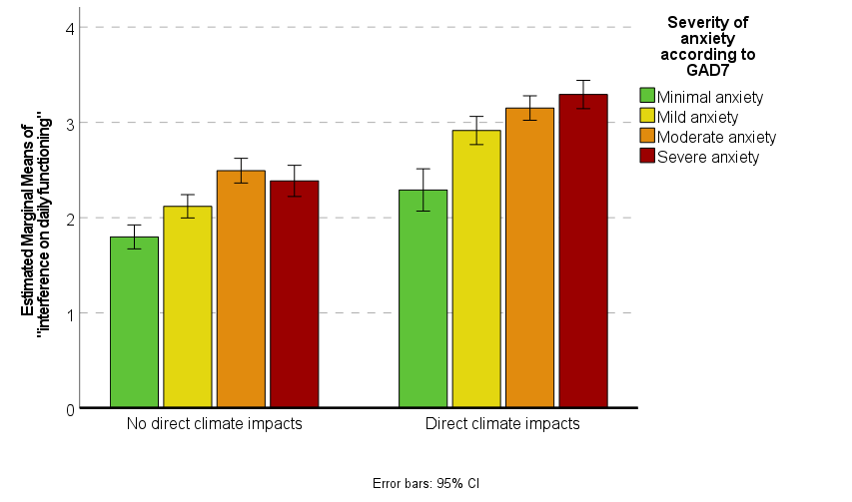
Differential impacts of specific climate-related experiences
We conducted between samples t-tests, comparing the scale scores for each of our key outcome variables for the group of respondents who had reported a specific climate-related experience vs those who had not reported experiencing this. The results are summarised in the table below, where *p<.05, **<.01, ***<.001 and colours indicate the effect size as small (green), moderate (orange) or large (red). Means and SD’s are provided on the next page.

Outcome | Cyclones/  hurricanes | Fires | Smoke exposure | Floods | Drought | Extreme temp | Air pollution | Environmental change
Hogg eco-anxiety scale |  | *** | *** | *** | *** | * | *** | **
Interference with daily life |  | *** | *** | *** | *** |  | *** | ***
Climate distress scale |  | *** | *** | *** | *** | *** | *** | ***
Agency scale | * |  | * |  |  | *** | *** | ***
Psychological adaptation scale |  |  | *** | * | * | *** | *** | ***
Meaning-focused coping scale |  | *** | *** | *** | *** | *** | *** | ***

Sample size (n), means (M) and standard deviation (SD) for the comparison of outcome variables between those who reported a specific climate-related impact and those who did not.

 |  | Hurricane/cyclone |  |  | Wildfires |  |  | Prolonged smoke exposure |  |  | Floods |  |  | Drought |  |  | Extreme temperatures |  |  | Air pollution |  |  | Significant changes to surrounding environment
 |  | N | M | SD | N | M | SD | N | M | SD | N | M | SD | N | M | SD | N | M | SD | N | M | SD | N | M | SD
Hogg Eco-anxiety Scale | No | 2150 | 13.24 | 10.02 | 2381 | 12.79 | 10.06 | 2135 | 12.52 | 10.07 | 2053 | 12.53 | 9.93 | 2184 | 12.76 | 9.98 | 1705 | 13.01 | 10.14 | 1821 | 12.89 | 10.05 | 2213 | 13.10 | 10.08
Hogg Eco-anxiety Scale | Yes | 575 | 13.86 | 10.39 | 344 | 17.38 | 9.42 | 590 | 16.45 | 9.58 | 672 | 15.94 | 10.19 | 541 | 15.82 | 10.19 | 1020 | 13.97 | 10.00 | 904 | 14.34 | 10.13 | 512 | 14.53 | 10.10
Climate thoughts and feelings interfering with daily life | No | 2136 | 2.58 | 1.42 | 2365 | 2.5 | 1.41 | 2121 | 2.50 | 1.42 | 2041 | 2.49 | 1.45 | 2169 | 2.52 | 1.43 | 1690 | 2.58 | 1.44 | 1807 | 2.50 | 1.46 | 2203 | 2.52 | 1.43
Climate thoughts and feelings interfering with daily life | Yes | 573 | 2.59 | 1.41 | 344 | 3.13 | 1.34 | 588 | 2.87 | 1.37 | 668 | 2.84 | 1.29 | 540 | 2.83 | 1.36 | 1019 | 2.57 | 1.38 | 902 | 2.73 | 1.32 | 506 | 2.84 | 1.35
Climate Distress Scale | No | 2144 | 21.69 | 7.51 | 2373 | 21.43 | 7.59 | 2126 | 21.24 | 7.55 | 2046 | 21.30 | 7.60 | 2175 | 21.33 | 7.44 | 1697 | 20.94 | 7.34 | 1813 | 21.00 | 7.44 | 2205 | 21.36 | 7.51
Climate Distress Scale | Yes | 571 | 22.24 | 7.65 | 342 | 24.4 | 6.64 | 589 | 23.85 | 7.16 | 669 | 23.34 | 7.16 | 540 | 23.73 | 7.65 | 1018 | 23.25 | 7.66 | 902 | 23.43 | 7.50 | 510 | 23.72 | 7.40
Climate Agency Scale | No | 2142 | 2.72 | 5.06 | 2369 | 2.85 | 5.23 | 2125 | 2.71 | 5.16 | 2046 | 2.77 | 5.14 | 2173 | 2.75 | 5.16 | 1694 | 2.37 | 4.89 | 1811 | 2.42 | 5.10 | 2203 | 2.62 | 5.01
Climate Agency Scale | Yes | 571 | 3.29 | 5.41 | 344 | 2.76 | 4.45 | 588 | 3.32 | 5.05 | 667 | 3.07 | 5.13 | 540 | 3.21 | 5.05 | 1019 | 3.62 | 5.44 | 902 | 3.69 | 5.13 | 510 | 3.80 | 5.57
Psychological Adaptation Scale | No | 2127 | 32.62 | 8.65 | 2356 | 32.73 | 8.74 | 2113 | 32.35 | 8.81 | 2033 | 32.54 | 8.68 | 2162 | 32.55 | 8.71 | 1685 | 31.77 | 8.73 | 1801 | 32.03 | 8.73 | 2191 | 32.26 | 8.67
Psychological Adaptation Scale | Yes | 571 | 33.25 | 8.88 | 342 | 32.96 | 8.43 | 585 | 34.23 | 8.14 | 665 | 33.42 | 8.74 | 536 | 33.58 | 8.63 | 1013 | 34.40 | 8.40 | 897 | 34.21 | 8.45 | 507 | 34.92 | 8.52
Meaning-focused coping Scale ^ | No | 1900 | 11.86 | 3.57 | 2107 | 11.84 | 3.67 | 1889 | 11.76 | 3.62 | 1814 | 11.69 | 3.62 | 1919 | 11.80 | 3.60 | 1486 | 11.70 | 3.55 | 1594 | 11.66 | 3.63 | 1944 | 11.77 | 3.60
Meaning-focused coping Scale ^ | Yes | 503 | 12.18 | 3.70 | 296 | 12.60 | 3.04 | 514 | 12.56 | 3.48 | 589 | 12.69 | 3.43 | 484 | 12.44 | 3.59 | 917 | 12.31 | 3.66 | 810 | 12.47 | 3.49 | 459 | 12.35 | 3.52
^ Those respondents who indicated that they had not at all “learned to process their thoughts and feelings around climate change” are omitted from this analysis, as this indicated that meaning-focused coping questions did not apply to them.

A technical mistake occurred where the same question is asked twice here (item 11 and 12 both ask “In recent years I have thought more about what I and my family might do to reduce our carbon footprint” and one item from Reser’s (2012) scale was accidentally overwritten.

