Extended data
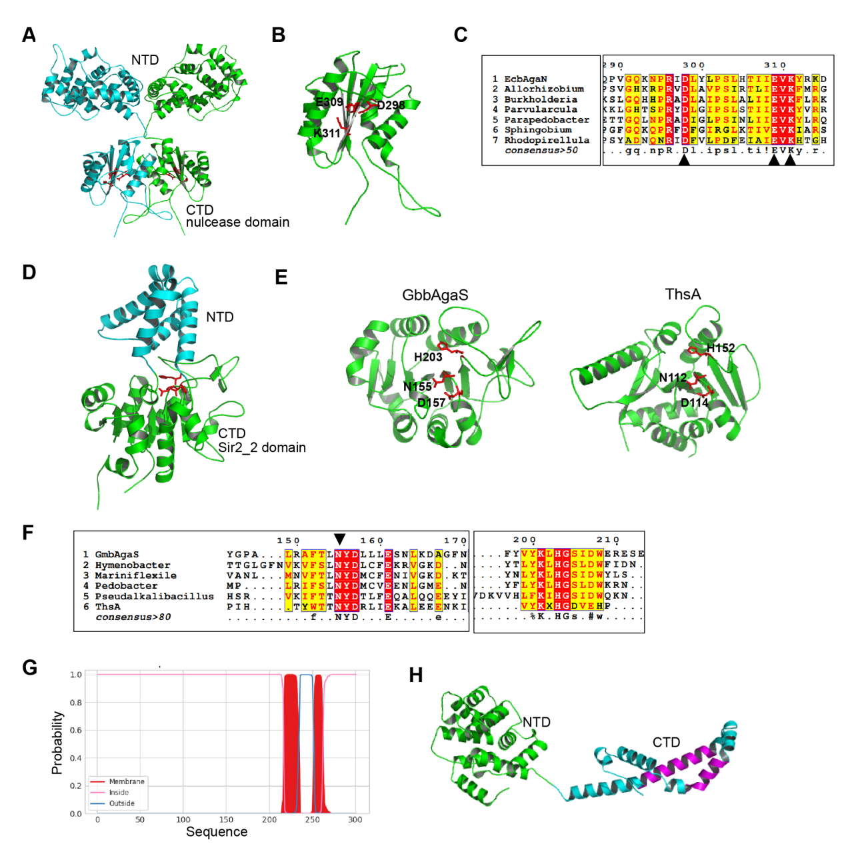
Figure S1. Bioinformatic analysis of long-B pAgo-associated proteins.
A. Structural prediction of the EcbAgaN dimer by AlphaFold2. The N-terminal domain (NTD) and the C-terminal domain (CTD, the nuclease domain) are indicated
B. A close-up view of the nuclease domain of EcbAgaN. The predicted catalytic sites are indicated.
C. Sequence alignment of EcbAgaN and other representative og_15 members with the genus name of the source organism shown. Only the conserved region containing the catalytic sites is shown. The arrows indicate the residues for mutagenesis.
D. Structural prediction of GbbAgaS by AlphaFold2. The CTD is the Sir2_2 domain.
E. Structural comparison of the Sir2_2 domain of GbbAgaS and the Sir2 domain of ThsA (PDB: 6LHX). The catalytic sites are shown.
F. Sequence alignment of GbbAgaS and other representative og_44 members, as well as ThsA. Only the conserved region containing the catalytic sites is shown. The arrow indicates the residue for mutagenesis.
G. Transmembrane prediction of EabAgaM by DeepTMHMM.
H. Structural prediction of EabAgaM by AlphaFold2. The predicted transmembrane region is shown in magenta.
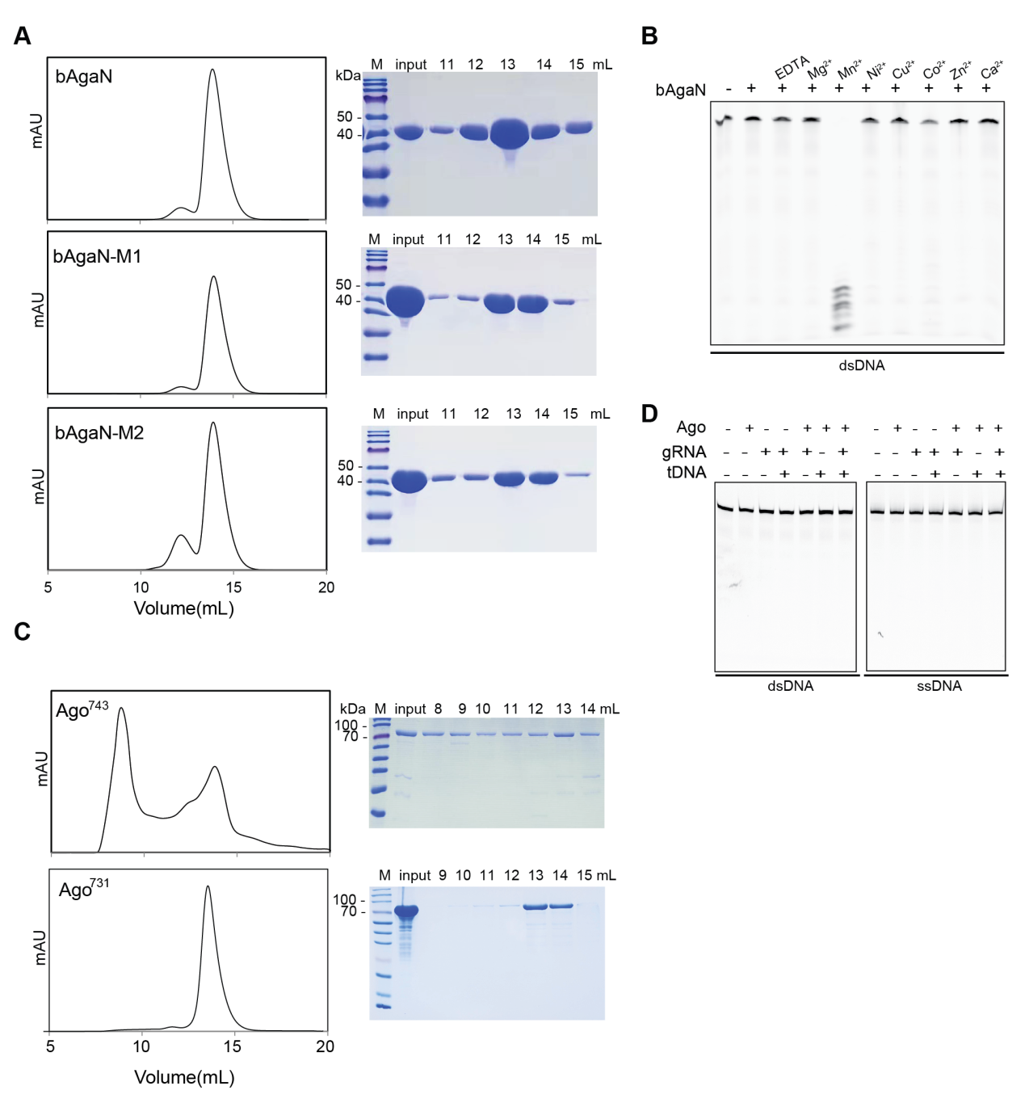
Figure S2. Protein purification and in vitro characterization of EcBPAN system.
A. Gel filtration profiles of purified EcbAgaN and its mutants (left panels), and SDS-PAGE analysis of the gel filtration samples (right panels). Input: the samples that were loaded onto the gel filtration column. M: protein marker.
B. Metal-dependency of EcbAgaN. FAM-labeled dsDNA was incubated with EcbAgaN in the presence of EDTA or indicated metal ions, and then analyzed by denaturing polyacrylamide gel electrophoresis.
C. Gel filtration profiles of purified EcAgo⁷⁴³ and EcAgo⁷³¹ (left panels), and SDS-PAGE analysis of the gel filtration samples (right panels).
D. EcAgo does not cleave target ssDNA or dsDNA. FAM-labeled target ssDNA or dsDNA was incubated with EcAgo⁷³¹. Guide RNA and/or non-labeled target ssDNA were also supplemented in aliquots of the reaction. Then, the samples were analyzed by denaturing polyacrylamide gel electrophoresis.

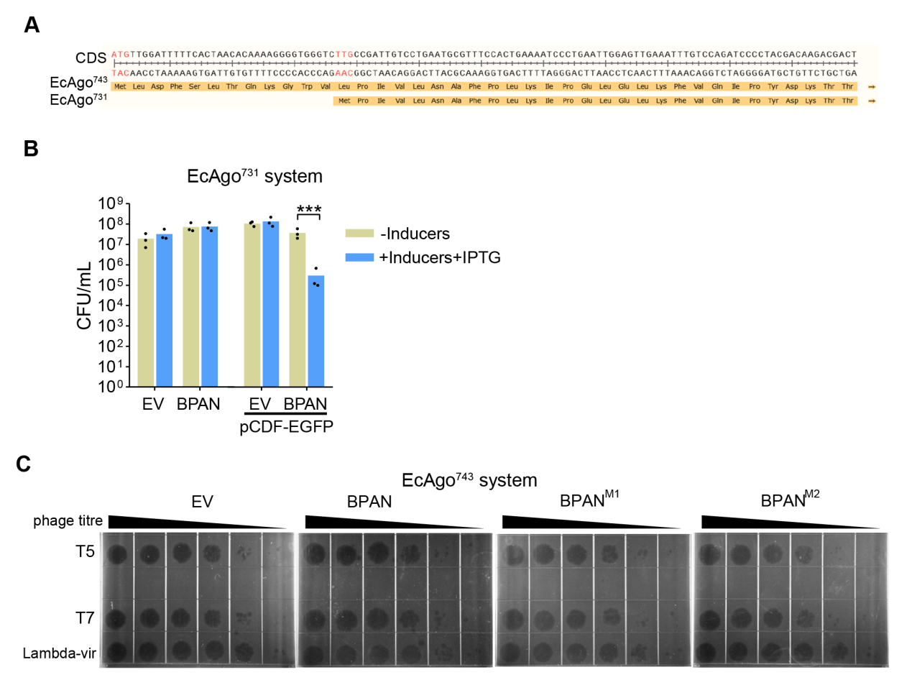
Figure S3. In vivo characterization of EcBPAN system.
A. Two predicted starting codons of EcAgo. The coding sequence (CDS) and amino acid sequences of EcAgo⁷⁴³ and EcAgo⁷³¹ respectively are shown. The two predicted starting codons are marked in red.
B. The EcAgo⁷³¹-expressing systems was activated by pCDF-EGFP. Cells containing empty vector (EV) or the EcAgo⁷³¹-expressing EcBPAN system in the presence or absence of pCDF-EGFP were plated onto the plates with or without inducers (arabinose and aTc) and IPTG. CFU/mL was calculated and the average of three biological replicates are shown, with individual data points overlaid. ***: p < 0.001.
C. EcBPAN system does not confer immunity against selected phages. The phages were serially diluted and dropped the bacterial lawns expressing EcBPAN system or the mutated systems.
EV: empty vector.

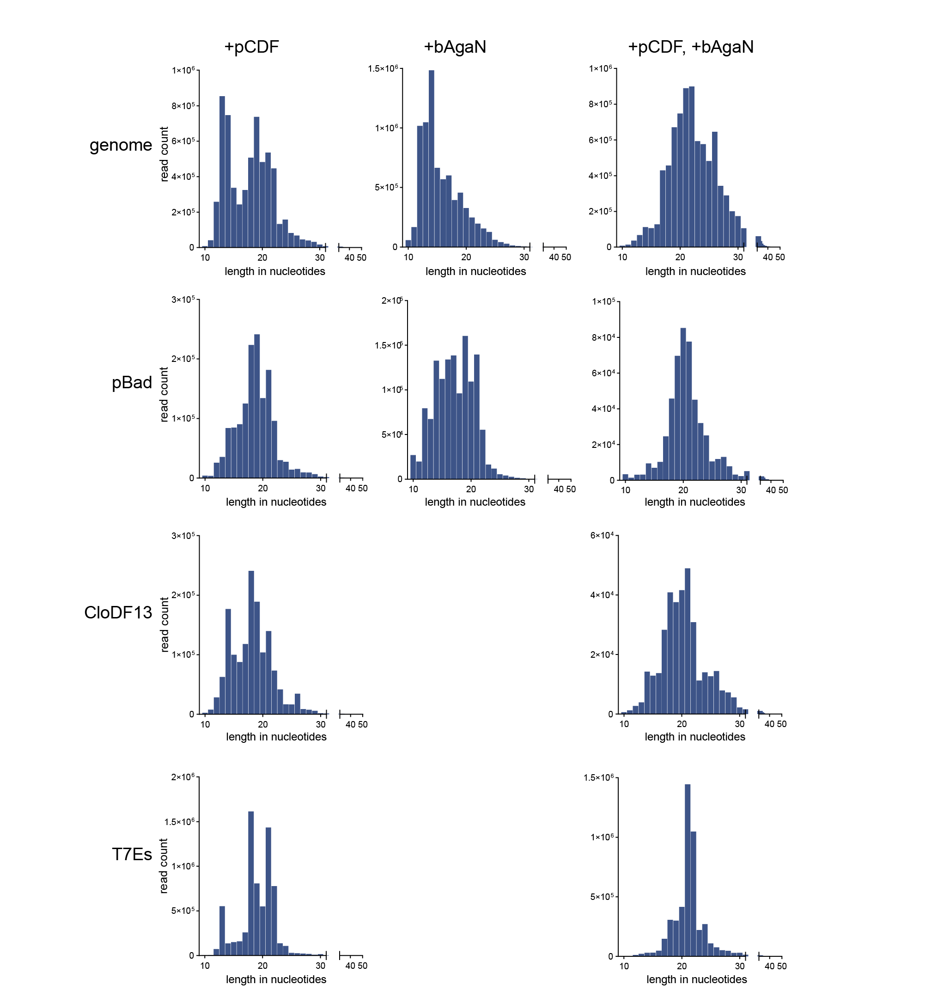
Figure S4. Length distribution of the EcAgo-associated small RNAs assigned to genome, pBAD plasmids, and the CloDF13 origin and the T7 expression cassettes (T7Es) of the pCDF-EGFP plasmid. pBAD can be pBad24-EcAgo⁷⁴³ or pBad24-EcAgo⁷⁴³-EcbAgaN, depending on the samples.

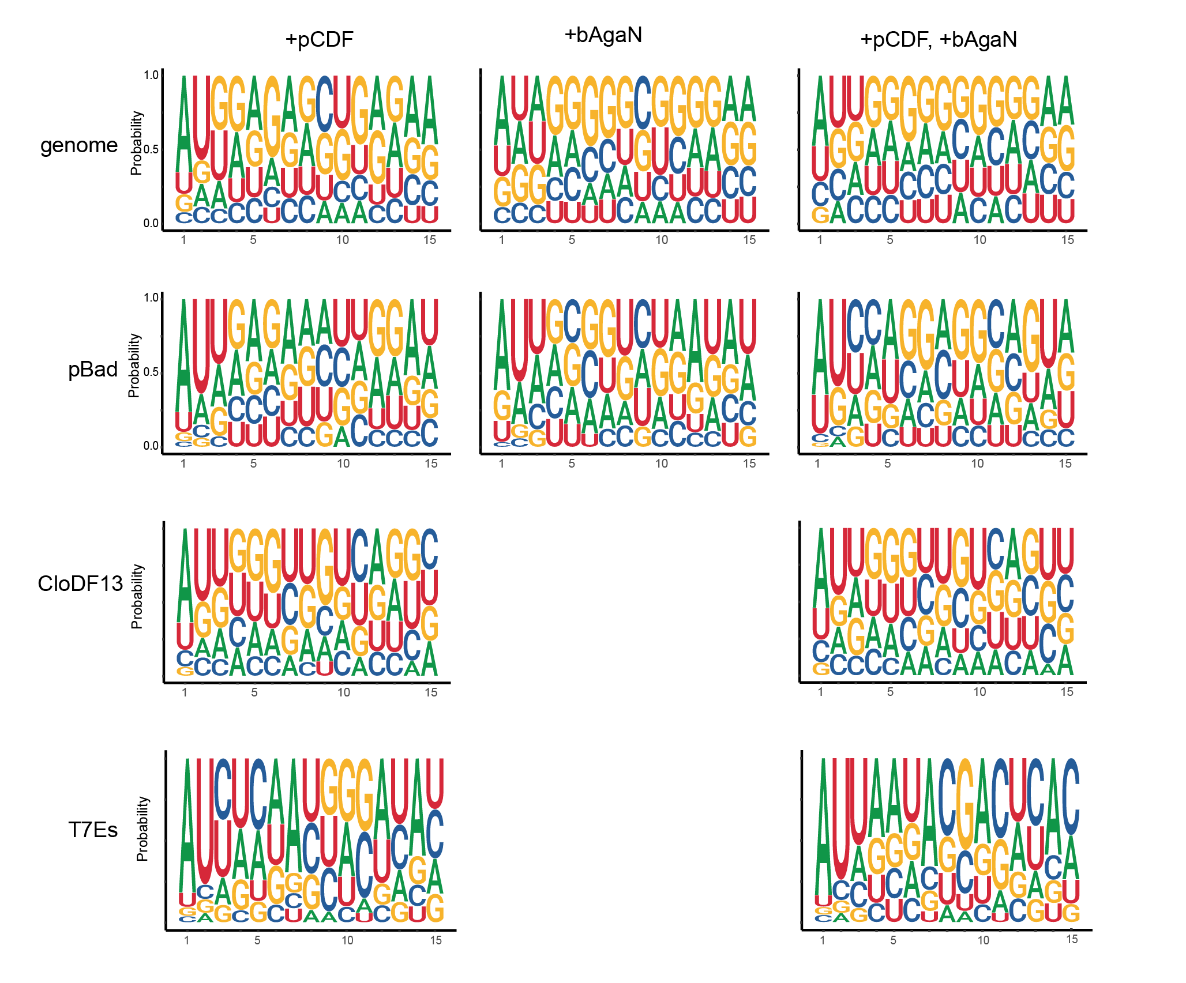
Figure S5. Nucleotide bias of the EcAgo-associated small RNAs assigned to genome, pBAD plasmids, and the CloDF13 origin and the T7 expression cassettes (T7Es) of the pCDF-EGFP plasmid. pBAD can be pBad24-EcAgo⁷⁴³ or pBad24-EcAgo⁷⁴³-EcbAgaN, depending on the samples.

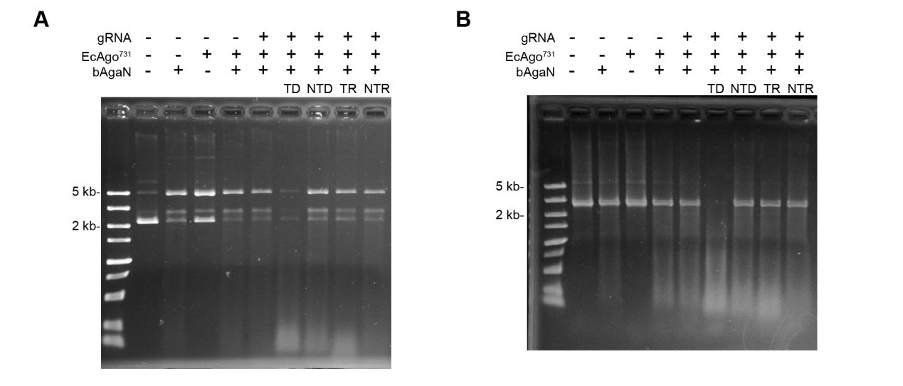
Figure S6. Degradation of plasmid (A) and PCR product (B) by EcbAgaN with or without activation.
About 200 ng pUC19 or PCR product was treated with EcbAgaN in the presence of EcAgo⁷³¹, 5P-RNA (gRNA) and/or target ssDNA or other oligonucleotides. TD: target ssDNA; NTD: nontarget ssDNA; TR: target ssRNA; NTR: nontarget ssRNA.

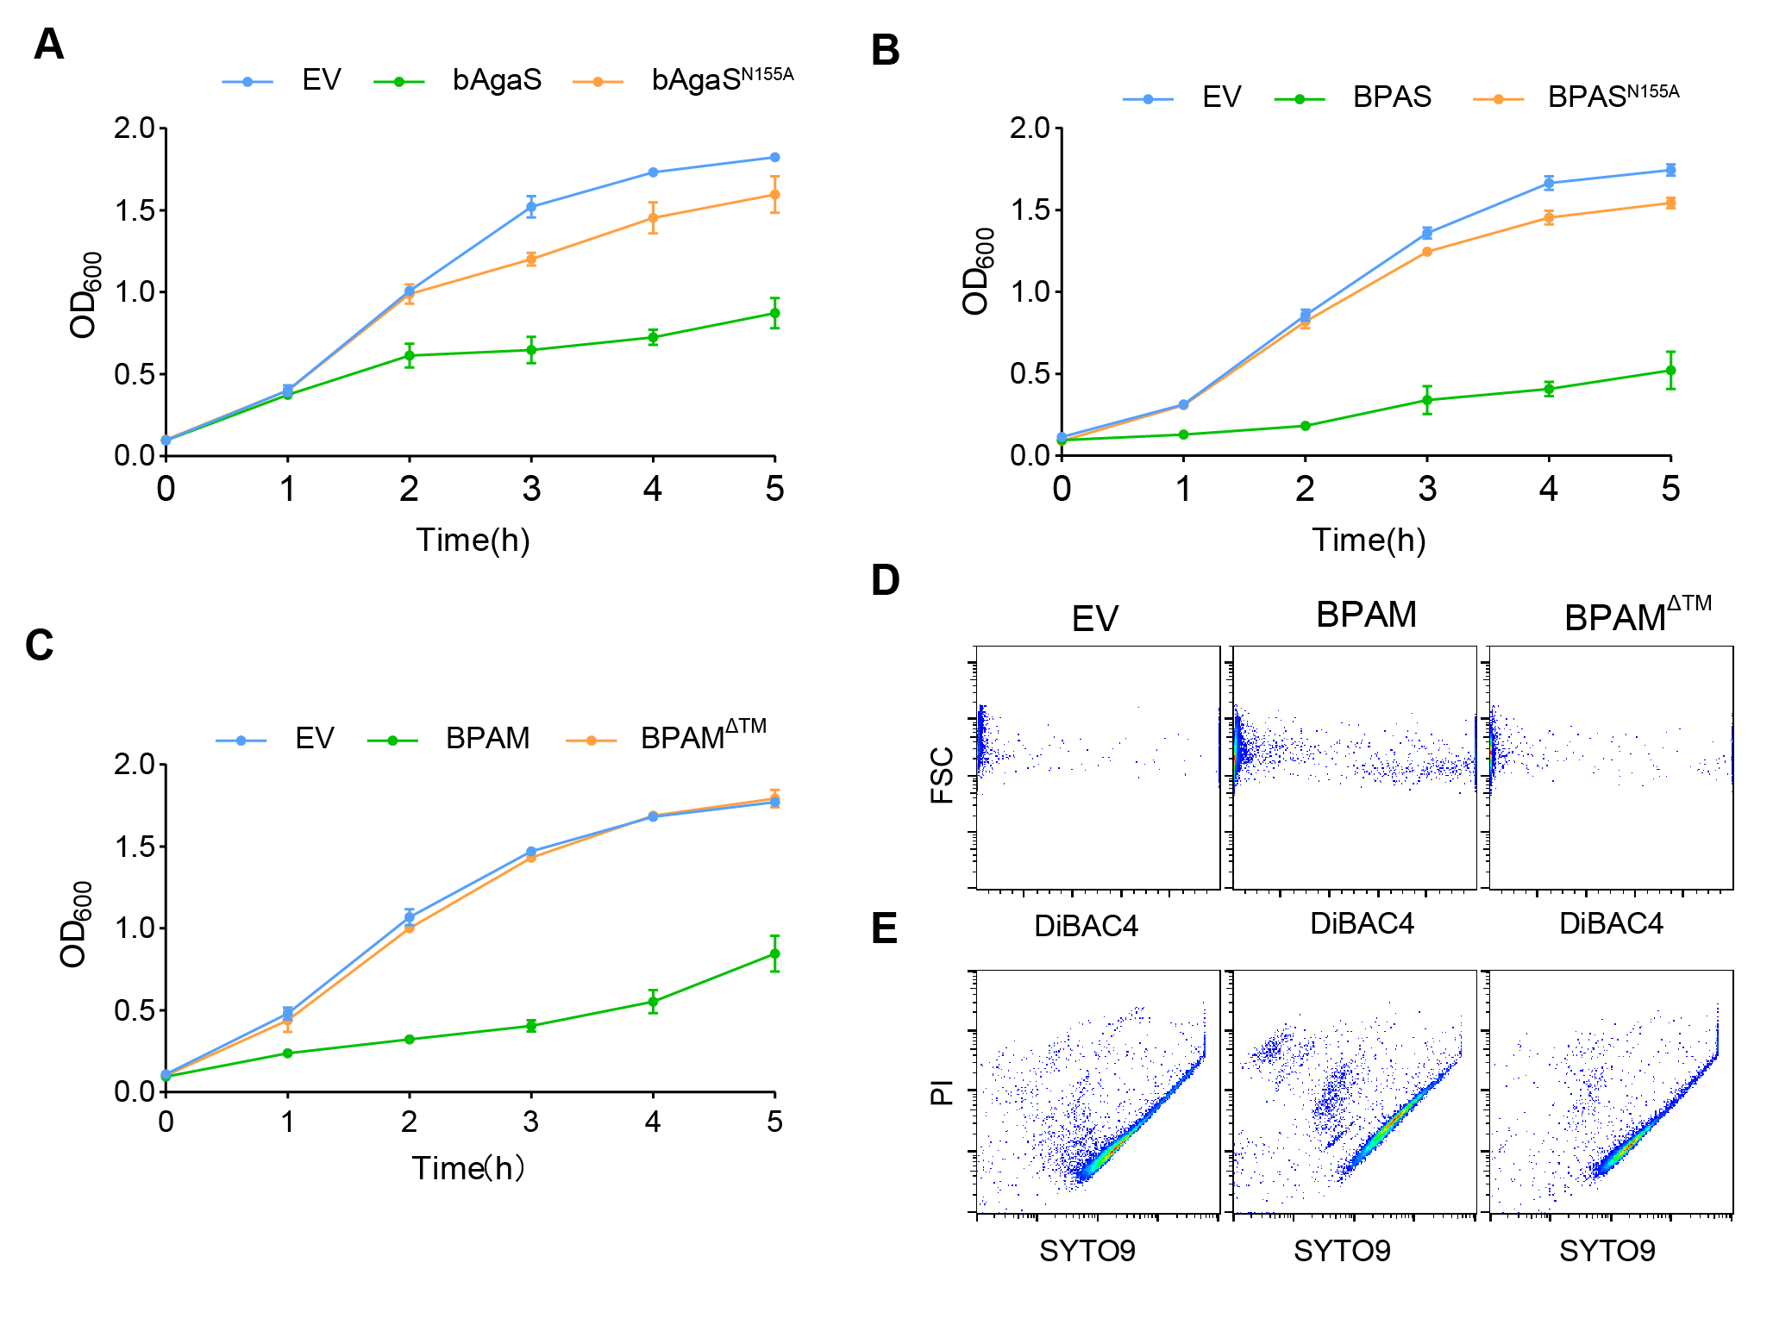
Figure S7. Analysis of the cytotoxicity of the GbBPAS system and the EaBPAM system.
A. Growth curves of the cultures carrying EV, wild type and mutant GbbAgaS proteins.
B. Growth curves of the cultures carrying EV, wild type and mutant GbBPAS systems in the presence of pCDF-EGFP.
C. Growth curves of the cultures carrying EV, wild type and mutant EaBPAM systems.
E. DiBAC₄ staining of the cells carrying EV, wild type and mutant EaBPAM systems after 2 h’s induction.
E. Live/dead (SYTO9/PI) staining of the cells carrying EV, wild type and mutant EaBPAM systems after 2 h’s induction.
EV: empty vector.

Table S1 Proteins analyzed in the study. The names, accession numbers, source strains, and sequences are listed.
Table S2 Plasmids used in the study.
Table S3 Primers used in the study.
Table S4 Oligos used in the study.
Table S5 Alignments of sequenced RNA reads.

