Supplementary data

Supplementary Table 1: Multidrug resistance patterns of E. coli and S. aureus isolates
 | Number of drugs | Antimicrobial’s name | Number resistant isolates
E. coli | Six drugs | AMP, AMC, OT, P, E S, | 3
E. coli | Six drugs | AMP, AMC, CTX, P, E, S, | 2
E. coli | Six drugs | AMP, K, AMC, CTX, P, E | 1
E. coli | Seven drugs | AMP, K, AMC, CTX, P, E S, | 1
E. coli | Total |  | 7
S. aureus | Two drugs | E, P | 1
S. aureus |  | AMP, P | 1
S. aureus |  | AMP, OT | 1
S. aureus | Three drugs | E, P, OT | 1
S. aureus |  | AMP, CTX, S | 1
S. aureus |  | AMP, P, AMC | 1
S. aureus |  | AMP, P, CTX | 3
S. aureus | Four drugs | AMP, E, P, S | 1
S. aureus |  | AMP, P, OT, S | 3
S. aureus |  | AMP, E, S, AMC | 1
S. aureus | Five drugs | AMP, E, K, P, S | 1
S. aureus |  | AMP, E, P, OT, S | 1
S. aureus |  | AMP, CTX, E, P, S | 1
S. aureus |  | AMP, E, P, OT, AMC | 2
S. aureus | Six drugs | AMP, P, OT, CTX, S, AMC | 2
S. aureus | Seven drugs | AMP, CTX, E, OT, P, S, AMC | 1
S. aureus | Total |  | 22

Ampicillin (AMP), Amoxicillin (AMC), Cefotaxime (CTX), Erythromycin (E), Oxytetracycline (OT), Penicillin(P), Kanamycin(K) and Streptomycin(S)

Supplementary Table 2: Antimicrobial susceptibility pattern of E. coli and S. aureus isolated from dairy mastitis.
 | Antimicrobial Agents | Susceptible № (%) | Intermediate № (%) | Resistant № (%)
E. coli | Streptomycin (S10𝜇g) | - | 1(14.3) | 6(85.7)
E. coli | Erythromycin (E15𝜇g) | - | - | 7(100)
E. coli | Ampicillin (AMP10𝜇g) | - | - | 7(100)
E. coli | Kanamycin (K30 𝜇g) | - | 5(71.4) | 2(28.6)
E. coli | Chloramphenicol (C30 𝜇g) | 7(100) | - | -
E. coli | Amoxicillin (AMC30 𝜇g) | - | - | 7(100)
E. coli | Penicillin-G (P10 𝜇g) | - | - | 7(100)
E. coli | Oxytetracycline (OT30 𝜇g) | 4(57.1) | - | 3(42.9)
E. coli | Cefotaxime (CTX30 𝜇g) | 1(14.3) | 2(28.6) | 4(57.1)
S. aureus | Streptomycin (S10𝜇g) | 7(31.8) | 4(18.2) | 11(50)
S. aureus | Erythromycin (E15𝜇g) | 8(36.4) | 2(9.1) | 12(54.5)
S. aureus | Ampicillin (AMP10𝜇g) | 2(9.1) | - | 20(90)
S. aureus | Kanamycin (K30 𝜇g) | 14(63.6) | 7(31.8) | 1(4.6)
S. aureus | Chloramphenicol(C30𝜇g) | 22(100) | - | -
S. aureus | Amoxicillin (AMC30 𝜇g) | 13(59.1) | 2(9.1) | 7(31.8)
S. aureus | Penicillin G (P10 𝜇g) | 5(22.7) | - | 17(77.3)
S. aureus | Ox tetracycline (OT30 𝜇g) | 11(50) | - | 11(50)
S. aureus | Cefotaxime (CTX30 𝜇g) | 6(27.3) | 7(31.8) | 9(40.9)

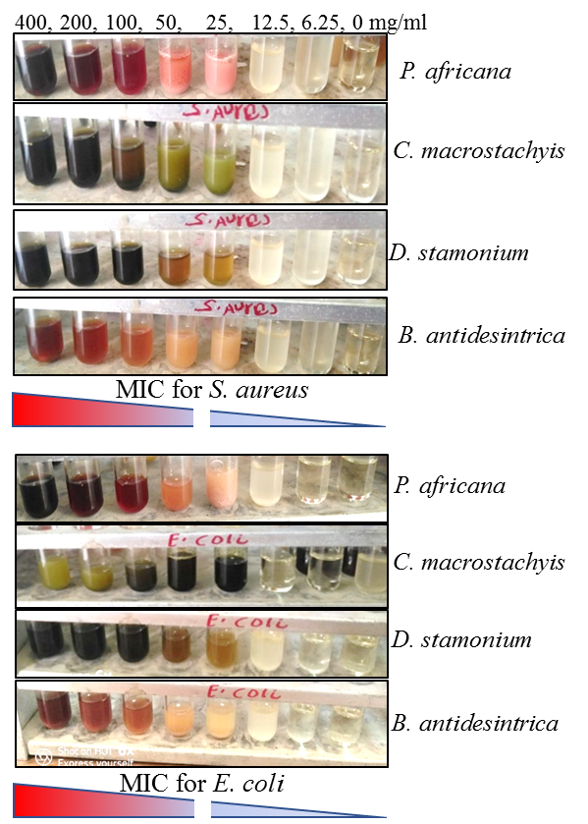
Supplementary Fig. 1: Serial dilution of plant extract for estimation of MIC to S. aureus (upper panel) and to E. coli test isolates (Lower panel). An equal volume of DMSO was used as vehicle control.

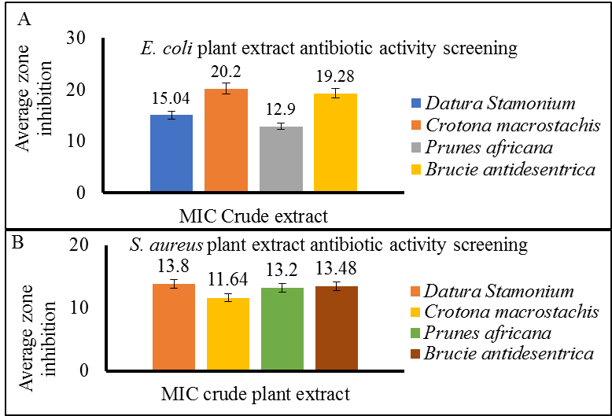
Supplementary Fig. 2: Average zone inhibition determined at MIC of crude extract against and E. coli (A) and S. aureus (B).

