A lesson from a magnificent eruption: year 2021, La Palma, Canary Islands
F. O. Marques, J. Catalão*, V. Soler¹

Supplementary Material

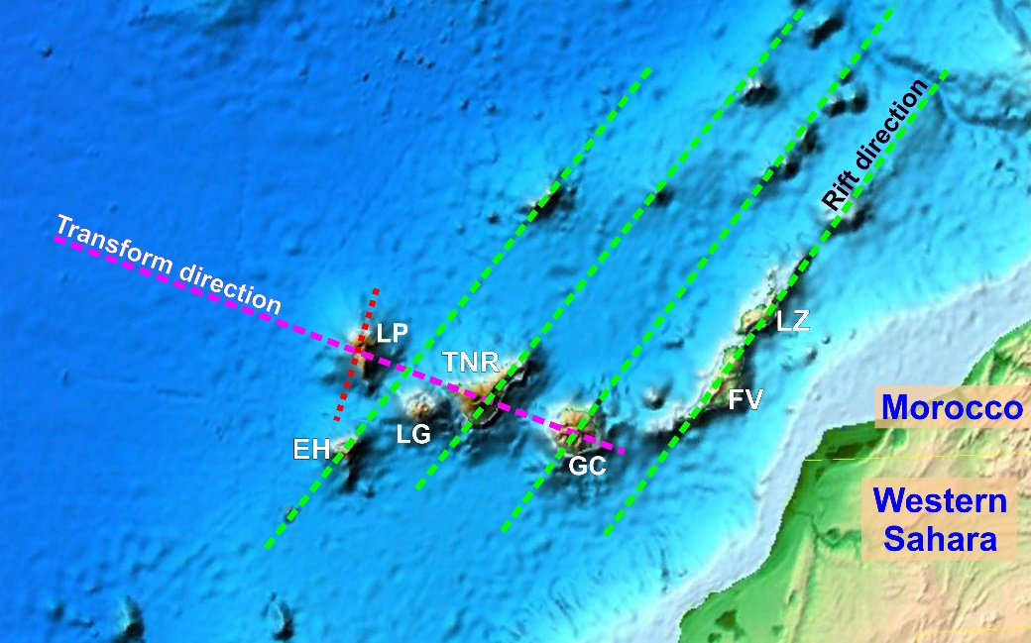
Figure S1. Gravity anomaly map with interpreted major lineaments. Note that the transform goes through the main eruptive centres of La Palma (LP), Tenerife (TNR) and Gran Canaria (GC). The dashed red line represents the Cumbre Vieja (Old Ridge) direction, which aligns with El Hierro Island (EH). Background image retrieved from Google Earth.

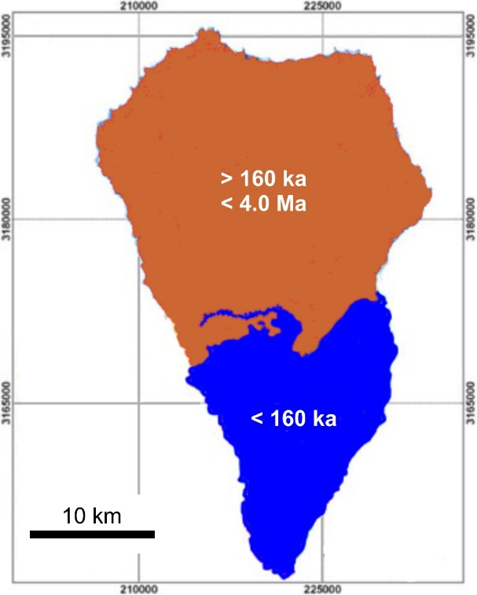
Figure S2. Simplified geological map showing the distribution of rocks older and younger than ca. 160 ka.
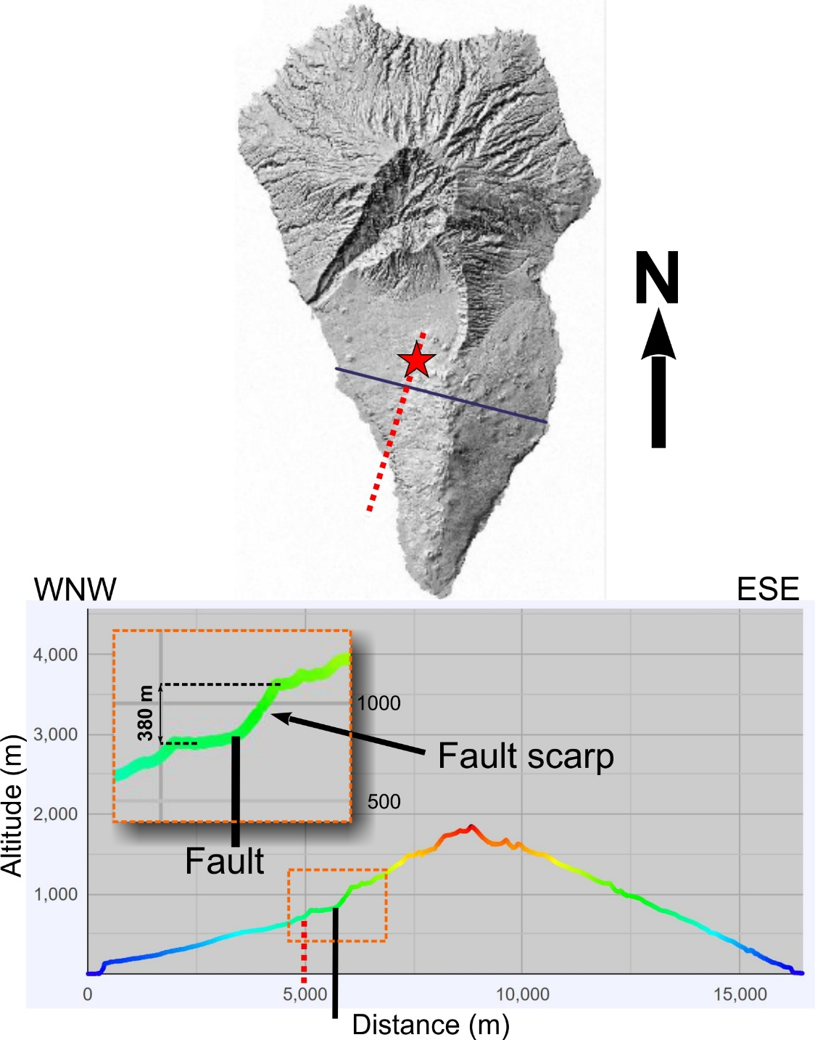
Figure S3. DEM and WNW-ESE topographic profile (both generated using the Grafcan web platform) across the northern part of Cumbre Vieja. Note (1) the difference in relief between the eastern (convex upward) and western (concave upward) flanks of Cumbre Vieja, and (2) the two slope breaks (marked by black arrow) that we interpret as fault scarps and faults (red dashed lines), which underlie the 2021 eruption volcanic cone (marked by red star).
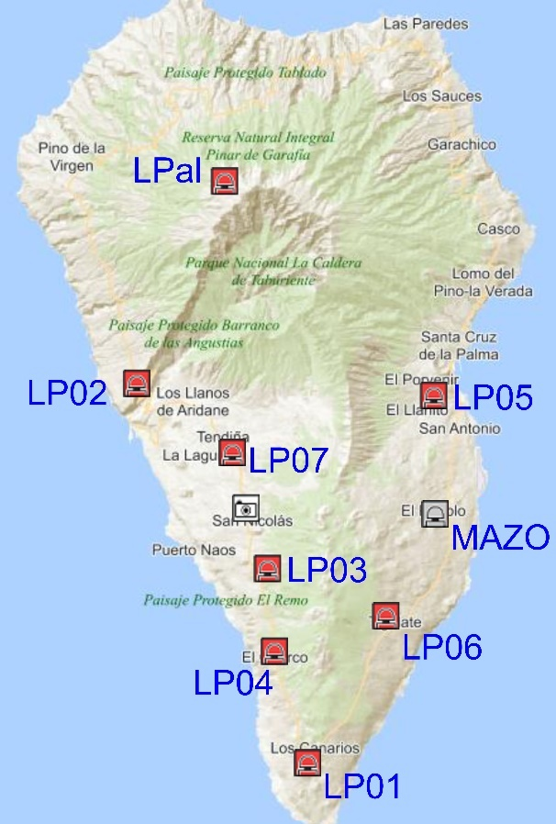
Figure S4. Location of the GPS stations of IGN in La Palma Island.

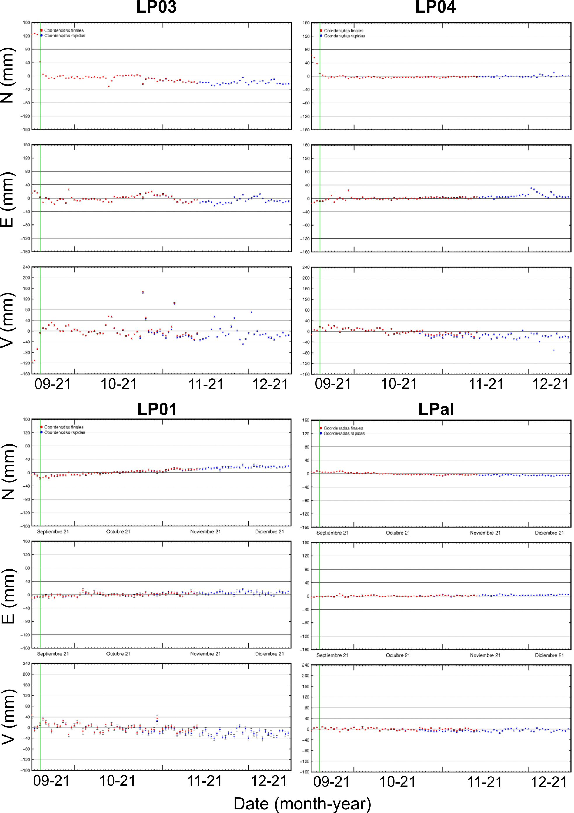
Figure S5. LP03 – station closest to, and to the south of, the eruption centre (cf. Fig. S4). Note: (1) great uplift immediately preceding eruption, (2) significant movement to the south, (3) appreciable movement to the west, (4) movement to the south at the end of October, and (5) appreciable subsidence following eruption take off. LP04 – note: (1) the considerable movement to the south immediately preceding eruption, (2) the slight uplift immediately following eruption take off, and (3) the appreciable subsidence during the 3 months of eruption. LP01 – southernmost station. Note the appreciable subsidence. LPal – northernmost station. Note the slight movement to the south and subsidence.
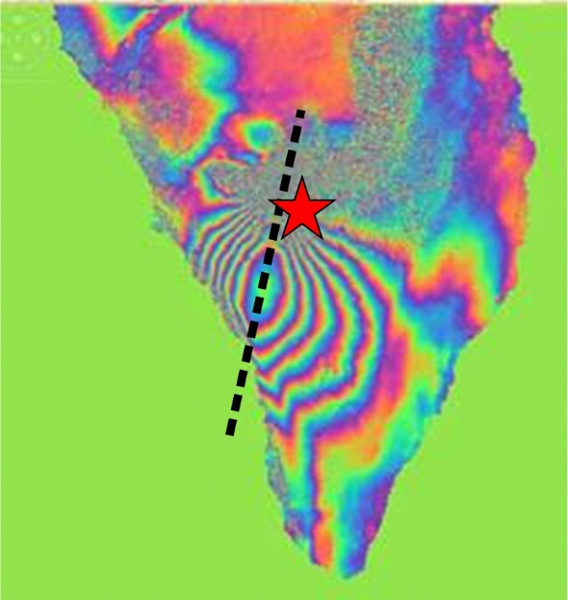
Figure S6. SAR interferogram computed with images acquired by Sentinel-1 satellite on 4.09.2021 and 28.09.2021. Note: (1) the direction (dashed line) coincident with the inferred fault in Fig. S3; (2) the asymmetry of the fringe spacing, likely indicating that the fault is not vertical.
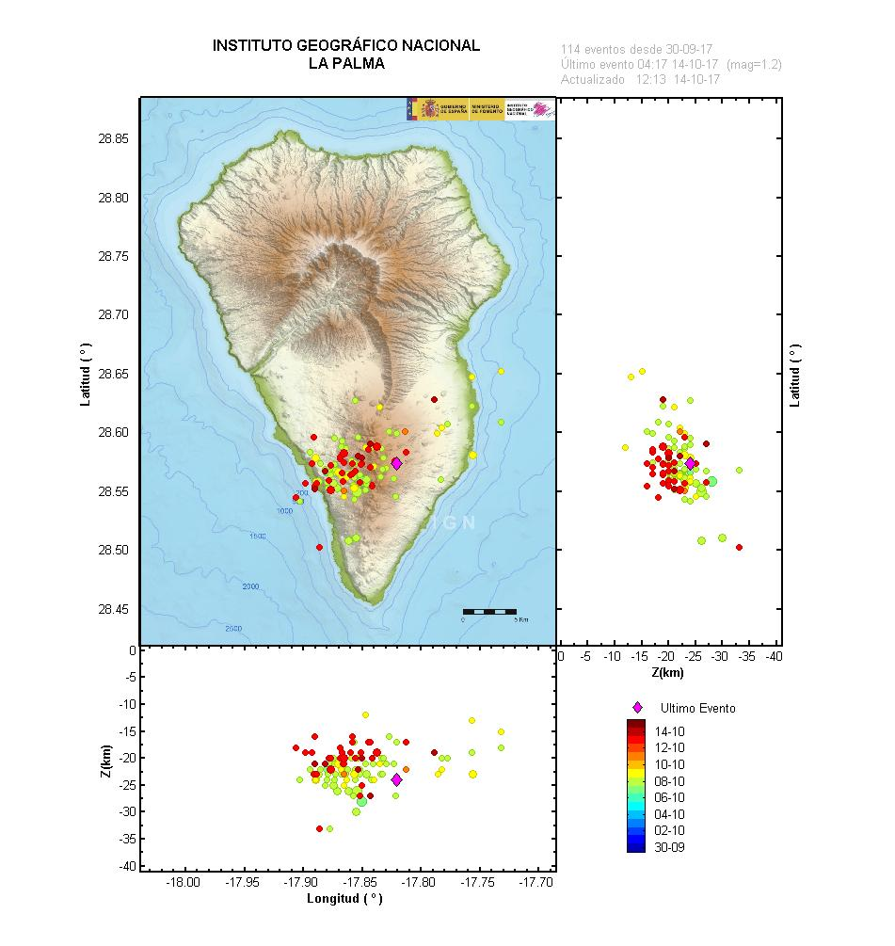
Figure S7. Seismic crisis in October 2017. Note: (1) concentration of earthquakes at around 20-25 km depth; (2) absence of earthquakes above -10 km and below -30 km.
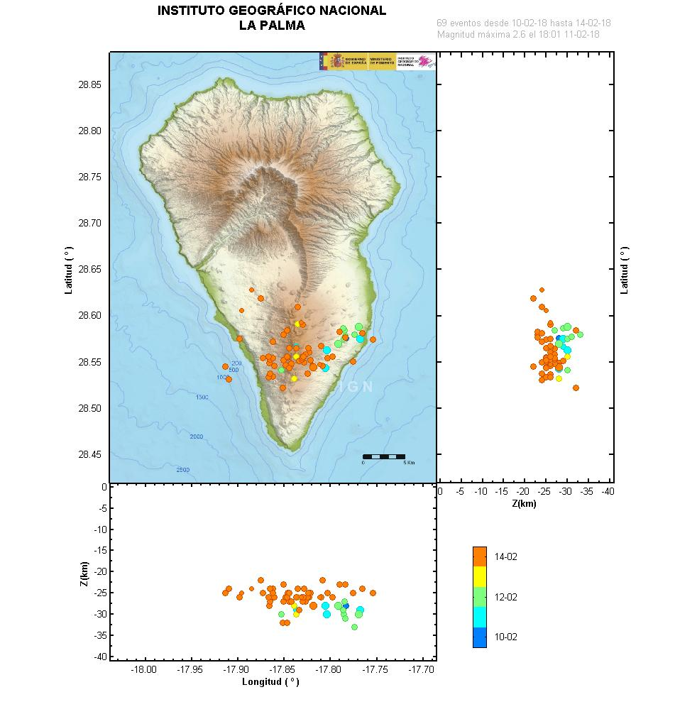
Figure S8. Seismic crisis in February 2018. Note: (1) concentration of earthquakes at around 25-30 km depth, i.e. at the base of the October 2017 swarm; (2) absence of earthquakes above 20 km and below 35 km.
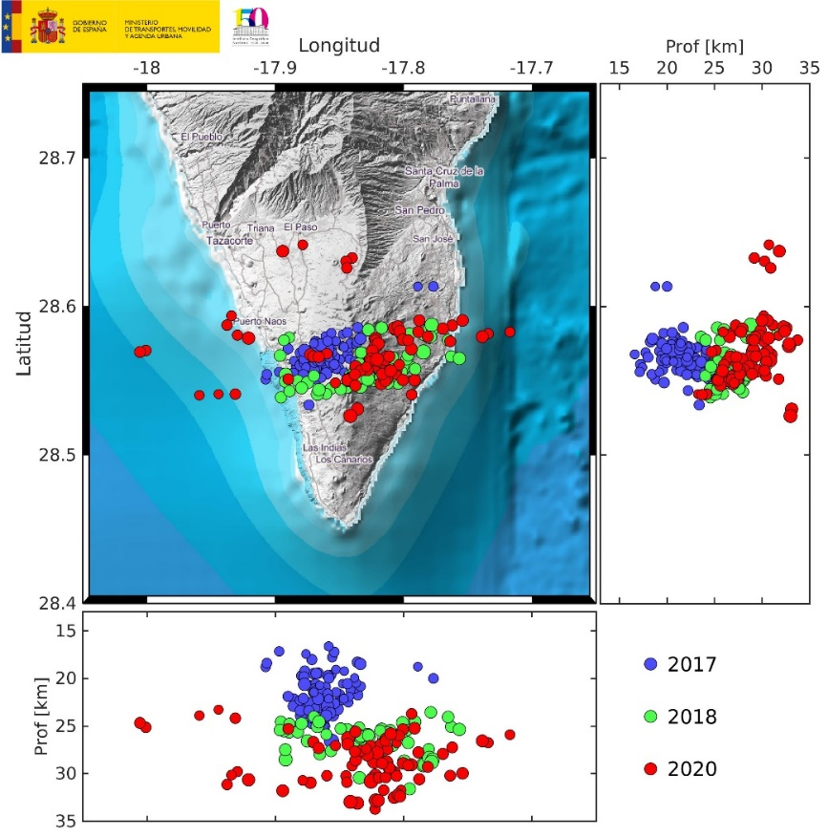
Figure S9. Seismicity distribution from 2017 to August 2020. Note: (1) the E-W trend; (2) the downward and eastward migration of earthquakes from 2017 to 2020; (3) the relatively narrow vertical distribution in the N-S profile in contrast to the elongated distribution in the E-W section, thus indicating a thick dyke along the transform direction; (4) the absence of earthquakes above -16 km; (5) the greater dispersion of earthquakes in 2020 (further E, W and N).
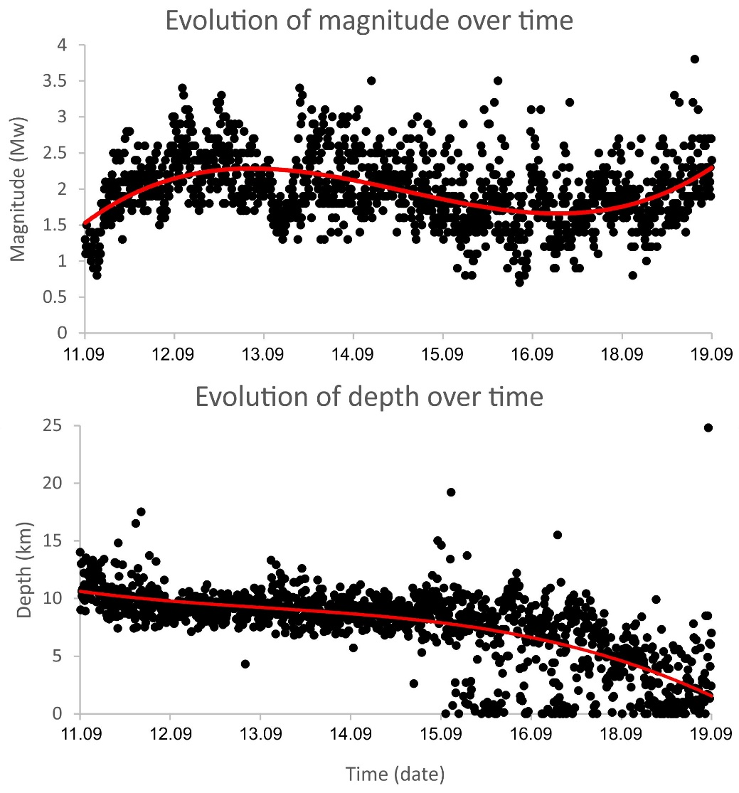
Figure S10. Evolutions of magnitude (top) and depth (bottom) during the week preceding the eruption (from 11 to 19.09.2021). The best fits to data points (red lines) are 3rd degree polynomials.

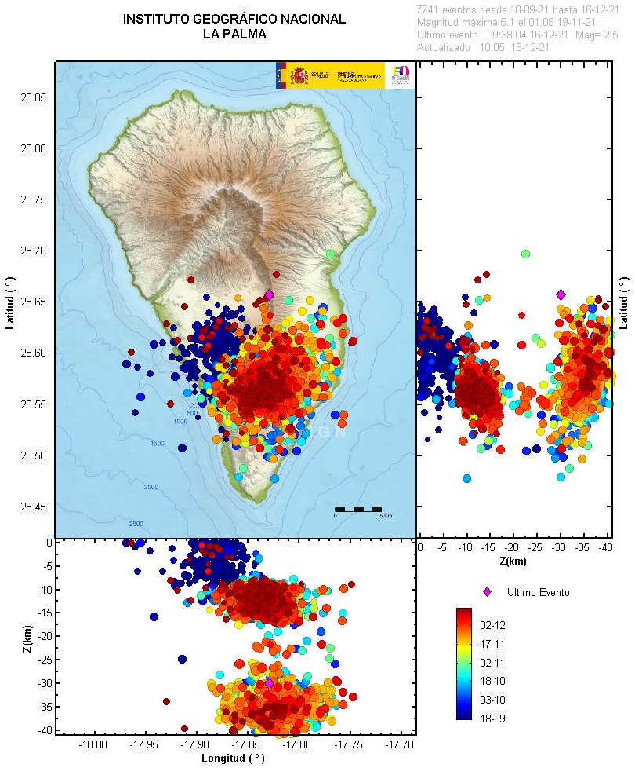
Figure S11. Earthquake spatial distribution in the period of the eruption. Note: the early cluster < -10 km, followed by concentration at -12 and -35 km; the shape of the early shocks cloud indicates a conduit elongated in the NNE-SSW direction; the shapes of the later shocks’ clouds indicate magma chambers in the form of laccoliths, the shallowest more circular and the deepest somewhat elongated N-S; some shocks indicate a connection between the -12 and -35 km magma ponds.

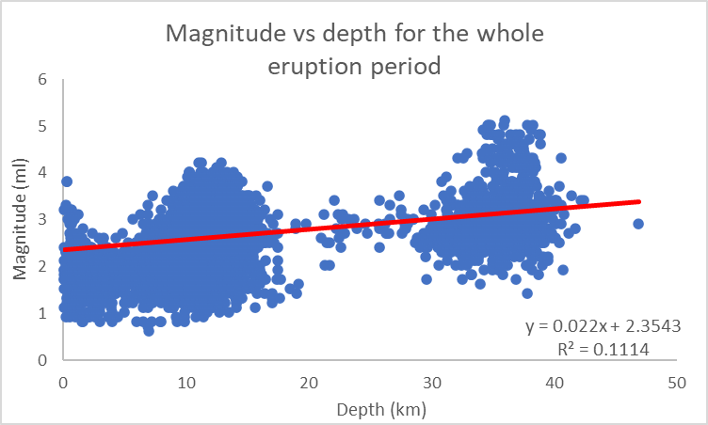
Figure S12. Note that, during the eruption period: (1) seismicity concentrated around 12 and 35 km depth; (2) there was a significant seismicity gap between 18 and 30 km depth; (3) the best-fit trend line shows a direct linear relation between magnitude and depth, i.e. the greater the depth the greater the magnitude.
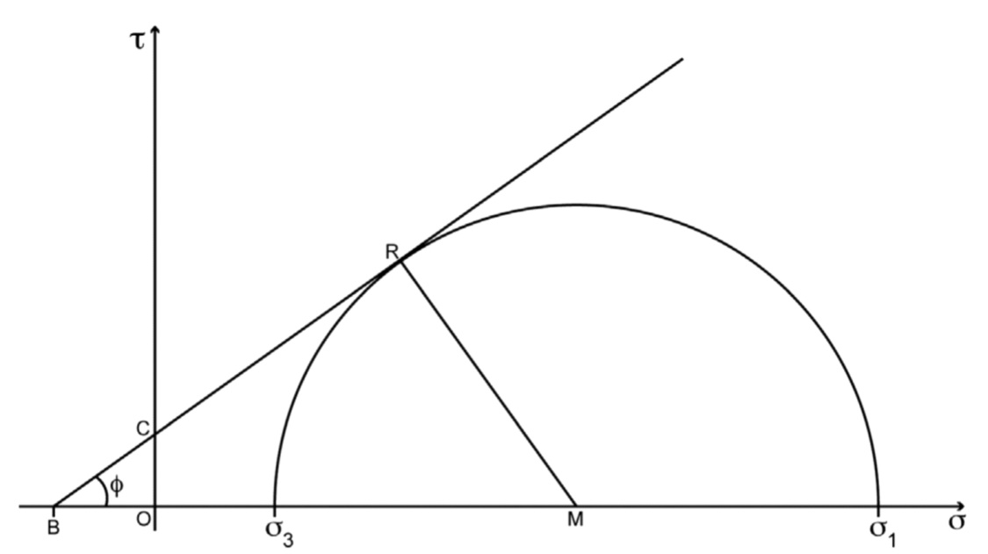
Figure S13. Mohr diagram for brittle facture as a function of shear (τ) and normal (σ) stresses. F = angle of internal friction; C = cohesion; B = intersection between envelope and abscissa axis; R = intersection between circle radius and envelope at tangent point with the Mohr circle; M = centre of the Mohr circle.

