Box
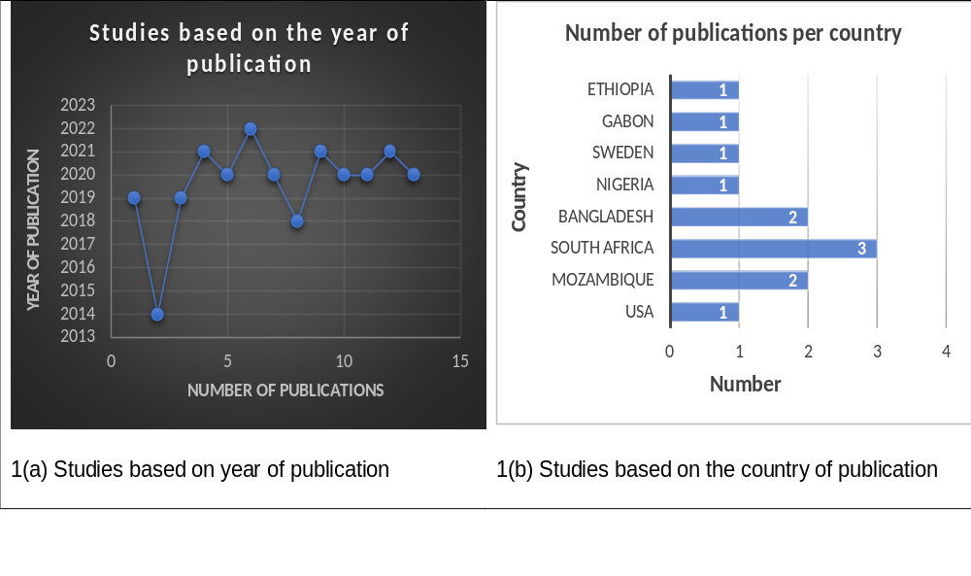
Box 1: included studies based on year and country of publication

