SUPPLEMENTARY INFORMATION
Growth of single-crystal imine-linked covalent organic frameworks in water using amphiphilic amino-acid derivatives
Zhipeng Zhou^{1,11}, Lei Zhang^{2,11}, Yonghang Yang¹, Iñigo J. Vitorica-Yrezabal³, Honglei Wang¹, Fanglin Tan¹, Li Gong⁴, Yuyao Li¹, Pohua Chen², Xin Dong¹, Zihao Liang¹, Jing Yang⁵, Chao Wang⁶, Yuexian Hong¹, Yi Qiu², Armin Gölzhäuser⁷, Xudong Chen^{1,8,9}, Haoyuan Qi¹⁰, Sihai Yang³, Wei Liu^{5,9}, Junliang Sun² & Zhikun Zheng^{1,8,9}
¹Key Laboratory for Polymeric Composite and Functional Materials of Ministry of Education, School of Chemistry, and State Key Laboratory of Optoelectronic Materials and Technologies, Sun Yat-sen University, Guangzhou, China.
²College of Chemistry and Molecular Engineering, Beijing National Laboratory for Molecular Sciences Peking University, Beijing, China.
³ Department of Chemistry and Photon Science Institute, The University of Manchester, Manchester, UK.
⁴Instrumental Analysis Research Center, Sun Yat-sen University, Guangzhou, China.
⁵Key Laboratory of Low-Carbon Chemistry & Energy Conservation of Guangdong Province, Key Laboratory for Polymeric Composite and Functional Materials of Ministry of Education, School of Materials Science and Engineering, and State Key Laboratory of Optoelectronic Materials and Technologies, Sun Yat-sen University, Guangzhou, China.
⁶MOE Key Laboratory of Bioinorganic and Synthetic Chemistry, School of Chemistry, Sun Yat-Sen University, Guangzhou, China.
⁷Faculty of Physics, Bielefeld University, Bielefeld, Germany.
⁸School of Chemical Engineering and Light Industry, Guangdong University of Technology, Guangzhou 510006, P. R. China
⁹ Jieyang Branch of Chemistry and Chemical Engineering Guangdong Laboratory, Jieyang, Guangdong 515200, China
¹⁰Central Facility of Electron Microscopy, Electron Microscopy Group of Materials Science, Universität Ulm, Ulm, Germany.
¹¹These authors contributed equally to this work.
email: liuw226@mail.sysu.edu.cn; junliang.sun@pku.edu.cn; zhengzhikun@mail.sysu.edu.cn
Table of Contents
Materials and Methods
Section 1. Synthesis procedures
Section 1.1 Synthesis procedures of amino acid derivatives
Section 1.2 Solvothermal synthesis of isoreticular COFs
Section 1.3 Synthesis and procedures analysis of single-crystal COFs
Section 2. Single-crystal XRD and cRED analysis
Section 3. Powder XRD analysis
Section 4. Solid-state nuclear magnetic resonance spectroscopic analysis
Section 5. Fourier transform infrared spectroscopic (FT-IR) analysis
Section 6. Thermogravimetric analysis (TGA)
Section 7. Gas absorption and desorption analysis
Section 8. Optical microscopic pictures and SEM images of synthesis COFs
Section 9. Atomic force microscopy analysis
Supplementary Methods
Materials
All solvents and reagents were used as received without further purification unless otherwise specified. p-Toluenesulfonic acid monohydrate (purity ≥ 98%) and Tetrahydrofuran (AR, purity ≥ 99%) were purchased from Aladdin Co. Octanoylglycine (C₈-GlyA, purity ≥ 97%) was purchased from Shanghai Bide Pharmaceutical Technology Co., Ltd. Tetrakis(4-aminophenyl)methane (TAM) (purity ≥ 98%), 1, 4-phthalaldehyde (purity ≥ 98%), 2,5-dihydroxy-1,4-benzenedicarboxaldehyde (purity ≥ 98%), 2,5-dimethoxyterephthalaldehyde (purity ≥ 98%), 2,5-bis(prop-2-yn-1-yloxy)terephthalaldehyde (purity ≥ 98%), 2,5-diethoxyterephthalaldehyde (purity ≥ 98%), 2,5-dipropoxyterephthalaldehyde (purity ≥ 98%), 2,3,5,6-tetrafluoroterephthalaldehyde (purity ≥ 98%), 2,5-dichloroterephthalaldehyde (purity ≥ 98%), 2,5-dibromoterephthalaldehyde (purity ≥ 98%), 2-nitroterephthalaldehyde (purity ≥ 98%), thieno[3,2-b]thiophene-2,5-dicarboxaldehyde (purity ≥ 98%) and [1,1'-biphenyl]-4,4'-dicarbaldehyde) (purity ≥ 98%) were purchased from Jilin Chinese Academy of Sciences-Yanshen Technology Co., Ltd. Petroleum Ether (AR, Boiling Range: 35－60 ºC) were purchased from Shanghai Taitan Technology Co. Hydrochloric acid (36% ~38%), acetone (AR, purity ≥ 99%) and sodium hydroxide (AR, purity ≥ 96%) were purchased from Guangzhou Chemical reagent Co.
Instrumentation and Methods
Single-crystal x-ray diffraction (SXRD)
C₁₆-L-tLeuA SXRD data were collected at 170 K on a Bruker D8 Venture Diffractometer equipped with a GaKα IμS source and MX optic. Using Olex2, the structure was solved with the SHELXT¹ structure solution program using Intrinsic Phasing and refined with the SHELXL refinement package² using Least Squares minimisation; COF-301-S and SYSU-9-S SXRD data reduction and analysis were both performed with the CrysAlisPro software (version 1.171.39.9f). Data sets were measured at beamline I19, Diamond Light Source, Didcot, UK using silicon double crystal monochromated synchrotron radiation (λ = 0.6889 Å, Pilatus 2M detector). Absorption corrections, using the multi-scan method, were performed with the program of SADABS³. For synchrotron X-ray data, collected at Diamond Light Source (λ = 0.6889Å), data reduction and absorption corrections were performed with xia2⁴.
Continuous rotation electron diffraction (cRED)
The cRED data of COF-320 were collected on a JEOL 2100-plus TEM equipped with MerlinEM direct electron detector under 200kV acceleration voltage. The COF powder was dusted onto a copper grid (R2/2, 200 mesh; QUANTIFOIL) and it was transferred to TEM with a Fischone 2550 cryo-holder. The cRED datasets were collected after the holder tip was cooled to 100K. Each frame was collected with exposure time of 2.0 s, resulting in a 1.0° wedge per frame. The collection time for one dataset was approximately 2 minutes.
Considering the beam sensitivity of COFs, the total electron dose on sample was controlled under 10 e⁻ Å⁻² using low-dose mode during the data collection.
All the data were reconstructed and visualized with program REDp⁵ and processed using XDS⁶ with the aid of Instamatic⁷ for batch processing. The structure solution and refinement were conducted with crystallographic computing system JANA2006⁸. The structural models were visualized with program VESTA⁹.
Powder X-ray diffraction. Powder X-ray diffraction measurements were carried out with a PANalytical Empyrean diffractometer using monochromated Cu/Kα (λ = 1.5406 Å) at 45 kV and 40 mA. Rietveld refinements of these experimental PXRD profiles were conducted by Jana2006 software. The crystallinity was calculated by MDI Jade 6.
Nuclear magnetic resonance. All the solid state nuclear magnetic resonance experiments were performed with magic angle spinning (MAS) on a Bruker Avance II 600 MHz wide-bore solid-state NMR spectrometer; Liquid NMR spectrums were recorded on a Bruker DPX 500/400 NMR spectrometer at 500/400 MHz for ¹H NMR, 126/101 MHz for ¹³C NMR. CDCl₃ was used as deuterated solvent. Tetramethylsilane (TMS) served as the internal standard (δ = 0.00 ppm) for ¹H NMR, while DMSO-d₆ (δ = 39.52 ppm), CDCl₃ (δ = 77.16 ppm) as the internal standard for ¹³C NMR. Chemical shifts are reported in ppm and coupling constants are given in Hz. Data for ¹H NMR, ¹³C NMR, were recorded as follows: chemical shift (ppm), multiplicity (s, singlet; d, doublet; dd, doublet of doublets; t, triplet; q, quarter; m, multiplet; brs, broad range singlet), coupling constant (Hz), integration.
Adsorption-desorption analysis. The N₂/CO₂ adsorption-desorption experiments were conducted on a Quantachrome iQ gas sorption analyzer at 77 K/195 K/273K by using ultra-high purity N₂/CO₂ (99.999% purity). The samples were degassed at 120 °C for 12 h before measurements.
Other characterization methods. The Fourier transform infrared (FT-IR) spectra were recorded with a PerkinElmer Frontier spectrometer. FT-IR spectra were obtained with an attenuated total reflection unit (ATR). Raman spectra were recorded with a Thermo Fisher DXR3xi raman imaging microscope. The transmittance values along the Y-axis were normalized for comparison; The optical micrographs were recorded on an OLYMPUS BX53M microscope equipped with a DP27 microscopy imaging system; High resolution mass spectrum (HRMS) data were obtained with electron spray ionization (ESI) sources on a Thermo Scientific Orbitrap Fusion Lumos Tribrid Mass Spectrometer; The TGA curve was recorded on a NETZSCH TG 209F1 Libra simultaneous thermal analyzer under nitrogen atmosphere. The sample was heated from ambient temperature to 900 °C with a heating rate of 10.0 °C min⁻¹.

Section 1. Synthesis procedures
Section 1.1. Synthesis procedures of amino acid derivatives
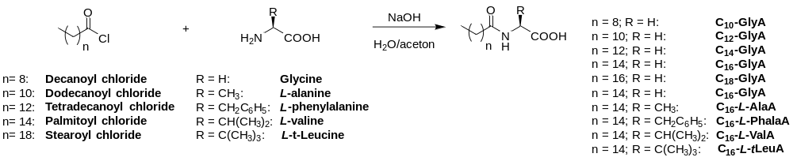
General procedure A: Amino acid derivatives were synthesized according to a reported procedure¹⁰ with some modifications. Briefly, we dissolved amino acid (0.1 mol) and sodium hydroxide (0.1 mol, 4.0 g) in a mixed solvent of acetone (80 mL) and water (120 mL), then added aliphatic acid chloride (0.1 mol) and sodium hydroxide aqueous solution (0.2 mol NaOH in 30 mL of water) slowly and alternatively at 0 ℃. After two hours of stirring, the pH of the solution was adjusted to 1 with 6 mol L⁻¹ hydrochloric acid, and then crude product was obtained by filtering. The product was washed three times with 250 mL of petroleum ether and amino acid derivatives was obtained as white solids.
Decanoylglycine (C₁₀-GlyA)
According to General procedure A decanoyl chloride (0.1 mol, 19.1 g) and glycine (0.1 mol, 7.5 g) were added. Yield: 58% (13.3 g). ¹H NMR (400 MHz, DMSO-d₆) δ 8.07 (t, J = 5.9 Hz, 1H), 3.71 (d, J = 5.9 Hz, 2H), 2.10 (t, J = 7.4 Hz, 2H), 1.49 – 1.46 (m, 2H), 1.23 (s, 12H), 0.85 (t, J = 7.6 Hz, 3H). ¹³C NMR (101 MHz, DMSO) δ 173.05, 171.86, 40.97, 40.56, 40.35, 40.14, 39.93, 39.73, 39.52, 39.31, 35.53, 31.76, 29.38, 29.29, 29.14, 29.07, 25.64, 22.56, 14.38. HRMS (ESI) calcd for [M-H]⁻ C₁₂H₂₂O₃N⁻, m/z: 228.16052, found: 228.16054.
Dodecanoylglycine (C₁₂-GlyA)
According to General procedure A dodecanoyl chloride (0.1 mol, 21.9 g) and glycine (0.1 mol, 7.5 g) were added. Yield: 52% (13.4 g). ¹H NMR (400 MHz, DMSO-d₆) δ 8.07 (t, J = 5.9 Hz, 1H), 3.71 (d, J = 5.9 Hz, 2H), 2.09 (t, J = 7.4 Hz, 2H), 1.51 – 1.44 (m, 2H), 1.23 (s, 14H), 0.85 (t, J = 7.4 Hz, 3H). ¹³C NMR (101 MHz, DMSO-d₆) δ 173.04, 171.86, 40.98, 40.58, 40.37, 40.16, 39.95, 39.74, 39.53, 39.33, 35.53, 31.77, 29.50, 29.48, 29.42, 29.29, 29.19, 29.08, 25.65, 22.56, 14.39. HRMS (ESI) calcd for [M-H]⁻ C₁₄H₂₆O₃N⁻, m/z: 256.19182, found: 256.19176.
Tetradecanoylglycine (C₁₄-GlyA)
According to General procedure A tetradecanoyl chloride (0.1 mol, 24.7 g) and glycine (0.1 mol, 7.5 g) were added. Yield: 61% (17.4 g). ¹H NMR (400 MHz, DMSO-d6) δ 8.09 (t, J = 6.1 Hz, 1H), 3.70 (d, J = 5.4 Hz, 2H), 2.09 (t, J = 7.3 Hz, 2H), 1.49 – 1.45 (m, 2H), 1.23 (s, 20H), 0.84 (t, J = 6.8 Hz, 3H). ¹³C NMR (101 MHz, DMSO-d₆) δ 172.65, 171.50, 40.58, 35.14, 31.41, 29.18, 29.14, 29.07, 28.94, 28.83, 28.72, 25.28, 22.20, 14.01. HRMS (ESI) calcd for [M-H]⁻ C₁₆H₃₀O₃N⁻, m/z: 284.22312, found: 284.22295.
Palmitoylglycine (C₁₆-GlyA)
According to General procedure A palmitoyl chloride (0.1 mol, 27.5 g) and glycine (0.1 mol, 7.5 g) were added. Yield: 52% (16.3 g). ¹H NMR (500 MHz, DMSO-d₆) δ 8.07 (t, J = 6.0 Hz, 1H), 3.71 (d, J = 5.8 Hz, 2H), 2.09 (t, J = 7.5 Hz, 2H), 1.50 – 1.44 (m, 2H), 1.23 (s, 24H), 0.85 (t, J = 6.9 Hz, 3H).¹³C NMR (126 MHz, DMSO-d₆) δ 172.50, 171.41, 40.50, 35.05, 31.29, 29.05, 29.01, 28.95, 28.81, 28.70, 28.61, 25.18, 22.09, 13.94. HRMS (ESI) calcd for [M-H]⁻ C₁₈H₃₄O₃N⁻, m/z: 312.25442, found: 312.25464.
Stearoylglycine (C₁₈-GlyA)
According to General procedure A stearoyl chloride (0.1 mol, 30.3 g) and glycine (0.1 mol, 7.5 g) were added. Yield: 63% (21.5 g). ¹H NMR (400 MHz, DMSO-d₆) δ 8.09 (t, J = 6.1 Hz, 1H), 3.70 (d, J = 5.9 Hz, 2H), 2.09 (t, J = 7.5 Hz, 2H), 1.49 – 1.45 (m, 2H), 1.23 (s, 28H), 0.84 (t, J = 7.1 Hz, 3H). ¹³C NMR (101 MHz, DMSO-d₆) δ 172.63, 171.49, 40.56, 35.12, 31.38, 29.13, 29.10, 29.04, 28.91, 28.80, 28.69, 25.26, 22.18, 14.00. HRMS (ESI) calcd for [M-H]⁻ C₂₀H₃₈O₃N⁻, m/z: 340.28572, found: 340.28560.
Palmitoyl-L-alanine (C₁₆-L-AlaA)
According to General procedure A palmitoyl chloride (0.1 mol, 27.5 g) and glycine (0.1 mol, 8.9 g) were added. Yield: 54% (17.7 g). ¹H NMR (500 MHz, DMSO-d₆) δ 12.41 (brs, 1H), 8.04 (d, J = 7.5 Hz, 1H), 4.20 – 4.14 (m, 1H), 2.07 (t, J = 7.4 Hz, 2H), 1.49 – 1.43 (m, 2H), 1.23 (s, 27H), 0.85 (t, J = 6.9 Hz, 3H). ¹³C NMR (126 MHz, DMSO- d₆) δ174.29, 171.94, 47.29, 34.98, 31.30, 29.06, 29.02, 28.96, 28.82, 28.71, 28.61, 25.18, 22.10, 17.20, 13.94. HRMS (ESI) calcd for [M-H]⁻ C₁₉H₃₆O₃N⁻, m/z: 326.26952, found: 326.27007.
Palmitoyl-L-phenylalanine (C₁₆-L-PhalaA)
According to General procedure A palmitoyl chloride (0.1 mol, 27.5 g) and glycine (0.1 mol, 16.5 g) were added. Yield: 59% (23.8 g). ¹H NMR (500 MHz, CDCl₃) δ 7.33 – 7.23 (m, 3H), 7.16 (d, J = 6.9 Hz, 2H), 5.97 (d, J = 7.5 Hz, 1H), 4.88 (q, J = 6.0 Hz, 1H), 3.25 (dd, J = 14.0, 5.5 Hz, 1H), 3.13 (dd, J = 14.1, 6.3 Hz, 1H), 2.18 (td, J = 7.4, 3.4 Hz, 2H), 1.58 – 1.53 (m, 2H), 1.25 (d, J = 6.3 Hz, 24H), 0.88 (t, J = 6.9 Hz, 3H). ¹³C NMR (126 MHz, CDC l₃) δ 174.55, 174.19, 135.78, 129.47, 128.81, 127.39, 53.31, 37.35, 36.58, 32.07, 29.85, 29.81, 29.78, 29.62, 29.52, 29.45, 29.29, 25.69, 22.85, 14.28. HRMS (ESI) calcd for [M-H]⁻ C₂₅H₄₀O₃N⁻, m/z: 402.30137, found: 402.30191.
Palmitoyl-L-valine (C₁₆-L-ValA)
According to General procedure A palmitoyl chloride (0.1 mol, 27.5 g) and glycine (0.1 mol, 11.7 g) were added. Yield: 56% (19.9 g). ¹H NMR (500 MHz, CDCl₃) δ 9.39 (brs, 1H), 6.23 (d, J = 8.7 Hz, 1H), 4.58 (dd, J = 8.6, 4.8 Hz, 1H), 2.27 (t, J = 7.6 Hz, 2H), 2.27 – 2.19 (m, 1H), 1.66 – 1.60 (m, 2H), 1.24 (s, 24H), 0.97 (d, J = 6.9 Hz, 3H), 0.94 (d, J = 6.9 Hz, 3H), 0.87 (t, J = 6.9 Hz, 3H). ¹³C NMR (126 MHz, CDCl₃) δ 175.38, 174.46, 57.18, 36.79, 32.06, 31.17, 29.83, 29.80, 29.76, 29.64, 29.50, 29.46, 29.37, 25.92, 22.82, 19.11, 17.82, 14.25. HRMS (ESI) calcd for [M-H]⁻ C₂₁H₄₀O₃N⁻, m/z: 354.30137, found: 354.30185.
(S)-3,3-dimethyl-2-palmitamidobutanoic acid (C₁₆-L-tLeuA)
According to General procedure A palmitoyl chloride (0.1 mol, 27.5 g) and glycine (0.1 mol, 13.1 g) were added. Yield: 49% (18.1 g). ¹H NMR (500 MHz, CDCl₃) δ 6.18 (d, J = 9.3 Hz, 1H), 4.51 (d, J = 9.3 Hz, 1H), 2.26 (t, J = 7.6 Hz, 2H), 1.66 – 1.60 (m, 2H), 1.24 (s, 24H), 1.02 (s, 9H), 0.87 (t, J = 6.9 Hz, 3H). ¹³C NMR (126 MHz, CDCl₃) δ 174.98, 174.03, 60.09, 36.90, 34.69, 32.07, 29.84, 29.80, 29.76, 29.64, 29.51, 29.45, 29.40, 26.72, 25.89, 22.84, 14.26. HRMS (ESI) calcd for [M-H]⁻ C₂₂H₄₂O₃N⁻, m/z: 368.31702, found: 368.31754.
Section 1.2 Solvothermal synthesis of isoreticular COFs
We repeated the synthesis of single-crystal COF-300¹¹, and tried all means to synthesize the isoreticular COFs in the manuscript. As can be seen from Supplementary Fig. 1a, single-crystal COF-300 was obtained. On the other hand, none of the other isoreticular COFs could be obtained, as exemplified by COF-301 and SYSU-8/9 (Supplementary Fig. 1b, c, d). This is not unexpected, since monomers with such functional groups cannot match the reactivity of their modulator¹¹ (aniline).
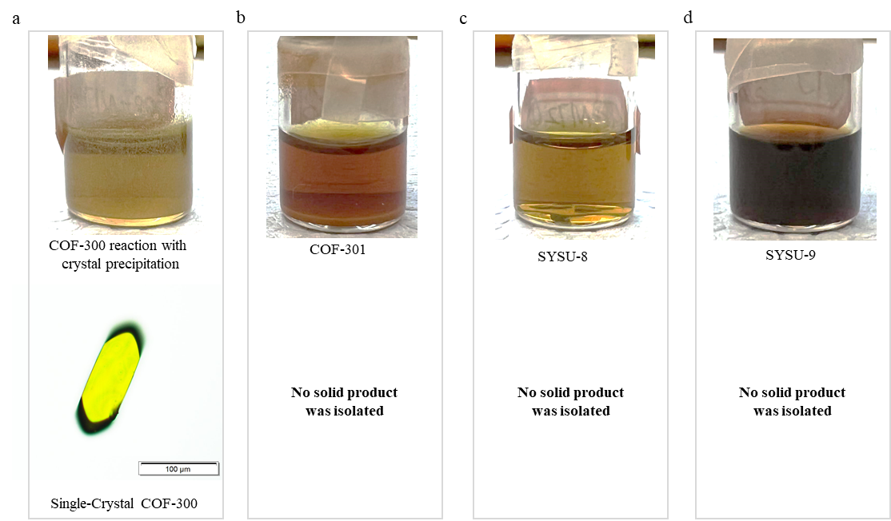

Supplementary Fig. 1. Solvothermal synthesis of COF-300/301 and SYSU-8/9.

Section 1.3 Synthesis and procedures analysis of single-crystal COFs
Synthesis procedures of COF-301 (concentration 0.005 mmol L⁻¹)
To grow the single-crystal COFs, we dissolved 0.1 mmol C₁₆-GlyA (31 mg) and 0.1 mmol sodium hydroxide in 10 L of water at 50 ℃ under ambient conditions. The solution was stirred for 10 minutes to obtain an emulsion, then 0.05 mmol (linker-A, 8.3 mg) was added and stirred. Subsequently, a solution of tetrakis(4-aminophenyl)methane (TAM, 9.5 mg, 0.025 mmol) in 0.2 mol L⁻¹ acid (PTSA 1.5 mL) was added, stirred for 5 minutes. After the completion of the reaction, the product was collected by centrifugation and washed three times with water and tetrahydrofuran. Further purification of COFs was carried out by immersing in tetrahydrofuran for 24 hours, dried at ambient temperature for 12 hours and 100 ℃ for 12 hours to afford single-crystal COFs powder.
Synthesis procedures of COF-301 (concentration 0.5 mol L⁻¹)
To grow the single-crystal COFs, we dissolved 10 mmol C₁₆-GlyA (3.1 g) and 10 mmol sodium hydroxide in 5 mL of water at 50 ℃ under ambient conditions. The solution was stirred for 10 minutes to obtain an emulsion, then 5 mmol (linker-A, 830 mg) was added and stirred. Subsequently, a solution of tetrakis(4-aminophenyl)methane (TAM, 950 mg, 2.5 mmol) in 6 mol L⁻¹ acid (PTSA 5 mL) was added, stirred for 5 minutes. After the completion of the reaction, the product was collected by centrifugation and washed three times with water and tetrahydrofuran. Further purification of COFs was carried out by immersing in tetrahydrofuran for 24 hours, dried at ambient temperature for 12 hours and 100 ℃ for 12 hours to afford single-crystal COFs powder.
Synthesis procedures of COF-300 with the average size of ~ 0.6 µm

To grow the single-crystal COFs, we dissolved C₁₆-L-AlaA (32.8 mg, 0.1 mmol) and 0.1 mmol sodium hydroxide in 10 mL of water. Stir at 50 ℃ for 10 minutes to obtain an emulsion, 0.2 mol L⁻¹ hydrochloric acid (0.5 mL) was added, then linker-B (6.7 mg, 0.05 mmol) was added and stirred. Then a solution of tetrakis(4-aminophenyl)methane (TAM, 9.5 mg, 0.025 mmol) in 0.2 mol L⁻¹ PTSA (0.5 mL) was added, stirred for 5 minutes. After the completion of the reaction, the product was collected by centrifugation and washed three times with water and tetrahydrofuran. Further purification of COFs was carried out by immersing in tetrahydrofuran for 24 hours, dried at ambient temperature for 12 hours and 100 ℃ for 12 hours to afford COF-300 powder.

Section 2. Single crystal XRD and cRED analysis
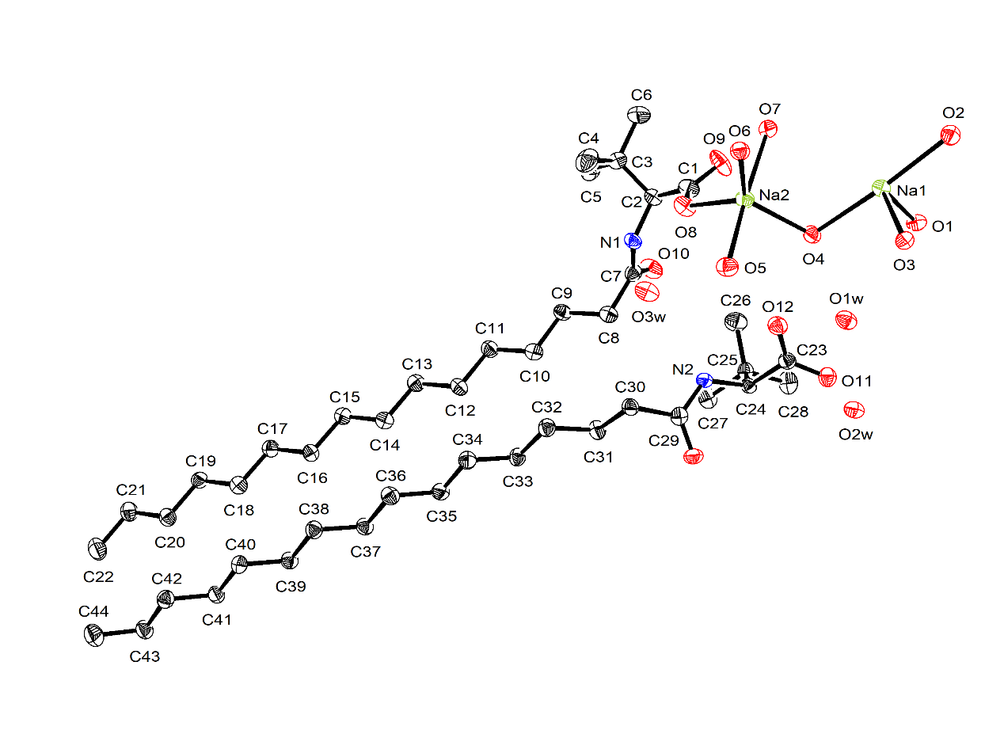

Supplementary Fig. 2. Asymmetric unit in the single-crystal structure of C₁₆-L-tLeuA. Thermal ellipsoids are drawn with 50% probability. Hydrogen atoms are omitted for clarity.

Supplementary Table 1. Crystal data, data collection, and structure refinement parameters for C₁₆-L-tLeuA. Detailed information for the crystal structure of C₁₆-L-tLeuA has been included in the CIF file.
Name | C₁₆-L-tLeuA
Chemical Formula | C₂₂ H₄₉ N Na O₈
Formula weight | 478.61
Crystal system | Monoclinic
Space group | P 1 21 1
Unit cell dimensions | a = 11.2679(6), b = 7.2829(4), c =35.1565(19) Å, α = γ = 90 °, β = 98.395(3)
V, Å³  d, g cm⁻³ | 2854.1(3)
V, Å³  d, g cm⁻³ | 1.114
μ, mm⁻¹ | 0.517
Z | 4
Measured reflections | 29360
Independent reflections | 9846
Observed reflections | 7337
θ_{min} , º | 3.32
θ_{max} , º | 52.50
h | -13 to 13
k | -8 to 8
l | -41 to 33
R_{int} | 0.0440
R [F²>2σ(F²)] | 0.0509
wR(F²) | 0.1330
S | 1.076
Parameters | 606
Restraints | 6
Δρ_{max}, e Å⁻³ | 0.399
Δρ_{min}, e Å⁻³ | -0.493
Crystal size, mm³ | 0.1×0.02×0.006
Radiation, Å | 1.34138
Temperature, K | 100
CCDC number | 2049342

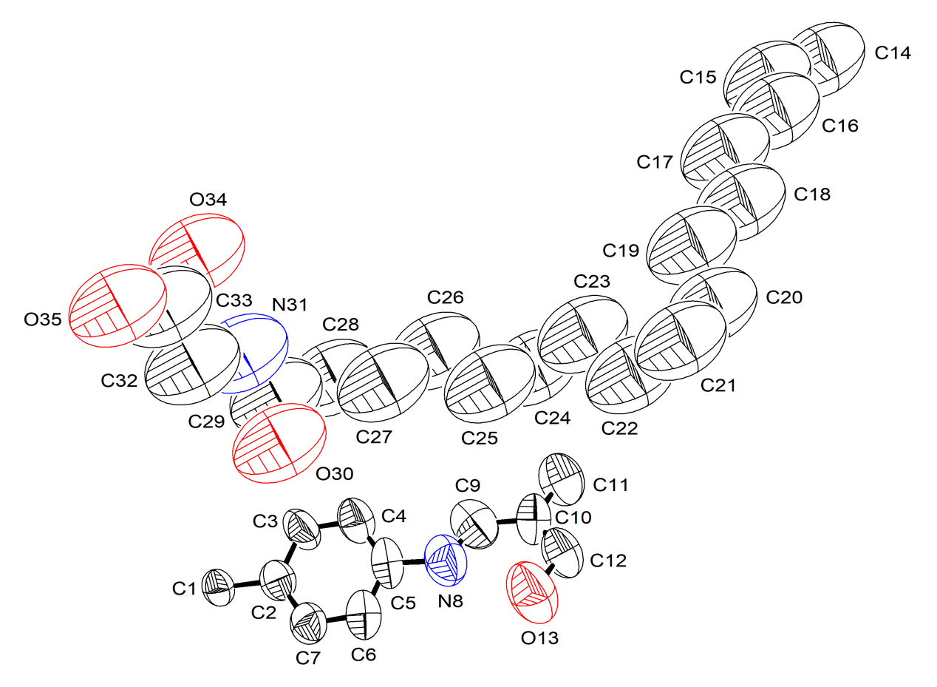
Supplementary Fig. 3. Asymmetric unit in the single-crystal structure of COF-301-S. Thermal ellipsoids are drawn with 50% probability. Hydrogen atoms are omitted for clarity.
Supplementary Table 2. Crystal data, data collection, and structure refinement parameters for COF-301-S. Detailed information for the crystal structure of COF-301-S has been included in the CIF file.
Name | COF-301-S
Chemical Formula | C_{129.97} H₅₆ N_{10.66} O₁₆
Formula weight | 2022.86
Crystal system | Tetragonal
Space group | I4₁/a
Unit cell dimensions | a = b = 26.434(4) Å, c = 7.5876(15) Å, α = β = γ = 90 °
V, Å³  d, g cm⁻³ | 5302.0(18)
V, Å³  d, g cm⁻³ | 1.267
μ, mm⁻¹ | 0.080
Z | 2
Measured reflections | 16643
Independent reflections | 1906
Observed reflections | 464
θ_{min} , º | 2.11
θ_{max} , º | 18.94
h | -29 to 29
k | -28 to 29
l | -8 to 8
R_{int} | 0.1190
R [F²>2σ(F²)] | 0.1238
wR(F²) | 0.3250
S | 0.858
Parameters | 172
Restraints | 49
Δρ_{max}, e Å⁻³ | 0.464
Δρ_{min}, e Å⁻³ | -0.257
Crystal size, mm³ | 0.02 × 0.01 × 0.01
Radiation, Å | 0.6889
Temperature, K | 293(2)
CCDC number | 2209466

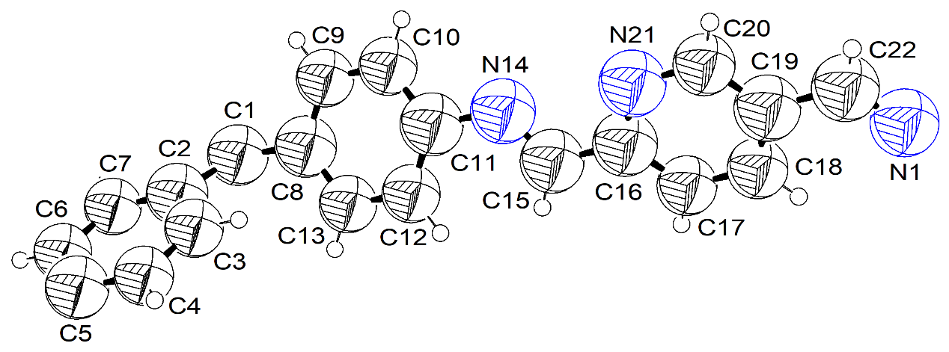

Supplementary Fig. 4. Asymmetric unit in the single-crystal structure of SYSU-9-S. Thermal ellipsoids are drawn with 50% probability.

Supplementary Table 3. Crystal data, data collection, and structure refinement parameters for SYSU-9-S. Detailed information for the crystal structure of SYSU-9-S has been included in the CIF file.
Name | SYSU-9-S
Chemical Formula | C₃₉N₆H₂₆
Formula weight | 578.66
Crystal system | Tetragonal
Space group | I4₁
Unit cell dimensions | a = b = 26.461(4), c = 7.4600(15) Å, α = β = γ = 90 °
V, Å³  d, g cm⁻³ | 5223.6(18)
V, Å³  d, g cm⁻³ | 0.736
μ, mm⁻¹ | 0.045
Z | 4
Measured reflections | 6712
Independent reflections | 2034
Observed reflections | 270
θ_{min} , º | 4.354
θ_{max} , º | 37.672
h | -24 to 24
k | -23 to 24
l | -6 to 6
R_{int} | 0.2140
R [F²>2σ(F²)] | 0.3186
wR(F²) | 0.7156
S | 1.398
Parameters | 35
Restraints | 33
Δρ_{max}, e Å⁻³ | 0.92
Δρ_{min}, e Å⁻³ | -0.48
Crystal size, mm³ | 0.037 × 0.005 × 0.006
Radiation, Å | 0.71073
Temperature, K | 293(2)
CCDC number | 2049378

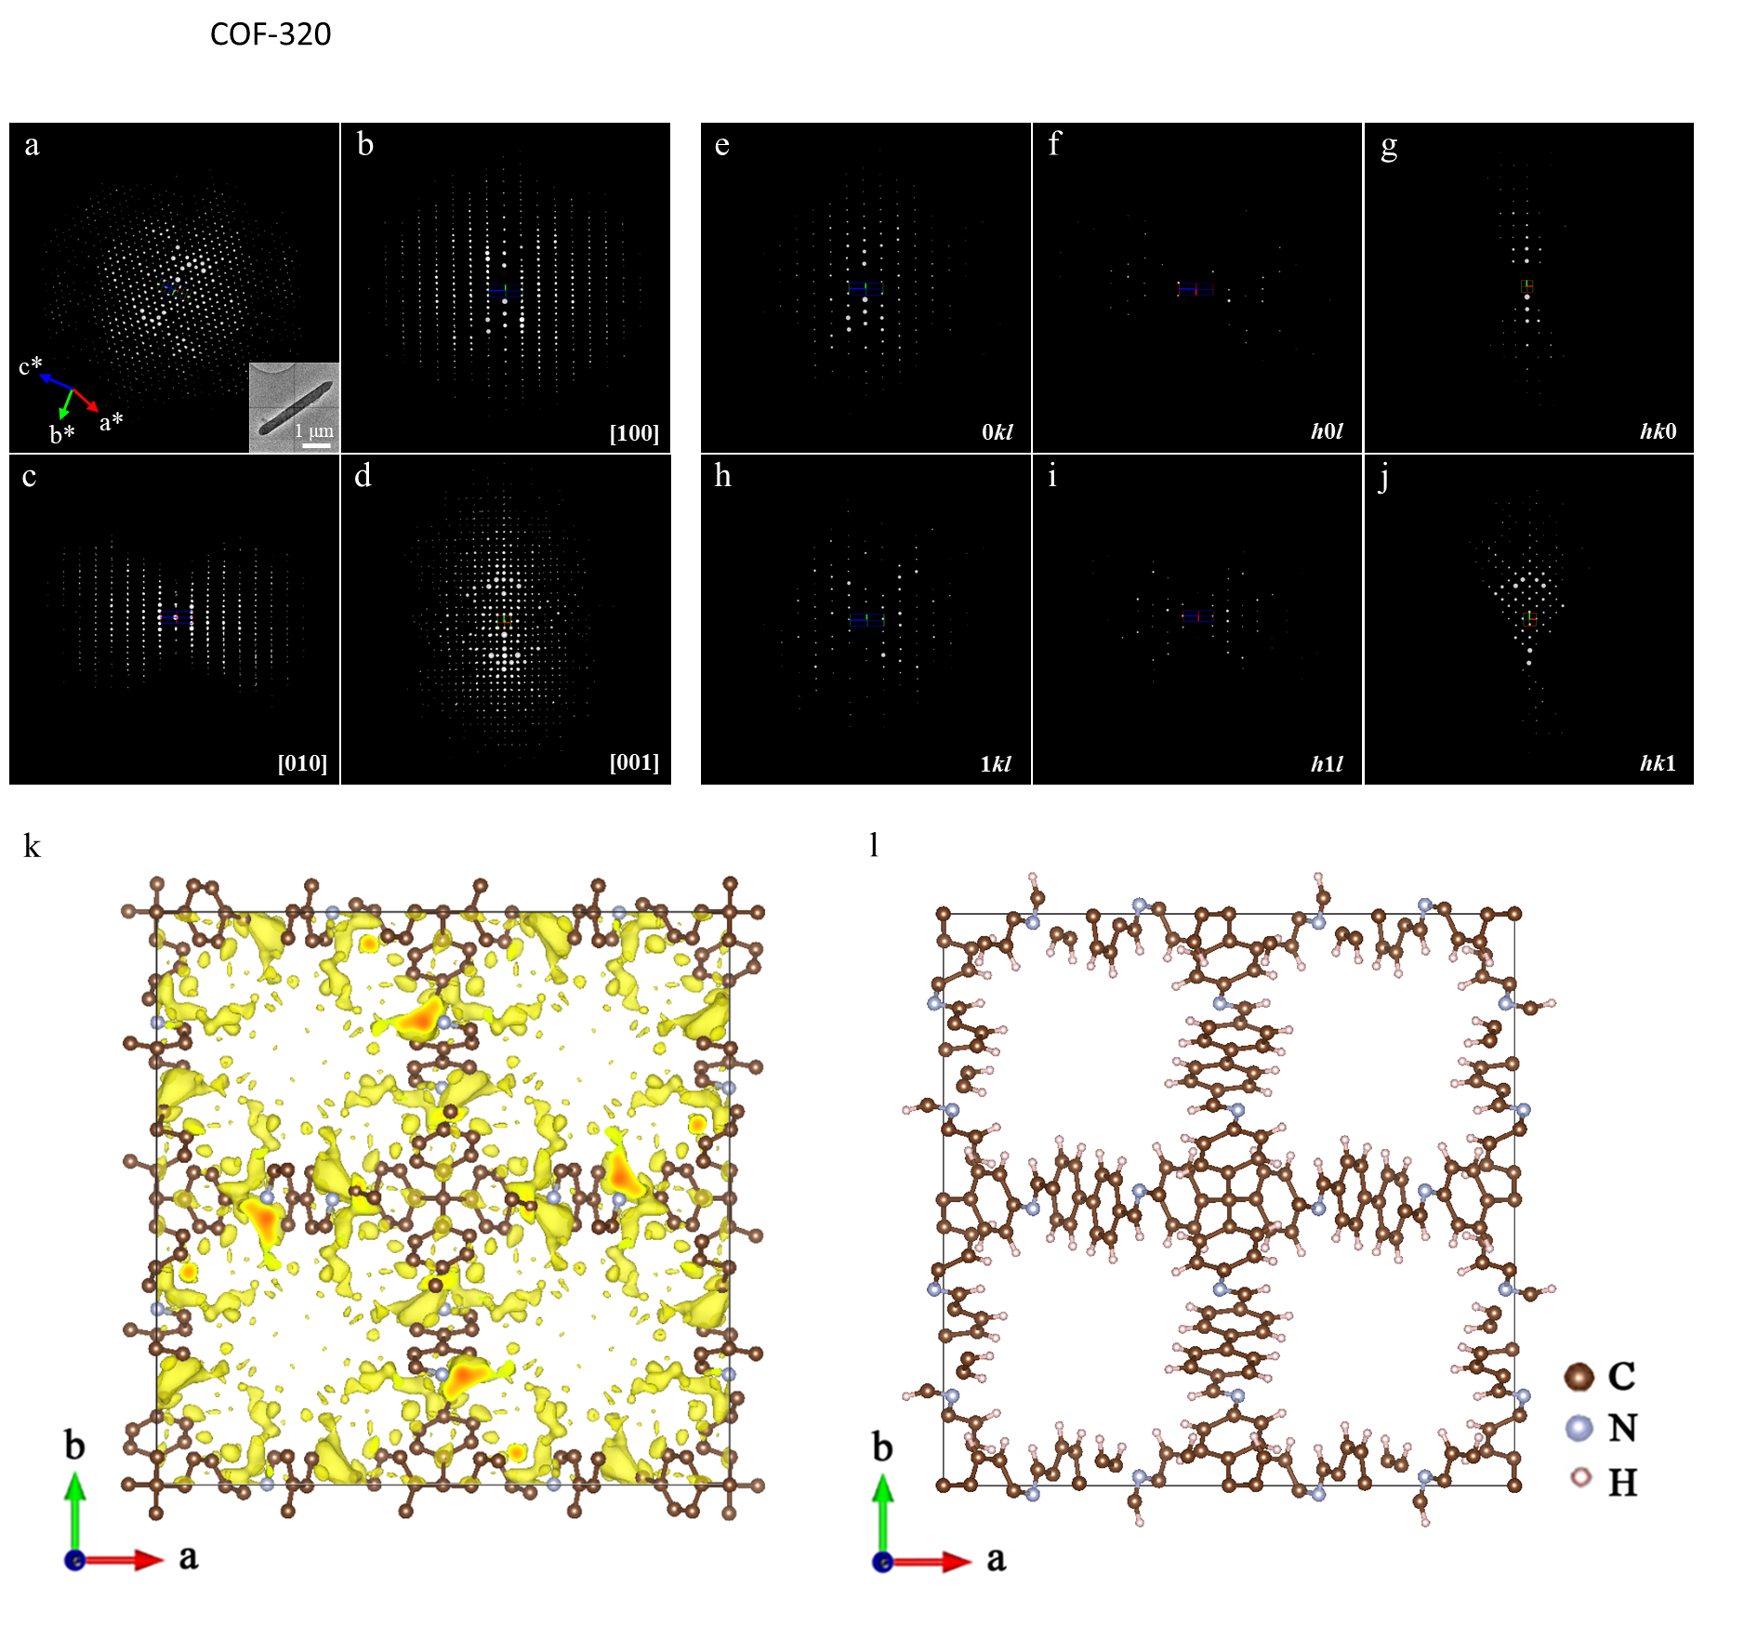

Supplementary Fig. 5. (a-d), The 3D reciprocal lattice of COF-320 reconstructed from the first cRED dataset. Overview of 3D reciprocal lattice. Inset: TEM image of the crystal (3.2 × 0.3 × 0.3 μm³), from which the cRED data was collected (a). View along [100], [010] and [001] direction, respectively (b-d). (e-j), Selected slices cut from the reconstructed 3D reciprocal lattice of COF-320 showing the 0kl (e), h0l (f), hk0 (g), 1kl (h), h1l (i) and hk1 (j). The reflection conditions can be obtained as: hkl: h + k + l = 2n; hk0, h, k = 2n; 00l, l = 4n. (k), The initial structure diagram of as-synthesized COF-320 from cRED data . (l), A schematic diagram of refined COF-320 structure.
Two cRED datasets of COF-320 were collected from different crystals. The data processing results are given in Supplementary Table 4. Structure solution and refinement were conducted on the merged one dataset. Crystallographic data and structure refinement details of COF-320 are given in Supplementary Table 5

Supplementary Table 4. Data processing results of two datasets and the merged one.
Dataset | R_{int} / % | Resolution / Å | Completeness / % | Mean (I/sigma) | No. Total Refls | Cell Dimension / Å | Volume | Tilt Range / °
1 | 21.08 | 0.91 | 90.4 | 3.93 | 5873 | 23.49, 8.35 | 4607.36 | 102.59
2 | 13.55 | 0.92 | 99.1 | 4.72 | 5271 | 23.24, 8.50 | 4590.83 | 91.30
Merged | 22.57 | 0.90 | 99.7 | 4.91 | 11636 | 23.36, 8.43 | 4600.16 | —

Supplementary Table 5. Crystallographic data and structure refinement details performed on the merged cRED dataset of COF-320.
Name | COF-320
Molecular formula | C₅₃N₄H₃₆
Data collection method | cRED
Temperature / K | 100
Wavelength / Å | 0.0251
Crystal system | Tetragonal
Space group | I4₁/a
Unit cell dimensions | a = b = 23.36 Å, c = 8.43 Å,  α = β = γ = 90 °
Cell volume /Å³ | 4600.16
Z | 4
Resolution /Å | 0.91
R_{int} | 22.57
Completeness / % | 99.70
R / % | 38.18
wR / % | 46.15

Section 3. Powder XRD analysis

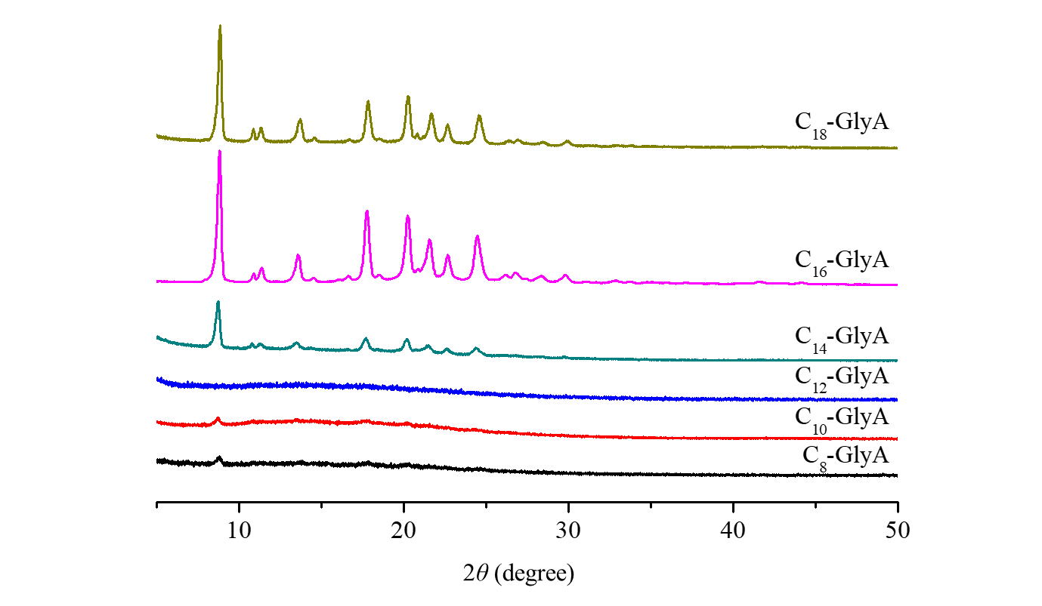

Supplementary Fig. 6. Powder XRD patterns of COF-301 synthesized by different amino acid derivatives.

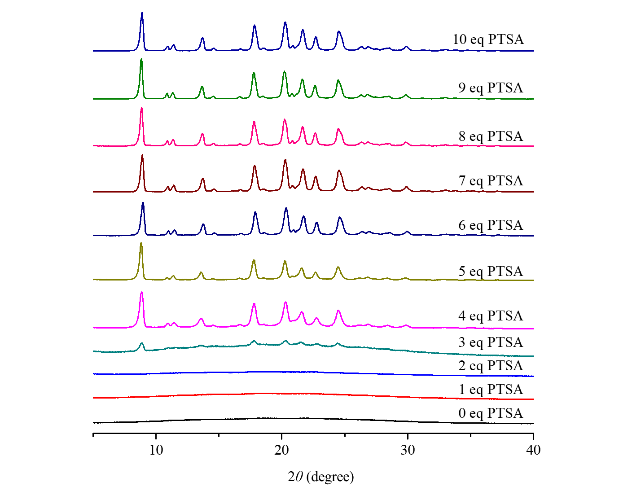

Supplementary Fig. 7. Powder XRD patterns of COF-301 synthesized with different amounts of catalyst.

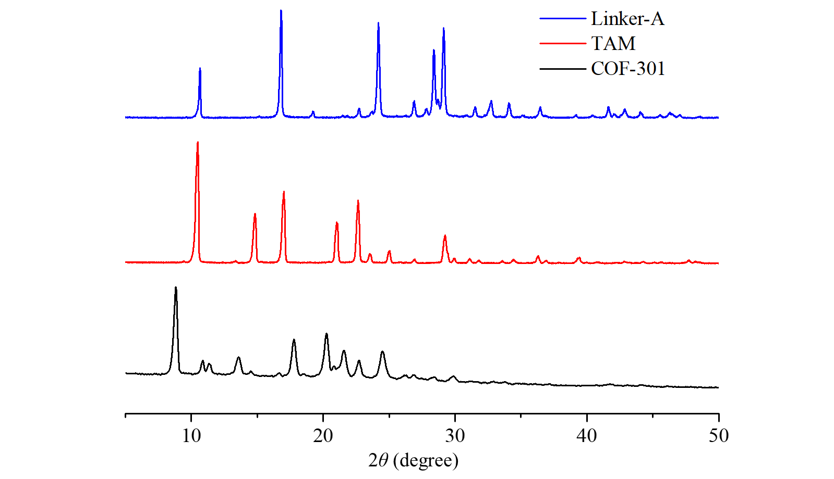

Supplementary Fig. 8. Powder XRD patterns of COF-301, TAM and linker-A.

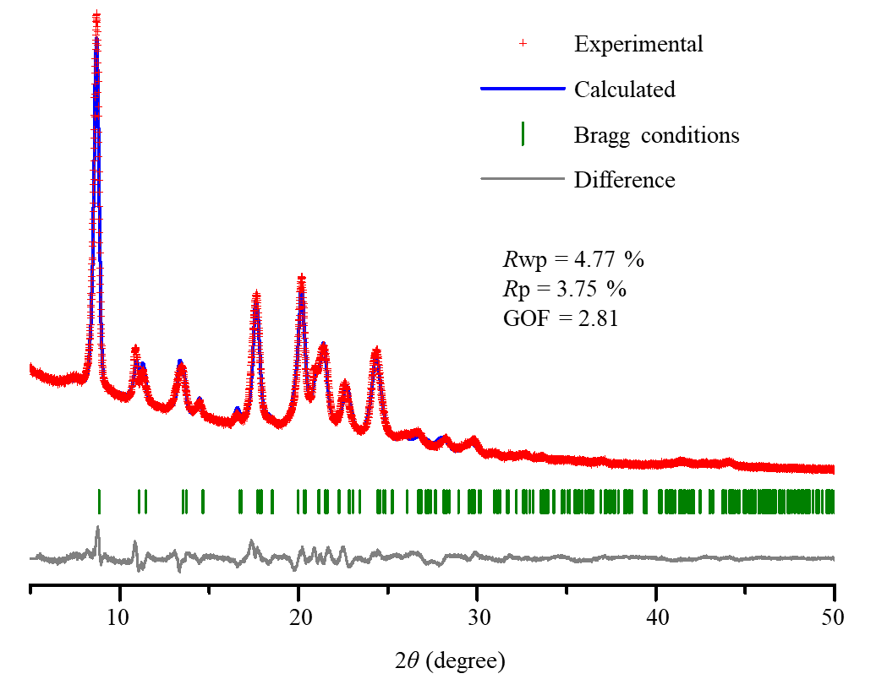

Supplementary Fig. 9. The Rietveld refined powder X-ray diffraction spectrum of COF-301-W.

Supplementary Table 6. Summary for the Rietveld refinement results of COF-301-W. Detailed information for the crystal structure of COF-301-W has been included in the CIF file.
Name | COF-301-W
Molecular formula | C₄₁N₄O₄H₂₈•4H₂O
Formula weight | 712.8
Temperature / K | Room temperature
Wavelength / Å | 1.54051
2θ range for extraction / ° | 5 ~ 50
Data collection | Reflection mode
Crystal system | Monoclinic
Space group | I2/c
Unit cell dimensions | a = 20.276(8) Å, b = 8.7098(18) Å, c = 20.212(4) Å, α = γ = 90 °, β = 99.308(12)°
Cell volume /Å³ | 3522.4(16)
Density / g/cm³ | 1.34
Rp / % | 3.75
Rwp / % | 4.77
GOF | 2.81

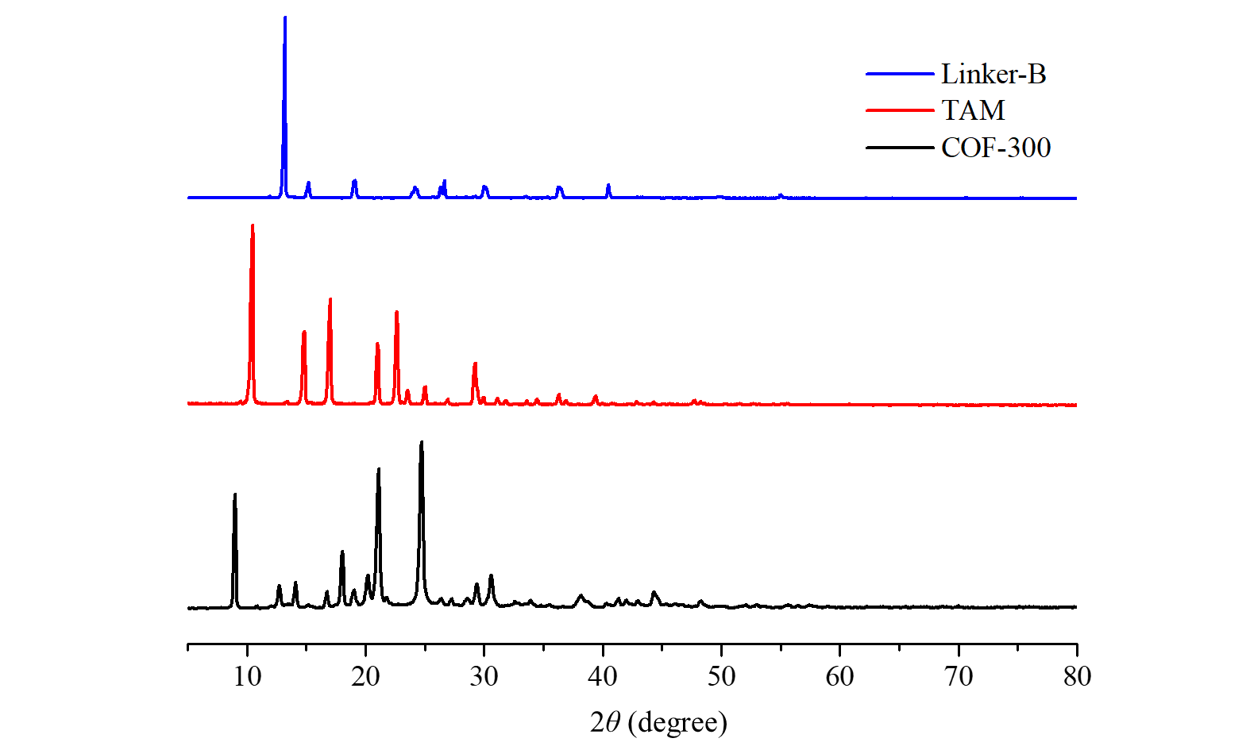

Supplementary Fig. 10. Powder XRD patterns of COF-300, TAM and linker-B.

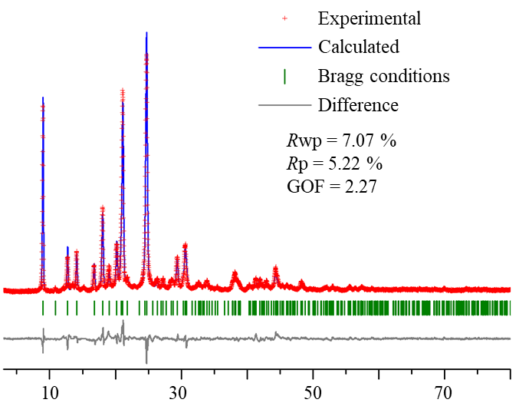

Supplementary Fig. 11. The Rietveld refined powder X-ray diffraction spectrum of COF-300.

Supplementary Table 7. Summary for the Rietveld refinement results of COF-300. Detailed information for the crystal structure of COF-300 has been included in the CIF file.
Name | COF-300
Molecular formula | C₄₁N₄H₂₈•4H₂O
Formula weight | 648.8
Temperature / K | Room temperature
Wavelength / Å | 1.54051
2θ range for extraction / ° | 3 ~ 80
Data collection | Reflection mode
Crystal system | Tetragonal
Space group | I4₁/a
Unit cell dimensions | a = b = 19.6449(14) Å, c = 8.9479(9) Å, α = β = γ = 90 °
Cell volume / Å³ | 3453.2(5)
Density / g/cm³ | 1.2479
Rp / % | 5.27
Rwp / % | 7.07
GOF | 2.27

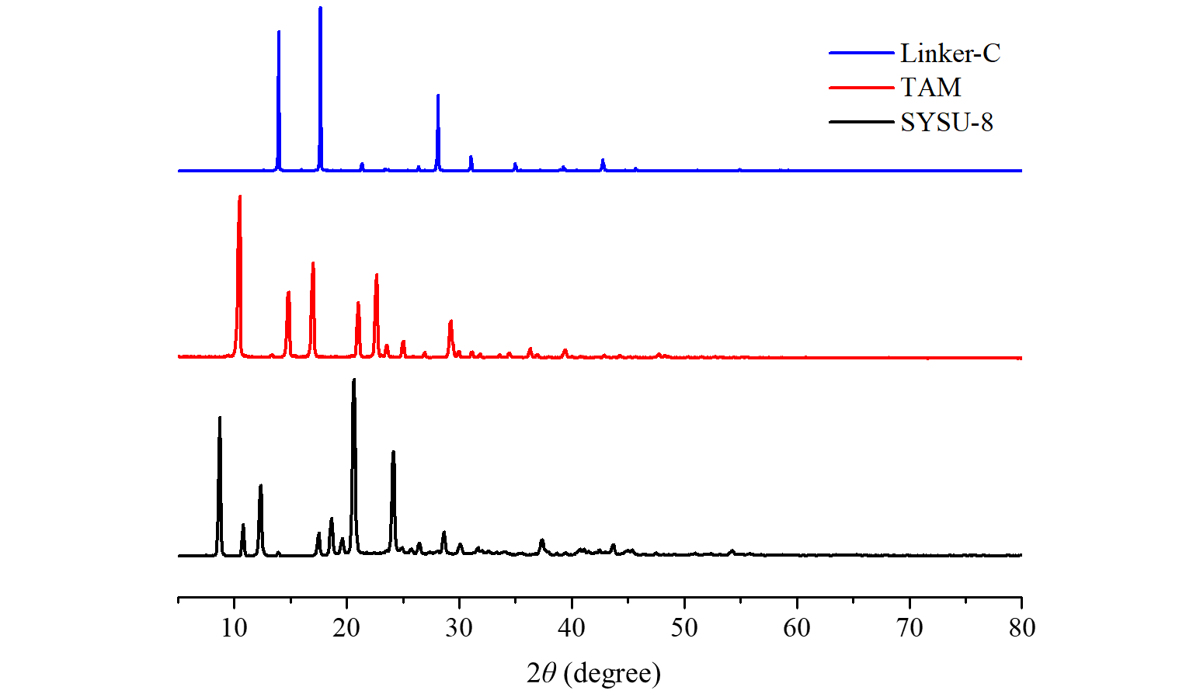

Supplementary Fig. 12. Powder XRD patterns of SYSU-8, TAM and linker-C.
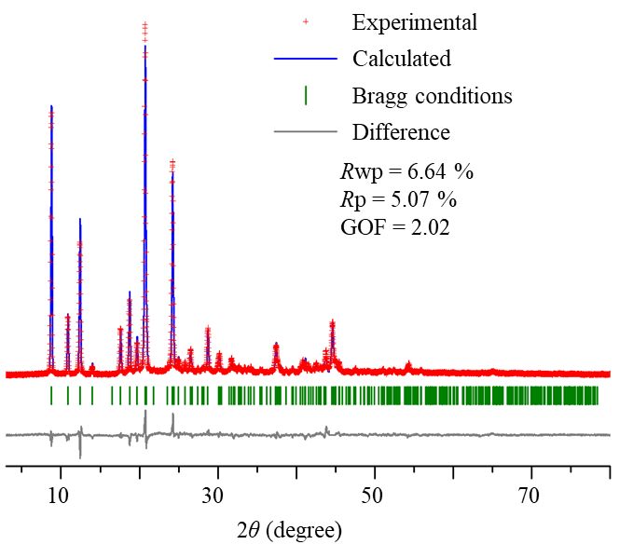

Supplementary Fig. 13. The Rietveld refined powder X-ray diffraction spectrum of SYSU-8.

Supplementary Table 8. Summary for the Rietveld refinement results of SYSU-8. Detailed information for the crystal structure of SYSU-8 has been included in the CIF file.
Name | SYSU-8
Molecular formula | C₄₁N₄F₈H₂₀•0.468H₂O
Formula weight | 729.1
Temperature / K | Room temperature
Wavelength / Å | 1.54051
2θ range for extraction / ° | 3 ~ 80
Data collection | Reflection mode
Crystal system | Tetragonal
Space group | I4₁/a
Unit cell dimensions | a = b = 20.1650(9) Å, c = 8.8984(5) Å, α = β = γ = 90 °
Cell volume / Å³ | 3618.3(3)
Density / g/cm³ | 1.3383
Rp / % | 5.07
Rwp / % | 6.64
GOF | 2.02

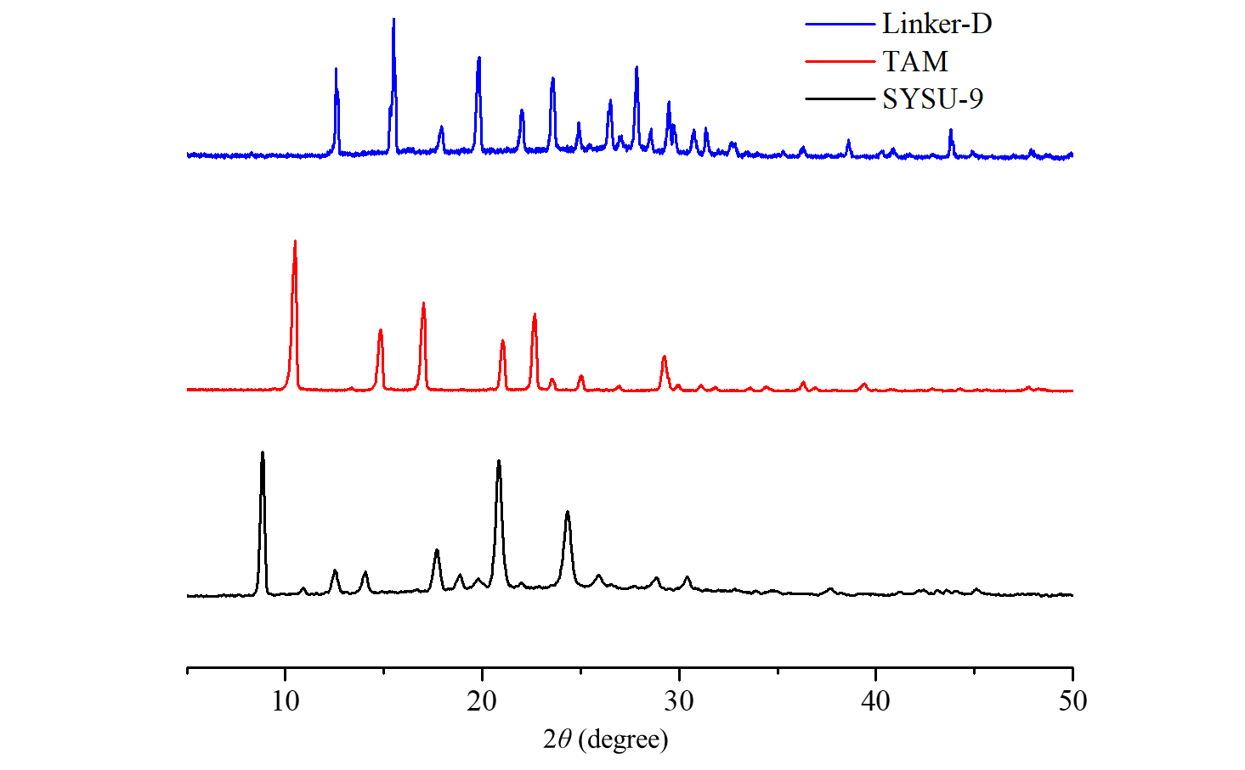

Supplementary Fig. 14. Powder XRD patterns of SYSU-9-W, TAM and linker-D.

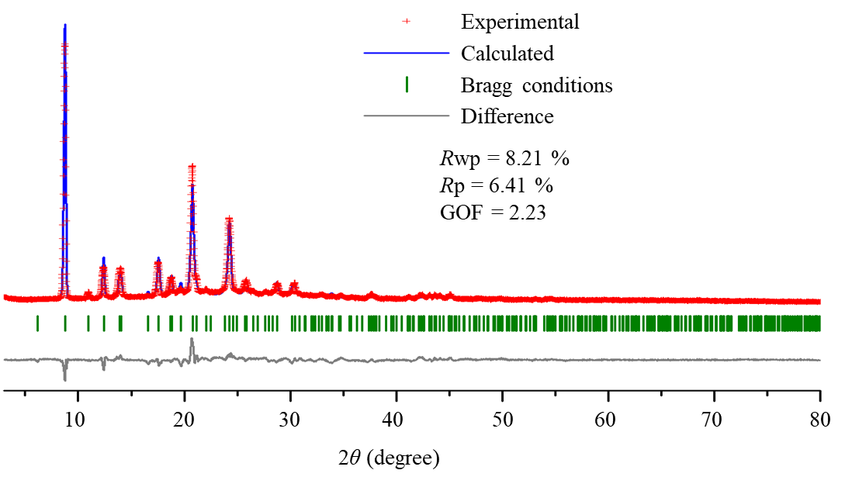

Supplementary Fig. 15. The Rietveld refined powder X-ray diffraction spectrum of SYSU-9-W.

Supplementary Table 9. Summary for the Rietveld refinement results of SYSU-9-W. Detailed information for the crystal structure of SYSU-9-W has been included in the CIF file.
Name | SYSU-9-W
Molecular formula | C₃₉N₆H₂₆•4H₂O
Formula weight | 650.7
Temperature / K | Room temperature
Wavelength / Å | 1.54051
2θ range for extraction / ° | 3 ~ 80
Data collection | Reflection mode
Crystal system | Tetragonal
Space group | I4₁
Unit cell dimensions | a = b = 20.193(3)Å, c = 8.803(2) Å, α = β = γ = 90 °
Cell volume / Å³ | 3589.6(11)
Density / g/cm³ | 1.2041
Rp / % | 6.41
Rwp / % | 8.21
GOF | 2.23

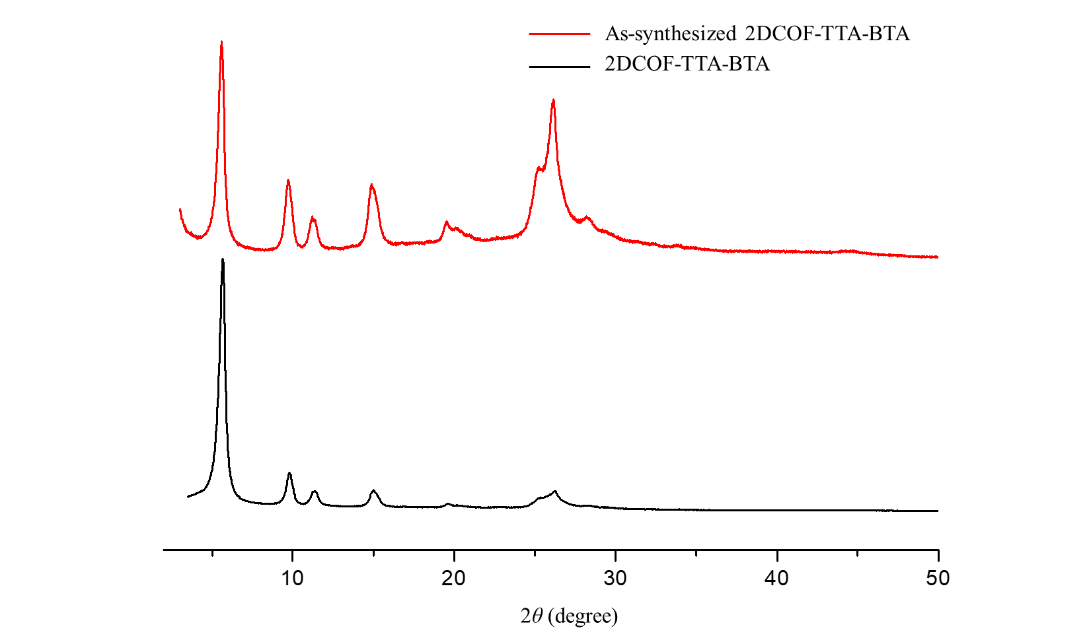

Supplementary Fig. 16. Powder XRD patterns of as-synthesized 2DCOF-TTA-BTA and 2DCOF-TTA-BTA.

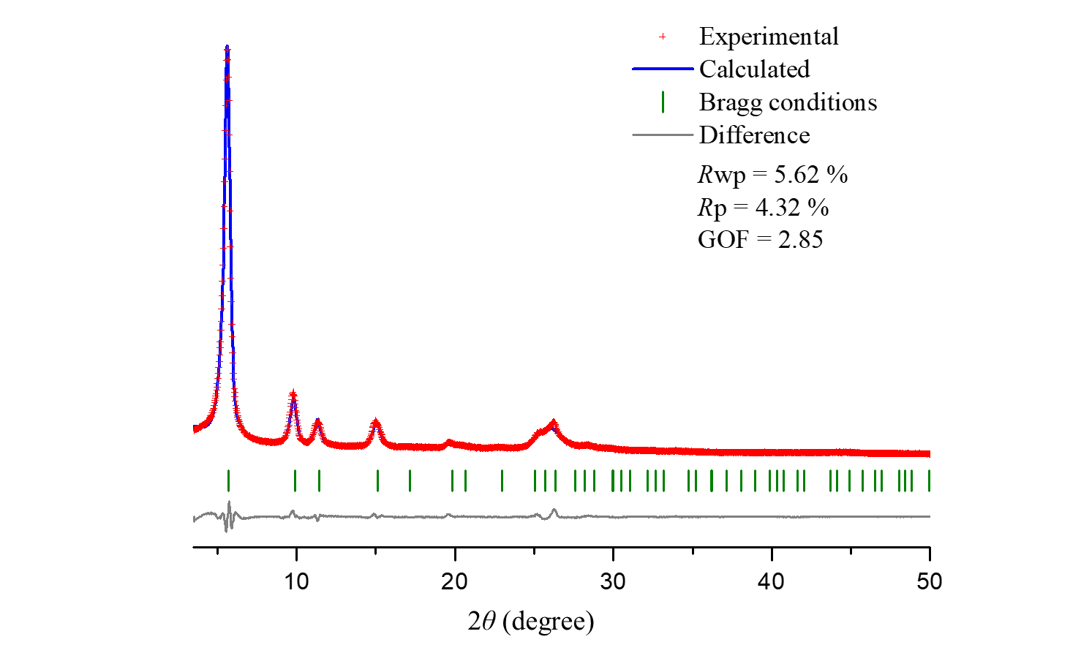

Supplementary Fig. 17. The Rietveld refined powder X-ray diffraction spectrum of 2DCOF-TTA-BTA.

Supplementary Table 10. Summary for the Rietveld refinement results of 2DCOF-TTA-BTA. Detailed information for the crystal structure of 2DCOF-TTA-BTA has been included in the CIF file.
Name | 2DCOF-TTA-BTA
Molecular formula | C₃₀ N₆H₁₈•9H₂O
Formula weight | 606.5
Temperature / K | Room temperature
Wavelength / Å | 1.54059
2θ range for extraction / ° | 3.5 ~ 50
Data collection | Reflection mode
Crystal system | hexagonal
Space group | P-6
Unit cell dimensions | a = b = 17.875(8) Å, c = 3.4652(11) Å, α = β = 90°, γ = 120°
Cell volume / Å³ | 958.8(7)
Density / g/cm³ | 1.0504
Rp / % | 4.32
Rwp / % | 5.62
GOF | 2.85

Section 4. Solid-state nuclear magnetic resonance spectroscopic analysis
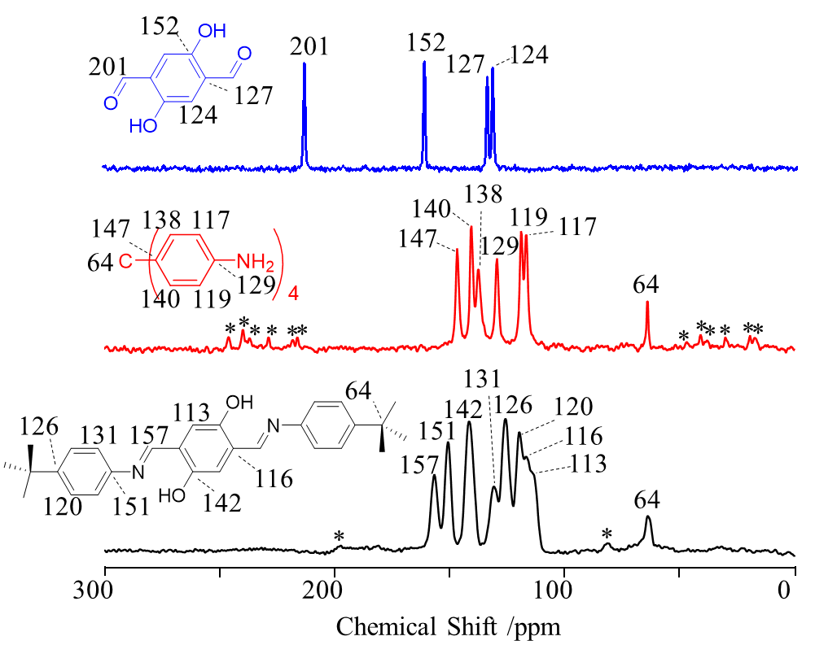

Supplementary Fig. 18. ¹³C CP/MAS spectrums of COF-301, TAM and linker-A.

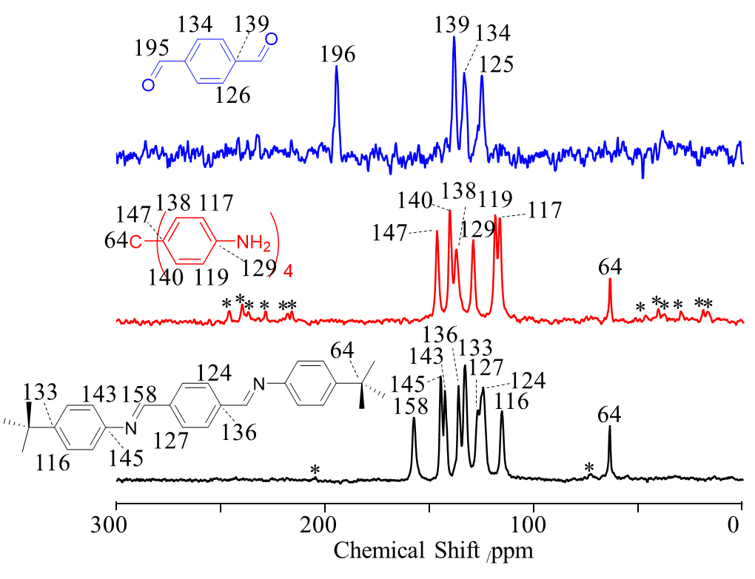

Supplementary Fig. 19. ¹³C CP/MAS spectrums of COF-300, TAM and linker-B.
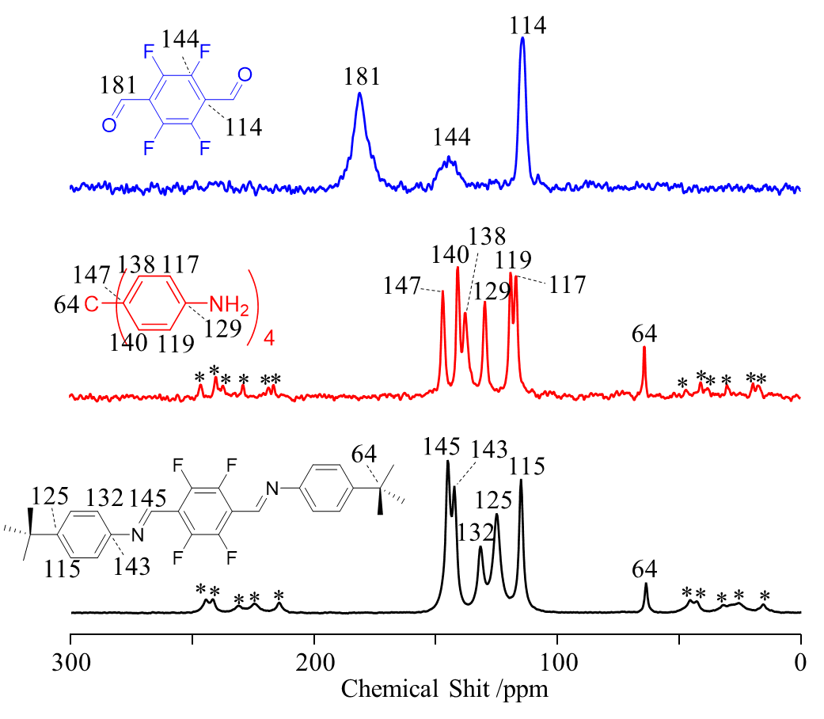

Supplementary Fig. 20. ¹³C CP/MAS spectrums of SYSU-8, TAM and linker-C.

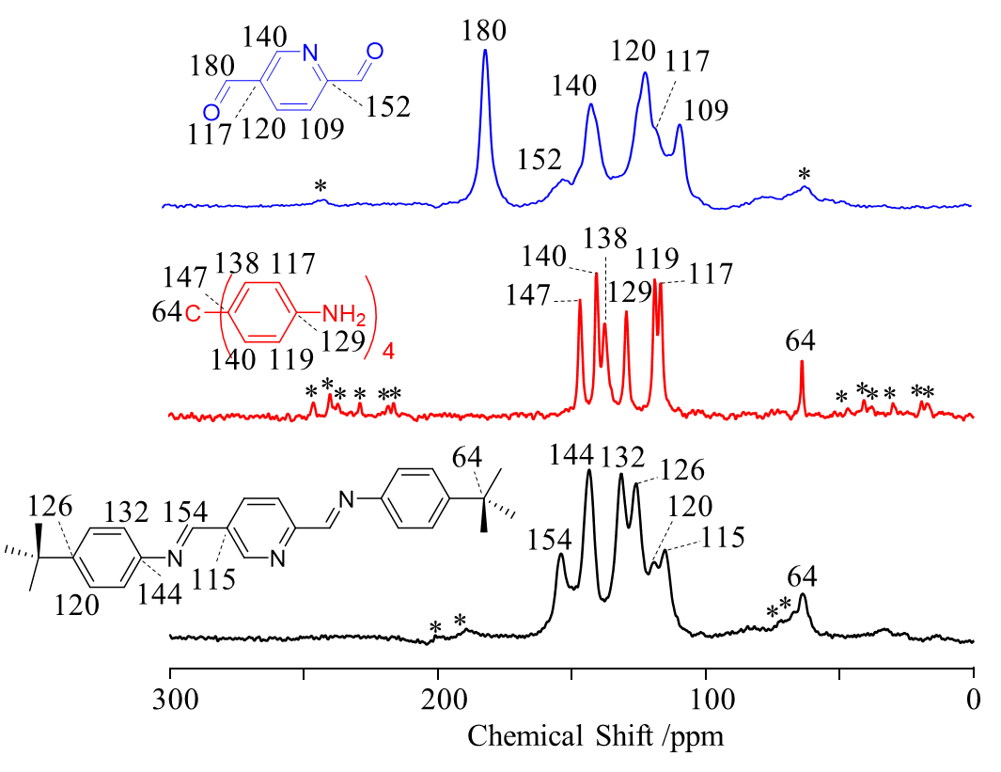

Supplementary Fig. 21. ¹³C CP/MAS spectrums of SYSU-9, TAM and linker-D.

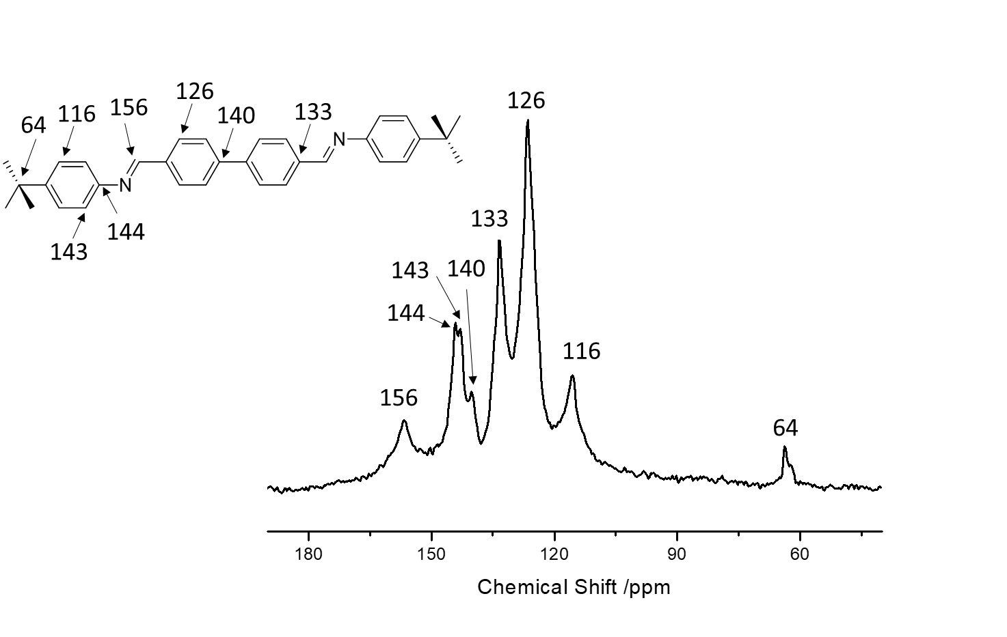

Supplementary Fig. 22. ¹³C CP/MAS spectrum of COF-320.
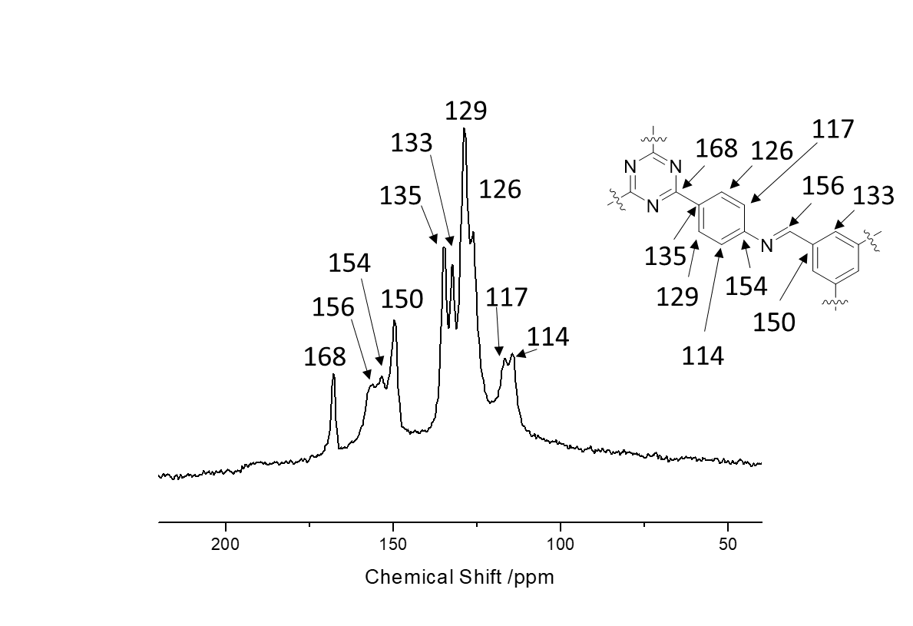

Supplementary Fig. 23. ¹³C CP/MAS spectrum of 2DCOF-TTA-BTA.

Section 5. Fourier transform infrared spectroscopic (FT-IR) analysis
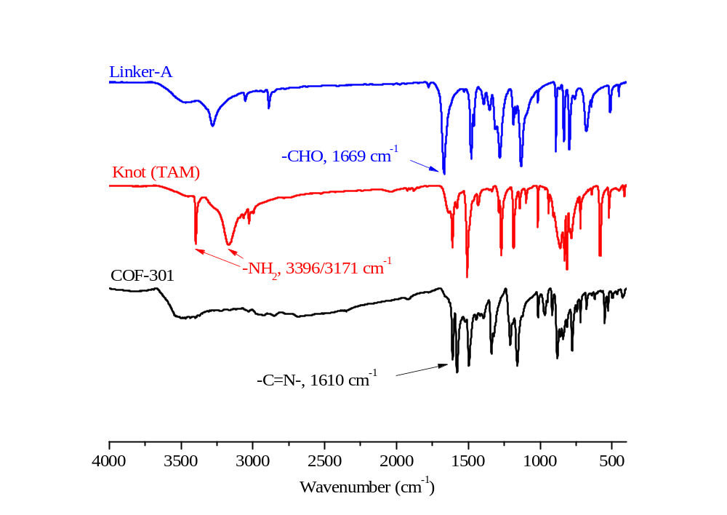

Supplementary Fig. 24. FT-IR spectrums of COF-301, TAM and linker-A.

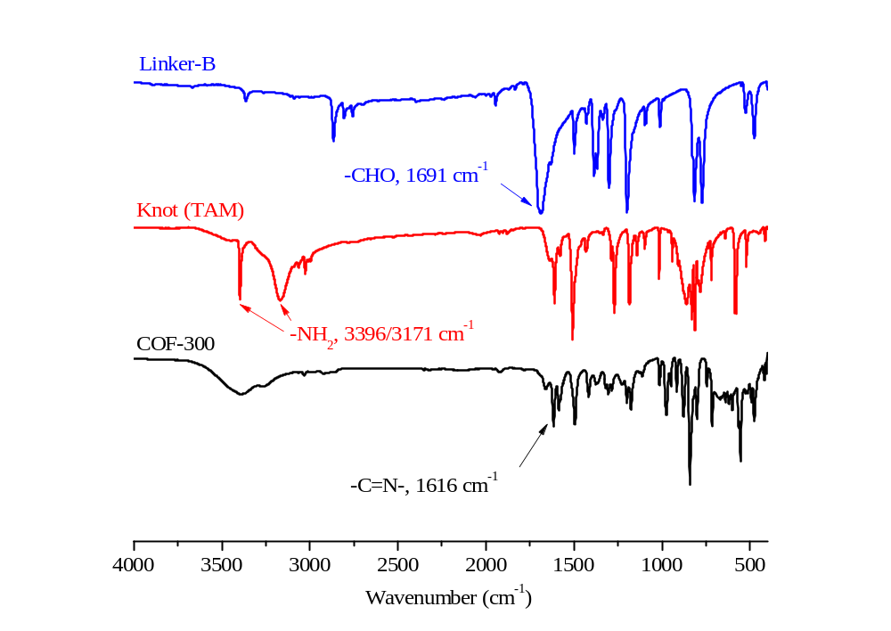

Supplementary Fig. 25. FT-IR spectrums of COF-300, TAM and linker-B.

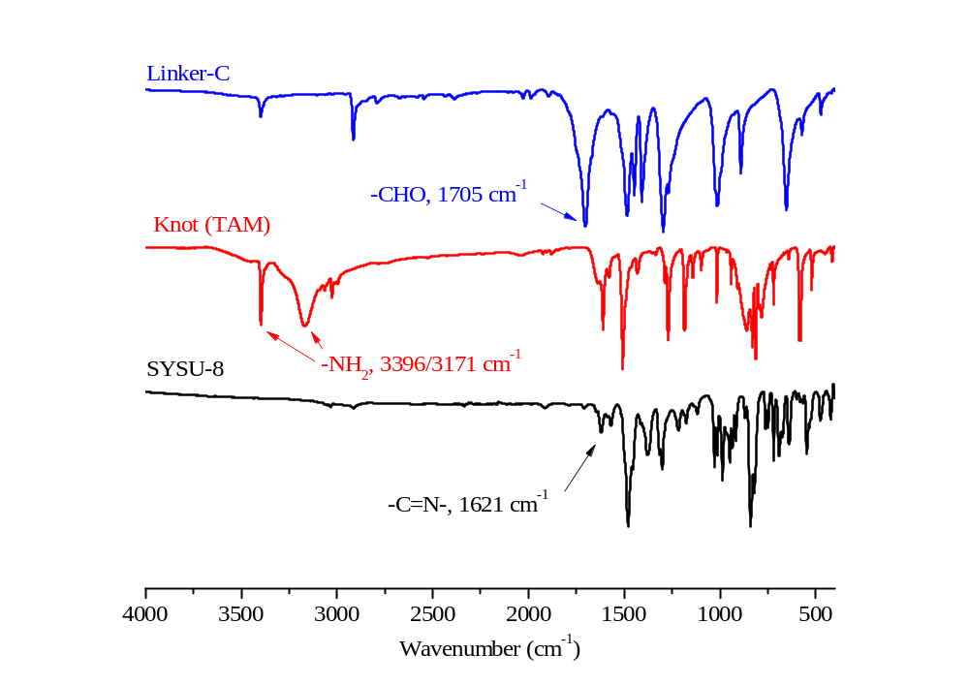

Supplementary Fig. 26. FT-IR spectrums of SYSU-8, TAM and linker-C.

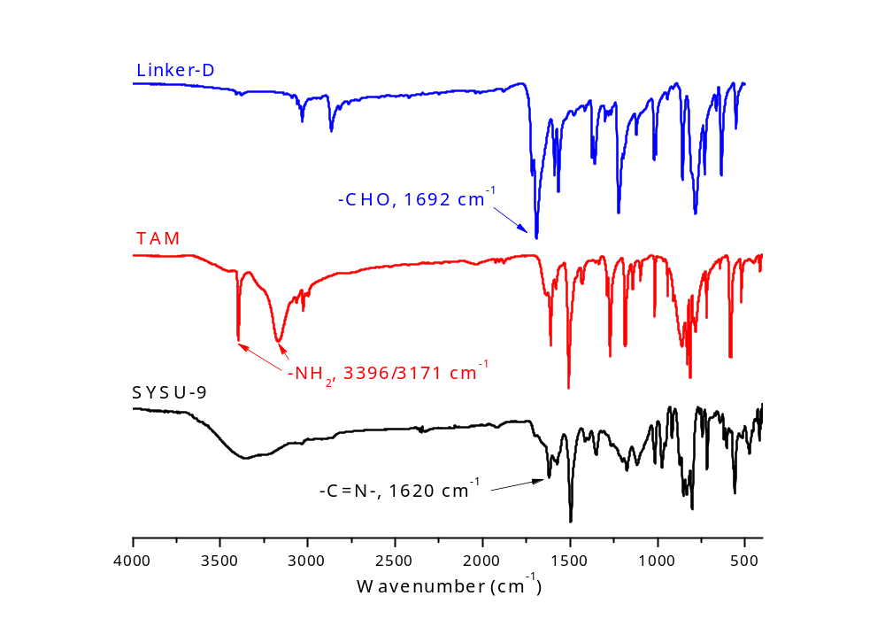

Supplementary Fig. 27. FT-IR spectrums of SYSU-9, TAM and linker-D.

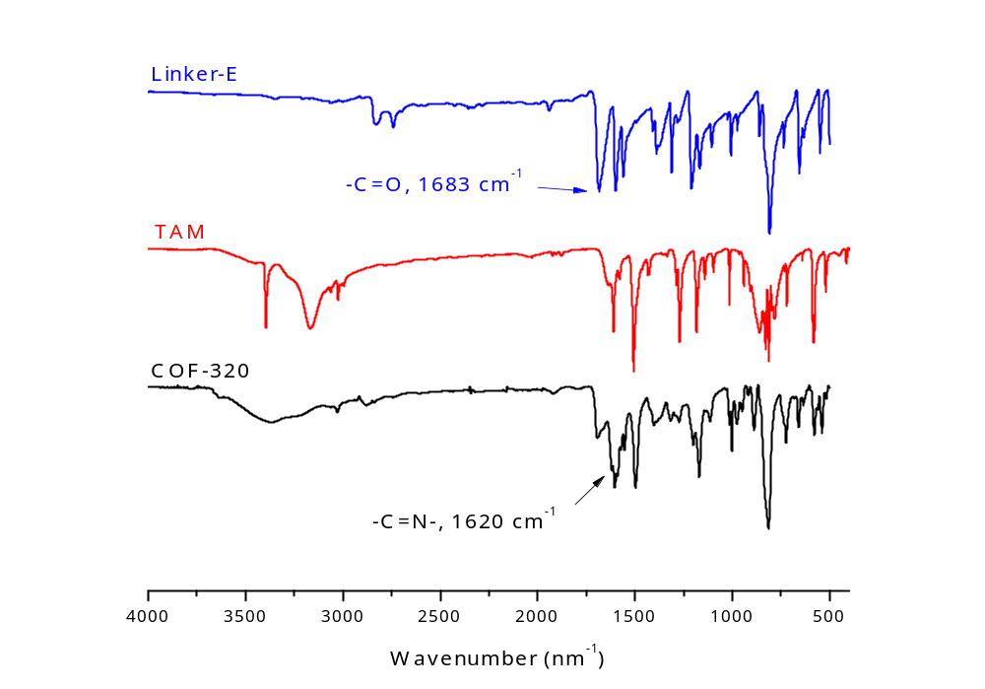

Supplementary Fig. 28. FT-IR spectrums of COF-320, TAM and linker-E.
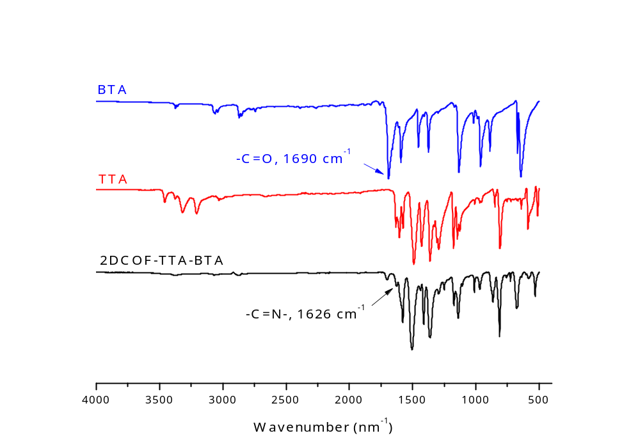

Supplementary Fig. 29. FT-IR spectrums of 2DCOF-TTA-BTA, TTA and BTA.

Section 6. Thermogravimetric analysis (TGA)

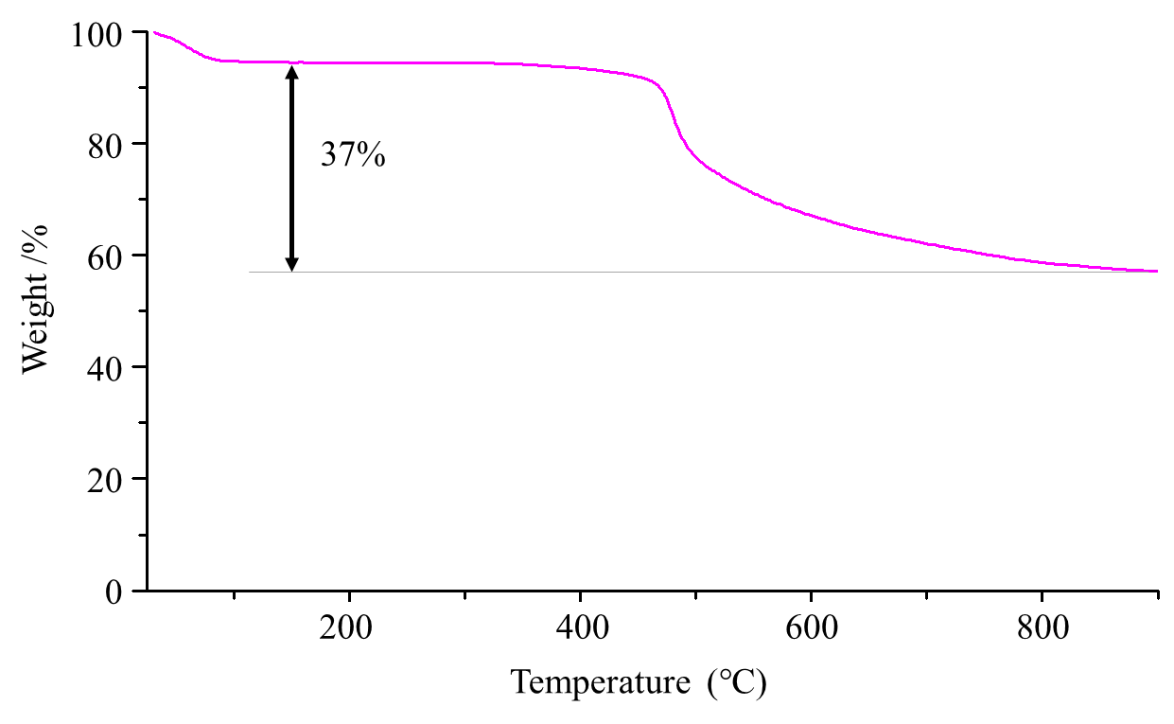

Supplementary Fig. 30. TGA traces of COF-301.

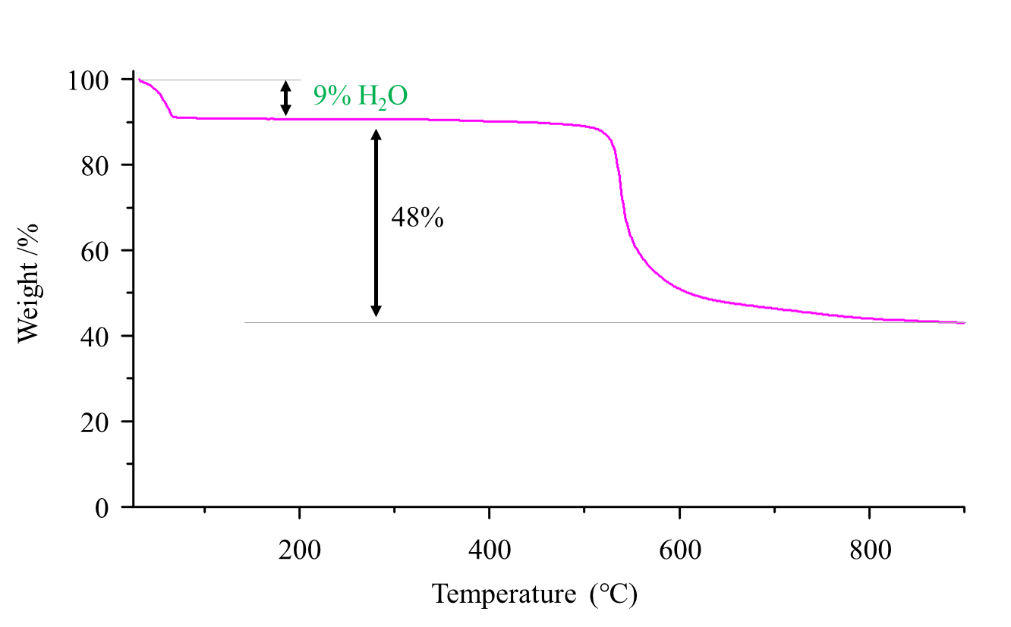

Supplementary Fig. 31. TGA traces of COF-300.

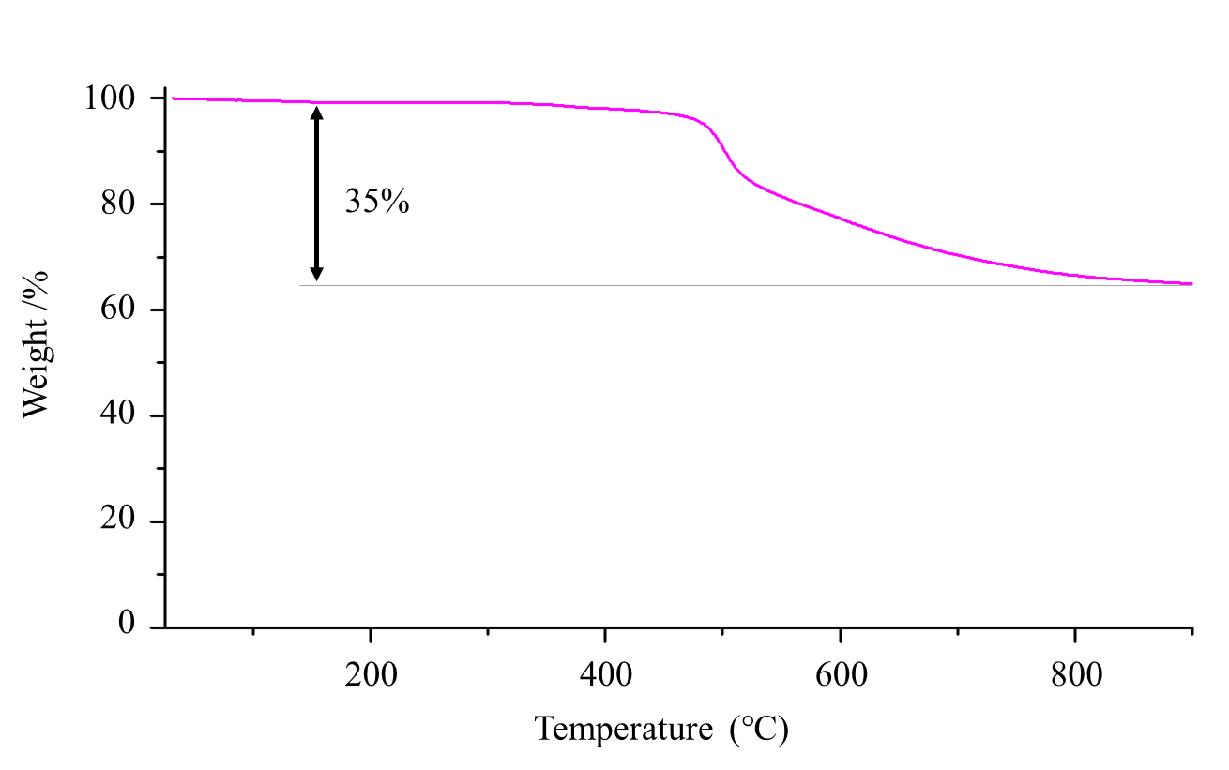

Supplementary Fig. 32. TGA traces of SYSU-8.

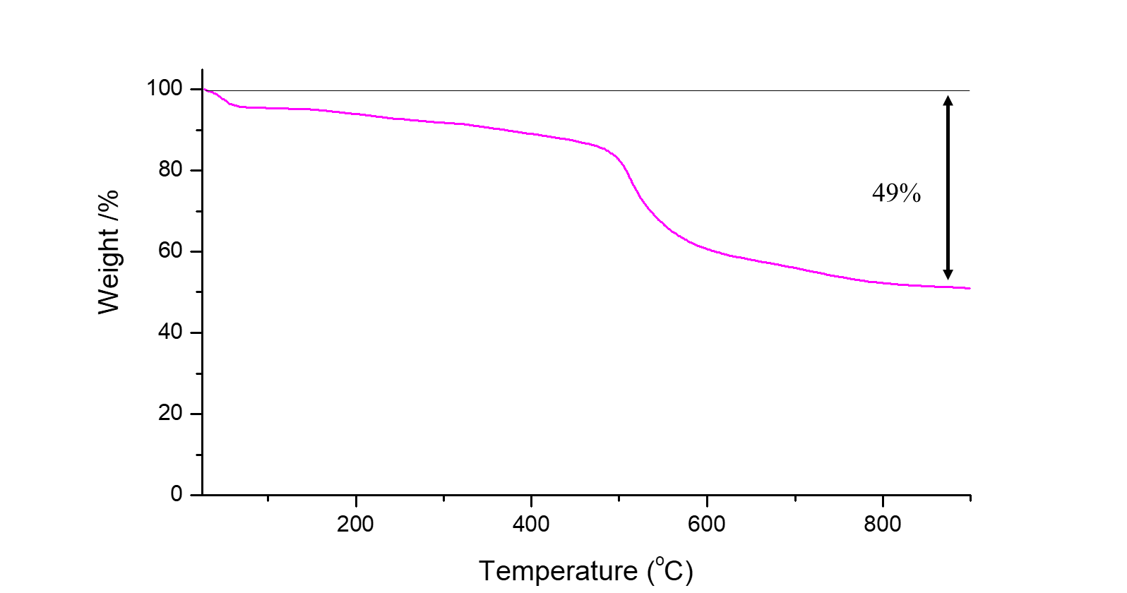

Supplementary Fig. 33. TGA trace of SYSU-9.

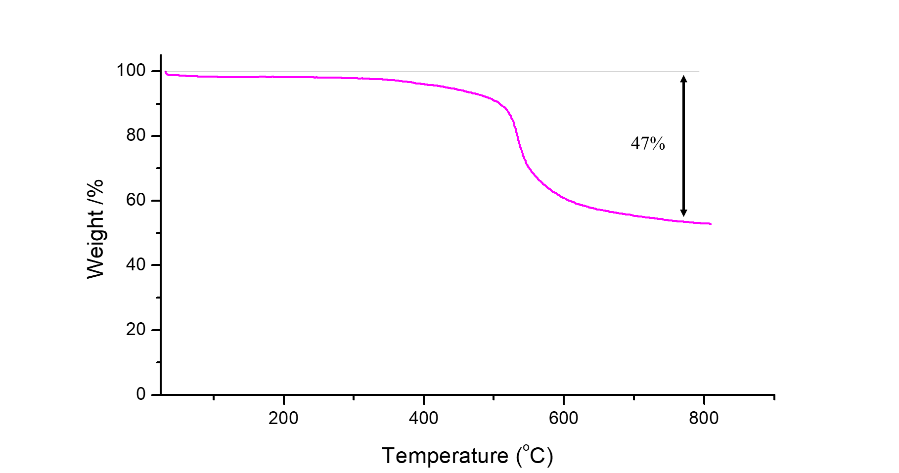

Supplementary Fig. 34. TGA trace of COF-320.

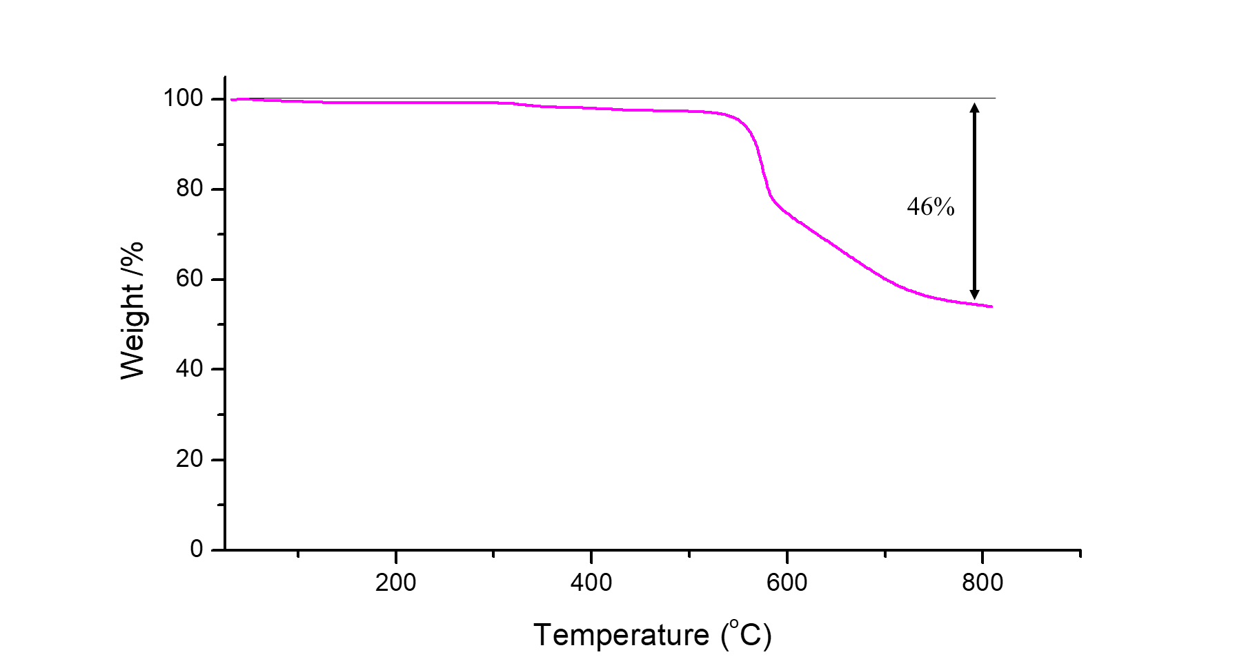

Supplementary Fig. 35. TGA trace of 2DCOF-TTA-BTA

Section 7. Gas absorption and desorption analysis
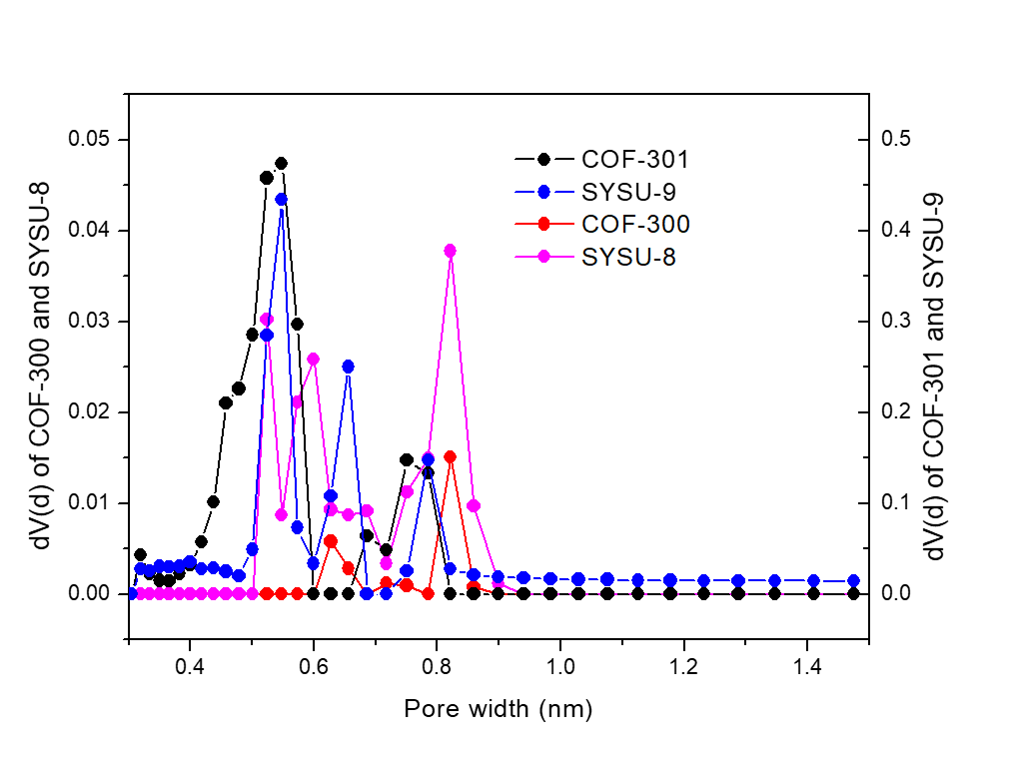

Supplementary Fig. 36. Pore size distribution of COF-300, COF-301 and SYSU-8/9 measured by carbon dioxide at 273K¹².

Supplementary Table 11. Summary of Brunauer-Emmett-Teller surface area and pore size for all the COFs measured with carbon dioxide at 195 K and 273K, respectively.
Entry | COFs | BET surface area / m² g⁻¹ | Pore width (nm)
1 | COF-300 | 458 | 0.82
2 | COF-301 | 314 | 0.55
3 | SYSU-8 | 306 | 0.82
4 | SYSU-9 | 412 | 0.55
5 | COF-320 | 392 | 0.57
6 | COF-AB-c | 448 | 0.57
7 | COF-BC-c | 299 | 0.60

Section 8. Optical microscopic pictures and SEM images of synthesis COFs
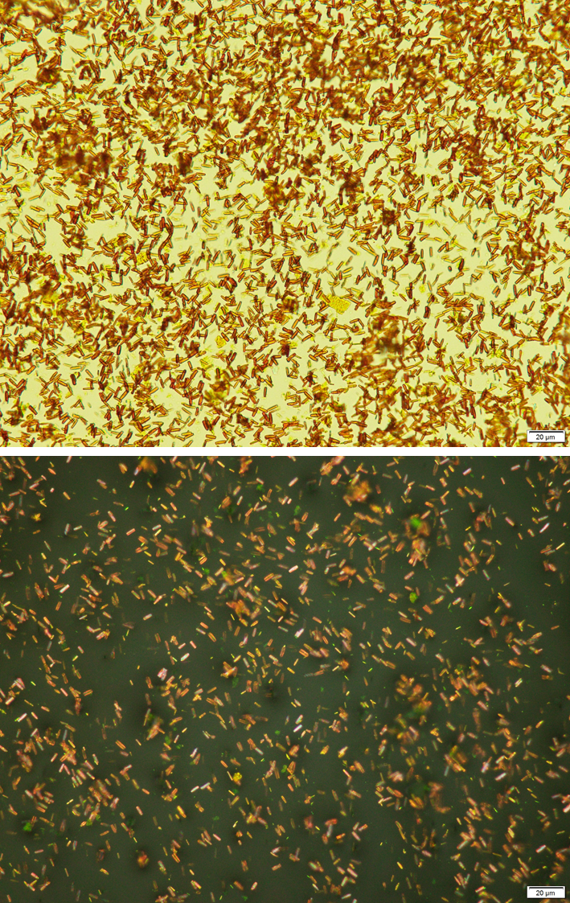

Supplementary Fig. 37. Optical microscopic pictures of gram-scale synthesis COF-301. Transmission mode (top), reflected mode (bottom).

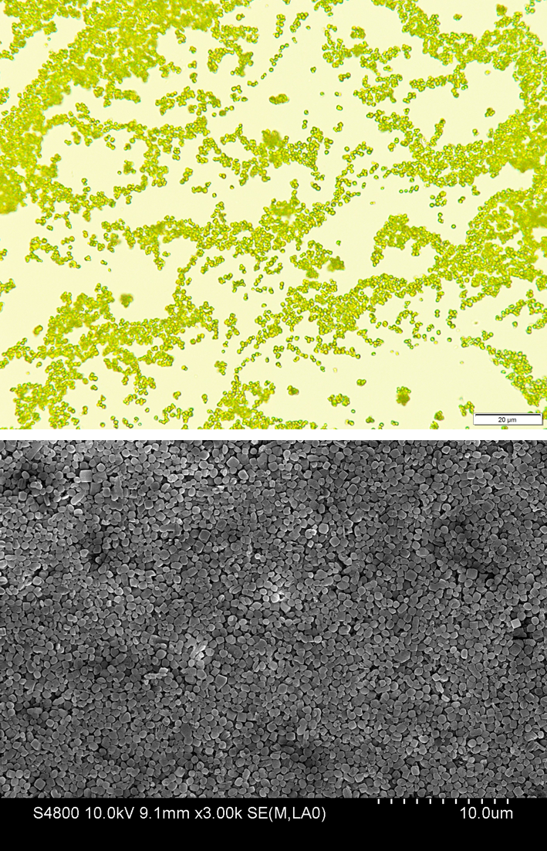

Supplementary Fig. 38. Optical microscopic pictures (transmission mode) and SEM image of gram-scale synthesis COF-300

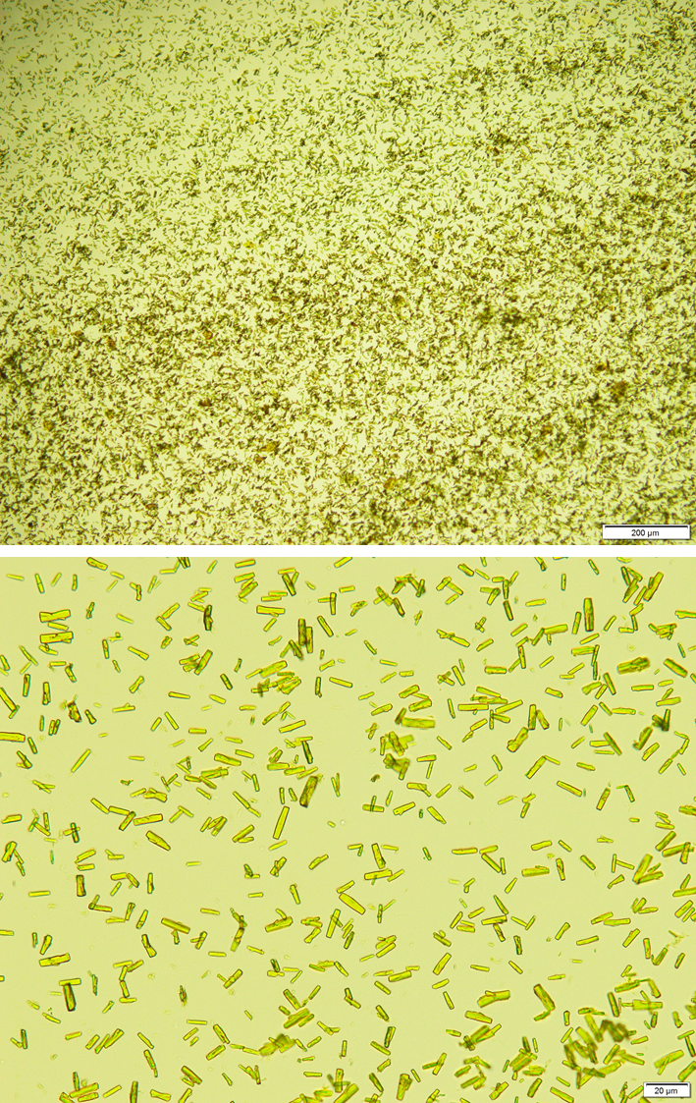

Supplementary Fig. 39. Optical microscopic pictures (transmission mode) of gram-scale synthesis SYSU-8.

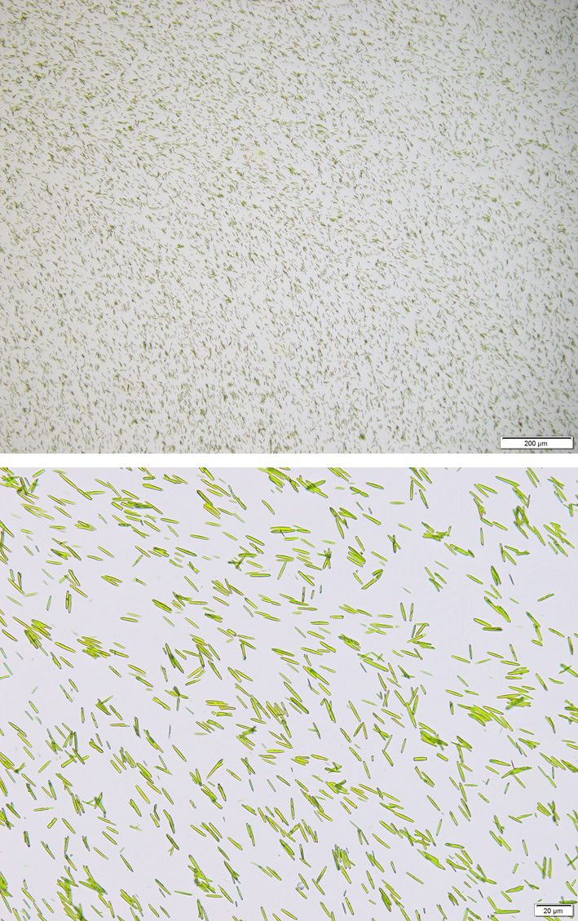

Supplementary Fig. 40. Optical microscopic pictures (transmission mode) of gram-scale synthesis SYSU-9.

Section 9. Atomic force microscopy analysis

Supplementary Fig. 41. SEM image of intentionally aggregated COF-301 crystals were prepared by dip coating on newly cleaved mica.

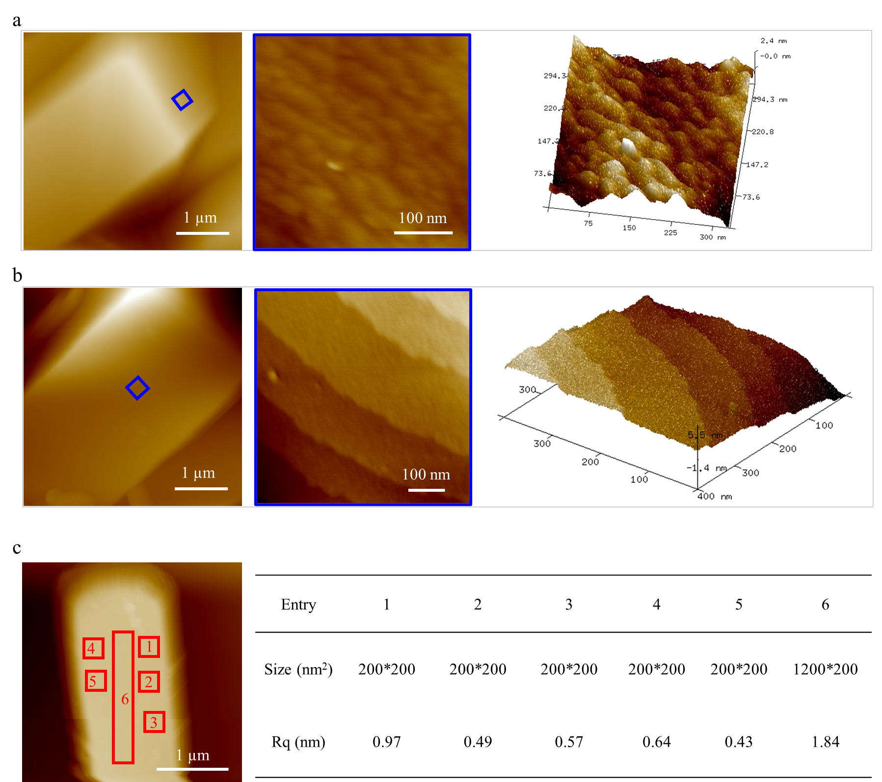

Supplementary Fig. 42 a, b, Atomic force microscopy (AFM) topographic images of the growing (0 1 0) (a) and (1 0 0)/ (0 0 1) facets (b) after being rinsed with tetrahydrofuran and dried in air. c, The root-mean-square roughness (Rq) of the single crystal surface measured by AFM.

Supplementary References
- Sheldrick, G. M. SHELXT-Integrated space-group and crystal-structure determination. Acta Cryst. A71, 3–8 (2015).
- Sheldrick, G. M. Crystal structure refinement with SHELXL. Acta Cryst. C71, 3–8 (2015).
- Sheldrick, G. M. Univ. Göttingen, Ger. (1996).
- Winter, G. et al. DIALS: implementation and evaluation of a new integration package. Acta Crystallogr. D 74, 85–97 (2018).
- Petříček, V. Dušek, M. & Palatinus, L. Crystallographic computing system JANA2006: General features. Z. Krist. -Cryst. Mater. 229, 342-352 (2014).
- Kabsch, W. XDS. Acta Crystallogr. D 66, 125-132 (2010).
- Cichocka, M. O. et al. High-throughput continuous rotation electron diffraction data acquisition via software automation. J. Appl. Crystallogr. 51, 1652-1661 (2018).
- Wan, W. et al. Three-dimensional rotation electron diffraction: software RED for automated data collection and data processing. J. Appl. Crystallogr. 46, 1863-1873 (2013).
- Momma, K. Izumi, F. VESTA 3for three-dimensional visualization of crystal, volumetric and morphology data. J. Appl. Crystallogr. 44, 1272-1276 (2011).
- Takehara, M. Yoshimura, I. Takizawa, K. & Yoshida, R. Surface active N-acylglutamate: I. Preparation of long chain N-acylglutamic acid. J. Am. Oil Chem. Soc. 49, 157-161 (1972).
- Ma, T. Q. et al. Single-crystal x-ray diffraction structures of covalent organic frameworks. Science 361, 48–52 (2018).
- Quantachrome Instruments Powder Tech Note 31.

