Extended Data Figures

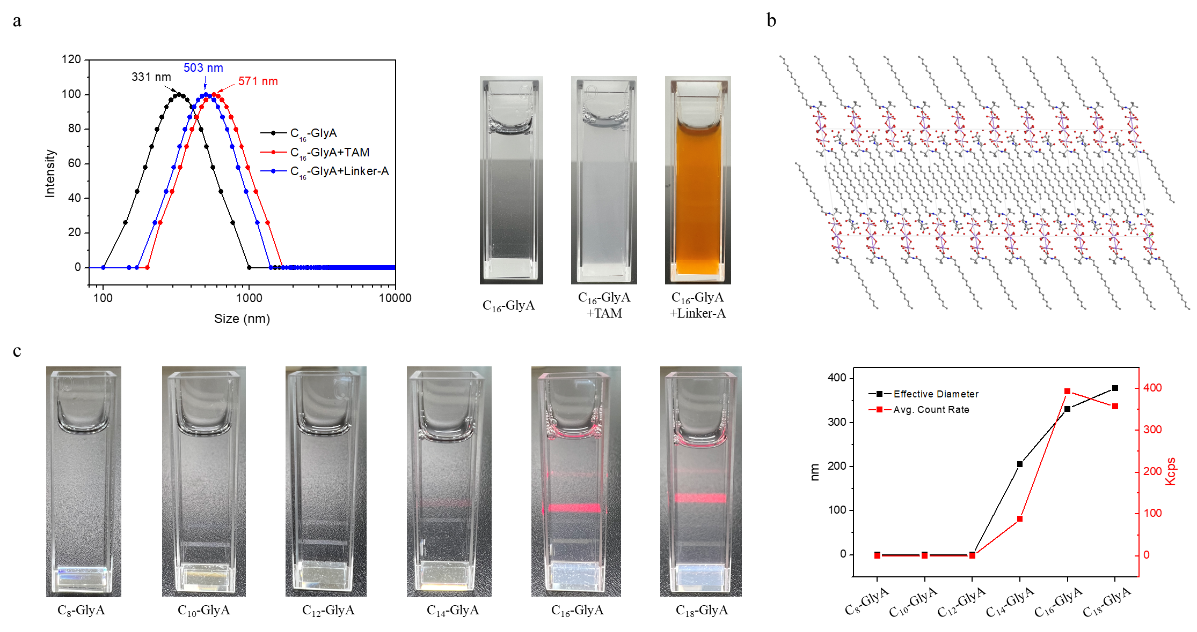
Extended Data Fig. 1 | a, The Dynamic light scattering (DLS) number-average size of the assembled C₁₆-GlyA, C₁₆-GlyA+TAM (TAM without protonation) and C₁₆-GlyA+linker-A. b, Structure of C₁₆-L-tLeuA by single-crystal XRD. c, The DLS number-average size of the assembled glycine derivative with different aliphatic chain lengths.
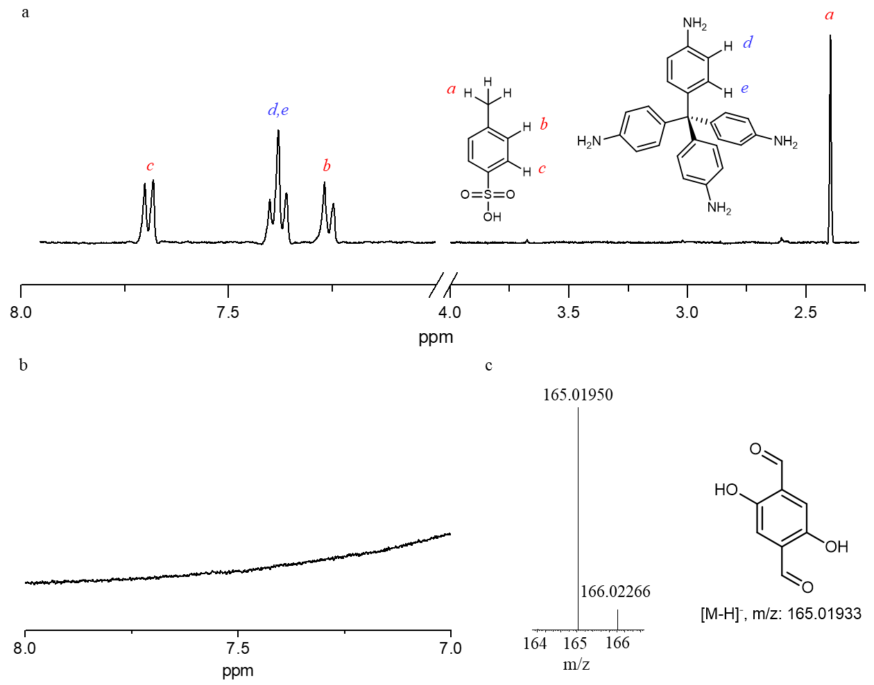
Extended Data Fig. 2 | a, ¹H-NMR of the aqueous phase after adding P-toluenesulfonic acid (PTSA) protonated TAM to aqueous solution of C₁₆-GlyA. b, ¹H-NMR of the aqueous phase after adding TAM powder. TAM was not detected in the aqueous phase. c, ESI-HRMS of oil phase after adding linker-A to aqueous solution of C₁₆-GlyA.
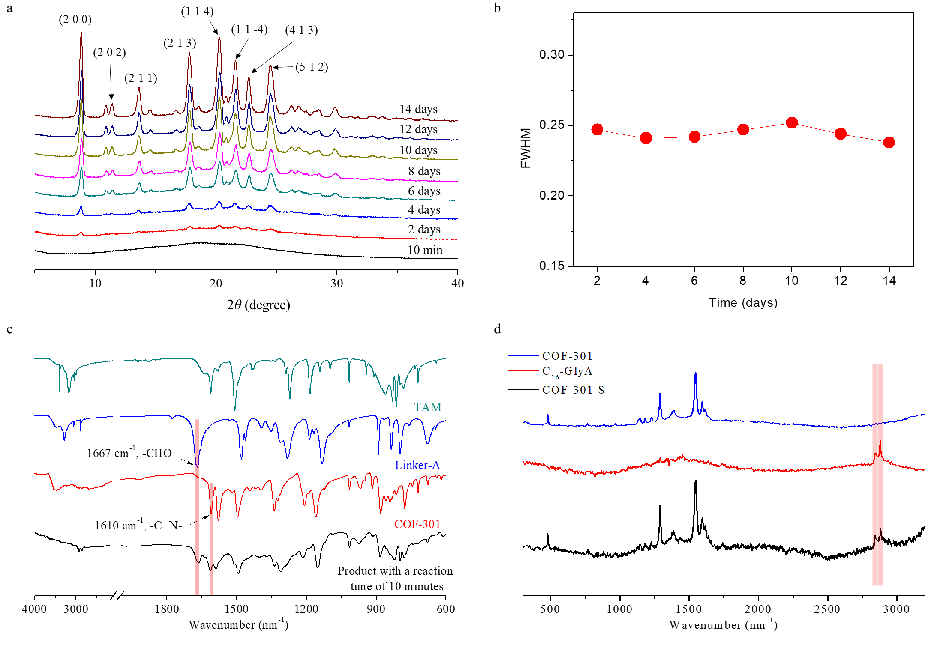
Extended Data Fig. 3 | a, b, Powder XRD patterns (a) and full width at half maxima (FWHM) of (2 0 0) (b) of solid products separated from the reaction system at different reaction times. c, Infrared spectra of TAM, linker-A, COF-301 and product with a reaction time of 10 minutes. d, Confocal Raman spectroscopy of COF-301, C₁₆-GlyA and COF-301-S.
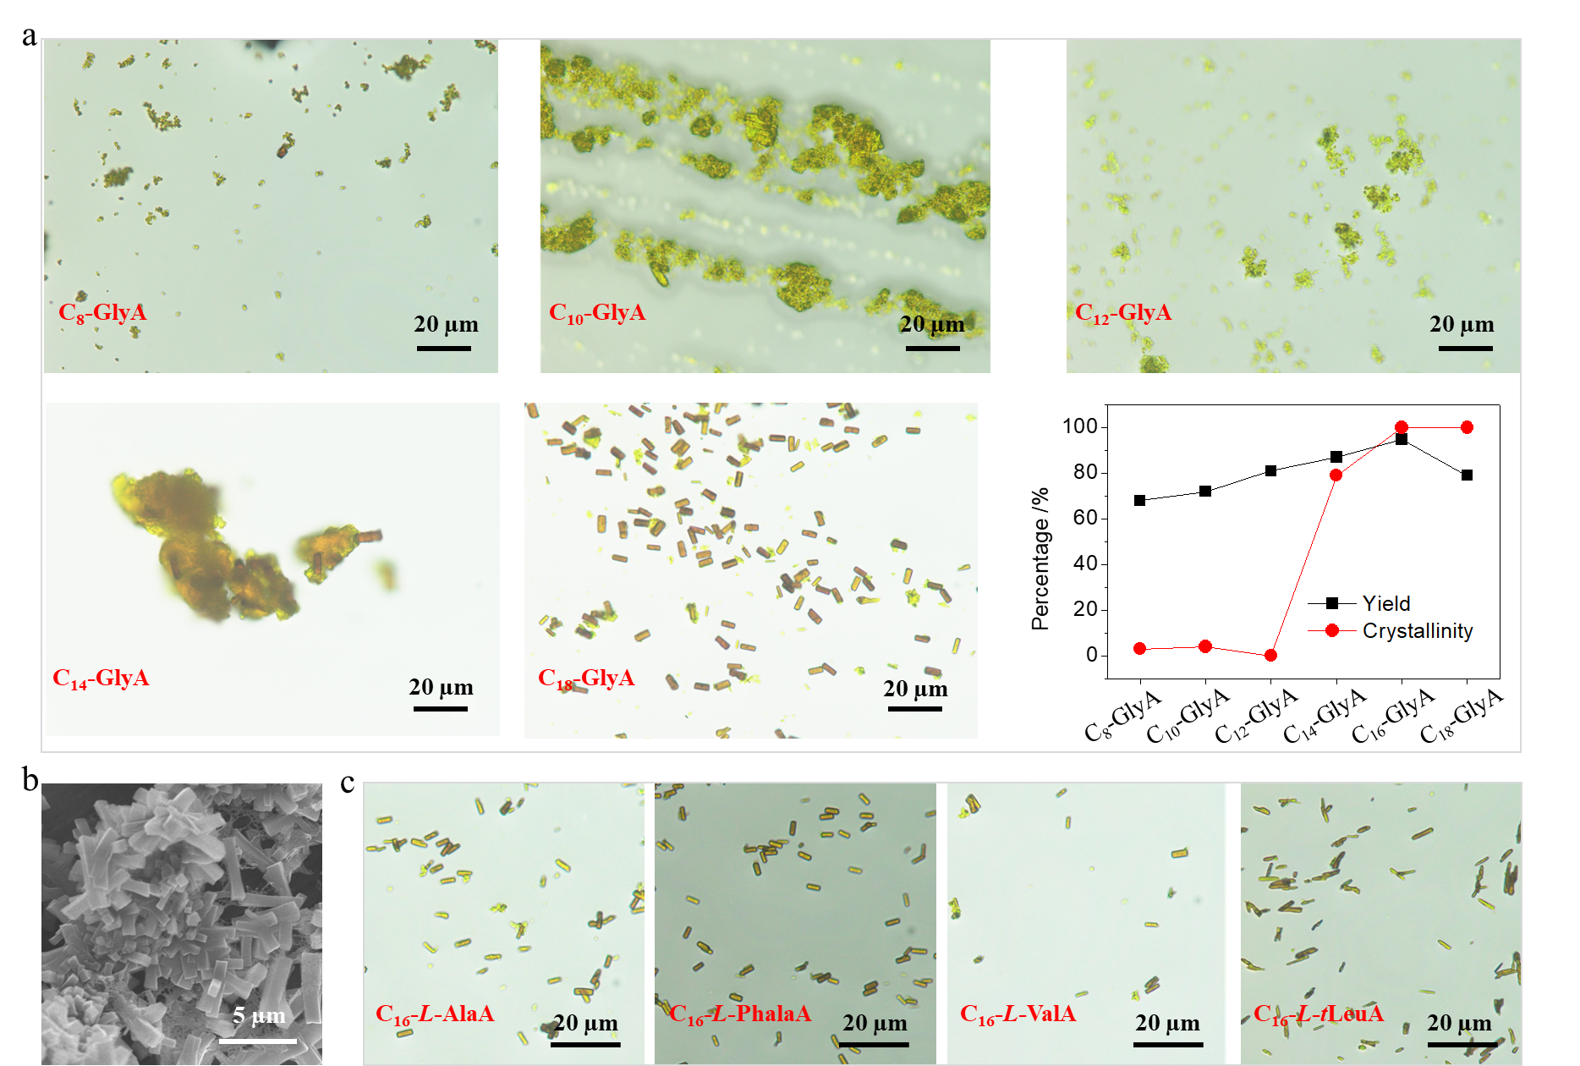
Extended Data Fig. 4 | a, The yield and crystallinity of COF-301 obtained from glycine derivatives with different aliphatic chain lengths. b, COF-301 synthesized under mediation of palmitic acid in water under ambient conditions. c, Optical images of COF-301 synthesized under mediation of different amino acid derivatives in water under ambient conditions.
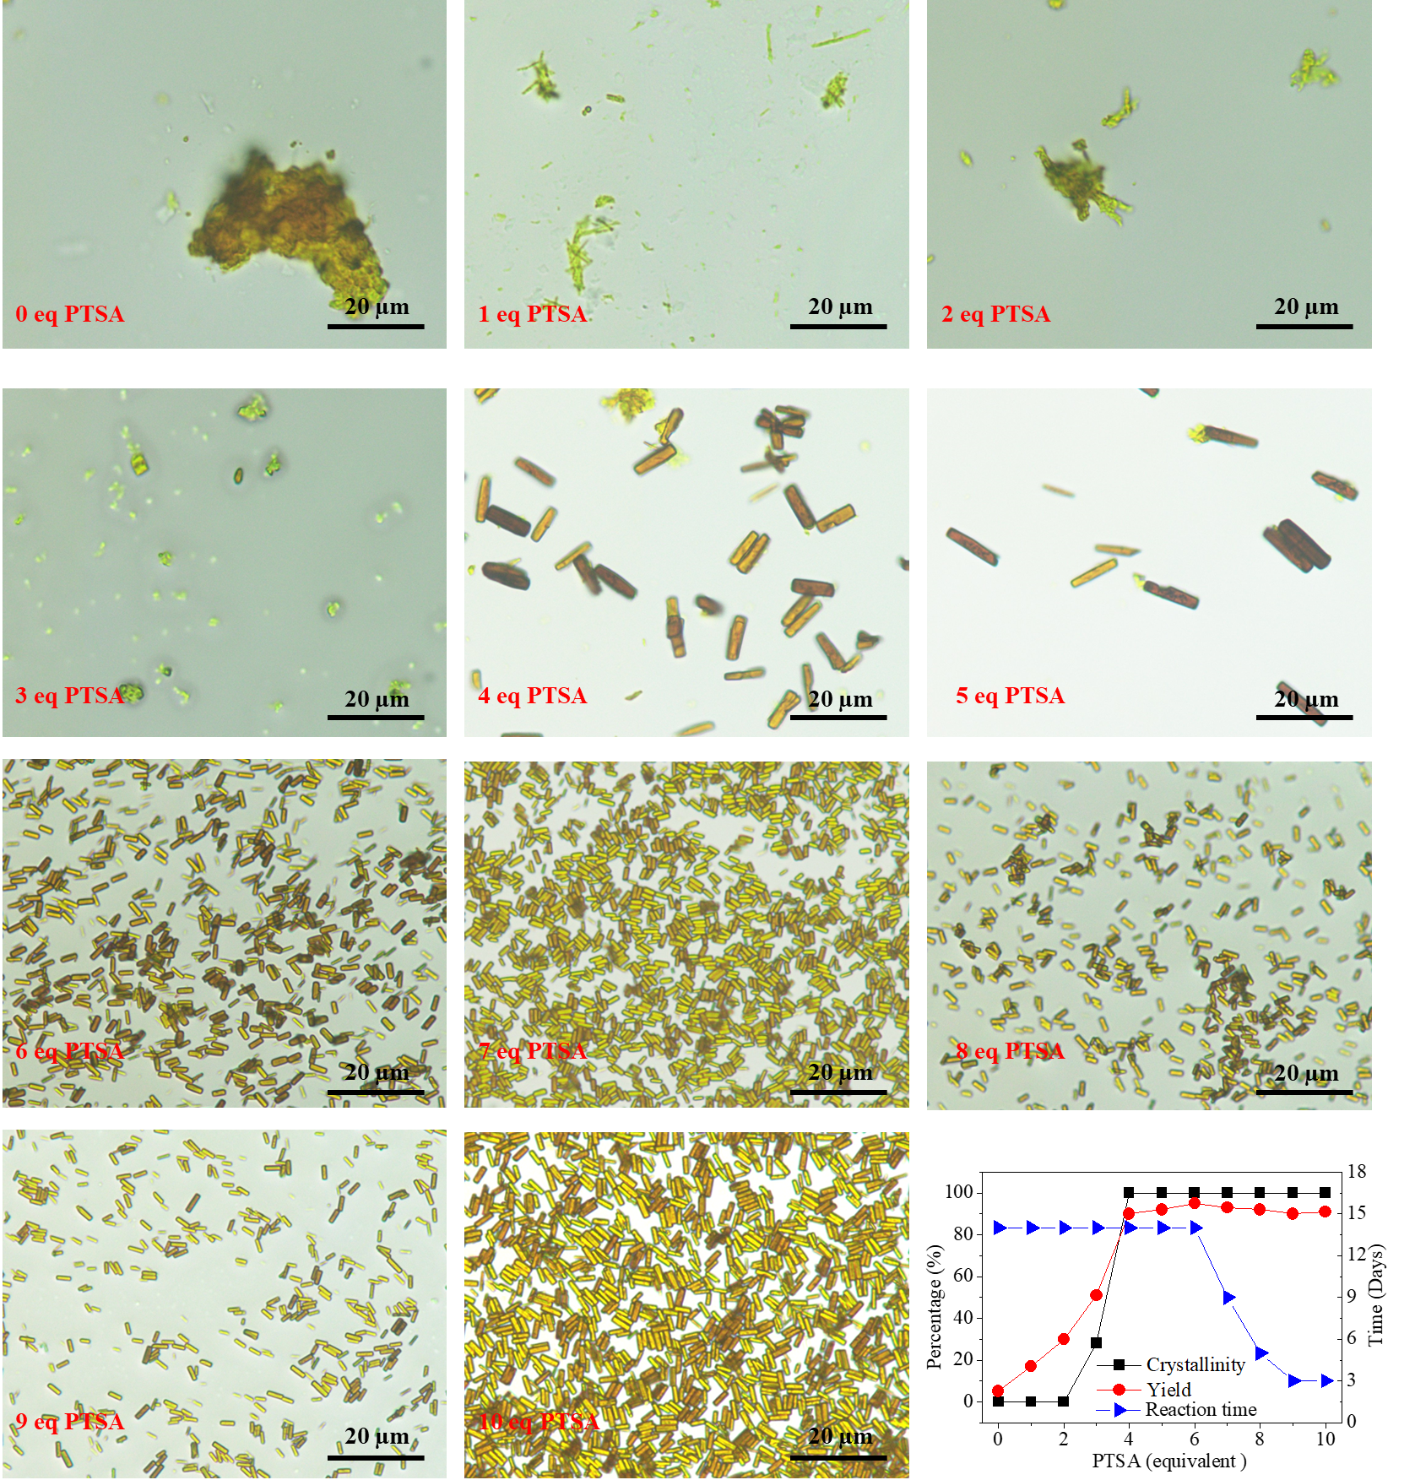
Extended Data Fig. 5 | The dependence of the yield, crystallinity and reaction time of the synthesized COF-301 on the added molar equivalent of PTSA to TAM.
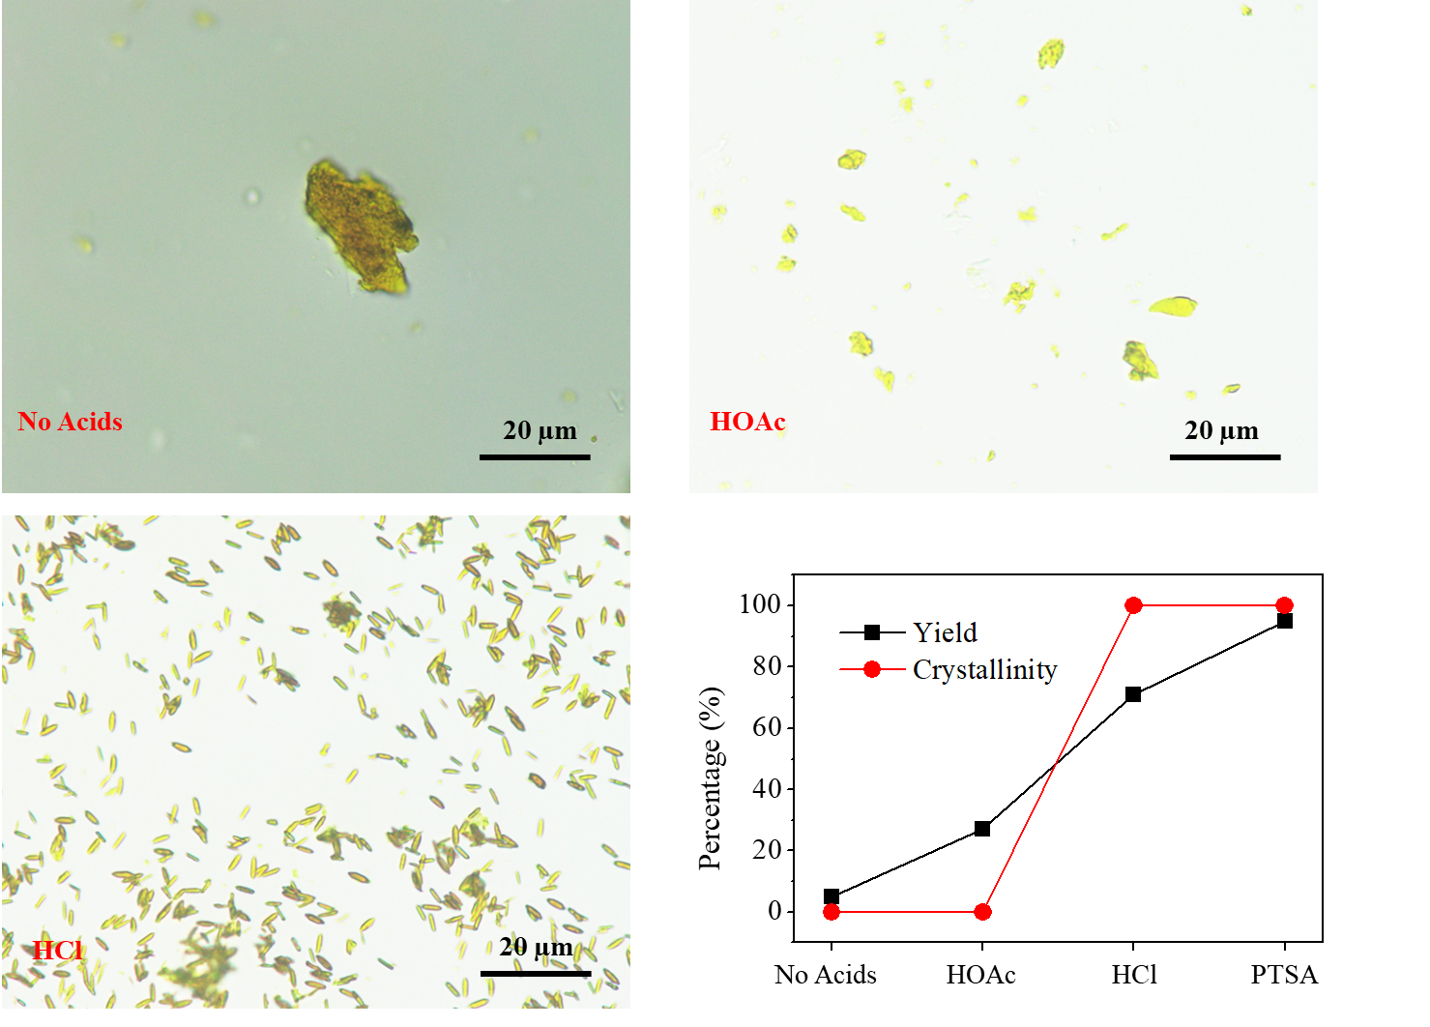
Extended Data Fig. 6 | The effects of different acids on the yield and crystallinity of products.
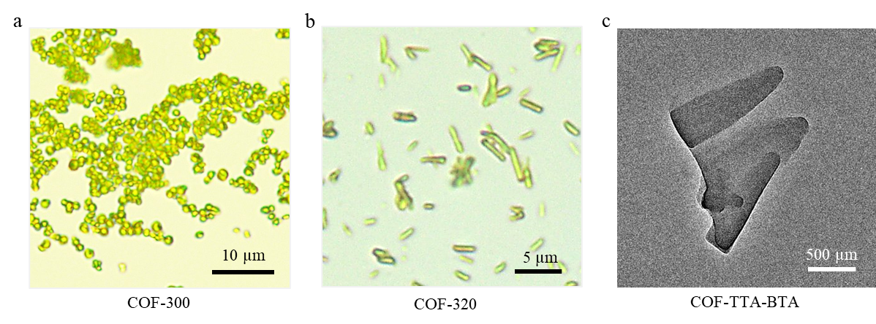
Extended Data Fig. 7 | a, b, Optical images of COF-300/320 c, TEM images of COF-TTA-BTA.
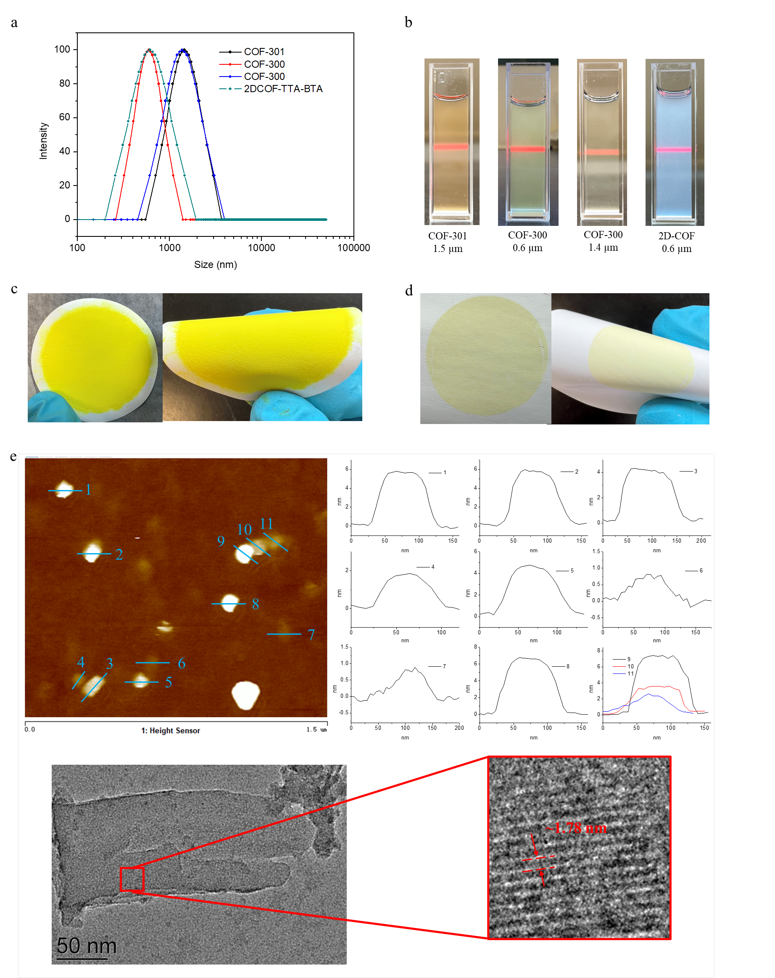
Extended Data Fig. 8 | See next page for caption.
Extended Data Fig. 8 | a, The DLS number-average size of COF-310, COF-300 and 2DCOF-TTA-BTA in water. b, Photographic image of COF-310, COF-300 and 2DCOF-TTA-BTA in water. c, d, Membranes formed by suction filtration of COF-300 (0.6 µm) (c) and 2DCOF-TTA-BTA (d), respectively. e, Atomic force microscopy (AFM) image of 2DCOF-TTA-BTA after ultrasonic peeling, and corresponding HRTEM images.
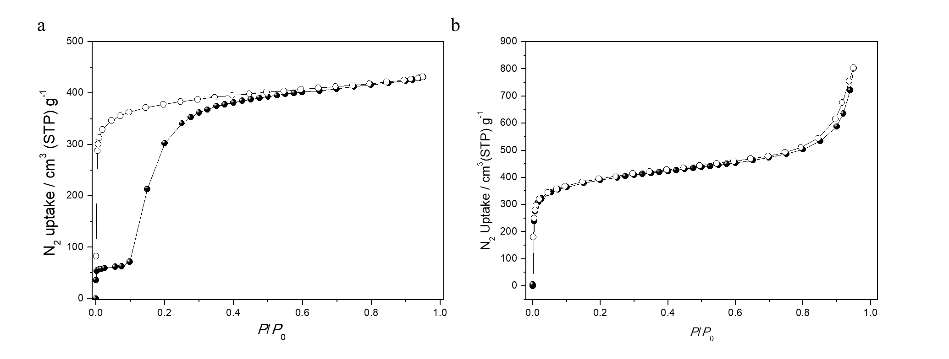
Extended Data Fig. 9 | a, b, N₂ adsorption isotherm of COF-300 (a) and COF-TTA-BTA (b) at 77 K.

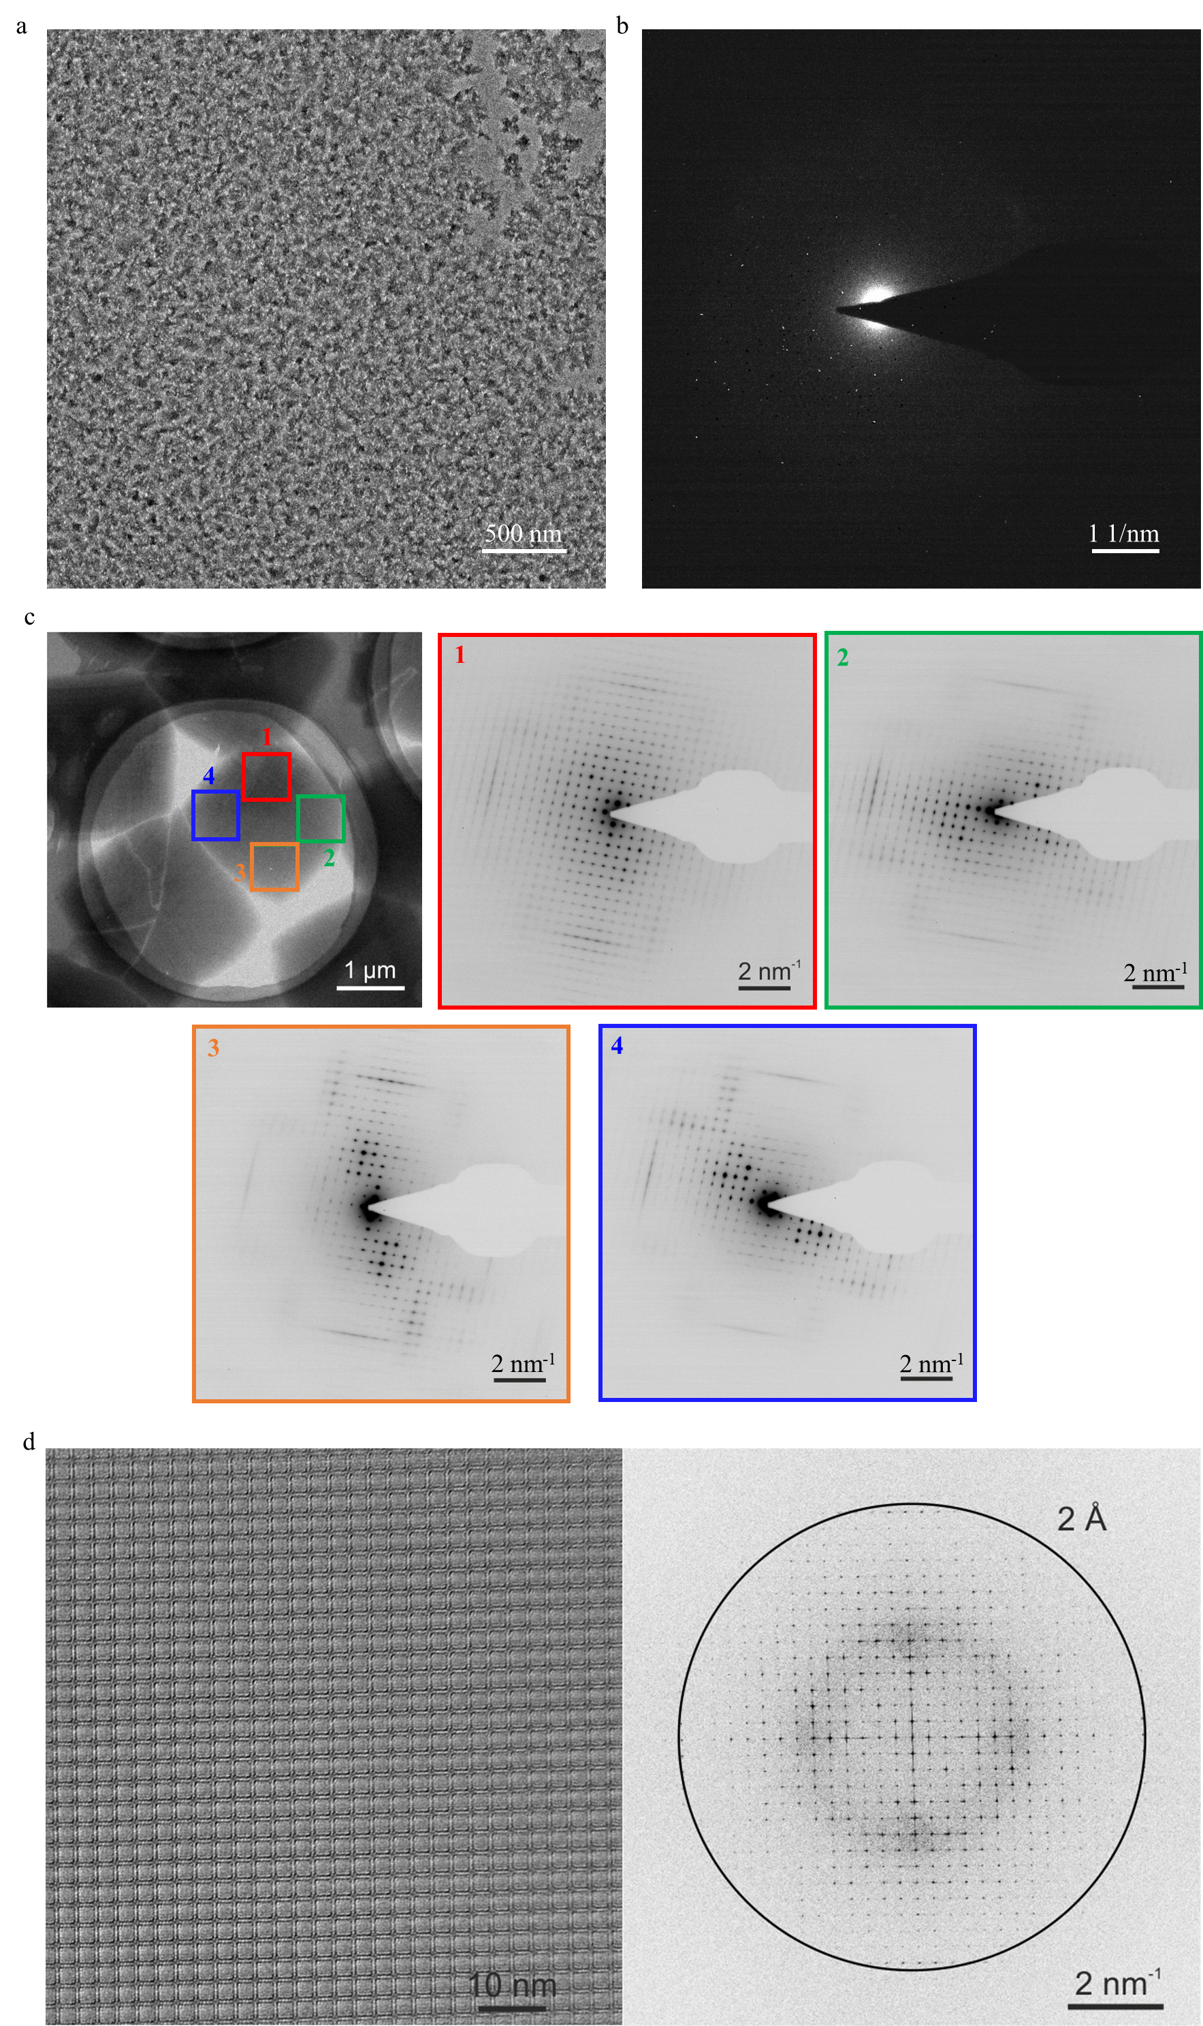
Extended Data Fig. 10 | See next page for caption.
Extended Data Fig. 10 | a, b, TEM image (a) and selected area electron diffraction (b) of the COF-366 obtained at the water-air interface mediated by C₁₆-GlyA on the first day. c, TEM images of COF-366 synthesized at the air-water interface mediated by C₁₆-GlyA on the seventh day. Selected area electron diffraction at different areas indicated the single crystallinity of the crystal. d, Near-atomic structure observation of COF-366 by aberration-corrected high-resolution TEM.

