Figure S1

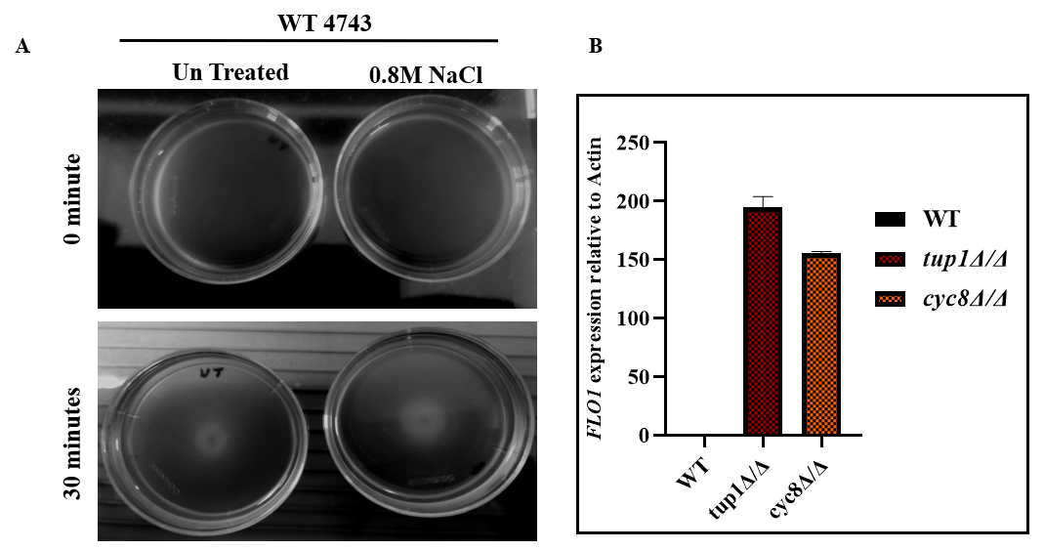
Figure S1. The activation of the Hog1 MAPK pathway in wild-type cells does not show significant flocculation compared to flocculating TUP1/CYC8 deleted cells. (A) Wild-type (WT) cells were grown until the exponential phase in SC media and then treated with and without 0.8 M NaCl for 1 hour and photographs were taken at indicated time points. (B) The WT cells and flocculating (tup1∆/∆ and cyc8∆/∆) cells were grown until the exponential phase in YPD media. Total mRNA was isolated, and qRT-PCR was performed with FLO1 primers. ACT1 mRNA was used as an internal control. The expression levels of FLO1 are relative to the expression level of untreated wild-type cells.

Figure S2
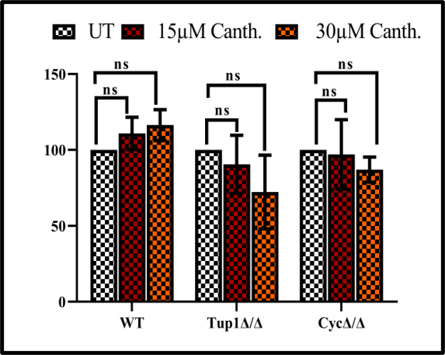
Figure S2. Colony forming unit (CFU) assay upon cantharidin exposure. Exponentially growing wild-type (WT), tup1∆/∆ and cyc8∆/∆ cells were treated with 15 µM and 30 µM cantharidin for 2 hours in YPD growth media. An equal number of cells serially diluted ten-fold until 10⁻⁴ cells. 100 µl from the final diluted culture was spreaded onto YPD agar plates. The cells containing plates were incubated at 30ºC, for 3-5 days and CFU was determined by counting colonies and graph plotted, with respect to untreated cells.
Figure S3
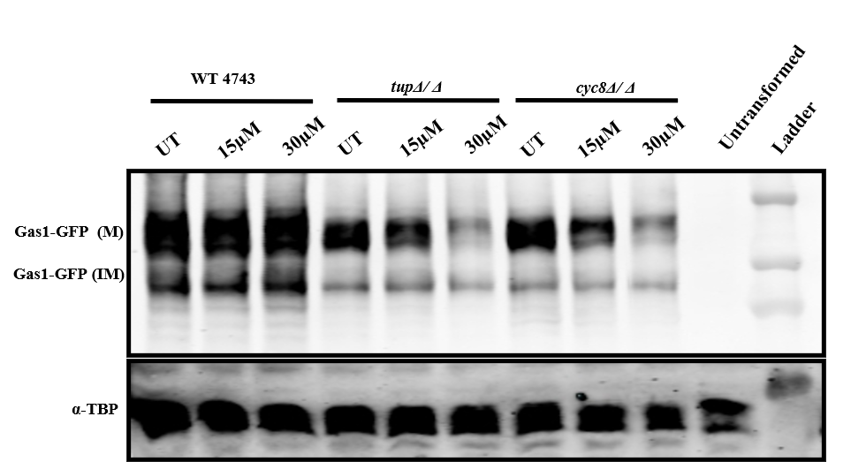
Figure S3 Cantharidin suppresses the yeast GPI-anchored cell surface Gas1 proteins expression in flocculating TUP1∆/∆ and CYC8∆/∆ cells. Western blot analysis for Gas1-GFP expression. The pRS415-Gas1-GFP plasmid transformed wild-type and flocculating (TUP1∆/∆ and CYC8∆/∆) cells were grown in selective SC-LEU medium until exponential phase and treated with and without 15 µM and 30 µM cantharidin for 1 hour and total protein extract was prepared. The western blot represents the Gas1-GFP levels. Where M and IM indicate the mature and immature forms of Gas1-GFP respectively. The α-TBP Polyclonal antibody was used as a loading control.

TABLE S1: Strains used in this study
S. No | Strain | Genotype | Reference
1 | WT (BY 4741) | MATa;leu2Δ0 ura3Δ0 his3Δ1 met15Δ0 | Open Bio systems
2 | tup1Δ | BY4741, tup1Δ::KanMX6 | This study
3 | cyc8 Δ | BY4741, cyc8Δ::URA | This study
4 | hog1Δ | BY4741, hog1::KanMX6 | This study
5 |  | BY4741, cyc8Δ::URA yap1Δ::HIS | This study
6 | hog1Δtup1Δ | BY4741, hog1Δ::KanMX6 tup1Δ::HIS | This study
7 | hog1Δcyc8 Δ | BY4741, hog1Δ::KanMX6 cyc8Δ::URA | This study
8 | WT (BY 4743) | (MATa/α; his3Δ/his3Δ1 leu2Δ0/leu2Δ0 LYS2/lys2Δ0 met15Δ0/MET15 ura3Δ0/ura3Δ0) | Open Bio systems
9 | tup1Δ/ Δ | BY4743, tup1 Δ/ Δ::KanMX | Open Bio systems
10 | cyc8 Δ/ Δ | BY4743, cyc8 Δ/ Δ::KanMX | Open Bio systems

Table S2: Primers used in this study

2.1 Primers for gene expression
Oligo Name | Sequence
ACT1 F | CCTTCTGTTTTGGGTTTGGA
ACT1 R | CGGTGATTTCCTTTTGCATT
CTT1 ORF F | AGAAAGAGTTCCGGAGCGTG
CTT1 ORF R | GGGTCTCTTGCAGTGTCTGG
GPD2 ORF F | GGAATCCAATGTGGCGCACTATC
GPD2 ORF R | TTGACGTGGAAGTAAGGTCTGTGG
PTC2 ORF F | TGGACTTGGTTCATCTCGGC
PTC2 ORF R | TGGGCCTTGGACTTCATACG
PTP2 ORF F | TACCTCACTCCCCGAAACCA
PTP2 ORF R | GCGGAGCTTGGGTAGCAATA
HOG1 ORF F | GGATGCCTTGGCTCATCCTT
HOG1 ORF R | TGGTCATCAAACGTGGCAGA
FLO1 ORF F | GGCAGTCTTTACACTTCTGGC
FLO1 ORF R | TGTCCTCCGACAGAACCTAGT
FLO5 ORF F | TGCATATTTTTGGTAATCTTGGCCT
FLO5 ORF R | TGTCCTCCGACAGAACCTAGT
FLO9 ORF F | CCATCGTCACATTGCTGGGA
FLO9 ORF R | TTTGTCCTCCGACAGAACCC
TUP1 ORF F | TCTGGTGGCCCGTCTATCTG
TUP1 ORF R | CGGATGATGGGGAAGACGAAG
CYC8 ORF F | GCTCTCAACTGCCACCTCAA
CYC8 ORF R | CTCTGTGTGGGTGCTACTGG
TUP1 KO F | AGCAGGGGAAGAAAGAAATCAGCTTTCCATCCAAACCAATCTGTGCGGTATTTCACACCG
TUP1 KO R | GTTAGTTACATTTGTAAAGTGTTCCTTTTGTGTTCTGTTCAGATTGTACTGAGAGTGCAC
CYC8 KO F | CAACAAACAAAACACGACTGGAAAAAAAAAATTAGGAAAACTGTGCGGTATTTCACACCG
CYC8 KO R | GATTATAAATTAGTAGATTAATTTTTTGAATGCAAACTTTAGATTGTACTGAGAGTGCAC

2.2 Primers used for Chip PCRs
Oligo Name | Sequence
FLO1 P1 F | AGCTCTGCAGCAGGGTTAAT
FLO1 P1 R | TGAGGCATTGTCATTTTTGG
FLO1 P2 F | GTGGAACCTTCTACAGTACTTCGG
FLO1 P2 R | GAGTGCCTTTCAACAATTTCAGACT
FLO1 P3 F | CTCCGATAGGGAGGCATCAT
FLO1 P3 R | CCTGTTCTACGCACTTCCAA
FLO1 P4 F | TGTGCGTCACTTTTCCTACG
FLO1 P4 R | GCATACTGGAAGCCAAAAGC

