Supporting information
Complete degradation of di-n-butyl phthalate by Glutamicibacter sp. strain 0426 with a novel pathway
Chongyang Ren^{a, b}, Yiying Wangª, Yanan Wuª, He-Ping Zhao*^{b}, Li Li*ª

Affiliations
ªShandong Provincial Key Laboratory of Water Pollution Control and Resource Reuse, School of Environmental Science and Engineering, Shandong University, Qingdao, China
^{b}MOE Key Lab of Environmental Remediation and Ecosystem Health, College of Environmental and Resource Science, Zhejiang University, Hangzhou, China, 310058.

* Correspondence to Dr. He-Ping Zhao. Tel (Fax): 0086-571-88982739, E-mail: zhaohp@zju.edu.cn; and Dr. Li Li Fax: +86-532-5863-0278, Tel: +86-532-5863-0926, E-mail: lili@sdu.edu.cn

8 pages
3 figures
4 tables

Table S1 Physicochemical properties of the soils used in this study
Parameter | pH | Moisture content (%) | Sand (%) | Silt (%) | Clay (%) | Texture | OM (%)
Soil samples | 6.54 | 14.5 | 7.90 | 70.10 | 22.00 | Heavy loam | 2.37

Table S2 The symbols and levels of two independent variables used in central composite design (CCD).
Independent variables | Symbol | Code levels of variables
Independent variables | Symbol | -1 | 0 | 1
Temperature (℃) | X₁ | 25 | 30 | 35
pH | X₂ | 6 | 7 | 8

Table S3 Central composite design (CCD) table and the response of dependent variable for DBP degradation.
Run | Code levels of independent variables |  | Response
Run | X₁ | X₂ | DBP degradation Y1 (%)
1 | 1 | 0 | 90.88±0.40
2 | -1 | -1 | 73.83±1.21
3 | 0 | -1 | 82.84±0.17
4 | 0 | 1 | 78.45±1.40
5 | -1 | 0 | 85.21±0.36
6 | 1 | -1 | 80.29±2.45
7 | 1 | 1 | 76.34±1.56
8 | 0 | 0 | 92.55±0.97
9 | 0 | 0 | 91.63±1.52
10 | 0 | 0 | 92.31±0.48
11 | -1 | 1 | 67.73±0.81

Table S4 Genome features of Glutamicibacter sp. strain 0426.
Features
Genome size (Mb) | 3.54947
GC content (%) | 62.00
Genes (total) | 3,309
CDS (total) | 3,237
Genes (coding) | 3,194
CDS (coding) | 3,194
Genes (RNA) | 72
rRNAs | 2, 1, 2 (5S, 16S, 23S)
tRNAs | 64
ncRNAs | 3
Pseudo Genes (total) | 47

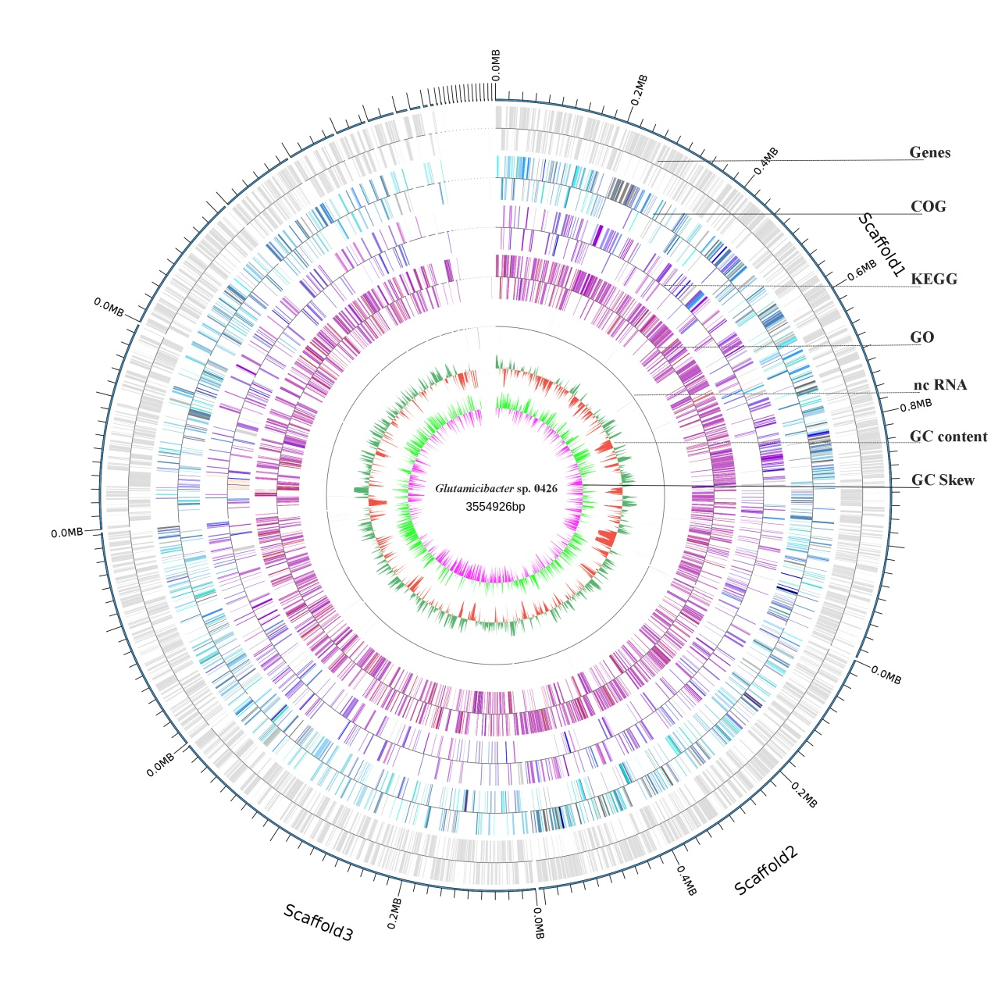
Fig. S1. Circular map of the Glutamicibacter sp. strain 0426 chromosome. Genes are colored according to their COG, KEGG, and GO functional annotations.

Fig. S2. Residual error diagnosis for the regression model and the predicted optimal conditions by the model.

Fig. S3. Mass spectra of DBP metabolites produced by Glutamicibacter sp. strain 0426.

