Supplementary Results and Figures

Baseline Plasma Metabolome Profile Robustly Differentiates Paediatric Cirrhosis
Plasma metabolomics in cirrhotics and non-cirrhotics annotated a total of 1184 metabolites [422 bacterial(B), 649 humans(H), 113 Human+bacterial (HB)] Of them, 213(H-109, B-78, HB-26) were up-and 163 (H- 83, B- 68, HB-12) were downregulated in cirrhotics (FC>1.5; p<0.05, FDR>0.05; Supplementary Figure 1A, supplementary table 2). Partial least square discriminant analysis (PLS-DA) and unsupervised hierarchical clustering analysis clearly segregated paediatric cirrhotics (Supplementary Figure 1B and 1C). Metabolites significantly increased in cirrhotics, were linked to purine, pyrimidine, bile acid, arachidonic acid, beta-alanine, methionine, aspartate, and glutamate metabolism, and others whereas metabolites down-regulated were linked to sphingolipid, nicotinamide, folate and glyoxylate metabolism (Supplementary Figure 1D and 1E). A panel of top 6 metabolites showed the diagnostic efficacy of 95% (AUC= 0.95 (0.9–1)) and probability of detection (POD) >95% (p<0.05) for the diagnosis of cirrhosis (Supplementary Figure 1F). Together, cirrhotics document a distinct plasma metabotype with prominent increase in intestinal and liver disease-associated metabolites suggesting possible involvement of gut microbiota and linked metabolites in severity of paediatric cirrhotics.
Supplementary Figure 1 (A-F)
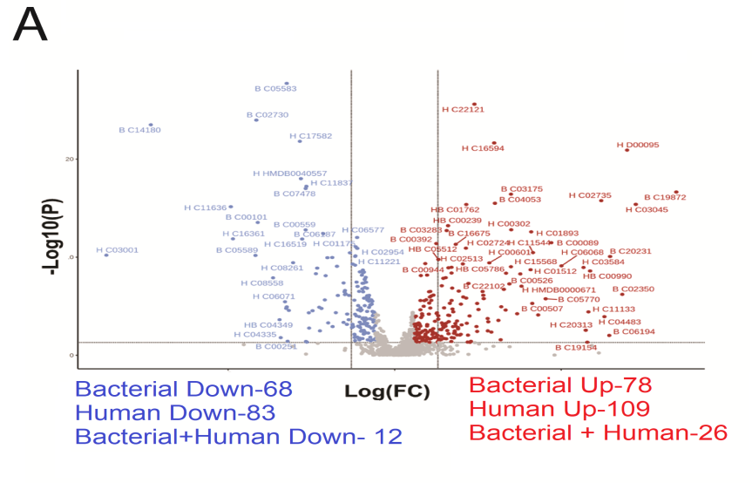
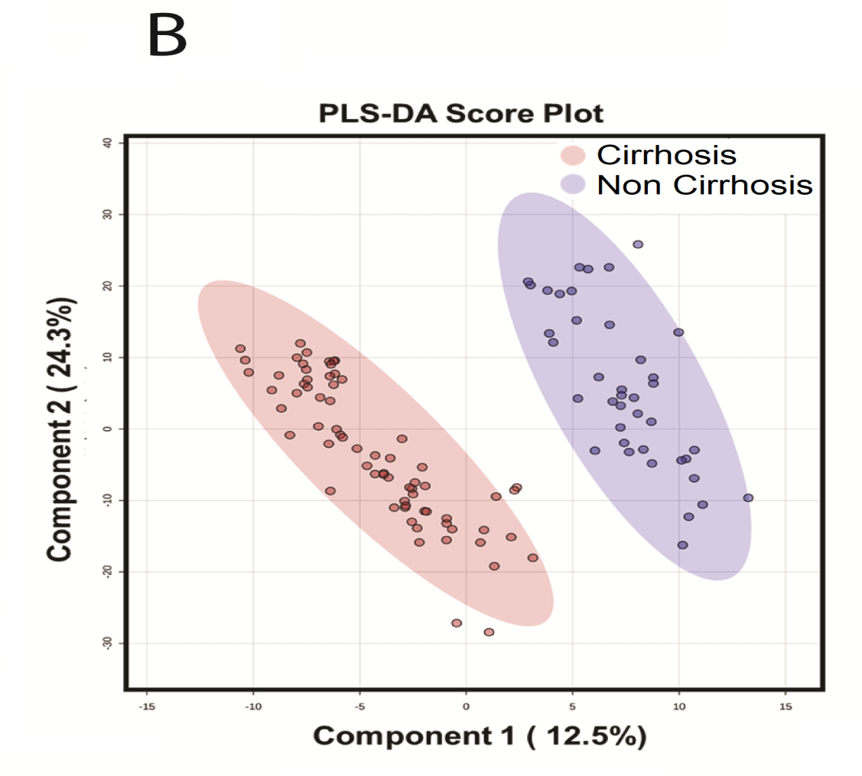
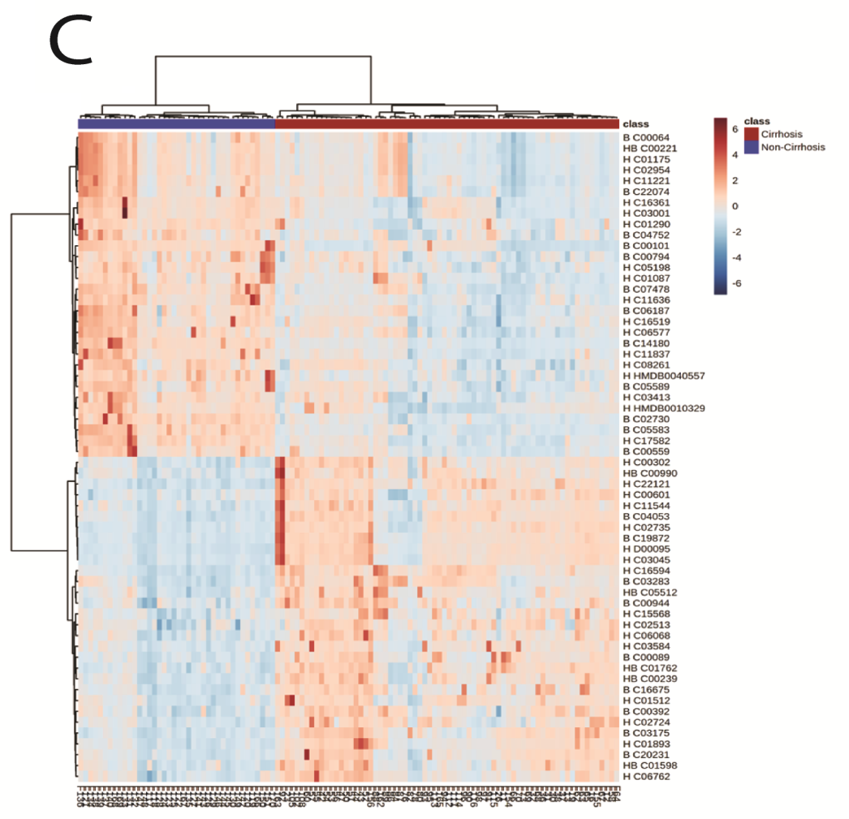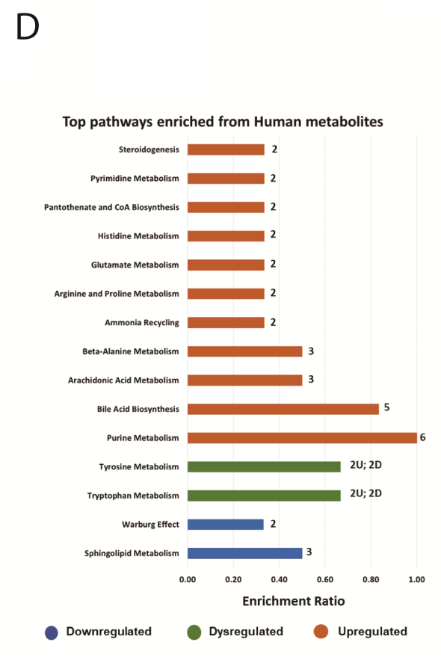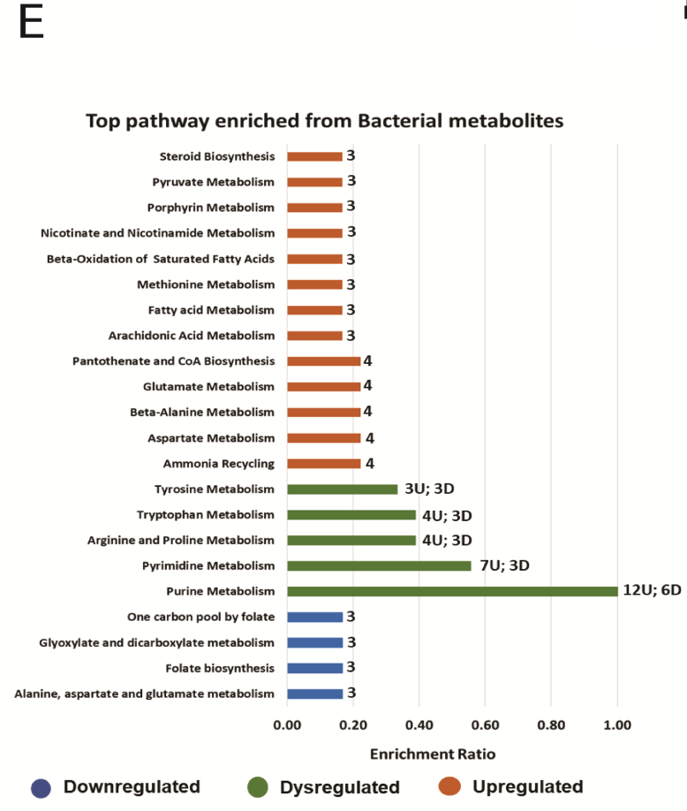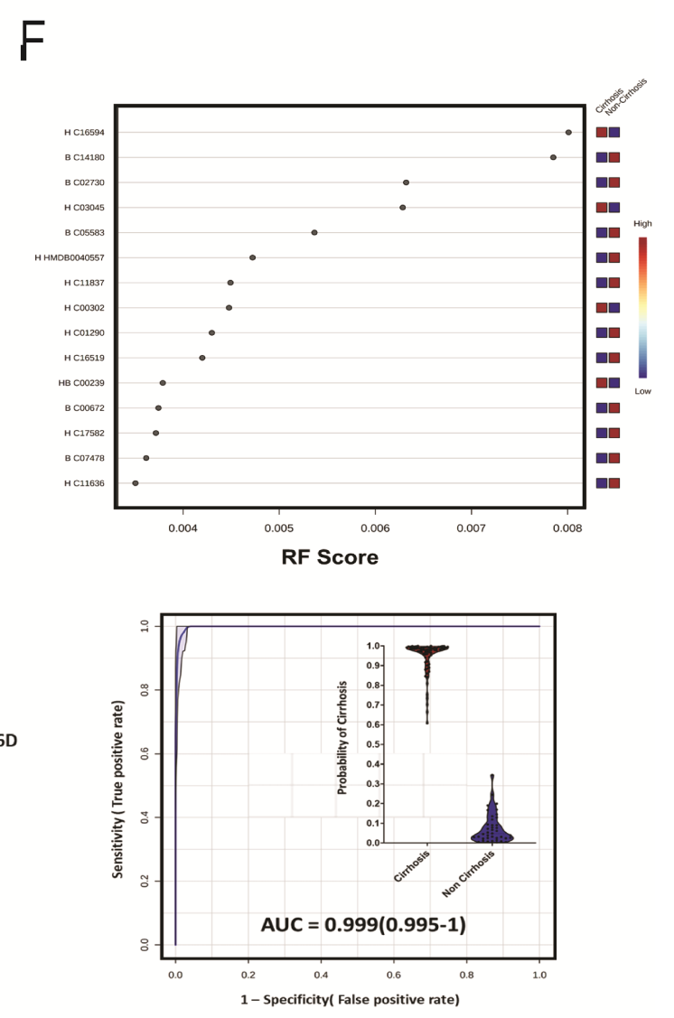

Baseline Plasma Metabolome Profile Robustly Differentiates Paediatric Cirrhotics
Supplementary Figure 1A- Volcano plot showing differentially expressed (Human(H), Bacterial(B), and Human + Bacterial (HB)) metabolites when cirrhotics were compared to non-cirrhotics patients. The blue dot represents down-regulated while the brown dots represent upregulated (F.C.>1.5, p < 0.05, FDR< 0.05).
Supplementary Figure 1B- Partial least square discriminant analysis (PLS-DA) showing clear segregation of cirrhotics and non-cirrhotic patients.
Supplementary Figure 1C- Heat map and hierarchical clustering analysis of top metabolites which are capable of segregating cirrhosis (brown bar) from non-Cirrhosis (Blue bar) at baseline.
Supplementary Figure 1D- Pathway enrichment from upregulated metabolites (Human and Bacterial).
Supplementary Figure 1E- Pathway enrichment from downregulated metabolites (Human and Bacterial).
Supplementary Figure 1F- RF score plot representing the mean decrease in accuracy (MDA) plot of metabolites and their expression status (Red = upregulated and blue = downregulated) along with POD plot based on the panel of the top 6 clinical indicators having the ability to differentiate cirrhotics from non-cirrhotics.
Plasma Metaproteome Profile Robustly Differentiates Paediatric Cirrhotics
Plasma metaproteome identified >17phyla and >169species in the study groups. Cirrhotics showed significant enrichment of Tenericutes, Firmicutes, Actinobacteria, Bacteroides, and others (Supplementary Figure 2A, Supplement Table-3). The alpha and beta diversity showed higher species richness in cirrhotics (Supplementary Figure 2B) and segregated cirrhotics from non-cirrhotics (Supplementary Figure 2C). Further, LDA score was higher for Bacillus Licheniformis, Bacillus cereus(14), Neisseria meningitides(15), Campylobacter jejuni (16), Nocardia farcinia (17), Salmonella enterica (18) and others, already reported in cirrhosis, and Sinorhizobium meliloti, Methanococcus aeolicus, and others novel in cirrhotics (Supplementary Figure 2D). Interestingly, cirrhotic showed a functional increase in amino acid, carbohydrate, inorganic ion transport and lipid metabolism whereas a functional decrease in replication, recombination and repair (Supplementary Figure 2E). A panel of top 6 bacterial peptides showed the diagnostic efficacy of 90% (AUC= 0.90 (0.85–0.95)) and probability of detection (POD) >86% (p<0.05) for the diagnosis of cirrhosis (p<0.01, FDR>0.05, Supplementary Figure 2F). Together, the plasma microbiome of cirrhotics is distinct, has higher richness, and the identified bacterial peptides could be used for segregation of cirrhotics and warrants validation.

Supplementary Figure 2(A-F):

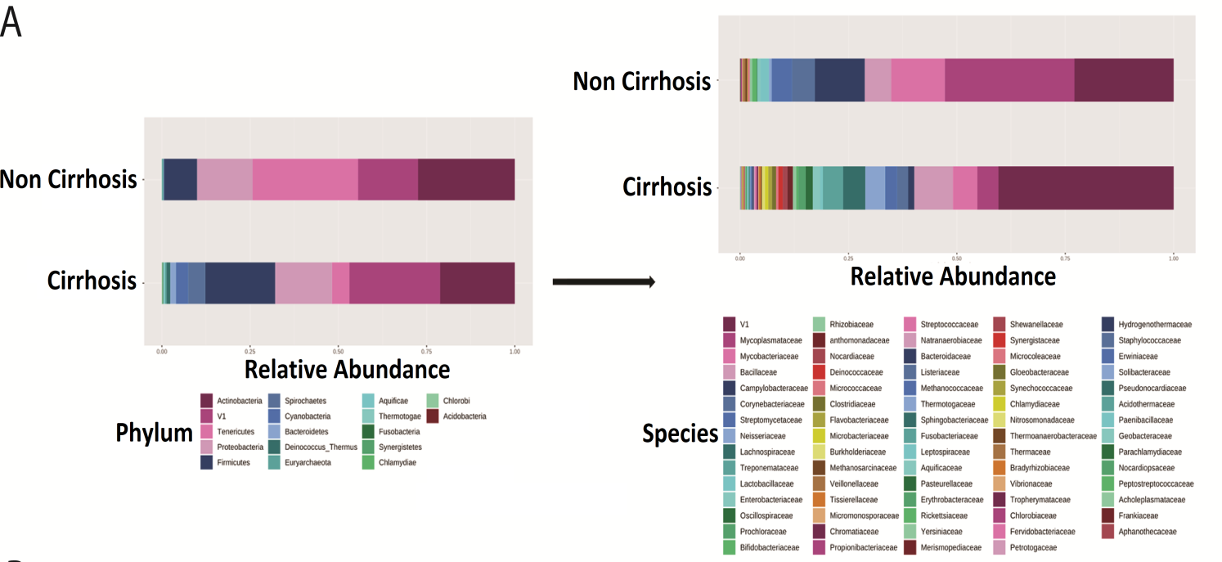
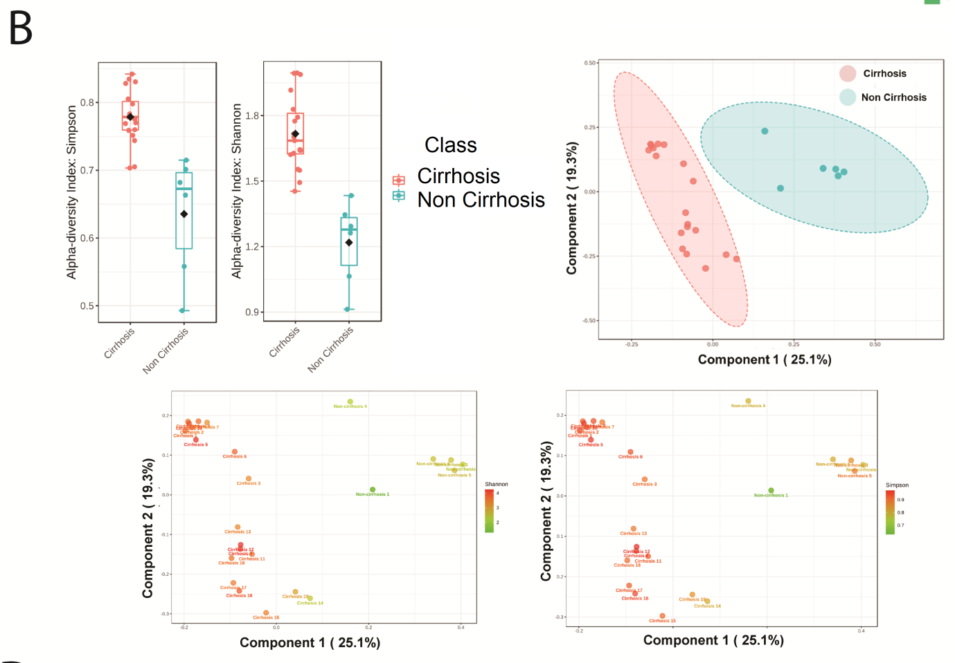
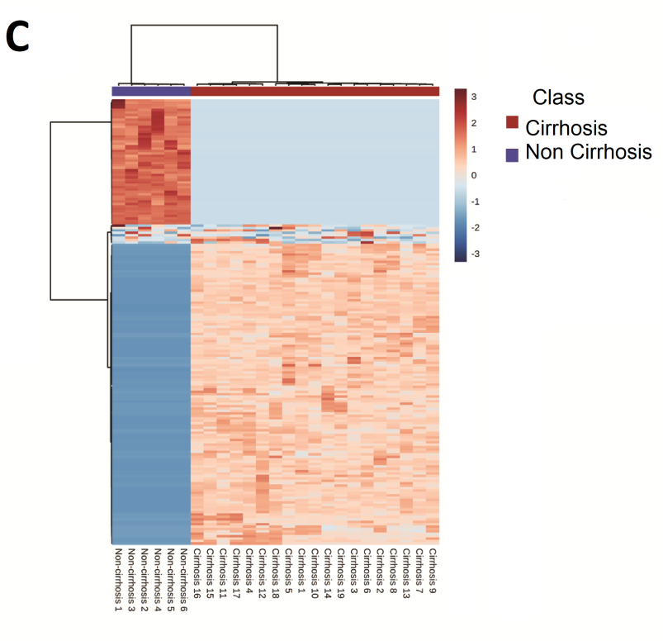
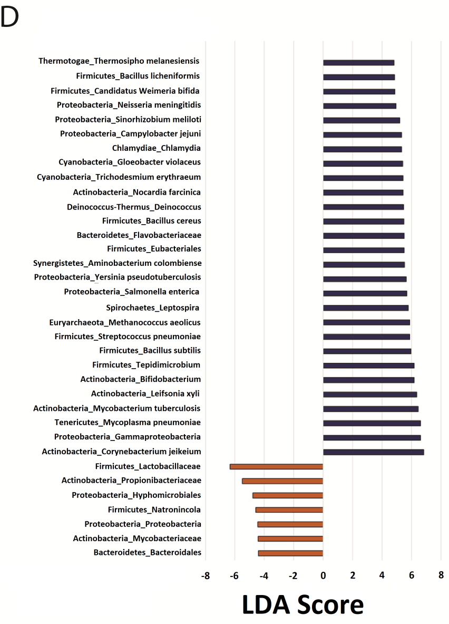

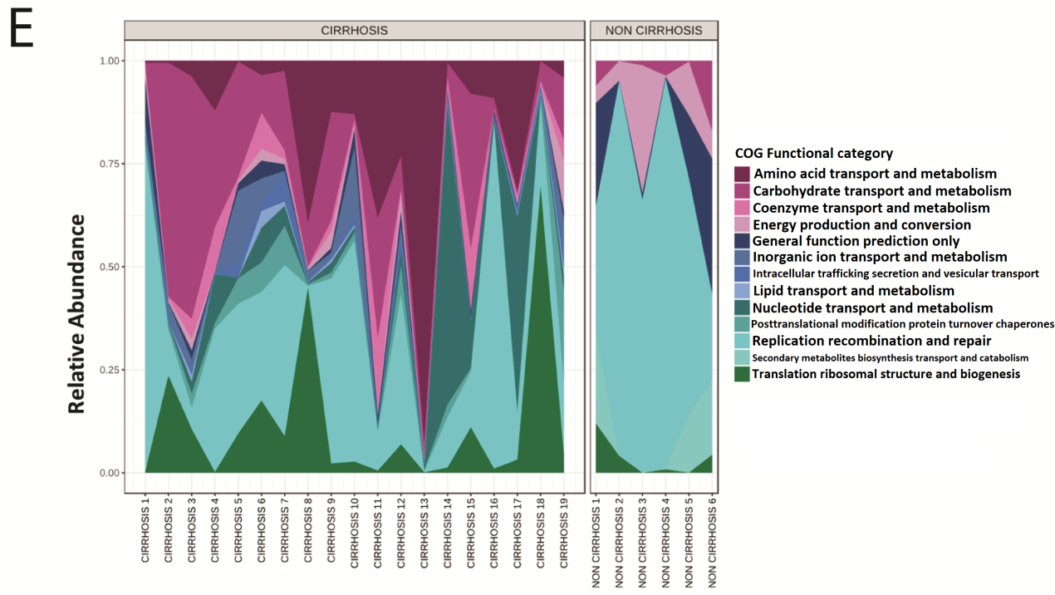

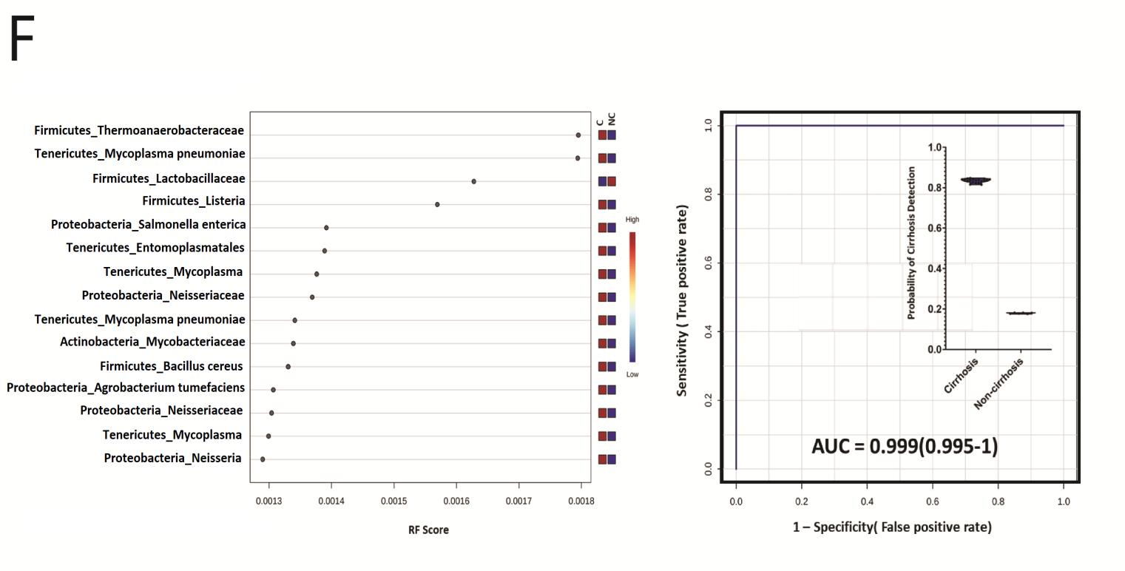
Plasma Metaproteome Profile Robustly Differentiates Paediatric Cirrhotics
Supplementary Figure 2A- Relative abundance of metaproteome in the study groups, cirrhosis and non-cirrhosis at phylum and species levels (p < 0.05, FDR< 0.05).
Supplementary Figure 2B- Alpha-diversity indices (Shannon and Simpson index) in metaproteome study groups Cirrhosis vs. Non-cirrhosis (p < 0.05) at the species level along with Principal coordinate analysis (beta-diversity) among patients(p < 0.05, FDR< 0.05).
Supplementary Figure 2C- Heat map and hierarchical clustering analysis of top bacterial species identified in Cirrhosis and Non-cirrhosis.
Supplementary Figure 2D- LDA score plot representing significantly upregulated and downregulated microbes when cirrhotics were compared to non-cirrhotics.
Supplementary Figure 2E- Cluster of Orthologous Groups (COG) functional enrichment of bacterial peptides enriched in study group cirrhotics and non-Cirrhotics.
Supplementary Figure 2F- - RF score plot representing the mean decrease in accuracy (MDA) score of microbial species and their expression status (Red = upregulated and blue = downregulated) along with a POD plot based on the panel of the top 6 microbial indicators having ability to differentiate cirrhotics from non-cirrhotics.
Plasma metabolome and metaproteome profile of sepsis is distinct and provide novel indicators for its segregation.
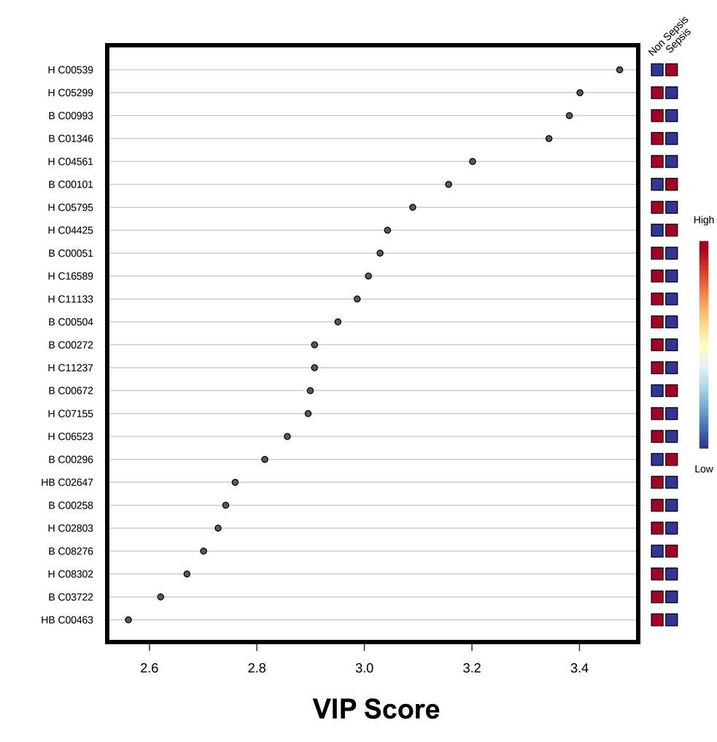
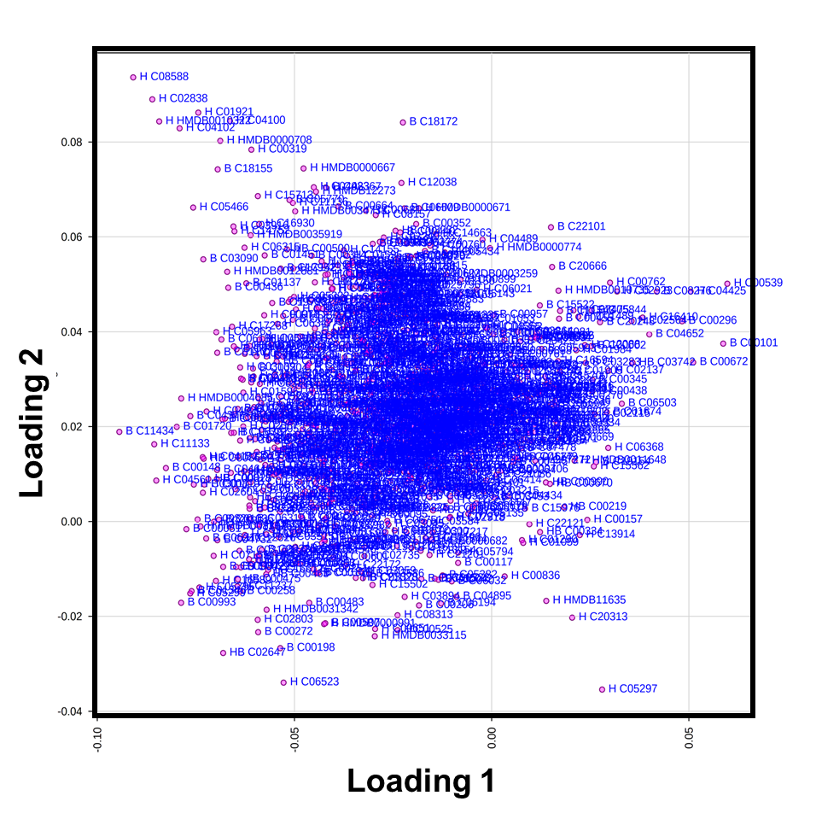
Untargeted plasma metabolomics and meta-proteomics of sepsis patients show that these patients carry distinct metabolite and meta-proteomic signatures which could be used for early diagnosis of sepsis in cirrhotics and is detailed in supplementary results and methods section (Supplementary Figure 5-15, supplementary results and methods).
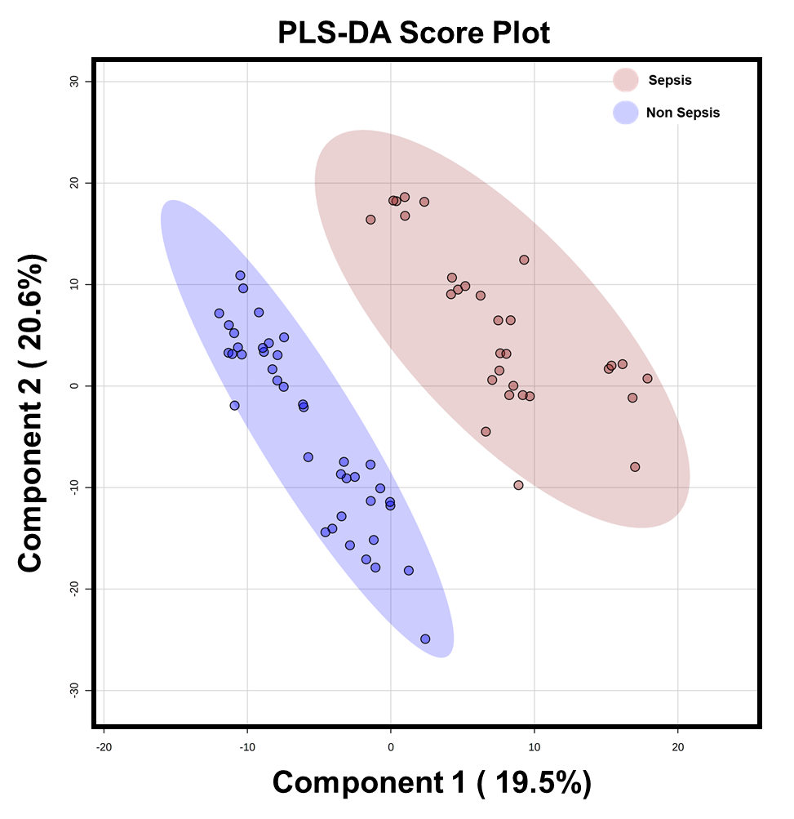
Supplementary Figure 3: PLSDA score plot analysis along with loading plot and VIP plot associated to sepsis metabolome when compared to non-sepsis.
Supplementary Figure 4: Heat map and hierarchical cluster analysis of top 50 metabolites can segregate sepsis vs non-sepsis at baseline.
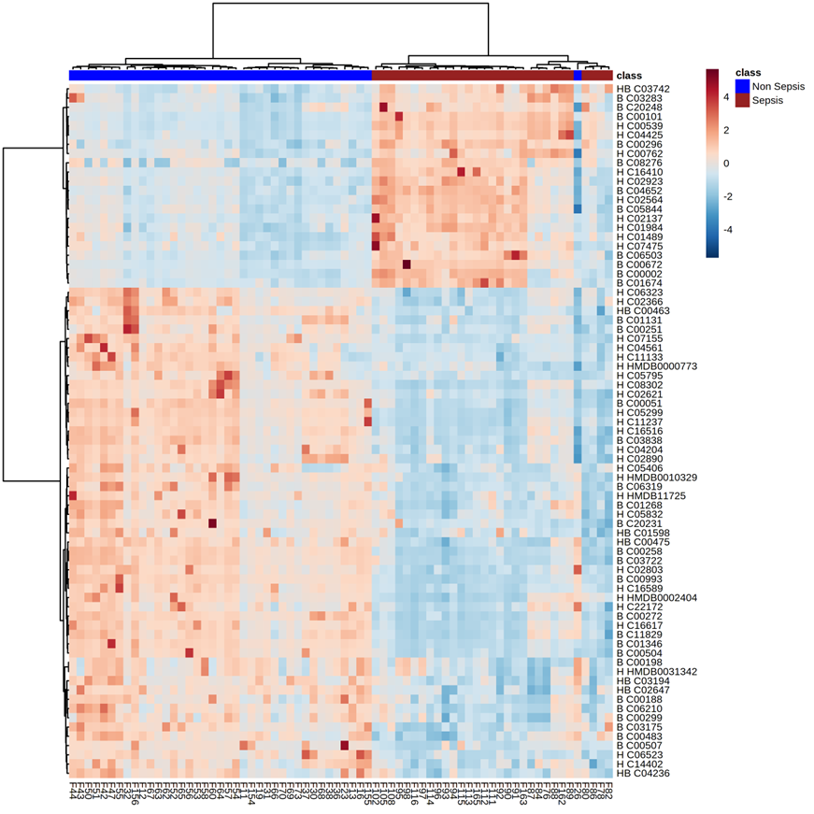
Supplementary Figure 5: Random Forest plot analysis along with RF score when sepsis metabolome was compared to non-sepsis.
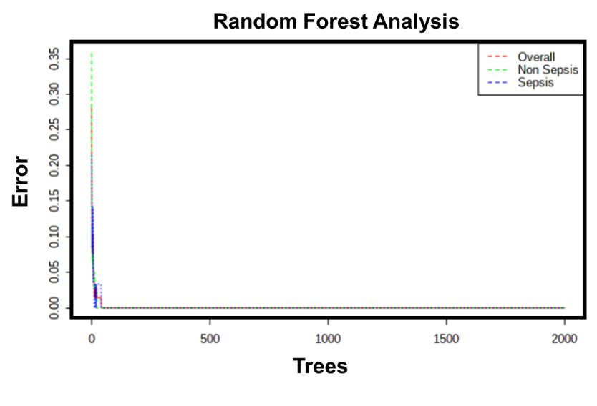
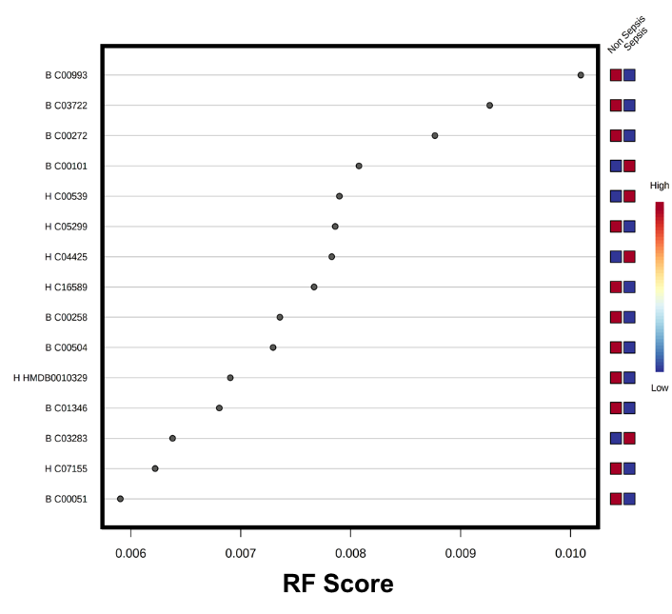
Supplementary Figure 6: POD plot based on the panel of the top 6 clinical indicators (metabolites) having the ability to differentiate sepsis vs non-sepsis.
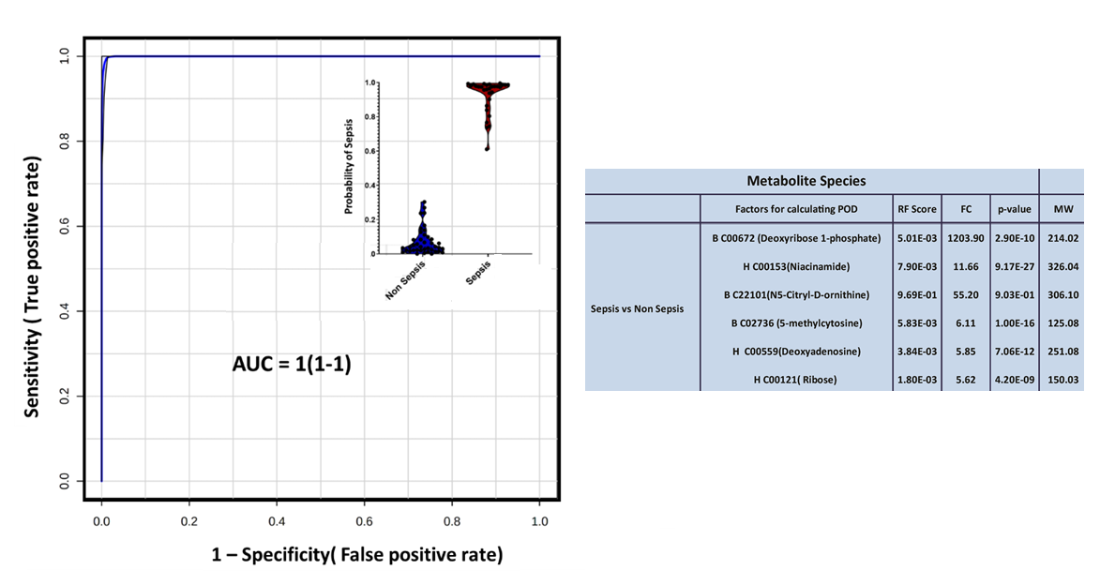

Supplementary Figure 7: Pathway enrichment from upregulated and downregulated metabolites-bacterial (P < 0.05).
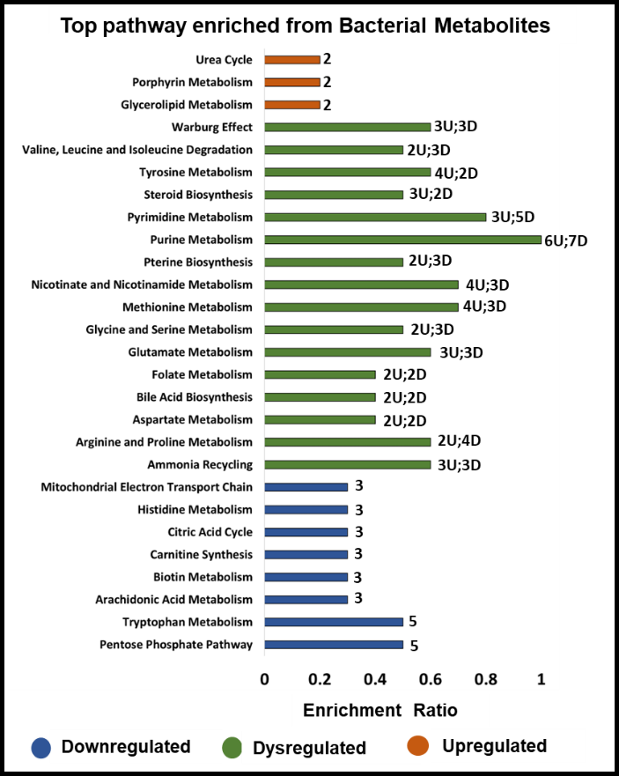
Supplementary Figure 8: Pathway enrichment from upregulated and downregulated metabolites-human.
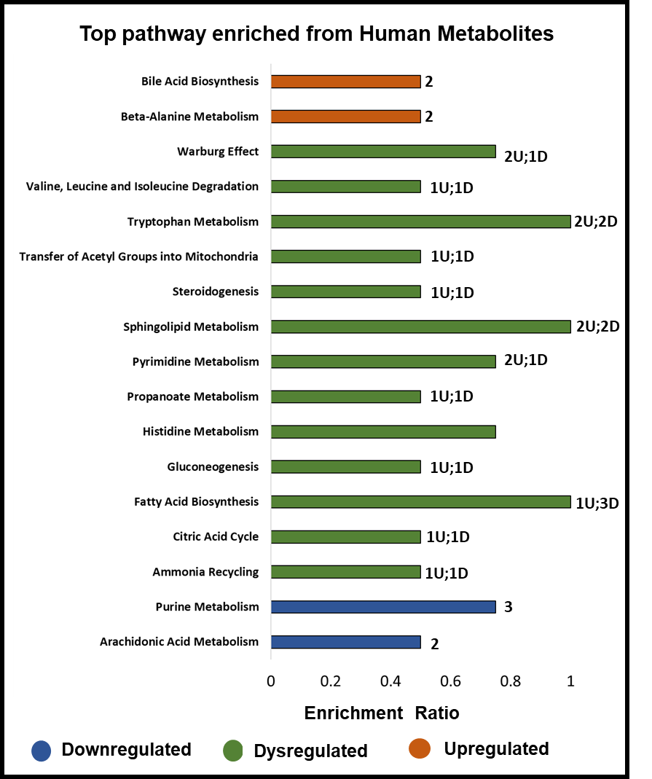
Supplementary Figure 9: Relative abundance of metaproteome in the study groups, cirrhosis and non-cirrhosis at phylum and species levels (p < 0.05).
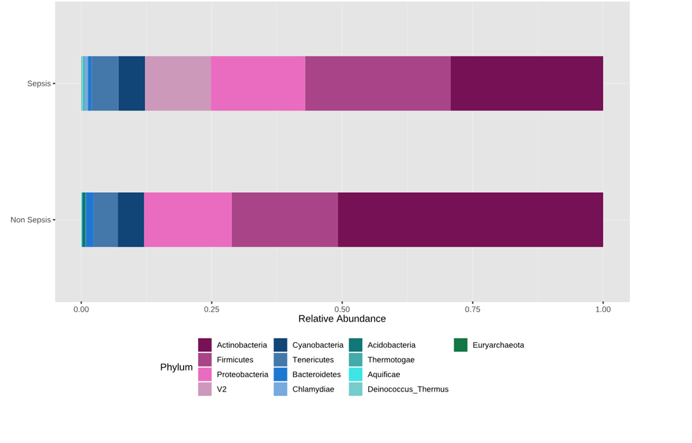

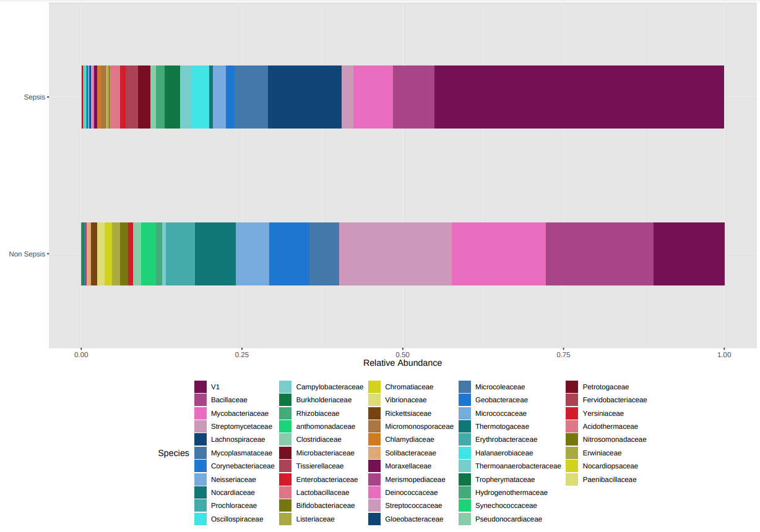
Supplementary Figure 10: Alpha-diversity indices (Shannon and Simpson index) in metaproteome study groups Sepsis vs. Non-sepsis (p < 0.05) at the species level along with Principal coordinate analysis (beta-diversity) among patients (p < 0.05).
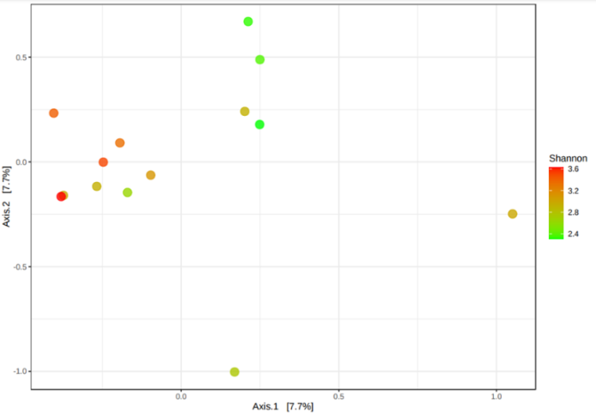
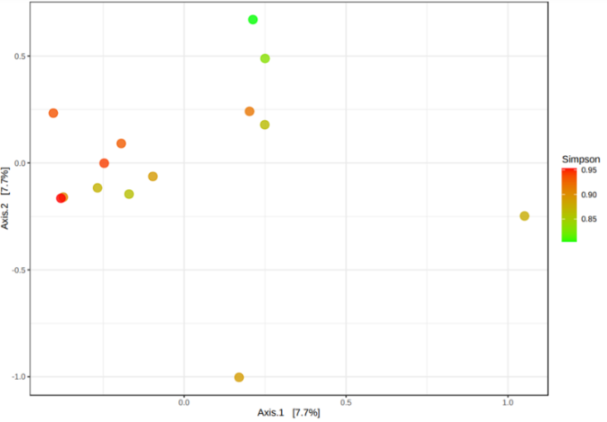
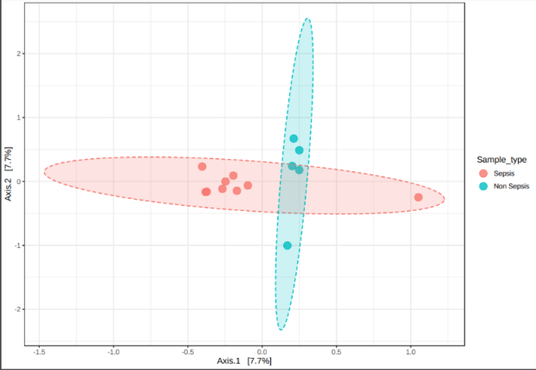
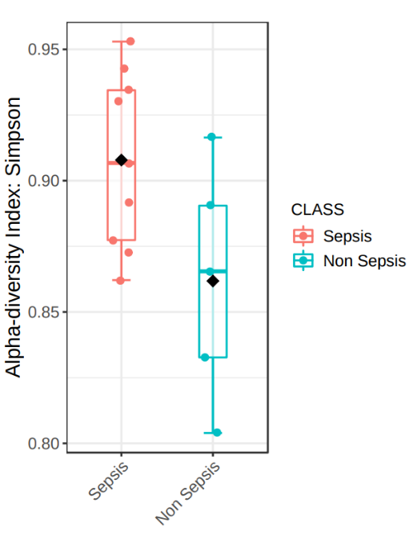
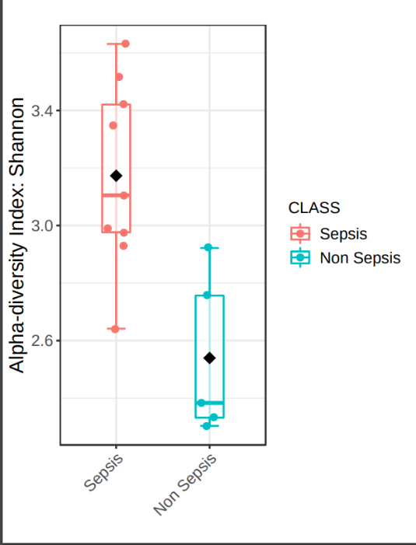
Supplementary Figure 11: Cluster of Orthologous Groups (COG) and kegg functional enrichment of bacterial peptides enriched in study group sepsis vs non sepsis.
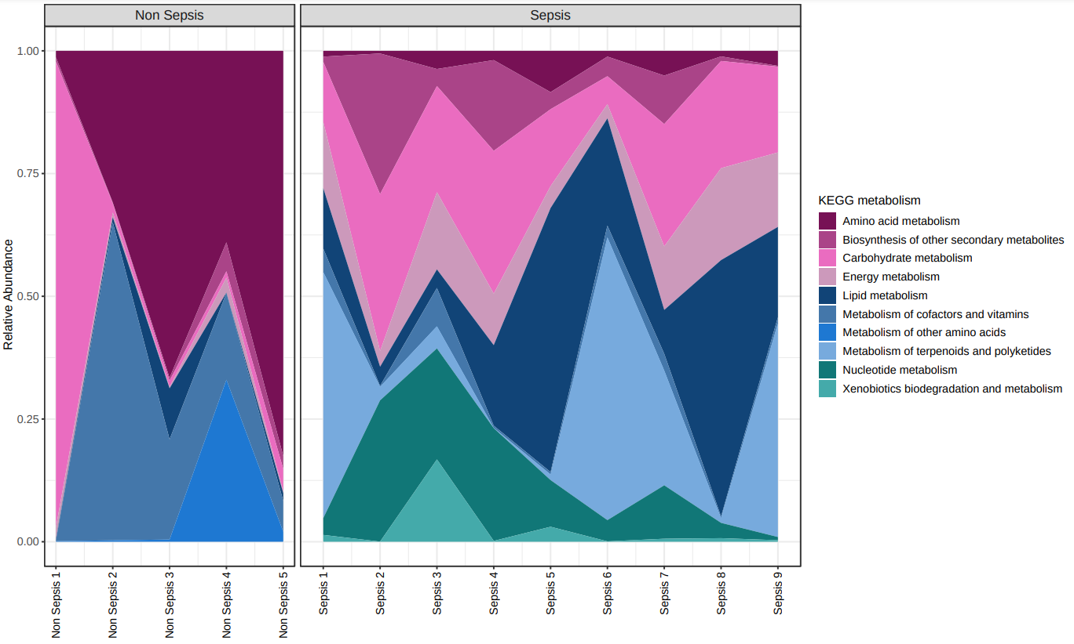
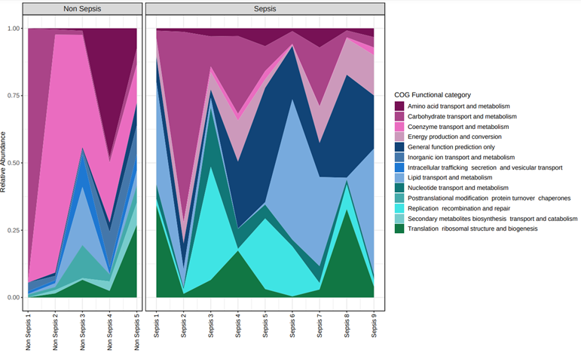
Supplementary Figure 12: Volcano plot analysis when sepsis metaproteome was compared to non-sepsis
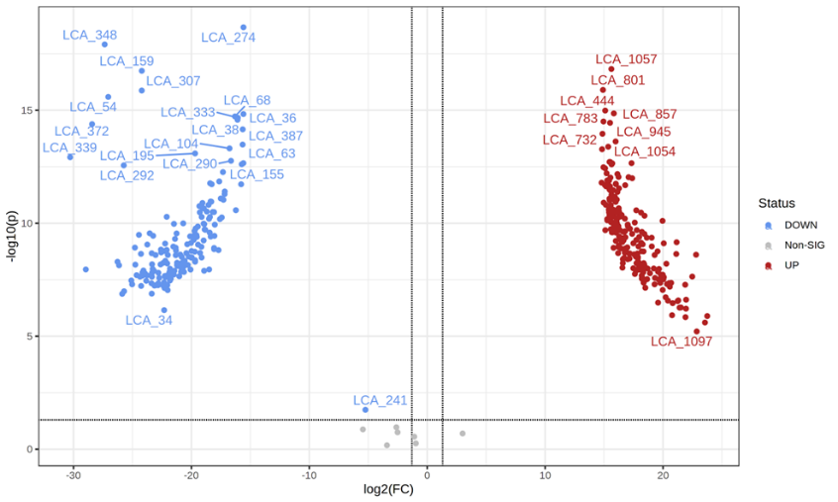
Supplementary Figure 13: RF score plot along with POD plot based on the panel of the top 6 clinical indicators (metabolites) having the ability to differentiate Sepsis from Non sepsis

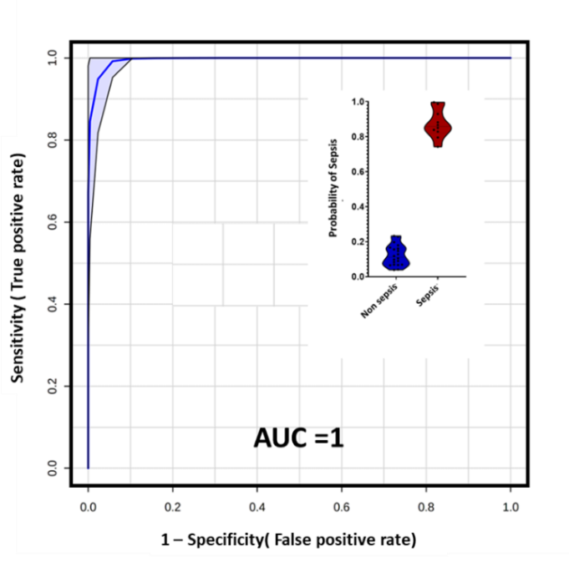
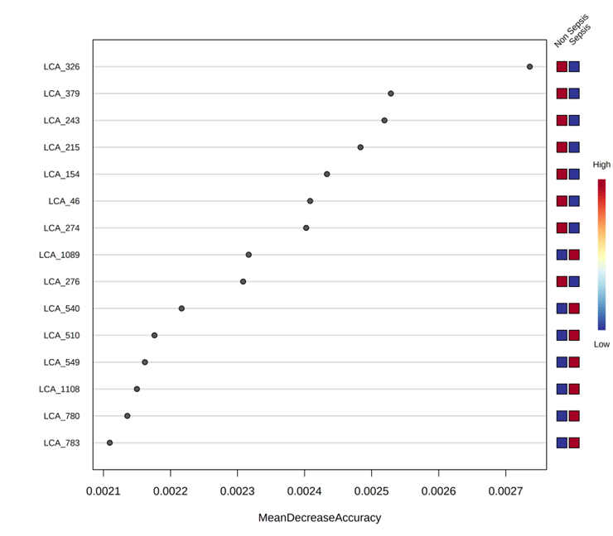
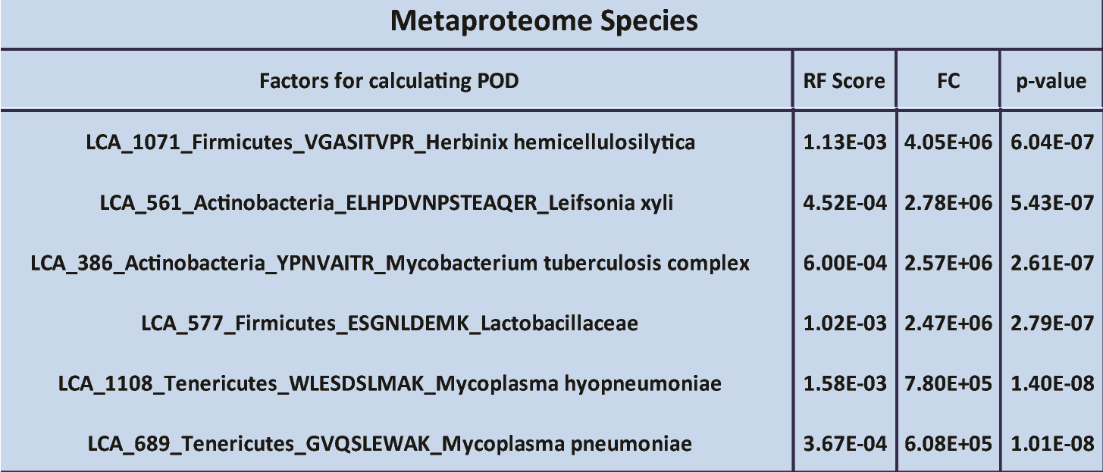
Supplementary Figure 14: A pathway tree map for all metabolite modules. Pathway enriched from member metabolites of each module is shown. (Pathways enriched by more than two members were used).
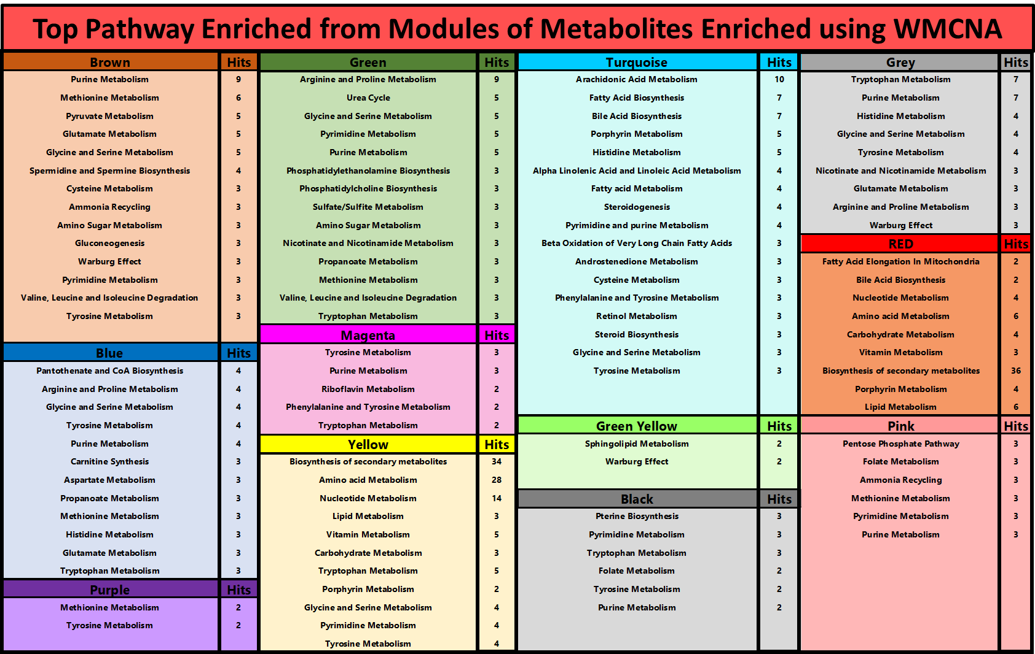
Supplementary Figure 15: LCA members and their functional enrichment of Survivor modules.
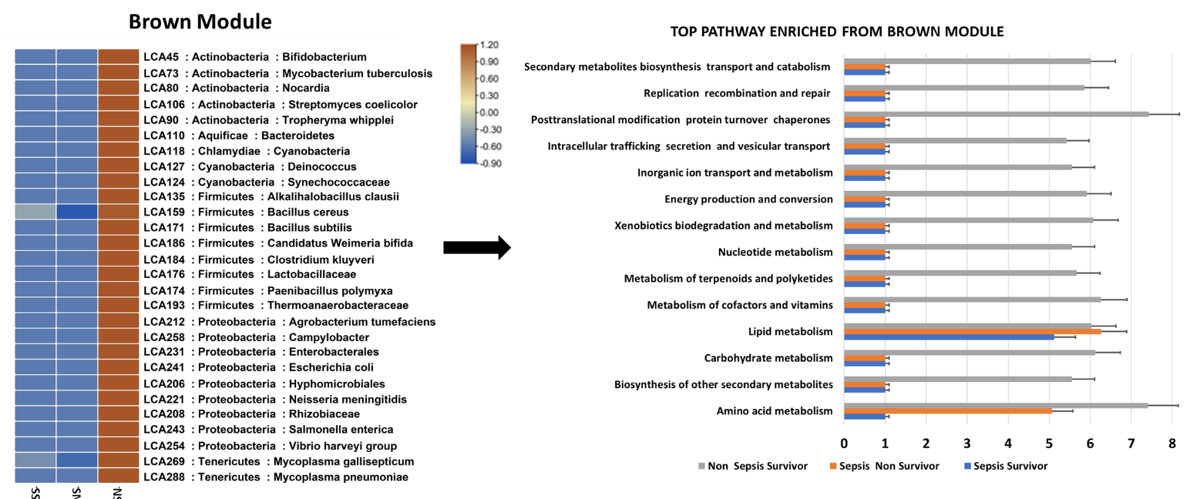
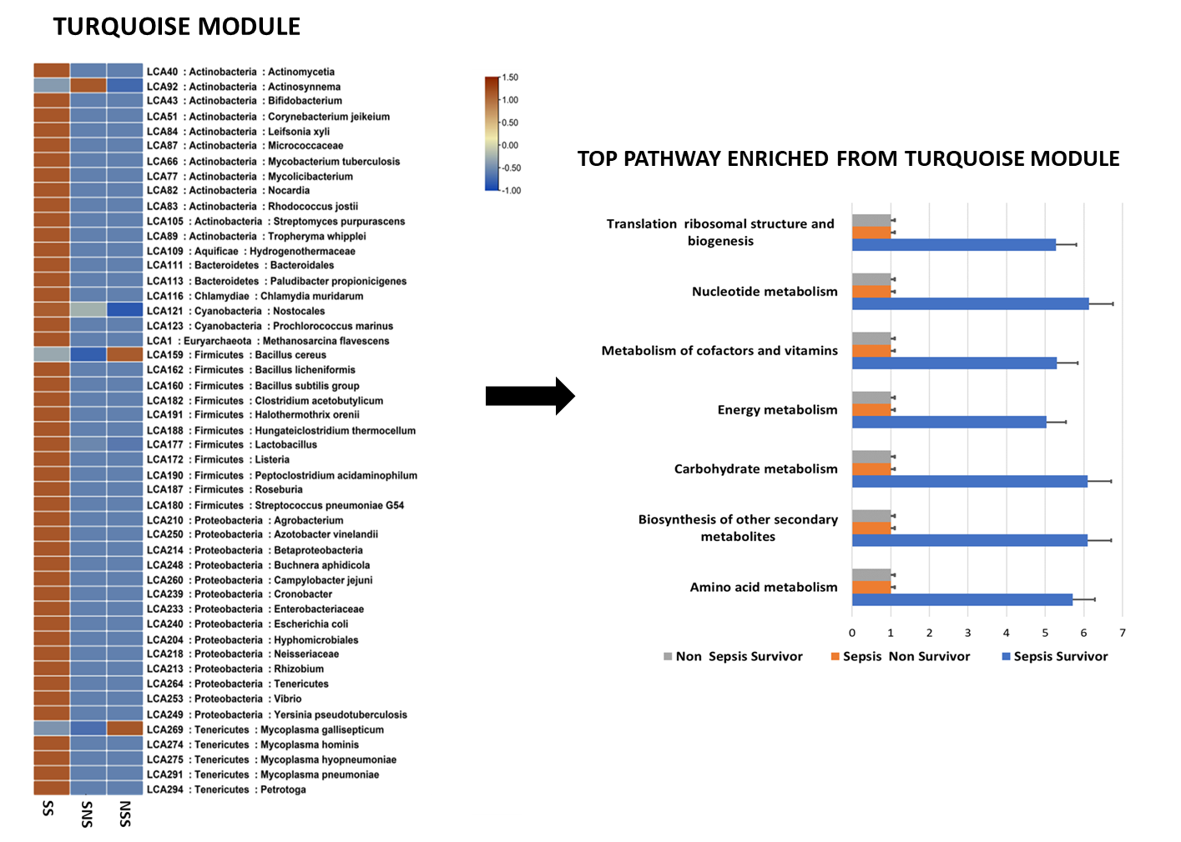

Supplementary Figure 16

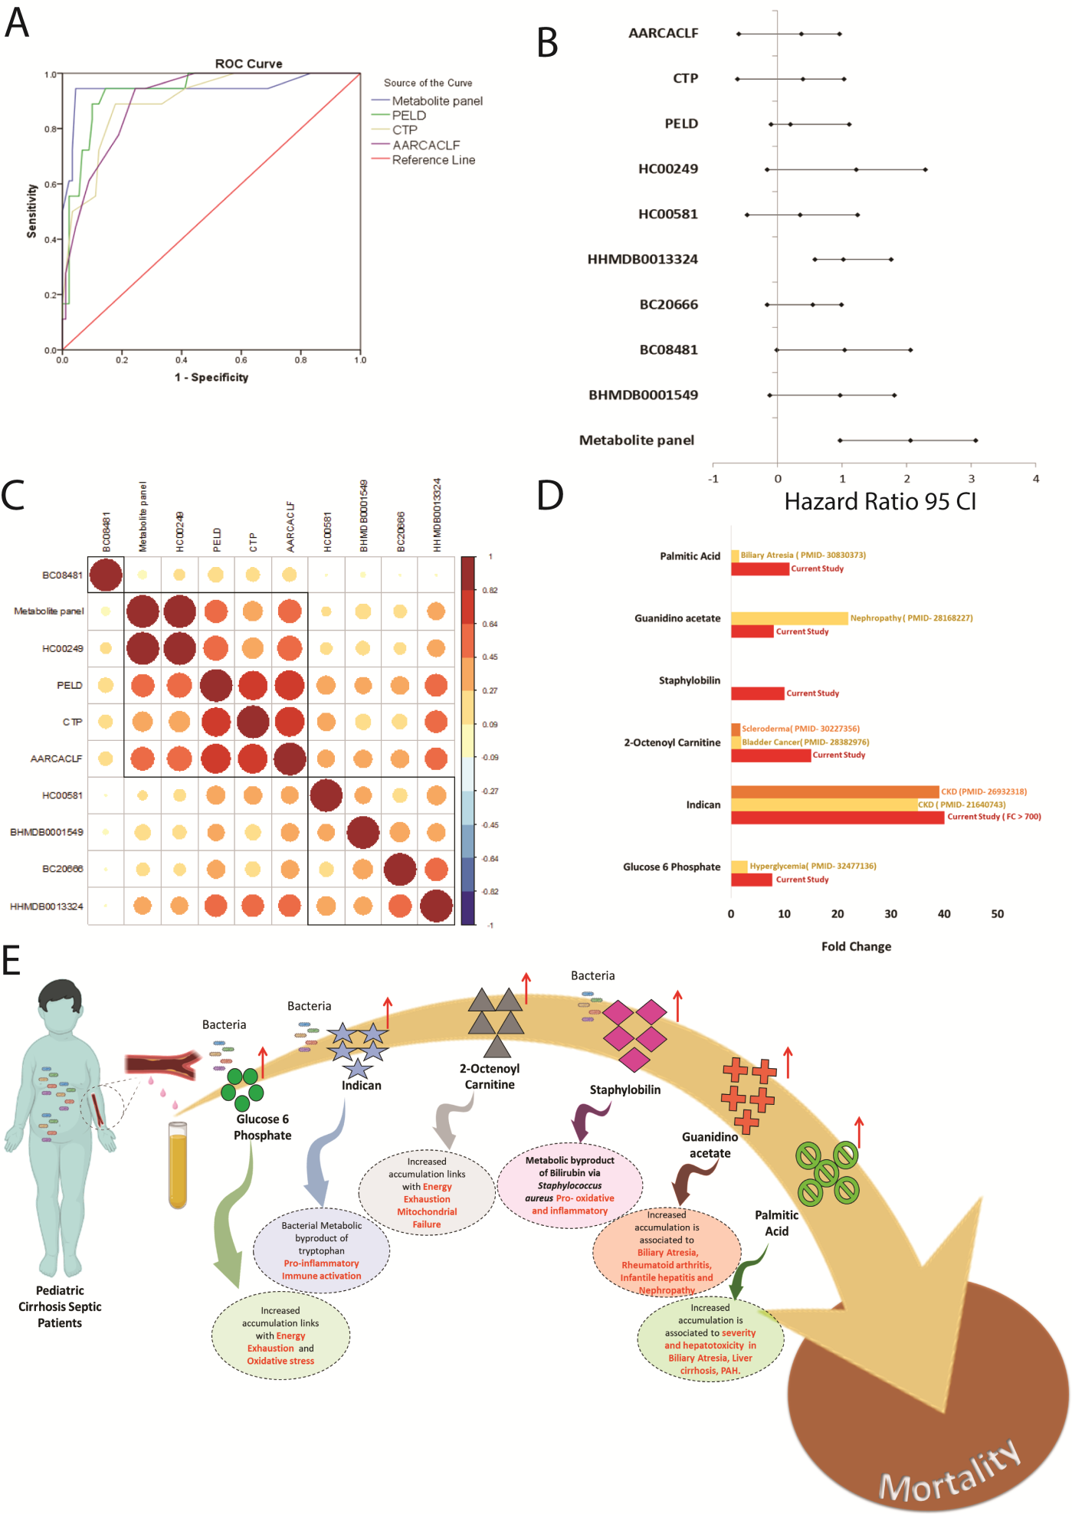
Metabolite panel provides insight on pathogenesis and deterioration of patients with cirrhosis and sepsis.
Supplementary Figure 16A- AUC analysis for comparison of metabolite panel with severity indices.
Supplementary Figure 16B- Cox regression analysis for calculation of hazard ratio for metabolite panel and severity indices
Supplementary Figure 16C- Correlation analysis of metabolite panel and severity indices in cirrhotic septic patients
Supplementary Figure 16D- Comparative analysis of metabolite panel with previously reported studies
Supplementary Figure 16E- The identified metabolite panel provides novel insight on pathogenesis of cirrhosis and sepsis patients. Further, increase in plasma levels of the metabolite panel outlines that energy exhaustion, mitochondrial failure, hyper-immune activation, pro-oxidative and inflammatory stress are probable reasons for the deterioration of cirrhotic septic patients to early mortality

