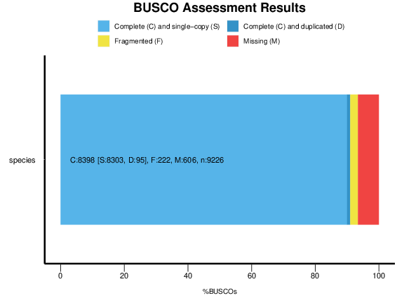
Figure S1 BUSCO notation assessment results of D. delphis genome

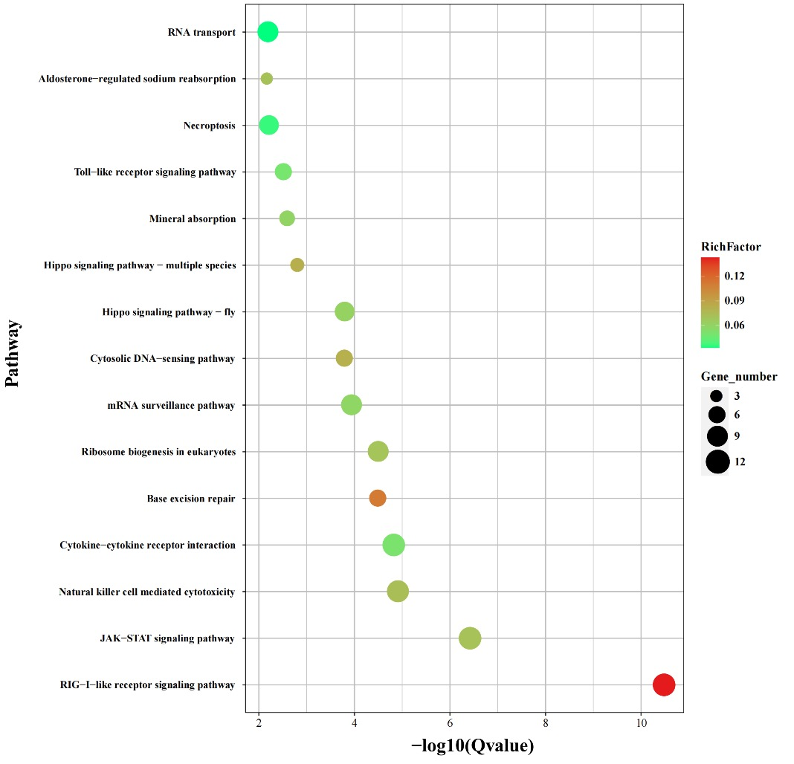
Figure S2 KEGG enrichment analysis of highly significantly expanded gene families in D. delphis (p < 0.01).

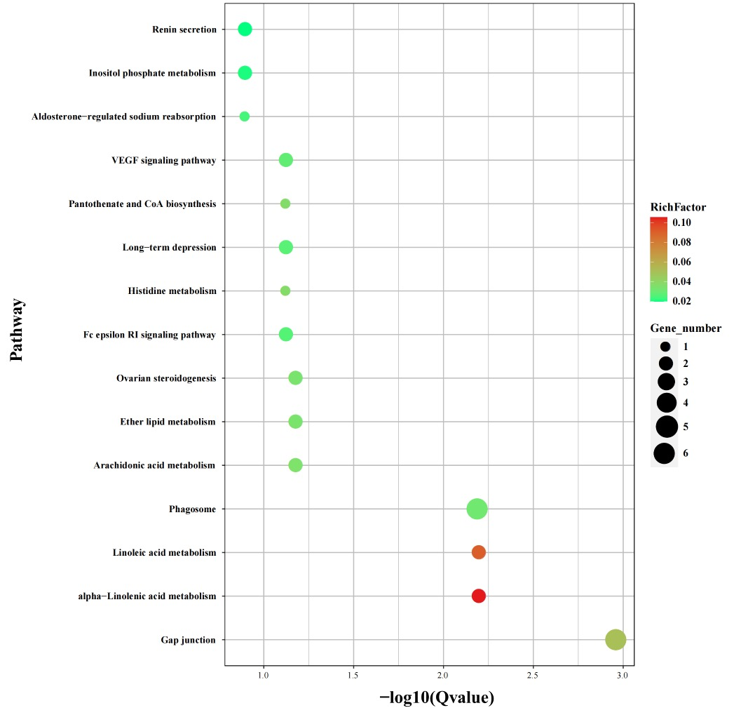
Figure S3 KEGG enrichment analysis of highly significantly contracted gene families in D. delphis (p < 0.01).

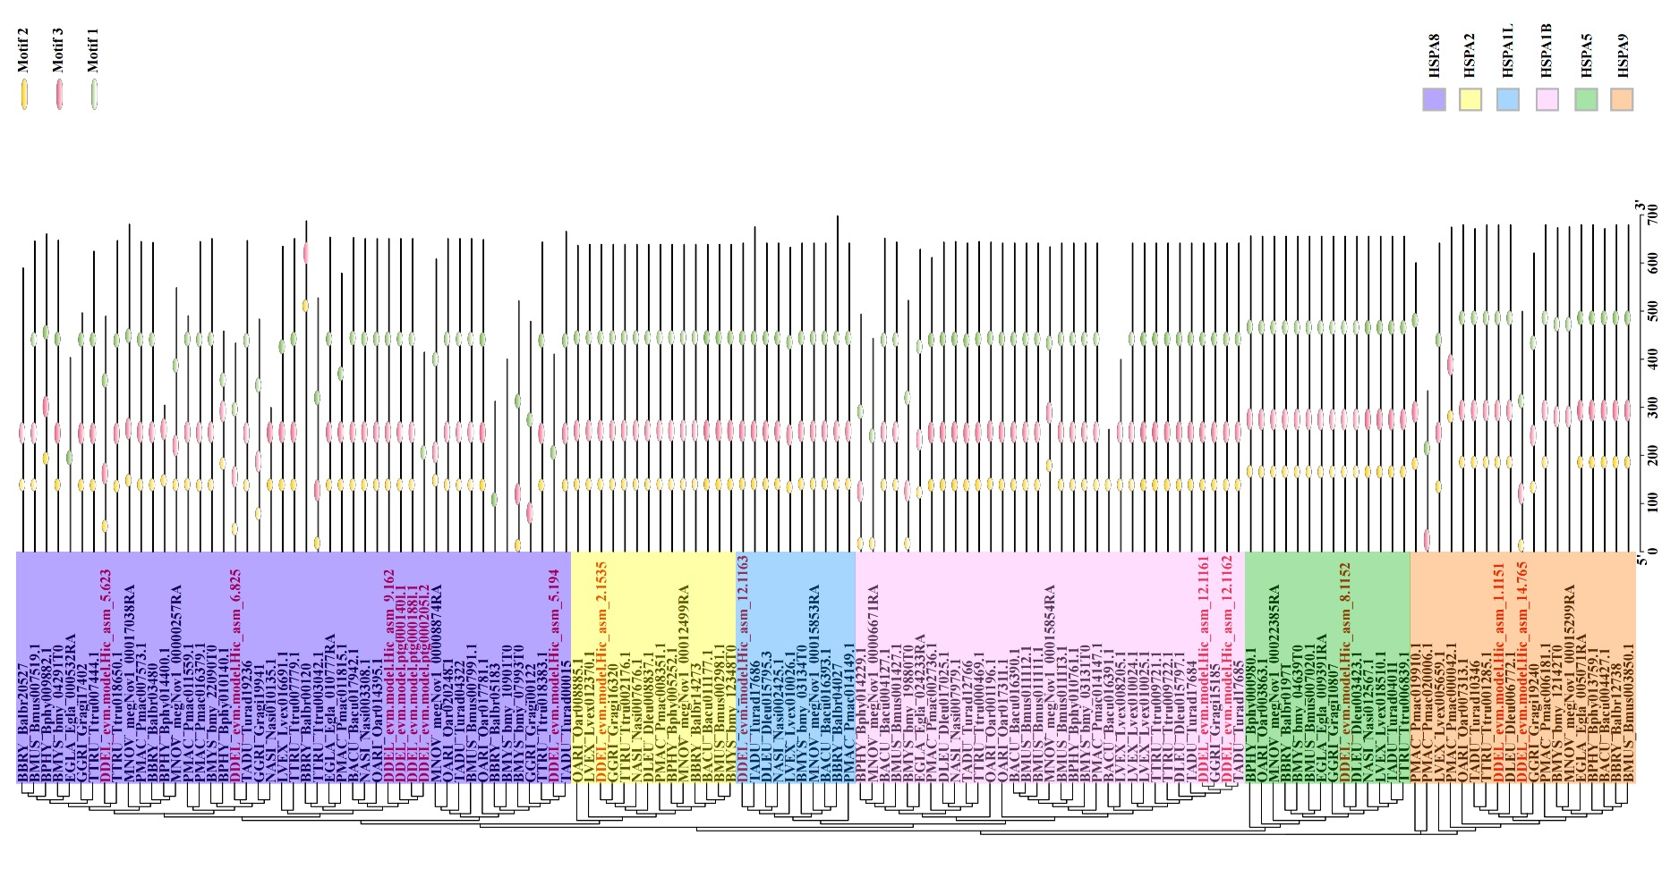
Figure S4 Maximum likelihood phylogenetic tree and motif constructed by Hsp70 genes in different species of cetaceans.
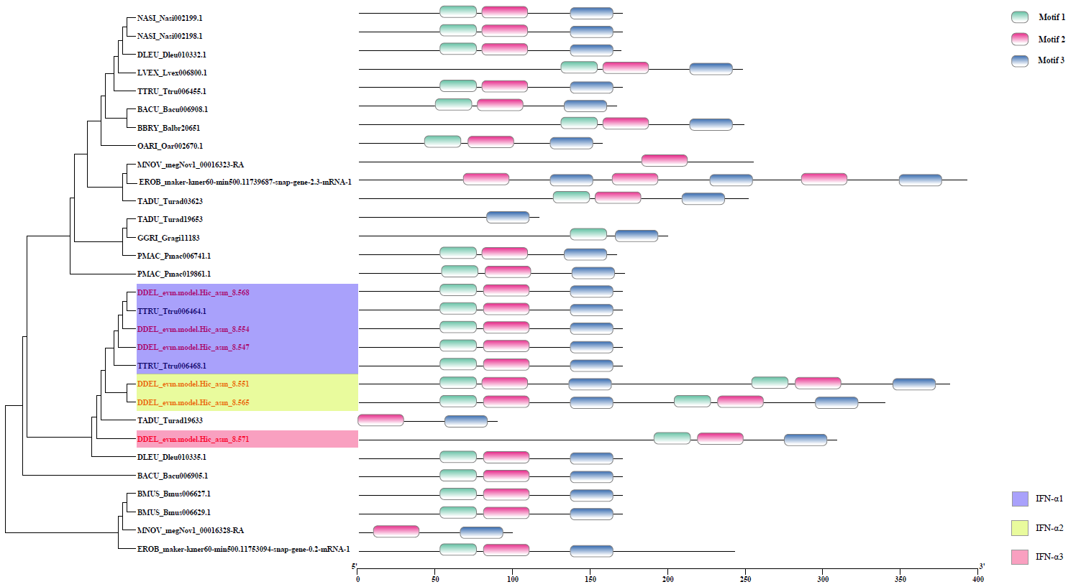
Figure S5 Maximum likelihood phylogenetic tree and motif constructed by IFN-α genes in different species of cetaceans.

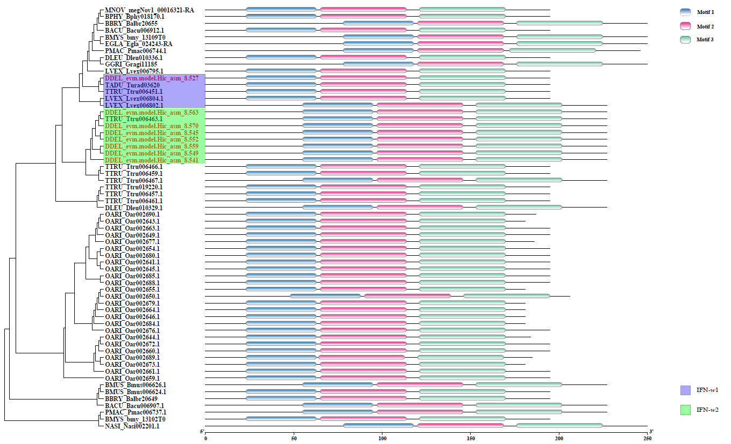
Figure S6 Maximum likelihood phylogenetic tree and motif constructed by IFN-ω genes in different species of cetaceans.

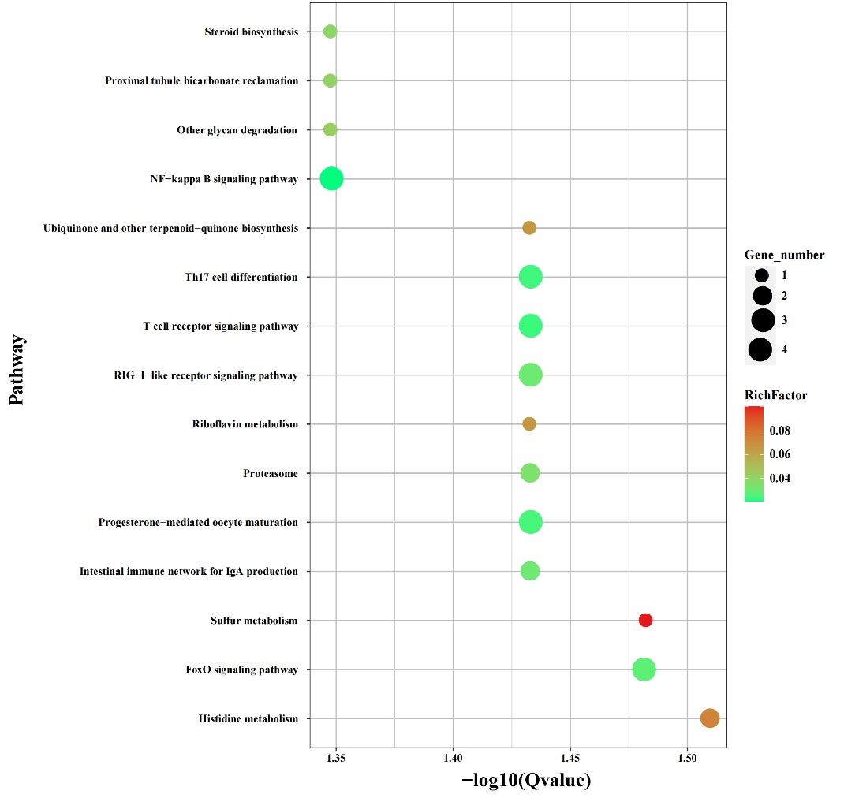
Figure S7 KEGG enrichment analysis of significantly positive selection genes in D. delphis (p < 0.01).

