Questionnaire
- Demographics
- Are you originally from U Minh Thuong (Ha)? (Origin) (if not, where is your origin? How long have you been in U Minh)
- When was you born? (Age)
- Gender
- Which ethnicity are you? (Ethnicity)
- To which level do you complete at school? (Education)
- What do you do to have income?
- How many people live in your household?
- How many lands do you have (hectares)? What do you use these lands for?

- Human-wildlife conflicts
- Do you own or farm livestock or aquaculture?
- Which species or types of animals do you own / farm?
- Has it become easier or more difficult to farm or keep these species?
- Are there any impacts from wildlife of the forest to your living or farming? (If yes, how do you tackle these problems? Do you use herbicide, pesticide, traps or anything else?)
- Which types of wild animals cause the most damage?
- How do you prevent or stop these wild animals from killing or damaging your crop, livestock and/or fish?
- Do otters ever take your fish? [if “no”, why not?]
- How do you prevent or limit any damage caused by otters?
- Do wild cats ever take your fish/livestock? [if “no”, why not?]
- How do you prevent or limit any damage caused by wild cats?

- Human perceptions for the species

- Can you name wild cat species in your area?
- Can you describe the types of wild cat that you see in your area?
- Do many people in your community know about Fishing cat (and otter?)?
- Do you see more or less of these species since your childhood? What do you think that has caused these changes?

- Wildlife trade dynamics
- Do you know anyone who comes to the forest to hunt?
- Which types of wildlife do they hunt?
- What do they do with the wildlife they have hunted?
- How much is the price of wildlife?
- What is wildlife sold for?
- Where is wildlife sold? And to who?

Images used in Fishing cat identification test
Images | Species
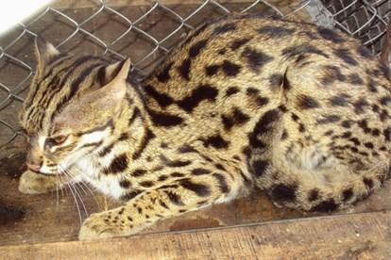 | Leopard Cat (Prionailurus bengalensis)
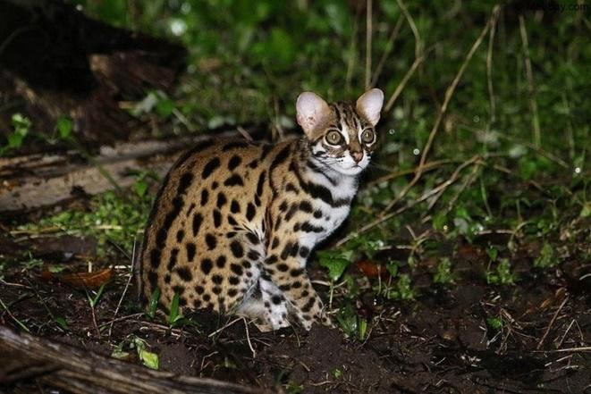 | Leopard Cat (Prionailurus bengalensis)
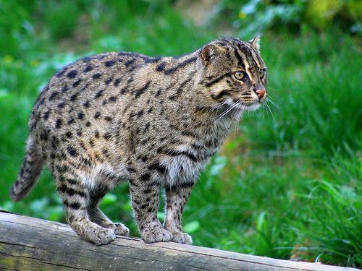 | Fishing Cat (Prionailurus viverrinus)
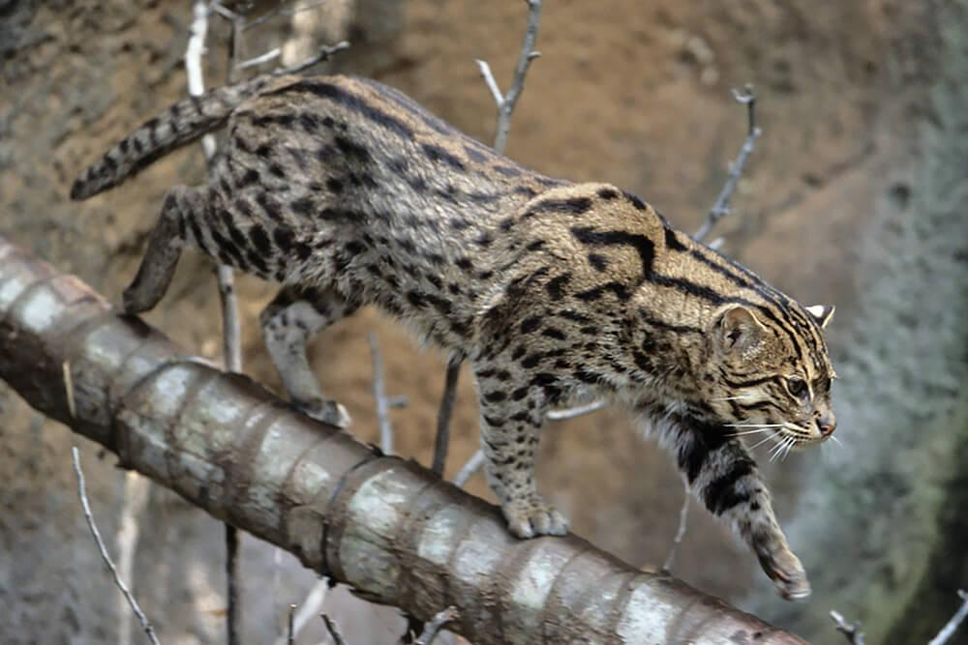 | Fishing Cat (Prionailurus viverrinus)
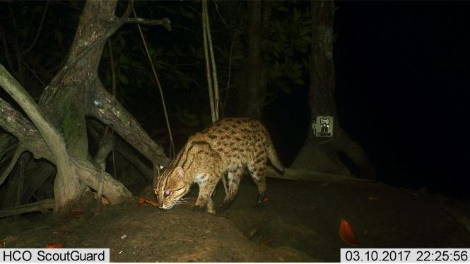 | Fishing Cat (Prionailurus viverrinus)
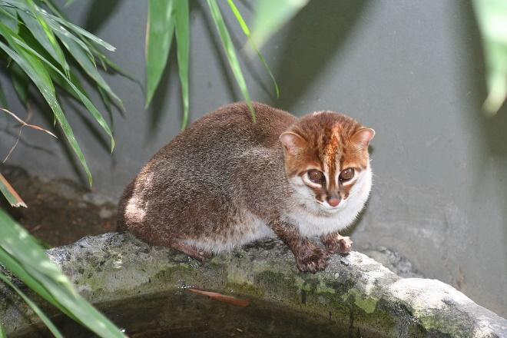 | Flat-headed Cat (Prionailurus planiceps)
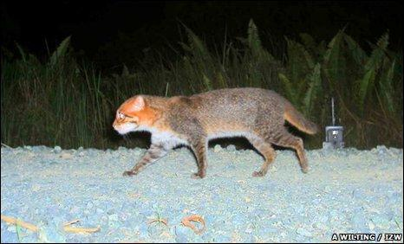 | Flat-headed Cat (Prionailurus planiceps)
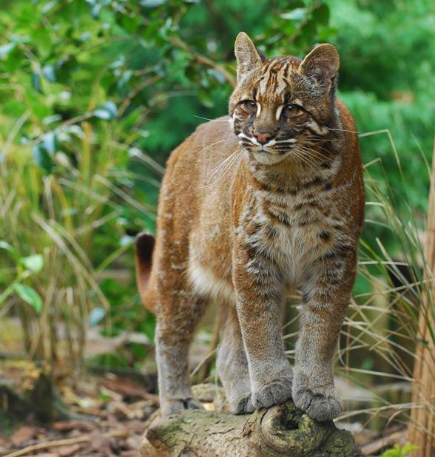 | Asiatic Golden Cat (Catopuma temminckii)
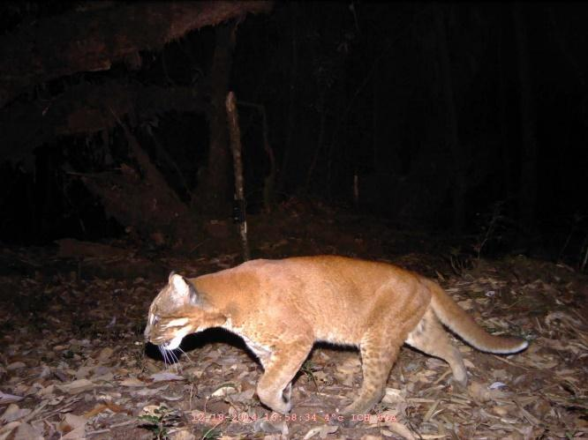 | Asiatic Golden Cat (Catopuma temminckii)
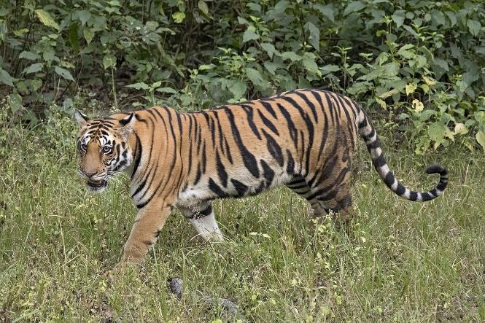 | Tiger (Panthera tigris)

