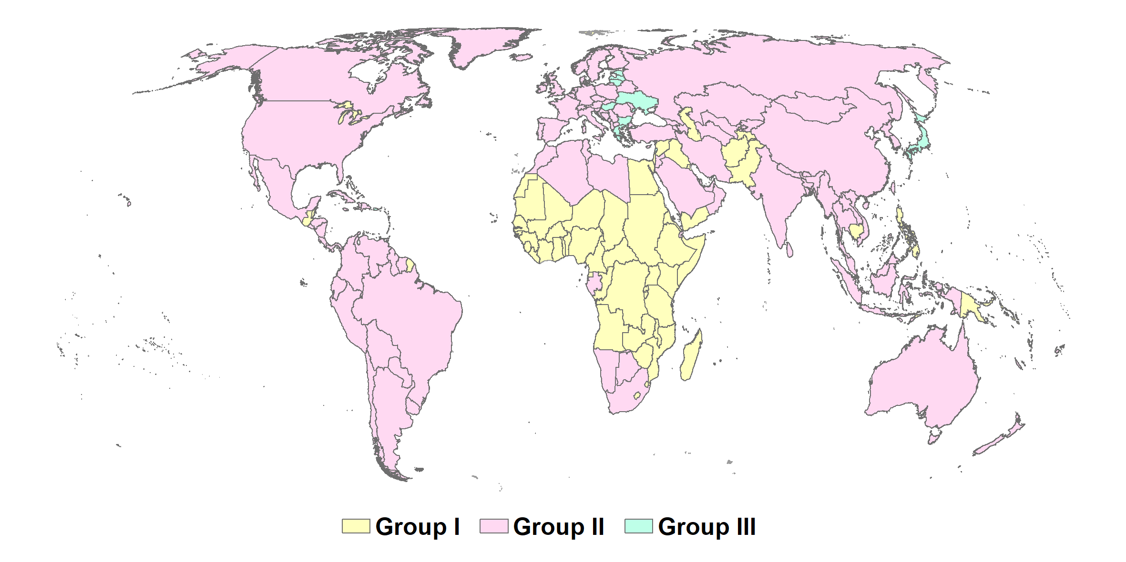
Extended Data Fig. 1 | Global countries divided into 3 groups, determined by the projected net change of urban and rural populations over the period from 2020 to 2050. ‘Group I’ countries have both increase in urban and rural population, mainly from Sub-Saharan Africa and South and West Asia. ‘Group II’ represent countries that urban population would increase while rural population would decrease, mainly including China, Russia, United States, India, France, Germany and Brazil. ‘Group III’ represent countries that both urban and rural population would decrease, mainly including countries in Eastern Europe and Japan.
Scenarios | Descriptions
BAU | Urbanization levels were to remain unchanged at 2020 levels (i.e. at 56%)
DOM | Global urbanization levels increase from 56% to 68% and rural-to-urban migration is only allowed within country
INT | Rural-to-urban migration is allowed to cross country boundaries, neither rural expansion nor urban shrinking would occur. As a consequence, the increased population in 2050, which has been attributed to rural growth in DOM, is instead allocated to urban areas, and areas where urban shrinking occurs in DOM are filled by transferring growth of rural population, leading to a relatively higher degree of urbanization, i.e., 72%.
Food Security | All released land areas were used for food production.
Nature Restoration | All released land areas were used for nature restoration.
Extended Data Table 1 | Scenarios descriptions of BAU, DOM, INT, Food Security and Nature Restoration.

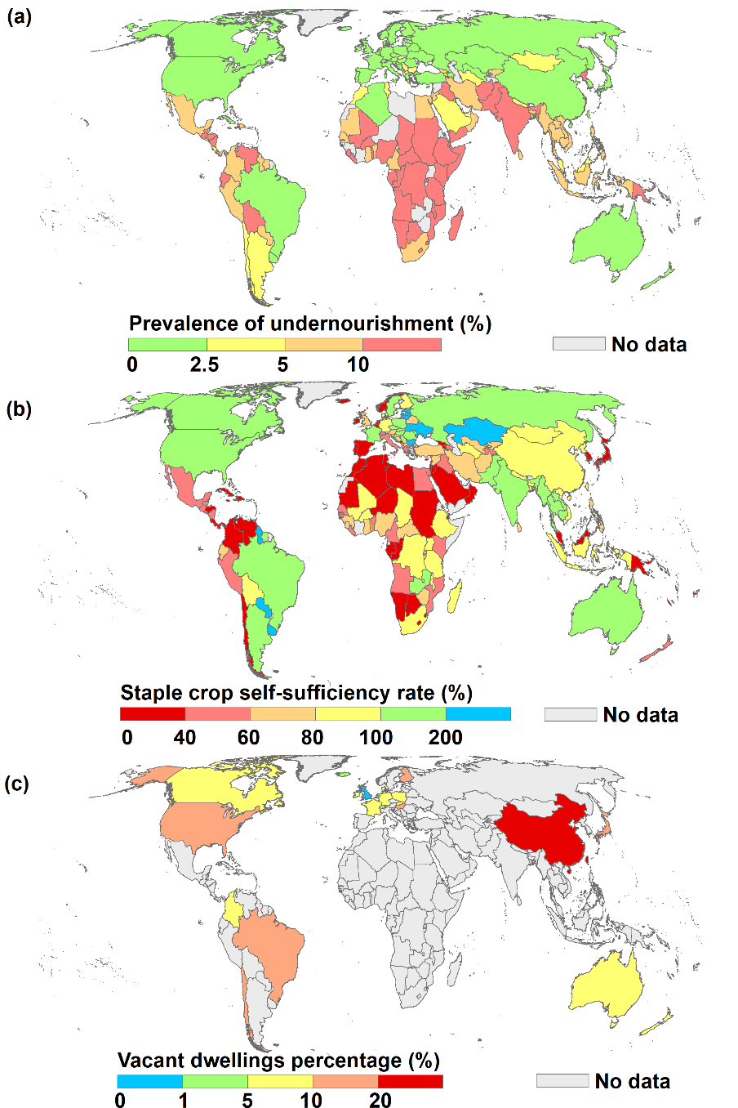
Extended Data Fig. 2 | Food security, nutrition and vacant dwellings of each country in 2020. a, Prevalence of undernourishment. b, Staple crop self-sufficiency rate. c, Vacant ratio of dwellings percentage.

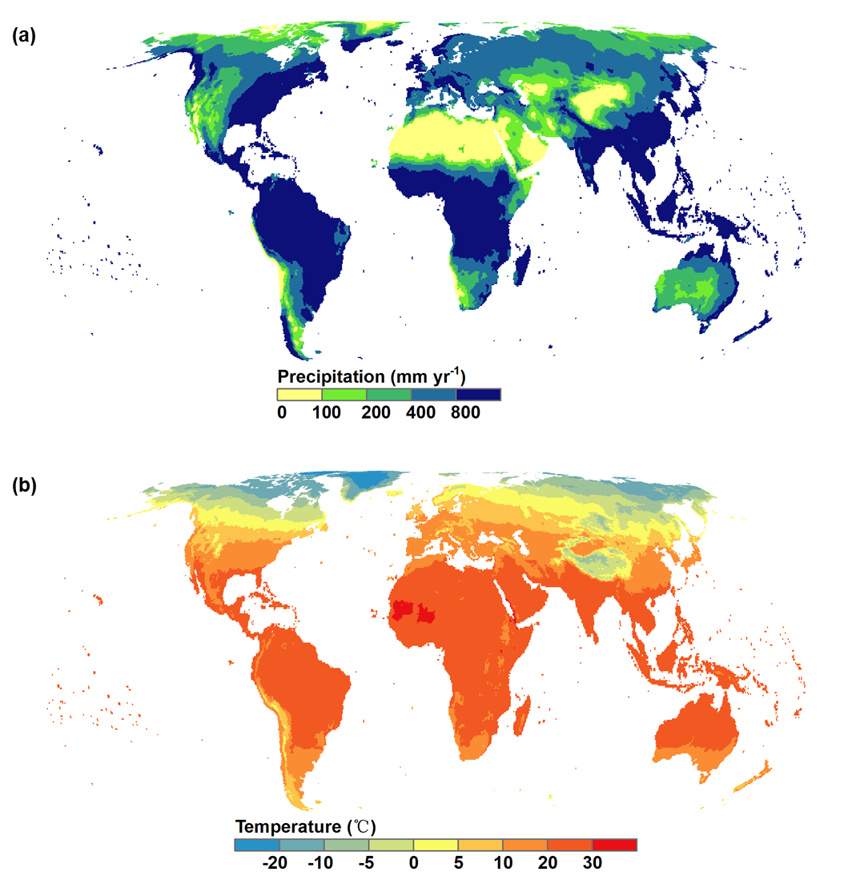
Extended Data Fig. 3 | Climate map in 2020. a, Precipitation (mm yr-1). b, Temperature (℃).

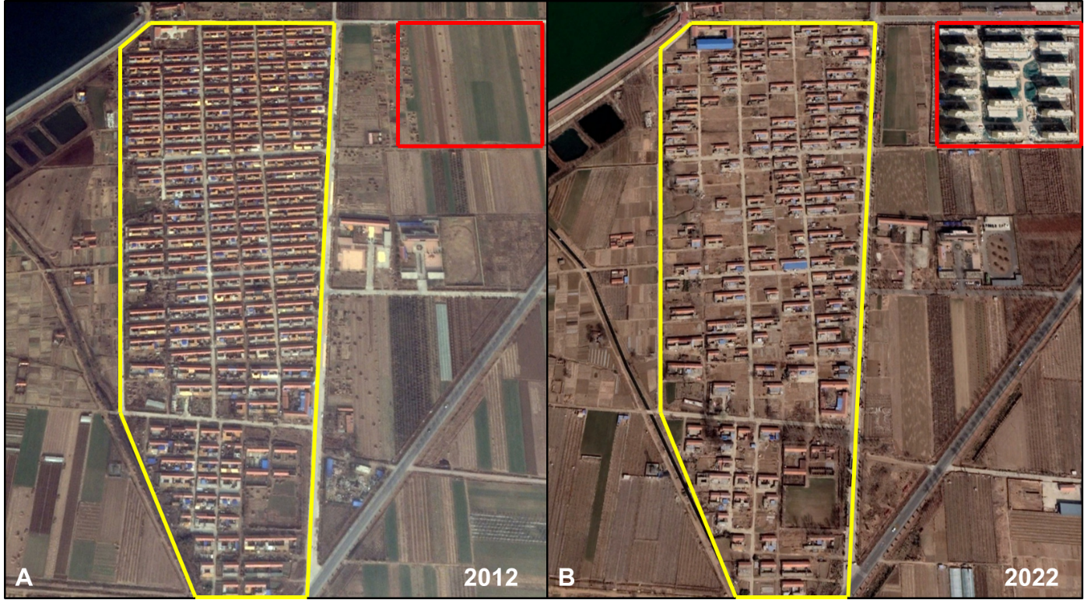
Extended Data Fig. 4 | Rural reclamation in Hetoudian Town, Qingdao City, China. The inside of the yellow frame indicates the ongoing reclaimed rural built-up areas (bungalows) from 2012 to 2020, while the inside of the red frame indicates the newly built high-rise resettlement buildings from 2012 to 2020. Credit: CNES/Airbus, Maxar Technologies, retrieved from Google Earth Engine (https://developers.google.com/earth-engine/datasets/catalog/sentinel)

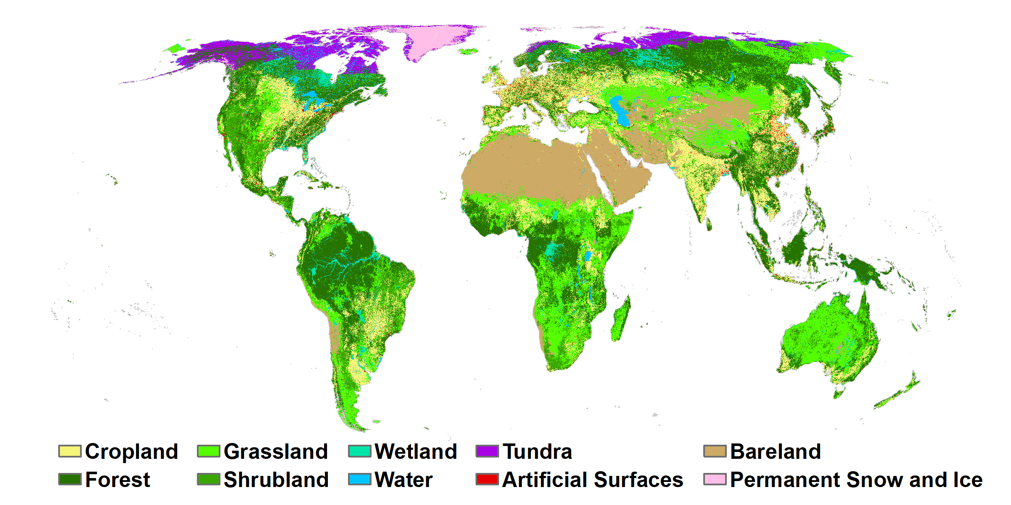
Extended Data Fig. 5 | Land use map of Globeland30 in 2020.

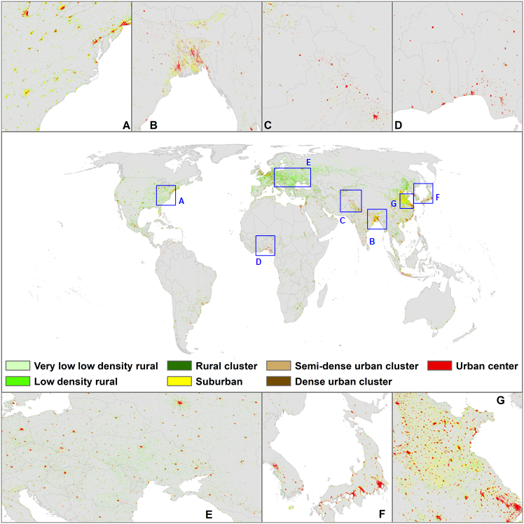
Extended Data Fig. 6 | Built-up land in 2020 reclassified by Global Human Settlement Layer-Settlement Model (GHSL-SMOD) dataset.

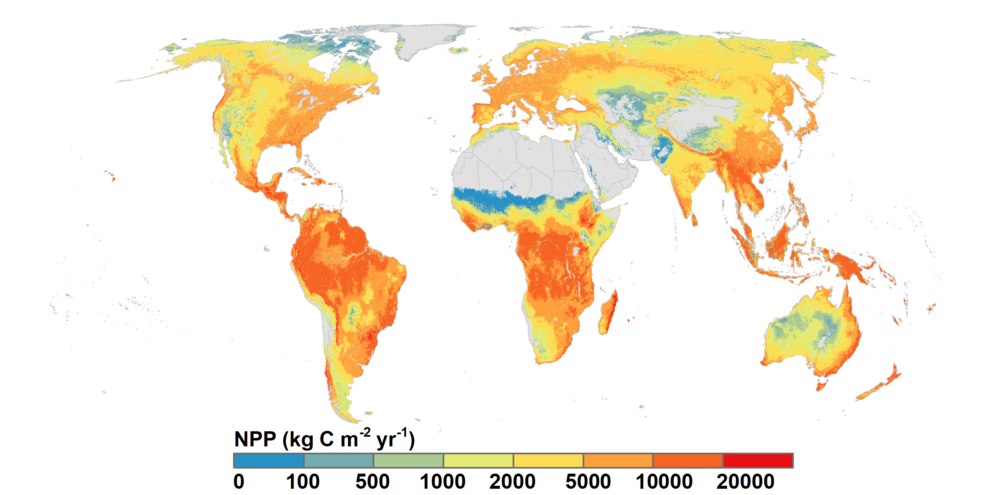
Extended Data Fig. 7 | MODIS-based, annual year-end gap-filled net primary production (kg C m⁻² yr⁻¹) in 2020.

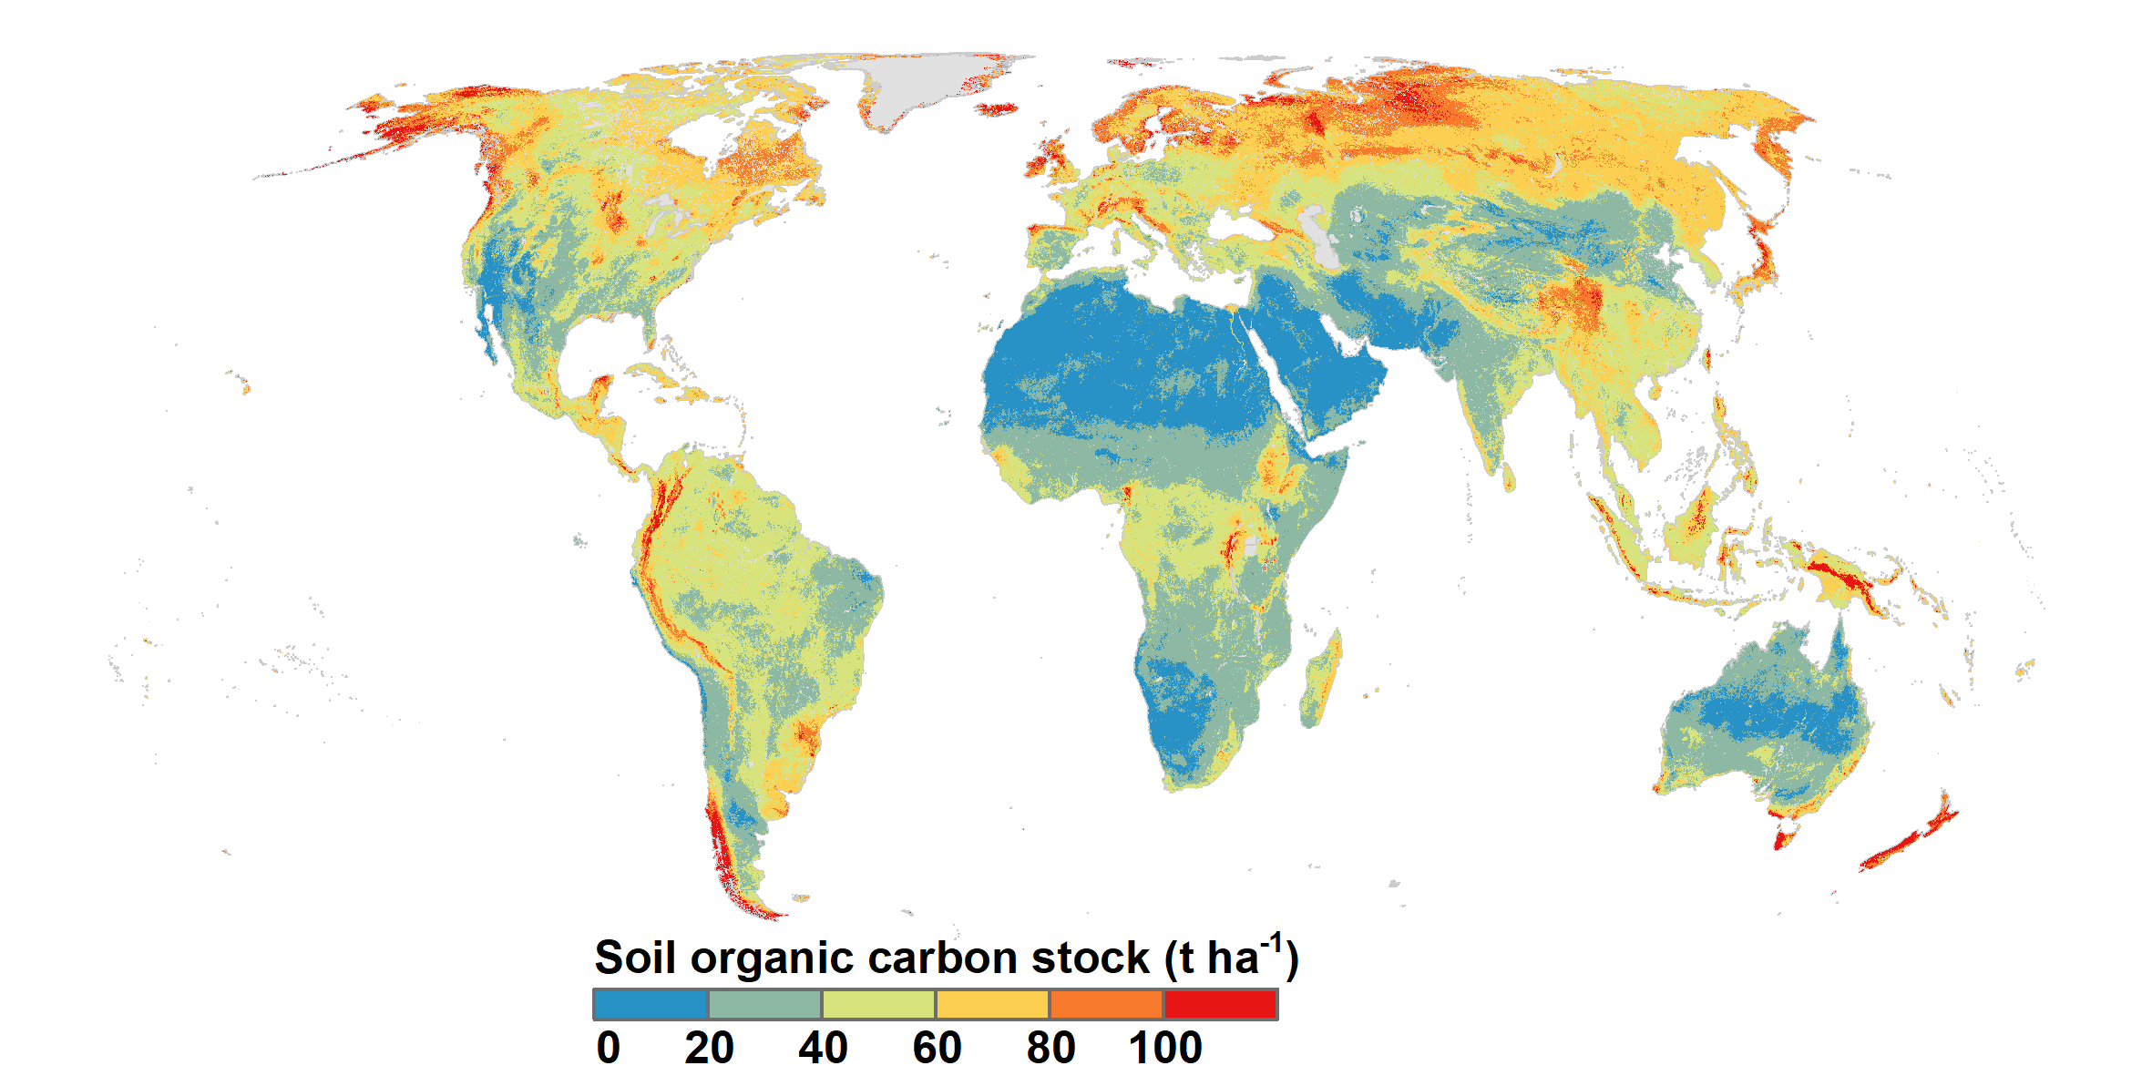
Extended Data Fig. 8 | Soil organic carbon stock data (t ha⁻¹) for 0-30 cm depth interval from International Soil Reference and Information Centre (ISRIC) in 2020.

