Ethyl tetratriacontanoate and non-polar compounds from Mitragyna inermis stem bark

Relwendé J. Ouédraogo^{1,2*}, Farzana Shaheen³, Lassina Ouattara^{1,2}, Georges A. Ouedraogo²

¹Departement de Biochimie-Microbiologie, Unité de Formation et de Recherche en Sciences de la Vie et de la Terre, Université Nazi BONI, 01 BP 1091 Bobo-Dioulasso 01, Burkina Faso
²Laboratoire de Recherche et d’Enseignement en Santé et Biotechnologies Animales, Université Nazi BONI, 01 BP 1091 Bobo-Dioulasso 01, Burkina Faso
^{3$}Third World Center for Science and Technology, Hussain Ebrahim Jamal Research Institute of Chemistry, University of Karachi, Karachi 75270, Pakistan

*Corresponding author, e-mail:rjustino14@yahoo.com

Received [Dates will be filled in by the Editorial office]

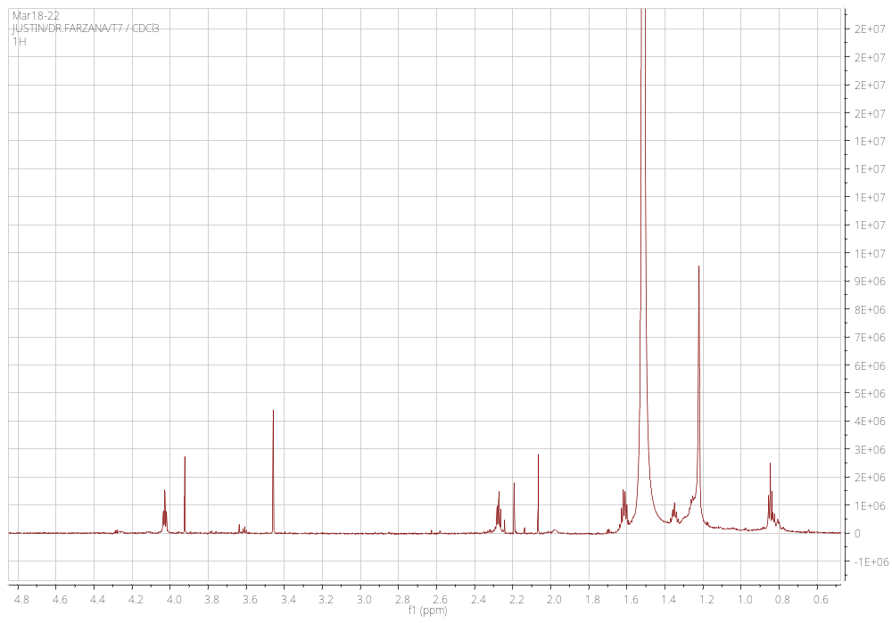
Fig. S1 ¹H NMR data (500 MHz, CDCl₃) of compound 1’

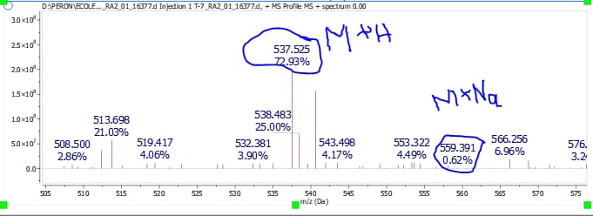
Fig. S2 ESIMS of compound 1’
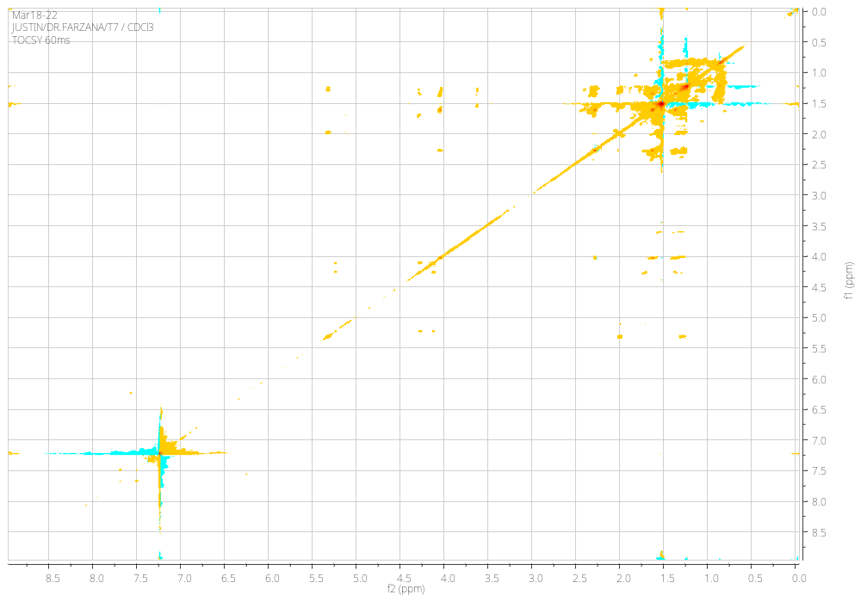
Fig. S3 TOCSY 60 ms data (800 MHz, CDCl₃) of compound 1’
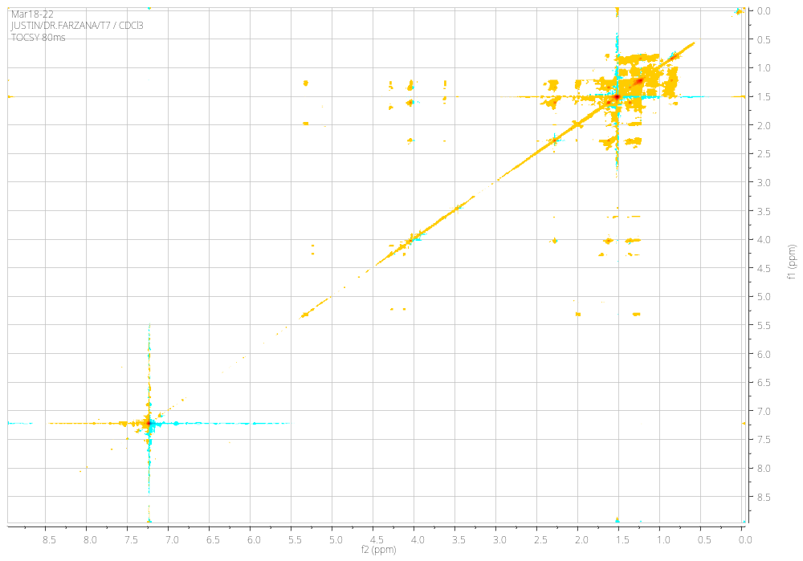
Fig. S4 TOCSY 80 ms data (800 MHz, CDCl₃) of compound 1’
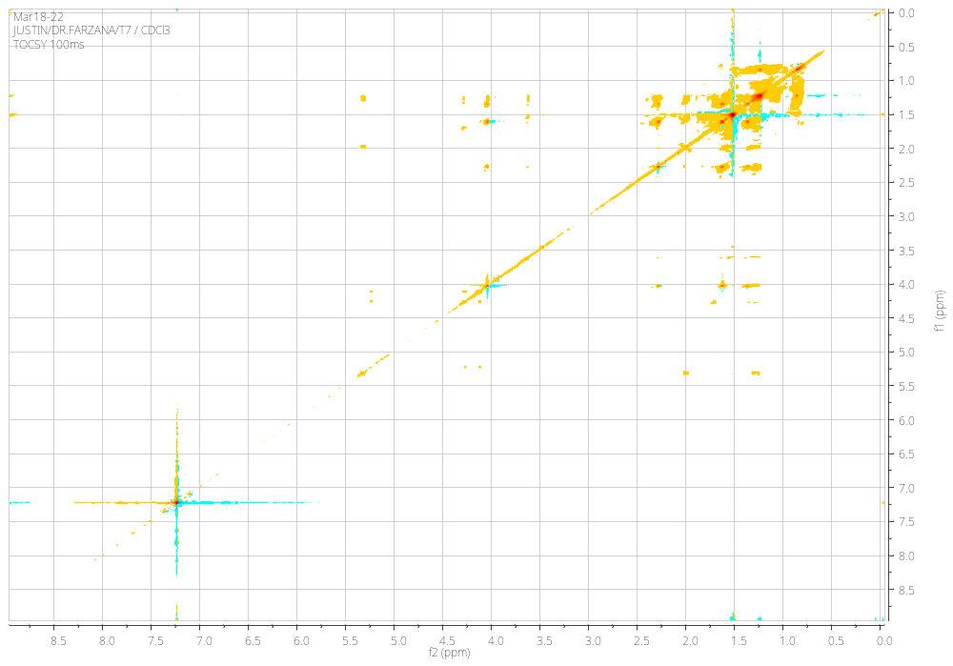
Fig. S5 TOCSY 100 ms data (800 MHz, CDCl₃) of compound 1’

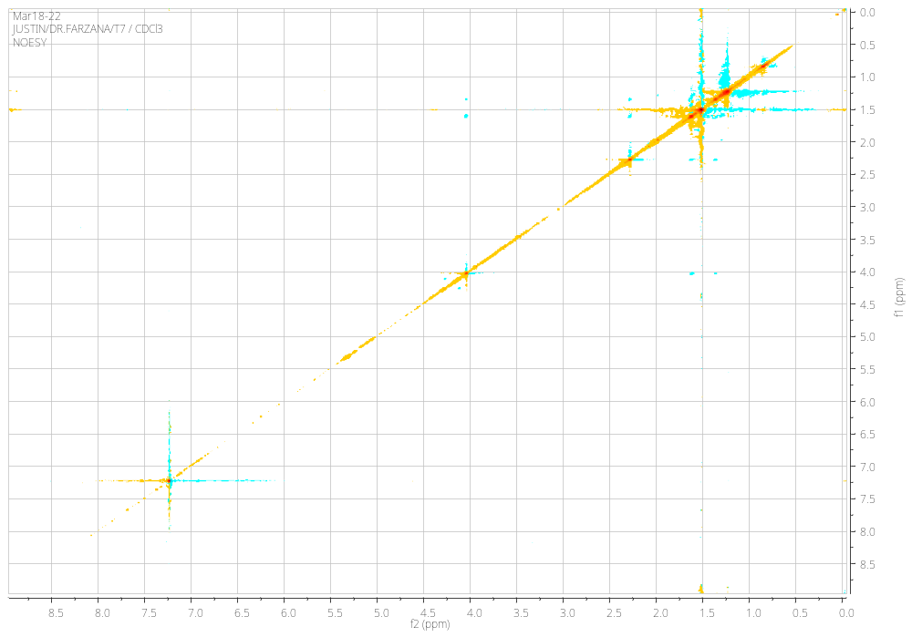
Fig. S6 NOESY data (800 MHz, CDCl₃) of compound 1’

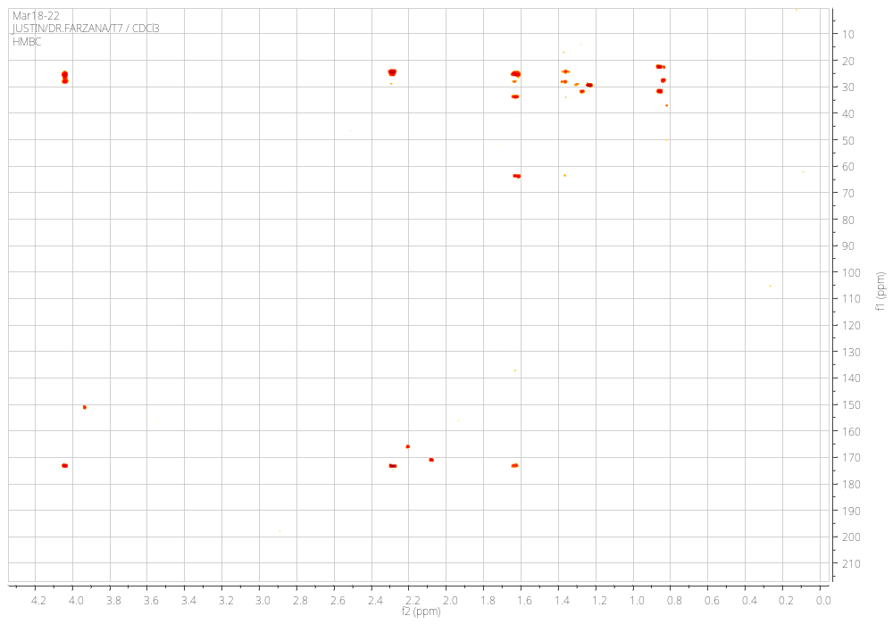
Fig. S7 HMBC data (800 MHz, CDCl₃) of compound 1’
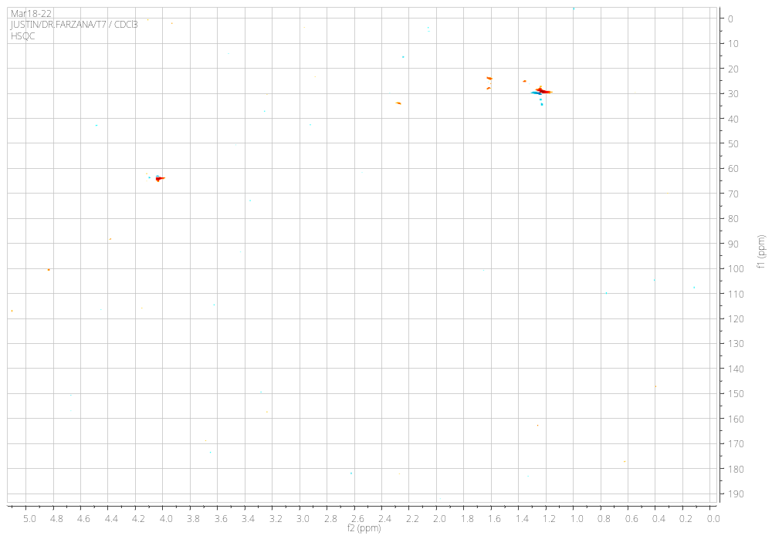
Fig. S8 HSQC data (800 MHz, CDCl₃) of compound 1’
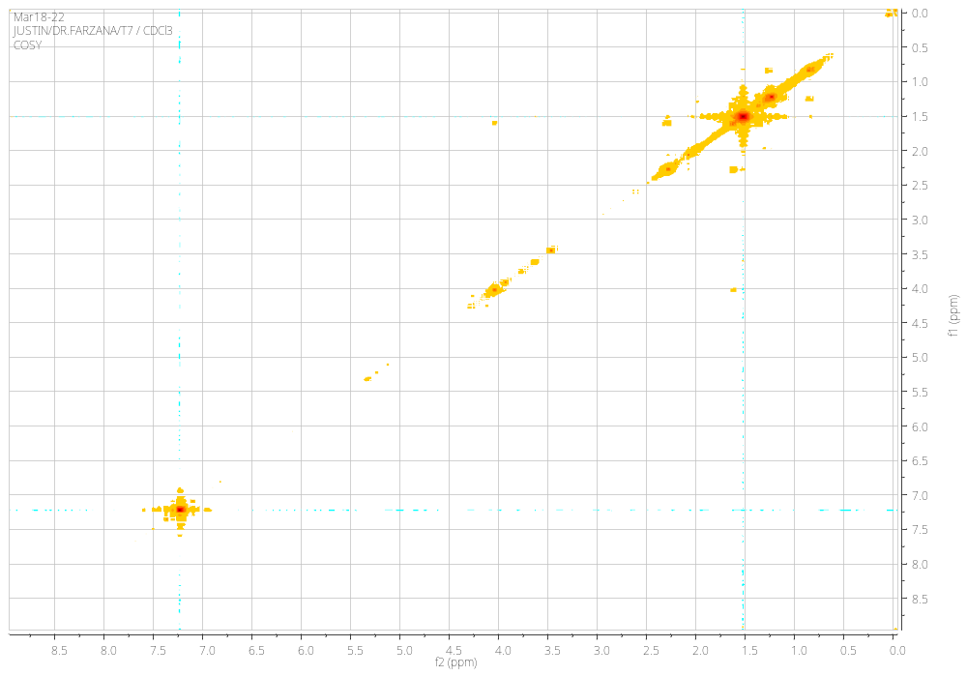
Fig. S9 Cosy data (800 MHz, CDCl₃) of compound 1’
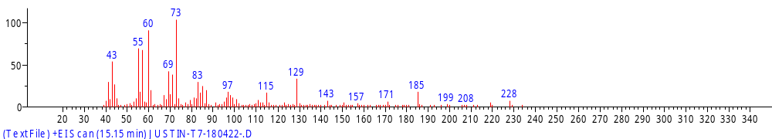
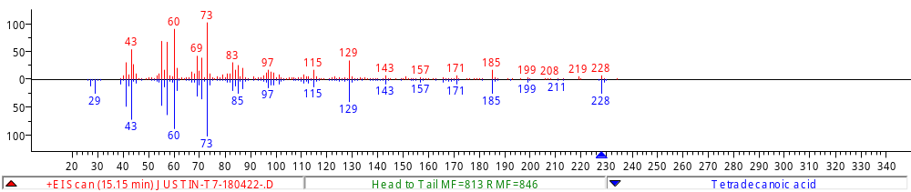
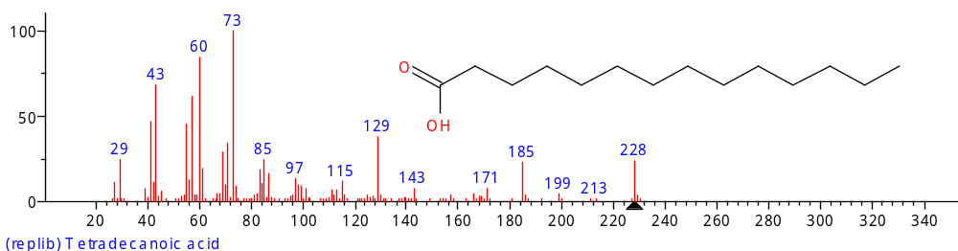
Fig. S10 GC-MS data of compound 1 compared to reported

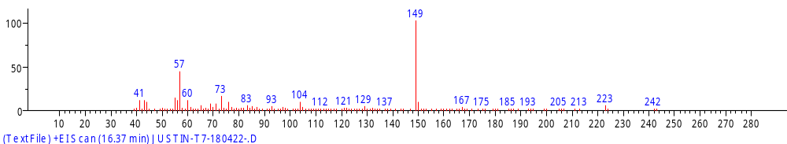
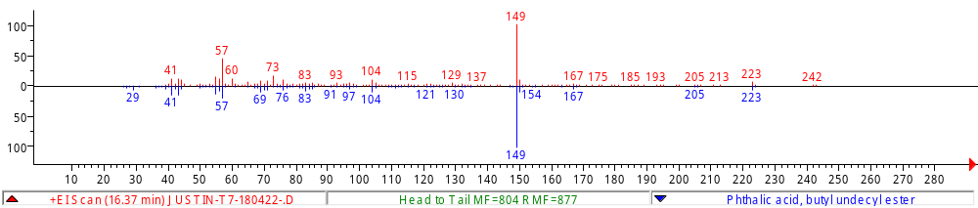
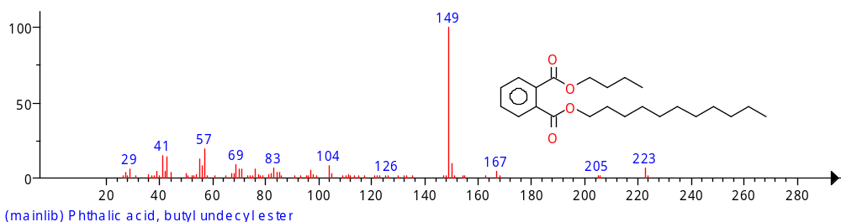
Fig. S11 GC-MS data of compound 2 compared to reported
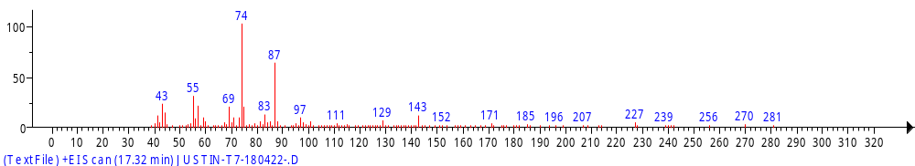
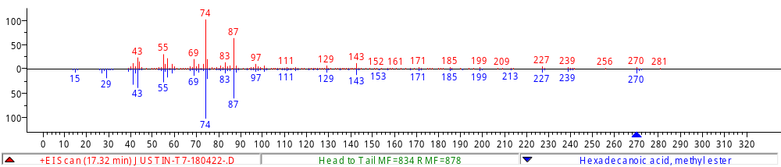
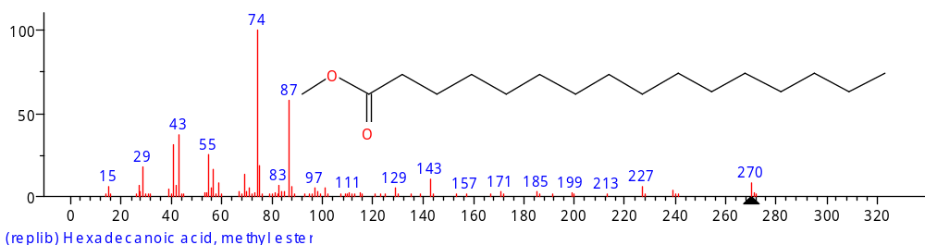
Fig. S12 GC-MS data of compound 3 compared to reported

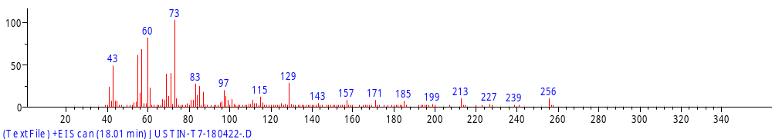
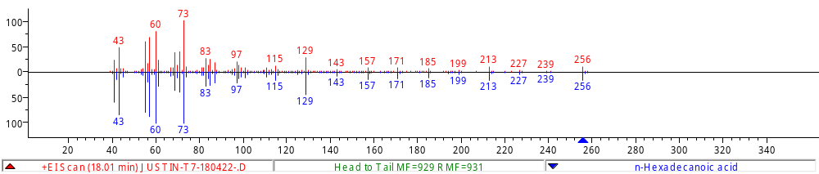
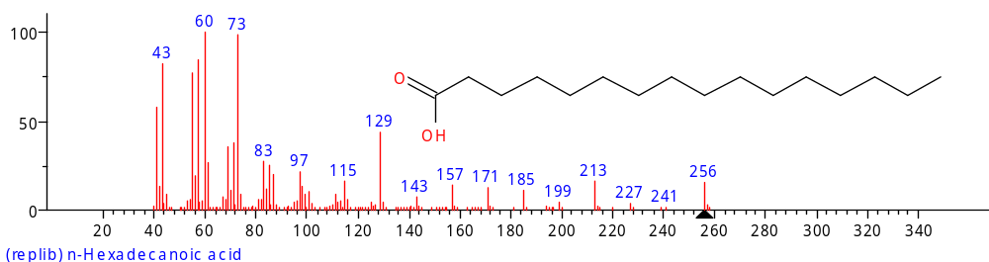
Fig. S13 GC-MS data of compound 4 compared to reported
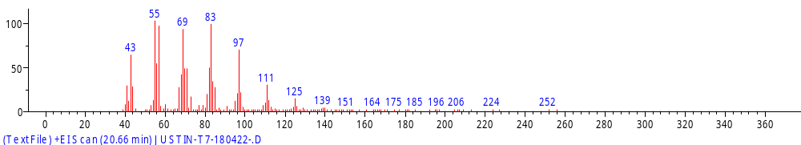
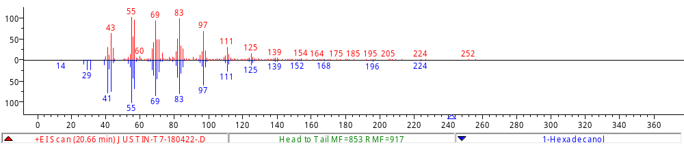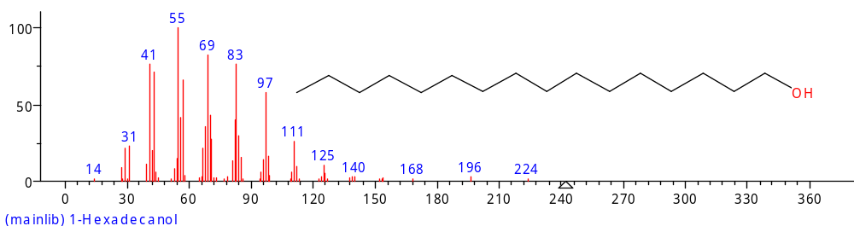
Fig. S14 GC-MS data of compound 5 compared to reported
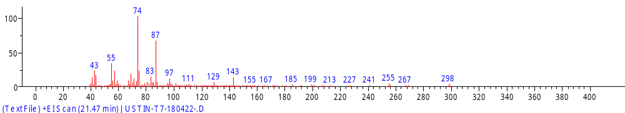
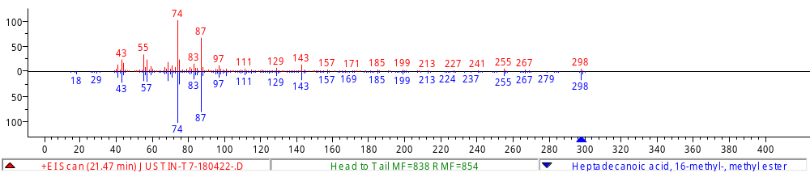
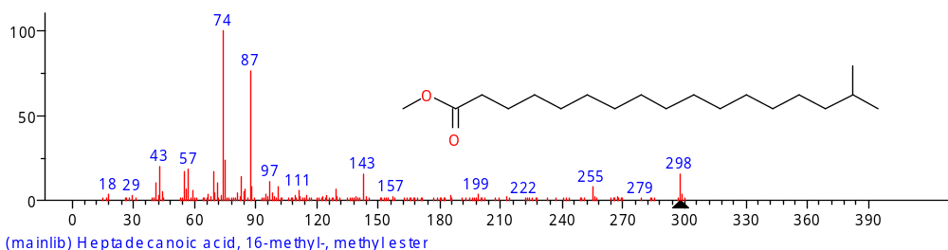
Fig. S15 GC-MS data of compound 6 compared to reported
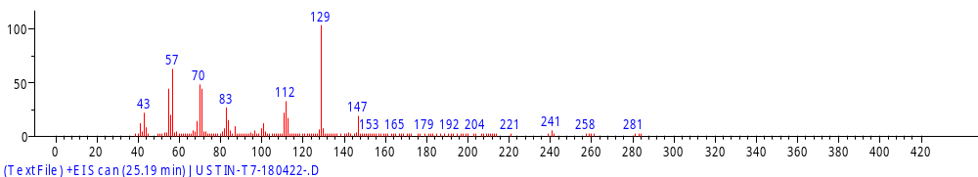
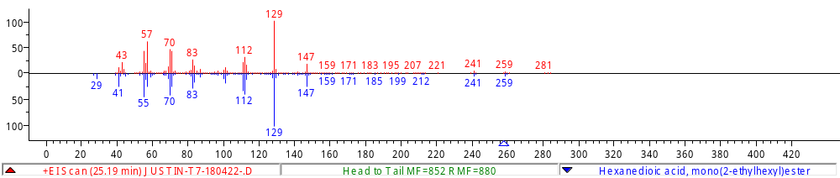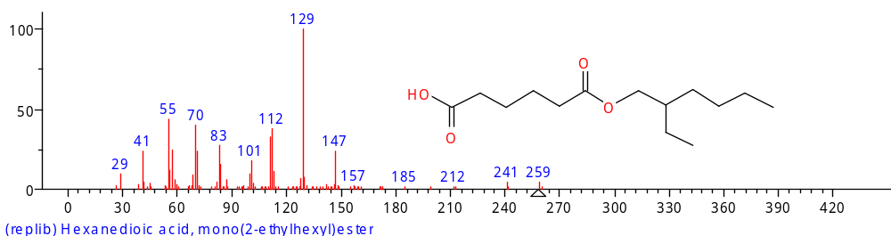
Fig. S16 GC-MS data of compound 7 compared to reported
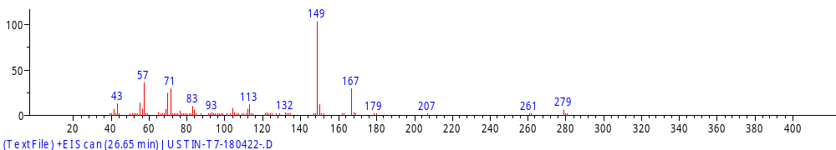
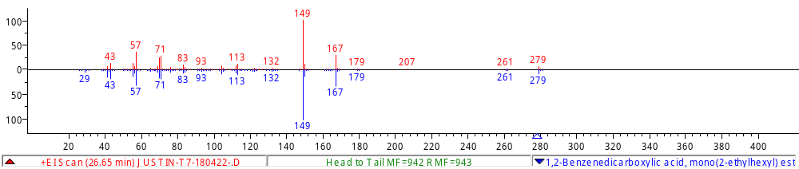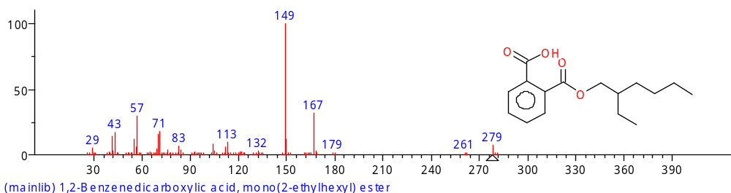
Fig. S17 GC-MS data of compound 8 compared to reported
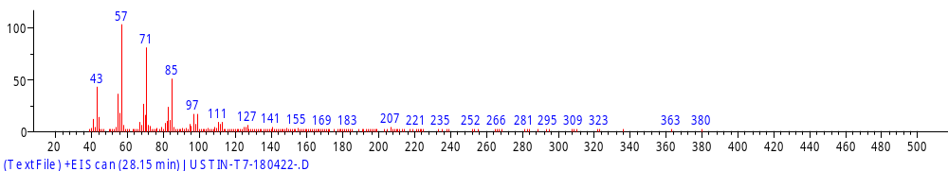
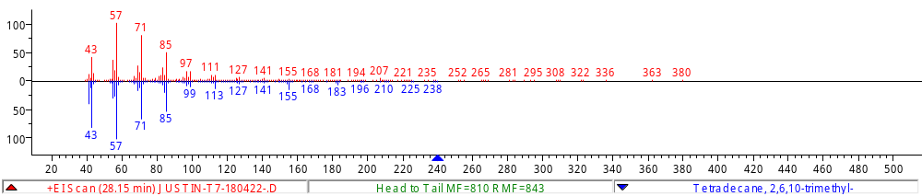
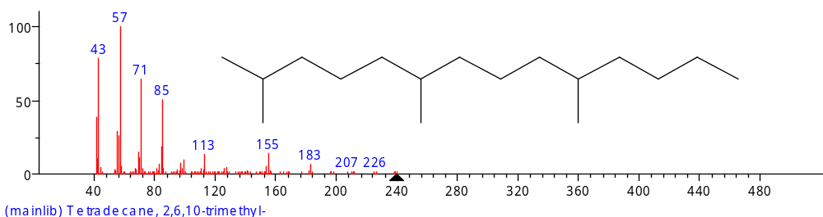
Fig. S18 GC-MS data of compound 10 compared to reported
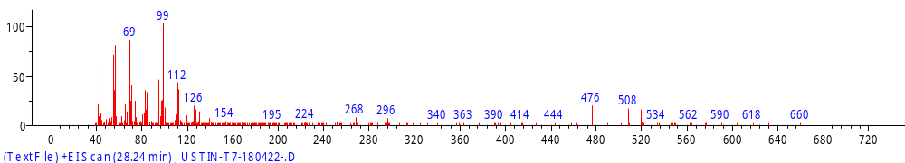
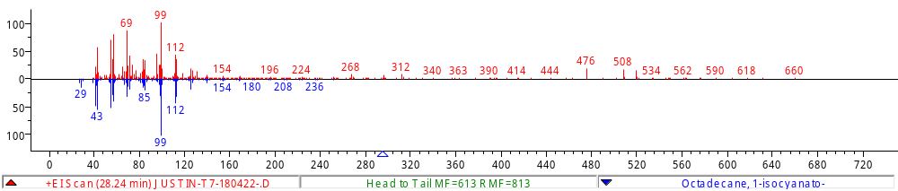
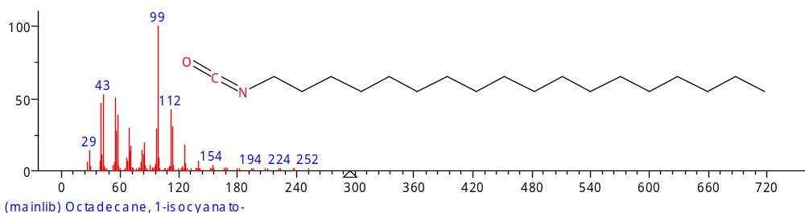
Fig. S19 GC-MS data of compound 11 compared to reported
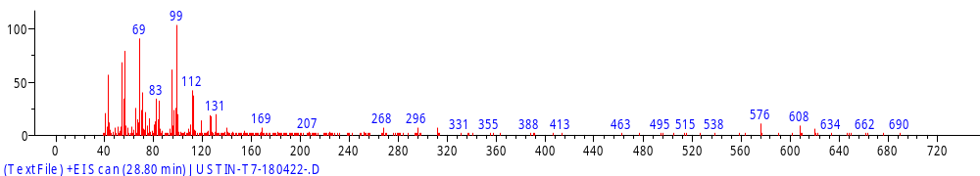
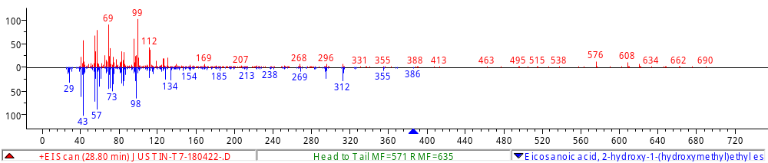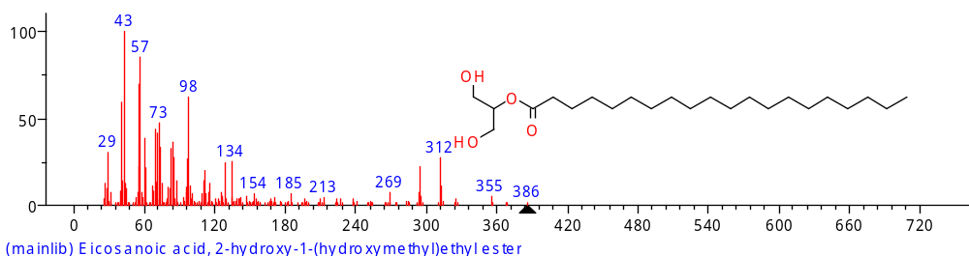
Fig. S20 GC-MS data of compound 12 compared to reported
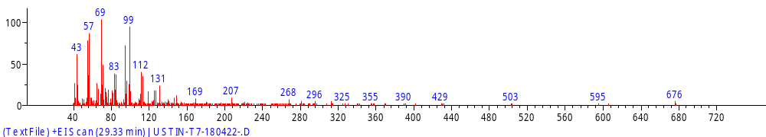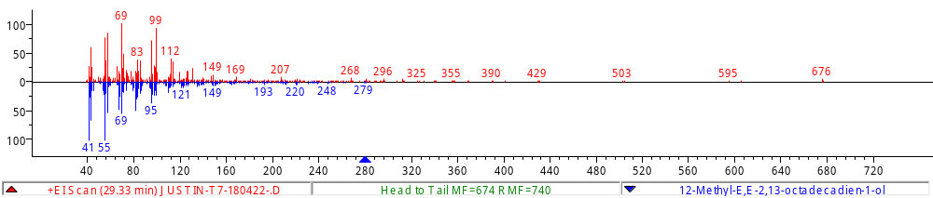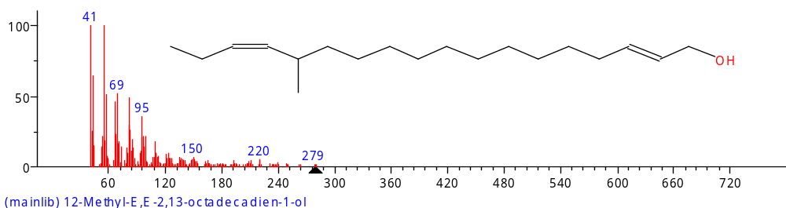
Fig. S21 GC-MS data of compound 13 compared to reported
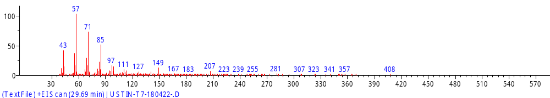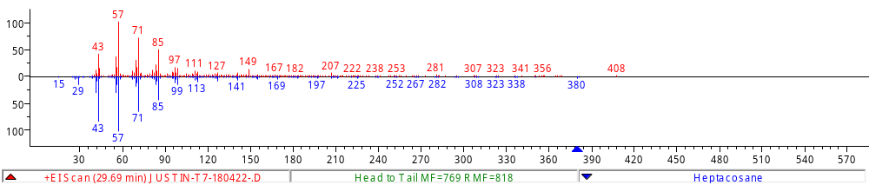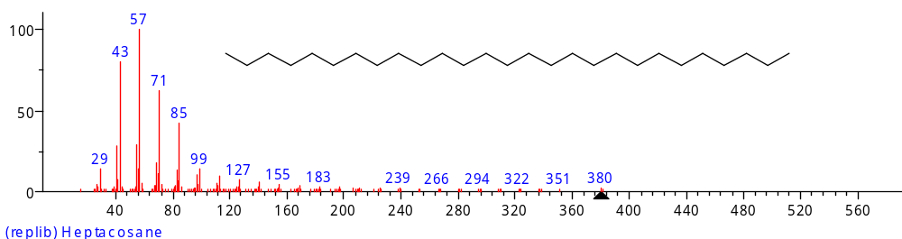
Fig. S22 GC-MS data of compound 14 compared to reported

Table S1 Summary data of compounds
Peak Number | RT | Area | Area % | Height | Width | Area Sum % | Height %
1 | 15,15 | 659369 | 6,42 | 183324 | 0,13 | 1,9 | 3,4
2 | 16,37 | 400440 | 3,9 | 136153 | 0,13 | 1,15 | 2,53
3 | 17,32 | 436538 | 4,25 | 158844 | 0,12 | 1,26 | 2,95
4 | 18,02 | 7108278 | 69,26 | 1463239 | 0,28 | 20,46 | 27,17
5 | 20,65 | 1036008 | 10,09 | 181537 | 0,22 | 2,98 | 3,37
6 | 21,47 | 333573 | 3,25 | 119778 | 0,1 | 0,96 | 2,22
7 | 25,19 | 1066796 | 10,39 | 558843 | 0,07 | 3,07 | 10,38
8 | 26,65 | 10263249 | 100 | 5384708 | 0,14 | 29,55 | 100
10 | 28,15 | 549881 | 5,36 | 304011 | 0,08 | 1,58 | 5,65
11 | 28,24 | 5739453 | 55,92 | 3171334 | 0,1 | 16,52 | 58,9
12 | 28,8 | 4509931 | 43,94 | 2538546 | 0,09 | 12,98 | 47,14
13 | 29,33 | 1334605 | 13 | 672207 | 0,09 | 3,84 | 12,48
14 | 29,69 | 524412 | 5,11 | 284611 | 0,08 | 1,51 | 5,29

