Supplementary Material 2 : Imaging analysis
Cardiac function analysis
Cardiac function analysis was performed in short 3D module with short-axis cine images. Phases with the largest and smallest chamber area were defined as end-diastolic and end-systolic phase. The most basal section was included in the analysis if it had been surrounded by at least 50% myocardium. Epicardial and endocardial boarder at end-diastolic and end-systolic phase were traced automatically and modified manually if they were not satisfactory. Papillary muscle and trabecular were excluded from the myocardium. Biventricular function parameters were computed, including left/right ventricular end-diastolic volume, left/right ventricular end-systolic volume, left/right ventricular stroke volume, left/right ventricular ejection fraction, left ventricular mass.

Cardiac structure analysis
Transverse dimension of bi-ventricle was measured on the short axis cine image at the level of the basal papillary muscles and was defined as the vertical distance from lateral wall to the midpoint of interventricular septum. Longitudinal dimension of bi-ventricle was measured on the four-chamber long axis cine image and was defined as the distance from apex to the midpoint of mitral or tricuspid valvular. Biventricular dimension indexes including left/right ventricular end-diastolic transverse dimension, left/right ventricular end-diastolic longitudinal dimension. Thickness of myocardium was measured on the slice that was same as transverse dimension measurement and was defined as the vertical distance from epicardium to the midpoint of endocardium in interventricular septum, inferior wall, lateral wall, and anterior wall(shown in Figure 1 of e-appendix 2 ).
Figure 1. Measurement of cardiac ventricular dimension and wall thickness
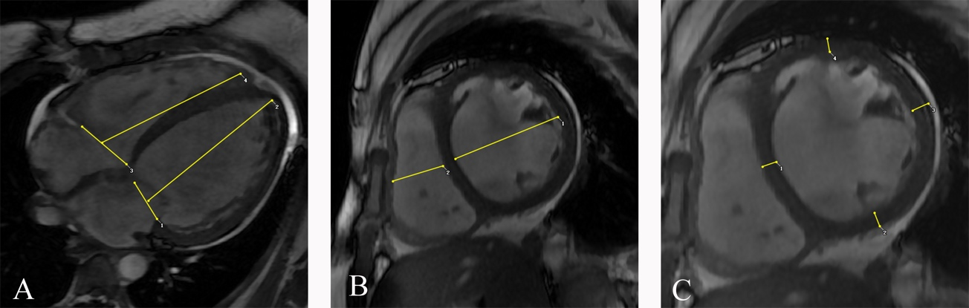

Myocardial strain analysis
Myocardial strain analysis was performed in tissue feature tracking module with short-axis, two-chamber and four chamber long-axis images. Epicardial and endocardial boarder of short-axis, two-chamber and four chamber long-axis images at end-diastolic phase was traced manually. 3D strain parameters including peak radial strain, peak circumferential strain, peak longitudinal strain in global, basal, middle, apical, and 16 AHA segments of left ventricle were computed(shown in Figure 2 of e-appendix 2 ).
Figure 2. Measurement of myocardial strain
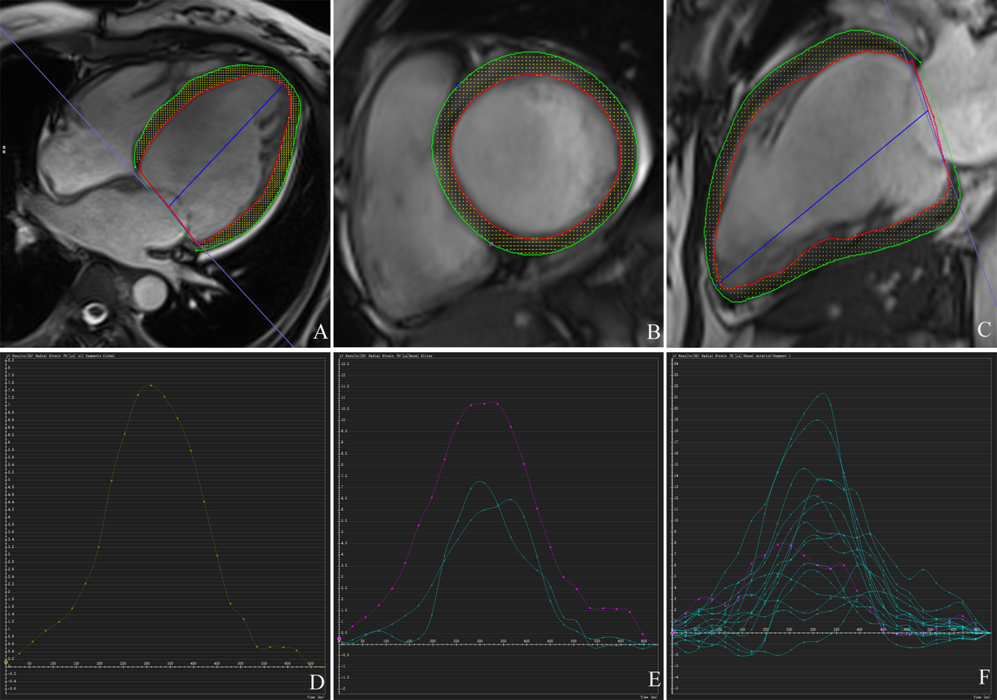
A-C. Epicardial and endocardial border of left ventricle; D. Global peak radial strain; E. Peak radial strain in basal, middle, apical part of left ventricle; F. Peak radial strain in 16 segments.

Late gadolinium enhancement analysis
Late gadolinium enhancement(LGE) analysis was performed in tissue characterization module with short-axis LGE images. Presence of LGE was evaluated visually and quantification of LGE was assessed using threshold of 5SD above the signal of remote normal myocardium. Percentage of LGE for global, basal, middle, apical, and 16 AHA segments of left ventricle were computed(shown in Figure 3 of e-appendix 3).

Figure 3. Quantification of LGE

