Supplementary Material 4: Figures
Figure S1. Comparison of circumferential strain in segments among acute SPPCM, chronic SPPCM, and female DCM patients
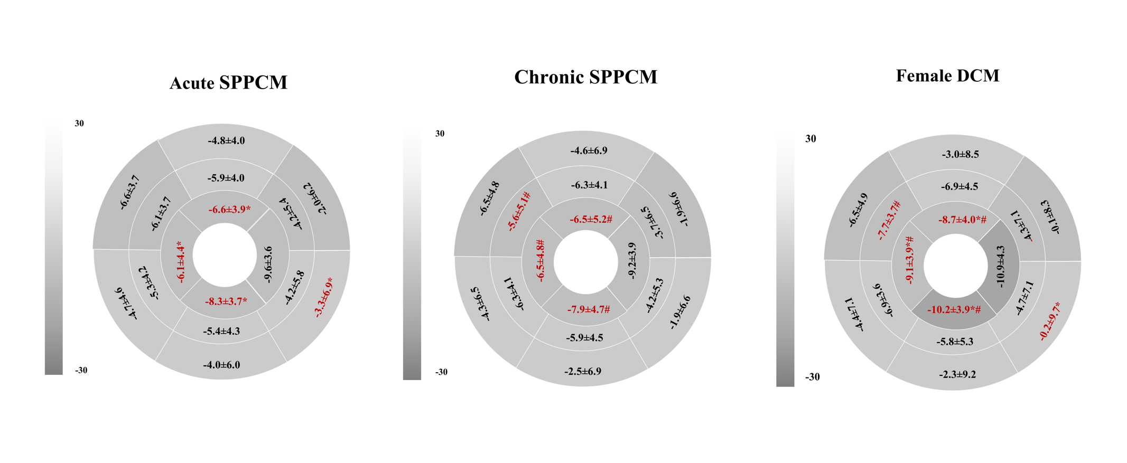
Segmental difference of PLS was revealed among the three groups . Abbreviation: as shown in Table 3.

Figure S2. CMR characters of acute SPPCM, chronic SPPCM, and female DCM
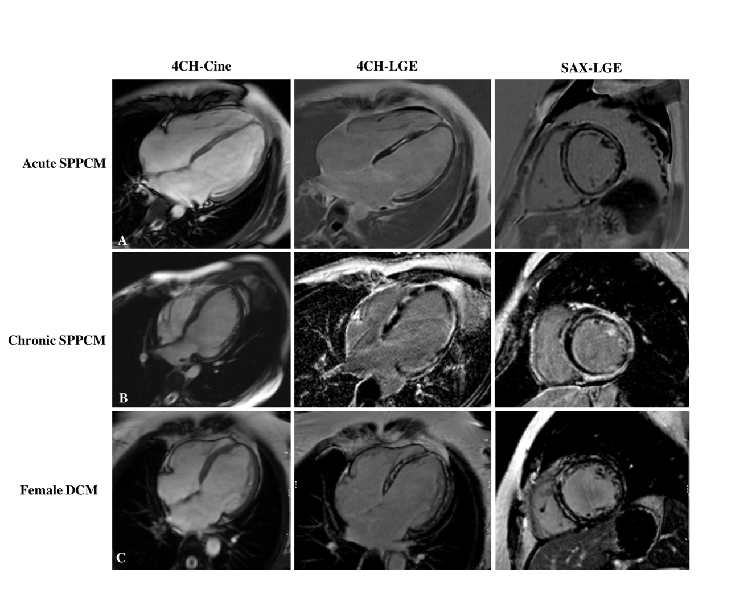
Cine images showed LV dilatation and LGE images showed myocardial fibrosis in acute SPPCM, chronic PPCM and female DCM.

