Supplementary materials
Table 1. 139 necroptosis-related genes based on the KEGG database
Necroptosis-related genes | Name
AIFM1 | apoptosis inducing factor mitochondria associated 1
ALOX15 | arachidonate 15-lipoxygenase
BAX | BCL2 associated X, apoptosis regulator
BCL2 | BCL2 apoptosis regulator
BID | BH3 interacting domain death agonist
BIRC2 | baculoviral IAP repeat containing 2
BIRC3 | baculoviral IAP repeat containing 3
CAMK2A | calcium/calmodulin dependent protein kinase II alpha
CAMK2B | calcium/calmodulin dependent protein kinase II beta
CAMK2D | calcium/calmodulin dependent protein kinase II delta
CAMK2G | calcium/calmodulin dependent protein kinase II gamma
CAPN1 | calpain 1
CAPN2 | calpain 2
CASP1 | caspase 1
CASP8 | caspase 8
CFLAR | CASP8 and FADD like apoptosis regulator
CHMP1A | charged multivesicular body protein 1A
CHMP1B | charged multivesicular body protein 1B
CHMP2A | charged multivesicular body protein 2A
CHMP2B | charged multivesicular body protein 2B
CHMP3 | charged multivesicular body protein 3
CHMP4A | charged multivesicular body protein 4A
CHMP4B | charged multivesicular body protein 4B
CHMP4C | charged multivesicular body protein 4C
CHMP5 | charged multivesicular body protein 5
CHMP6 | charged multivesicular body protein 6
CHMP7 | charged multivesicular body protein 7
CYBB | cytochrome b-245 beta chain
CYLD | CYLD lysine 63 deubiquitinase
DNM1L | dynamin 1 like
EIF2AK2 | eukaryotic translation initiation factor 2 alpha kinase 2
FADD | Fas associated via death domain
FAF1 | Fas associated factor 1
FAS | Fas cell surface death receptor
FASLG | Fas ligand
FTH1 | ferritin heavy chain 1
FTL | ferritin light chain
GLUD1 | glutamate dehydrogenase 1
GLUD2 | glutamate dehydrogenase 2
GLUL | glutamate-ammonia ligase
H2AB1 | H2A.B variant histone 1
H2AB2 | H2A.B variant histone 2
H2AB3 | H2A.B variant histone 3
H2AC1 | H2A clustered histone 1
H2AC11 | H2A clustered histone 11
H2AC12 | H2A clustered histone 12
H2AC13 | H2A clustered histone 13
H2AC14 | H2A clustered histone 14
H2AC15 | H2A clustered histone 15
H2AC16 | H2A clustered histone 16
H2AC17 | H2A clustered histone 17
H2AC18 | H2A clustered histone 18
H2AC19 | H2A clustered histone 19
H2AC20 | H2A clustered histone 20
H2AC21 | H2A clustered histone 21
H2AC4 | H2A clustered histone 4
H2AC6 | H2A clustered histone 6
H2AC7 | H2A clustered histone 7
H2AC8 | H2A clustered histone 8
H2AJ | H2A.J histone
H2AW | H2A.W histone
H2AX | H2A.X variant histone
H2AZ1 | H2A.Z variant histone 1
H2AZ2 | H2A.Z variant histone 2
HMGB1 | high mobility group box 1
HSP90AA1 | heat shock protein 90 alpha family class A member 1
HSP90AB1 | heat shock protein 90 alpha family class B member 1
IFNA1 | interferon alpha 1
IFNA10 | interferon alpha 10
IFNA13 | interferon alpha 13
IFNA14 | interferon alpha 14
IFNA16 | interferon alpha 16
IFNA17 | interferon alpha 17
IFNA2 | interferon alpha 2
IFNA21 | interferon alpha 21
IFNA4 | interferon alpha 4
IFNA5 | interferon alpha 5
IFNA6 | interferon alpha 6
IFNA7 | interferon alpha 7
IFNA8 | interferon alpha 8
IFNAR1 | interferon alpha and beta receptor subunit 1
IFNAR2 | interferon alpha and beta receptor subunit 2
IFNB1 | interferon beta 1
IFNG | interferon gamma
IFNGR1 | interferon gamma receptor 1
IFNGR2 | interferon gamma receptor 2
IL1A | interleukin 1 alpha
IL1B | interleukin 1 beta
IL33 | interleukin 33
IRF9 | interferon regulatory factor 9
JAK1 | Janus kinase 1
JAK2 | Janus kinase 2
JAK3 | Janus kinase 3
JMJD7-PLA2G4B | Phospholipase A2
MACROH2A1 | macroH2A.1 histone
MACROH2A2 | macroH2A.2 histone
MAPK10 | mitogen-activated protein kinase 10
MAPK8 | mitogen-activated protein kinase 8
MAPK9 | mitogen-activated protein kinase 9
MLKL | mixed lineage kinase domain like pseudokinase
NLRP3 | NLR family pyrin domain containing 3
PARP1 | poly(ADP-ribose) polymerase 1
PGAM5 | PGAM family member 5, mitochondrial serine/threonine protein phosphatase
PLA2G4A | phospholipase A2 group IVA
PLA2G4B | phospholipase A2 group IVB
PLA2G4C | phospholipase A2 group IVC
PLA2G4D | phospholipase A2 group IVD
PLA2G4E | phospholipase A2 group IVE
PLA2G4F | phospholipase A2 group IVF
PPIA | peptidylprolyl isomerase A
PPID | peptidylprolyl isomerase D
PYCARD | PYD and CARD domain containing
PYGB | glycogen phosphorylase B
PYGL | glycogen phosphorylase L
PYGM | glycogen phosphorylase, muscle associated
RBCK1 | RANBP2-type and C3HC4-type zinc finger containing 1
RIPK1 | receptor interacting serine/threonine kinase 1
RIPK3 | receptor interacting serine/threonine kinase 3
RNF103-CHMP3 | RNF103-CHMP3 readthrough
RNF31 | ring finger protein 31
SHARPIN | SHANK associated RH domain interactor
SLC25A31 | solute carrier family 25 member 31
SLC25A4 | solute carrier family 25 member 4
SLC25A5 | solute carrier family 25 member 5
SLC25A6 | solute carrier family 25 member 6
SMPD1 | sphingomyelin phosphodiesterase 1
SPATA2 | spermatogenesis associated 2
SPATA2L | spermatogenesis associated 2 like
SQSTM1 | sequestosome 1
STAT1 | signal transducer and activator of transcription 1
STAT2 | signal transducer and activator of transcription 2
STAT3 | signal transducer and activator of transcription 3
STAT4 | signal transducer and activator of transcription 4
STAT5A | signal transducer and activator of transcription 5A
STAT5B | signal transducer and activator of transcription 5B
STAT6 | signal transducer and activator of transcription 6
TICAM1 | toll like receptor adaptor molecule 1
TICAM2 | toll like receptor adaptor molecule 2
TLR3 | toll like receptor 3
TLR4 | toll like receptor 4
TNF | tumor necrosis factor
TNFAIP3 | TNF alpha induced protein 3
TNFRSF10A | TNF receptor superfamily member 10a
TNFRSF10B | TNF receptor superfamily member 10b
TNFRSF1A | TNF receptor superfamily member 1A
TNFSF10 | TNF superfamily member 10
TRADD | TNFRSF1A associated via death domain
TRAF2 | TNF receptor associated factor 2
TRAF5 | TNF receptor associated factor 5
TRPM7 | transient receptor potential cation channel subfamily M member 7
TYK2 | tyrosine kinase 2
USP21 | ubiquitin specific peptidase 21
VDAC1 | voltage dependent anion channel 1
VDAC2 | voltage dependent anion channel 2
VDAC3 | voltage dependent anion channel 3
VPS4A | vacuolar protein sorting 4 homolog A
VPS4B | vacuolar protein sorting 4 homolog B
XIAP | X-linked inhibitor of apoptosis
ZBP1 | Z-DNA binding protein 1

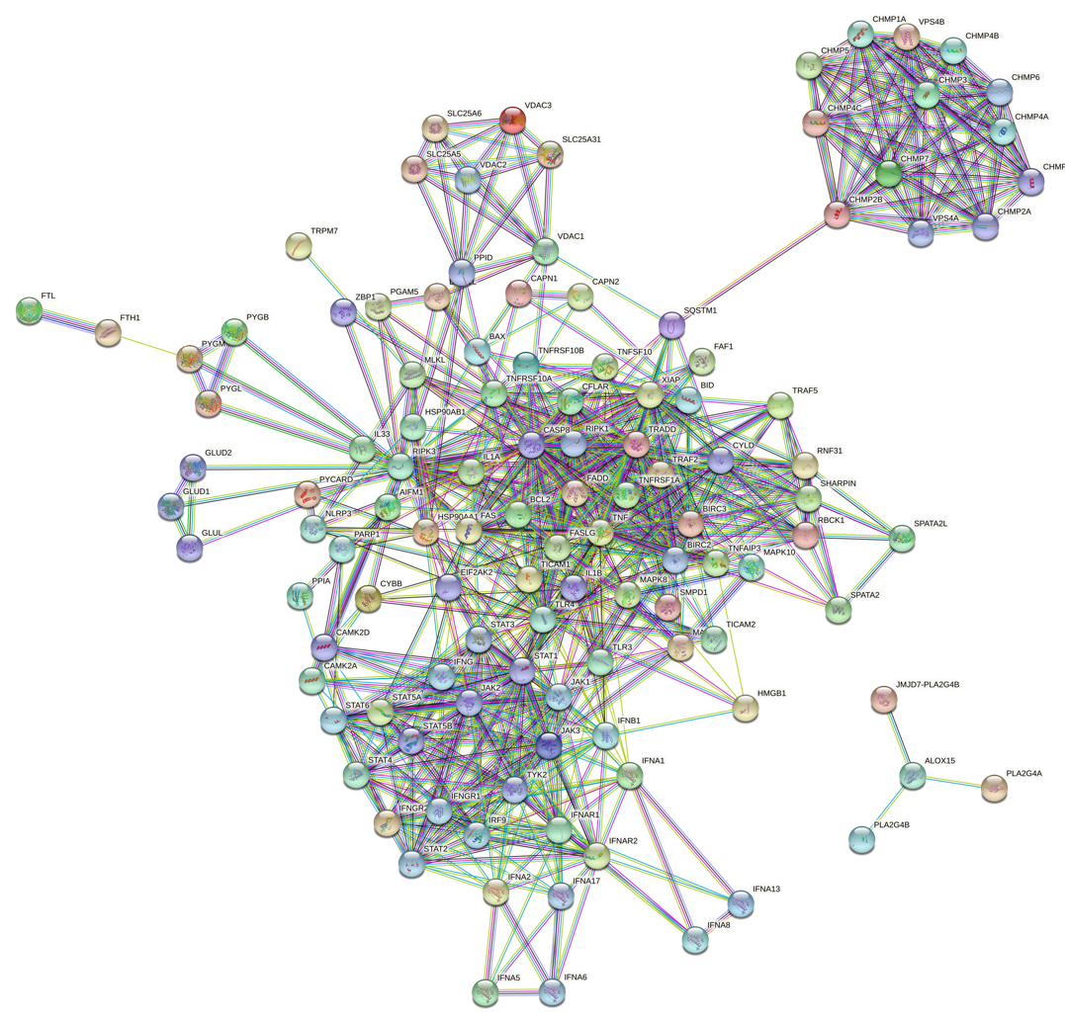
Supplementary Fig. 1 the PPI network of the necroptosis-related genes based on the String database
Supplementary Fig. 2 (A-B) KEGG functional enrichment analysis of DEGs

