Supplementary material

Hub gene identification and prognostic model establishment for patients with HBV-related hepatocellular carcinoma
Lianmei Wang¹, Jing Liu¹, Zhong Xian¹, Jingzhuo Tian¹, Chunying Li¹, Yushi Zhang¹, Suyan Liu¹, Jiayin Han¹, Chen Pan¹, Yan Yi¹, Yong Zhao¹, Hongbing Zhang², Aihua Liang^{1*}
¹Key Laboratory of Beijing for Identification and Safety Evaluation of Chinese Medicine, Institute of Chinese Materia Medica, China Academy of Chinese Medical Sciences, Beijing, China
²State Key Laboratory of Medical Molecular Biology, Department of Physiology, Institute of Basic Medical Sciences and School of Basic Medicine, Graduate School of Peking Union Medical College, Chinese Academy of Medical Sciences, Beijing, China.
*Correspondence to: Professor Aihua Liang. 16. Dongzhimen Nanxioejie, Dongcheng District, Beijing, China. Email: ahliang@icmm.ac.cn.

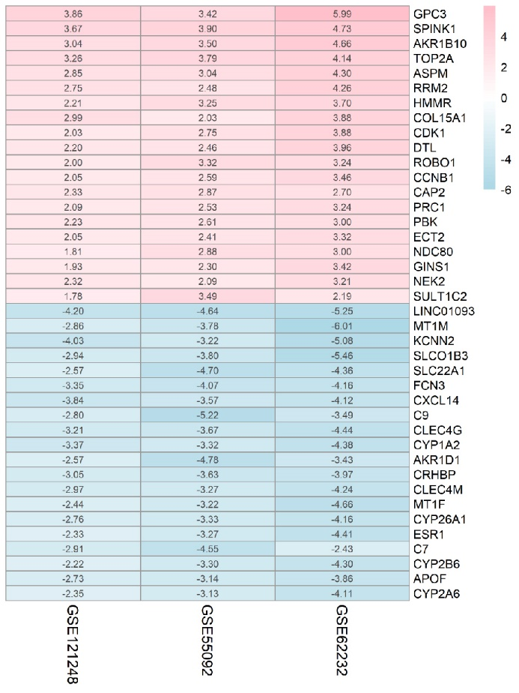
Supplementary Figure S1. The top-20 upregulated and downregulated DEGs in GSE55092, GSE62232 and GSE121248 datasets according to the RRA method. The value in the blocks represent the gene expression of log FC as indicated in the ordinate.

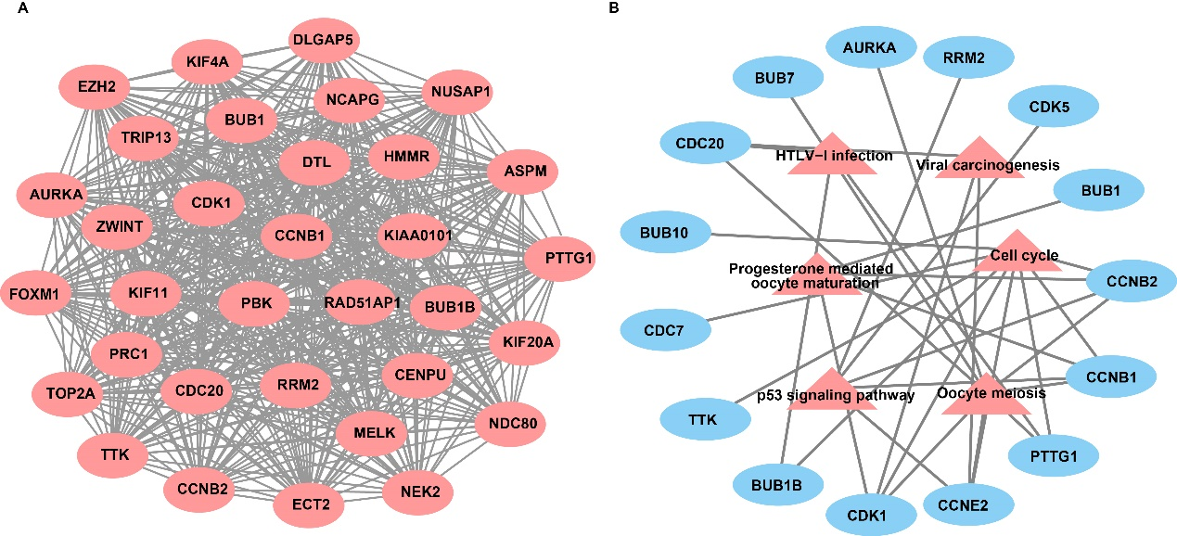
Supplementary Figure S2. Hub module in the PPI network (A) and the genes enrichment in the KEEG pathway (B).

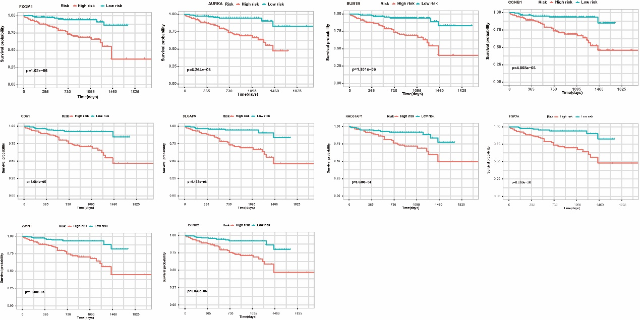
Supplementary Figure S3. Kaplan–Meier survival curves of TOP2A, DLGAP5, FOXM1, RAD51AP1, ZWINT, BUB1B, CCNB1, CCNB2, CDK1 and AURKA in ICGC-LIRI cohort.

