Supplementary materials
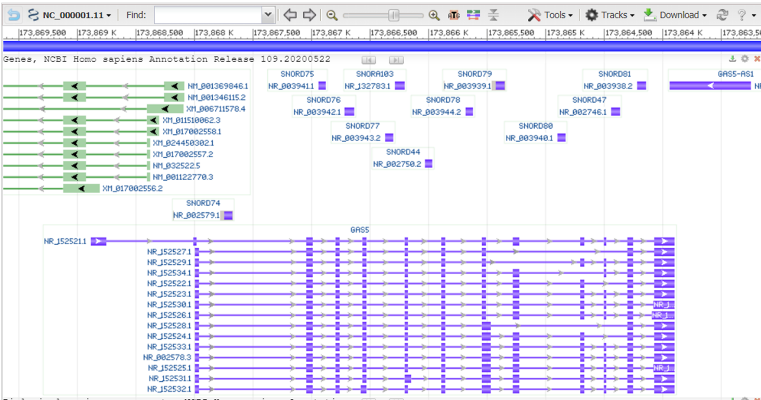
Supplementary Figure 1A. The landscape of lncRNA GAS5 transcript variants.
NR_152521.1: growth arrest specific 5, transcript variant 2
NR_152527.1: transcript variant 8
NR_152529.1: transcript variant 10
NR_152534.1: transcript variant 15
NR_152522.1: transcript variant 3
NR_152523.1: transcript variant 4
NR_152530.1: transcript variant 11
NR_152526.1: transcript variant 7
NR_152528.1: transcript variant 9
NR_152524.1: transcript variant 5
NR_152533.1: transcript variant 14
NR_152578.3: transcript variant 1
NR_152525.1: transcript variant 6
NR_152531.1: transcript variant 12
NR_152532.1: transcript variant 13

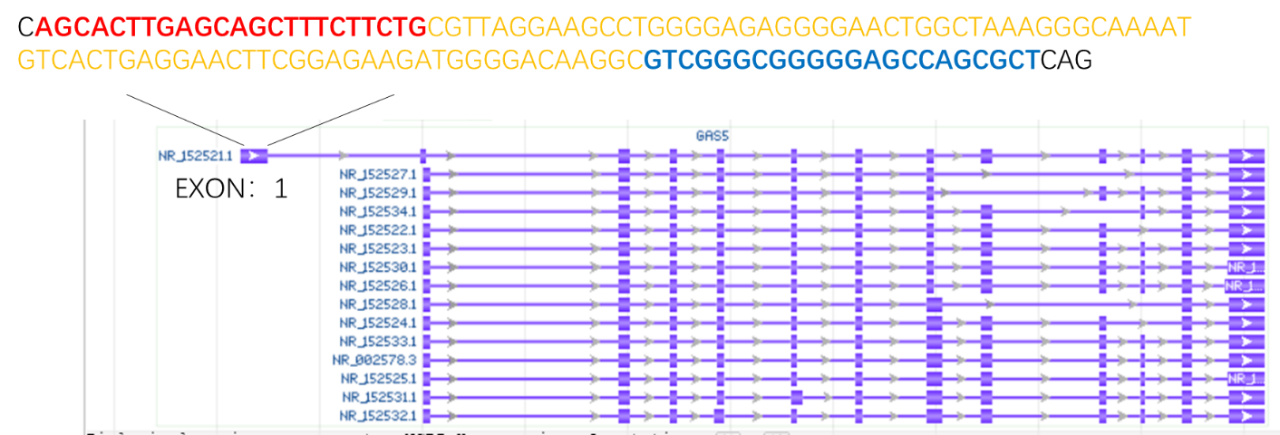
Supplementary Figure 1B. The location of primers and region of amplification in the sequence of GAS5 (transcript variant 2).
Upstream primers: AGCACTTGAGCAGCTTTCTTCTG
Downstream primers: GTCGGGCGGGGGAGCCAGCGCT
The region of amplification: CGTTAGGAAGCCTGGGGAGAGGGGAACTGG CTAAAGGGCAAAATGTCACTGAGGAACTTCGGAGAAGATGGGGACAAGGC

Supplementary Table 1:
The primer sequences used in qPCR analyses.
PCR primers
GAS5 (Forward) | AGCACTTGAGCAGCTTTCTTCTG
GAS5 (Reverse) | AGCGCCTGGCTCCCCCGCCCGAC
miR-23a-3p (Forward) | ACACTCCAGCTGGGATCACATTGCCAGGGATTT
miR-23a-3p (Reverse) | CTCAACTGGTGTCGTGGAGTCGGCAATTCAGTT GAGGGAAATCC
PTEN (Forward) | ACCAGTGGCACTGTTGTTTCAC
PTEN (Reverse) | TTCCTCTGGTCCTGGTATGAAG
U6 (Forward)  U6 (Reverse)  GAPDH (Forward)  GAPDH (Reverse) | CTCGCTTCGGCAGCACA  AACGCTTCACGAATTTGCGT  GAAATCCCATCACCATCTTCCAGG  GAGCCCCAGCCTTCTCCATG

