Supplementary Figure S1-S8
Figure S1. ZNF500 was highly expressed in breast cancer and correlated with good prognosis
(A) Comparison of ZNF500 mRNA level between breast cancer tissue and non-cancerous tissues based on TCGA database (B) Comparison of ZNF500 mRNA level between Non-TNBC and TNBC (C-E) Comparison of ZNF500 mRNA level in patients with different Her2, ER and PR states (F) AUC curve was drawn according to the expression of ZNF500. (G) Univariate COX analysis was used to investigated among the clinicopathological factor and prognosis of breast cancer patients. (H-I) Comparison of ZNF500 DNA and mRNA expression in breast cancer patients within wild-type and mutated P53 (J) ZNF500 protein levels was evaluated in 12 freshly isolated samples from breast cancer patients analyzed by western blotting. (K) Representative image of immunofluorescence images of ZNF500 breast cancer cell lines. Scale bar=10 μm. Quantitative data were expressed as mean ±SD of three independent experiments. *, P < 0.05;***, P < 0.001, t test

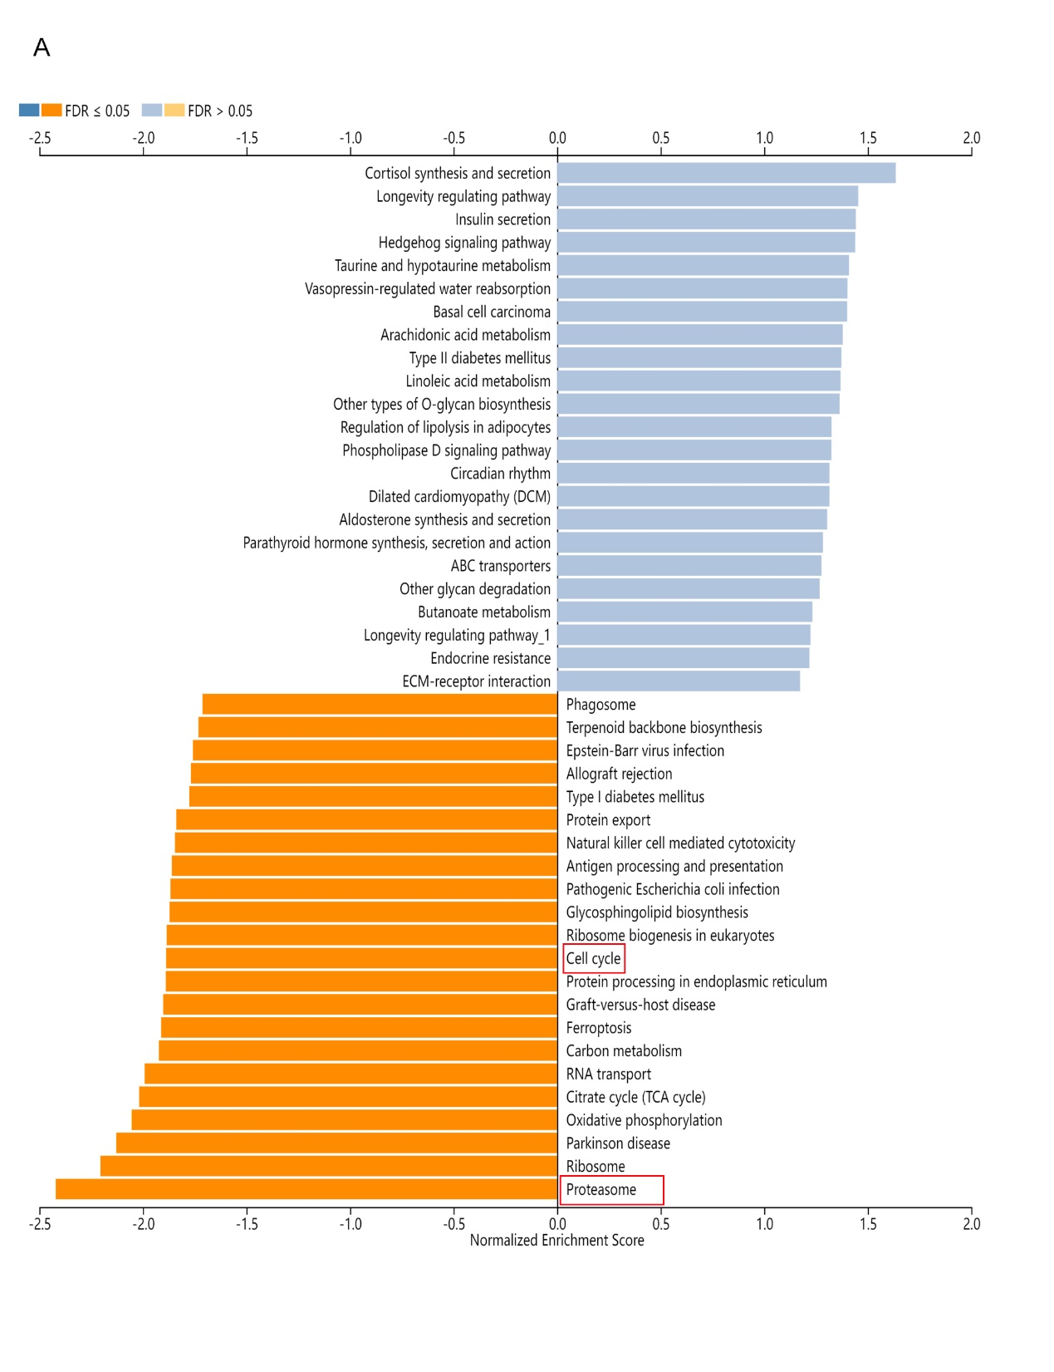
Figure S2. ZNF500 negatively correlated with cell cycle and proteasome process
(A) GSEA analysis was used to explored the process were enriched within or without ZNF500 mRNA expression
Figure S3. Overexpression of ZNF500 inhibited tumor proliferation in P53-WT breast cancer cells rather than P53-mutated or -null cells
(A-C) Western blotting assay was used to examine the overexpression or knockout efficiency in breast cancer cell lines within diverse P53 status. (D,G,J) MTT, (E,H,K) colony formation, (F，I，L) and EdU assays were used to detect the effect on proliferation of breast cancer cells within ectopic or silenced ZNF500 . Quantitative data were expressed as mean ±SD of three independent experiments. *p < 0.05, **p < 0.01, ***p < 0.001, t test, scale bar= 50um. For Western blot experiments, the samples derive from the same experiment and the gels/ blots were processed in parallel.
Figure S4. Overexpression of ZNF500 enhanced G1 phase arrest in P53-WT cells
(A) Flow cytometry was used to detect the effect on cell cycle progression within ZNF500 overexpression or knockout in P53-WT cells. (B) Cell cycle-related proteins were detected by western blotting after overexpressing or knocking out ZNF500.Quantitative data were expressed as mean ±SD of three independent experiments. * p<0.05, **, p<0.01, ***p<0.001, t test. For Western blot experiments, the samples derive from the same experiment and the gels/ blots were processed in parallel.

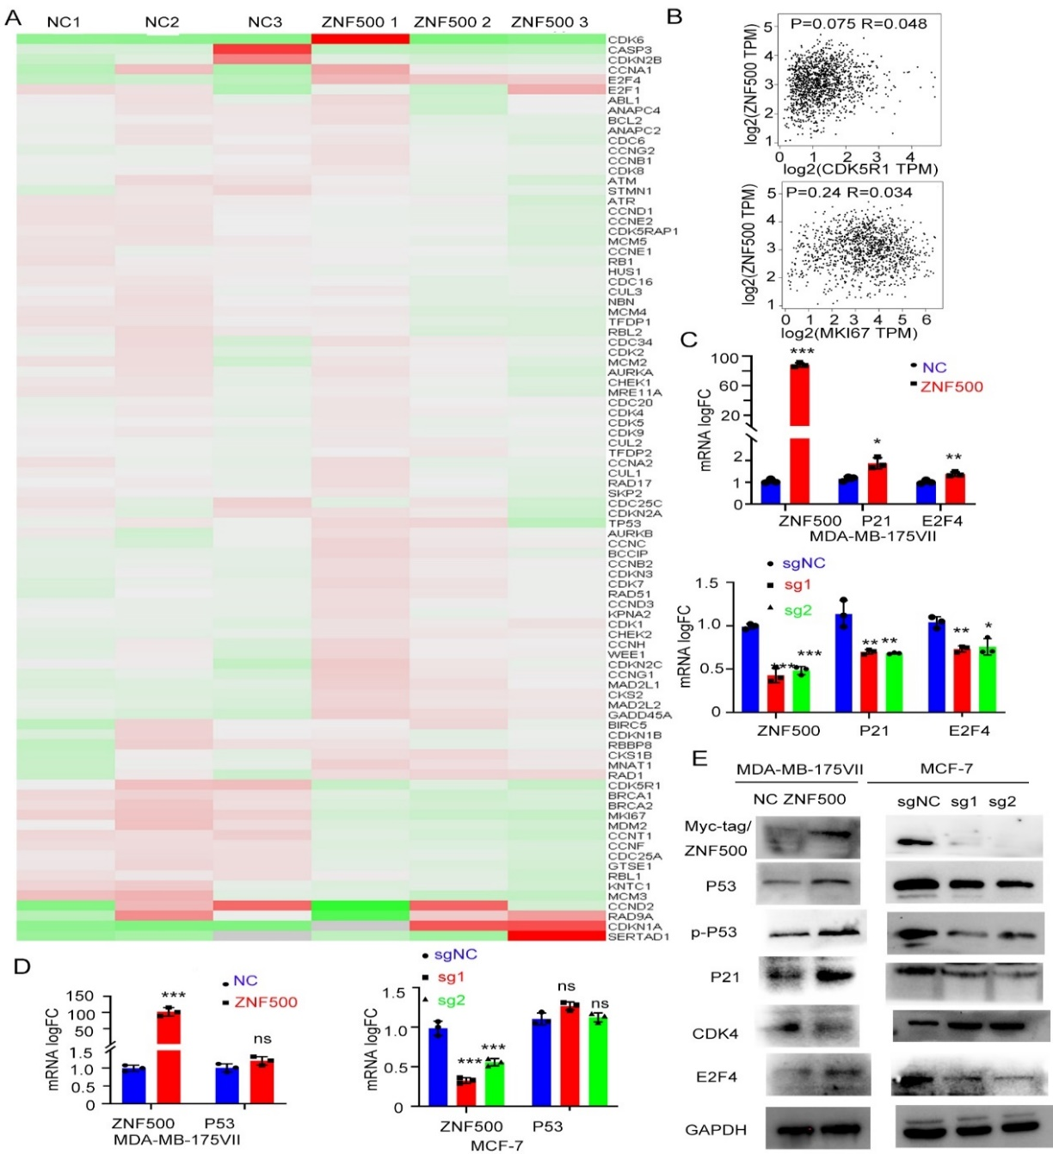
Figure S5. Overexpression of ZNF500 activated the P53-P21-E2F4 signal axis
(A) Heat map of the differentially expressed genes (DEGs) within ZNF500 overexpression (B) Correlation was assessed between DEGs and ZNF500 mRNA expression by GEPIA (C-D) MRNA levels of P21, E2F4 as well as P53 was tested by qPCR after overexpressing or inhibiting ZNF500. (E) Western blotting was used to detect the expressions of P53, phosphorylated P53 in Serine 15, P21, CDK4, and E2F4 after ZNF500 overexpression or knockout.* p<0.05, **, p<0.01, ***p<0.001, t test. For Western blot experiments, the samples derive from the same experiment and the gels/ blots were processed in parallel.

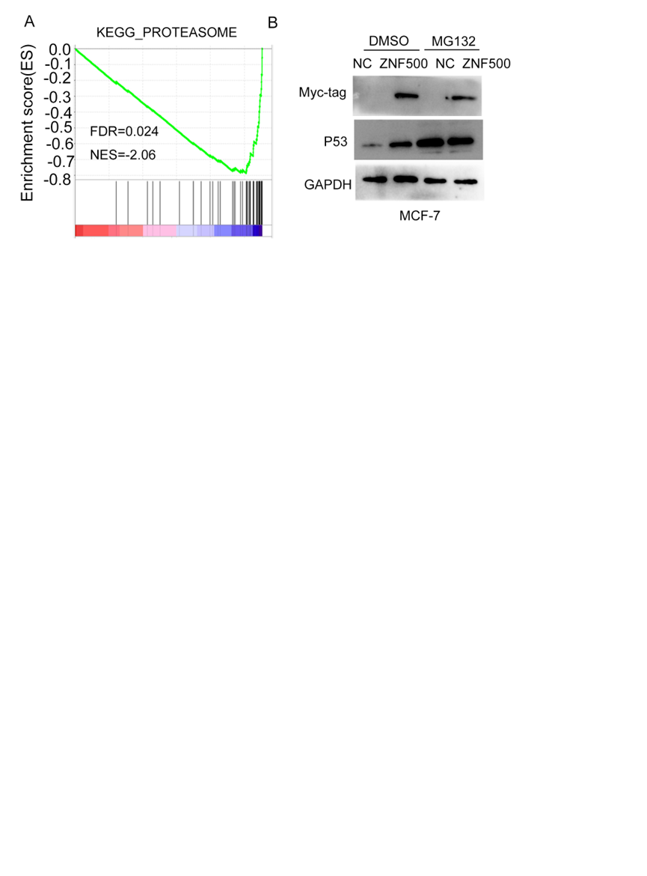
Figure S6. ZNF500 abrogated proteasome-mediated degradation of P53
(A) GSEA analysis revealed the correlation between ZNF500 expression and process of proteasome. (B) Western blotting was used to detect the expression of P53 with or without MG132 (5μM). For Western blot experiments, the samples derive from the same experiment and the gels/ blots were processed in parallel.

Figure S7. ZNF500 strengthened the sensitivity to Nutlin3a
(A) The association between ZNF500 and Nutlin3a IC50 was investigated by the TCGA database. (B) Western blotting was used to detect the expression of P53 after knocking out ZNF500 together with adding Nutlin3a (5uM). (C) Colony formation assay was used to evaluate proliferation of breast cancer cell. Quantitative data were expressed as mean ±SD of three independent experiments. * p < 0.05, **p < 0.01, t test. For Western blot experiments, the samples derive from the same experiment and the gels/ blots were processed in parallel.

Figure S8. Overexpressing ZNF500 accelerated DNA damage response
(A) Western blotting was used to detect the expression of γ- H2AX with or without Camptothecin. (B) Representative image of immunoﬂuorescence images of the number of γ-H2AX foci after Camptothecin. Quantitative data were expressed as mean ±SD of three independent experiments. *p < 0.05, t test. The scale bar=10µm. For Western blot experiments, the samples derive from the same experiment and the gels/ blots were processed in parallel.

