Supplementary Information for
Surface triggered stabilization of
metastable charge-ordered phase in SrTiO₃

Kitae Eom,^{1,2,8} Bongwook Chung,^{1,8} Sehoon Oh,¹ Hua Zhou,³ Jinsol Seo,⁴ Sang Ho Oh,⁴ Jinhyuk Jang,⁵ Si-Young Choi,⁵ Minsu Choi,¹ Ilwan Seo,⁶ Yun Sang Lee,⁶ Mark Rzchowski,⁷ Chang-Beom Eom,^{2 ✉} and Jaichan Lee^{1 ✉}

¹School of Advanced Materials Science and Engineering, Sungkyunkwan University (SKKU), Suwon, 16419, Republic of Korea.
²Department of Materials Science and Engineering, University of Wisconsin-Madison, Madison, WI 53706, USA.
³X-ray Science Division, Advanced Photon Source, Argonne National Laboratory, Lemont, IL 60439, USA.
⁴Department of Energy Engineering, KENTECH Institute for Energy Materials and Devices, Korea Institute of Energy Technology (KENTECH), Naju, 58330, Republic of Korea.
⁵Department of Materials Science and Engineering, Pohang University of Science and Technology (POSTECH), Pohang, Gyeongbuk 37673, Republic of Korea.
⁶Department of Physics, Soongsil University, Seoul, 06978, Republic of Korea.
⁷Department of Physics, University of Wisconsin, Madison, WI 53706, USA.
⁸These authors contributed equally: Kitae Eom, Bongwook Chung.
✉e-mail: ceom@wisc.edu; jclee@skku.edu
This PDF file includes:
Supplementary Note 1: DFT calculation and symmetry analysis of the bulk LSTO
Supplementary Note 2: Film growth
Supplementary Note 3: Optical conductivity measurements
Supplementary Note 4: Coherent Bragg rod analysis
Supplementary Note 5: STEM and EELS analysis
Supplementary Note 6: DFT calculation and symmetry analysis of the LSTO/STO heterogeneous slab
Supplementary Note 1: DFT calculation and symmetry analysis of the bulk LSTO
We investigate the atomic and electronic structures of the bulk La_{0.25}Sr_{0.75}TiO₃ (LSTO) using the density functional theory (DFT) with semi-empirical Hubbard U correction. Considering the experimentally observed oxygen octahedral rotation pattern, we assume bulk LSTO has a⁰a⁰c⁻ Glazer`s notation. We optimize the lattice constants and the internal atomic coordination of metallic bulk LSTO based on the 2a × 2a × 2c cell. The optimized in-plane and out-of-plane lattice constants with the anti-phase octahedral rotation distortion (a⁰a⁰c⁻ in Glazer’s notation) are a = 0.39679 and c = 0.40159 nm, respectively. For the La_{Sr} doping configuration, we investigate several doping configurations, and the total energy difference between different doping configurations is up to 3 meV/formula unit. A configuration where La_{Sr} dopants are linearly aligned along the out-of-plane direction is found to be energetically favorable, and this doping configuration is adopted for all the calculations.
It was theoretically shown that breathing oxygen octahedral distortion, which expands or contracts the oxygen octahedra nearest neighbor unit cells, allows charge ordering (CO) in half-doped titanate double perovskite¹. Therefore, we initially introduce periodic modulation of oxygen octahedral distortion that consists of expansion and contraction of TiO₆ octahedra and obtained the charge-ordered LSTO bulk structure. It shows the antiferromagnetic Mott insulating behavior with the localized Ti 3d band as shown in Supplementary Figure 1. The optimized lattice constants of this structure obtained from the 2a × 2b × 4c cell (Supplementary Fig. 2a) are a = 0.39869, b = 0.39506, and c = 0.40371 nm, respectively.
We analyze the lattice modulation of the CO state bulk LSTO. The lattice modulations of the CO state bulk LSTO are decomposed into distortion modes, i.e., ∆r = ∑_{i} c_{i} Φ_{i}, where ∆r is the lattice modulation vector of the bulk LSTO as the atomic displacement vector from the symmetrical structure (Supplementary Fig. 2b), c_{i} is the coefficients of the normalized distortion mode Φ_{i} (i = 1, 2, 3, z- and rem), respectively. For the distortion mode vector Φ_{i} (i = 1, 2, 3, z- and rem), Φ₁ is the inter-layer breathing mode that is oxygen octahedra volume expansion and contraction along the z direction (Fig. 1c). Φ₂ is the intra-layer breathing mode that an in-plane nearest-neighbor oxygen octahedron to either expand or contract. This expansion and contraction of oxygen octahedra along the in-plane direction have a one-layer interval and out-of-phase motions along the z direction (Fig. 1d). Φ₃ is the Jahn-Teller type distortion mode which has different Ti-O bond lengths along the x and y directions. Similar to Φ₂, Φ₃ also has a one-layer interval and out-of-phase motions along the z direction (Fig. 1e). Φ_{z-} is the antiferrodistortive rotation (a⁰a⁰c⁻ in Glazer’s notation) i.e., an anti-phase octahedral rotation along the z direction (Fig. 1f). Note that these distortion mode vectors Φ_{i} (i = 1, 2, 3, z-), are orthogonal to each other. The remaining term (Φ_{rem}) mainly comes from the displacements of atoms near the La_{Sr} dopants (Supplementary Fig. 3). d_{i}s are oxygen displacement with respect to the high symmetric structure, which is defined as the multiply c_{i} by individual oxygen displacement of the normalized distortion mode vector Φ_{i} (i = 1, 2, 3, z-). Oxygen octahedral rotation angle θ_{z-} of antiferrodistortive rotation is converted from d_{z-}. The obtained coefficients c_{i}s of the CO phase are c₁ = 0.170, c₂= 0.193, c₃ = 0.104, c_{z-} = 1.79, and c_{rem} = 0.369. The oxygen displacements and the oxygen octahedral rotation angle of the CO phase are d₁ = 4.24 pm, d₂= 3.41 pm, d₃ = 2.59 pm, and θ_{z-} = 9.08°, respectively.
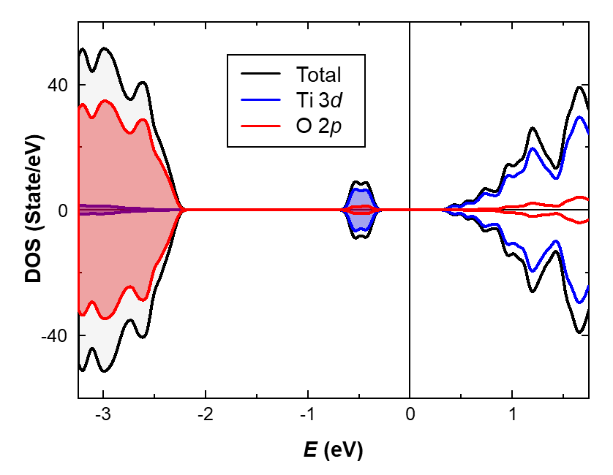
Supplementary Fig. 1 | Spin-polarized DOS of the charge-ordered insulating bulk LSTO. Total DOS is represented by black lines, and those projected onto the Ti 3d and O 2p orbitals are represented by blue and red lines, respectively. Positive and negative regions correspond to the up-spin and the down-spin states, respectively. The midpoint between the energies of the lowest unoccupied state and the highest occupied state is set to be zero and represented by the vertical line.
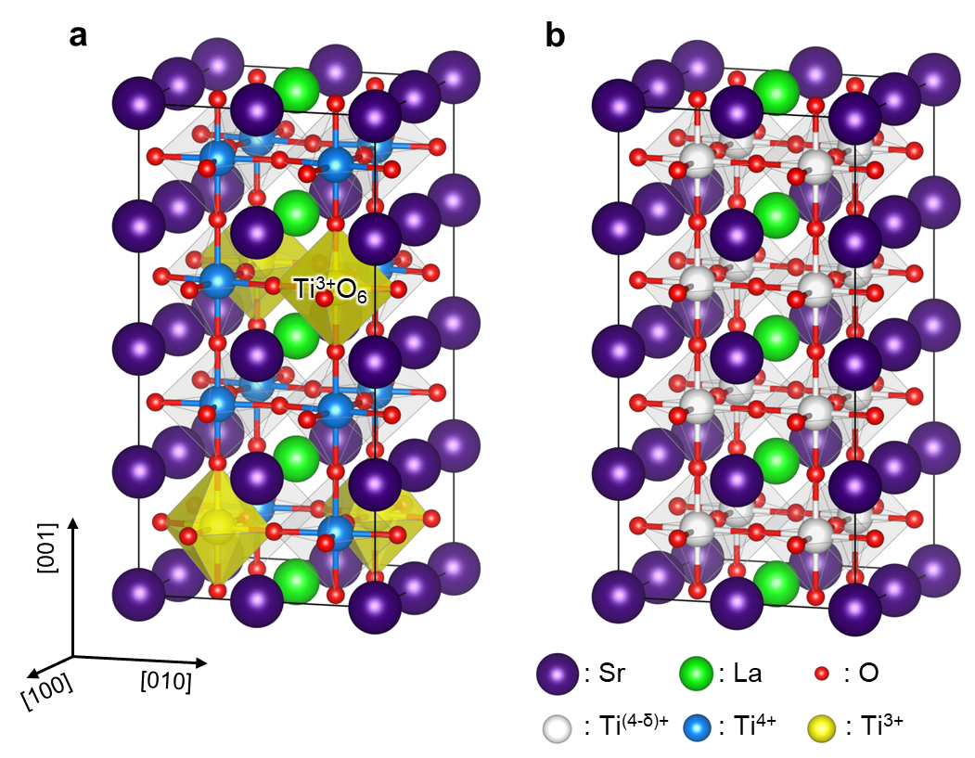
Supplementary Fig. 2 | Atomic structure of the LSTO bulk. a, Charge-ordered metastable structure of the LSTO bulk. The obtained structure shows the periodic expansion and contraction of the oxygen octahedral pattern. b, Symmetric structure of the LSTO bulk without periodic structural distortion. In a,b the linear configuration of the La_{Sr} dopant in the 2a × 2b × 4c cell is adopted for both structures. The unit cell is represented by black lines. Purple, chartreuse, red, blue, yellow, and white spheres represent the Sr, La, and O atoms and Ti⁴⁺, Ti³⁺, and partially filled Ti^{(4-δ)+} cations, respectively. In a, the yellow shades on the Ti³⁺O₆ octahedral surface are guides for eyes.
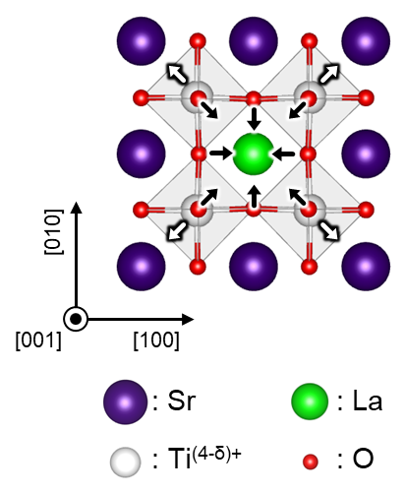
Supplementary Fig. 3 | Schematics of the remaining term Φ_{rem} for the LSTO bulk. Φ_{rem} mainly consists of the displacements near La_{Sr}. Green, purple, red, and white spheres represent the (La, Sr), Sr, and O atoms and Ti^{(4-δ)+} cation, respectively.
Supplementary Note 2: Film growth
Digitally controlled La_{0.25}Sr_{0.75}TiO₃ (LSTO) films were grown on (001)-oriented SrTiO₃ by pulsed laser deposition in an ambient oxygen/ozone mixture with a pressure of 10⁻⁵ Torr and substrate temperature of 650 ºC. The RHEED intensity oscillations obtained from specular spots exhibit layer-by-layer growth as shown in Supplementary Figure 4a. All the surfaces, regardless of thickness, are atomically flat and smooth (Supplementary Fig. 4b). The film thicknesses ranged from 4 to 20 u.c. and were controlled by monitoring the RHEED oscillations during the growth (Supplementary Fig. 4a).
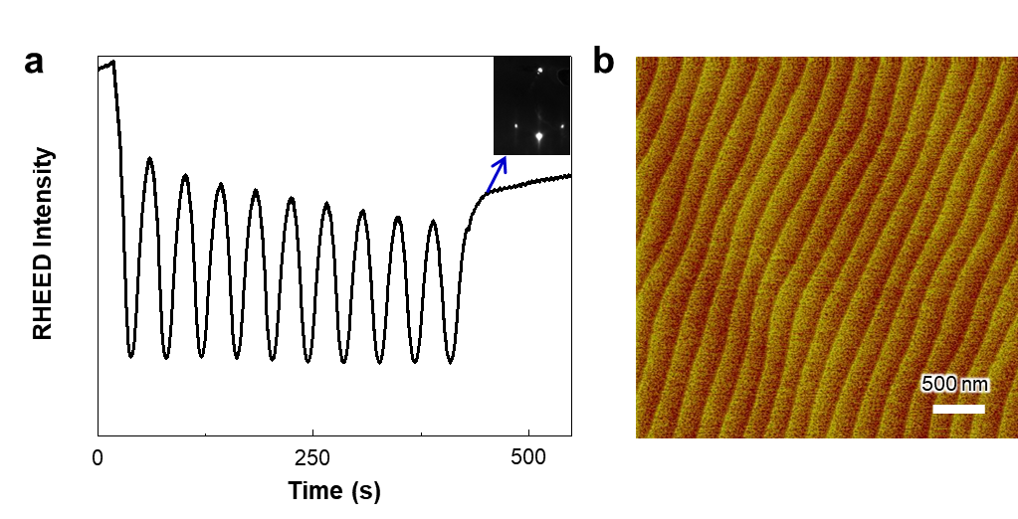
Supplementary Fig. 4 | Epitaxial growth of LSTO films. a, RHEED intensity oscillations during growth of La_{0.25}Sr_{0.75}TiO₃ film grown on SrTiO₃ substrate. (Inset) Typical RHEED patterns of the LSTO film. b, AFM image of the LSTO film which shows the atomically smooth film surface.
Supplementary Note 3: Optical conductivity measurements
To obtain the complex optical conductivity spectra $\tilde{σ}\left(ω\right)\left[≡σ_{1}\left(ω\right)+iσ_{2}\left(ω\right)\right]$, we performed ellipsometry at room temperature which directly yields the complex optical constants without Kramers-Kronig analysis. We measured the ellipsometric angular spectra of the superlattices using a spectroscopic ellipsometer (VASE, J. A. Woollan). The angles of the incident light and the spectral ranges were 65°, 70°, and 75° (angle between the plane of the samples and the incident beam), and 0.7 – 5.5 eV, respectively. The complex dielectric functions, $\tilde{ε}\left(ω\right)\left[≡1+i\frac{4π}{ω}\tilde{σ}\left(ω\right)\right]$, were estimated with a three-phase model composed of one Drude component and two Lorentz oscillators. The two Lorentz oscillators, located at 1.5 eV and 3.4 eV, correspond to the incoherent mode and the charge transfer excitation, respectively. The dielectric function yielded from the three-phase model fitting was checked by point-by-point fitting. The two dielectric functions, extracted by different fitting methods, were consistent with each other. The optical data were also confirmed by comparing a reflectivity directly measured by the conventional FT-IR/grating-type spectrometers in a photon energy range of 0.1 eV – 5.5 eV. The reflectivity taken from the direct measurement was in accordance with the resistivity extracted from the ellipsometry. The incoherent part within the bandgap, observed in the LSTO films, was not present at the SrTiO₃ substrate (Supplementary Fig. 5). This implies that the incoherent spectral peak from the bandgap is the intrinsic behavior of the LSTO films. In the high energy region σ₁(ω) of LSTO, similarly to the case of undoped STO, a strong absorption above 4 eV is observed due to the charge transfer excitation (CTE) from O 2p to Ti t_{2g} bands, as shown in Supplementary Figure 5. We note that the CTE edge of the LSTO spectra shifts to higher energies compared with that of an undoped STO single crystal, which has been observed for the doped STO bulk samples². Notably, the La ion doping leads to the emergence of spectral weight below CTE.
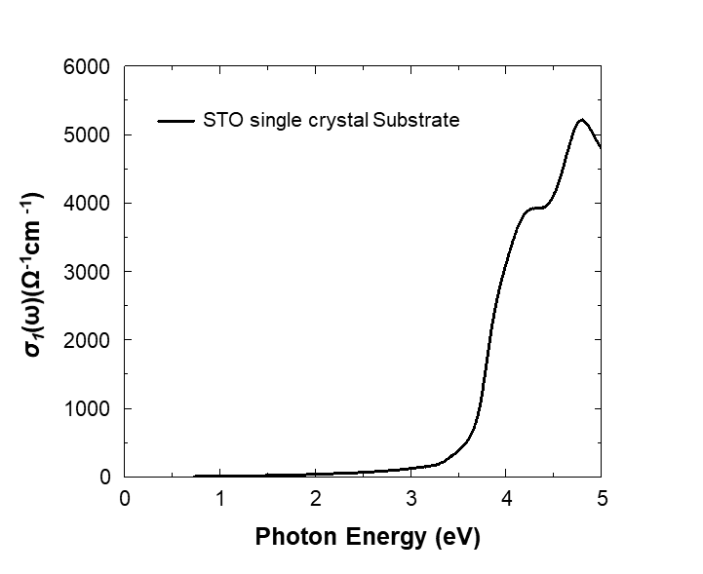
Supplementary Fig. 5 | Optical conductivity spectra of STO substrate. Optical conductivity is obtained from the ellipsometry of the STO substrate. Note that no incoherent part of the spectra is observed.
Supplementary Note 4: Coherent Bragg rod analysis
Experimentally recorded CTR data were first background subtracted using the 2D detector images, and then properly corrected for geometric and polarization factors. The resulting structural factors were used for the subsequent COBRA analysis. The total 3D electron densities (EDs) for the complete atomic structures of the thin film system, including the epitaxial thin film unit cells and the top few unit cells of the substrate (e.g. typically 6-8 substrate unit cells), were reconstructed from the complete set of CTRs by using a Fourier phase retrieval iterative technique, known as coherent Bragg rods analysis (COBRA), through a self-developed MATLAB code universally optimized for systems with symmetry lower than 4 mm (or a simple four-fold symmetric system). Within each iteration in COBRA analysis, real space and reciprocal space constraints are alternatively applied to recover the phase information at each reciprocal space point from measured CTRs. In the cases where thin film and substrate symmetries are different (i.e., different octahedral rotation patterns and amplitudes), the epitaxial thin film may form different structural domains (as compared to the bulk substrate). In this case, the reconstructed thin film ED contains thin film structural information that is folded into the substrate-defined in-plane unit cell. Specific information such as oxygen octahedral rotation can be deduced from the broadening of the folded-unit cell ED profile induced by the rotation.
The general approach for obtaining experimental errors based on traditional fitting models is not applicable to COBRA-generated Eds. A method called “Noise Analysis”, based on bootstrap-type statistical analysis was used to determine the uncertainties in COBRA results. This method applies additional random noises to the experimentally obtained CTR data and then analyzes the degree of scattering in the parameters extracted from EDs.
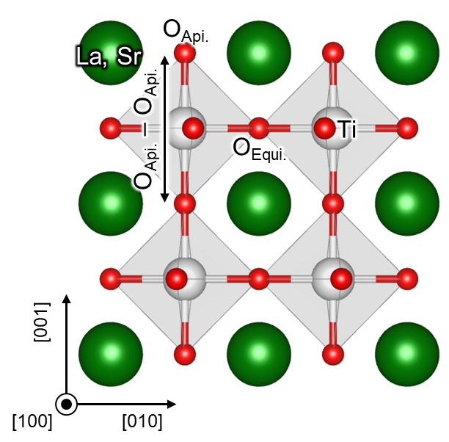
Supplementary Fig. 6 | Definition for the height of oxygen octahedron. The atomic structure of the LSTO is shown. Green, white, and red spheres represent (La, Sr), Ti, and O atoms, respectively. The apical oxygen-to-oxygen distance (O_{Api.}–O_{Api.}) is defined as described above figure, which is used for quantitative analysis of the octahedral modulation in this study.
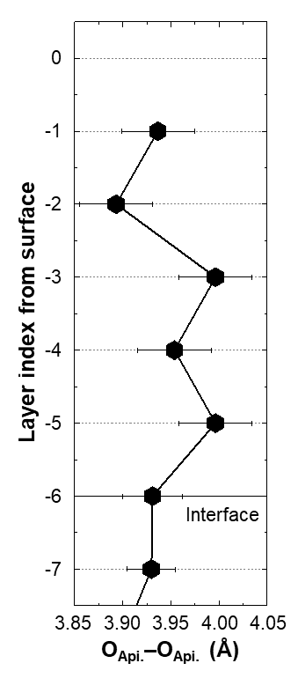
Supplementary Fig. 7 | COBRA result of LSTO 6 u.c. on STO. A layer resolved distance between apical oxygen atoms, which is defined as shown in Supplementary Fig. 6. The result is in good agreement with DFT calculation results (Fig. 4c).
Supplementary Note 5: STEM/ EELS analyses
EELS 2D scan was conducted across the LSTO/STO interface to trace the electron confinement at Ti 3d orbitals. When an additional electron is confined at the Ti 3d orbital, it tends to occupy the t_{2g} orbital which is at a lower energy state due to the crystal field splitting. If the t_{2g} orbital is occupied, the fine structure of EELS Ti-L_{2,3} edge is changed in such a way that the t_{2g} peak becomes suppressed compared to the e_{g} peak as fewer core electrons are excited to t_{2g} and the Ti-L_{2,3} edge shifts to lower energy (redshift) as the binding energy is lowered. We quantified the Ti³⁺ fraction by using multiple linear least square (MLLS) fitting of the EELS Ti-L_{2,3} edge with the assumption that it consists of a linear combination of the signals from the Ti⁴⁺ and Ti³⁺ state. The periodic fluctuation in the Ti³⁺ fraction is clearly captured when the measured Ti³⁺ fraction is plotted with the distance from the interface (Fig. 3d). However, it should be mentioned that the measured Ti³⁺ profile can be spread out from the real profile because the EELS signal can also be generated from neighboring atomic sites by beam spreading and channeling.
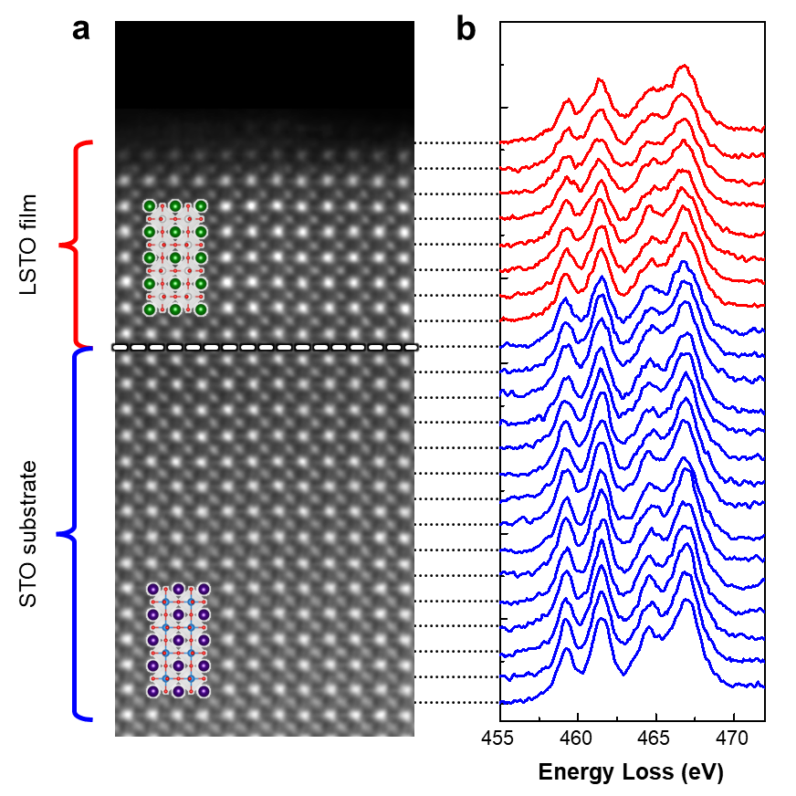
Supplementary Fig. 8 | Electron Energy Loss Spectra (EELS) of LSTO 8 u.c./STO heterostructure. a, STEM images of the LSTO heterostructure. b, Ti-L_{2,3} edge spectra extracted from their line profiles.
Supplementary Note 6: DFT calculation and symmetry analysis of the LSTO/STO heterogeneous slab
As mentioned in the main article, we investigate LSTO/STO heterogeneous slab structure with various LSTO film thicknesses using the density functional theory (DFT) with semi-empirical Hubbard U correction like LSTO bulk. To describe the STO substrate, we first investigate the atomic and electronic structure of STO bulk. Considering the experimentally observed structure with the anti-phase octahedral rotation distortion (a⁰a⁰c⁻ in Glazer’s notation)³ in STO, we optimize the lattice constants and the internal atomic coordination. The optimized in-plane and out-of-plane lattice constants are a = 0.39587 and c = 0.39866 nm, respectively. Using the obtained atomic structure of STO bulk, we construct the candidate structures of the LSTO/STO heterogeneous slab as shown in Supplementary Figure 9. We use 6.5 layers of TiO₂-terminated STO for the substrate and put the LSTO film with various thickness, t (t = 2, 4, 6, and 8 u.c.), on top of the STO substrate. A vacuum length of 4c is included in the slab structure, and the in-plane directions, 2a × 2a cell is used, where a is fixed to that of the optimized value of the STO bulk. Note that a⁰a⁰c⁻ pattern is used for the LSTO films as well as the STO substrate based on the experimental observation. The atomic structures of the constructed LSTO/STO slab are optimized by relaxing the atomic positions with the atoms on the 3 bottom layers of the substrate fixed.
We also investigate the magnetic and electronic structures of the LSTO/STO slab. We consider several different magnetic configurations, and the total energy difference between different magnetic configurations is up to 6.5 meV. We find an A-type-like antiferromagnetic (AFM) spin alignment as the ground-state magnetic structure of the LSTO thin films for all t investigated, where Ti³⁺ has parallel spin alignment in the in-plane direction, and anti-parallel spin alignment in the out-of-plane direction (Fig. 4d, Supplementary Fig. 13b, Supplementary Fig. 14c,f, and Supplementary Fig. 15c). We would like to note that the obtained magnetic state of the LSTO film, the A-type-like AFM order, is different from those of other rare-earth titanates with a⁻a⁻c⁺ rotation pattern which has G-type AFM or ferromagnetic (FM)⁴ order (a⁻a⁻c⁺ Glazer’s notation). The A-type-like AFM order can be stabilized by the a⁰a⁰c⁻ rotation by super-exchange interaction^{4,5}. We also calculate the electronic band structure and the density of states of the LSTO/STO slab as shown in Supplementary Figure 10 and Figure 4a. The slab is insulating when t ≤ 6 u.c., while metallic when t = 8 u.c..
We analyze the lattice modulation of the LSTO film similar to the bulk LSTO. The lattice modulations of the LSTO films are decomposed into distortion modes, i.e., ∆r^{t} = ∑_{i} c^{t}_{i} Φ^{t}_{i}, where ∆r^{t} is the lattice modulation vector of the LSTO film with the thickness t (t = 2, 4, 6, and 8 u.c.) defined as the atomic displacement vector from the symmetrical structure, c^{t}_{i} is the coefficients of the normalized distortion mode Φ^{t}_{i} (i = 1, 2, 3, z- and rem) with Φ^{t}₁: the inter-layer breathing mode, Φ^{t}₂: the intra-layer breathing mode, and Φ^{t}₃: the Jahn-Teller type distortion mode, Φ^{t}_{z-}: the antiferrodistortive rotation (Supplementary Fig. 11). For t = 8 u.c., ∆r^{8u.c.} and Φ^{8u.c}_{i} are defined for only the modulated LSTO (top 6 layers, -0th to -5th layers), i.e., the atomic displacements of the -6th and -7th layers are excluded in the definition of ∆r^{8u.c.} and Φ^{8u.c}_{i}. d^{t}_{i}s are oxygen displacements with respect to the high symmetric structures, which are defined as the multiply c^{t}_{i}s by individual oxygen displacements of the normalized distortion mode vectors Φ^{t}_{i}s (i = 1, 2, 3, z-). Oxygen octahedral rotation angles θ^{t}_{z-}s of antiferrodistortive rotation are converted from d^{t}_{z-}s. The obtained coefficients c^{t}_{i}s and oxygen displacements d^{t}_{i}s and oxygen octahedral rotation angles θ^{t}_{z} are summarized in Supplementary Tables 1 and 2, respectively. Note that for all the invested thickness (t = 2, 4, 6, and 8 u.c.), the remaining term (Φ^{t}_{rem}) mainly come from the atomic displacements on the surface layer (Supplementary Fig. 12), and the displacements of atoms near the La_{Sr} dopants (Supplementary Fig. 3).
This slab structure also shows the periodic charge modulation of Ti³⁺O₆ and Ti⁴⁺O₆ with the expanded and contracted TiO₆ octahedra and exhibits the antiferromagnetic Mott insulating behavior with the localized d band when t ≤ 6 u.c. (Fig. 4d, Supplementary Fig. 14c,f), indicating CO phase. Note that the obtained atomic and electronic structures of the LSTO/STO slab have similar characteristics to those of the CO phase in the bulk LSTO. Thus, we conclude that the metastable CO phase of bulk LSTO is stabilized in the LSTO/STO heterostructure (Supplementary Fig. 16).
We would like to note a few things. First, the calculated electronic structure of each layer might not perfectly match the experimental situation, since the La_{Sr} dopants in the calculation are regularly distributed unlike in the real sample case. However, the underlying physics of the surface-induced OSMT, the stabilization of the CO phase, and subsequent MIT are irrelevant to the doping distribution. Second, all the calculations and theoretical explanations here are focused on 25% doping concentration. Investigating the doping concentration dependence would be interesting but it is outside the scope of this study.
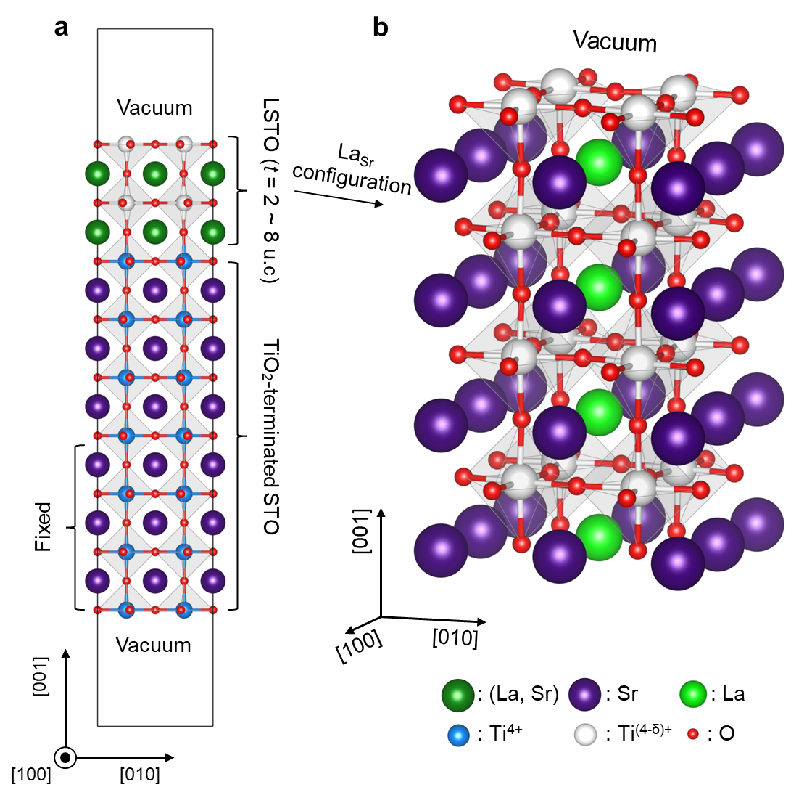
Supplementary Fig. 9 | Atomic structure of the LSTO/STO heterogeneous slab in DFT. a, Schematic of the LSTO/STO heterogeneous slab structure used in the DFT calculation. The 6.5 layers of TiO₂-terminated STO substrate and the LSTO film with various thickness, t (t = 2, 4, 6, and 8 u.c.), are included in the heterogeneous slab. b, Schematic of the La_{Sr} doping configuration in the LSTO film. La_{Sr} dopants are linearly aligned in the surface normal direction, i.e., [001] direction. Green, purple, chartreuse, red, blue, and white spheres represent the (La, Sr), Sr, La, O atoms, Ti⁴⁺ cation, and partially filled Ti^{(4-δ)+} cation, respectively.
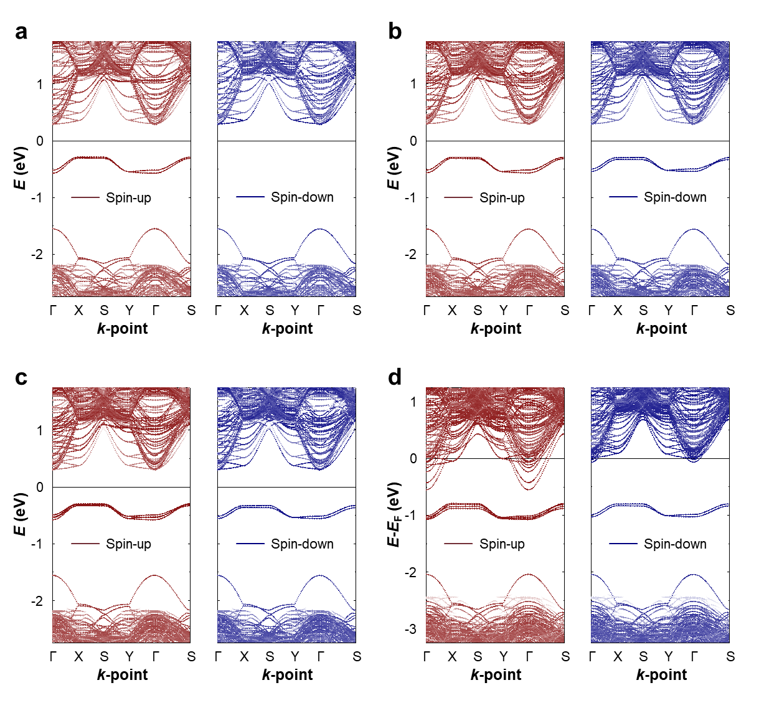
Supplementary Fig. 10 | DFT calculated spin-polarized band structure of the LSTO/STO slab. Spin-polarized band structures of the LSTO films on STO with various film thickness t = 2, 4, 6 and 8 u.c.. a, 2 u.c., b, 4 u.c., c, 6 u.c. and d, 8 u.c.. The bands are projected to minimize spurious electronic states originating from the fixed bottom surface layer of the slab, where the STO 2 u.c. from the bottom surface are excluded from the projection. Burgundy and indigo colors represent the spin-up and spin-down bands, respectively. For t = 2, 4, 6 u.c., the midpoint of the energies of the lowest unoccupied state and the highest occupied state is set to be zero and represented by the horizontal lines. For t = 8 u.c., the Fermi energy is set to be zero and represented by the horizontal lines.
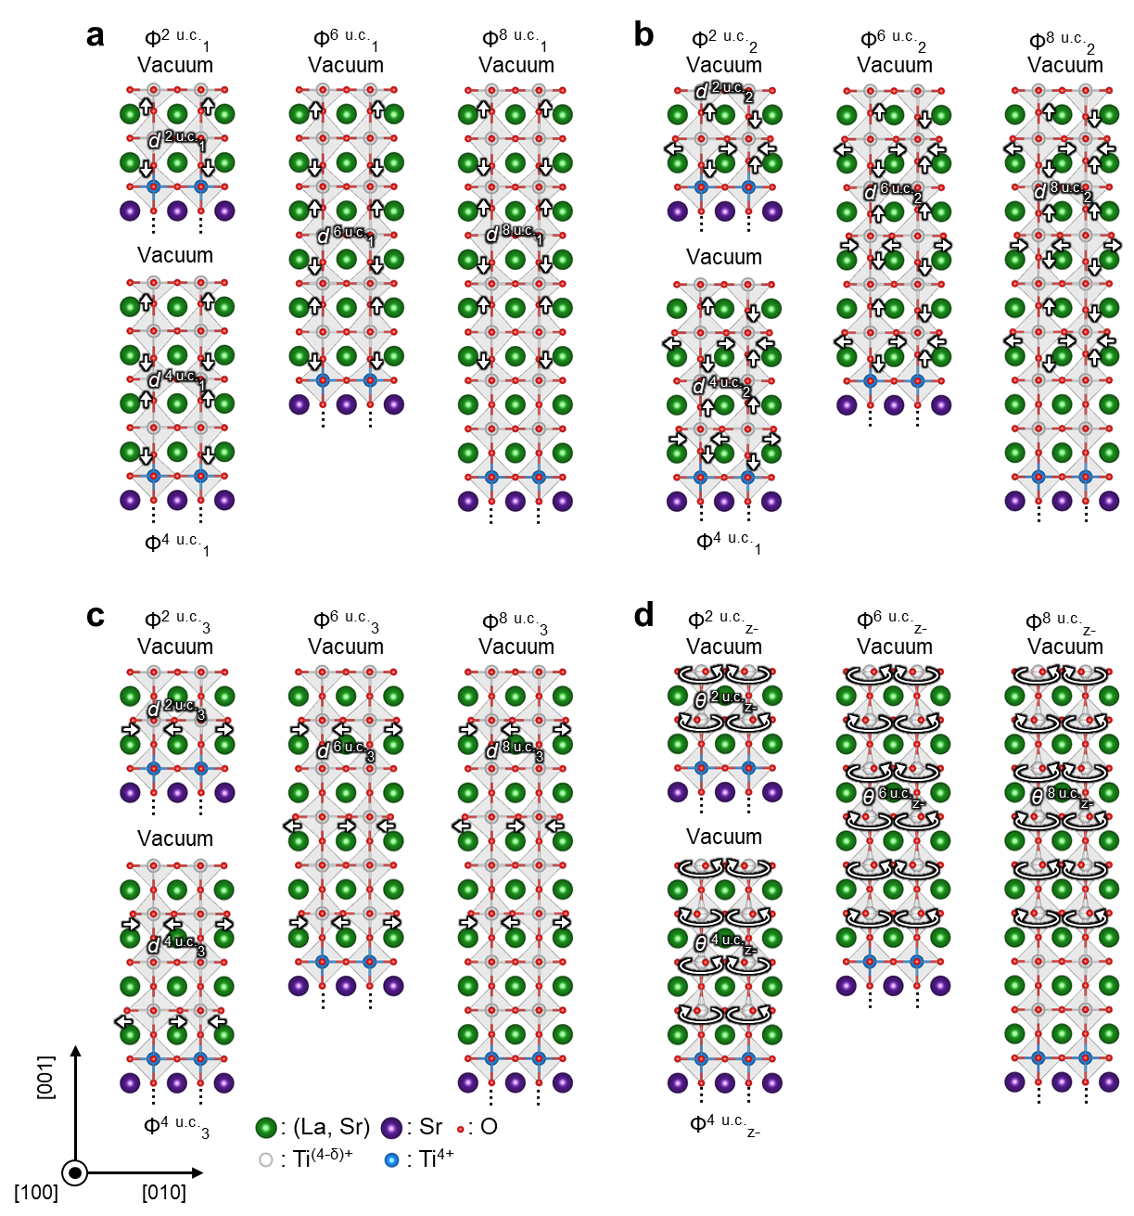
Supplementary Fig. 11 | Distortion modes for the LSTO film. The normalized distortion mode Φ^{t}_{i} are schematically shown (i = 1, 2, 3, and z-). a, The inter-layer TiO₆ breathing mode Φ^{t}₁, b, the intra-layer TiO₆ breathing mode Φ^{t}₂, c, the Jahn-Teller type distortion Φ^{t}₃, d, the antiferrodistortive rotation Φ^{t}_{z-}. Green, purple, red, white, and blue spheres represent the (La, Sr), Sr, and O atoms and Ti^{(4-δ)+}, and Ti⁴⁺ cation, respectively.
Supplementary Table 1 | Analyzed coefficients of the normalized distortion modes of the LSTO films with various film thickness t = 2, 4, 6, and 8 u.c..
 | $$c_{1}^{t}$$ | $$c_{2}^{t}$$ | $$c_{3}^{t}$$ | $$c_{z^{-}}^{t}$$ | $$c_{rem}^{t}$$
$t$ = 2 u.c. | 0.0902 | 0.125 | 0.0720 | 0.753 | 0.828
$t$ = 4 u.c. | 0.136 | 0.178 | 0.0844 | 1.43 | 0.949
$t$ = 6 u.c. | 0.180 | 0.224 | 0.122 | 1.91 | 1.02
$t$ = 8 u.c. | 0.184 | 0.225 | 0.122 | 1.90 | 1.08

Supplementary Table 2 | Analyzed oxygen displacements and oxygen rotation angle of the LSTO films by the distortion modes with various film thickness t = 2, 4, 6, and 8 u.c..
 | $d_{1}^{t}$ (pm) | $d_{2}^{t}$ (pm) | $d_{3}^{t}$ (pm) | $θ_{z^{-}}^{t}$ (°)
$t$ = 2 u.c. | 3.19 | 3.12 | 2.55 | 9.79
$t$ = 4 u.c. | 3.41 | 3.14 | 2.11 | 9.39
$t$ = 6 u.c. | 3.67 | 3.23 | 2.48 | 9.31
$t$ = 8 u.c. | 3.75 | 3.25 | 2.49 | 9.26

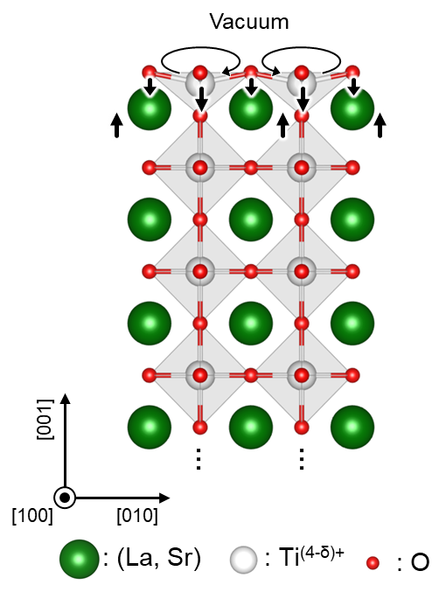
Supplementary Fig. 12 | Schematics of the remaining term Φ^{t}_{rem} for the LSTO/STO slab. For all the invested film thickness t (t = 2, 4, 6, and 8 u.c.), Φ^{t}_{rem} mainly consists of the displacements on the surface layer, and the displacements near La_{Sr} (Supplementary Fig. 3). Green, white, and red spheres represent the (La, Sr) atoms, Ti^{(4-δ)+} cation, and O atoms, respectively.
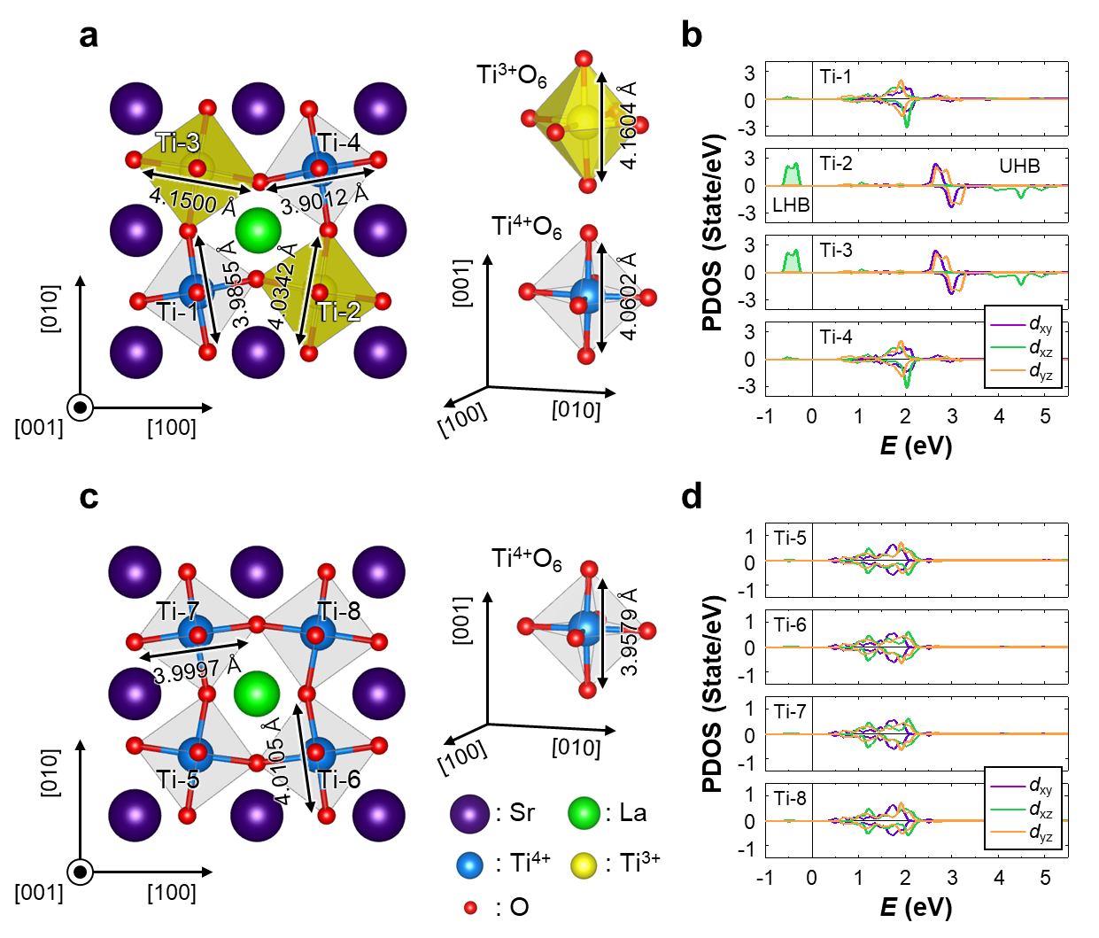
Supplementary Fig. 13 | Atomic and electronic structures of the LSTO film on STO substrate with t = 6 u.c.. a, Atomic structure of the -1st layer of the film. b, Spin-polarized density of states (DOS) projected onto the t_{2g} orbitals of Ti atoms on the -1st layer. c, Atomic structure of -2nd layer of the film. d, Spin-polarized DOS projected onto the t_{2g} orbitals of Ti atoms on the -2nd layer. In a,c, purple, chartreuse, red, blue, and yellow spheres represent the Sr, La, and O atoms and Ti⁴⁺, and Ti³⁺ cations, respectively. In a, the yellow shades on the Ti³⁺O₆ octahedral surface are guides for eyes. In b,d, purple, chartreuse, and orange lines represent the DOS projected onto the Ti d_{xy}, d_{xz}, and d_{yz} orbitals, respectively. Positive and negative regions correspond to the up-spin and the down-spin states, respectively. The midpoint of the energies of the lowest unoccupied state and the highest occupied state is set to be zero and represented by the vertical line.
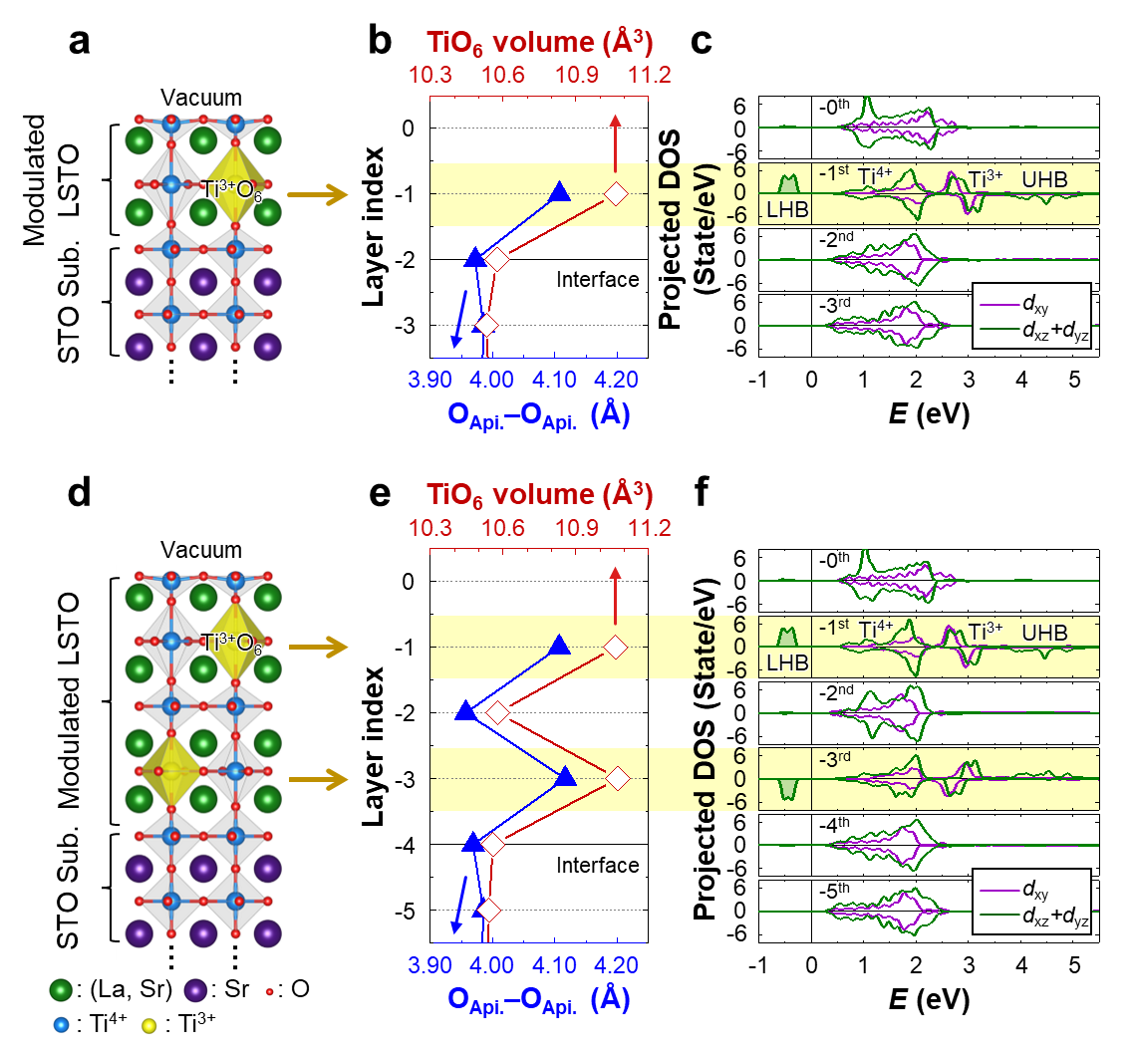
Supplementary Fig. 14 | Atomic and electronic structures of the LSTO/STO slab with t = 2 and 4 u.c.. a, Schematic representation of the atomic structure of the LSTO film on STO (001) surface for thickness, t = 2 u.c.. b, The height and volume of TiO₆ octahedra of the LSTO/STO heterostructures. The layer-averaged height and volume of the TiO₆ octahedra obtained from the DFT calculations are plotted. c, The layer-resolved DOS projected onto the Ti 3d t_{2g} orbitals for t = 2 u.c.. d, Schematic representation of the atomic structure of the LSTO film on STO (001) surface for t = 4 u.c.. e, The height and volume of TiO₆ octahedra of the LSTO/STO heterostructures. The layer-averaged height and volume of the TiO₆ octahedra obtained from the DFT calculations are plotted. f, The layer-resolved DOS projected onto the Ti 3d t_{2g} orbitals for t = 4 u.c.. In a,d, green, purple, red, blue, and yellow spheres represent the (La, Sr), Sr, O atoms and Ti⁴⁺, and Ti³⁺ cations, respectively. The yellow shades on the Ti³⁺O₆ octahedral surface are guides for eyes. In b,c, the light-gold highlights for the -1st sublayers are guides for eyes. In b,e, the blue line with the closed triangles and the red line with the open diamonds represent the layer-averaged height and volume of TiO₆ octahedra, respectively. In c,f, purple and green lines represent the DOS projected onto the Ti d_{xy} and d_{xz}+d_{yz}, respectively. Positive and negative regions correspond to the up-spin and the down-spin states, respectively. The midpoint of the energies of the lowest unoccupied state and the highest occupied state is set to be zero and represented by the vertical line. In e,f, the yellow highlights for the -1st and -3rd sublayers are guides for eyes.
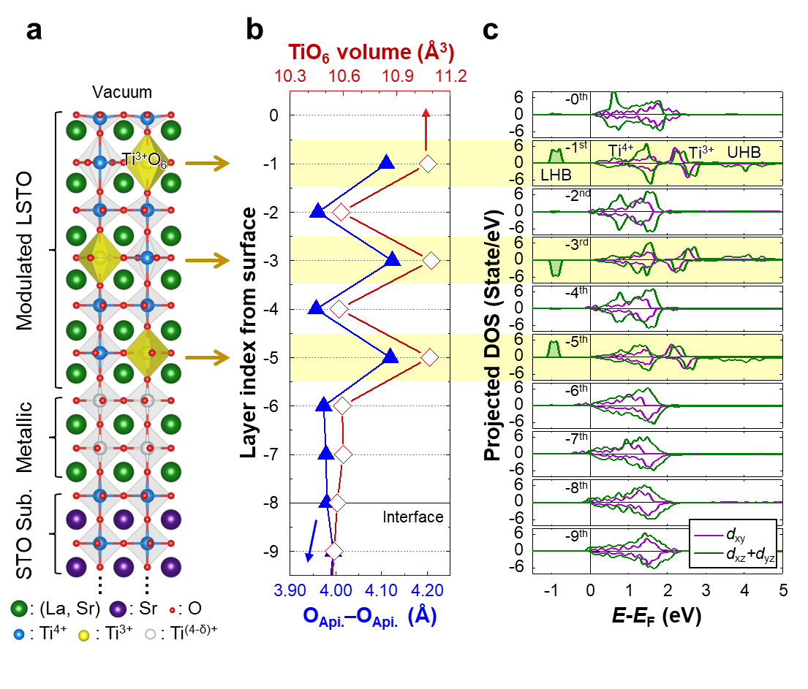
Supplementary Fig. 15 | Atomic and electronic structures of the LSTO/STO slab with t = 8 u.c.. a, Schematic representation of the atomic structure of the LSTO film on STO (001) surface for thickness, t = 8 u.c.. Green, purple, red, blue, and yellow spheres represent the (La, Sr), Sr, O atoms and Ti⁴⁺, and Ti³⁺ cations, respectively. The yellow shades on the Ti³⁺O₆ octahedral surface are guides for eyes. b, The height and volume of TiO₆ octahedra of the LSTO/STO heterostructures. The layer-averaged height and volume of the TiO₆ octahedra obtained from the DFT calculations are plotted. The blue line with the closed triangles and the red line with the open diamonds represent the layer-averaged height and volume of TiO₆ octahedra, respectively. c, The layer-resolved DOS projected onto the Ti 3d t_{2g} orbitals for t = 8 u.c.. Purple and green lines represent the DOS projected onto the Ti d_{xy} and d_{xz}+d_{yz}, respectively. Positive and negative regions correspond to the up-spin and the down-spin states, respectively. The Fermi energy is set to be zero and represented by the vertical line. In b,c, the yellow highlights for the -1st, -3rd, and -5th sublayers are guides for eyes.
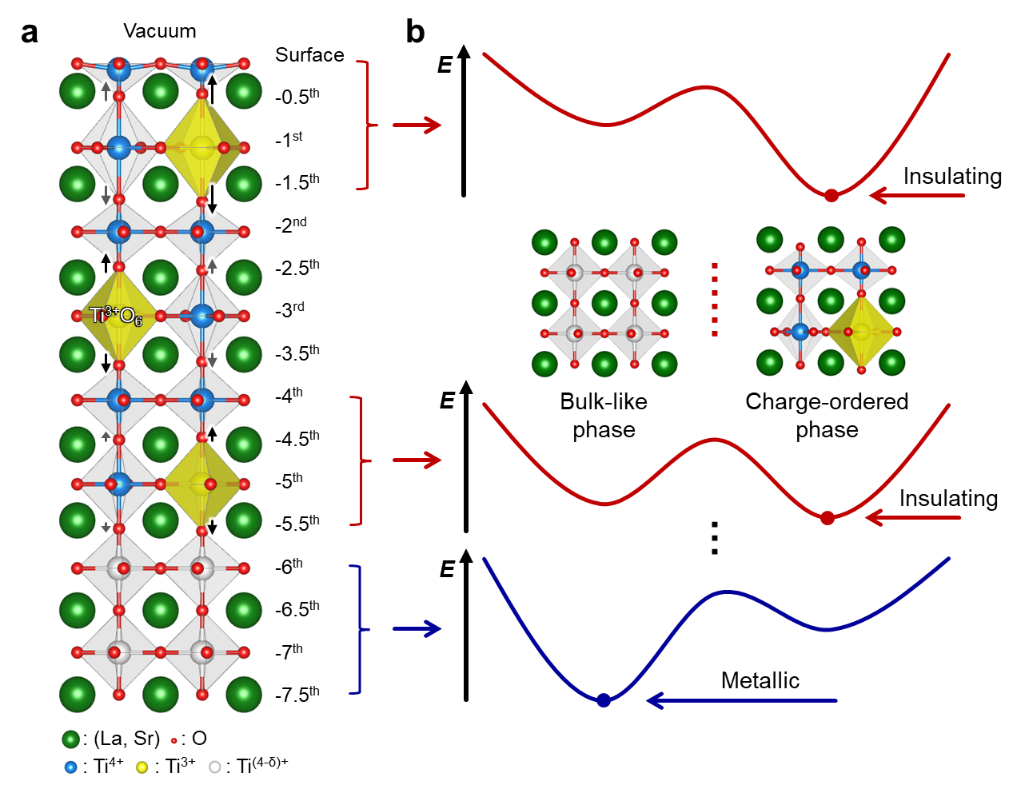
Supplementary Fig. 16 | Schematics of how the surface dangling bond triggers the charge-ordered instability in the surface region. a, Schematic of apical oxygen displacement due to the surface dangling bond. A TiO₅ pyramid, formed at the top surface leads to a shortened equilibrium Ti-O bond length. The apical oxygen in the -0.5th layer was pushed upward which results in an elongated Ti-O bond length in the -1st layer. Therefore, Ti³⁺ states with the charge-ordered patten are stabilized in this layer, giving rise to an increase in the TiO₆ volume and pushing down on the apical oxygen in the -1.5th sublayer. Note that the apical oxygen raising in the -0.5th layer corresponds to the inter-layer breathing mode (Φ₁) (Fig. 4e). b, Schematic of the energy landscape between bulk-like metallic phase and charge-ordered insulating phase depending on the depth, i.e., sublayer index. In the surface region, the charge-ordered insulating phase is stabilized by the surface dangling bond and this phase is attenuated at depth. In a,b, green, red, blue, yellow, and white spheres represent the (La, Sr), O atoms and Ti⁴⁺, Ti³⁺, and partially filled Ti^{(4-δ)+} cations, respectively. The yellow shades on the Ti³⁺O₆ octahedral surface are guides for eyes.
Supplementary References
- Bristowe, N. C., Varignon, J., Fontaine, D., Bousquet, E. & Ghosez, Ph. Ferromagnetism induced by entangled charge and orbital orderings in ferroelectric titanate perovskites. Nat. Commun. 6, 6677 (2015).
- Kim, S. J. et al. Optical Characterization of Doped SrTiO₃ in a Wide Photon Energy Region. J. Korean. Phys. Soc. 51, 161–165 (2007).
- Unoki, H. & Sakudo, T. Synthesis, Electron Spin Resonance of Fe³⁺ in SrTiO₃ with Special Reference to the 110°K Phase Transition. J. Phys. Soc. Jpn. 23, 546–552 (1967).
- Solovyev, I. V. Superexchange interactions in orthorhombically distorted titanates RTiO₃ (R = Y, Gd, Sm and La). New J. Phys. 11, 093003 (2009).
- Fedorova, N. S. et al. Relationship between crystal structure and multiferroic orders in orthorhombic perovskite manganites. Phys. Rev. Mater. 2, 104414 (2018).

