Supplementary Information
Table of Contents
Supplementary Table 1............................................................................................................3-5
Supplementary Table 2............................................................................................................6
Supplementary Figure 1............................................................................................................7
Supplementary Figure 2............................................................................................................8
Supplementary Figure 3............................................................................................................9
Supplementary Figure 4............................................................................................................10
Supplementary Figure 5............................................................................................................11
Supplementary Figure 6............................................................................................................12
Supplementary Figure 7............................................................................................................13
Supplementary Figure 8............................................................................................................13
Supplementary Figure 9............................................................................................................14
Supplementary Figure 10..........................................................................................................15
Supplementary Figure 11..........................................................................................................16
Supplementary Figure 12..........................................................................................................17
Supplementary Figure 13..........................................................................................................18
Supplementary Figure 14..........................................................................................................19
Supplementary Figure 15..........................................................................................................20
Supplementary Figure 16..........................................................................................................21
Supplementary Figure 17..........................................................................................................22
Supplementary Figure 18..........................................................................................................23
Supplementary Figure 19..........................................................................................................24
Supplementary Figure 20..........................................................................................................25
Supplementary Figure 21..........................................................................................................26
Supplementary Figure 22..........................................................................................................27
Supplementary Figure 23..........................................................................................................28
Supplementary Figure 24..........................................................................................................29
Supplementary Figure 25..........................................................................................................30
Supplementary Figure 26..........................................................................................................31
Supplementary Figure 27..........................................................................................................32
Supplementary Figure 28..........................................................................................................33
Supplementary Figure 29..........................................................................................................34
Supplementary Figure 30..........................................................................................................35
Supplementary Figure 31..........................................................................................................36
Supplementary Figure 32..........................................................................................................37
Supplementary Figure 33..........................................................................................................38
Supplementary Figure 34..........................................................................................................39
Supplementary Figure 35..........................................................................................................39

Table S1: Details of Eddy Covariance (EC) sites used in this study. Color coding of the sites is based on the dominant landcover class.
Site | Long | Lat | Zm (m) | Mean canopy height (m) | Time period | Data release | Dominant Landcover
AR-SLu | -66.459801 | -33.464802 | 11 | 4.5 | 2010 | FLUXNET2015 | MF
AT-Neu | 11.3175001 | 47.1166687 | 3 | 1 | 2002-2012 | FLUXNET2015 | GRA
AU-ASM | 133.248993 | -22.283001 | 11.6 | 6.5 | 2011-2017 | OzFlux | ENF
AU-Cpr | 140.589127 | -34.00206 | 20 | 4 | 2011-2017 | OzFlux | SAV
AU-Cum | 150.722473 | -33.613297 | 30 | 23 | 2013-2018 | OzFlux | ENF
AU-DaP | 131.3181 | -14.0633 | 15 | 0.30 | 2011-2017 | OzFlux | GRA
AU-DaS | 131.388001 | -14.159283 | 21 | 16.4 | 2010-2017 | OzFlux | SAV
AU-Dry | 132.370606 | -15.2588 | 15 | 12.3 | 2011-2015 | OzFlux | SAV
AU-Emr | 148.474594 | -23.8587 | 5.6 | 2 | 2012-2013 | OzFlux | GRA
AU-Gin | 120.654099 | -30.191299 | 35 | 18 | 2012-2017 | OzFlux | SAV
AU-GWW | 115.650002 | -31.375 | 15 | 7 | 2013-2017 | OzFlux | WSA
AU-How | 131.149994 | -12.4952 | 23 | 16 | 2003-2017 | OzFlux | WSA
AU-Rig | 145.575897 | -36.649899 | 2.5 | 0.4 | 2011-2016 | OzFlux | GRA
AU-Stp | 133.350205 | -17.1507 | 4.8 | 0.5 | 2010-2017 | OzFlux | GRA
AU-TTE | 133.639999 | -22.287001 | 9.8 | 4.85 | 2013-2017 | OzFlux | OSH
AU-Tum | 148.151703 | -35.656601 | 70 | 40 | 2002-2017 | OzFlux | EBF
AU-Ync | 146.290695 | -34.9893 | 8 | 0.5 | 2011-2017 | OzFlux | GRA
BE-Lon | 4.74612999 | 50.55159 | 2.7 | 1 | 2005-2014 | FLUXNET2015 | CRO
BE-Vie | 5.99805021 | 50.305069 | 40 | 35 | 1997-2014 | FLUXNET2015 | MF
BR-Sa3 | -54.971436 | -3.0180292 | 64 | 40 | 2001-2003 | FLUXNET2015 | EBF
CA-NS1 | -98.483902 | 55.8792 | 24 | 20 | 2003 | FLUXNET2015 | ENF
CA-NS2 | -98.524696 | 55.9057999 | 20 | 20 | 2002-2004 | FLUXNET2015 | ENF
CA-NS4 | -98.3806 | 55.9143982 | 10 | 7 | 2003-2004 | FLUXNET2015 | ENF
CA-NS5 | -98.485001 | 55.8630981 | 9 | 5 | 2003-2004 | FLUXNET2015 | ENF
CA-NS6 | -98.964401 | 55.9166985 | 6 | 4 | 2002-2004 | FLUXNET2015 | OSH
CA-NS7 | -99.948303 | 56.6357994 | 6 | 0.25 | 2003-2004 | FLUXNET2015 | OSH
CA-Qfo | -74.342102 | 49.6925011 | 24 | 14 | 2004-2010 | FLUXNET2015 | ENF
CA-SF1 | -105.8176 | 54.4850006 | 12 | 6 | 2004-2006 | FLUXNET2015 | ENF
CA-SF2 | -105.8775 | 54.2538986 | 10 | 4 | 2003-2005 | FLUXNET2015 | ENF
CA-SF3 | -106.0053 | 54.0915985 | 20 | 1 | 2003-2005 | FLUXNET2015 | OSH
CH-Cha | 8.41044045 | 47.2102203 | 2 | 0.5 | 2006-2014 | FLUXNET2015 | GRA
CH-Dav | 9.85591984 | 46.8153343 | 35 | 25 | 1997-2014 | FLUXNET2015 | ENF
CH-Fru | 8.53777981 | 47.1158333 | 2.55 | 0.5 | 2007-2014 | FLUXNET2015 | GRA
CH-Oe1 | 7.73193979 | 47.2858315 | 2 | 0.5 | 2002-2008 | FLUXNET2015 | GRA
CN-Cha | 128.095795 | 42.4025002 | 40 | 28 | 2003-2005 | FLUXNET2015 | MF
CN-Cng | 123.509201 | 44.5933991 | 2 | 0.75 | 2008-2009 | FLUXNET2015 | GRA
CN-Dan | 91.0663986 | 30.4978008 | 2.1 | 1 | 2004-2005 | FLUXNET2015 | GRA
CN-Din | 112.536102 | 23.1732998 | 32 | 30 | 2003-2005 | FLUXNET2015 | EBF
CN-Du2 | 116.2836 | 42.0466995 | 3 | 0.5 | 2007-2008 | FLUXNET2015 | GRA
CN-HaM | 101.18 | 37.3699989 | 2.2 | 0.30 | 2002-2003 | FLUXNET2015 | GRA
CN-Qia | 115.058098 | 26.7413998 | 39.6 | 13 | 2003-2005 | FLUXNET2015 | ENF
DE-Geb | 10.9143 | 51.1001015 | 6 | 1 | 2001-2014 | FLUXNET2015 | CRO
DE-Gri | 13.5125303 | 50.9494705 | 3 | 0.7 | 2004-2014 | FLUXNET2015 | GRA
DE-Hai | 10.4530001 | 51.0791664 | 43.5 | 33 | 2000-2012 | FLUXNET2015 | DBF
DE-Kli | 13.5223799 | 50.8930588 | 3.5 | 1.5 | 2005-2014 | FLUXNET2015 | CRO
DE-Obe | 13.7212896 | 50.7866592 | 30 | 19 | 2008-2014 | FLUXNET2015 | ENF
DE-Seh | 6.44964981 | 50.8706245 | 2 | 0.80 | 2008-2010 | FLUXNET2015 | CRO
DE-Tha | 13.5669403 | 50.9636116 | 42 | 26.5 | 1998-2014 | FLUXNET2015 | ENF
ES-LMa | -2.9658301 | 37.0979347 | 1.5 | 0.2 | 2004-2006 | LaThuile | OSH
FI-Hyy | 24.2950001 | 61.8474999 | 23 | 14 | 1996-2014 | FLUXNET2015 | ENF
FI-Sod | 26.6378307 | 67.3618622 | 23 | 12.7 | 2008-2014 | FLUXNET2015 | ENF
FR-Gri | 1.95191002 | 48.8442192 | 3.17 | 1 | 2005-2013 | FLUXNET2015 | CRO
FR-LBr | -0.7693 | 44.7171097 | 38 | 20 | 2003-2008 | FLUXNET2015 | ENF
GF-Guy | -52.924858 | 5.27877188 | 55 | 35 | 2004-2014 | FLUXNET2015 | EBF
IT-BCi | 14.9574404 | 40.5237999 | 2 | 1 | 2005-2010 | FLUXNET2015 | CRO
IT -CA1 | 12.0265598 | 42.3804092 | 8 | 5.5 | 2012-2013 | FLUXNET2015 | DBF
IT-CA2 | 12.0260401 | 42.3772202 | 3.2 | 0.3 | 2012-2013 | FLUXNET2015 | CRO
IT-CA3 | 12.0221996 | 42.3800011 | 7 | 3.5 | 2012-2013 | FLUXNET2015 | DBF
IT-Col | 13.5881395 | 41.8493614 | 25.2 | 13 | 2007-2014 | FLUXNET2015 | DBF
IT-Cpz | 12.3761101 | 41.7052498 | 15 | 13 | 2001-2008 | FLUXNET2015 | EBF
IT-Isp | 8.63358021 | 45.8126411 | 38 | 19 | 2013-2014 | FLUXNET2015 | DBF
IT-LMa | 11.2813196 | 45.9561997 | 33 | 28 | 2003-2004 | LaThuile | ENF
IT-Mal | 11.0458298 | 46.014679 | 2.5 | 0.3 | 2003 | LaThuile | GRA
IT-Noe | 8.15168953 | 40.6061783 | 3 | 1.2 | 2004-2014 | FLUXNET2015 | CSH
IT-PT1 | 9.06103993 | 45.2008705 | 30 | 26 | 2003-2004 | FLUXNET2015 | DBF
IT-Ren | 11.4336901 | 46.5868607 | 40 | 28 | 2010-2013 | FLUXNET2015 | ENF
IT-Ro1 | 11.9300098 | 42.4081192 | 20 | 15 | 2002-2006 | FLUXNET2015 | DBF
IT-Ro2 | 11.9209299 | 42.3902588 | 20 | 15 | 2002-2008 | FLUXNET2015 | DBF
IT-SR2 | 10.2909098 | 43.732029 | 23.5 | 19 | 2013-2014 | FLUXNET2015 | ENF
IT-SRo | 10.28444 | 43.7278595 | 23.5 | 16 | 2003-2012 | FLUXNET2015 | ENF
NL-Loo | 5.74355984 | 52.1665802 | 27 | 15.5 | 1997-2013 | FLUXNET2015 | ENF
RU-Fyo | 32.922081 | 56.4615288 | 48 | 21 | 2003-2014 | FLUXNET2015 | ENF
SD-Dem | 30.4783001 | 13.2828999 | 2.5 | 1.5 | 2005-2009 | FLUXNET2015 | SAV
US-AR1 | -99.419998 | 36.4267006 | 2.84 | 1 | 2010-2012 | FLUXNET2015 | GRA
US-AR2 | -99.597504 | 36.6357994 | 2.95 | 1 | 2010-2011 | FLUXNET2015 | GRA
US-ARM | -97.4888 | 36.6058006 | 60 | 0.5 | 2003-2012 | FLUXNET2015 | CRO
US-Blo | -120.63275 | 38.8953018 | 12.5 | 4.7 | 2000-2006 | FLUXNET2015 | ENF
US-Cop | -109.39 | 38.0900002 | 1.85 | 0.5 | 2002-2003 | FLUXNET2015 | GRA
US-GLE | -106.2399 | 41.3665009 | 23 | 10 | 2009-2014 | FLUXNET2015 | ENF
US-Goo | -89.873497 | 34.2546997 | 4 | 0.3 | 2004-2006 | LaThuile | GRA
US-KS2 | -80.671532 | 28.6085777 | 3.5 | 2 | 2003-2006 | FLUXNET2015 | CSH
US-Me2 | -121.5574 | 44.452301 | 29 | 16 | 2002-2014 | FLUXNET2015 | ENF
US-Me4 | -121.6224 | 44.4991989 | 47 | 20 | 1996-2000 | LaThuile | ENF
US-Me6 | -121.6078 | 44.3232994 | 14 | 5.2 | 2011-2014 | FLUXNET2015 | ENF
US-MMS | -86.413101 | 39.3232002 | 48 | 27 | 1999-2014 | FLUXNET2015 | DBF
US-Ne1 | -105.5464 | 40.0329018 | 26 | 12 | 2002-2012 | FLUXNET2015 | ENF
US-Ne2 | -96.476601 | 41.1651001 | 6 | 3 | 2002-2012 | FLUXNET2015 | CRO
US-Ne3 | -96.4701 | 41.1649017 | 6 | 2.5 | 2002-2012 | FLUXNET2015 | CRO
US-NR1 | -96.439697 | 41.1796989 | 6 | 2.5 | 1999-2014 | FLUXNET2015 | CRO
US-Prr | -147.48759 | 65.123703 | 16 | 7 | 2011-2013 | FLUXNET2015 | ENF
US-SRG | -110.8277 | 31.7894001 | 3.25 | 1 | 2009-2014 | FLUXNET2015 | GRA
US-SRM | -110.866 | 31.8213997 | 6.4 | 2.5 | 2004-2014 | FLUXNET2015 | WSA
US-Syv | -89.347702 | 46.2420006 | 36 | 27 | 2002-2008 | FLUXNET2015 | MF
US-Ton | -120.966 | 38.4315987 | 23 | 7.1 | 2001-2014 | FLUXNET2015 | WSA
US-UMB | -84.713799 | 45.5597992 | 50 | 20 | 2000-2014 | FLUXNET2015 | DBF
US-Var | -120.95076 | 38.4132996 | 3 | 0.55 | 2001-2014 | FLUXNET2015 | GRA
US-WCr | -90.079903 | 45.8059006 | 30 | 24 | 1999-2006 | FLUXNET2015 | DBF
US-Whs | -110.0522 | 31.7437992 | 4 | 0.5 | 2008-2014 | FLUXNET2015 | OSH
US-Wkg | -109.9419 | 31.7364998 | 6.4 | 1 | 2005-2014 | FLUXNET2015 | GRA
ZA-Kru | 31.4969006 | -25.019699 | 16 | 12 | 2000-2002 | FLUXNET2015 | SAV
ZM-Mon | 23.2527809 | -15.437778 | 33 | 12 | 2008 | FLUXNET2015 | DBF

Table S2: The variables used for training ANN for the estimation of stomatal conductance ($g_{sc}$) in pure ML approach.
Number | Variables | Full Name | Units | Data source | Frequency
1 | Ta | Air temperature | ℃ | PLUMBER2¹ | 30 minutes / 1 hour
2 | SRad | Incoming Shortwave Radiation | $$W m^{-2}$$ | PLUMBER2 | 30 minutes / 1 hour
3 | fPAR | Fraction of photosynthetically active radiation | - | MCD15A3H (https://modis.ornl.gov/cgi-bin/MODIS/global/subset.pl) | 4 days
4 | USTAR | Friction velocity | $$m s^{-1}$$ | PLUMBER2 | 30 minutes / 1 hour
5 | VPD | Vapor pressure deficit | $$kPa$$ | PLUMBER2 | 30 minutes / 1 hour
6 | WS | Wind speed | $$m s^{-1}$$ | PLUMBER2 | 30 minutes / 1 hour
7 | Ca | Atmospheric $CO_{2}$ concentration | $$μmolCO_{2} mol^{-1}$$ | PLUMBER2 | 30 minutes / 1 hour
8 | LAI | Leaf area index | $$m^{2} m^{-2}$$ | MCD15A2H.006 (available from MODISTools R package) | 8 days (interpolated to the time resolution of the flux tower data)
9 | SM | Soil water content | $$m^{3} m^{-3}$$ | PLUMBER2 | 30 minutes / 1 hour
10 | Rn | Net radiation | $$W m^{-2}$$ | PLUMBER2 | 30 minutes / 1 hour
11 | G | Soil heat flux | $$W m^{-2}$$ | PLUMBER2 | 30 minutes / 1 hour
12 | LE | Latent heat flux | $$W m^{-2}$$ | PLUMBER2 | 30 minutes / 1 hour
13 | T | Plant transpiration | $$W m^{-2}$$ | Obtained from different ET partitioning methods (see Methods in the main manuscript) | 30 minutes / 1 hour
Note: Variables 1-11 were used as input variables and variables 12-13 were used as target variables.

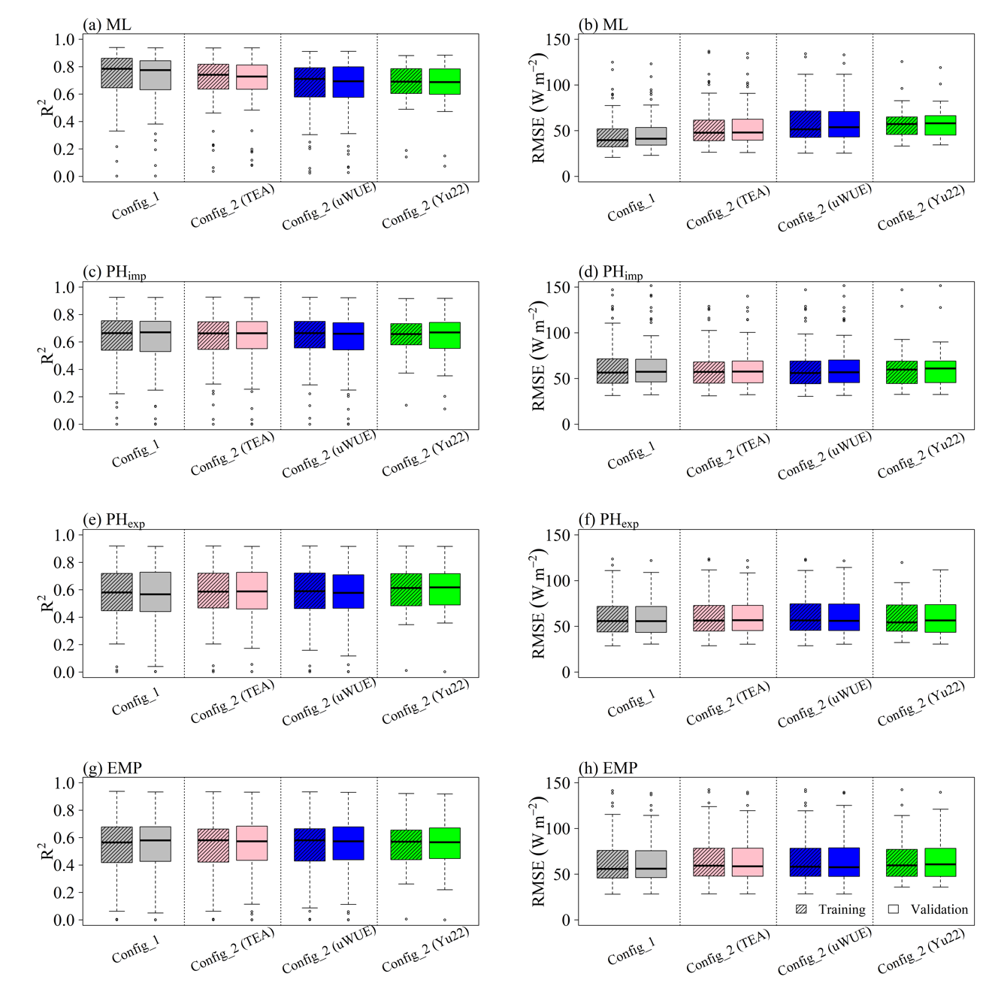
Fig. S1. Performance of different models (i.e., ML (machine learning), PH_{imp} (implicit representation of plant hydraulics), PH_{exp} (explicit representation of plant hydraulics), and EMP (empirical)) for the prediction of evapotranspiration (ET) during training (textured boxes) and validation (plain boxes) of the models across the eddy covariance flux sites. Config_1 and Config_2 correspond to Configuration-1 and Configuration-2, respectively.

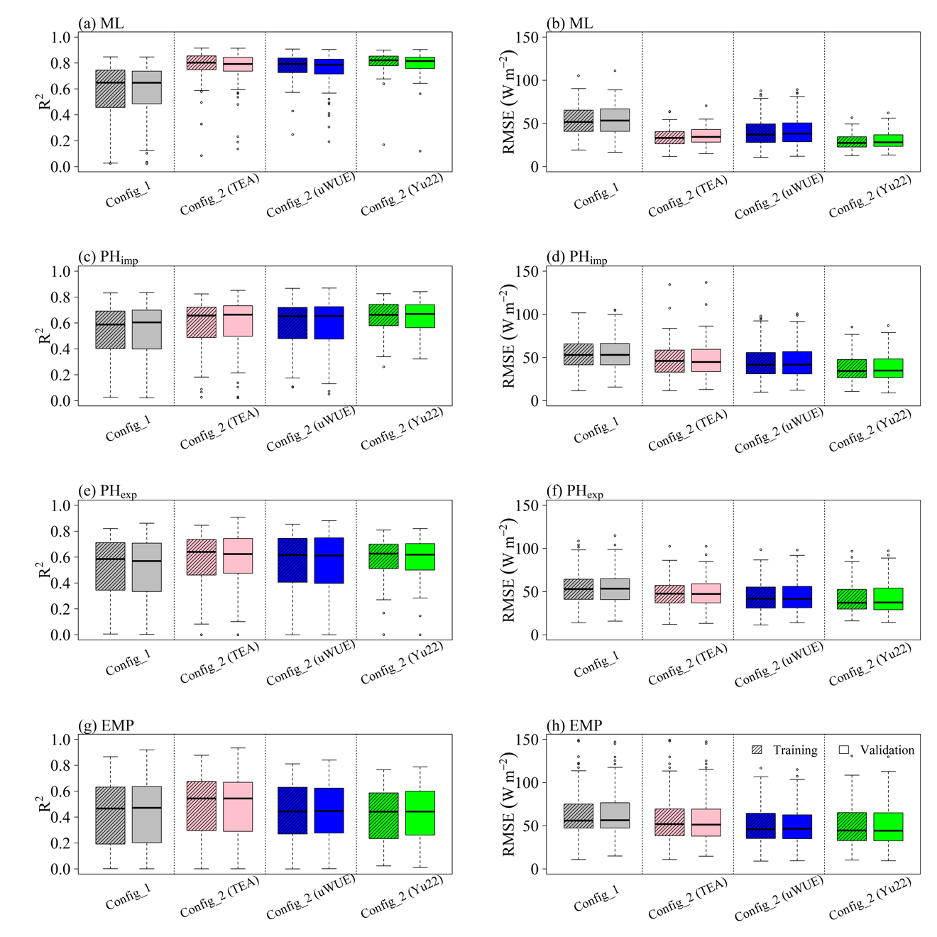
Fig. S2. Performance of different models (i.e., ML (machine learning), PH_{imp} (implicit representation of plant hydraulics), PH_{exp} (explicit representation of plant hydraulics), and EMP (empirical)) for the prediction of plant transpiration (T) during training (textured boxes) and validation (plain boxes) of the models across the eddy covariance flux sites. Config_1 and Config_2 correspond to Configuration-1 and Configuration-2, respectively.

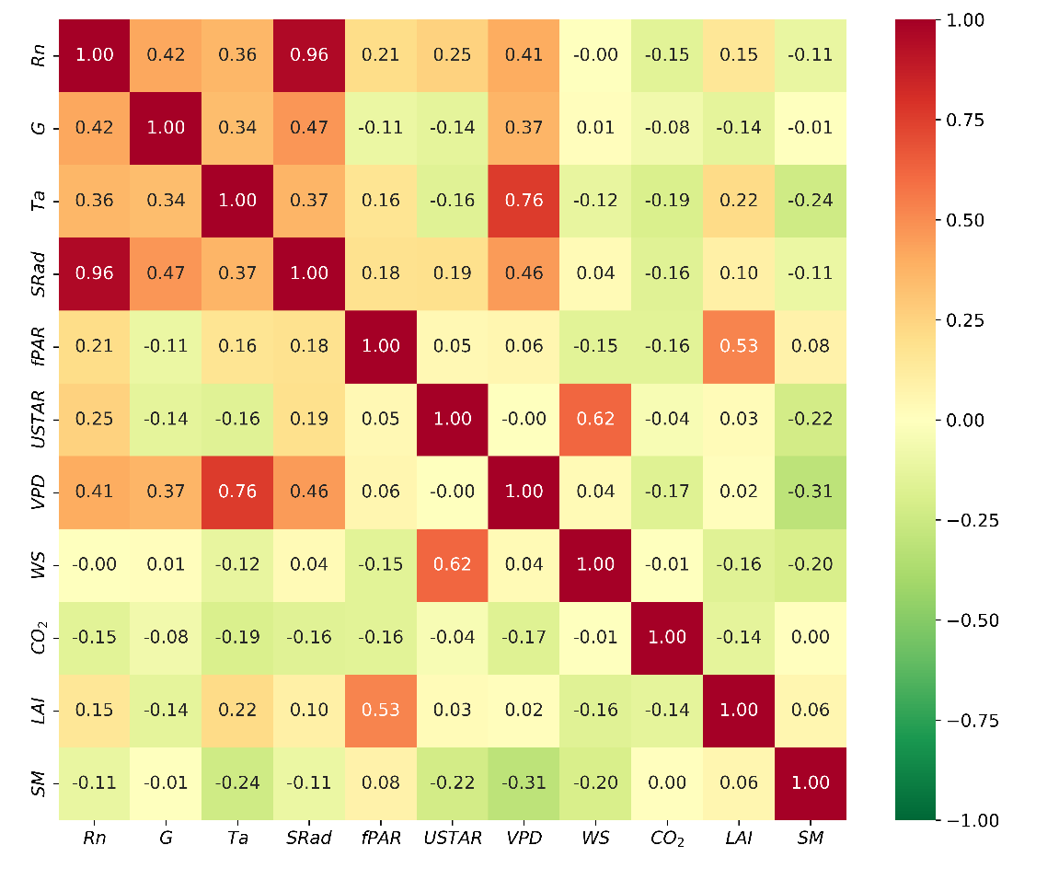
Fig. S3. Correlation matrix of different input variables used to model stomatal conductance ($g_{sc}$) in the machine learning (ML) model.

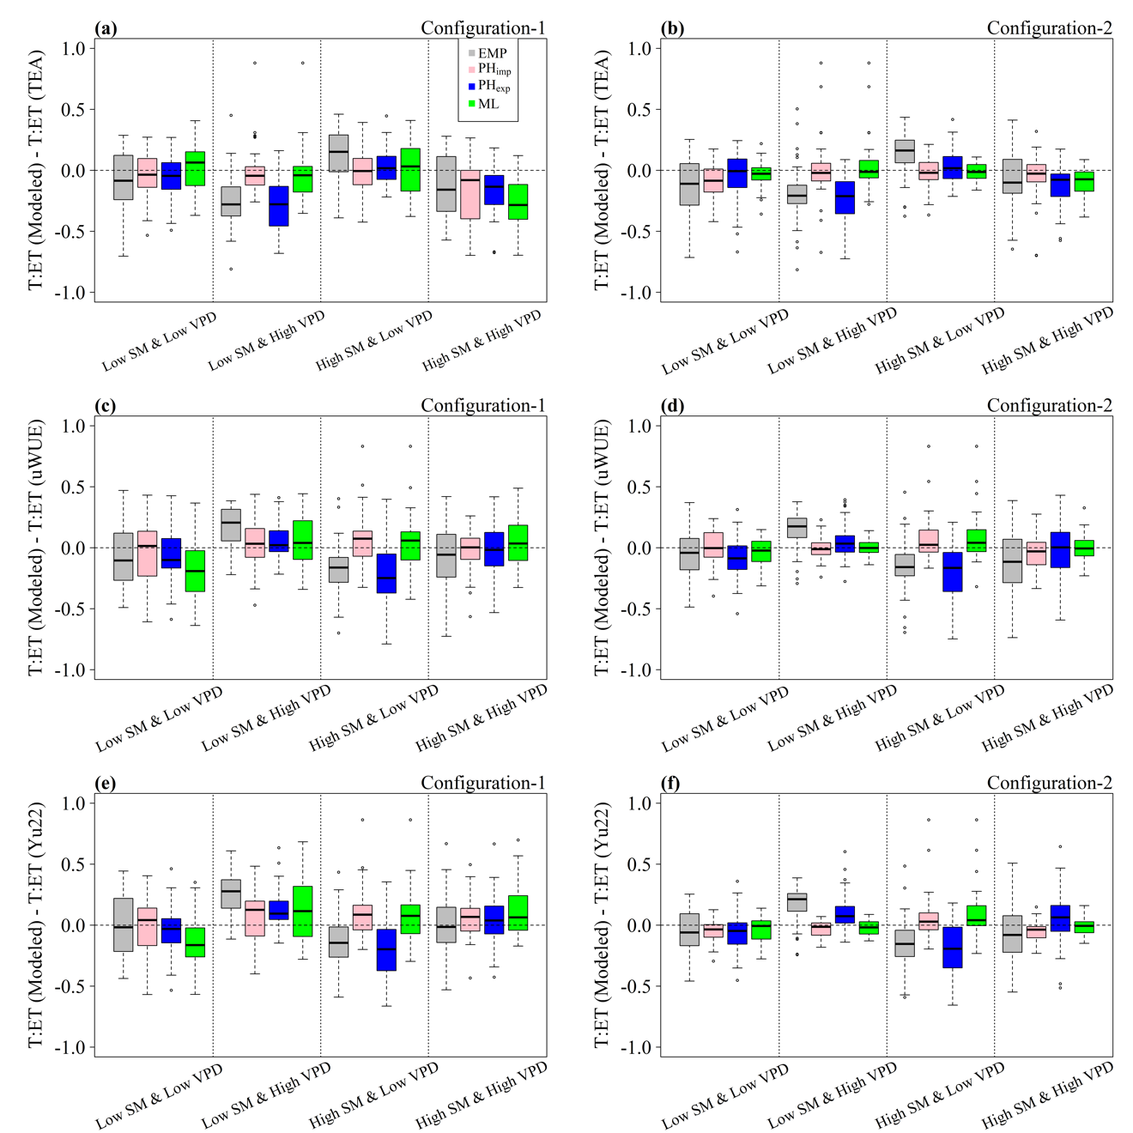
Fig. S4. Error statistics of different models (i.e., ML (machine learning), PH_{imp} (implicit representation of plant hydraulics), PH_{exp} (explicit representation of plant hydraulics), and EMP (empirical)) for ET partitioning under different regimes of soil moisture (SM) and VPD at all the sites. Y-axis in each panel shows the mean difference between the T:ET obtained from either of the three models and mean T:ET from either of the three ET partitioning methods. The difference evaluations shown in the right column are between modeled estimated T:ET and that from the ET partitioning method whose T is used to train the model in Configuration-2. High and Low designation of SM and VPD is based on 25 and 75 percentile values, respectively, for each site.

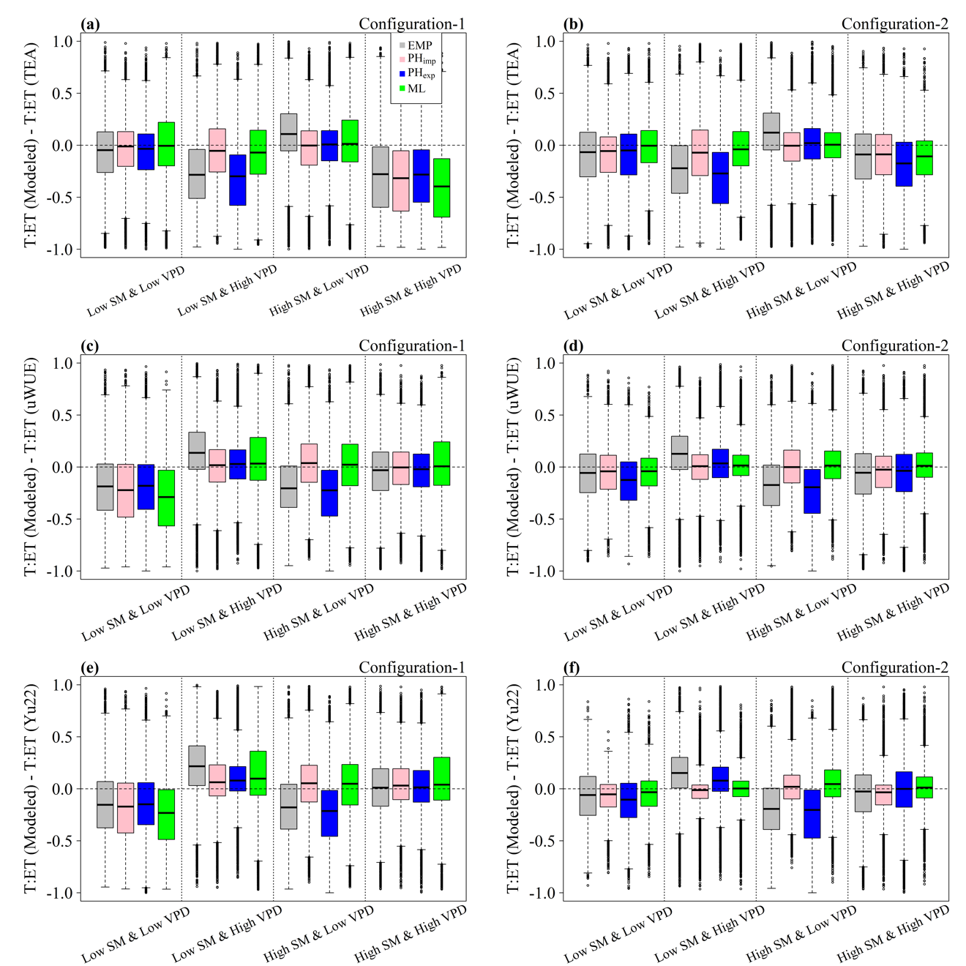
Fig. S5. Error statistics of different models (i.e., ML (machine learning), PH_{imp} (implicit representation of plant hydraulics), PH_{exp} (explicit representation of plant hydraulics), and EMP (empirical)) for ET partitioning under different regimes of soil moisture (SM) and VPD at all the sites. Y-axis in each panel shows the difference between the T:ET obtained from either of the three models and T:ET from either of the three ET partitioning methods across all the sites. The difference evaluations shown in the right column are between modeled estimated T:ET and that from the ET partitioning method whose T is used to train the model in Configuration-2. Definition of high and low SM or VPD is noted in the caption of Fig. S4.

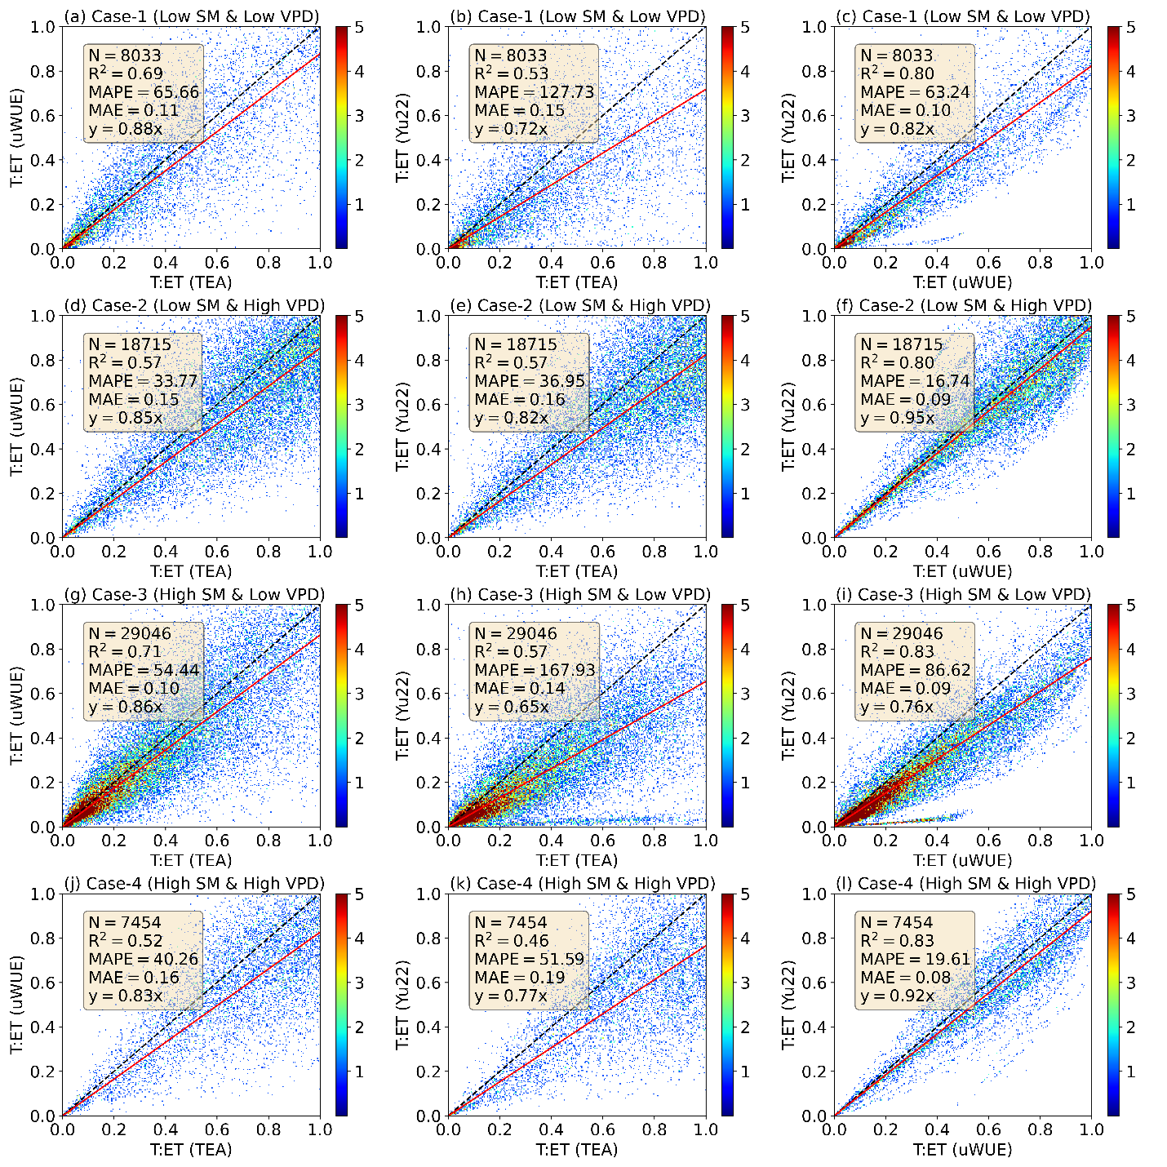
Fig. S6. Comparison of T:ET from different ET partitioning methods (TEA, uWUE, and Yu22) under different regimes of soil moisture (SM) and vapor pressure deficit (VPD). Definition of high and low SM or VPD is noted in the caption of Fig. S4.

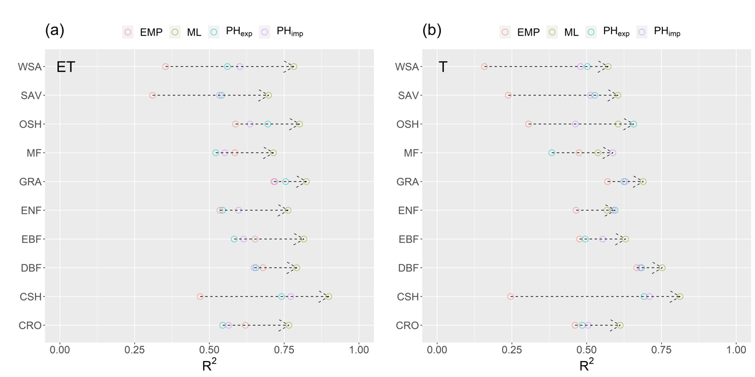
Fig. S7. Performance of different models (i.e., ML (machine learning), PH_{imp} (implicit representation of plant hydraulics), PH_{exp} (explicit representation of plant hydraulics), and EMP (empirical)) for the prediction of evapotranspiration (ET) and plant transpiration (T) under different biomes for Configuration-1. Abbreviations of the land covers can be referred in Fig. 1 of the main document.

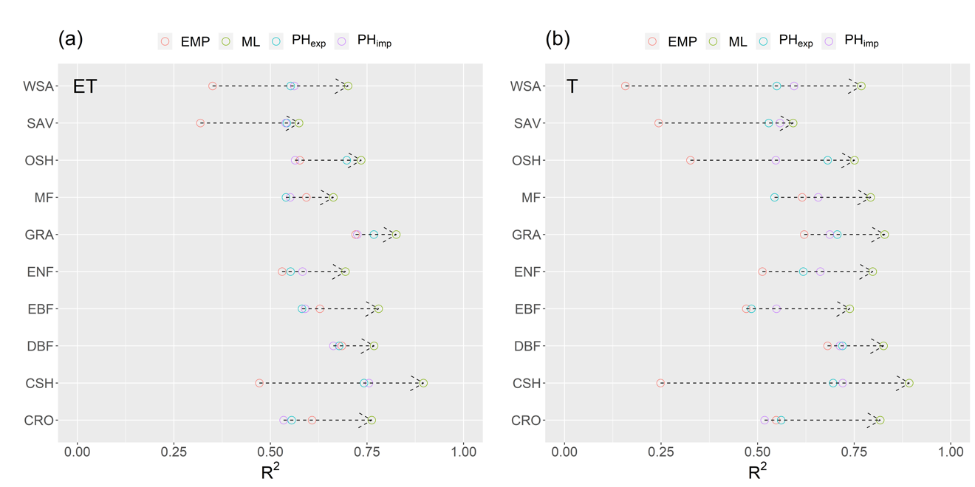
Fig. S8. Performance of different models (i.e., ML (machine learning), PH_{imp} (implicit representation of plant hydraulics), PH_{exp} (explicit representation of plant hydraulics), and EMP (empirical)) for the prediction of evapotranspiration (ET) and plant transpiration (T) under different biomes for Configuration-2 (TEA). Abbreviations of the land covers can be referred in Fig. 1 of the main document.

Fig. S9. Performance of the machine learning (ML) model for predicting latent heat flux (LE) in different biomes for Configuration-1. The diagonal black dashed line is a 1:1 line, and the red solid line is the nonbiased linear regression line. The shaded colors represent the density of scatter points. N, $R^{2}$, MAPE, MAE, and RMSE are the total number of scatter points in each panel, coefficient of determination, mean absolute percentage error, mean absolute error, and root-mean-square-error, respectively.

Fig. S10. Energy conservation in the machine learning (ML) model outputs in different biomes for Configuration-1. The diagonal black dashed line is a 1:1 line, and the red solid line is the nonbiased linear regression line. The shaded colors represent the density of scatter points. N, $R^{2}$, MAPE, MAE, and RMSE are the total number of scatter points in each panel, coefficient of determination, mean absolute percentage error, mean absolute error, and root-mean-square-error, respectively.

Fig. S11. Performance of the implicit plant hydraulics (PH_{imp}) model for predicting latent heat flux (LE) in different biomes for Configuration-1. The diagonal black dashed line is a 1:1 line, and the red solid line is the nonbiased linear regression line. The shaded colors represent the density of scatter points. N, $R^{2}$, MAPE, MAE, and RMSE are the total number of scatter points in each panel, coefficient of determination, mean absolute percentage error, mean absolute error, and root-mean-square-error, respectively.

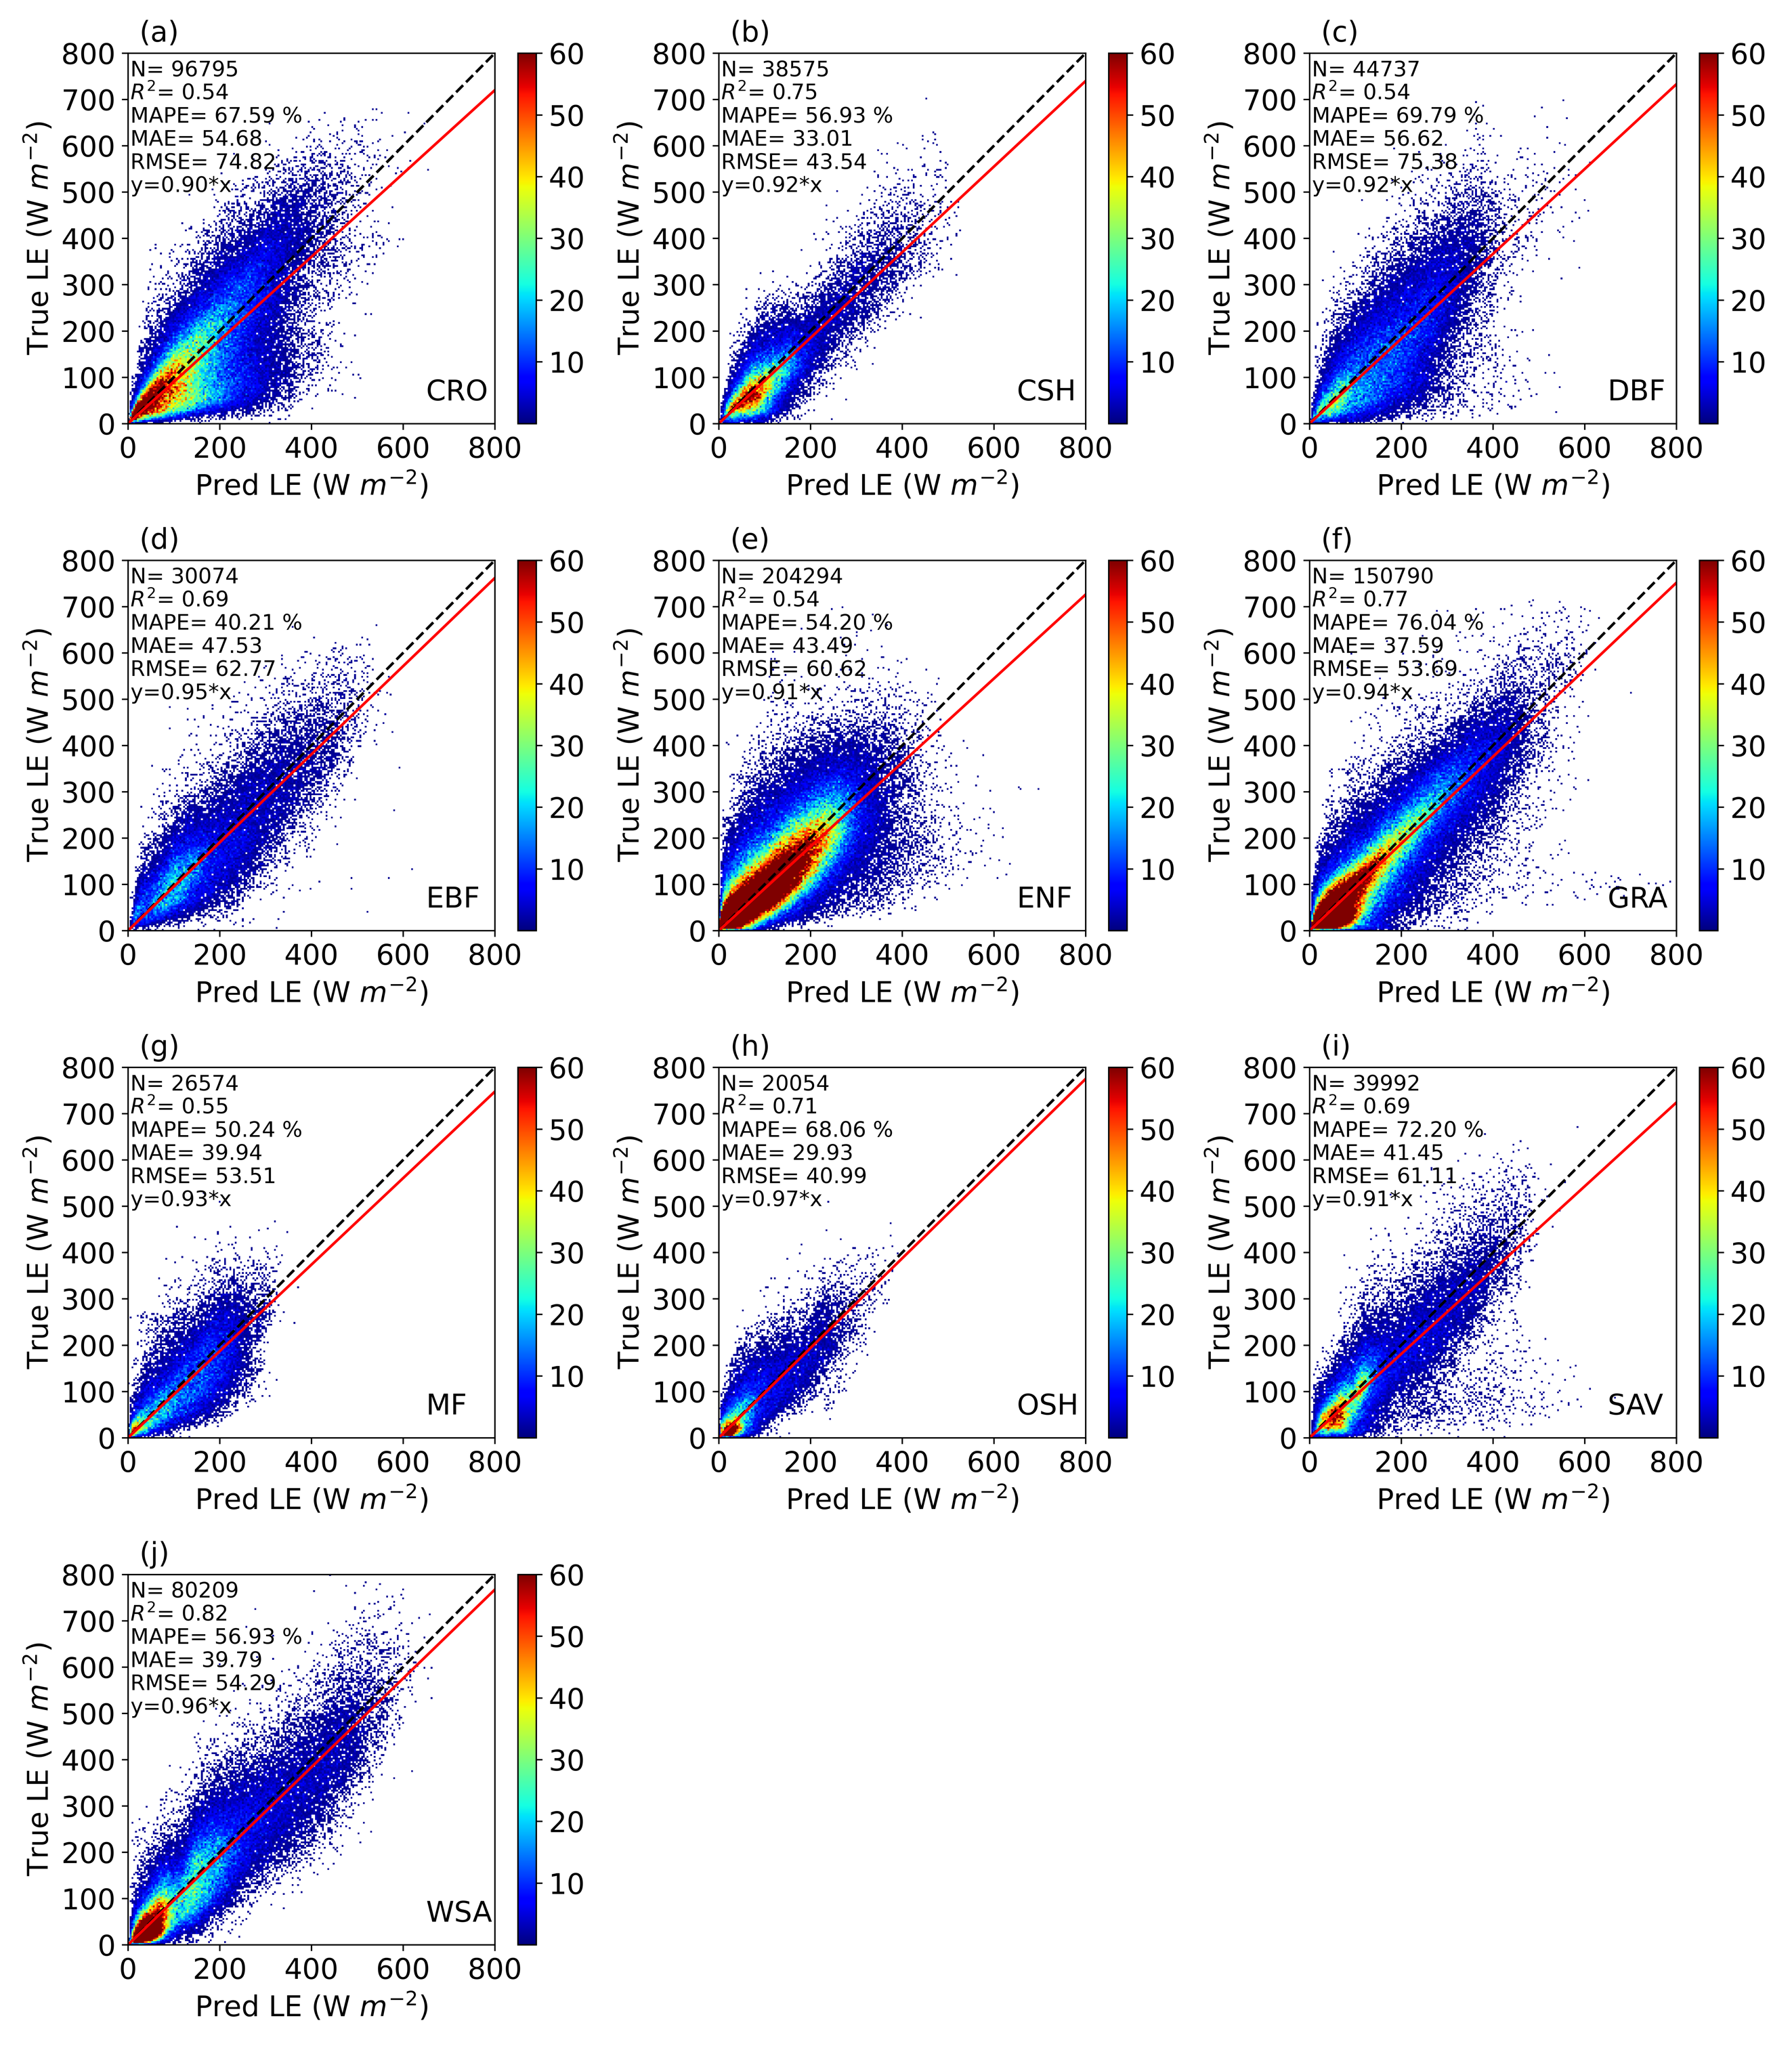

Fig. S12. Energy conservation in PH_{imp} model outputs in different biomes for Configuration-1. The diagonal black dashed line is a 1:1 line, and the red solid line is the nonbiased linear regression line. The shaded colors represent the density of scatter points. N, $R^{2}$, MAPE, MAE, and RMSE are the total number of scatter points in each panel, coefficient of determination, mean absolute percentage error, mean absolute error, and root-mean-square-error, respectively.

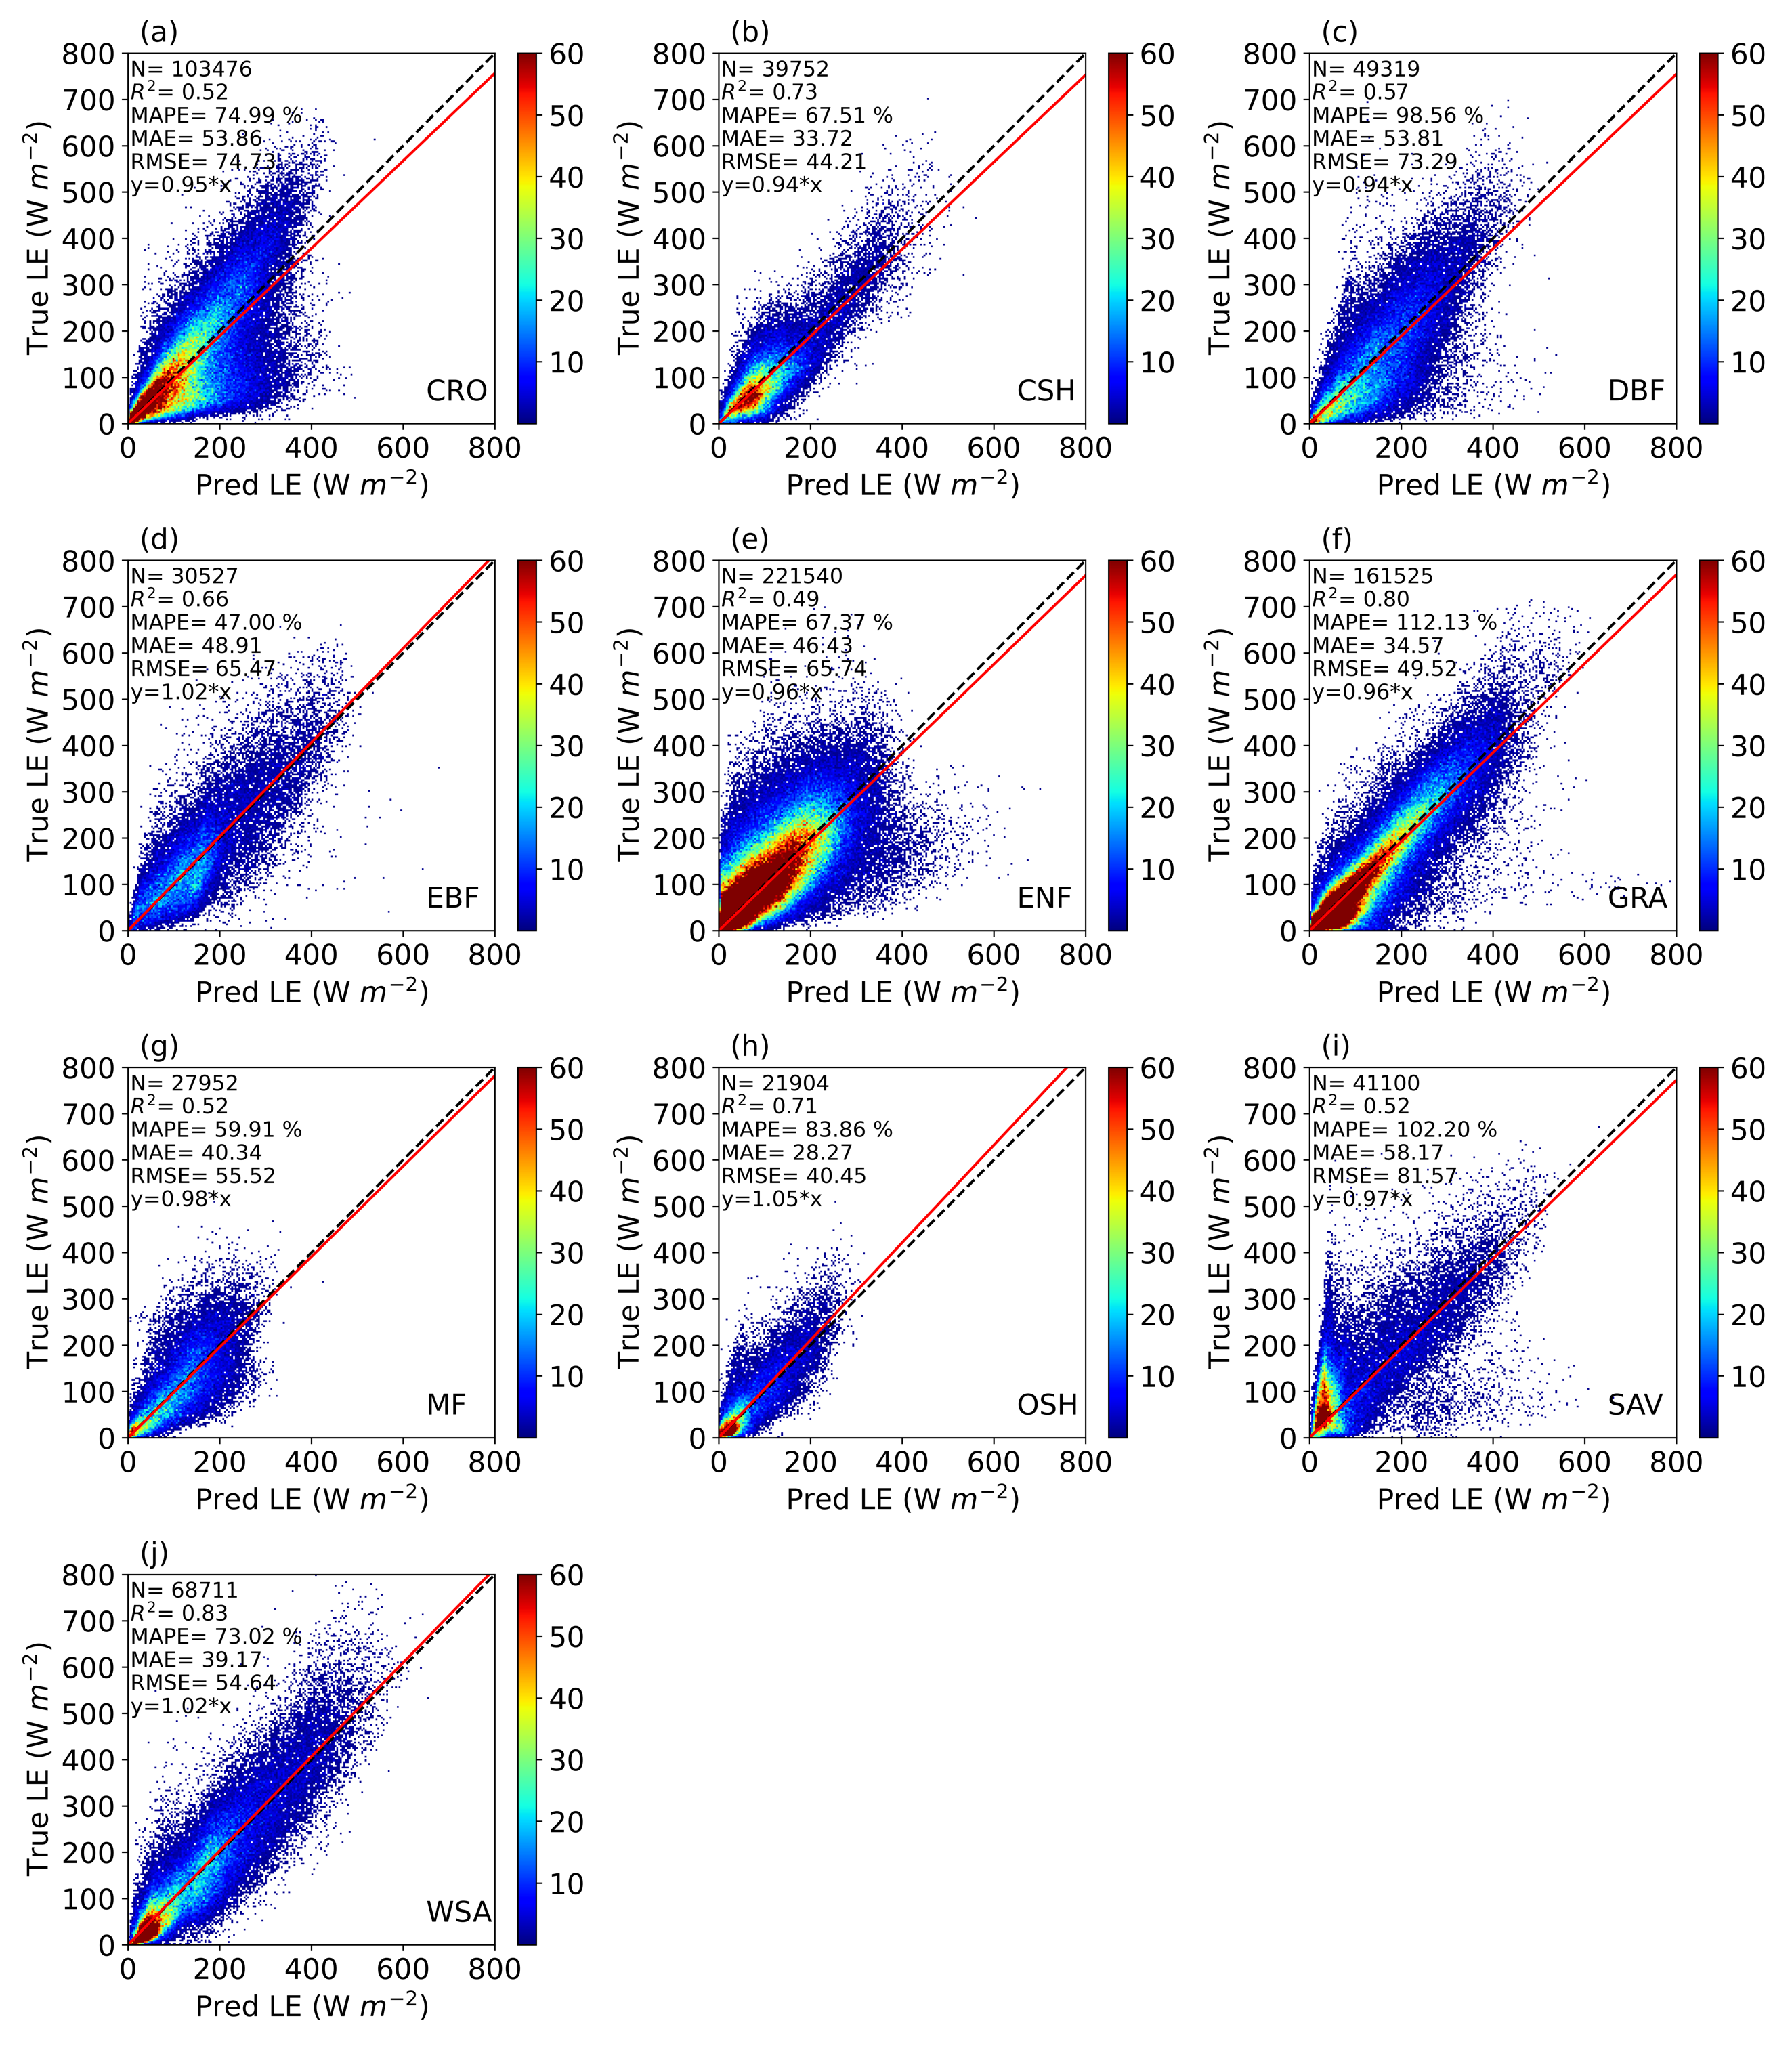
Fig. S13. Performance of the classic plant hydraulics (PH_{exp}) model for predicting latent heat flux (LE) in different biomes for Configuration-1. The diagonal black dashed line is a 1:1 line, and the red solid line is the nonbiased linear regression line. The shaded colors represent the density of scatter points. N, $R^{2}$, MAPE, MAE, and RMSE are the total number of scatter points in each panel, coefficient of determination, mean absolute percentage error, mean absolute error, and root-mean-square-error, respectively.

Fig. S14. Energy conservation in the classic plant hydraulic (PH_{exp}) model’s outputs in different biomes for Configuration-1. The diagonal black dashed line is a 1:1 line, and the red solid line is the nonbiased linear regression line. The shaded colors represent the density of scatter points. N, $R^{2}$, MAPE, MAE, and RMSE are the total number of scatter points in each panel, coefficient of determination, mean absolute percentage error, mean absolute error, and root-mean-square-error, respectively.

Fig. S15. Performance of the empirical model (EMP) for predicting latent heat flux (LE) in different biomes for Configuration-1. The diagonal black dashed line is a 1:1 line, and the red solid line is the nonbiased linear regression line. The shaded colors represent the density of scatter points. N, $R^{2}$, MAPE, MAE, and RMSE are the total number of scatter points in each panel, coefficient of determination, mean absolute percentage error, mean absolute error, and root-mean-square-error, respectively.

Fig. S16. Energy conservation in the empirical model’s (EMP) output in different biomes for Configuration-1. The diagonal black dashed line is a 1:1 line, and the red solid line is the nonbiased linear regression line. The shaded colors represent the density of scatter points. N, $R^{2}$, MAPE, MAE, and RMSE are the total number of scatter points in each panel, coefficient of determination, mean absolute percentage error, mean absolute error, and root-mean-square-error, respectively.

Fig. S17. Performance of the machine learning (ML) model for predicting plant transpiration (T) in different biomes for Configuration-2 (TEA). The diagonal black dashed line is a 1:1 line, and the red solid line is the nonbiased linear regression line. The shaded colors represent the density of scatter points. N, $R^{2}$, MAPE, MAE, and RMSE are the total number of scatter points in each panel, coefficient of determination, mean absolute percentage error, mean absolute error, and root-mean-square-error, respectively.

Fig. S18. Performance of the ML-based plant hydraulics (PH_{imp}) model for predicting plant transpiration (T) in different biomes for Configuration-2 (TEA). The diagonal black dashed line is a 1:1 line, and the red solid line is the nonbiased linear regression line. The shaded colors represent the density of scatter points. N, $R^{2}$, MAPE, MAE, and RMSE are the total number of scatter points in each panel, coefficient of determination, mean absolute percentage error, mean absolute error, and root-mean-square-error, respectively.

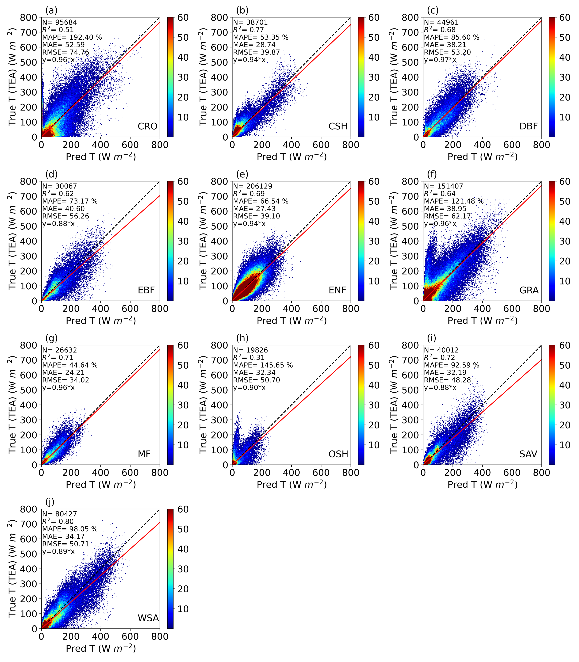

Fig. S19. Performance of the classic plant hydraulics (PH_{exp}) model for predicting plant transpiration (T) in different biomes for Configuration-2 (TEA). The diagonal black dashed line is a 1:1 line, and the red solid line is the nonbiased linear regression line. The shaded colors represent the density of scatter points. N, $R^{2}$, MAPE, MAE, and RMSE are the total number of scatter points in each panel, coefficient of determination, mean absolute percentage error, mean absolute error, and root-mean-square-error, respectively.

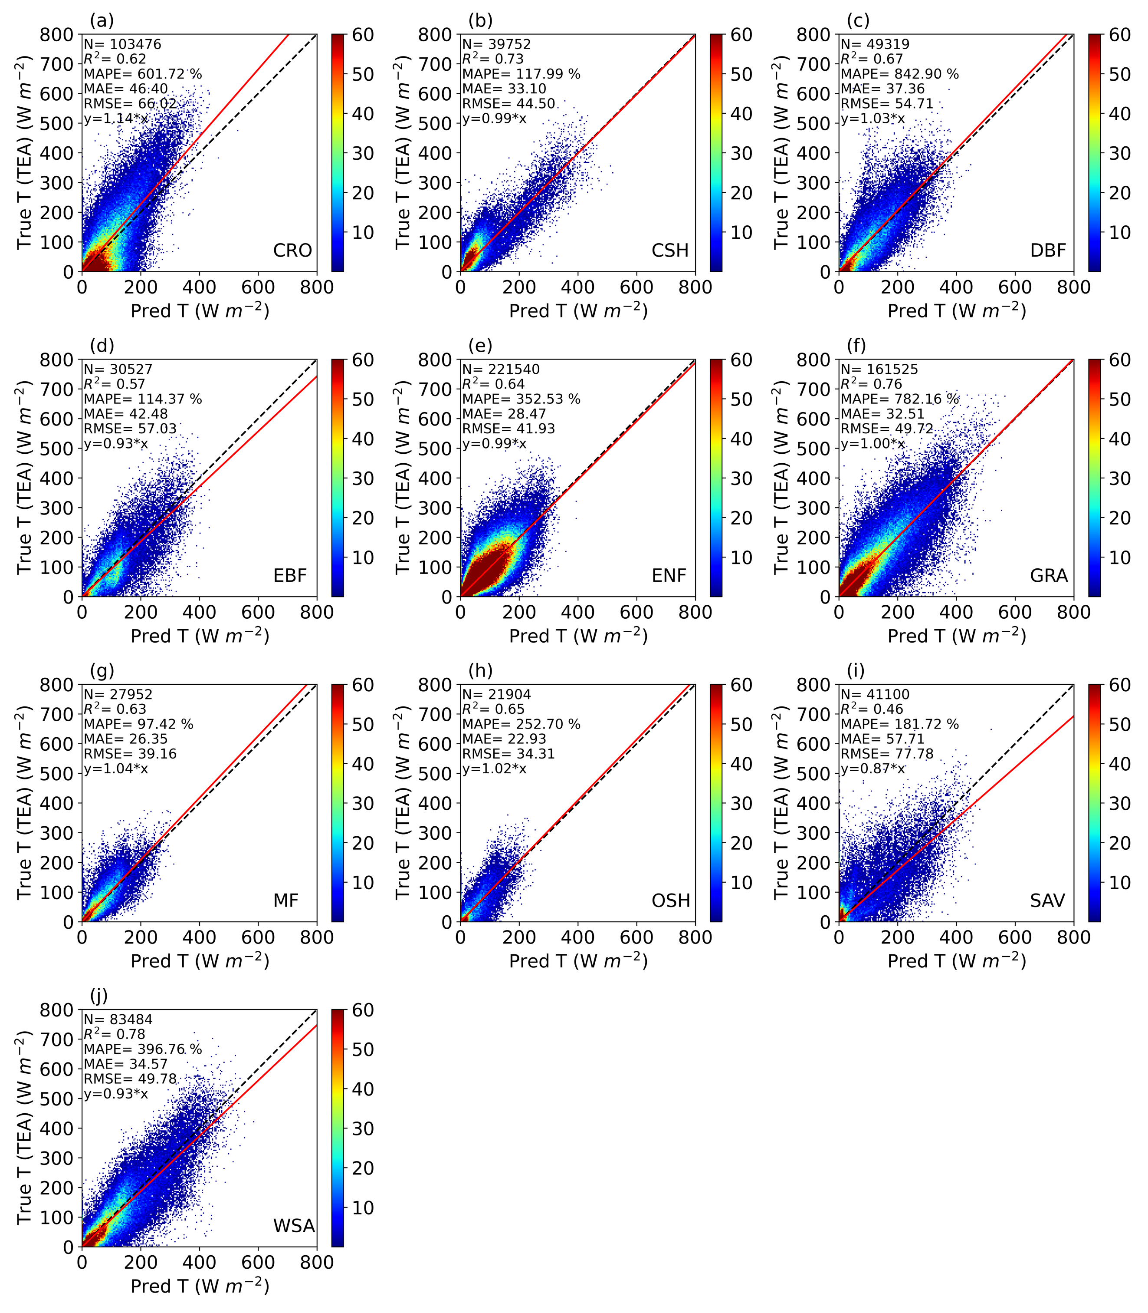

Fig. S20. Performance of the empirical model (EMP) for predicting plant transpiration (T) in different biomes for Configuration-2 (TEA). The diagonal black dashed line is a 1:1 line, and the red solid line is the nonbiased linear regression line. The shaded colors represent the density of scatter points. N, $R^{2}$, MAPE, MAE, and RMSE are the total number of scatter points in each panel, coefficient of determination, mean absolute percentage error, mean absolute error, and root-mean-square-error, respectively.

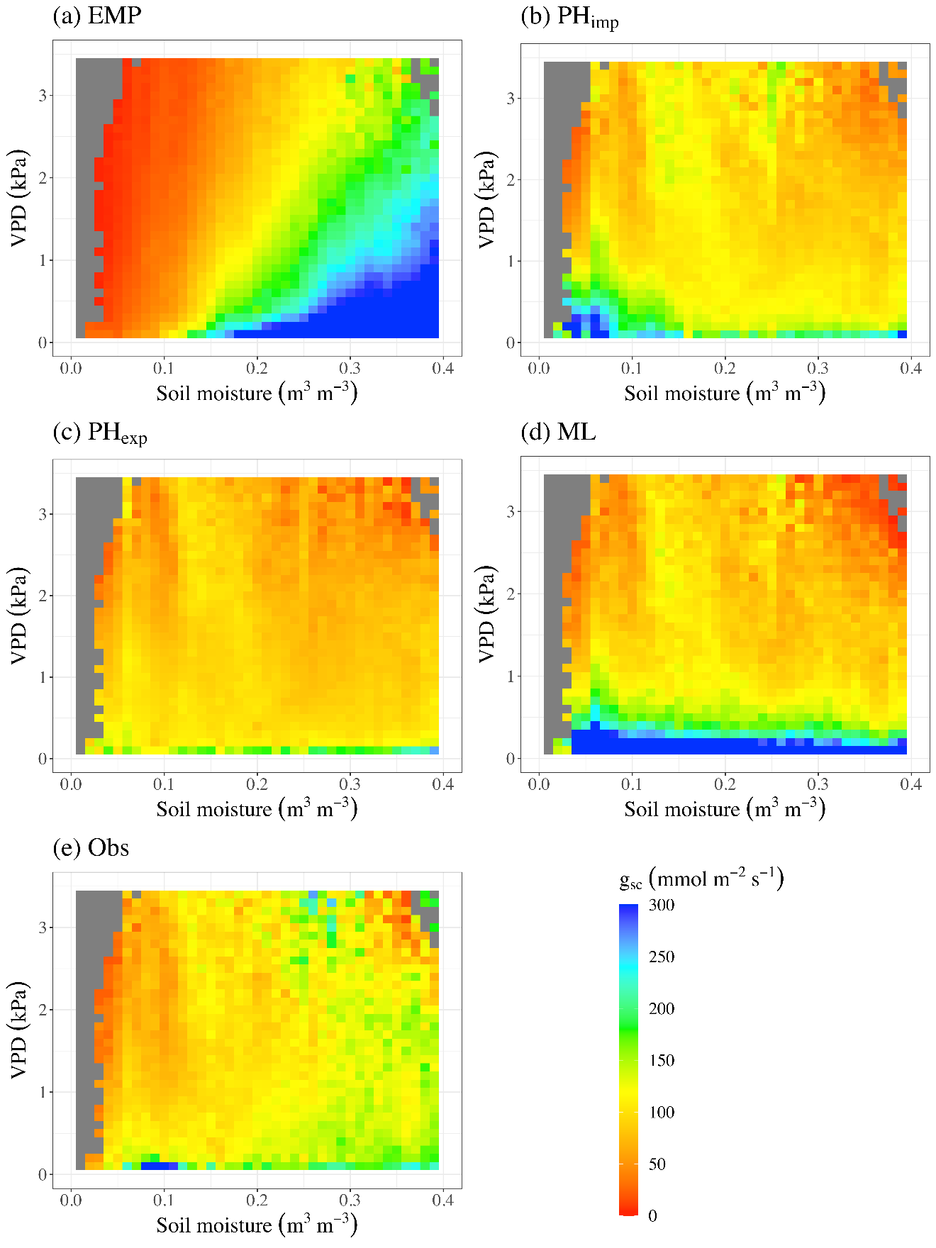
Fig. S21. Stomatal conductance ($g_{sc}$) co-regulated by VPD and soil moisture (SM). Co-regulation pattern for $g_{sc}$ obtained from the (a) empirical model (EMP), (b) implicit representation of plant hydraulics model (PH_{imp}), (c) explicit representation of plant hydraulics model (PH_{exp}), (d) pure machine learning model (ML), and (e) observations. Note that the results here are shown for the case when model calibration is performed against evapotranspiration (ET) only (i.e., Configuration-1).

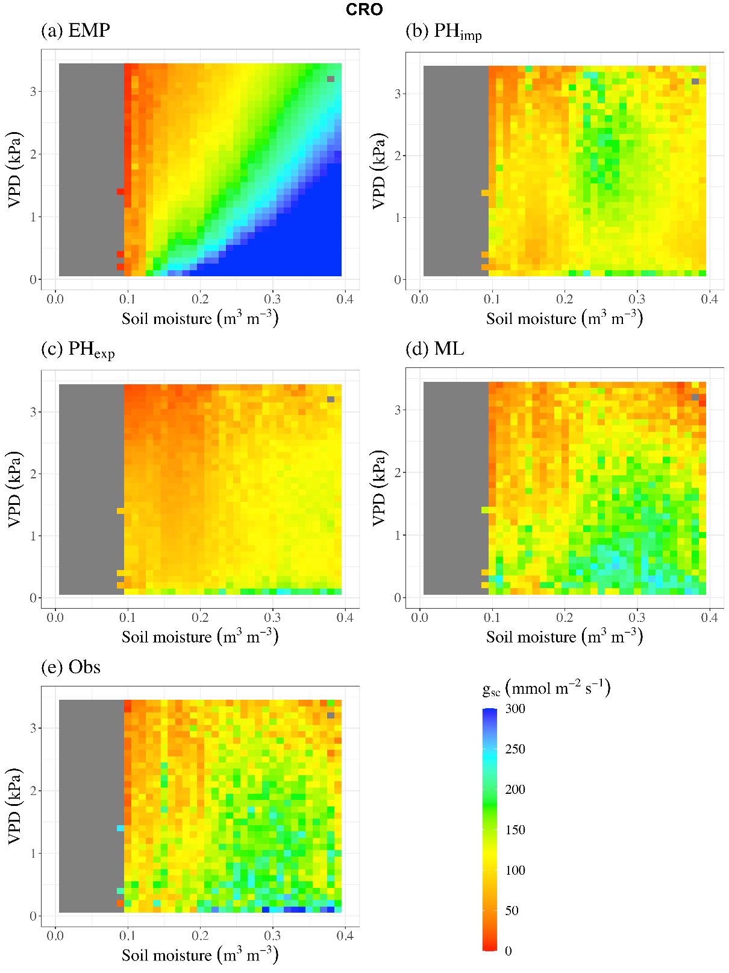
Fig. S22. Stomatal conductance ($g_{sc}$) co-regulated by VPD and soil moisture (SM) in Croplands (CRO) settings. Co-regulation pattern for $g_{sc}$ obtained from (a) empirical model (EMP), (b) implicit representation of plant hydraulics model (PH_{imp}), (c) explicit representation of plant hydraulics model (PH_{exp}), (d) pure machine learning model (ML), and (e) observations. Note that the results here are shown for the case when model calibration is performed against both evapotranspiration (ET) and TEA-obtained plant transpiration (T) (i.e., Configuration-2 with TEA).

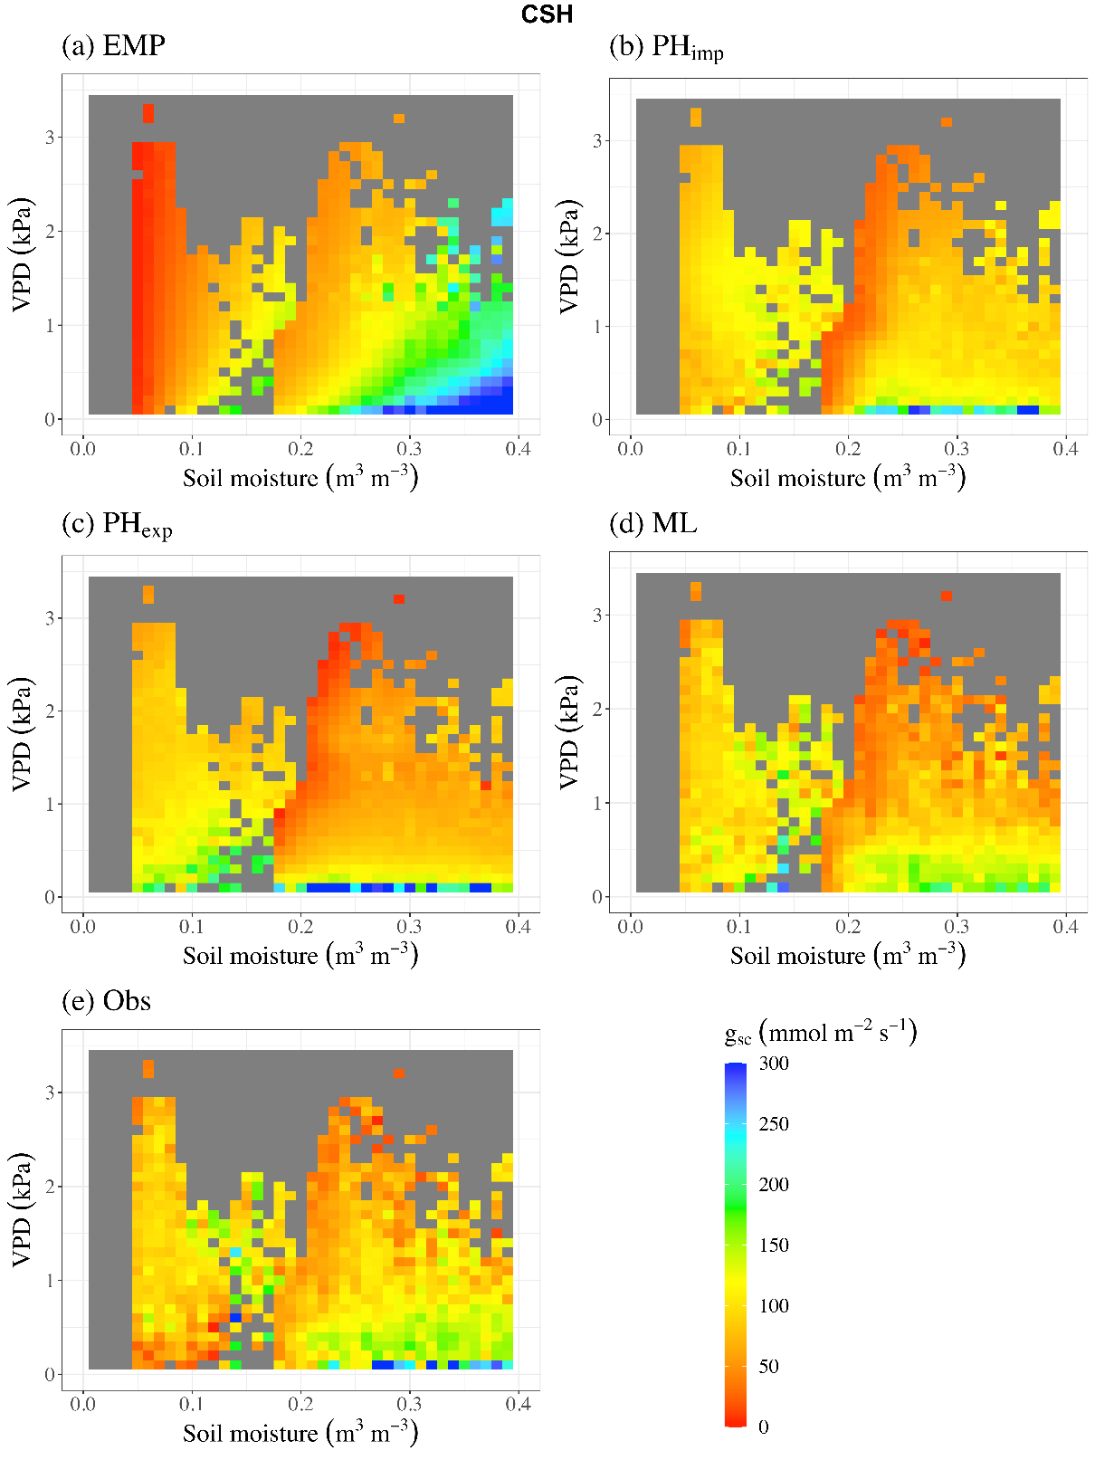
Fig. S23. Stomatal conductance ($g_{sc}$) co-regulated by VPD and soil moisture (SM) in Closed Shrublands (CSH) settings. Co-regulation pattern for $g_{sc}$ obtained from (a) empirical model (EMP), (b) implicit representation of plant hydraulics model (PH_{imp}), (c) explicit representation of plant hydraulics model (PH_{exp}), (d) pure machine learning model (ML), and (e) observations. Note that the results here are shown for the case when model calibration is performed against both evapotranspiration (ET) and TEA-obtained plant transpiration (T) (i.e., Configuration-2 with TEA).

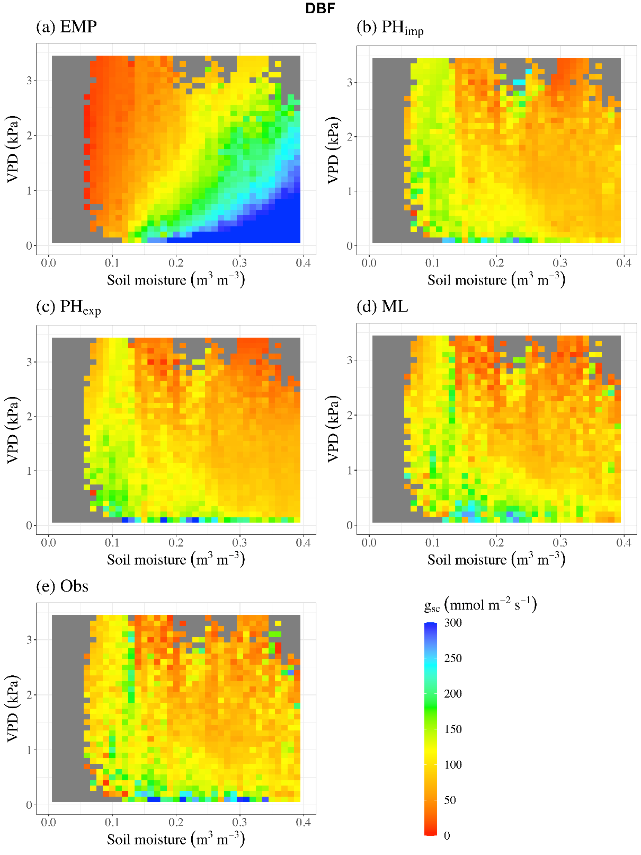
Fig. S24. Stomatal conductance ($g_{sc}$) co-regulated by VPD and soil moisture (SM) in Deciduous Broadleaf Forests (DBF) settings. Co-regulation pattern for $g_{sc}$ obtained from (a) empirical model (EMP), (b) implicit representation of plant hydraulics model (PH_{imp}), (c) explicit representation of plant hydraulics model (PH_{exp}), (d) pure machine learning model (ML), and (e) observations. Note that the results here are shown for the case when model calibration is performed against both evapotranspiration (ET) and TEA-obtained plant transpiration (T) (i.e., Configuration-2 with TEA).

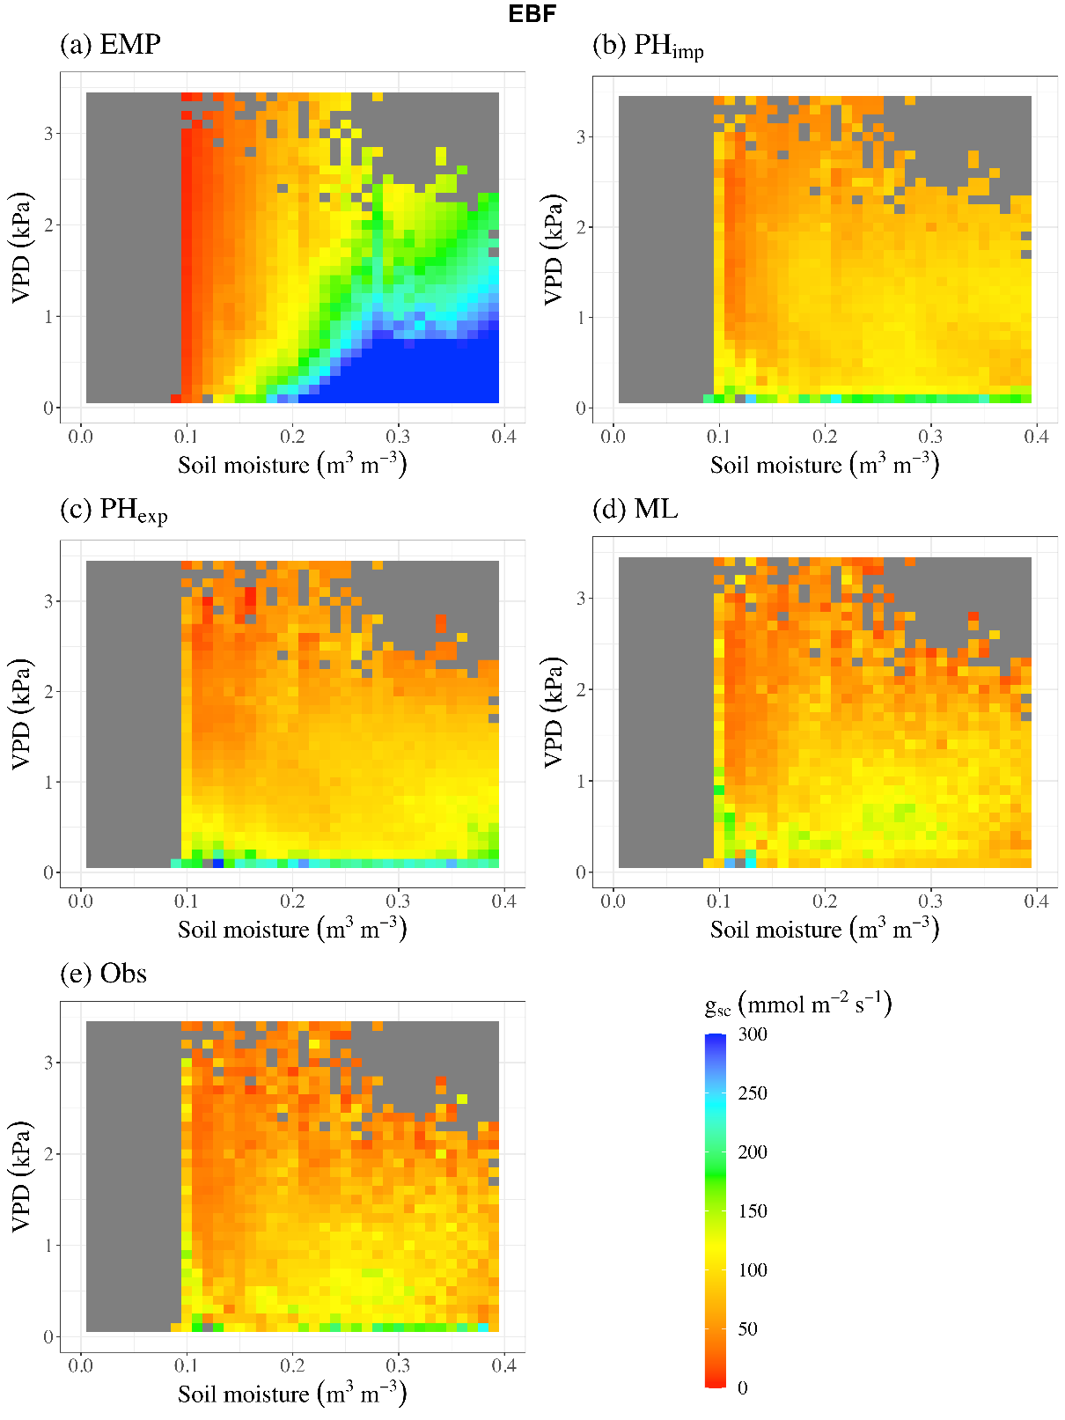
Fig. S25. Stomatal conductance ($g_{sc}$) co-regulated by VPD and soil moisture (SM) in Evergreen Broadleaf Forests (EBF) settings. Co-regulation pattern for $g_{sc}$ obtained from (a) empirical model (EMP), (b) implicit representation of plant hydraulics model (PH_{imp}), (c) explicit representation of plant hydraulics model (PH_{exp}), (d) pure machine learning model (ML), and (e) observations. Note that the results here are shown for the case when model calibration is performed against both evapotranspiration (ET) and TEA-obtained plant transpiration (T) (i.e., Configuration-2 with TEA).

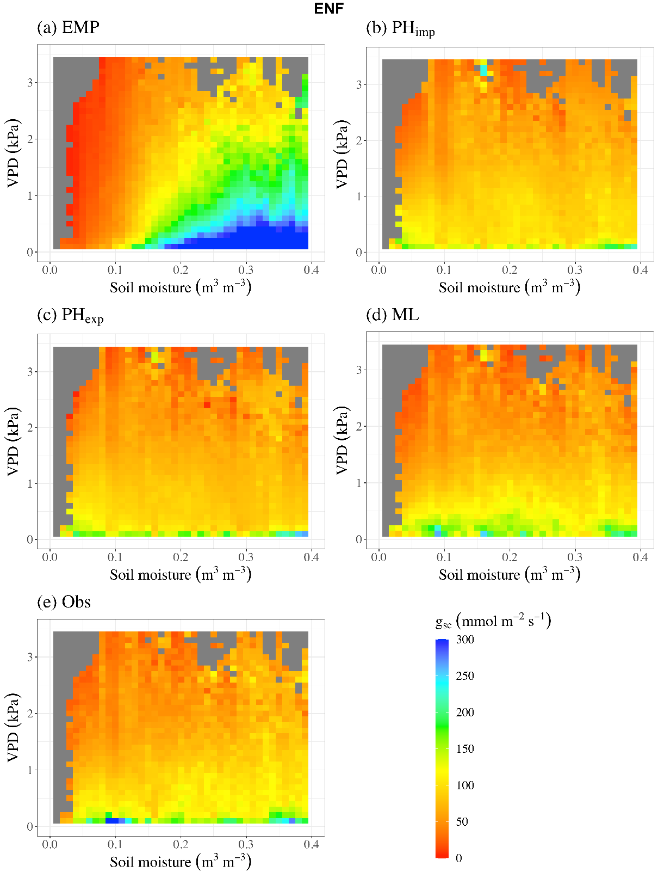
Fig. S26. Stomatal conductance ($g_{sc}$) co-regulated by VPD and soil moisture (SM) in Evergreen Needleleaf Forests (ENF) settings. Co-regulation pattern for $g_{sc}$ obtained from (a) empirical model (EMP), (b) implicit representation of plant hydraulics model (PH_{imp}), (c) explicit representation of plant hydraulics model (PH_{exp}), (d) pure machine learning model (ML), and (e) observations. Note that the results here are shown for the case when model calibration is performed against both evapotranspiration (ET) and TEA-obtained plant transpiration (T) (i.e., Configuration-2 with TEA).

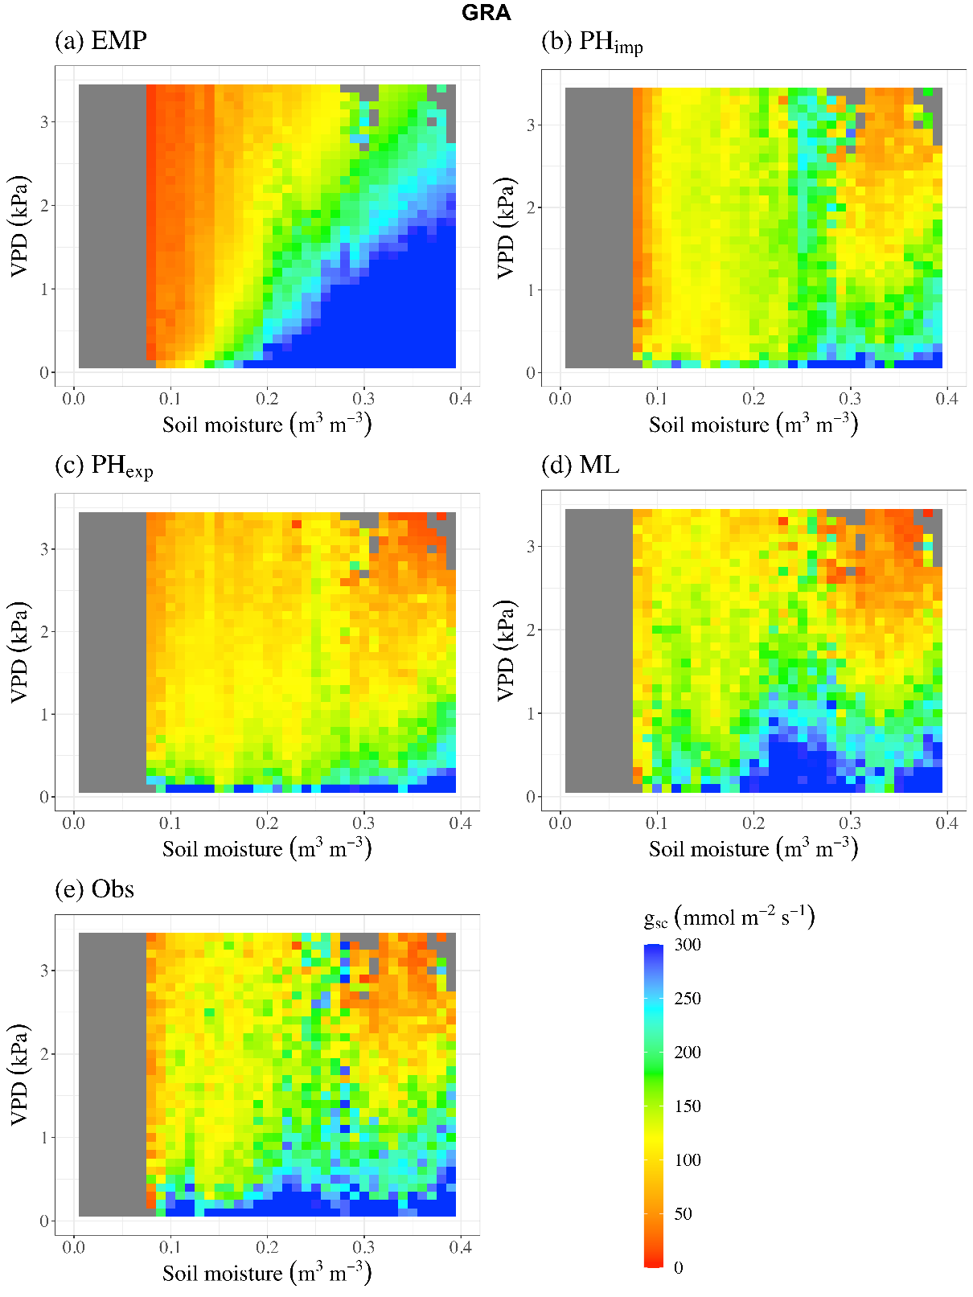
Fig. S27. Stomatal conductance ($g_{sc}$) co-regulated by VPD and soil moisture (SM) in Grasslands (GRA) settings. Co-regulation pattern for $g_{sc}$ obtained from (a) empirical model (EMP), (b) implicit representation of plant hydraulics model (PH_{imp}), (c) explicit representation of plant hydraulics model (PH_{exp}), (d) pure machine learning model (ML), and (e) observations. Note that the results here are shown for the case when model calibration is performed against both evapotranspiration (ET) and TEA-obtained plant transpiration (T) (i.e., Configuration-2 with TEA).

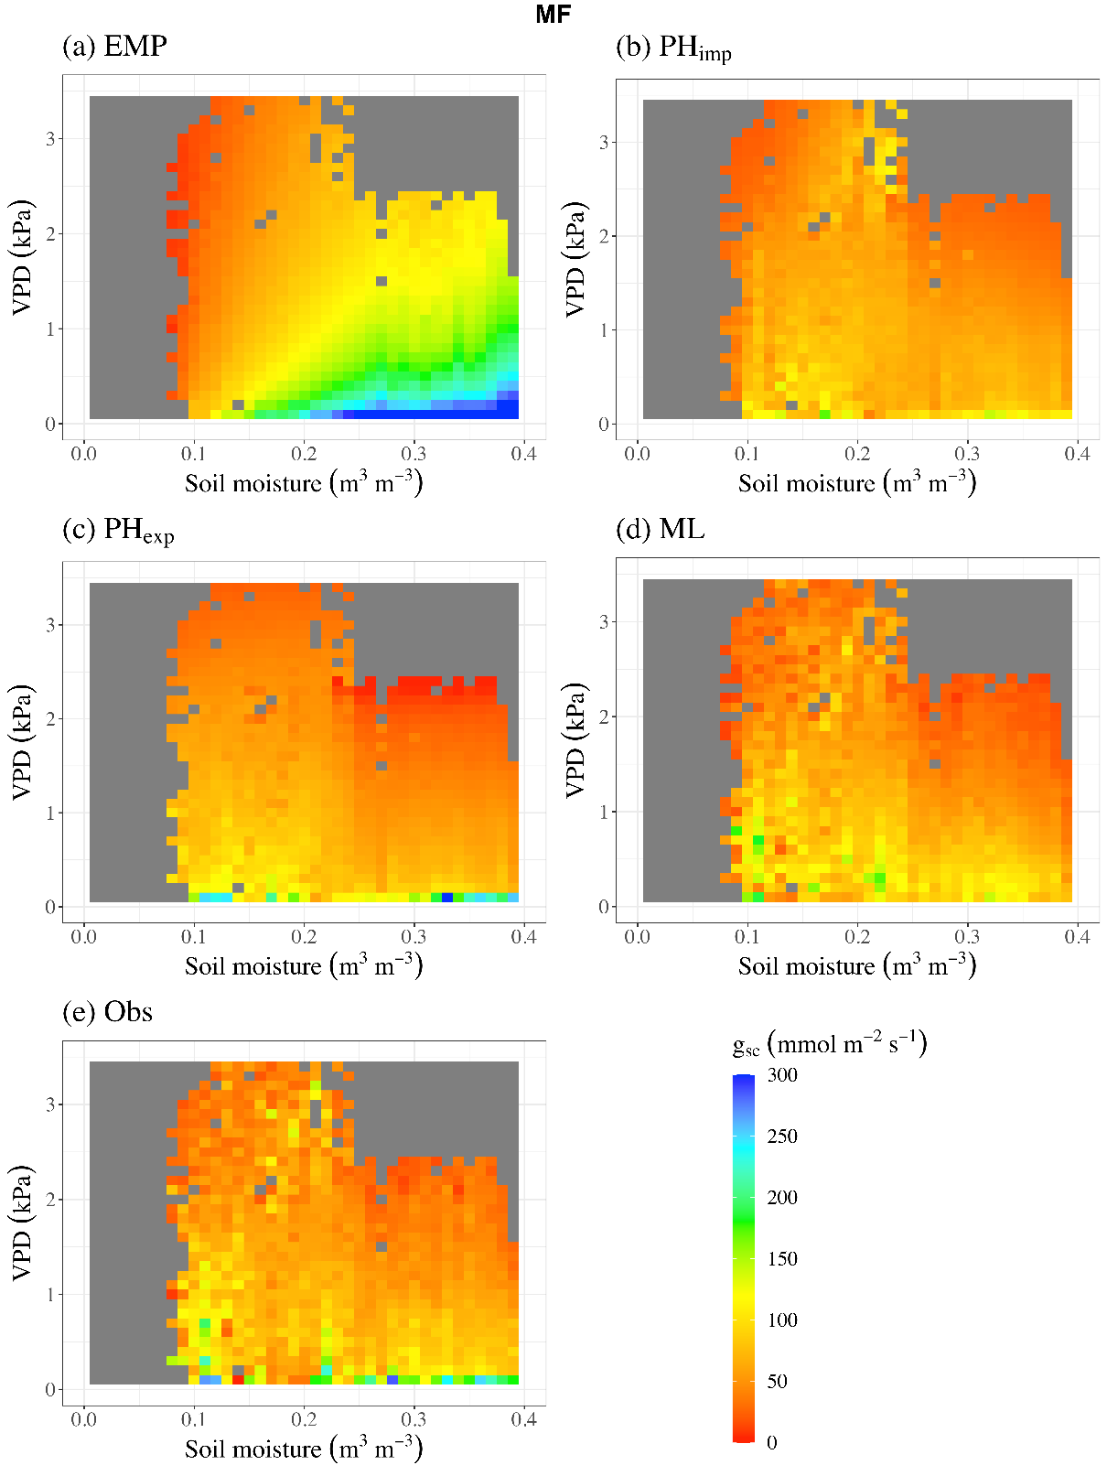
Fig. S28. Stomatal conductance ($g_{sc}$) co-regulated by VPD and soil moisture (SM) in Mixed Forests (MF) settings. Co-regulation pattern for $g_{sc}$ obtained from (a) empirical model (EMP), (b) implicit representation of plant hydraulics model (PH_{imp}), (c) explicit representation of plant hydraulics model (PH_{exp}), (d) pure machine learning model (ML), and (e) observations. Note that the results here are shown for the case when model calibration is performed against both evapotranspiration (ET) and TEA-obtained plant transpiration (T) (i.e., Configuration-2 with TEA).

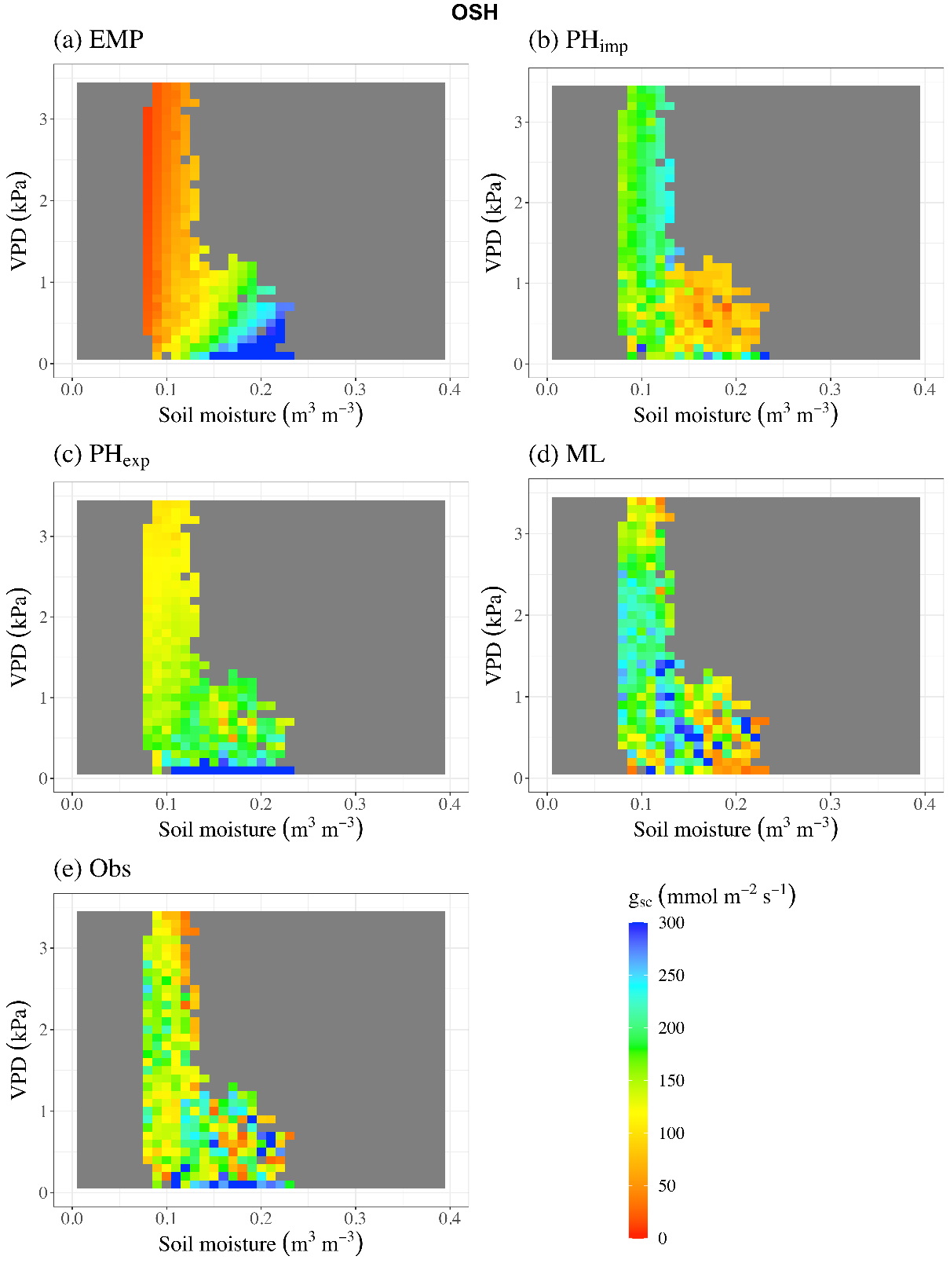
Fig. S29. Stomatal conductance ($g_{sc}$) co-regulated by VPD and soil moisture (SM) in Open Shrublands (OSH) settings. Co-regulation pattern for $g_{sc}$ obtained from (a) empirical model (EMP), (b) implicit representation of plant hydraulics model (PH_{imp}), (c) explicit representation of plant hydraulics model (PH_{exp}), (d) pure machine learning model (ML), and (e) observations. Note that the results here are shown for the case when model calibration is performed against both evapotranspiration (ET) and TEA-obtained plant transpiration (T) (i.e., Configuration-2 with TEA).

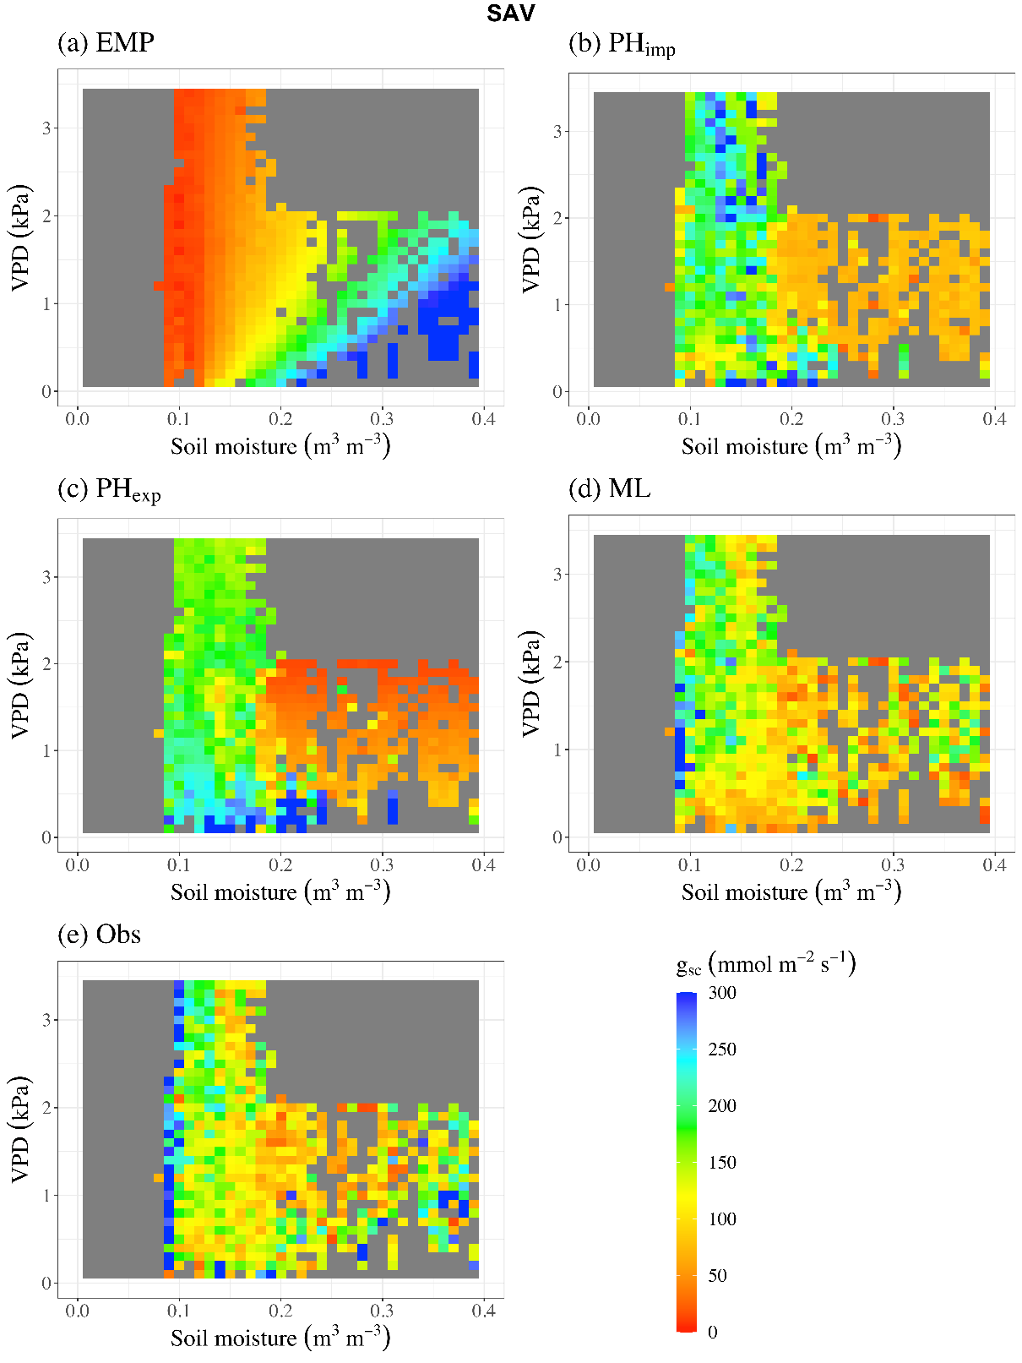
Fig. S30. Stomatal conductance ($g_{sc}$) co-regulated by VPD and soil moisture (SM) in Savannas (SAV) settings. Co-regulation pattern for $g_{sc}$ obtained from (a) empirical model (EMP), (b) implicit representation of plant hydraulics model (PH_{imp}), (c) explicit representation of plant hydraulics model (PH_{exp}), (d) pure machine learning model (ML), and (e) observations. Note that the results here are shown for the case when model calibration is performed against both evapotranspiration (ET) and TEA-obtained plant transpiration (T) (i.e., Configuration-2 with TEA).

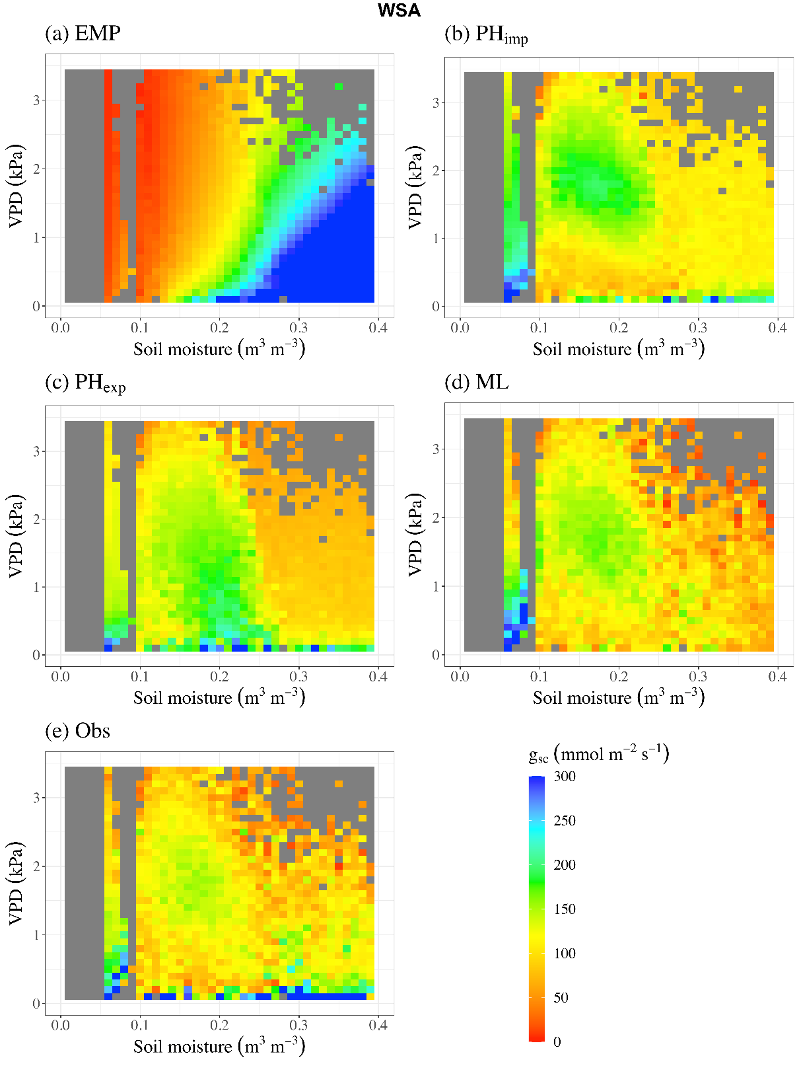
Fig. S31. Stomatal conductance ($g_{sc}$) co-regulated by VPD and soil moisture (SM) in Woody Savannas (WSA) settings. Co-regulation pattern for $g_{sc}$ obtained from (a) empirical model (EMP), (b) implicit representation of plant hydraulics model (PH_{imp}), (c) explicit representation of plant hydraulics model (PH_{exp}), (d) pure machine learning model (ML), and (e) observations. Note that the results here are shown for the case when model calibration is performed against both evapotranspiration (ET) and TEA-obtained plant transpiration (T) (i.e., Configuration-2 with TEA).

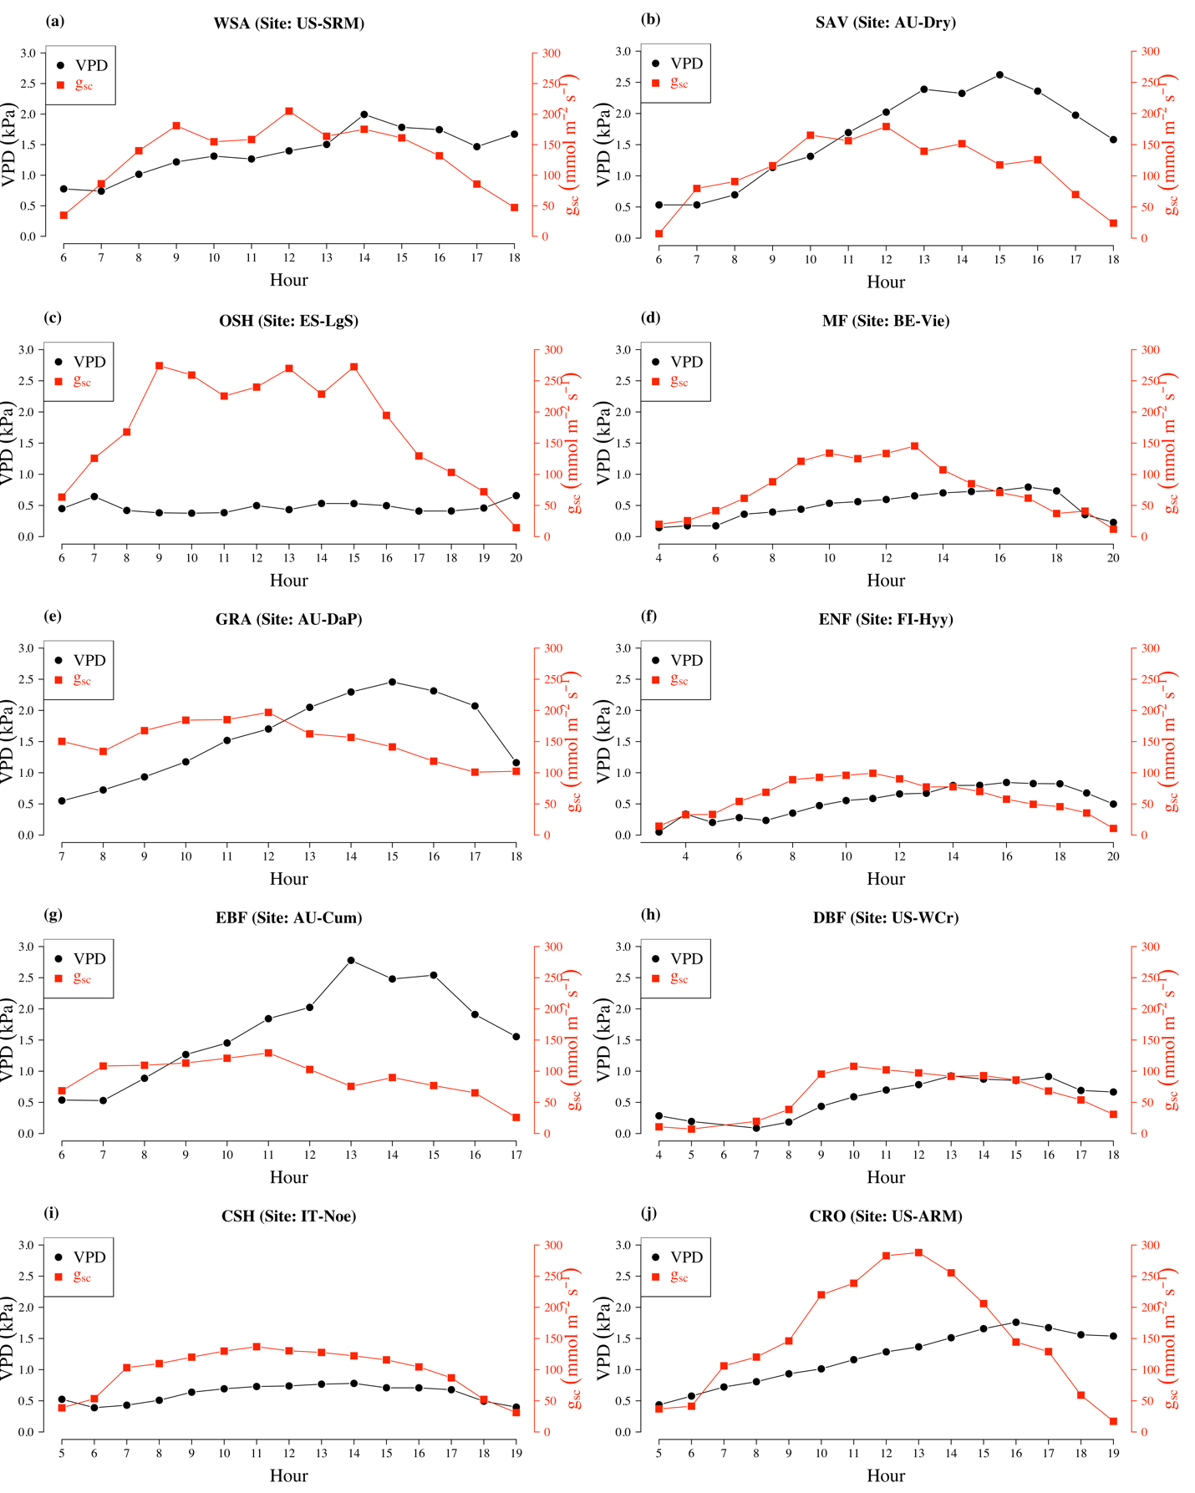
Fig. S32. Diurnal variation of stomatal conductance ($g_{sc}$) and vapor pressure deficit (VPD) across different biomes. Data in these plots are the mean diurnal values of $g_{sc}$ and VPD for the month of April in a given year at a site in particular biome. This illustrates the hysteresis between $g_{sc}$ and VPD.

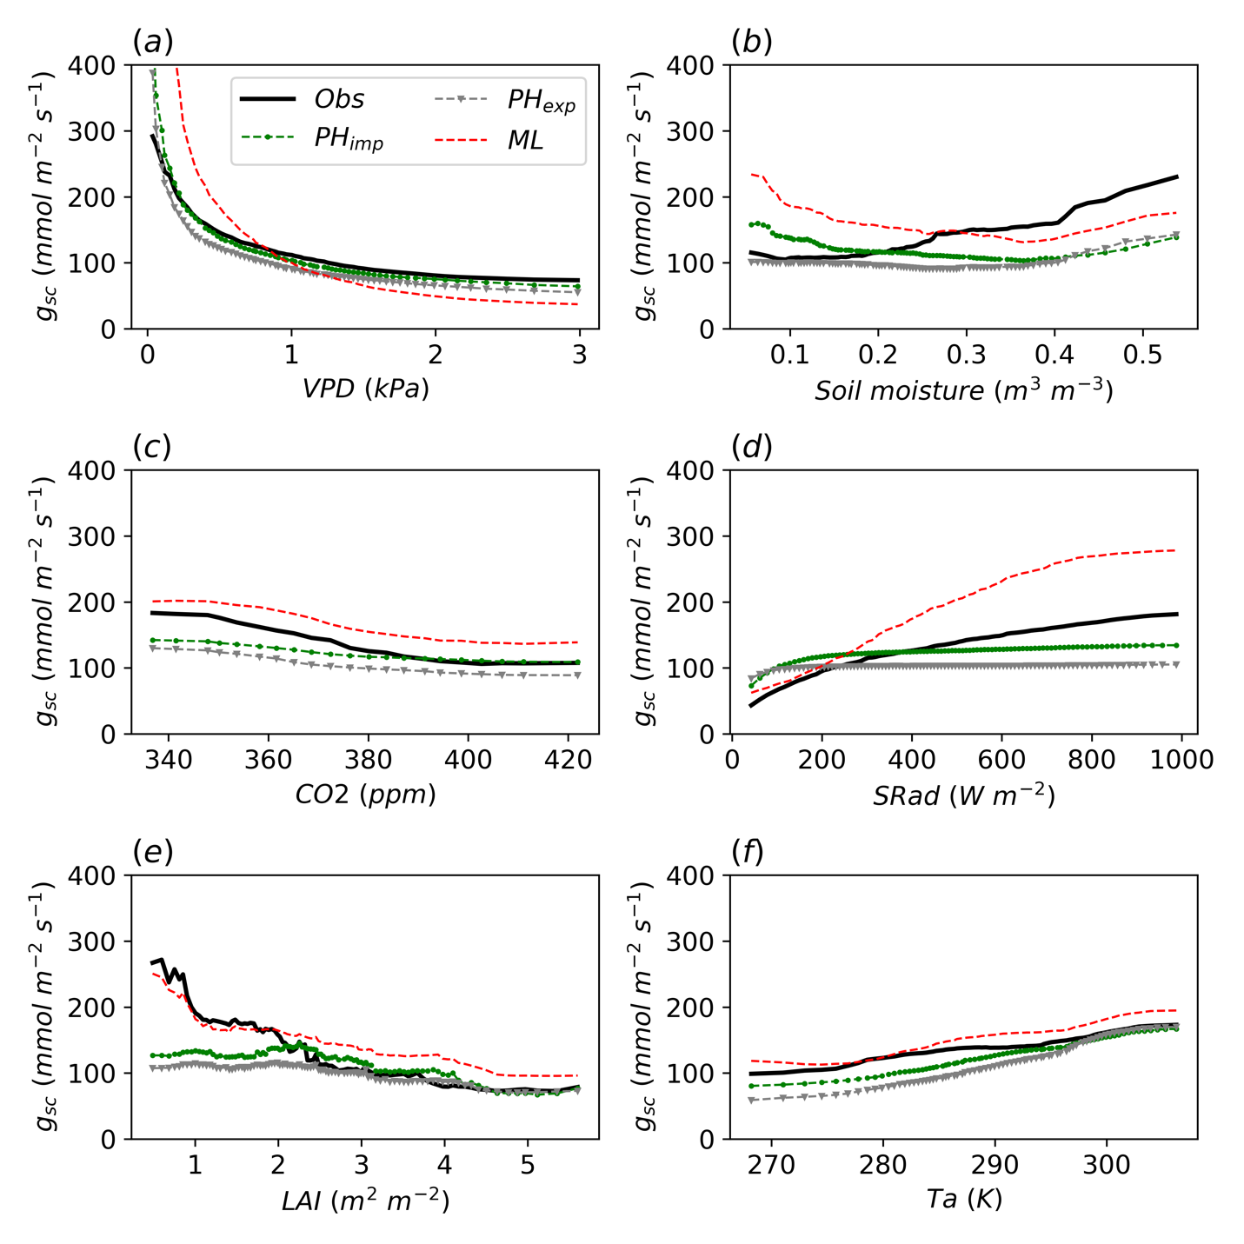
Fig. S33. Partial dependance plots: Stomatal conductance (𝑔𝑠𝑐) as a function of different variables including vapor pressure deficit (VPD), soil moisture (SM), atmospheric $CO_{2}$ concentration ($CO_{2}$), solar radiation (SRad), leaf area index (LAI), and air temperature ($T_{a}$) in the observations and different models for Configuration-1.

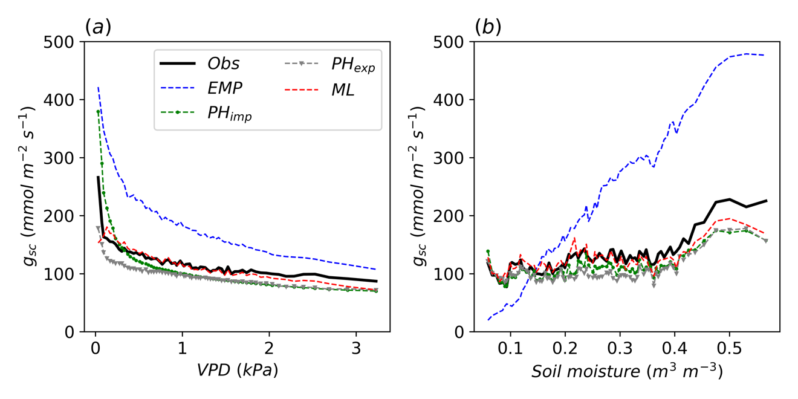
Fig. S34. Partial dependance plots: Stomatal conductance (𝑔𝑠𝑐) as a function of vapor pressure deficit (VPD) and soil moisture (SM) in the observations and different models for Configuration-2.

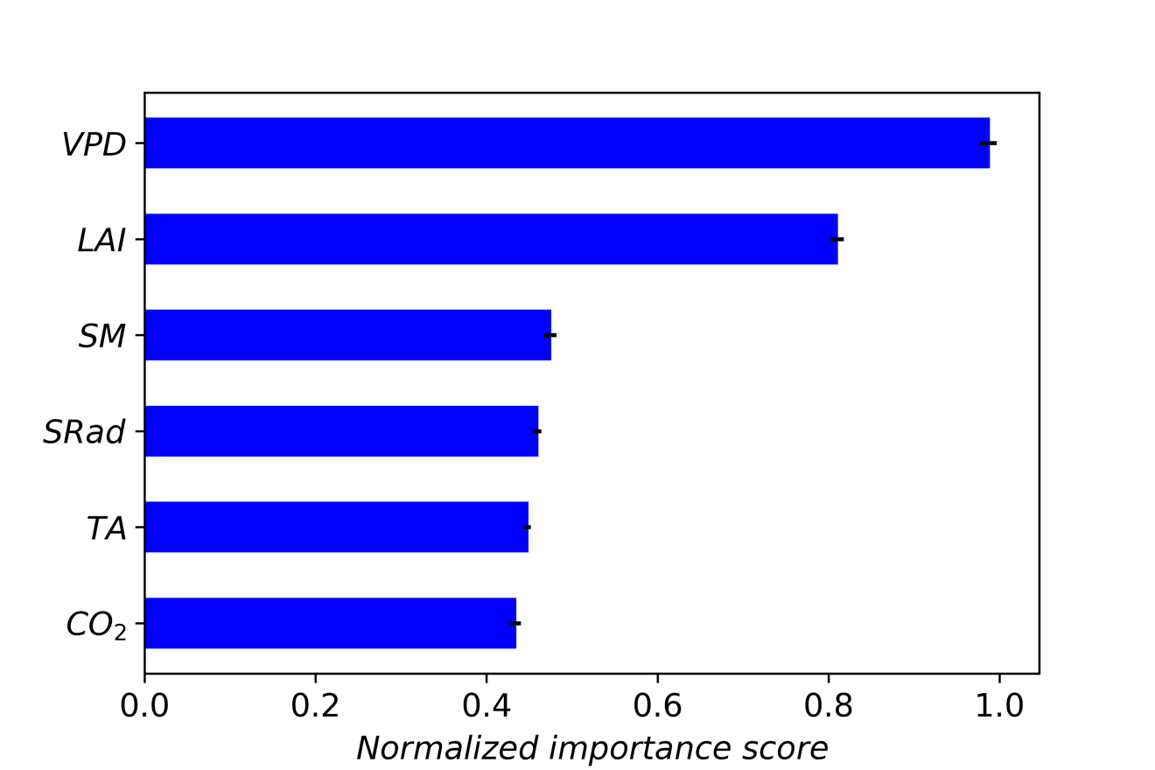
Fig. S35. Normalized variable importance for predicting observed $g_{sc}$. Variable importance of a variable is calculated based on the increase in prediction error when the concerned variable is randomly shuffled within the random forest regressor. Variable importance is calculated for n = 100 random reshuffles. The error bars represent the 95% confidence interval for the importance score. Considered variables include vapor pressure deficit (VPD), soil moisture (SM), solar radiation (SRad), atmospheric $CO_{2}$ concentration ($CO_{2}$), leaf area index (LAI), and air temperature ($T_{a}$). Data from all the sites are used.

References for Supporting Information
1 Ukkola, A. M., Abramowitz, G. & De Kauwe, M. G. A flux tower dataset tailored for land model evaluation. Earth System Science Data 14, 449-461 (2022).

