Supplementary material: Llamas (Llama glama) enhance novel proglacial ecosystem development: an experimental approach in the Cordillera Blanca, Peru.

Appendix 1: Method details

- Experimental design
The 8 plots were separated by a minimum of 6 m between each other to avoid strong effects of autocorrelation. We built fences sufficiently large to respect the well-being of the animals without impacting their movement and latrine and grazing behaviors. The fences were made with barbed wire and eucalyptus posts to prevent llamas from escaping the grazing plots, and the 4 corners of the control plots were delimited with wood posts. In addition, we included a buffer zone of 1 m inside the fences to avoid a hypothetical fence effect. The subplots — marked with wood posts buried at the 4 corners —were placed at a minimum distance of 3 m from each other to reduce spatial autocorrelation. A posteriori, we computed species accumulation curves for the 2019 and 2022 data to validate the adequacy of the 64 subplot surveys in representing the vascular richness of the overall experiment.
To avoid an identity effect of the llama within the plots, we established a monthly llama rotation between the fenced plots using a calendar set up with the local community. The llamas were tagged with a number to recognize them and distributed them within the grazed plots according to the calendar. During the 3 day stays of the llama in the plots, the farmers brought the llamas down to the valleys once a day to (1) ensure they had enough forage to complement their diet from the experiment and (2) replicate the natural Andean camelid travel between ranges ¹. After two months of experimentation, we observed that the presence of the farmers and the llamas at the location of the experiment attracted livestock (cattle and donkeys) from the downstream grazing areas to the experimental zone. Therefore, in August 2019, we built a protection fence downstream from the experiment to prevent the cattle and donkeys from entering the control plots and damaging the fences of the experiment.
- Field data collection
Floristic and geomorphic permanent subplot evaluations
We did not reiterate the floristic subplots evaluation in June 2020 due to the Covid pandemic and our inability to go to the field; instead, we surveyed the experimental plots in December 2020 (Table 1). Vascular plant density was measured as the percentage of foliar tissues within the overall volume of the species. Similarly, the relative necromass was estimated as the percentage of foliar tissues within the overall volume of the species. The average of each species was measured with a ruler as the vertical distance from the ground to the vegetative stem of the plant. We measured slope degree using a Suunto Tandem clinometer. We collected temperature data from the buried data logger once a year from June 2019 to June 2022.
Leaf sampling
Because of the shapes and size of the leaf, and their prompt curling after being collected, the measurement of the Specific Leaf Area (SLA) is challenging and may not be the appropriate parameter to reflect the differences in productivity and leaf structure of the different individuals ². Since LDMC, defines leaf construction costs and can be used instead of SLA we favored this trait measurement over SLA. The four species selected for the trait measurement displayed different growth forms (Tussock grass: Cinnagrostis rigida and Agrostis tolucensis, Shrub: Senecio sublutescens, and Subshrub: Pernettya prostrata).
Each leaf sample is a composite of a minimum of 3 individuals, summing to 15 to 40 leaves per sample depending on the species: approximately 5 leaves per individual were collected for the gender Senecio, Agrostis and Cinnagrostis because of their larger sizes, and 10 leaves per individual were collected in the cases of Pernettya. We sampled mature leaves from the middle part of the stem of adult individuals and avoided leaves with obvious symptoms of pathogen or herbivore attack. We stored the leaf material in Ziploc bags filled with a humid paper towel and kept them in a cooler until our arrival to the city of Huaraz. We kept the samples refrigerated overnight and transferred them the following morning to the Environmental Quality Laboratory of the Faculty of Environmental Sciences of the Santiago Antúnez de Mayolo National University (UNASAM) in Huaraz for analysis.
Soil sampling
For each sample, we collected 300-500 gr of material for laboratory analysis. The samples gathered in June 2022 from the llama plots were sampled below or next to latrines (when possible) at a minimal distance of 1 m from the latrine. The 2022 samples were air-dried in the city of Huaraz, sieved at 2mm, and sent to the Soil and Geoarchaeology Laboratory of the University of Texas at Austin for further analysis, whereas the samples collected in 2019 were oven dried at 100°C in Huaraz before being sent to our laboratory.
Feces sampling
We sampled the feces from the llama latrine removing the very top layer of the dung to avoid the collection of moss or other external organic material. We sampled in the upper, medium, and lower part of the plots to detect a leaching effect from water run-off and therefore explain potential distinct responses of soil composition and plant development to the presence of llamas. For each sample, we collected approximately 800g of material in a Ziploc bag. After homogenization of the sample in the bag, we subsampled approximately half of it for nutrient analysis and a half for the analysis of the presence and viability of seeds. The feces samples for nutrient analysis were stored in the same manner as the leaf material and transferred to the Environmental Quality Laboratory in Huaraz the following morning. The samples for the seeds analysis were transferred the same day to the Herbarium of the Museum of Natural History of the National University of San Marcos in Lima for further analysis.
Table A1 gives an overview of the datasets collected in the field and measured in the laboratory between 2019 and 2022.

Table A1: Characteristics of datasets and dependent and independent variables.
Variable | Datatype | Unit | Support (n) | Source
Plant cover | Quantitative, continuous | % | Subplots (64) | Field floristic surveys
Vascular plant species | Nominal | - | Subplots (64) | Field floristic surveys
Plant height | Quantitative, continuous | cm | Subplots (64) | Field floristic surveys
Plant necromass | Quantitative, continuous | % | Subplots (64) | Field floristic surveys
Fertility | Binary | - | Subplots (64) | Field floristic surveys
BSC cover | Quantitative, continuous | % | Subplots (64) | Field floristic surveys
Pasture eaten | Binary | - | Subplots (64) | Field floristic surveys
Greenery index | Ordinal | - | Subplots (64) | Field floristic surveys
Leaf Dry Matter Content (LDMC) | Quantitative, continuous | ratio | Plot | Laboratory Analysis
Leaf Total Nitrogen (PN) | Quantitative, continuous | mg/Kg | Plot | Laboratory Analysis
Leaf Total Phosphorus (PP) | Quantitative, continuous | mg/Kg | Plot | Laboratory Analysis
Seed species | Nominal | - | Llama plot (3x4) | Laboratory analysis
Number of seed | Quantitative, discrete | - | Llama plot (3x4) | Laboratory analysis
Seed viability | Binary | - | Llama plot (3x4) | Laboratory analysis
Vegetation Index | Quantitative, continuous | - | Subplots (64) | Image Analysis
Soil pH | Quantitative, continuous | - | Plot (3x8) | Soil laboratory analysis
Clay, Silt, Sand contents | Quantitative, continuous | % | Plot (3x8) | Soil laboratory analysis
Soil organic carbon (SOC) | Quantitative, continuous | % | Plot (3x8) | Soil laboratory analysis
Soil inorganic carbon (IC) | Quantitative, continuous | % | Plot (3x8) | Soil laboratory analysis
Soil total nitrogen (TN) | Quantitative, continuous | % | Plot (3x8) | Soil laboratory analysis
Slope | Quantitative, continuous | % | Subplots (64) | Field geomorphic surveys
Sand, Gravel, Rock, Block content | Quantitative, continuous | % | Subplots (64) | Field geomorphic surveys
Geomorphic activity | Binary | - | Subplots (64) | Field geomorphic surveys
Soil temperature | Quantitative, continuous | [deg] | Plot (2x8) | Field sensors

- Laboratory analysis
Soil analysis - Loss of Ignition
We determined soil pH on the dried fine (<2mm) earth samples using a pH probe and a soil: solution ratio of 1:2 using approximately 15g of sample. For soil carbon analysis, first, we estimated SOC, and carbonate mineral content using the LOI method ³. The subsamples were first dried at 105°C for 24 hours in a ventilated oven and then ignited at 550°C for 4 hours in a muffle furnace (Cole-Parmer StableTemp Muffle Furnace). We estimated SOC using the conventional equation (SOC (mg/kg) = LOI₅₅₀ (mg/kg) *0.58). We recognize that converting LOI data by multiplication with the conventional conversion factor 0.58 can overestimate the SOC stock ⁴ for soil with high clay content (50 g clay 100g⁻¹) or underestimate the SOC stock for soil with a small clay content (10 g 100 g−1). In our case, most samples were sandy clay loam or sandy loam with a clay content between 10 and 30%. Therefore, we consider the conventional conversion factor a good estimate for our work. Finally, the samples were heated at 1000°C for 2 hours to remove carbonates. Calculation of the inorganic carbon (IC) assumes that ignition follows a stoichiometric relationship ³, and that the amount of carbonate is 1.36 × LOI₁₀₀₀ ³. This implies that IC = 0.273 × LOI₁₀₀₀. For the Elemental analyzer method, we used a Thermo MAT253 isotope ratio mass spectrometer of the Jackson School of Geosciences, UT Austin, TX, USA, and use soil samples sieved at 250 µm and free of carbonates. Finally, N was measured using an elemental analyzer CHNS-O (ECS 8020 Model, Costech Analytical Technology, INC) at our Soils and Geoarchaeology Laboratory.
Clay deflocculation and Particle Size Analysis
Particle Size analysis was on unmilled, sieved (< 2 mm) material (3 to 4.5gr) using a Fritsch Analysette 22 at the Laboratory for Environmental Archaeology of UT Austin. Before particle size analysis, the samples were shaken for 24 h with 5% sodium hexametaphosphate to deflocculate the clays. Before adding the material to the sample bath, we used a splitter to help gather the reliable representative samples needed to yield accurate particle size analysis.
Leaf and feces samples analysis
Leaf total Nitrogen and Phosphorus were determined respectively using Kjeldahl digestion and Molybdovanadate acid digestion. The fresh leaf samples were weighed upon arrival at the laboratory and then dried for 60min at 105 °C and then weighed again. Dry weight was measured to compute LDMC (ratio of leaf dry mass to leaf saturated mass). The total carbon of the llama feces was measured using disintegration with sulfuric acid and peroxodisulfate and photometric method. Since we collected our samples only within the latrines, we consider that the total carbon concentration measured corresponds to the Total Organic Carbon (TOC) concentration within the latrines, and therefore is comparable to our measures of SOC on the soil samples.
Seed viability
For the analysis of presence and viability of seeds, first the samples were oven-dried at 23 C° for 3 days ^{5,6}. We analyzed only fecal pellets to be sure to study seeds ingested by llamas. The final latrine pellet samples analyzed weighed between 6.5 and 15g. We identified the seed species with botanical specialist support and using a list of the plant species present in the studied area (Table S2: Supplementary material), and seed reference collections (Seed Bank of the Plant Physiology Laboratory of the UNMSM). Then, we apply the Tetrazolium test to test the viability of the seed following França-Neto & Krzyzanowski ⁷. Part of the pericarp was removed from all seeds and submerged in distilled water for 24 hours and later for 24 hours in a 1% 2,3,5-triphenyl-2H-tetrazolium solution. After this treatment, seeds were then classified as (1) viable, when embryos were totally dyed, and (2) not viable, when embryos were partially dyed or not dyed.
- Data analysis
We employed restricted maximum likelihood estimation (REML) to fit the linear mixed models because of our small sample size ⁸. We used random intercept models with “Block” as a random factor. Since the soil nitrogen data from 2019 and 2022 are not comparable because of different drying methods, we did not run the full 3-years model on soil nitrogen. To facilitate the visualization of the results, the estimated marginal means and confidence intervals were back transformed (Figure 4).
The 16 data loggers registered soil temperature data every 4 hours from 23.06.2019 to 09.06.2022. However, due to the Covid pandemic and our inability to go to the field in June 2020 to replace their batteries, some of the sensors stopped registering temperature and several data gaps were present between 22.05.2021 and 09.06.2022. Therefore, for our analysis we used the period from 23.06.2019 to 22.05.2021. Since the upper logger of the control plot number 4 was lost between May 2019 and June 2021 resulting in incomplete data for the period studied, we computed the same Wilcoxon test including only 3 of the 4 control plots. We found the same result and therefore did not report them.

Appendix 2: Supplementary figures and tables

Figure S1. Soil particle size distribution – the percentage of clay, silt, and sand – of the controls (dark magenta points) and llama (dark orange points) soil samples collected in (A) 2019 (triangles) and (B) 2022 (full circles). The abbreviated names of the USDA texture class polygons correspond to sand (Sa), loamy sand (LoSa), sandy loam (SaLo), loam (Lo), sandy clay loam (SaClLo), sandy clay (SaCl), clay loam (ClLo), silty loam (SiLo), silty clay loam (SiClLo), silty clay (SiCl), silt (Si) and clay (Cl).

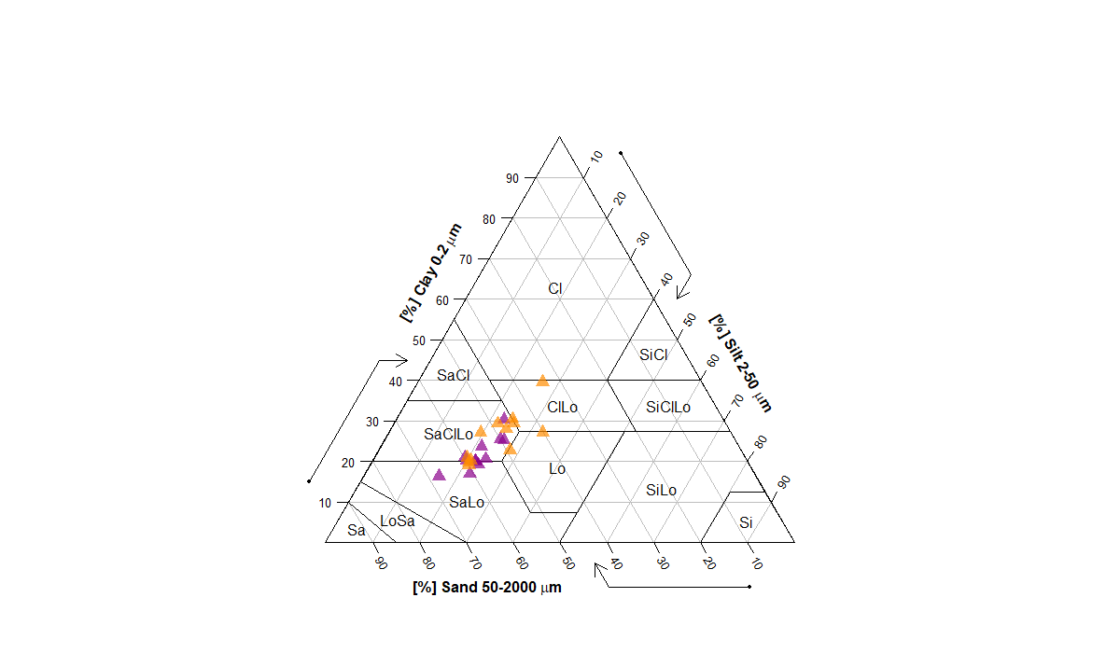
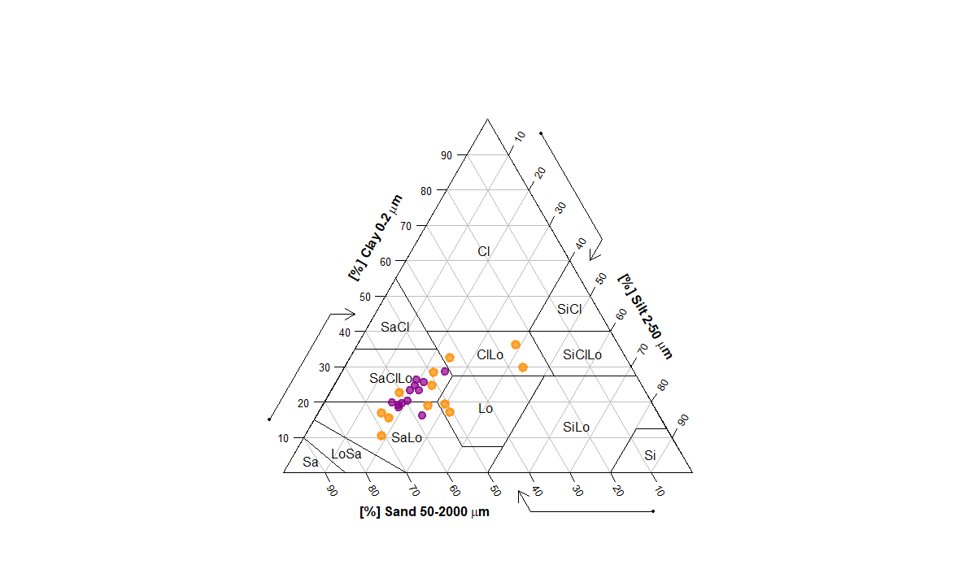
A
B

Table S1 – List of species found at the Uruashraju glacier foreland (from the position of the glacier forefront in 2019 to the Little Ice Age glacial extension; Zimmer et al., unpublished)
Species | Age groups: | 0-14 yrs | 14-31yrs | 31-57yrs | 57-77yrs | LIA
Achyrocline alata |  |  |  |  | x | x
Agrostis tolucensis |  | x | x | x | x
Alchemilla pinnata |  |  |  |  | x | x
Baccharis caespitosa |  |  |  |  | x | x
Bartsia diffusa |  |  |  |  | x
Belloa piptolepis |  |  |  |  | x
Calamagrostis brevifolia |  |  |  |  |  | x
Calamagrostis coronalis |  | x | x | x | x
Calamagrostis ovata |  | x |  | x
Calamagrostis recta |  |  |  |  |  | x
Calamagrostis rigida |  | x | x | x | x
Calamagrostis vicunarum |  |  |  |  |  | x
Chaerophyllum andicola |  |  |  |  |  | x
Chersodoma ovopedata |  |  |  | x | x
Distichia muscoides |  |  |  |  |  | x
Elaphoglossum sp. |  |  |  |  |  | x
Epilobium nivale |  |  |  |  |  | x
Gentiana thyrsoidea |  |  |  |  |  | x
Gentianella thyrsoidea |  |  |  |  | x
Hieracium sp |  |  |  |  |  | x
Lobelia oligophylla |  |  |  |  |  | x
Loricaria ferruginea |  |  |  | x | x
Lucilia conoidea |  | x |  | x | x
Lucilia kunthiana |  |  |  | x | x | x
Lupinus aff. microphyllus |  |  |  |  |  | x
Lupinus sp. |  |  |  |  |  | x
Luzula racemosa |  |  |  |  | x | x
Melpomene peruviana |  |  | x | x | x | x
Mniodes longifolia |  |  |  |  | x | x
Muehlenbeckia volcanica |  |  |  | x | x | x
Muhlenbergia peruviana |  |  |  |  |  | x
Oritrophium limnophilum |  |  |  |  |  | x
Pernettya prostrata |  | x | x | x | x | x
Phlegmariurus crassus |  |  |  | x | x
Plantago lamprophylla |  |  |  |  |  | x
Plantago tubulosa |  |  |  |  |  | x
Polystichum orbiculatum |  |  | x |  | x
Ribes cuneifolium |  |  |  |  |  | x
Senecio macrorrhizus |  |  |  |  | x | x
Senecio rufescens |  |  |  |  | x
Senecio sublutescens |  | x | x | x | x | x
Senecio sulinicus |  |  |  |  | x
Trichophorum rigidum |  |  |  |  |  | x
Werneria nubigena |  |  |  | x |  | x
Werneria pygmaea |  |  |  |  |  | x
Werneria villosa |  |  |  |  |  | x

Table S2 – List of species found within the experiment, Control and Llamas mean presence or absence within the plots for the year presented. Total cover corresponds to the total cover of each species over the overall experiment. Dispersal Mode: anemochory (A), Endozoochory (EZ).
Nombre | Autor | Family | Growth form | Dispersal mode | Habitat | Control 2019 | Control 2022 | Llamas 2019 | Llamas 2022 | Total cover (%) | Cover llama plots (%) | Palatability for Andean camelid
Agrostis tolucensis | Kunth | Poaceae | Tussock grass | A | Disturbed areas, grasslands | yes | yes | yes | yes | 4.43 | 2.58 | Yes ⁹
Belloa piptolepis | (Wedd.) Cabrera | Asteraceae | Herb | A | Grasslands, shrublands | no | no | no | yes | 0.05 | 0.11
Cinnagrostis ovata |  | Poaceae | Tussock grass | A | Grasslands, riversides, swamps | yes | yes | yes | no | 0.5 | 0.24 | Yes - field obs.
Cinnagrostis rigida | (Kunth) P.M. Peterson, Soreng, Romasch. & Barberá | Poaceae | Tussock grass | A | Grassland | yes | yes | yes | yes | 50.6 | 45.2 | Yes - field ob.
Cinnagrostis vicunarum | (Wedd.) P.M. Peterson, Soreng, Romasch. & Barberá | Poaceae | Tussock grass | A | Grasslands, rocky slopes | no | yes | no | yes | 0.12 | 0.04 | Yes ^{9,10}
Gnaphalium polium | Wedd. | Asteraceae | Rosette | A | Grasslands, shrublands | no | no | yes | yes | 0.46 | 0.97
Luzula racemosa | Desv. | Cyperaceae | Tussock grass | A | Grasslands, rocky slopes | no | yes | no | yes | 0.03 | 0.04 | No ¹¹
Melpomene peruviana | (Desv.) A.R. Sm. & R.C. Moran | Polypodiaceae | Herb | - | Zone protected by | yes | yes | no | no | 0.12 | 0
 |  |  |  |  | boulders
Mniodes kunthiana | (DC.) S.E. Freire, Chemisquy, Anderb. & Urtubey | Asteraceae | Rosette | A | Grasslands, shrublands | yes | yes | yes | yes | 18.3 | 12.9
Oritrophium limnophilum | (Sch. Bip.) Cuatrec. | Asteraceae | Acaulescent rosette | A | n.d | no | no | no | yes | 0.11 | 0.24
Pernettya prostrata | (Cav.) DC. | Ericaceae | Subshrub | EZ | Disturbed areas, forests, grasslands, rocky slopes | yes | yes | yes | yes | 2.51 | 1.36 | Yes - field obs.
Senecio rufescens | DC. | Asteraceae | Erect shrub | A | Rocky subnival puna | no | no | no | yes | 0.05 | 0.1 | Yes - field obs.
Senecio sublutescens | Cuatrec. | Asteraceae | Herb | A | Rocky subnival puna | yes | yes | yes | yes | 22.7 | 36.2
Sp. |  | Asteraceae | Herb |  |  | no | no | no | yes | 0.03 | 0.06

Table S3. Summary statistics for the environmental characteristic of the llama and control plots. The daily temperature minimum and maximum correspond respectively to the minimum of the daily minimum and the maximum of the daily maximum.
 | Control | Llama | p.value | p.signif
Slope | 23.81 (11.51) | 26.03 (12.96) | 0.44 | ns
Granulometry
Sand | 18.91 (18.15) | 31.89 (28.74) | 0.078 | ns
Gravel | 16.09 (11.57) | 15.52 (13.67) | 0.59 | ns
Rock | 35.71 (20.23) | 31.13 (22.15) | 0.37 | ns
Block | 10.14 (11.35) | 6.41 (7.57) | 0.3 | ns
Daily temp
mean | 7.65 (2.09) | 7.67 (2.21) | 0.96 | ns
min | 0.01 (1.28) | -0.44 (1.23) | 3.80E-10 | ***
max | 29.55 (4.79) | 33.43 (5.9) | 0.001 | ***

Table S4. Summary statistics for Clay, Silt and Sand contents, pH, IC by LOI, SOC by LOI and EA methos, and δ13C in control and llama plots, in 2019 and 2022.
 | 2019 |  | 2022 |  |  |  | 2019 |  | 2022
 | Control | Llama | Control | Llama |  |  | Control | Llama | Control | Llama
Clay (%) |  |  |  |  |  | SOC by LOI (%)
Max | 30.39 | 39.54 | 28.56 | 36.09 |  | Max | 2.08 | 2.16 | 2.12 | 2.67
Mean | 21.67 | 26.17 | 22.12 | 22.72 |  | Mean | 1.61 | 1.59 | 1.74 | 1.94
Min | 16.41 | 18.95 | 16.16 | 10.5 |  | Min | 1.16 | 1.11 | 1.34 | 1.55
SD | 3.97 | 5.95 | 3.72 | 7.68 |  | SD | 0.26 | 0.3 | 0.24 | 0.32
Silt (%)
Max | 25.38 | 32.81 | 25.91 | 43.82 |  | SOC by EA (%)
Mean | 21.86 | 23.81 | 20.52 | 25.93 |  | Max |  |  | 1.62 | 1.67
Min | 16.06 | 19.5 | 16.73 | 15.47 |  | Mean |  |  | 1.22 | 1.38
SD | 2.52 | 3.97 | 2.66 | 8.83 |  | Min |  |  | 0.93 | 0.98
Sand (%) |  |  |  |  |  | SD |  |  | 0.17 | 0.22
Max | 67.51 | 59.95 | 63.37 | 70.67
Mean | 56.45 | 50.01 | 57.34 | 51.34
Min | 46.72 | 33.93 | 46.24 | 25.1 |  | IC by LOI (%)
SD | 5.72 | 8.42 | 4.93 | 14.59 |  | Max | 0.98 | 1.02 | 1 | 1.26
pH |  |  |  |  |  | Mean | 0.76 | 0.75 | 0.82 | 0.92
Max | 3.96 | 3.9 | 4.35 | 5.34 |  | Min | 0.55 | 0.52 | 0.63 | 0.73
Mean | 3.61 | 3.7 | 4.06 | 4.31 |  | SD | 0.12 | 0.14 | 0.11 | 0.15
Min | 3.19 | 3.58 | 3.6 | 3.38
SD | 0.23 | 0.1 | 0.2 | 0.55
N (%) |  |  |  |  |  | δ13C (‰)
Max | 0.13 | 0.12 | 0.19 | 0.22 |  | Max |  |  | -24.4 | -24.9
Mean | 0.09 | 0.08 | 0.14 | 0.19 |  | Mean |  |  | -25.09 | -25.32
Min | 0.06 | 0.06 | 0.08 | 0.16 |  | Min |  |  | -25.8 | -26
SD | 0.02 | 0.02 | 0.04 | 0.02 |  | SD |  |  | 0.36 | 0.4

Table S5. Full Mixed effect models for clay, silt, and sand contents, comparing the control and llama plots and including the 2019 baseline and 2022 data. Models are fit by REML.
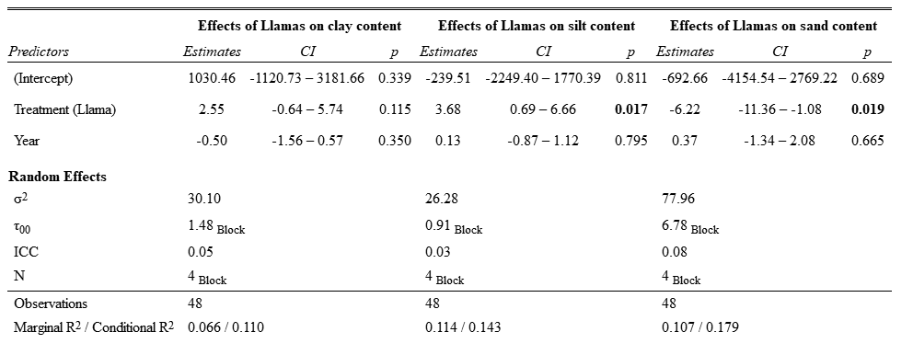
Table S6. Full Mixed effect models for soil pH and soil organic carbon (SOC, by LOI method) content, comparing the control and llama plots and including the 2019 baseline and 2022 data.
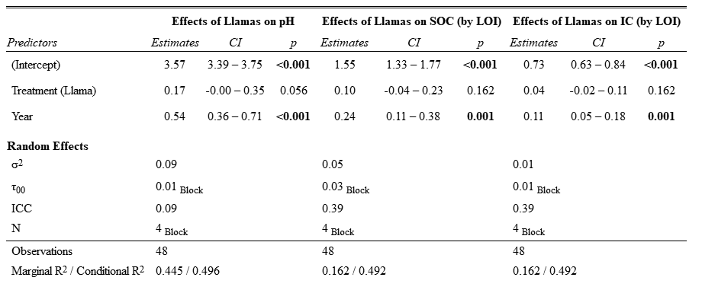
Table S7: Composition in total organic carbon (TOC), total nitrogen (TN) and total phosphorus (P) of the llama latrines. n=12.
Parameter | Mean | sd
TOC (%) | 15.4 | 2.99
TN (%) | 5.07 | 1.34
P (%) | 0.12 | 0.01

Table S8. Summary statistics for vascular plant cover, richness, greenness, height, necromass and fertility, in control and llama plots, in 2019, 2020, 2021 and 2022.
 | Cover |  |  |  |  | Richness |  |  | Greeness |  |  | Height |  |  | Necromass |  |  | Fertility
 | Control | Llama | Difference | Percent difference |  | Control | Llama |  | Control | Llama |  | Control | Llama |  | Control | Llama |  | Control | Llama
June 2019
mean | 11.38 | 7.96 | -3.42 | -17.69 |  | 2.47 | 2.19 |  | na | na |  | 16.18 | 18.68 |  | 1.06 | 0.91 |  | 52.76 | 57.86
sd | 14.27 | 9.33 |  |  |  | 0.98 | 1.09 |  | na | na |  | 9.11 | 10.27 |  | 1.05 | 0.86 |  | 33.73 | 35.16
max | 72.50 | 45.00 | -27.50 | -23.40 |  | 5 | 5 |  | na | na |  | 34.38 | 42.83 |  | 4 | 3.81 |  | 100 | 100
min | 0.50 | 0.00 | -0.50 | -100.00 |  | 1 | 0 |  | na | na |  | 1 | 4 |  | 0 | 0 |  | 0 | 0
January 2020
mean | 8.89 | 8.27 | -0.63 | -3.64 |  | 2.53 | 2.31 |  | 0.75 | 1.16 |  | 10.88 | 12.3 |  | 8.68 | 14.34 |  | 0 | 2.19
sd | 8.91 | 10.21 |  |  |  | 0.95 | 1.18 |  | 0.72 | 0.88 |  | 7.62 | 7.22 |  | 10.59 | 12.8 |  | 0 | 9.41
max | 40.50 | 54.00 | 13.50 | 14.29 |  | 5 | 5 |  | 2 | 2 |  | 33.5 | 39.81 |  | 37.27 | 40.74 |  | 0 | 50
min | 0.50 | 0.00 | -0.50 | -100.00 |  | 1 | 0 |  | 0 | 0 |  | 1 | 3.67 |  | 0 | 0 |  | 0 | 0
May 2021
mean | 9.63 | 8.91 | -0.71 | -3.84 |  | 2.75 | 2.50 |  | 0.06 | 0.31 |  | 11.42 | 11.27 |  | 22.44 | 27.07 |  | 22.76 | 11.3
sd | 9.35 | 9.88 |  |  |  | 1.05 | 1.30 |  | 0.25 | 0.69 |  | 6 | 7.42 |  | 13.61 | 16.08 |  | 32.31 | 21.37
max | 42.20 | 47.00 | 4.80 | 5.38 |  | 5 | 6 |  | 1 | 2 |  | 28.17 | 34.87 |  | 50 | 66 |  | 100 | 75
min | 0.30 | 0.00 | -0.30 | -100.00 |  | 1 | 0 |  | 0 | 0 |  | 1 | 2.07 |  | 0 | 3.78 |  | 0 | 0
June 2022
mean | 12.64 | 13.97 | 1.32 | 4.97 |  | 2.94 | 3.25 |  | 0.06 | 0.63 |  | 11.28 | 11.92 |  | 23.54 | 17.47 |  | 64.9 | 39.17
sd | 13.22 | 14.11 |  |  |  | 0.91 | 1.44 |  | 0.25 | 0.83 |  | 6.17 | 6.9 |  | 12.82 | 7.84 |  | 31.58 | 35.63
max | 59.00 | 62.00 | 3.00 | 2.48 |  | 5 | 6 |  | 1 | 2 |  | 26.67 | 27.76 |  | 57.63 | 32.62 |  | 100 | 100
min | 0.70 | 0.00 | -0.70 | -100.00 |  | 2 | 0 |  | 0 | 0 |  | 1.07 | 2.42 |  | 3.62 | 0 |  | 0 | 0

Table S9. Mixed effect models for Plant Cover, Plant Richness and Greenness, comparing the control and llama plots.
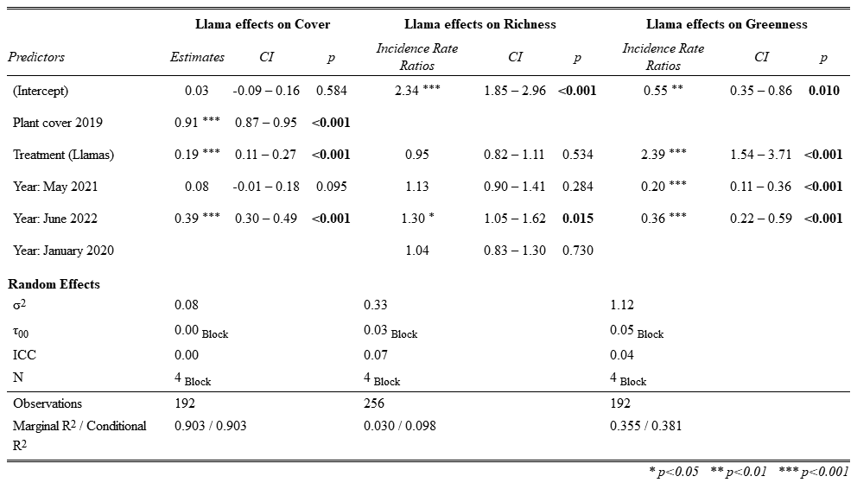

Table S10 – Results of the contrast tests for multiple comparisons for the plant cover. p-values adjusted with the Bonferroni procedure.
contrast | estimate | SE | df | t.ratio | p.value
Control January 2020 - Llama January 2020 | -0.188 | 0.042 | 194.809 | -4.506 | ≤0.001
Control January 2020 - Control May 2021 | -0.083 | 0.050 | 191.079 | -1.664 | 1.000
Control January 2020 - Llama May 2021 | -0.270 | 0.065 | 192.762 | -4.170 | ≤0.001
Control January 2020 - Control June 2022 | -0.395 | 0.050 | 191.079 | -7.943 | ≤0.001
Control January 2020 - Llama June 2022 | -0.583 | 0.065 | 192.762 | -8.982 | ≤0.001
Llama January 2020 - Control May 2021 | 0.105 | 0.065 | 192.762 | 1.619 | 1.000
Llama January 2020 - Llama May 2021 | -0.083 | 0.050 | 191.079 | -1.664 | 1.000
Llama January 2020 - Control June 2022 | -0.207 | 0.065 | 192.762 | -3.193 | 0.025
Llama January 2020 - Llama June 2022 | -0.395 | 0.050 | 191.079 | -7.943 | ≤0.001
Control May 2021 - Llama May 2021 | -0.188 | 0.042 | 194.809 | -4.506 | ≤0.001
Control May 2021 - Control June 2022 | -0.312 | 0.050 | 191.079 | -6.279 | ≤0.001
Control May 2021 - Llama June 2022 | -0.500 | 0.065 | 192.762 | -7.707 | ≤0.001
Llama May 2021 - Control June 2022 | -0.124 | 0.065 | 192.762 | -1.918 | 0.849
Llama May 2021 - Llama June 2022 | -0.312 | 0.050 | 191.079 | -6.279 | ≤0.001
Control June 2022 - Llama June 2022 | -0.188 | 0.042 | 194.809 | -4.506 | ≤0.001

Table S11 – Results of the contrast tests for multiple comparisons for the subplot greenness. p-values adjusted with the Bonferroni procedure.
contrast | ratio | SE | z.ratio | p.value
Control January 2020 / Llama January 2020 | 0.418 | 0.094 | -3.888 | 0.002
Control January 2020 / Control May 2021 | 5.083 | 1.601 | 5.164 | ≤0.001
Control January 2020 / Llama May 2021 | 2.124 | 0.821 | 1.949 | 0.770
Control January 2020 / Control June 2022 | 2.773 | 0.688 | 4.113 | ≤0.001
Control January 2020 / Llama June 2022 | 1.159 | 0.388 | 0.441 | 1.000
Llama January 2020 / Control May 2021 | 12.164 | 4.703 | 6.462 | ≤0.001
Llama January 2020 / Llama May 2021 | 5.083 | 1.601 | 5.164 | ≤0.001
Llama January 2020 / Control June 2022 | 6.635 | 2.219 | 5.659 | ≤0.001
Llama January 2020 / Llama June 2022 | 2.773 | 0.688 | 4.113 | ≤0.001
Control May 2021 / Llama May 2021 | 0.418 | 0.094 | -3.888 | 0.002
Control May 2021 / Control June 2022 | 0.545 | 0.195 | -1.694 | 1.000
Control May 2021 / Llama June 2022 | 0.228 | 0.096 | -3.501 | 0.007
Llama May 2021 / Control June 2022 | 1.305 | 0.551 | 0.631 | 1.000
Llama May 2021 / Llama June 2022 | 0.545 | 0.195 | -1.694 | 1.000
Control June 2022 / Llama June 2022 | 0.418 | 0.094 | -3.888 | 0.002

Figure S2. Effect of (a) the 2019 initial plot cover (log-transformed) on the percentage change in cover for the Control and Llama subplots
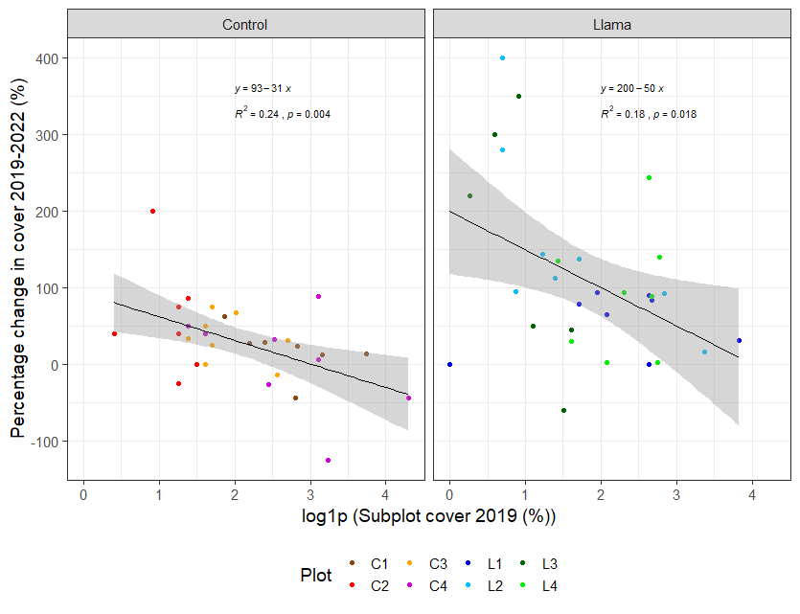
Table S12. Mixed effect models for Plant Cover of Cinnagrostis rigida, Senecio sublutescens, Minoides kunthiana and Agrostis toluscensis, comparing the control and llama plots.
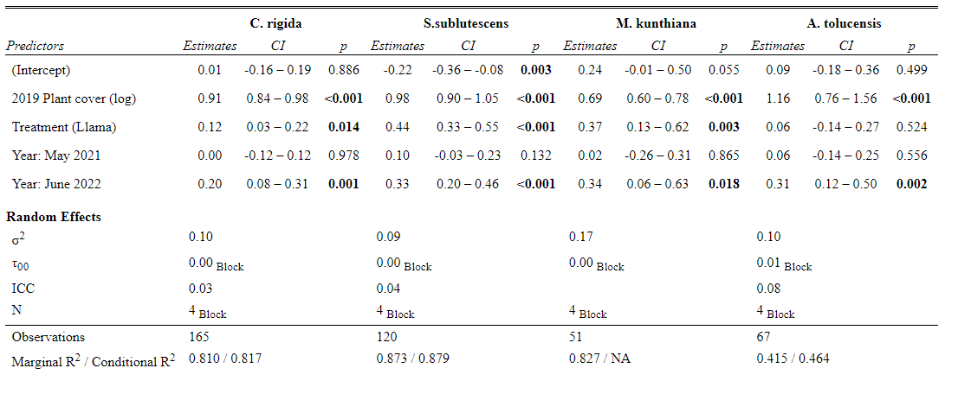

Figure S3. Coefficients of the mixed effect models for the plant cover of the 4 most representative species
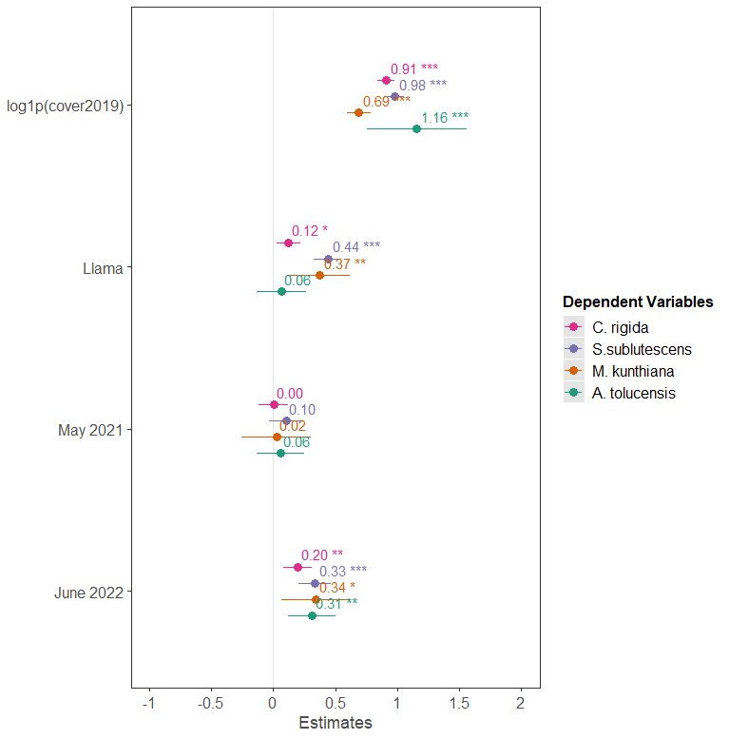

Table S13. Summary statistic for LDMC, Nitrogen and Phosphorus contents of P. prostrata leaf for the control, samples from llama plots far from latrine (i.e., Llama: no latrine), and samples from llama plots with proximity from latrine (i.e., Llama: latrine prox) treatments.
 | LDMC (mg.g-1) | Nitrogen (g.kg-1) | Phosphorus (g.kg-1)
Pernettya prostrata | mean (sd) | mean (sd) | mean (sd) | n
Control | 732.02 (57.14) | 9.32 (3.82) | 2.88 (1.11) | 31
Llama: no latrine | 760.73 (36.66) | 9.13 (3.76) | 3.27 (1.35) | 16
Llama: latrine prox | 728.76 (48.95) | 8.7 (4.66) | 3.39 (1.9) | 14
Senecio sublutescens
Control | 791.42 (53.77) | 11.39 (3.43) | 3.08 (1.01) | 40
Llama: no latrine | 804.65 (39.26) | 10.91 (3.83) | 3.02 (0.99) | 20
Llama: latrine prox | 770.06 (119.63) | 12.08 (4.19) | 3 (0.75) | 20
Agrostis toluscencis
Control | na | 12.44 (3.71) | 4.44 (1.47) | 40
Llama: no latrine | na | 11.65 (3.84) | 4.10 (2.14) | 19
Llama: latrine prox | na | 12.84 (3.77) | 4.32 (1.76) | 20
Cinnagrostis rigida
Control | na | 9.29 (2.67) | 2.73 (0.66) | 40
Llama: no latrine | na | 8.56 (2.84) | 2.68 (0.84) | 20
Llama: latrine prox | na | 9.69 (4.1) | 2.91 (0.97) | 20

Table S14. Mixed effect models of the presence of llamas on P. prostrata LDMC comparing control, samples from llama plots far from latrine (i.e., Llama: no latrine), and samples from llama plots with proximity from latrine (i.e., Llama: latrine prox) treatments.
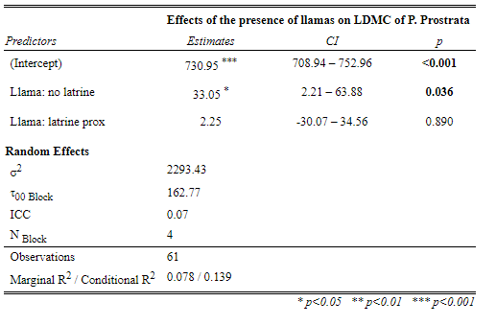
Figure S4. Box plot of the LDMC of the Pernettya prostrata individuals collected within the Control plots, within the llama plot far from latrine influence, and with latrine proximity.
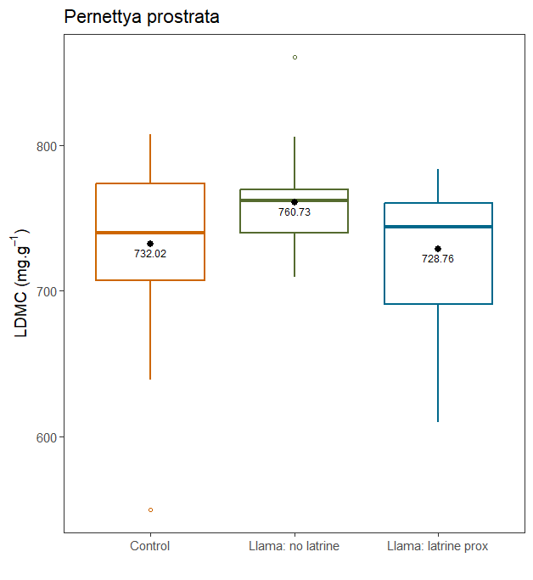
Table S15. Mixed effect models for Plant Fertility, comparing the control and llama plots.
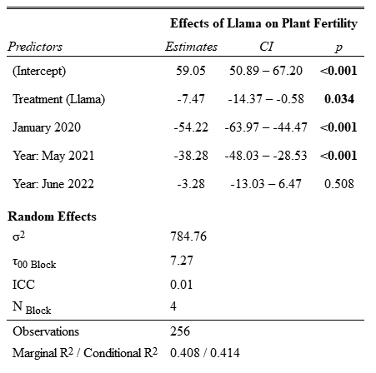

Figure S5. Effects of the llama on reproduction attributes. Barplot of the percentage of species with observable reproduction attributes within the Llama and Control plots in 2019, 2020, 2021 and 2022. Means not sharing any letter are significantly different by Bonferroni tests (p≤0.05).
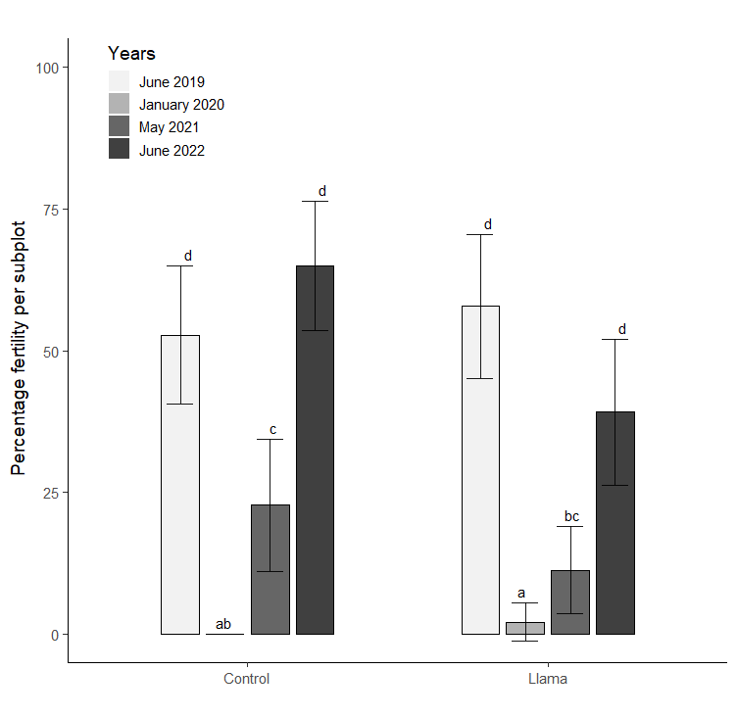

Table S16 – Results of the contrast tests for multiple comparisons for the subplot fertility. p-values adjusted with the Bonferroni procedure.
contrast | estimate | SE | df | t.ratio | p.value
Control June 2019 - Llama June 2019 | 7.474 | 3.530 | 256.065 | 2.117 | 0.985
Control June 2019 - Control January 2020 | 54.219 | 4.992 | 256.065 | 10.861 | ≤0.001
Control June 2019 - Llama January 2020 | 61.693 | 6.114 | 256.065 | 10.091 | ≤0.001
Control June 2019 - Control May 2021 | 38.281 | 4.992 | 256.065 | 7.669 | ≤0.001
Control June 2019 - Llama May 2021 | 45.755 | 6.114 | 256.065 | 7.484 | ≤0.001
Control June 2019 - Control June 2022 | 3.281 | 4.992 | 256.065 | 0.657 | 1.000
Control June 2019 - Llama June 2022 | 10.755 | 6.114 | 256.065 | 1.759 | 1.000
Llama June 2019 - Control January 2020 | 46.745 | 6.114 | 256.065 | 7.646 | ≤0.001
Llama June 2019 - Llama January 2020 | 54.219 | 4.992 | 256.065 | 10.861 | ≤0.001
Llama June 2019 - Control May 2021 | 30.807 | 6.114 | 256.065 | 5.039 | ≤0.001
Llama June 2019 - Llama May 2021 | 38.281 | 4.992 | 256.065 | 7.669 | ≤0.001
Llama June 2019 - Control June 2022 | -4.193 | 6.114 | 256.065 | -0.686 | 1.000
Llama June 2019 - Llama June 2022 | 3.281 | 4.992 | 256.065 | 0.657 | 1.000
Control January 2020 - Llama January 2020 | 7.474 | 3.530 | 256.065 | 2.117 | 0.985
Control January 2020 - Control May 2021 | -15.938 | 4.992 | 256.065 | -3.193 | 0.044
Control January 2020 - Llama May 2021 | -8.464 | 6.114 | 256.065 | -1.384 | 1.000
Control January 2020 - Control June 2022 | -50.938 | 4.992 | 256.065 | -10.204 | ≤0.001
Control January 2020 - Llama June 2022 | -43.464 | 6.114 | 256.065 | -7.109 | ≤0.001
Llama January 2020 - Control May 2021 | -23.411 | 6.114 | 256.065 | -3.829 | 0.005
Llama January 2020 - Llama May 2021 | -15.938 | 4.992 | 256.065 | -3.193 | 0.044
Llama January 2020 - Control June 2022 | -58.411 | 6.114 | 256.065 | -9.554 | ≤0.001
Llama January 2020 - Llama June 2022 | -50.938 | 4.992 | 256.065 | -10.204 | ≤0.001
Control May 2021 - Llama May 2021 | 7.474 | 3.530 | 256.065 | 2.117 | 0.985
Control May 2021 - Control June 2022 | -35.000 | 4.992 | 256.065 | -7.011 | ≤0.001
Control May 2021 - Llama June 2022 | -27.526 | 6.114 | 256.065 | -4.502 | ≤0.001
Llama May 2021 - Control June 2022 | -42.474 | 6.114 | 256.065 | -6.947 | ≤0.001
Llama May 2021 - Llama June 2022 | -35.000 | 4.992 | 256.065 | -7.011 | ≤0.001
Control June 2022 - Llama June 2022 | 7.474 | 3.530 | 256.065 | 2.117 | 0.985

Table S17: Number of counts (n) of subplots with observed pasture eaten.
Years | Treatment | Plot | n
January 2020 | Control | C3 | 1
January 2020 | Control | C4 | 1
January 2020 | Llama | L1 | 2
January 2020 | Llama | L2 | 1
January 2020 | Llama | L3 | 5
January 2020 | Llama | L4 | 5
May 2021 | Control | C1 | 1
May 2021 | Control | C3 | 2
May 2021 | Llama | L1 | 5
May 2021 | Llama | L2 | 5
May 2021 | Llama | L3 | 4
May 2021 | Llama | L4 | 6
June 2022 | Llama | L1 | 1

Table S18: Seed composition of the llama feces samples. The presence in the Cordillera Blanca and geographic distribution data were extracted from Smith¹².
Species | Family | Genus | Germination viability (%) | Present in the experiment | Presence in the Cordillera Blanca | Genera Geographic distribution | Dispersal type | References Dispersal type
Agrostis sp. | Poaceae | Agrostis | 0 | yes | Present | Wide Temperate | Anemochory | Claure-Herrera et al., 2022
Alchemilla sp. | Rosaceae | Alchemilla | 7.41 | no | Present | Wide Temperate | Epizoochory | Piiraine & Chkalov 2018
Cyperaceae | Cyperaceae | na | 0 | no | Present | na | Epizoochory | Leck & Schütz 2005
Cyperus sp. | Cyperaceae | Cyperus | 0 | no | Present | Wide Tropical | Hydrochory | Leck & Schütz 2005
Eleocharis sp. | Cyperaceae | Eleocharis | 0 | no | Present | Cosmopolitan | Hydrochory, Epizoochory | Leck & Schütz 2005
Ericaceae | Ericaceae | na | 0 | no | Present | na | Endozoochory | Claure-Herrera et al., 2022
Galium sp. | Rubiaceae | Galium | 0 | no | Present | Wide Temperate | Epizoochory, Endozoochory | Taylor, 1999
Luzula sp. | Juncaceae | Luzula | 42.86 | no | Present | Wide Temperate | Autochory, Endozoochory | Claure-Herrera et al., 2022
Pennisetum sp. | Poaceae | Pennisetum | 70 | no | Present | Ruderal | Epizoochory | Claure-Herrera et al., 2022
Pernettya prostrata | Ericaceae | Pernettya | 13.33 | yes | Present | Austral | Endozoochory | Claure-Herrera et al., 2022
Sisyrinchium sp. | Iridaceae | Sisyrinchium | 0 | no | Present | American | Autochory | Claure-Herrera et al., 2022
Sporobolus sp. | Poaceae | Sporobolus | 60 | no | Present | Wide Tropical | Autochory, Endozoochory | Claure-Herrera et al., 2022

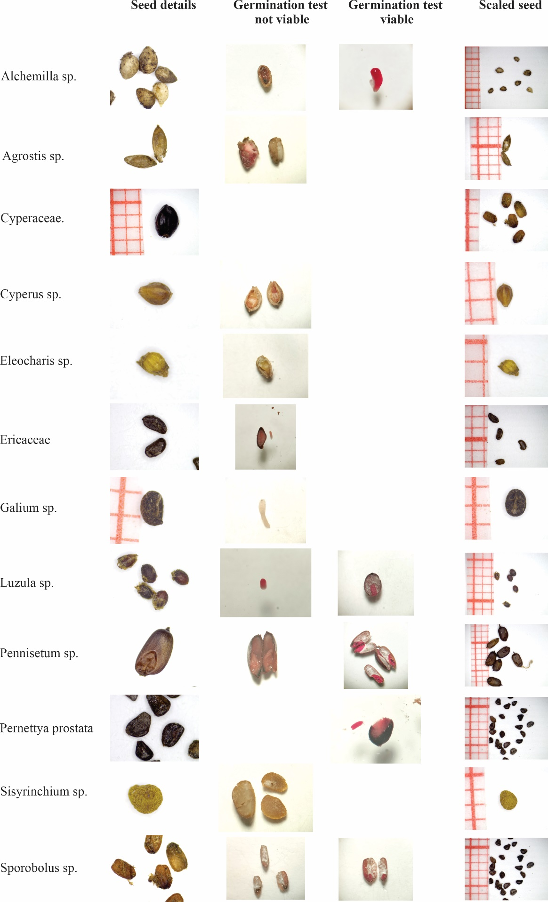
Table S19: Seed identification and germination test photographs

References

1. Franklin, W. L. Biology, ecology, and relationship to man of the South American camelids. Mamm. Biol. South Am. 6, 457–489 (1982).
2. Meneses, R. I., Loza Herrera, S., Lliully, A., Palabral, A. & Anthelme, F. Métodos para cuantificar diversidad y productividad vegetal de los bofedales frente al cambio climático. Ecol. en Boliv. 49, 42–55 (2014).
3. Heiri, O., Lotter, A. F. & Lemcke, G. Loss on ignition as a method for estimating organic and carbonate content in sediments: reproducibility and comparability of results. J. Paleolimnol. 25, 101–110 (2001).
4. Jensen, J. L., Christensen, B. T., Schjønning, P., Watts, C. W. & Munkholm, L. J. Converting loss‐on‐ignition to organic carbon content in arable topsoil: pitfalls and proposed procedure. Eur. J. Soil Sci. 69, 604–612 (2018).
5. Matías, L., Zamora, R., Mendoza, I. & Hódar, J. A. Seed Dispersal Patterns by Large Frugivorous Mammals in a Degraded Mosaic Landscape. Restor. Ecol. 18, 619–627 (2010).
6. Sayers, R. L. & Ward, R. T. Germination responses in alpine species. Bot. Gaz. 127, 11–16 (1966).
7. França-Neto, J. de B. & Krzyzanowski, F. C. Tetrazolium: An important test for physiological seed quality evaluation. J. Seed Sci. 41, 359–366 (2019).
8. McNeish, D. Small Sample Methods for Multilevel Modeling: A Colloquial Elucidation of REML and the Kenward-Roger Correction. Multivariate Behav. Res. 52, 661–670 (2017).
9. FLorez, A., Malpartida, E. & San Martín Howard, F. Manual de forrajes para zonas áridas y semiáridas andinas. (1992).
10. Achu Nina, C. Determination of the botanical and chemical composition of the pasture diet selected by llamas (Lama glama) during the rainy season in the community of Pujrata. (2003).
11. Tapia Núñez, M. E. & Flores Ochoa, J. A. Pastoreo y Pastizales de los Andes del Sur del Perú. (Instituto Nacional de Investigación y Promoción Agropecuaria, Lima (Perú …, 1984).
12. Smith, D. N. Flora and vegetation of the Huascaran National Park, Ancash, Peru, with preliminary taxonomic studies for a manual of the flora. (Iowa State University, 1988).

