Supplemental figures and legends
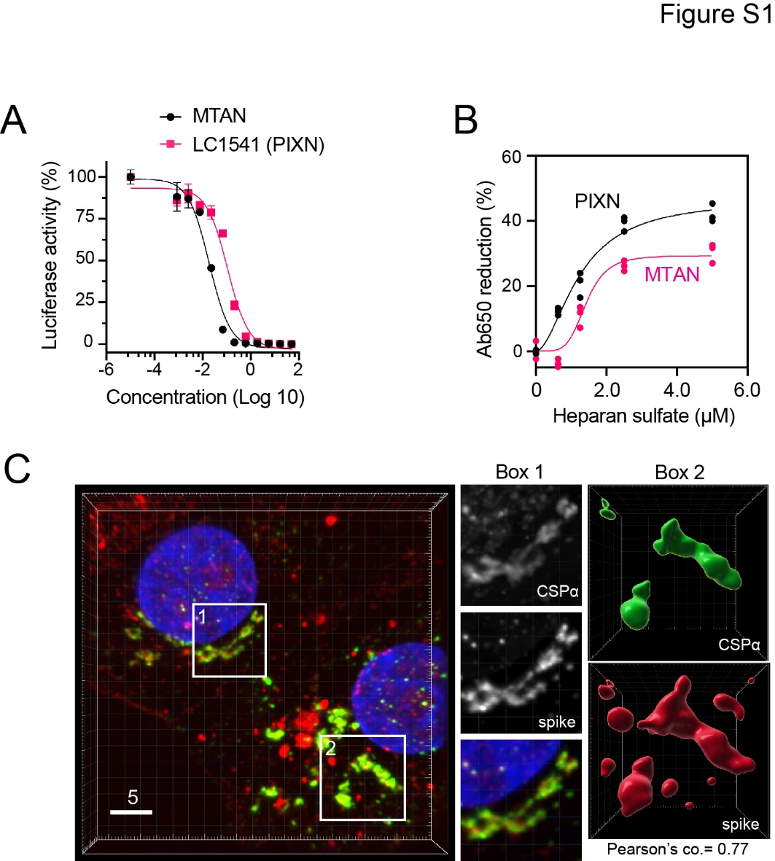

Figure S1. PIXN blocks endocytosis-mediated entry of SARS-CoV-2
(A) PIXN (LC1541) and MTAN inhibit the entry of luciferase-expressing pseudoviral particles coated with the spike of the SARS-CoV-2 Omicron variant. Error bars indicate means ± SD, n=3.
(B) Heparan sulfate binds to PIXN and MTAN. The indicated drugs (50 μM) were incubated with purified heparan sulfate at the indicated concentrations. The change of Absorbance at 650 nm was recorded. The fitted curves represent the average of three experiments.
(C) The USA-WA1/2020 variant enters cells mostly via endocytosis. Vera TA6 cells were treated with the USA-WA1/2020 at MOI of 0.1 for 4 h. Cells were fixed and stained with antibodies against the lysosome-associated protein CSPα (green), the spike (red), and with Hoechst (blue). Shown are examples of cells in a 3D view (left). Scale bar, 5 μm. The Box1-labeled area is enlarged in the middle panels. The right panels show a surface-rendered view of the Box2-indicated area.

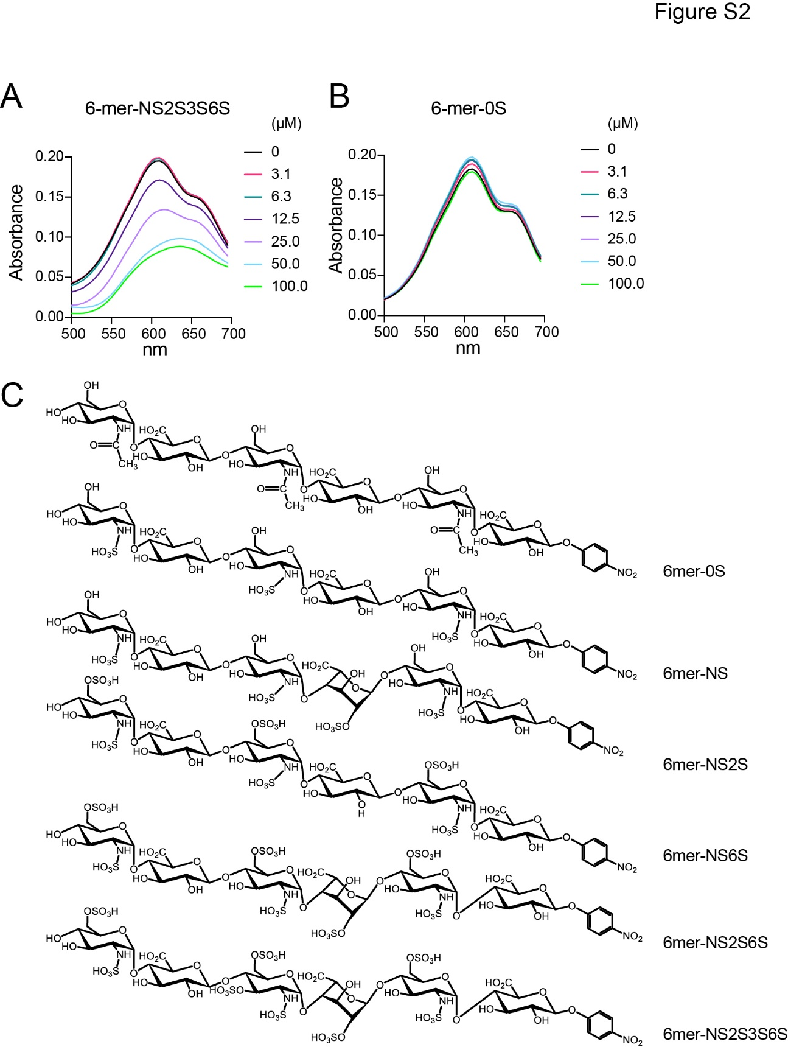

Figure S2. MTAN (MTAN) binds HS 6-mer NS2S3S6S in a sulfate dependent manner
(A) MTAN (50 μM) was incubated with HS-6-mer NS2S3S6S at the indicated concentrations (μM). The absorbance spectra of the reactions were measured.
(B) As in (A), except that a HS 6-mer with zero sulfate was used.
(C) The structures of HS 6-mers.

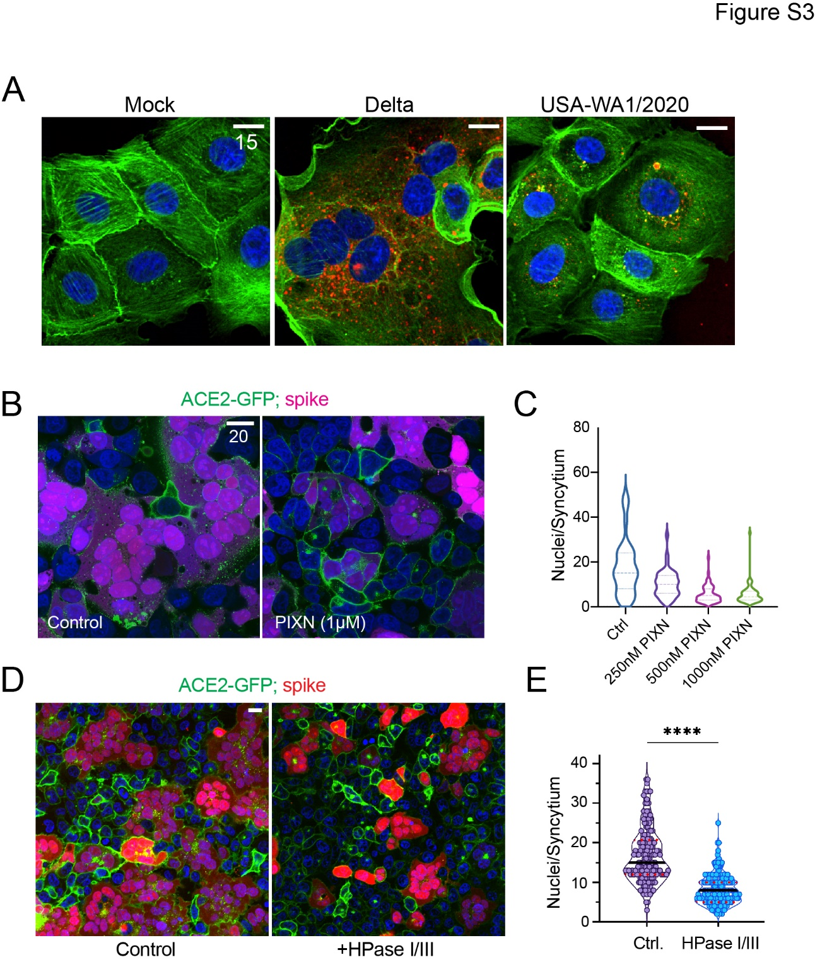

Figure S3. The cell surface heparan sulfate promotes spike-induced cell-cell fusion
(A) Vero TA6 cells were infected with indicated SARS-CoV-2 variants (MOI=0.5) for 4 h and stained with anti-nucleocapsid protein (red) and the actin staining dye Alexa Fluor 488 Phalloidin (green). Scale bars, 15 μm.
(B, C) PIXN inhibits spike-induced cell-cell fusion. ACE2-GFP cells (green) were incubated with spike/mCherry-expressing cells (magenta) in the absence (Control) or presence of PIXN for 60 minutes. The graph in (C) shows the size of syncytia, as indicated by the number of nuclei per syncytium. Scale bars, 20 μm.
(D, E) Heparinase I/III treatment inhibits spike-mediated cell-cell fusion. ACE2-GFP cells (green) were either mock-treated or treated with Heparinase I/III (HPase I/III) for 3 h before incubation with spike/mCherry-expressing cells (red). The graph in (E) measures the syncytium size. ****, p<0.0001 by unpaired student’s t-test, n=3 independent experiments.

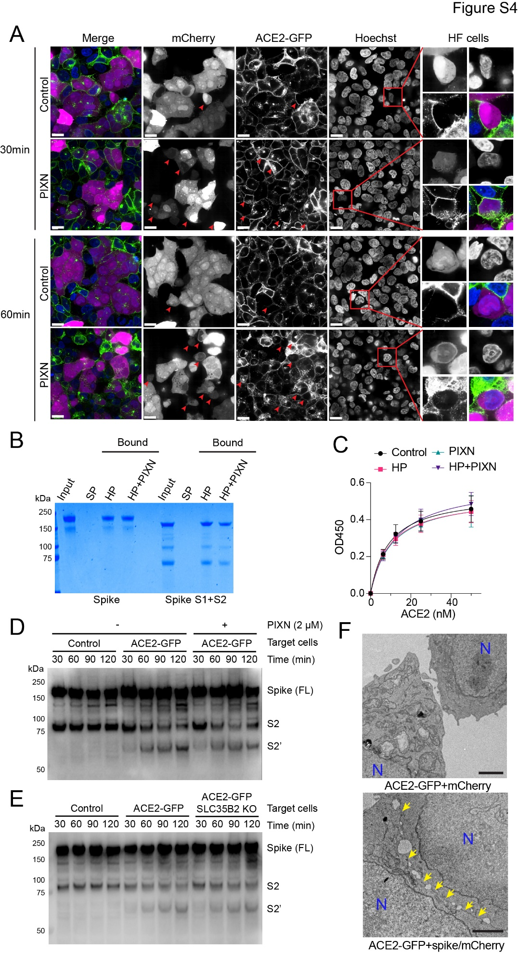

Figure S4. PIXN inhibits spike-stimulated cell-cell fusion in a hemi-fusion state
(A) ACE2-GFP cells (green) were incubated with spike/mCherry-expressing cells (magenta) in the absence (Control) or presence of PIXN (2 μM) for 30 or 60 minutes. Shown are representative pictures with examples of semi-fusion (SF) cells highlighted (red boxes). Red arrows show more example of HF cells. Scale bars, 20 μm.
(B) PIXN does not inhibit the interaction of HS with the spike. The spike proteins (Lanes 1-4, a mutant with the furin-cleavage site mutated; Lanes 5-8, wild-type spike with a fraction cleaved by the furin protease) were incubated with Sepharose beads (SP), heparin-conjugated beads (HP) or heparin beads prebound with PIXN (HP+PIXN). The bound proteins and a fraction of the input (15%) were analyzed by SDS-PAGE followed by Coomassie blue staining.
(B) PIXN does not affect the spike-ACE2 interactions. The interaction of ACE2 with spike was measure by an ELISA-based plate assay with the indicated compounds. HP, heparin.
(C, D) PIXN does not inhibit ACE2-dependent proteolytic processing of the spike. ACE2-GFP cells or control cells without ACE2 overexpression (-) were incubated with spike/mCherry-expressing cells in the absence (Control) or presence of PIXN (2 μM) for the indicated time points. Cell extracts were analyzed by immunoblotting with an antibody detecting both fully length spike and the cleaved S2 and S2’ fragment. Note that the conversion of S to S2’ fragment, which is dependent on ACE2, is not affected by PIXN.
(F) The spike dependent formation of synapse-like cell-cell contracts. ACE2-GFP cells were mixed with mCherry transfected cells (left) or spike/mCherry co-transfected cells (right) for 12 minutes before fixing and analyzed by transmission electron microscopy. N, nucleus. The arrows indicate synapse-like cell-cell contacts formed between ACE2-GFP and Spike cells. Scale bar, 2 μm.

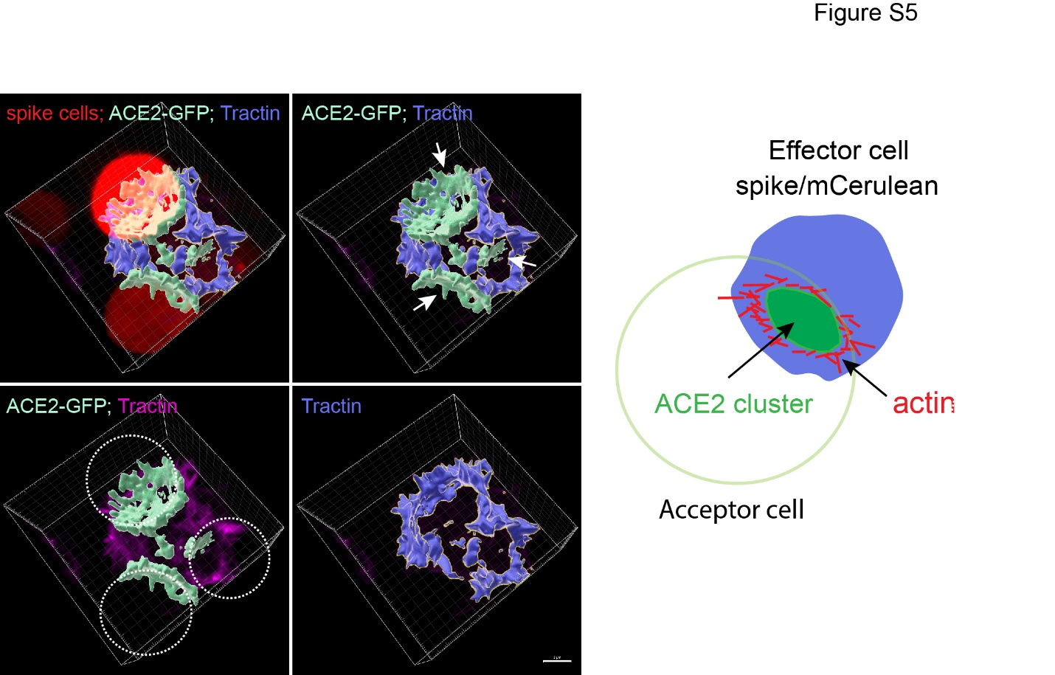

Figure S5. Heparan sulfate promotes the assembly of ACE2 super-clusters
Synapse-like membrane contact sites containing ACE2 clusters are encircled by actin filaments. ACE2-GFP cells were transfected with mCherry-Tractin to label actin filaments and then co-cultured with spike/CFP co-transfected cells (red) for 5 minutes before 3D imaging. Arrows indicate 3 ACE2 clusters in surface-rendered 3D view (green). Note that F-tractin-labeled actin filaments are concentrated around the ACE2 clusters. The dashed lines indicate CFP-positive effector cells. Scale bar, 5 μm. The diagram on the right is a schematic illustration of a spike-induced membrane synapse.

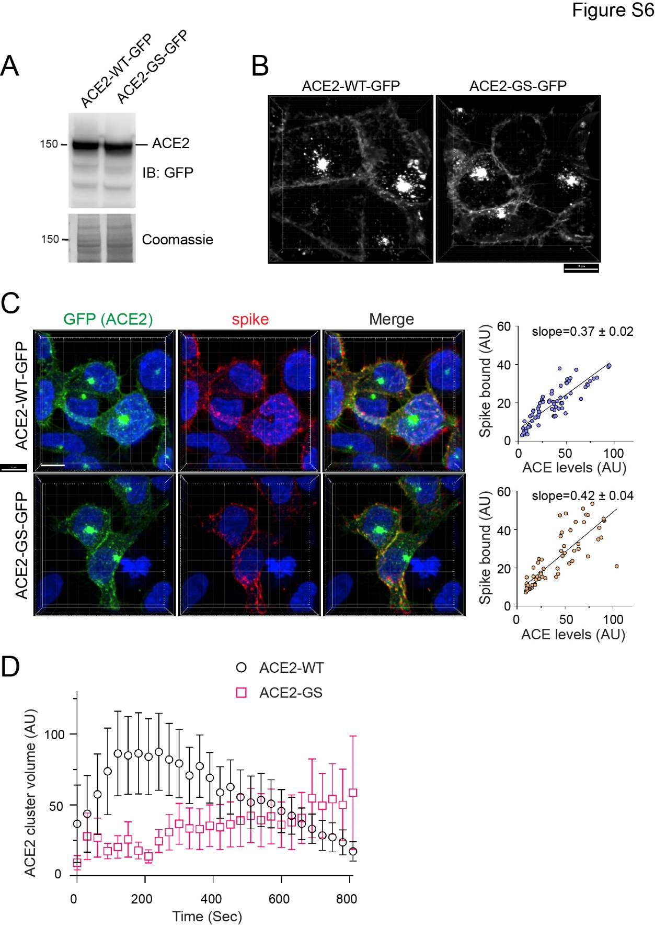

Figure S6. A linker segment in ACE2 is required for spike-induced ACE2 clustering
(A) ACE2-GS-GFP is expressed at a similar level as wild-type ACE2. Cell extracts of the indicated cell lines were analyzed by immunoblotting.
(B) ACE2-GS-GFP and wild-type ACE2-GFP are both localized to the plasma membrane and endocytic vesicles. Scale bar, 10 μm.
(C) ACE2-GS-GFP and wild-type ACE2-GFP bind the spike with a similar affinity. The indicated cell lines were incubated with the spike and stained with spike antibody (red) and Hoechst (blue). The graphs show the amount of cell surface bound spike, which correlates with ACE2 levels as measured by Image J.
(D) ACE2-GS-GFP cells are defective in forming ACE2 clusters when co-cultured with spike/mCherry cells. The graph shows the averaged 3D volume of ACE2 clusters from randomly selected live cell imaging videos. Error bars indicate means ± SEM, n=5.

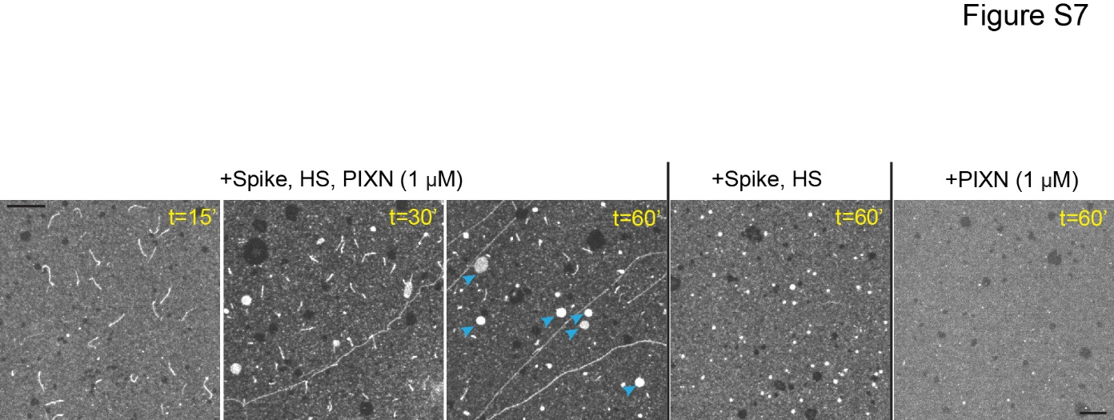

Figure S7. PIXN alters the morphology of ACE2 clusters in the presence of spike and HS
Fluorescence-labeled ACE2 1-740 was anchored to lipid bilayers on a cover glass and treated as indicated. Note that PIXN alters the shape of clustered ACE2, forming filament-like structures instead. Additionally, some round ACE2 clusters were observed (blue arrowheads) but they are much bigger than those formed in the absence of the drug. Scale bar, 10 µm.

Video 1. 4D live imaging of spike-induced cell-cell fusion
A spike/mCherry-expressing cell (magenta) contacts an ACE2-GFP cell (green), which induced the clustering of ACE2 at the cell-cell contact site. As the cluster grows, mCherry is leaked into ACE2-GFP cells, which is followed by the formation of a visible pore. The pore eventually expands to cause the complete fusion of the two cells.

Table S1. A list of key reagents used in the study

