Appendix
Table A1: Parameters included in management model on distribution of Jacobaea aquatica in Bavarian grasslands.

Factor | Factor levels | Description
J. aquatica Absence/presence | 0/1 | Absence/presence of Jacobaea aquatica
J. aquatica Frequency class | A:0,  B: 0-1,  C: 1-10,  D: 10-100,  E: 100-1000,  F: >1000 | Estimated frequency of Jacobaea aquatica in individuals/100-m2
Organic Farming | True/False
Land use type (LUT) | True/false  True/false  True/false  True/false  True/false | Predominant use of the site
  - Pasture
  - Meadow
  - Mowing pasture
  - Litter meadow
  - Unused
Use intensity | 1 to 6 | Number of cutting or grazing events per year; as factor
Grazing in autumn | True/False | Post-grazing after hey production in autumn
Fertilizer (FER) | True/False | Application of Fertilizer
- FER Mineral | True/False | Application of mineral fertilizer
- FER Manure | True/False | Application of manure
- FER Slurry | True/False | Application of slurry
Agri-environmental measures (AUM) | True/False | Agri-environmental schemes implemented on the field
Disturbance (DIS) | True/False | Apparent soil disturbance, such as vehicle tracks, animal tracks etc.

Table A2: List of soil classes (IUSS Working Group WRB, 2022) and subclasses recorded in the Bavarian soil map (Landesamt für Umwelt, 2021). Code represents classes and subclasses along a gradient of decreasing soil moisture.

Class | Soil class (WRB classification) | Subclass (German classification) | Codes
H | Histosol | HN Niedermoor (Fen)  HH Hochmoor (Bog) | 100  110
G | Gleysol | GN Nassgley  GM Anmoorgley  GH Moorgley  GG Gley | 120  120  130  140
S | Stagnosol | SH Haftpseudogley  SG Stagnogley  SS Pseudogley | 160  170  180
A | Fluvisol | AB Vega  AO Rambla  AQ Paternia  AZ Kalkpaternia | 200  220  220  240
P | Podzols | PP Podzol | 260
B | Cambisol | BB Pseudogley-Braunerde  BB Braunerde | 280  300
C | Terrae calcis | CF Terra fusca  CR Terra rossa | 320  330
L | Luvisol | LL Parabraunerde  LF Fahlerde | 340  NA
D | Pelosol | DD Pelosol | 360
R | Leptosol (>10 cm topsoil) | RN Ranker  RQ Regosol  RR Rendzina  RZ Pararendzina | 380  400  420  440
O | Lithic Leptosol (<10 cm topsoil) | OO Syrosem  OL Lockersyrosem (Unconsolidated Syrosem) | 460  460
F | O/C Syrosem | FF Felshumusboden (Rock-Humus Soil)  FS Skeletthumusboden (Skeletic Humus Soil) | 460  460
Y | Anthropogenic soils | Kolluvisol, Hortisol, Rigosol, Treposol | NA
Z | Sealed, Water |  | NA

Table A3: Climatic and edaphic predictor variables included in the generalized boosted regression model for the occurrence of Jacobaea aquatica in Bavarian grasslands

Variable name | Meaning | Remark
rainMAM | Spring rainfall (March-May); | Data for 1988-1997 and 2008-2017 obtained from Deutscher Wetterdienst (opendata.dwd.de; downloaded on 10.1.2022), averaged and the original resolution of 1000 x 1000 m resampled to match the 50 x 50m resolution of the soil map. Future data for 2028-2037 under rcp4.5 and rcp8.5 scenario were obtained from Bayerisches Landesamt für Umwelt (downloaded 14.3.2022); original resolution 5000 x 5000 m resampled to match 50 x 50 m resolution of soil map.
rainJJA | Sommer rainfall (June-August)
rainSON | Autumn rainfall (September-November)
airTempMin | All year minimum air temperature 2m above ground
airTempMax | All year maximum air temperature 2m above ground
IceDays | Number of days per year on which the air temperature does not go above 0°C
FrostDays | Number of days per year on which the minimum air temperature is below 0°C
HotDays | Number of days per year on which the maximum air temperature reaches or exceeds 30 °
SoilClass | Soil class | Digital soil map was obtained as a shape file from the Bayerisches Landesamt für Umwelt 2021a; https://www.lfu.bayern.de/boden/karten_daten/uebk25/ (accessed 10.2.2022). Soil classes were recoded according to table A2 and converted into raster data with 50 x 50 m resolution.

Table A4: Tuning parameters for the gradient boosted model used to predict the habitat suitability for Jacobaea aquatica in Bavarian grasslands

Model parameter | Initial value | Tuned value
n.tree | 5000 | 2500
Interaction.depth | 7 | 7
n.minobsinnode | 5 | 5
shrinkage | 0.001 | 0.01
bag.fraction | 0.5 | 0.5
train.fraction | 0.5 | 0.7
cv.folds | 3 | 3

Table A5: Assessment of the generalized regression models for the occurrence of Jacobaea aquatica in in Bavarian grasslands relation to soil type and climatic factors. PA1 … PA10: models for the respective set of pseudo absences; variable importance given as mean±SD; AVG averaged model

Model performance |  |  |  |  |  | Relative variable importance
Model | AUC | Cut off | Sensitivity | Specifity
 |  |  |  |  |  | rainMAM | rainJJA | rainSON | airTempMin | airTempMax | IceDays | FrostDays | HotDays | SoilClass
PA1 | 0,962 | 0,168 | 93,8 | 88,9 |  | 4,6 | 49,7 | 1,8 | 5,8 | 8,6 | 3,9 | 6,0 | 2,9 | 16,7
PA2 | 0,946 | 0,364 | 87,6 | 88,9 |  | 5,2 | 55,2 | 1,9 | 6,9 | 3,7 | 7,8 | 6,3 | 1,5 | 11,6
PA3 | 0,975 | 0,512 | 86,4 | 98,8 |  | 3,6 | 49,2 | 2,0 | 5,8 | 7,5 | 5,5 | 7,7 | 2,7 | 15,9
PA4 | 0,966 | 0,465 | 91,1 | 98,5 |  | 5,1 | 49,3 | 1,3 | 5,0 | 5,0 | 7,8 | 5,1 | 3,0 | 18,3
PA5 | 0,948 | 0,171 | 92,6 | 86,4 |  | 7,3 | 51,9 | 3,1 | 8,1 | 5,8 | 4,0 | 5,0 | 2,1 | 12,9
PA6 | 0,953 | 0,263 | 91,4 | 90,1 |  | 4,6 | 49,7 | 1,8 | 5,8 | 8,7 | 3,9 | 6,0 | 2,9 | 16,7
PA7 | 0,941 | 0,642 | 86,4 | 93,8 |  | 6,2 | 47,8 | 2,6 | 7,1 | 5,5 | 6,5 | 6,5 | 2,8 | 15,2
PA8 | 0,965 | 0,288 | 92,9 | 95,9 |  | 5,1 | 49,3 | 1,2 | 5,0 | 5,0 | 7,8 | 5,1 | 3,0 | 18,3
PA9 | 0,972 | 0,309 | 92,4 | 93,8 |  | 14,8 | 37,8 | 4,8 | 6,8 | 6,4 | 4,3 | 8,0 | 2,0 | 16,0
PA10 | 0,971 | 0,288 | 92,9 | 97,0 |  | 7,3 | 51,9 | 3,1 | 8,1 | 5,8 | 4,0 | 5,0 | 2,1 | 12,9
mean | - | - | - | - |  | 6,4±3,2 | 49,2±4,5 | 2,4±1,1 | 6,4±1,1 | 6,2±1,6 | 5,4±1,8 | 6,1±1,1 | 2,5±0,5 | 15,5±2,3
AVG | 0,961 | 0,350 | 91,4 | 97,7 |  | - | - | - | - | - | - | - | - | -

Table A6: Area at risk and risk changes on distribution of Jacobaea aquatica in Bavarian grasslands within the respective periods

Time period | Climate change scenario | Risk area in km²
Time period | Climate change scenario | Total | High  p > 80% | Moderate  p 65-80% | Low  p 50-65% | New | Not anymore | Increase  dp > 20% | Decrease  dp > 20%
1988-1997 | - | 23707 | 11052 | 2019 | 10636 | - | - | - | -
2008-2017 | - | 11817 | 7979 | 2263 | 1575 | 1221 | 13692 | 1372 | 1438
2028-2037 | Rcp4.5 | 9742 | 283 | 2633 | 6826 | 4582 | 4277 | 43 | 7385
2028-2037 | Rcp8.5 | 5936 | 5 | 1028 | 4903 | 4544 | 3967 | 43 | 7693

p: probability of occurrence, dp: change in probability of occurrence; new, not anymore, increase and decrease: related to previous period

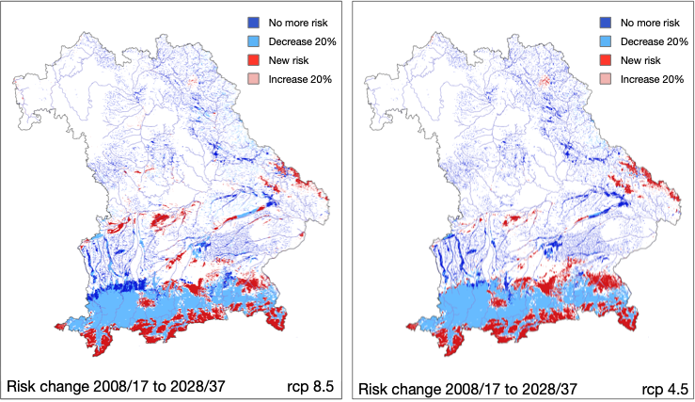
Figure A1: Risk change on occurrence of Jacobaea aquatica in Bavarian grasslands as predicted by the gbm based on climatic factors and soil types for the future period 2028-2037 under rcp4.5 and rcp8.5 scenario.

