Supplementary Figure 1: The effects of product and prey type on Al concentrations. Groups not containing the same letter were significantly different by Games-Howell post-hoc analysis. Letters do not connect across prey groups.

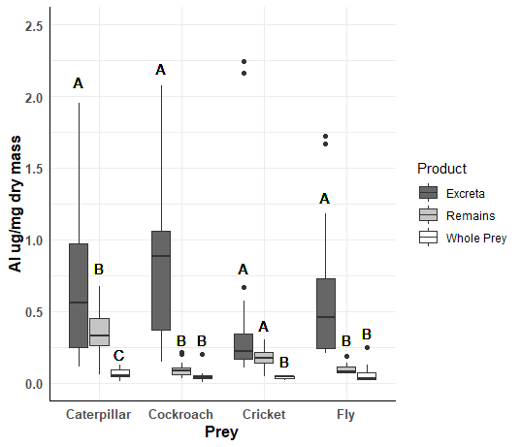

Supplementary Figure 2: The effects of product and prey type on B concentrations. Groups not containing the same letter were significantly different by Games-Howell post-hoc analysis. Letters do not connect across prey groups.

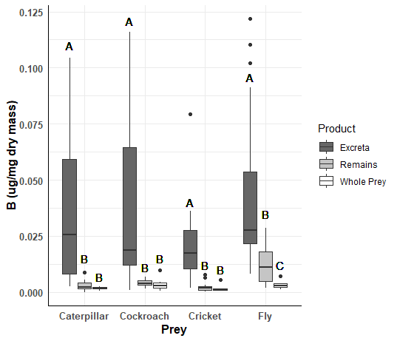

Supplementary Figure 3: The effects of product and prey type on Ba concentrations. Groups not containing the same letter were significantly different by Games-Howell post-hoc analysis. Letters do not connect across prey groups.

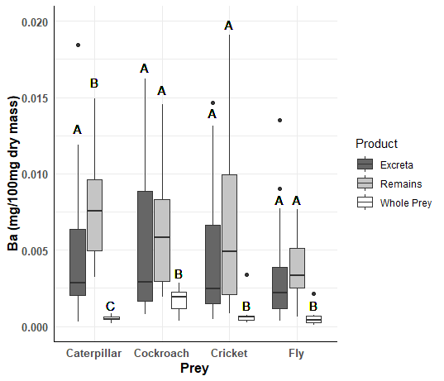

Supplementary Figure 4: The effects of product and prey type on Ca concentrations. Groups not containing the same letter were significantly different by Games-Howell post-hoc analysis. Letters do not connect across prey groups.

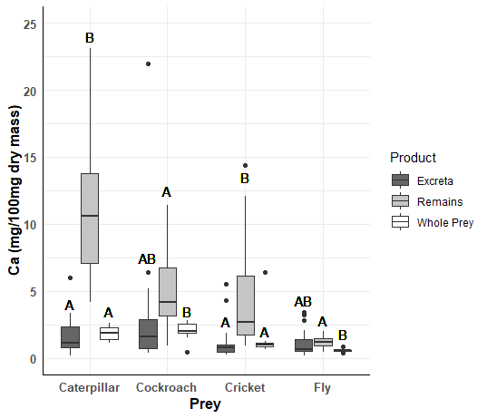

Supplementary Figure 5: The effects of product and prey type on Cd concentrations. Groups not containing the same letter were significantly different by Games-Howell post-hoc analysis. Letters do not connect across prey groups.

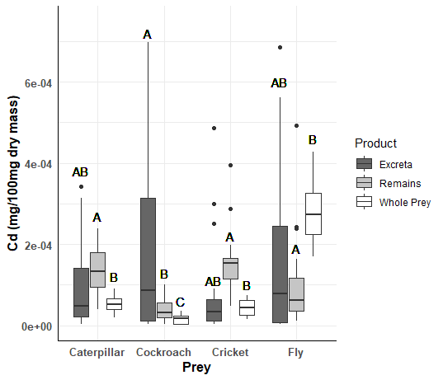

Supplementary Figure 6: The effects of product and prey type on Cr concentrations. Groups not containing the same letter were significantly different by Games-Howell post-hoc analysis. Letters do not connect across prey groups.

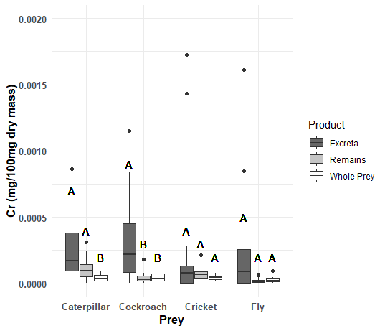

Supplementary Figure 7: The effects of product and prey type on Cu concentrations. Groups not containing the same letter were significantly different by Games-Howell post-hoc analysis. Letters do not connect across prey groups.

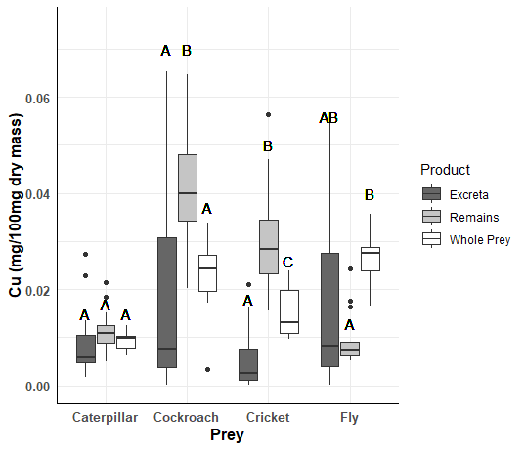

Supplementary Figure 8: The effects of product and prey type on Fe concentrations. Groups not containing the same letter were significantly different by Games-Howell post-hoc analysis. Letters do not connect across prey groups.

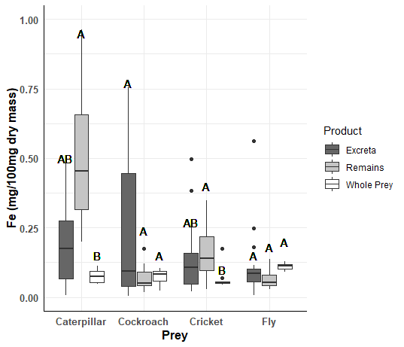

Supplementary Figure 9: The effects of product and prey type on K concentrations. Groups not containing the same letter were significantly different by Games-Howell post-hoc analysis. Letters do not connect across prey groups.

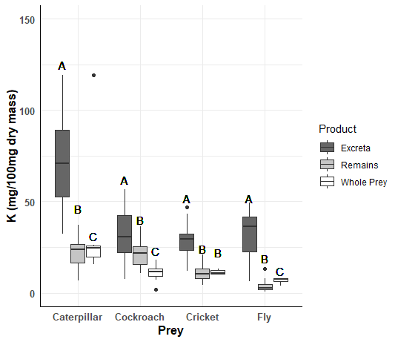

Supplementary Figure 10: The effects of product and prey type on Li concentrations. Groups not containing the same letter were significantly different by Games-Howell post-hoc analysis. Letters do not connect across prey groups.

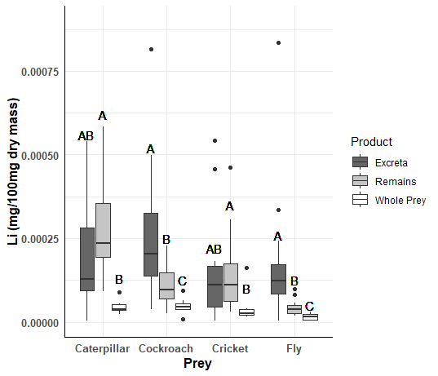

Supplementary Figure 11: The effects of product and prey type on Mg concentrations. Groups not containing the same letter were significantly different by Games-Howell post-hoc analysis. Letters do not connect across prey groups.

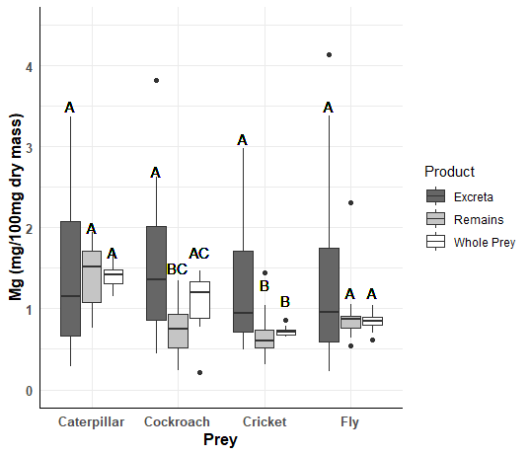

Supplementary Figure 12: The effects of product and prey type on Mn concentrations. Groups not containing the same letter were significantly different by Games-Howell post-hoc analysis. Letters do not connect across prey groups.

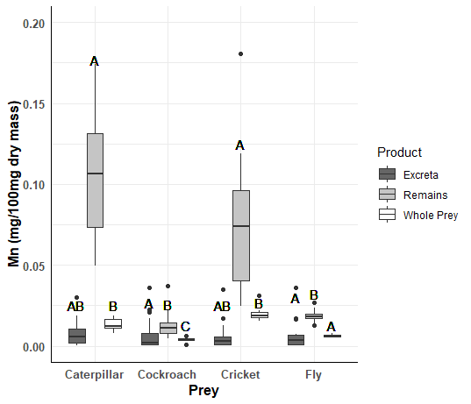

Supplementary Figure 13: The effects of product and prey type on Mo concentrations. Groups not containing the same letter were significantly different by Games-Howell post-hoc analysis. Letters do not connect across prey groups.

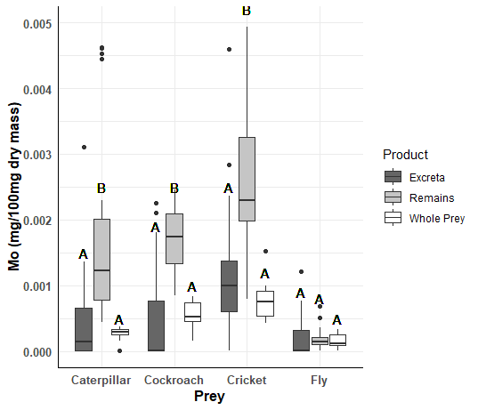

Supplementary Figure 14: The effects of product and prey type on Na concentrations. Groups not containing the same letter were significantly different by Games-Howell post-hoc analysis. Letters do not connect across prey groups.

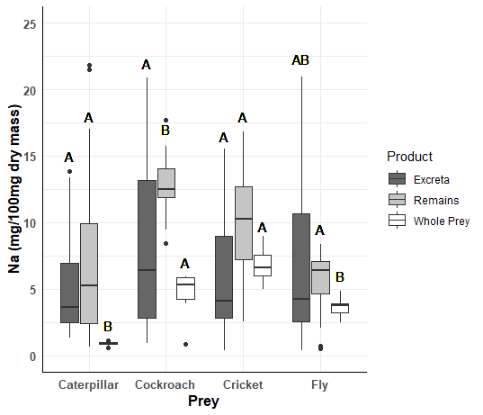

Supplementary Figure 15: The effects of product and prey type on Ni concentrations. Groups not containing the same letter were significantly different by Games-Howell post-hoc analysis. Letters do not connect across prey groups.

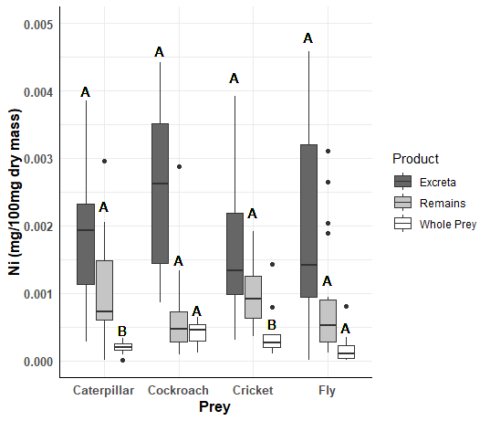

Supplementary Figure 16: The effects of product and prey type on P concentrations. Groups not containing the same letter were significantly different by Games-Howell post-hoc analysis. Letters do not connect across prey groups.

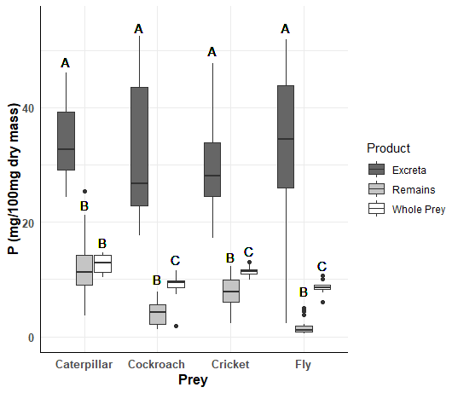

Supplementary Figure 17: The effects of product and prey type on S concentrations. Groups not containing the same letter were significantly different by Games-Howell post-hoc analysis. Letters do not connect across prey groups.

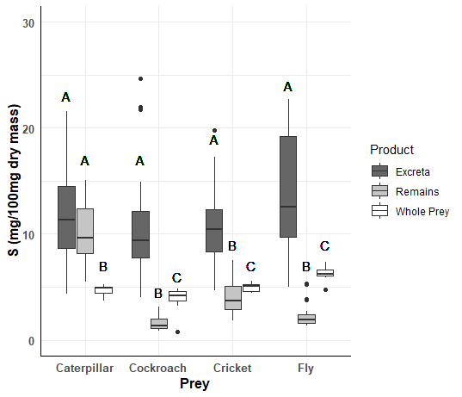

Supplementary Figure 18: The effects of product and prey type on Si concentrations. Groups not containing the same letter were significantly different by Games-Howell post-hoc analysis. Letters do not connect across prey groups.

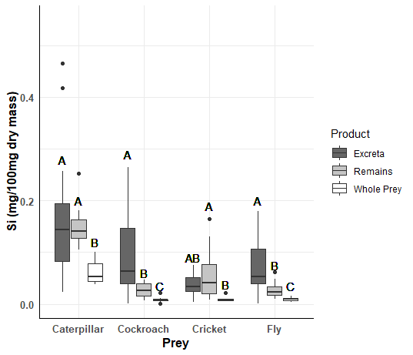

Supplementary Figure 19: The effects of product and prey type on Sr concentrations. Groups not containing the same letter were significantly different by Games-Howell post-hoc analysis. Letters do not connect across prey groups.

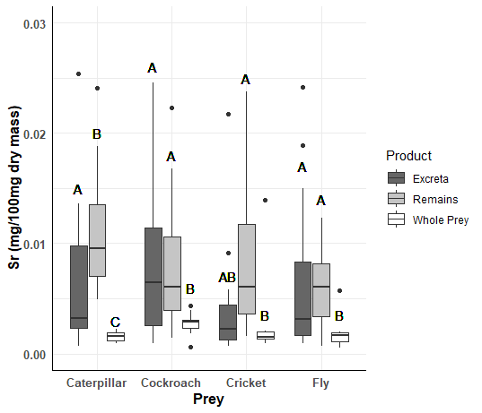

Supplementary Figure 20: The effects of product and prey type on V concentrations. Groups not containing the same letter were significantly different by Games-Howell post-hoc analysis. Letters do not connect across prey groups.

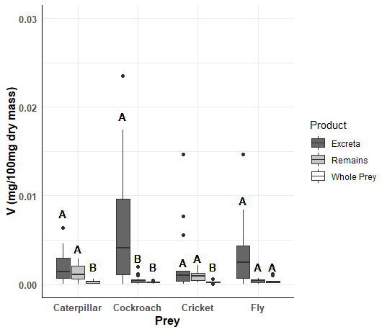

Supplementary Figure 21: The effects of product and prey type on Zn concentrations. Groups not containing the same letter were significantly different by Games-Howell post-hoc analysis. Letters do not connect across prey groups.

