Table 2. List of top twenty-five molecules selected based on Fingerprint based 2D QSAR.
Sr.No. | Code assigned | No of QSAR models ligands predicted was as active | IUPAC Name | 2D structure
 | 108535 | 86 | (1S,3R,4S,6R)-7-oxabicyclo[4.1.0]heptane-3,4-dicarbonitrile | 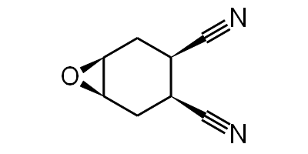
 | 109586 | 87 | (2S,3S,4R,5S)-2-(4-hydroxyanilino)oxane-3,4,5-triol | 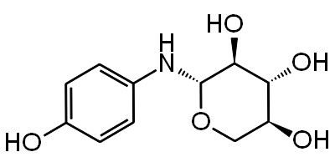
 | 115183 | 87 | (2S,3S,4R,5S,6S)-2-(4-hydroxyanilino)-6-(hydroxymethyl)oxane-3,4,5-triol | 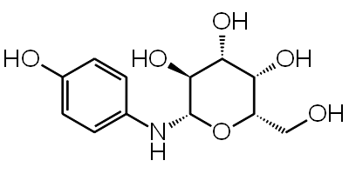
 | 122155 | 85 | ethyl (4S)-6-amino-5-cyano-4-(2,5-diethoxyphenyl)-2-methyl-4H-pyran-3-carboxylate | 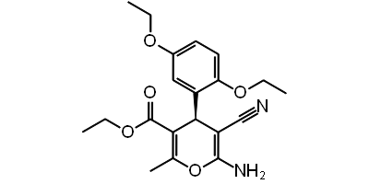
 | 123435 | 85 | (2R)-2-(5-hydroxy-4-oxo-2-phenylchromen-7-yl)oxypropanoate | 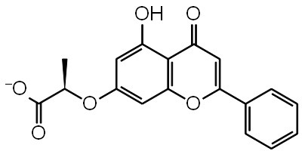
 | 125036 | 87 | 1,5-Diethyl 2,4-dicyano-3-(3,5-dichloro-2-hydroxyphenyl)pentanedioate | 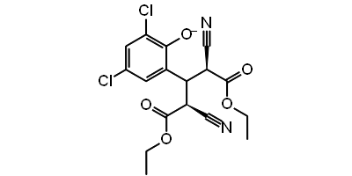
 | 125037 | 85 | 1,5-Diethyl 2,4-dicyano-3-(3,5-dibromo-2-hydroxyphenyl)pentanedioate | 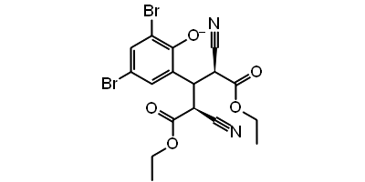
 | 126004 | 85 | ethyl (2R,3R)-2-[(2,2-dichloroacetyl)amino]-3-(2,2-dichloroacetyl)oxy-3-phenylpropanoate | 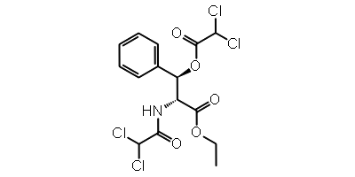
 | 129318 | 85 | (4S)-2-amino-4-(2,5-diethoxyphenyl)-7-hydroxy-4H-chromene-3-carbonitrile | 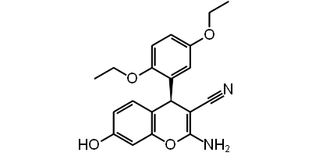
 | 129323 | 85 | ethyl (4S)-6-amino-5-cyano-4-(4-fluorophenyl)-2-methyl-4H-pyran-3-carboxylate | 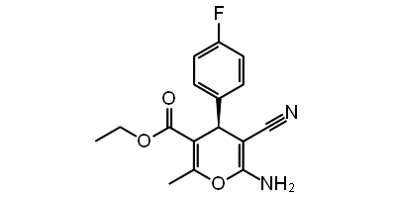
 | 130971 | 85 | ethyl (4S)-6-amino-5-cyano-4-(2-fluorophenyl)-2-propyl-4H-pyran-3-carboxylate | 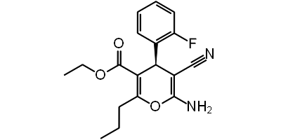
 | 130985 | 85 | ethyl (4S)-6-amino-5-cyano-2-ethyl-4-(2-fluorophenyl)-4H-pyran-3-carboxylate | 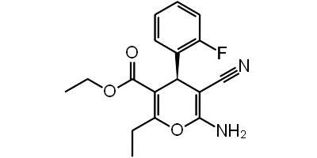
 | 132665 | 85 | (4S)-2-amino-4-(1,3-benzodioxol-5-yl)-7-hydroxy-4H-chromene-3-carbonitrile | 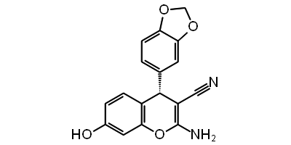
 | 133079 | 85 | 1,5-Diethyl 2,4-dicyano-3-(3,5-dibromo-2-hydroxyphenyl) pentanedioate | 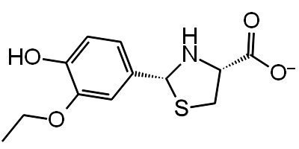
 | 133584 | 85 | 3-Hydroxy-4-[(2,3,4,6-tetra-O-acetyl-β-D-glucopyranosyl)oxy]benzaldehyde | 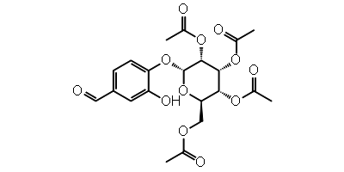
 | 135489 | 85 | ethyl (4S)-6-amino-5-cyano-4-(2-ethoxyphenyl)-2-methyl-4H-pyran-3-carboxylate | 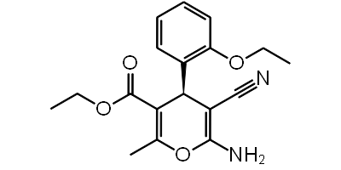
 | 136530 | 85 | (4S)-2,7-diamino-4-(4-chlorophenyl)-4H-chromene-3-carbonitrile | 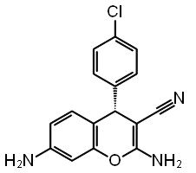
 | 136532 | 85 | ethyl (4S)-2-amino-4-(3-chlorophenyl)-5-oxo-4,6,7,8-tetrahydrochromene-3-carboxylate | 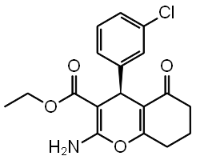
 | 136540 | 85 | (4S)-2,7-diamino-4-(3-chlorophenyl)-4H-chromene-3-carbonitrile | 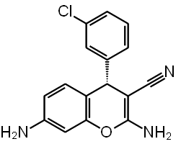
 | 139882 | 85 | ethyl (4S)-6-amino-5-cyano-4-(2,6-dichlorophenyl)-2-methyl-4H-pyran-3-carboxylate | 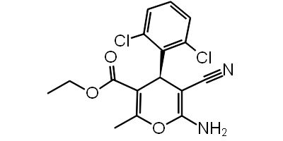
 | 142354 | 87 | Diacetone-D-galacturonic acid | 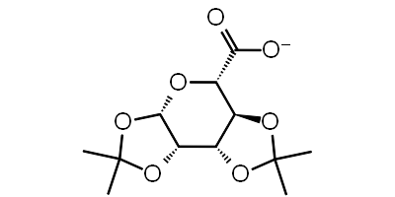
 | 197105 | 87 | (2S,3R)-2-(carbamoylamino)-3-hydroxybutanoate | 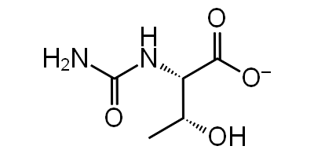
 | 253878 | 87 | (2S)-2-(2,4-difluorophenoxy)propanoate | 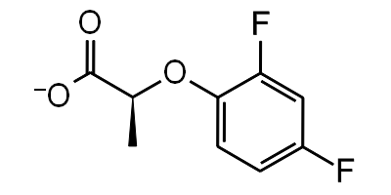
 | 256085 | 87 | (2R)-2-(4-fluorophenoxy)butanoate | 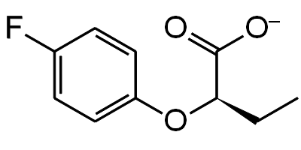
 | 261126 | 86 | 6-chloro-4-oxochromene-2-carboxylate | 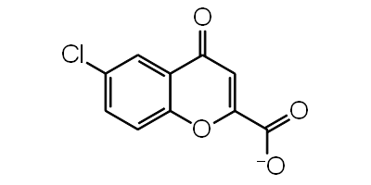

Table 4. 2D interaction diagrams of the top five lead molecules selected after molecular docking and derivates of 261126, 123435 with a summary of docking score, binding energy, and all non-bonding interactions
Sr. No. | Title | Docking Score  (kcal/mol) | MMGBSA dg-bind  (kcal/mol) | 2D Interaction diagram | Non-bonding interactions
 | 197105 | -4.978 | -19.83 | 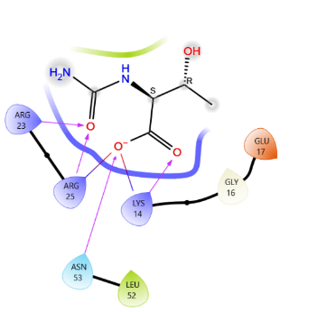 | H-bond: Lys 14, Asn 53, Arg 23, Arg 25  Salt bridge: Lys 14  Charged negative: Glu 17  Charged positive: Arg 15  Hydrophobic: Leu 52, Gly 16
 | 261126 | -4.876 | -33.17 | 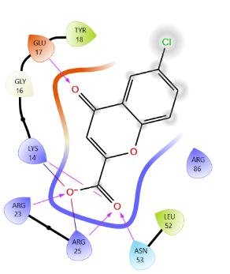 | H-bond: Glu 17, Lys 14, Arg 23, Arg 25, Asn 53  Salt bridge: Lys 14  Charged positive: Arg 86  Hydrophobic: Gly 16, Tyr 18, Leu 52
 | 253878 | -4.821 | -17.27 | 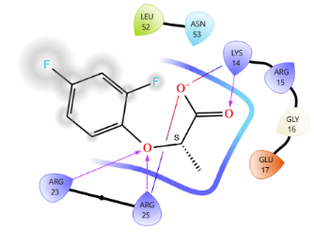 | H-bond: Arg 23, Arg 25, Lys 14  Salt bridge: Lys 14, Arg 25  Charged negative: Glu 17  Charged positive: Arg 15  Polar: Asn 53  Hydrophobic: Leu 52, Gly 16
 | 256085 | -4.803 | -20.63 | 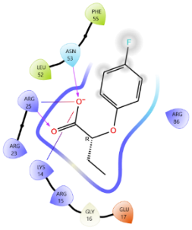 | H-bond: Arg 25, Asn 53  Salt bridge: Lys 14, Arg 25  Charged negative: Glu 17  Charged positive: Arg 86, Arg 15, Arg 23  Hydrophobic: Gly 16, Leu 52, Phe 55
 | 123435 | -4.605 | -39.89 | 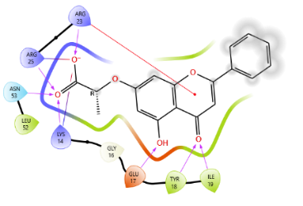 | H-bond: Arg 23, Arg 25, Ile 19, Tyr 18, Glu 17, Asn 53, Lys 14  Salt bridge: Arg 25, Lys 14  Pi cation interaction: Arg 23  Hydrophobic: Gly 16, Leu 52
Derivatives of 261126
 | 12289533 | -6.3 | -76.71 | 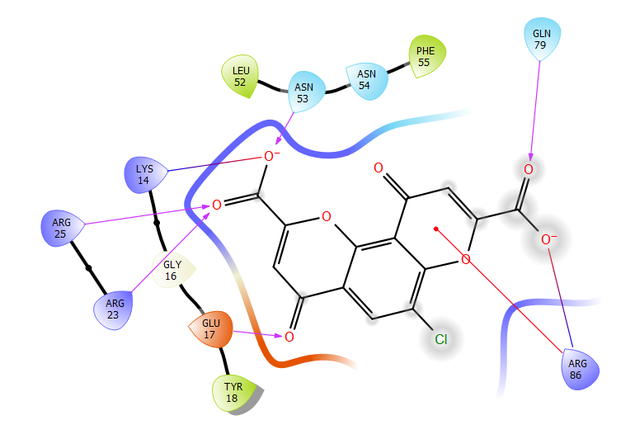 | H-bond: Asn 53, Gln 79, Glu 17, Arg 23, Arg 25  Salt bridge: Arg 86, Lys 14  Pi cation interaction: Arg 86  Polar: Asn 54  Hydrophobic: Leu 52, Phe 55, Tyr 18, Glu 16
 | 12785801 | -6.027 | -34.09 | 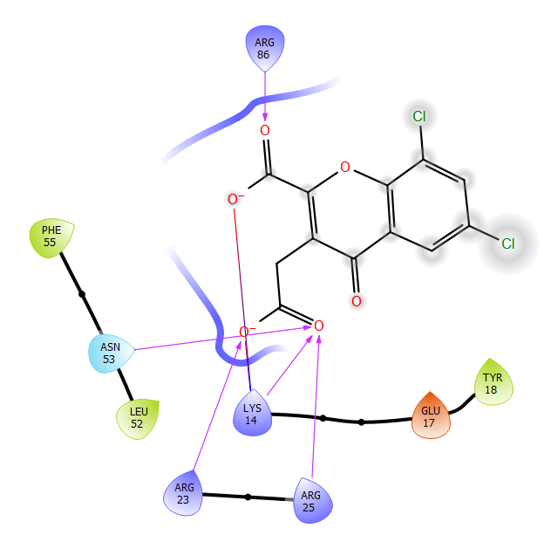 | H-bond: Arg 86, Asn 53, Arg 23, Arg 25, Lys 14  Salt bridge: Lys 14  Charged negative: Glu 17  Hydrophobic: Tyr 18, Leu 52, Phe 55
 | 83824832 | -5.965 | -30.19 | 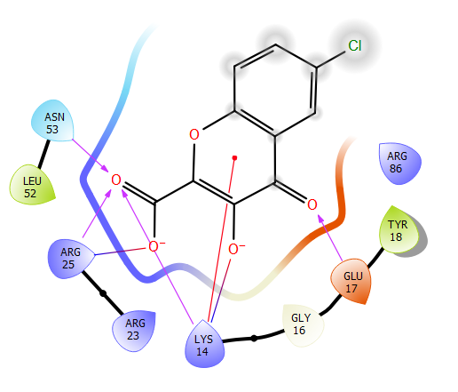 | H-bond: Asn 53, Arg 25, Lys 14, Glu 17  Salt bridge: Arg 25, Lys 14  Pi cation interaction: Lys 14  Charged positive: Arg 86, Arg 23  Hydrophobic: Tyr 18, Leu 52, Gly 16
Derivatives of 123435
 | 102479045 | -6.291 | -40.89 | 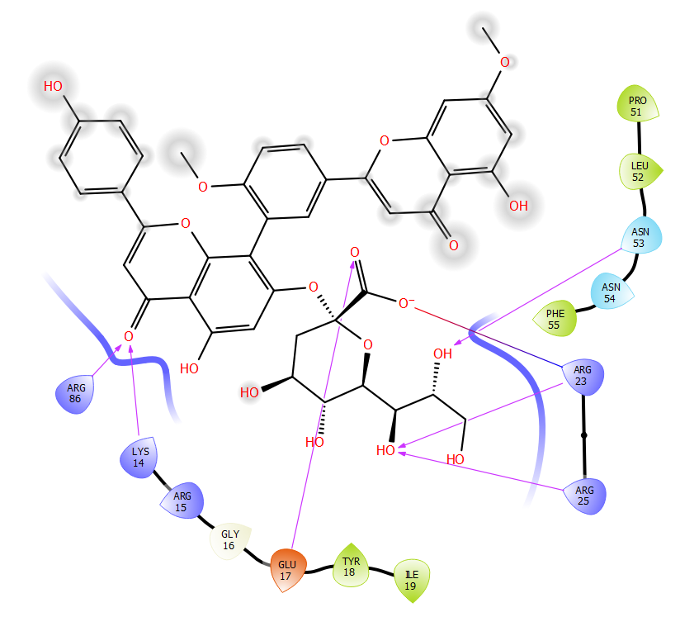 | H-bond: Arg 23, Asn 53, Arg 25, Glu 17, Lys 14, Arg 86  Salt bridge: Arg 23  Charged positive: Arg 15  Polar: Asn 54  Hydrophobic: Pro 51, Leu 52, Phe 55, Tyr 18, Ile 19, Gly 16
 | 6972939 | -6.222 | -44.88 | 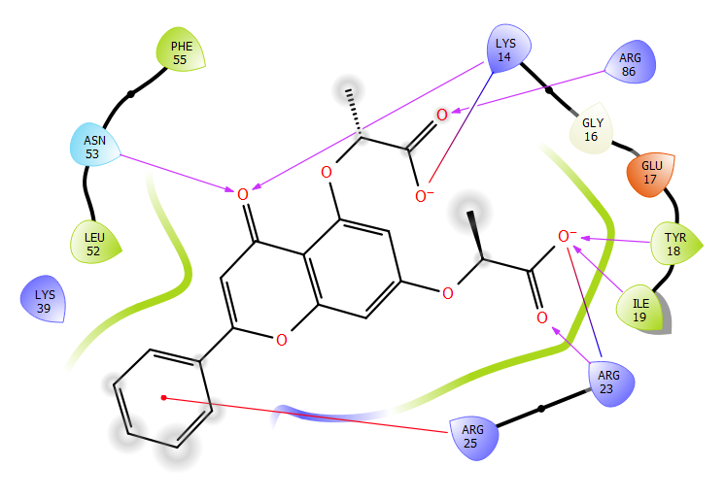 | H-bond: Arg 86, Tyr 18, Ile 19, Arg 23, Asn 53  Salt bridge: Lys 14, Arg 23  Pi cation interaction: Arg 25  Charged negative: Glu 17  Charged positive: Lys 39  Hydrophobic: Leu 52, Phe 55, Gly 16

