TABLE OF CONTENTS
- Tables
  - Full regression table, Table S1
  - Unimputed results, Table S2
  - MSEL raw score trajectories, Table S3
  - MSEL males only AE score trajectories, Table S4
  - MSEL males only raw score trajectories, Table S5
- Figures
  - MSEL raw score trajectories, Figures S1-S5
  - MSEL males only composite and AE score trajectories, Figures S6-S12
  - MSEL males only raw score trajectories, Figures S13-S17

SUPPLEMENTAL RESULTS - TABLES
Table S1. Regression Model Estimates of Group on MSEL Measures, extended
 | Beta | SE | t-statistic | df | p-value | Cohen's d
NVDQ
Intercept | 113.012 | 1.606 | 70.37 | 869.1 | < 0.001 | --
Visit (Ordinal) | 0.514 | 0.887 | 0.579 | 1296.361 | 0.563 | 0.0356
FXS | -16.976 | 3.446 | -4.927 | 52.642 | < 0.001 | -0.499
FH-ASD | -3.711 | 2.299 | -1.614 | 106.451 | 0.11 | -0.1548
FH-nonASD | -3.291 | 1.525 | -2.158 | 836.362 | 0.031 | -0.1912
Male | -3.706 | 0.928 | -3.992 | 776.727 | < 0.001 | -0.2494
UW Site | -0.886 | 1.319 | -0.672 | 1027.887 | 0.502 | -0.0417
WU Site | -4.751 | 1.329 | -3.576 | 269.06 | < 0.001 | -0.2309
UNC Site | 1.584 | 1.337 | 1.185 | 190.873 | 0.238 | 0.11
Visit x FXS | -7.204 | 2.357 | -3.056 | 120.012 | 0.003 | -0.2912
Visit x FH-ASD | -7.862 | 1.612 | -4.878 | 260.386 | < 0.001 | -0.4484
Visit x FH-nonASD | -1.117 | 1.11 | -1.006 | 1084.541 | 0.315 | -0.0623
VDQ
Intercept | 92.905 | 1.792 | 51.844 | 907.389 | < 0.001 | --
Visit (Ordinal) | 7.955 | 0.951 | 8.369 | 1145.744 | < 0.001 | 0.5174
FXS | -10.672 | 3.37 | -3.167 | 498.394 | 0.002 | -0.2848
FH-ASD | -2.97 | 2.396 | -1.239 | 364.619 | 0.216 | -0.1125
FH-nonASD | -3.175 | 1.689 | -1.88 | 677.655 | 0.061 | -0.1676
Male | -3.254 | 1.06 | -3.07 | 711.215 | 0.002 | -0.1922
UW Site | -2.103 | 1.504 | -1.398 | 998.421 | 0.162 | -0.0868
WU Site | -4.487 | 1.477 | -3.039 | 581.387 | 0.002 | -0.1913
UNC Site | 5.407 | 1.443 | 3.748 | 1036.312 | < 0.001 | 0.3303
Visit x FXS | -21.113 | 2.482 | -8.508 | 155.22 | < 0.001 | -0.7993
Visit x FH-ASD | -14.976 | 1.725 | -8.682 | 242.928 | < 0.001 | -0.7996
Visit x FH-nonASD | -2.292 | 1.185 | -1.935 | 1105.263 | 0.053 | -0.1198
RL
Intercept | 4.855 | 0.406 | 11.953 | 207.54 | < 0.001 | --
Visit (Ordinal) | 10.858 | 0.234 | 46.477 | 992.702 | < 0.001 | 2.884
FXS | 0.232 | 0.756 | 0.307 | 556.185 | 0.759 | 0.0275
FH-ASD | 0.786 | 0.545 | 1.442 | 279.464 | 0.15 | 0.132
FH-nonASD | -0.098 | 0.398 | -0.247 | 183.318 | 0.805 | -0.0231
Male | -0.581 | 0.214 | -2.718 | 1058.369 | 0.007 | -0.1684
UW Site | 0.048 | 0.305 | 0.156 | 1204.664 | 0.876 | 0.0096
WU Site | -0.796 | 0.311 | -2.558 | 213.89 | 0.011 | -0.1665
UNC Site | 0.942 | 0.298 | 3.164 | 652.31 | 0.002 | 0.2823
Visit x FXS | -5.784 | 0.612 | -9.454 | 135.437 | < 0.001 | -0.8945
Visit x FH-ASD | -4.803 | 0.42 | -11.429 | 277.155 | < 0.001 | -1.0473
Visit x FH-nonASD | -0.963 | 0.299 | -3.218 | 366.347 | 0.001 | -0.2054
EL
Intercept | 5.168 | 0.378 | 13.687 | 1026.091 | < 0.001 | --
Visit (Ordinal) | 9.907 | 0.228 | 43.527 | 1121.364 | < 0.001 | 2.6921
FXS | -0.35 | 0.765 | -0.458 | 207.861 | 0.648 | -0.0426
FH-ASD | 0.339 | 0.515 | 0.659 | 872.648 | 0.51 | 0.0583
FH-nonASD | -0.141 | 0.371 | -0.38 | 730.885 | 0.704 | -0.0339
Male | -0.722 | 0.216 | -3.346 | 337.514 | 0.001 | -0.2141
UW Site | -0.399 | 0.298 | -1.336 | 1176.517 | 0.182 | -0.0825
WU Site | -0.535 | 0.291 | -1.84 | 892.488 | 0.066 | -0.1145
UNC Site | 1.156 | 0.285 | 4.053 | 1338.254 | < 0.001 | 0.3547
Visit x FXS | -4.843 | 0.59 | -8.21 | 179.026 | < 0.001 | -0.766
Visit x FH-ASD | -3.254 | 0.392 | -8.307 | 1382.646 | < 0.001 | -0.726
Visit x FH-nonASD | -0.766 | 0.285 | -2.687 | 875.34 | 0.007 | -0.1673
FM
Intercept | 6.691 | 0.247 | 27.044 | 1029.921 | < 0.001 | --
Visit (Ordinal) | 9.39 | 0.141 | 66.473 | 1141.057 | < 0.001 | 4.1115
FXS | -1.264 | 0.465 | -2.718 | 1279.802 | 0.007 | -0.2381
FH-ASD | 0.076 | 0.337 | 0.224 | 471.383 | 0.823 | 0.02
FH-nonASD | -0.067 | 0.247 | -0.27 | 244.559 | 0.787 | -0.0249
Male | -0.519 | 0.14 | -3.698 | 1205.827 | < 0.001 | -0.2285
UW Site | 0.339 | 0.203 | 1.673 | 875.023 | 0.095 | 0.1042
WU Site | -0.341 | 0.197 | -1.729 | 688.463 | 0.084 | -0.1087
UNC Site | 1.197 | 0.197 | 6.075 | 559.643 | < 0.001 | 0.5445
Visit x FXS | -2.773 | 0.384 | -7.231 | 80.632 | < 0.001 | -0.7077
Visit x FH-ASD | -1.871 | 0.244 | -7.668 | 1241.422 | < 0.001 | -0.6728
Visit x FH-nonASD | -0.687 | 0.179 | -3.848 | 630.551 | < 0.001 | -0.2418
GM
Intercept | 5.7 | 0.288 | 19.777 | 770.588 | < 0.001 | --
Visit (Ordinal) | 9.014 | 0.165 | 54.491 | 1284.756 | < 0.001 | 3.3578
FXS | -1.641 | 0.554 | -2.964 | 521.764 | 0.003 | -0.2661
FH-ASD | -0.224 | 0.396 | -0.565 | 333.27 | 0.572 | -0.0516
FH-nonASD | -0.216 | 0.281 | -0.771 | 494.052 | 0.441 | -0.0693
Male | -0.175 | 0.162 | -1.077 | 869.527 | 0.282 | -0.067
UW Site | 0.447 | 0.234 | 1.909 | 661.129 | 0.057 | 0.1197
WU Site | -0.021 | 0.231 | -0.09 | 335.162 | 0.929 | -0.0058
UNC Site | 1.661 | 0.224 | 7.409 | 739.805 | < 0.001 | 0.659
Visit x FXS | -2.143 | 0.428 | -5.002 | 198.928 | < 0.001 | -0.4649
Visit x FH-ASD | -1.507 | 0.289 | -5.208 | 895.075 | < 0.001 | -0.4608
Visit x FH-nonASD | -0.37 | 0.211 | -1.757 | 560.685 | 0.079 | -0.1107
VR
Intercept | 6.372 | 0.338 | 18.825 | 872.224 | < 0.001 | --
Visit (Ordinal) | 10.394 | 0.203 | 51.293 | 1225.89 | < 0.001 | 3.1652
FXS | -0.328 | 0.65 | -0.505 | 987.532 | 0.614 | -0.0445
FH-ASD | 0.46 | 0.471 | 0.978 | 370.574 | 0.329 | 0.0886
FH-nonASD | -0.04 | 0.334 | -0.12 | 528.291 | 0.904 | -0.0109
Male | -0.651 | 0.188 | -3.458 | 756.931 | 0.001 | -0.2163
UW Site | 0.189 | 0.264 | 0.719 | 1546.634 | 0.472 | 0.044
WU Site | -0.791 | 0.256 | -3.089 | 1397.877 | 0.002 | -0.1897
UNC Site | 0.347 | 0.255 | 1.363 | 1350.045 | 0.173 | 0.1193
Visit x FXS | -4.058 | 0.582 | -6.97 | 43.777 | < 0.001 | -0.72
Visit x FH-ASD | -2.968 | 0.353 | -8.417 | 1044.246 | < 0.001 | -0.742
Visit x FH-nonASD | -0.723 | 0.254 | -2.841 | 900.592 | 0.005 | -0.1768

Table S2. Regression Model Estimates of Group on MSEL Measures, Unimputed Results
 | Beta | SE | t-statistic | df | p-value | Cohen's d
NVDQ
Intercept | 113.627 | 1.600 | 71.007 | 928 | < 0.001 | --
Visit (Ordinal) | 0.766 | 0.853 | 0.898 | 928 | 0.369 | 0.059
FXS | -25.096 | 3.431 | -7.315 | 534 | < 0.001 | -0.633
FH-ASD | -5.463 | 2.194 | -2.490 | 534 | 0.013 | -0.216
FH-nonASD | -4.429 | 1.534 | -2.887 | 534 | 0.004 | -0.250
Male | -4.200 | 0.941 | -4.465 | 534 | < 0.001 | -0.293
UW Site | -0.848 | 1.336 | -0.635 | 534 | 0.526 | -0.042
WU Site | -5.190 | 1.307 | -3.972 | 534 | < 0.001 | -0.261
UNC Site | 1.801 | 1.291 | 1.395 | 534 | 0.164 | 0.121
Visit x FXS | -7.244 | 2.472 | -2.930 | 928 | 0.003 | -0.254
Visit x FH-ASD | -7.095 | 1.523 | -4.658 | 928 | < 0.001 | -0.403
Visit x FH-nonASD | -0.715 | 1.075 | -0.665 | 928 | 0.506 | -0.044
VDQ
Intercept | 93.562 | 1.759 | 53.176 | 926 | < 0.001 | --
Visit (Ordinal) | 8.428 | 0.896 | 9.403 | 926 | < 0.001 | 0.618
FXS | -18.147 | 3.717 | -4.882 | 534 | < 0.001 | -0.422
FH-ASD | -4.864 | 2.376 | -2.047 | 534 | 0.041 | -0.177
FH-nonASD | -5.102 | 1.663 | -3.068 | 534 | 0.002 | -0.266
Male | -3.350 | 1.052 | -3.185 | 534 | 0.002 | -0.209
UW Site | -2.483 | 1.495 | -1.661 | 534 | 0.097 | -0.109
WU Site | -5.378 | 1.462 | -3.679 | 534 | < 0.001 | -0.242
UNC Site | 5.919 | 1.444 | 4.099 | 534 | < 0.001 | 0.355
Visit x FXS | -18.471 | 2.619 | -7.052 | 926 | < 0.001 | -0.610
Visit x FH-ASD | -14.141 | 1.606 | -8.808 | 926 | < 0.001 | -0.762
Visit x FH-nonASD | -1.410 | 1.131 | -1.247 | 926 | 0.213 | -0.082
RL
Intercept | 4.953 | 0.383 | 12.937 | 926 | < 0.001 | --
Visit (Ordinal) | 10.938 | 0.228 | 47.984 | 926 | < 0.001 | 3.154
FXS | 0.239 | 0.849 | 0.281 | 534 | 0.779 | 0.024
FH-ASD | 0.523 | 0.546 | 0.958 | 534 | 0.339 | 0.083
FH-nonASD | -0.421 | 0.381 | -1.106 | 534 | 0.269 | -0.096
Male | -0.652 | 0.214 | -3.053 | 534 | 0.002 | -0.201
UW Site | 0.029 | 0.303 | 0.094 | 534 | 0.925 | 0.006
WU Site | -0.912 | 0.297 | -3.070 | 534 | 0.002 | -0.202
UNC Site | 1.019 | 0.293 | 3.476 | 534 | < 0.001 | 0.301
Visit x FXS | -7.118 | 0.646 | -11.020 | 926 | < 0.001 | -0.954
Visit x FH-ASD | -4.749 | 0.407 | -11.677 | 926 | < 0.001 | -1.011
Visit x FH-nonASD | -0.822 | 0.287 | -2.862 | 926 | 0.004 | -0.188
EL
Intercept | 5.296 | 0.391 | 13.544 | 926 | < 0.001 | --
Visit (Ordinal) | 9.946 | 0.222 | 44.801 | 926 | < 0.001 | 2.945
FXS | -0.650 | 0.855 | -0.761 | 534 | 0.447 | -0.066
FH-ASD | 0.087 | 0.548 | 0.159 | 534 | 0.873 | 0.014
FH-nonASD | -0.428 | 0.383 | -1.118 | 534 | 0.264 | -0.097
Male | -0.791 | 0.223 | -3.540 | 534 | < 0.001 | -0.233
UW Site | -0.449 | 0.317 | -1.415 | 534 | 0.158 | -0.093
WU Site | -0.635 | 0.311 | -2.042 | 534 | 0.042 | -0.134
UNC Site | 1.217 | 0.307 | 3.967 | 534 | < 0.001 | 0.343
Visit x FXS | -5.734 | 0.635 | -9.026 | 926 | < 0.001 | -0.781
Visit x FH-ASD | -3.149 | 0.397 | -7.941 | 926 | < 0.001 | -0.687
Visit x FH-nonASD | -0.638 | 0.280 | -2.279 | 926 | 0.023 | -0.150
FM
Intercept | 6.737 | 0.250 | 26.939 | 928 | < 0.001 | --
Visit (Ordinal) | 9.463 | 0.132 | 71.625 | 928 | < 0.001 | 4.702
FXS | -1.720 | 0.535 | -3.218 | 534 | 0.001 | -0.278
FH-ASD | -0.054 | 0.342 | -0.158 | 534 | 0.874 | -0.014
FH-nonASD | -0.228 | 0.239 | -0.956 | 534 | 0.340 | -0.083
Male | -0.600 | 0.148 | -4.069 | 534 | < 0.001 | -0.267
UW Site | 0.351 | 0.210 | 1.673 | 534 | 0.095 | 0.110
WU Site | -0.421 | 0.205 | -2.056 | 534 | 0.040 | -0.135
UNC Site | 1.297 | 0.203 | 6.405 | 534 | < 0.001 | 0.554
Visit x FXS | -3.398 | 0.384 | -8.861 | 928 | < 0.001 | -0.767
Visit x FH-ASD | -1.837 | 0.236 | -7.788 | 928 | < 0.001 | -0.674
Visit x FH-nonASD | -0.637 | 0.167 | -3.823 | 928 | < 0.001 | -0.251
GM
Intercept | 5.637 | 0.294 | 19.150 | 911 | < 0.001 | --
Visit (Ordinal) | 9.070 | 0.158 | 57.252 | 911 | < 0.001 | 3.794
FXS | -2.230 | 0.630 | -3.537 | 534 | < 0.001 | -0.306
FH-ASD | -0.242 | 0.403 | -0.600 | 534 | 0.549 | -0.052
FH-nonASD | -0.402 | 0.282 | -1.427 | 534 | 0.154 | -0.124
Male | -0.177 | 0.173 | -1.027 | 534 | 0.305 | -0.068
UW Site | 0.510 | 0.247 | 2.068 | 534 | 0.039 | 0.137
WU Site | -0.001 | 0.241 | -0.004 | 534 | 0.997 | -0.000
UNC Site | 1.873 | 0.238 | 7.861 | 534 | < 0.001 | 0.680
Visit x FXS | -2.645 | 0.456 | -5.799 | 911 | < 0.001 | -0.502
Visit x FH-ASD | -1.592 | 0.285 | -5.595 | 911 | < 0.001 | -0.484
Visit x FH-nonASD | -0.310 | 0.200 | -1.552 | 911 | 0.121 | -0.103
VR
Intercept | 6.475 | 0.335 | 19.313 | 928 | < 0.001 | --
Visit (Ordinal) | 10.473 | 0.200 | 52.429 | 928 | < 0.001 | 3.442
FXS | -0.553 | 0.744 | -0.743 | 534 | 0.458 | -0.064
FH-ASD | 0.232 | 0.478 | 0.485 | 534 | 0.628 | 0.042
FH-nonASD | -0.281 | 0.334 | -0.842 | 534 | 0.400 | -0.073
Male | -0.712 | 0.187 | -3.805 | 534 | < 0.001 | -0.250
UW Site | 0.158 | 0.265 | 0.594 | 534 | 0.553 | 0.039
WU Site | -0.940 | 0.260 | -3.615 | 534 | < 0.001 | -0.237
UNC Site | 0.361 | 0.257 | 1.408 | 534 | 0.160 | 0.122
Visit x FXS | -5.115 | 0.566 | -9.037 | 928 | < 0.001 | -0.782
Visit x FH-ASD | -2.888 | 0.356 | -8.120 | 928 | < 0.001 | -0.703
Visit x FH-nonASD | -0.621 | 0.252 | -2.470 | 928 | 0.014 | -0.162

Group Contrast Estimates (SE)
 | FXS v.  FH-ASD | FXS v.  FH-nonASD | FXS v.  Control | FH-ASD v.  FH-nonASD | FH-ASD v.  Control | FH-nonASD v.  Control
V06
RL | -0.06 (0.66) | 0.55 (0.59) | 0.46 (0.62) | 0.61 (0.40) | 0.51 (0.43) | -0.09 (0.31)
EL | -0.31 (0.71) | 0.01 (0.64) | -0.17 (0.64) | 0.31 (0.40) | 0.14 (0.43) | -0.17 (0.31)
FM | -1.00 (0.48) | -1.02 (0.45) | -1.18 (0.45) | -0.02 (0.27) | -0.19 (0.29) | -0.16 (0.22)
GM | -1.12 (0.63) | -1.27 (0.58) | -1.58 (0.59) | -0.15 (0.32) | -0.45 (0.34) | -0.31 (0.24)
VR | -0.51 (0.63) | -0.36 (0.57) | -0.59 (0.58) | 0.15 (0.37) | -0.08 (0.38) | -0.23 (0.28)
V12
RL | -1.88 (0.44) | -4.46 (0.40) | -5.24 (0.42) | -2.57 (0.25) | -3.36 (0.27) | -0.79 (0.19)
EL | -2.38 (0.46) | -4.11 (0.41) | -4.86 (0.43) | -1.73 (0.25 | -2.49 (0.27) | -0.76 (0.20)
FM | -2.17 (0.31) | -3.08 (0.29) | -3.74 (0.29) | -0.91 (0.19) | -1.57 (0.20) | -0.66 (0.15)
GM | -2.17 (0.41) | -3.09 (0.38) | -3.61 (0.38) | -0.92 (0.21) | -1.44 (0.23) | -0.52 (0.17)
VR | -2.14 (0.41) | -3.74 (0.39) | -4.42 (0.39) | -1.59 (0.24) | -2.28 (0.26) | -0.69 (0.19)
V24
RL | -3.71 (0.72) | -9.47 (0.65) | -10.95 (0.68) | -5.75 (0.39) | -7.24 (0.43) | -1.48 (0.30)
EL | -4.45 (0.70) | -8.22 (0.63) | -9.56 (0.65) | -3.77 (0.40) | -5.12 (0.43) | -1.35 (0.31)
FM | -3.35 (0.48) | -5.14 (0.43) | -6.30 (0.44) | -1.80 (0.26) | -2.95 (0.28) | -1.16 (0.20)
GM | -3.21 (0.61) | -4.91 (0.59) | -5.64 (0.59) | -1.70 (0.32) | -2.43 (0.34) | -0.72 (0.24)
VR | -3.77 (0.60) | -7.11 (0.54) | -8.25 (0.56) | -3.34 (0.35) | -4.48 (0.38) | -1.14 (0.27)

Table S3. Estimated Marginal Means Contrasts for MSEL Raw Scores

Group Contrast Estimates (SE)
 | FXS v.  FH-ASD | FXS v.  FH-nonASD | FXS v.  Control | FH-ASD v.  FH-nonASD | FH-ASD v.  Control | FH-nonASD v.  Control
V06
NVDQ | -14.78 (3.89) | -17.84 (3.37) | -18.95 (3.77) | -3.06 (2.67) | -4.17 (2.60) | -1.11 (2.27)
VDQ | -9.46 (4.01) | -12.39 (3.93) | -13.89 (3.86) | -2.93 (2.83) | -4.44 (2.86) | -1.50 (2.31)
RL | -0.57 (0.91) | -0.02 (0.86) | -0.04 (0.92) | 0.55 (0.58) | 0.53 (0.64) | -0.02 (0.51)
EL | -0.71 (0.93) | -0.59 (0.88) | -0.68 (0.92) | 0.12 (0.55) | 0.03 (0.62) | -0.09 (0.49)
FM | -1.27 (0.59) | -1.38 (0.51) | -1.30 (0.55) | -0.11 (0.39) | -0.03 (0.38) | 0.08 (0.33)
GM | -1.68 (0.75) | -1.69 (0.69) | -1.67 (0.70) | -0.01 (0.40) | 0.01 (0.44) | 0.02 (0.37)
VR | -0.50 (0.80) | -0.36 (0.74) | -0.42 (0.78) | 0.14 (0.48) | 0.08 (0.52) | -0.06 (0.43)
V12
NVDQ | -15.80 (2.62) | -24.23 (2.33) | -27.29 (2.48) | -8.43 (1.76) | -11.49 (1.77) | -3.06 (1.49)
VDQ | -16.00 (3.68) | -30.20 (3.37) | -34.25 (3.32) | -14.20 (1.90) | -18.25 (1.98) | -4.06 (1.59)
RL | -1.76 (0.69) | -4.86 (0.63) | -5.73 (0.66) | -3.11 (0.38) | -3.97 (0.43) | -0.86 (0.33)
EL | -2.58 (0.66) | -4.60 (0.63) | -5.47 (0.66) | -2.01 (0.36) | -2.89 (0.41) | -0.88 (0.32)
FM | -2.52 (0.39) | -3.59 (0.35) | -4.34 (0.37) | -1.07 (0.24) | -1.82 (0.25) | -0.75 (0.22)
GM | -2.61 (0.50) | -3.81 (0.44) | -4.09 (0.47) | -1.19 (0.26) | -1.47 (0.29) | -0.28 (0.24)
VR | -2.39 (0.58) | -4.18 (0.52) | -4.63 (0.55) | -1.80 (0.31) | -2.25 (0.33) | -0.45 (0.28)
V24
NVDQ | -16.82 (3.64) | -30.62 (3.38) | -35.63 (3.51) | -13.80 (2.32) | -18.81 (2.53) | -5.01 (1.99)
VDQ | -22.54 (6.57) | -48.00 (5.94) | -54.61 (5.67) | -25.46 (2.59) | -32.07 (2.91) | -6.61 (2.30)
RL | -2.95 (1.19) | -9.71 (1.05) | -11.41 (1.09) | -6.76 (0.58) | -8.47 (0.64) | -1.70 (0.52)
EL | -4.46 (1.26) | -8.60 (1.15) | -10.27 (1.14) | -4.15 (0.57) | -5.81 (0.64) | -1.66 (0.49)
FM | -3.77 (0.58) | -5.80 (0.53) | -7.38 (0.54) | -2.03 (0.35) | -3.60 (0.38) | -1.57 (0.31)
GM | -3.55 (0.86) | -5.92 (0.76) | -6.50 (0.78) | -2.38 (0.41) | -2.96 (0.46) | -0.58 (0.35)
VR | -4.27 (0.95) | -8.01 (0.85) | -8.84 (0.87) | -3.74 (0.49) | -4.57 (0.53) | -0.83 (0.42)

Table S4. Estimated Marginal Means Contrasts for MSEL Composite and Age Equivalent Scores, Males Only
Group Contrast Estimates (SE)
 | FXS v.  FH-ASD | FXS v.  FH-nonASD | FXS v.  Control | FH-ASD v.  FH-nonASD | FH-ASD v.  Control | FH-nonASD v.  Control
V06
RL | -0.36 (0.77) | -0.02 (0.70) | 0.01 (0.71) | 0.35 (0.49) | 0.38 (0.53) | 0.03 (0.42)
EL | -0.41 (0.73) | -0.43 (0.68) | -0.45 (0.70) | -0.02 (0.48) | -0.04 (0.51) | -0.01 (0.43)
FM | -1.28 (0.55) | -1.32 (0.50) | -1.32 (0.51) | -0.04 (0.31) | -0.04 (0.33) | -0.00 (0.27)
GM | -1.78 (0.64) | -1.70 (0.59) | -1.79 (0.61) | 0.08 (0.41) | -0.02 (0.42) | -0.09 (0.31)
VR | -0.70 (0.65) | -0.60 (0.60) | -0.82 (0.63) | 0.10 (0.40) | -0.12 (0.44) | -0.22 (0.36)
V12
RL | -2.28 (0.62) | -4.96 (0.56) | -5.56 (0.56) | -2.68 (0.31) | -3.29 (0.34) | -0.60 (0.27)
EL | -2.89 (0.65) | -4.70 (0.59) | -5.32 (0.61) | -1.81 (0.30) | -2.42 (0.32) | -0.62 (0.28)
FM | -2.66 (0.36) | -3.51 (0.33) | -4.11 (0.34) | -0.84 (0.21) | -1.45 (0.23) | -0.60 (0.19)
GM | -2.83 (0.51) | -3.68 (0.48) | -3.92 (0.49) | -0.85 (0.25) | -1.09 (0.27) | -0.24 (0.21)
VR | -2.63 (0.58) | -4.19 (0.54) | -4.61 (0.55) | -1.55 (0.26) | -1.97 (0.29) | -0.42 (0.24)
V24
RL | -4.19 (1.23) | -9.90 (1.11) | -11.14 (1.07) | -5.71 (0.48) | -6.95 (0.54) | -1.24 (0.42)
EL | -5.38 (1.17) | -8.97 (1.10) | -10.19 (1.05) | -3.59 (0.47) | -4.81 (0.52) | -1.22 (0.42)
FM | -4.05 (0.62) | -5.70 (0.58) | -6.90 (0.56) | -1.65 (0.30) | -2.85 (0.34) | -1.20 (0.27)
GM | -3.88 (0.73) | -5.66 (0.68) | -6.05 (0.67) | -1.78 (0.35) | -2.17 (0.40) | -0.39 (0.31)
VR | -4.57 (1.01) | -7.77 (0.95) | -8.40 (0.94) | -3.20 (0.40) | -3.83 (0.50) | -0.63 (0.37)

Table S5. Estimated Marginal Means Contrasts for MSEL Raw Scores, Males Only
SUPPLEMENTAL RESULTS - FIGURES
Figure S1. MSEL Receptive Language Raw Score Trajectory by Group and Timepoint

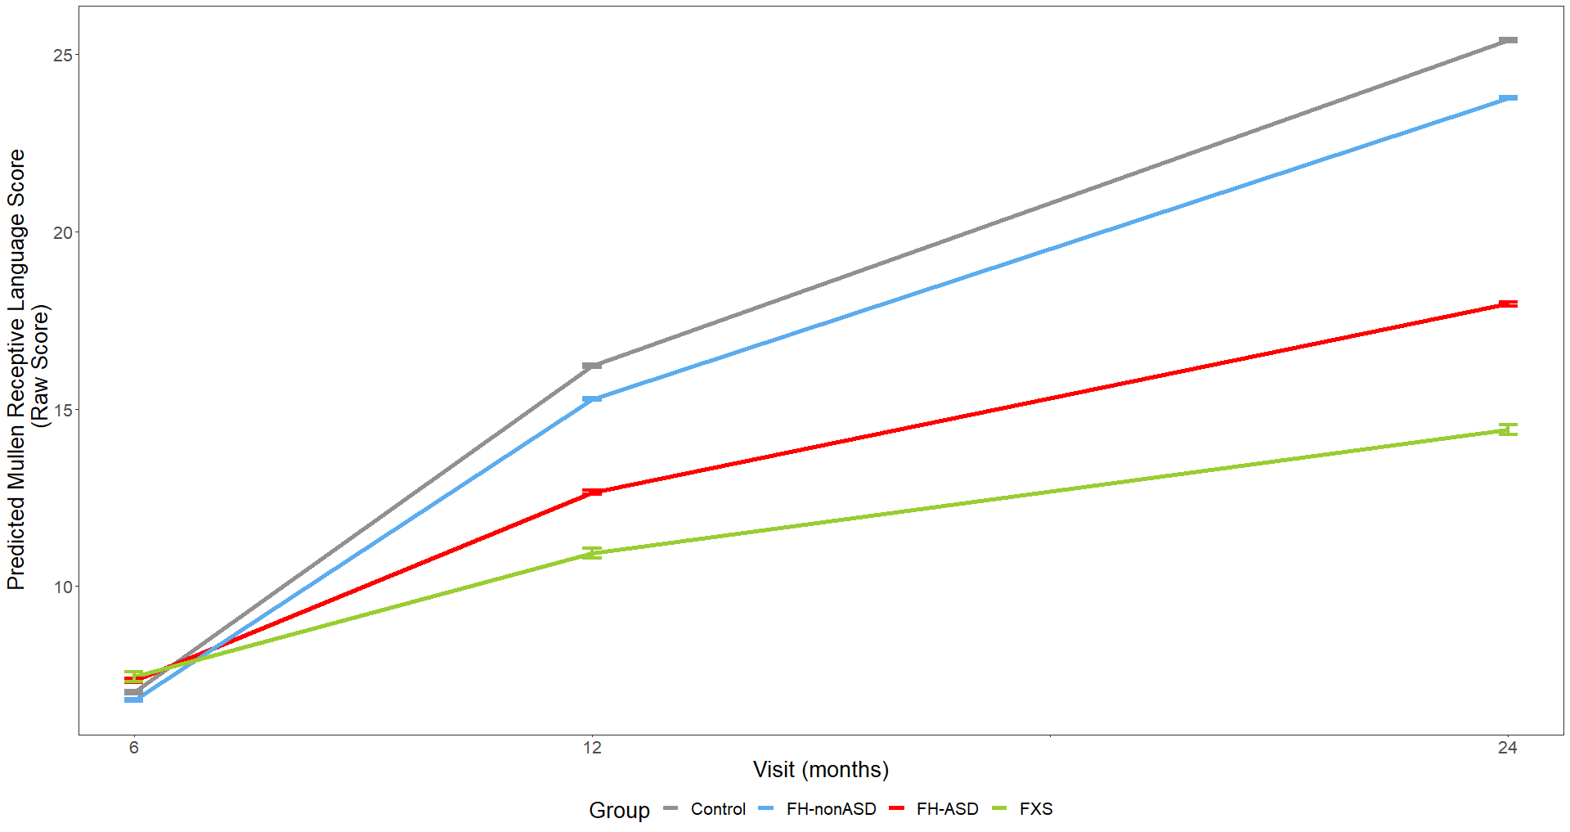

Model-generated differential trajectories of Receptive Language mean raw score from the MSEL by group and timepoint (Visit). At 6 months, no group trajectories significantly differed from one another. By 12 months of age a pattern emerged between groups (Table S3) that persisted through 24 months, such that control > FH-nonASD > FH-ASD > FXS.

Figure S2. MSEL Expressive Language Raw Score Trajectory by Group and Timepoint

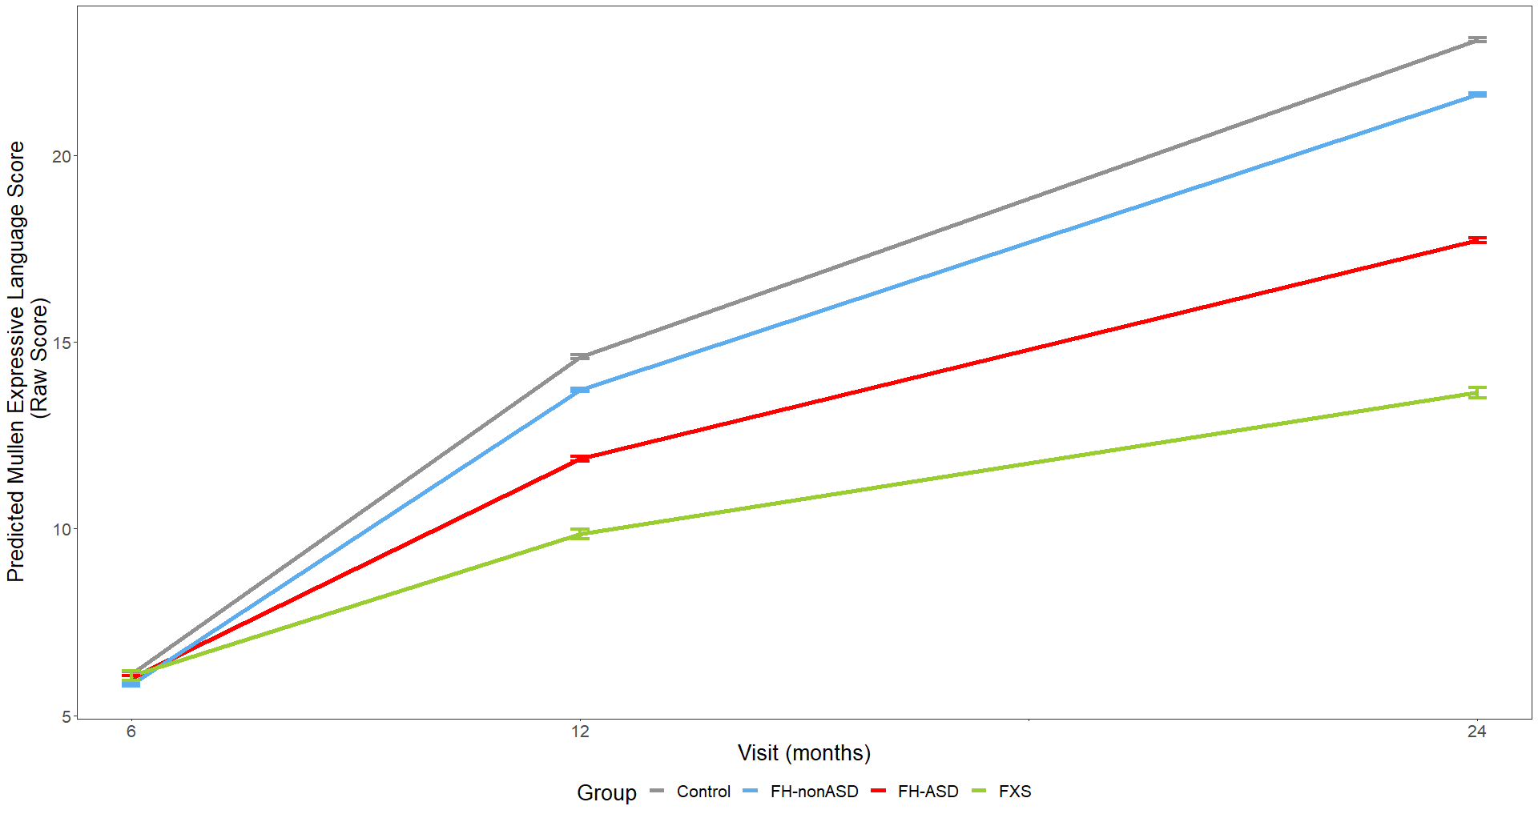

Model-generated differential trajectories of Expressive Language mean raw score from the MSEL by group and timepoint (Visit). At 6 months, no group trajectories significantly differed from one another. By 12 months of age a pattern emerged between groups (Table S3) that persisted through 24 months, such that control > FH-nonASD > FH-ASD > FXS.

Figure S3. MSEL Fine Motor Raw Score Trajectory by Group and Timepoint

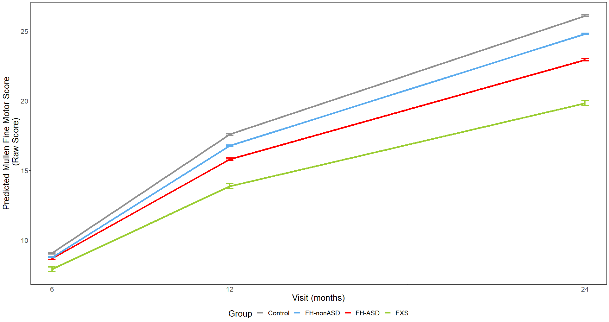

Model-generated differential trajectories of Fine Motor mean raw score from the MSEL by group and timepoint (Visit). At 6 months, no group trajectories significantly differed from one another. By 12 months of age a pattern emerged between groups (Table S3) that persisted through 24 months, such that control > FH-nonASD > FH-ASD > FXS.

Figure S4. MSEL Gross Motor Raw Score Trajectory by Group and Timepoint

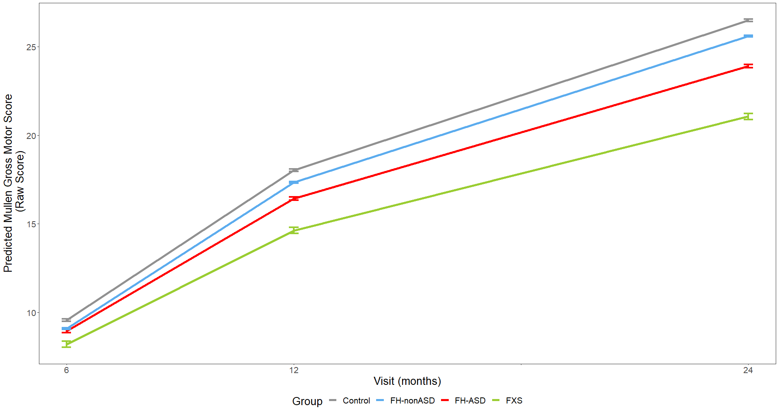

Model-generated differential trajectories of Gross Motor mean raw score from the MSEL by group and timepoint (Visit). At 6 months, no group trajectories significantly differed from one another. At 12 months, all groups significantly differed from one another such that control > FH-nonASD > FH-ASD > FXS. At 24 months, a similar pattern persisted, except for FH-nonASD and controls not significantly differing (Table S3).

Figure S5. MSEL Visual Reception Raw Score Trajectory by Group and Timepoint

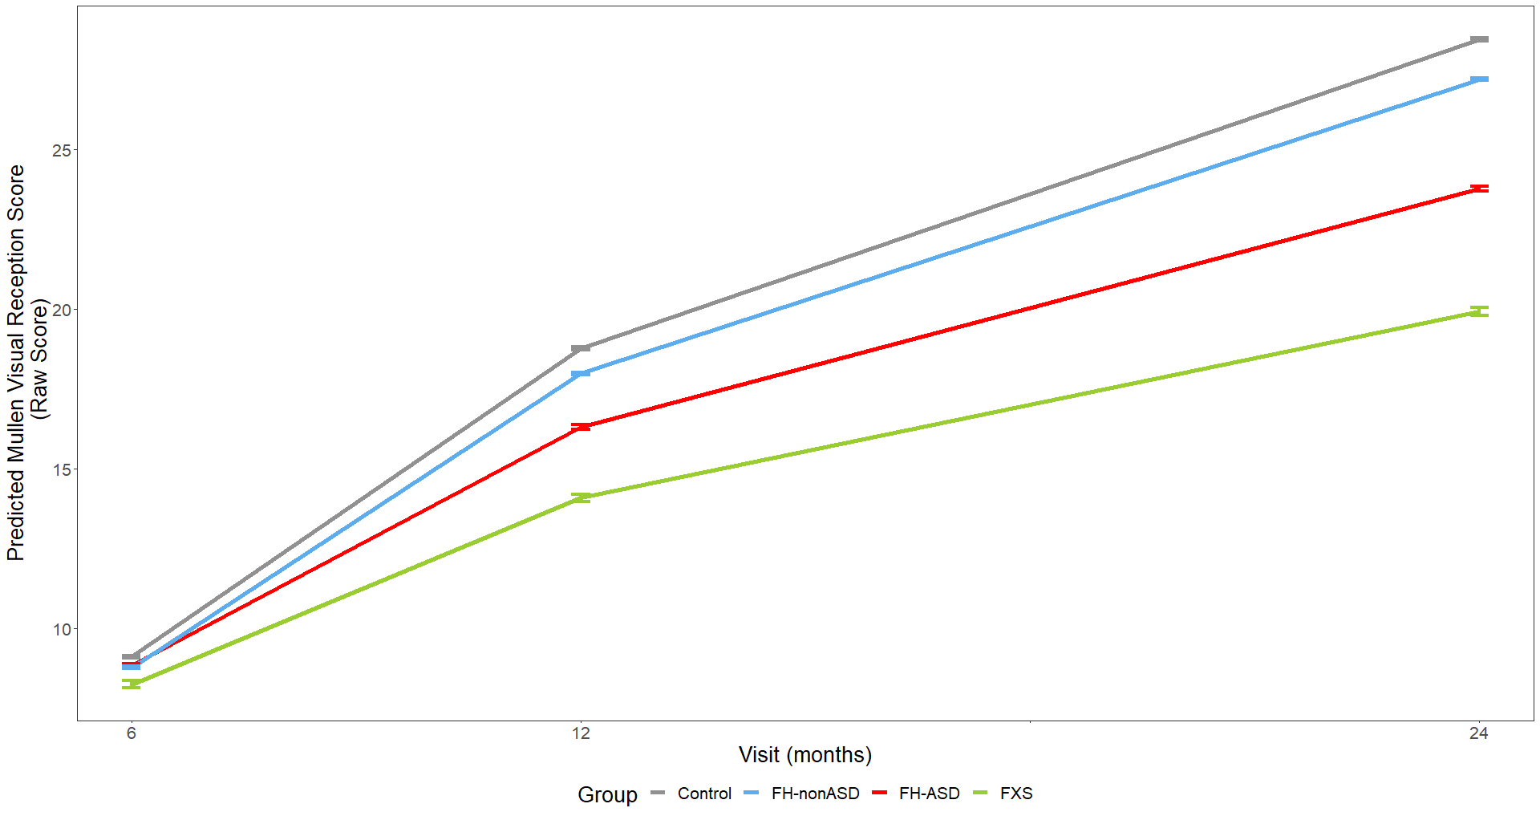

Model-generated differential trajectories of Visual Reception mean raw score from the MSEL by group and timepoint (Visit). At 6 months, no group trajectories significantly differed from one another. By 12 months of age a pattern emerged between groups (Table S3) that persisted through 24 months, such that control > FH-nonASD > FH-ASD > FXS.

Figure S6. MSEL NVDQ Score Trajectory by Group and Timepoint, Males Only

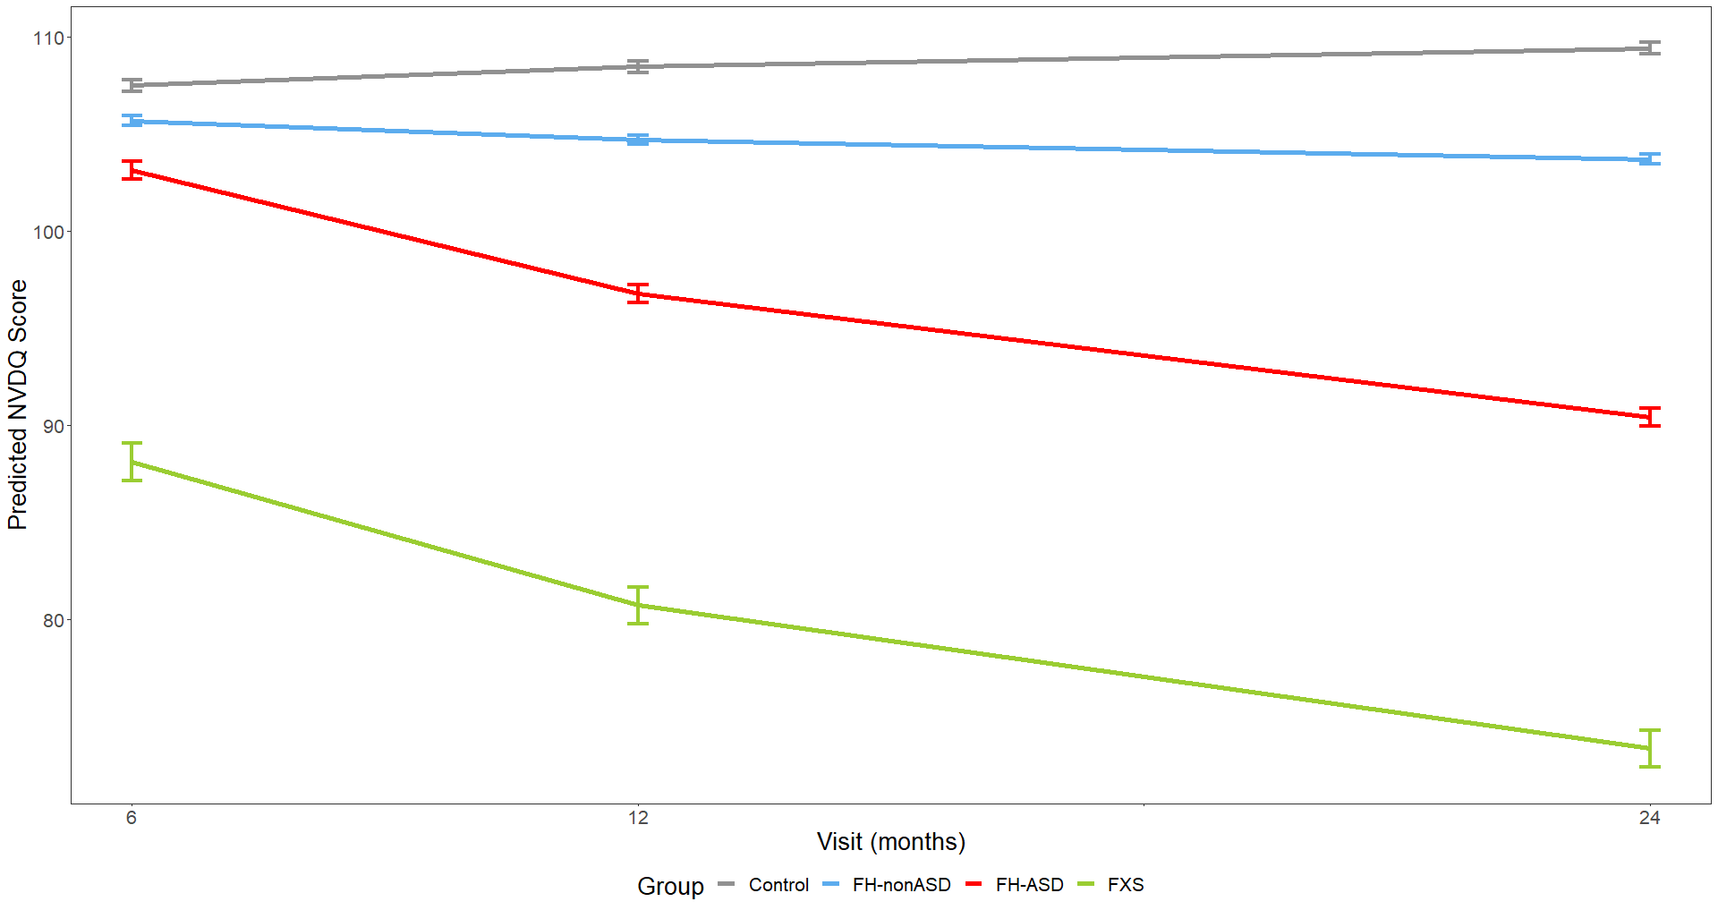

Model-generated differential trajectories of derived Nonverbal Developmental Quotient (NVDQ) from the MSEL by group and timepoint (Visit) for males only. The FXS group exhibited significantly delayed trajectories of NVDQ from 6-24 months compared to all other groups. By 12 months of age a pattern emerged between groups (Table S4) that persisted through 24 months, such that all groups significantly differed from one another except for FH-nonASD and control groups.

Figure S7. MSEL VDQ Score Trajectory by Group and Timepoint, Males Only

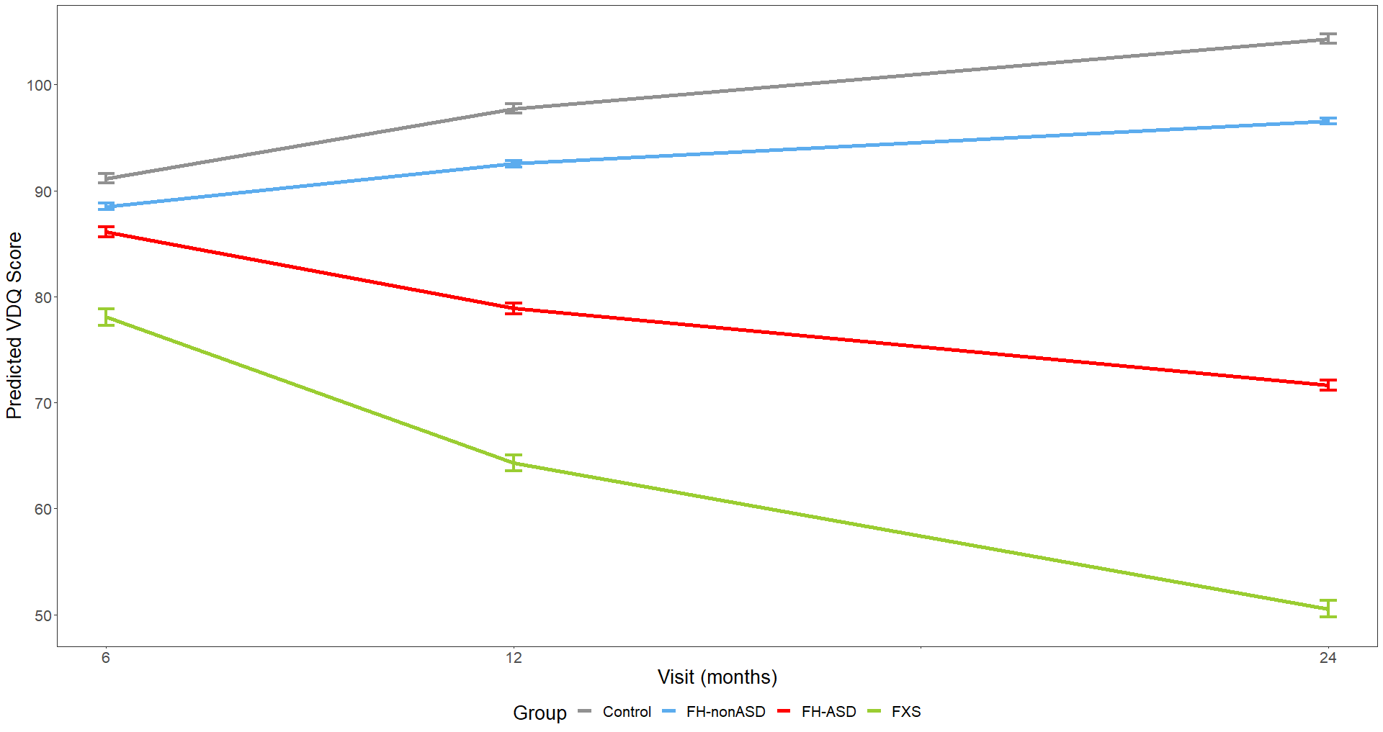

Model-generated differential trajectories of derived Verbal Developmental Quotient (VDQ) from the MSEL by group and timepoint (Visit) for males only. The FXS group exhibited significantly delayed trajectories of VDQ from 6-24 months compared to FH-nonASD and controls. By 12 months of age a pattern emerged between groups (Table S4) that persisted through 24 months, such that all groups significantly differed from one another except FH-nonASD and controls.

Figure S8. MSEL Receptive Language Score Trajectory by Group and Timepoint, Males Only

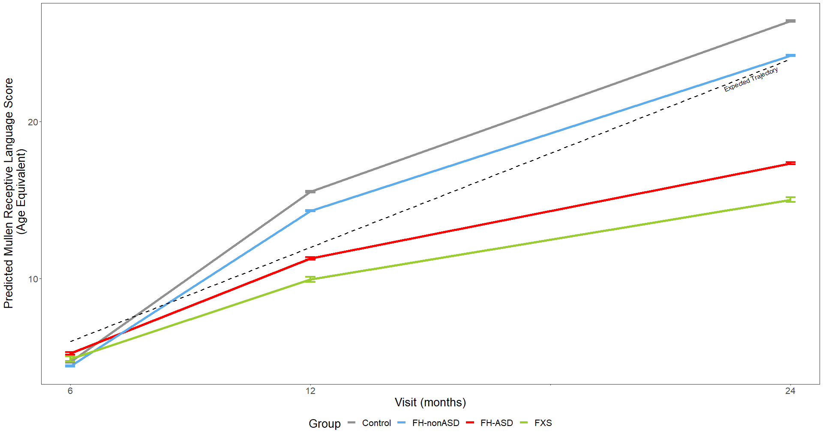

Model-generated differential trajectories of Receptive Language from the MSEL by group and timepoint (Visit) for males only. At 6 months, no group trajectories significantly differed from one another. At 12 months, all group trajectories except between FXS and FH-ASD, and between FH-nonASD and control significantly differed from one another. At 24 months, all groups except FXS and FH-ASD significantly differed from one another (Table S4).

Figure S9. MSEL Expressive Language Score Trajectory by Group and Timepoint, Males Only

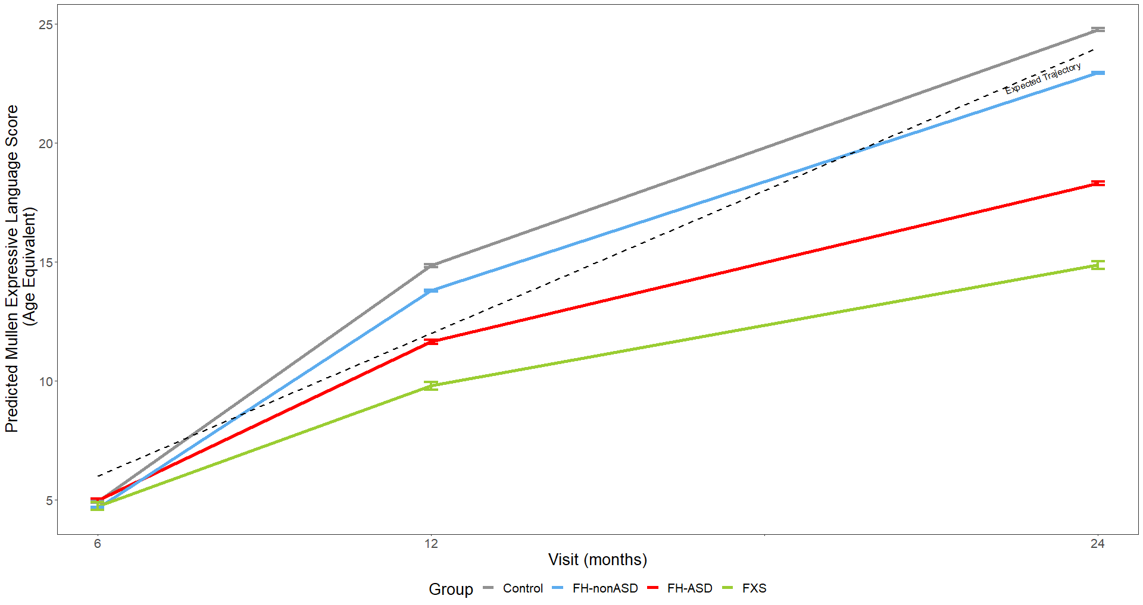

Model-generated differential trajectories of Expressive Language from the MSEL by group and timepoint (Visit) for males only. At 6 months, no group trajectories significantly differed from one another. At 12 months, all groups except FH-nonASD and control significantly differed from one another. At 24 months, all groups significantly differed from one another such that control > FH-nonASD > FH-ASD > FXS (Table S4).

Figure S10. MSEL Fine Motor Score Trajectory by Group and Timepoint, Males Only

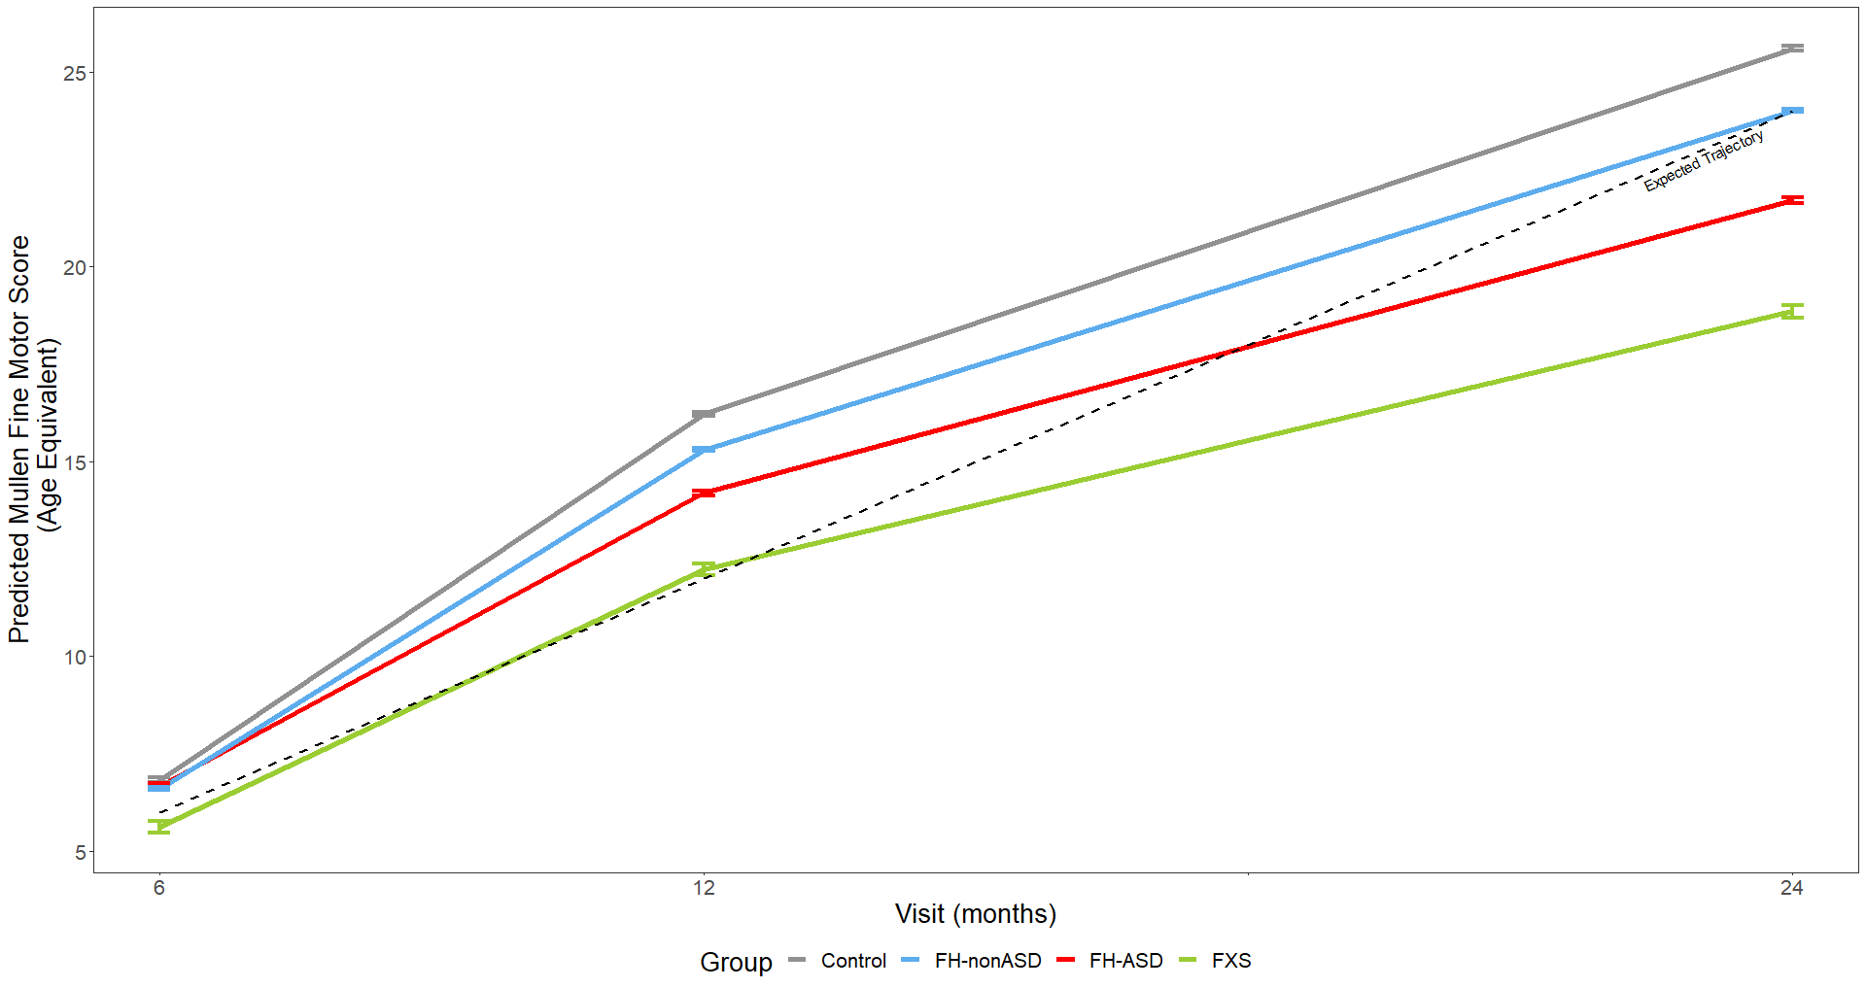

Model-generated differential trajectories of Fine Motor from the MSEL by group and timepoint (Visit) for males only. At 6 months, no group trajectories significantly differed from one another. By 12 months of age a pattern emerged between groups (Table S4) that persisted through 24 months, such that control > FH-nonASD > FH-ASD > FXS.

Figure S11. MSEL Gross Motor Score Trajectory by Group and Timepoint, Males Only

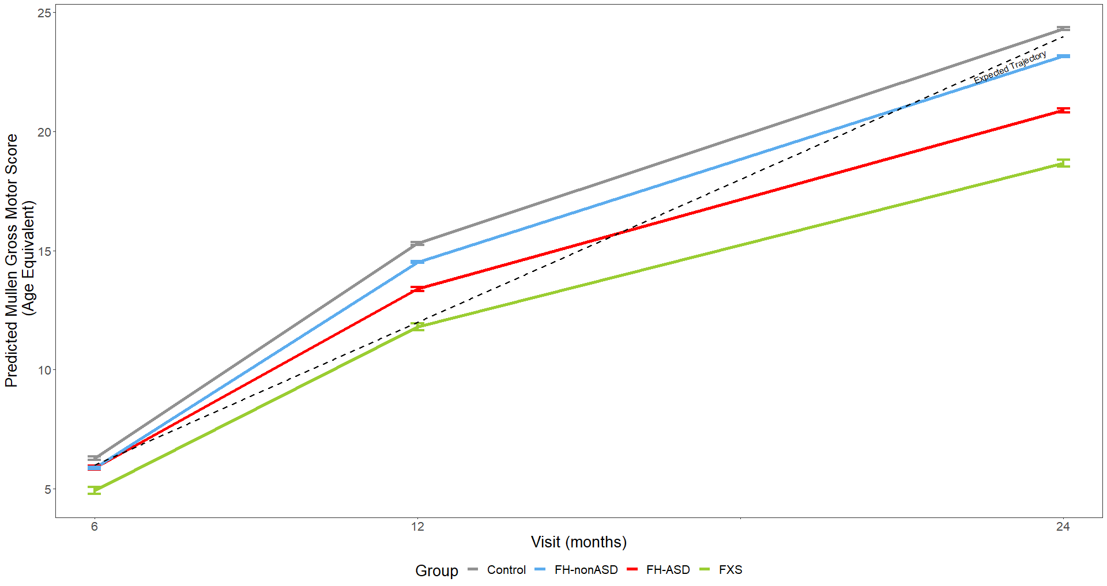

Model-generated differential trajectories of Gross Motor from the MSEL by group and timepoint (Visit) for males only. At 6 months, no group trajectories significantly differed from one another. At 12 and 24 months, all groups except FH-nonASD and control significantly differed from one another (Table S4).

Figure S12. MSEL Visual Reception Score Trajectory by Group and Timepoint, Males Only

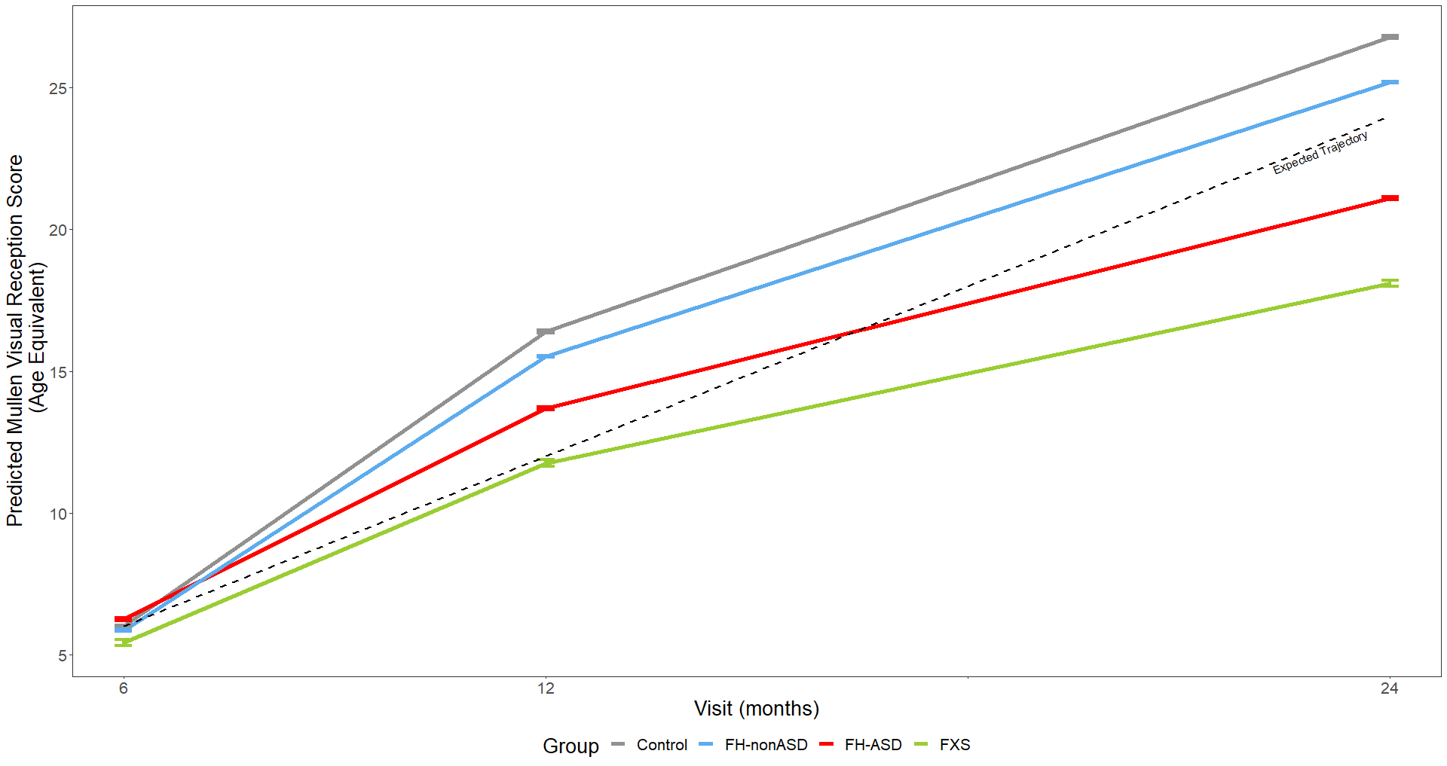

Model-generated differential trajectories of Visual Reception from the MSEL by group and timepoint (Visit) for males only. At 6 months, no group trajectories significantly differed from one another. At 12 and 24 months, all groups except FH-nonASD and control significantly differed from one another (Table S4).

Figure S13. MSEL Receptive Language Raw Score Trajectory by Group and Timepoint, Males Only

Model-generated differential trajectories of Receptive Language mean raw score from the MSEL by group and timepoint (Visit) for males only. At 6 months, no group trajectories significantly differed from one another. By 12 months of age a pattern emerged between groups (Table S5) that persisted through 24 months, such that all groups significantly differed from one another except for FH-nonASD and control groups.

Figure S14. MSEL Expressive Language Raw Score Trajectory by Group and Timepoint, Males Only

Model-generated differential trajectories of Expressive Language mean raw score from the MSEL by group and timepoint (Visit) for males only. At 6 months, no group trajectories significantly differed from one another. By 12 months of age a pattern emerged between groups (Table S5) that persisted through 24 months, such that all groups significantly differed from one another except for FH-nonASD and control groups.

Figure S15. MSEL Fine Motor Raw Score Trajectory by Group and Timepoint, Males Only

Model-generated differential trajectories of Fine Motor mean raw score from the MSEL by group and timepoint (Visit) for males only. At 6 months, no group trajectories significantly differed from one another. By 12 months of age a pattern emerged between groups (Table S5) that persisted through 24 months, such that control > FH-nonASD > FH-ASD > FXS.

Figure S16. MSEL Gross Motor Raw Score Trajectory by Group and Timepoint, Males Only

Model-generated differential trajectories of Gross Motor mean raw score from the MSEL by group and timepoint (Visit) for males only. At 6 months, no group trajectories significantly differed from one another. By 12 months of age a pattern emerged between groups (Table S5) that persisted through 24 months, such that all groups significantly differed from one another except for FH-nonASD and control groups.

Figure S17. MSEL Visual Reception Raw Score Trajectory by Group and Timepoint, Males Only

Model-generated differential trajectories of Visual Reception mean raw score from the MSEL by group and timepoint (Visit) for males only. At 6 months, no group trajectories significantly differed from one another. By 12 months of age a pattern emerged between groups (Table S5) that persisted through 24 months, such that all groups significantly differed from one another except for FH-nonASD and control groups.

