Supplement
Methods
The SCT schedule was retrospectively reviewed to identify parents of CFNBS+ infants with SCT from September 1, 2019 – December 31, 2021. Exclusion criteria included: non-biological parenthood, non-parental guardianship, and non-English speaking, though these populations are of future interest. Eligible parents were invited by telephone. Those interested received additional information with a REDCap link by email. Participants voluntarily completed the questionnaire 1-12 months after SCT. A unique study ID provided allowed trained study staff to link parental responses with child medical data in the electronic medical record (EMR).
NBS experience was elicited including results disclosure, resource utilization and GC involvement. Demographics, known family history, prior testing, and carrier status were assessed. Emotional response to NBS+ results was reported, and respondents retrospectively rated levels of sadness, anxiety and bondedness with their baby on a scale of 0-10 (0=not at all, 10=extremely) at different timepoints.
Participants who received GC (GC+) were asked to rate how helpful, informative, comforting and distracting it was to receive GC during the SCT on a scale of 0-10 (0=not at all, 10=extremely). All participants self-reported their child’s diagnostic resolution (i.e., CF, CRMS, carrier, unaffected and not a carrier) to assess congruence between parental understanding with diagnostic resolution in the EMR. With branching logic, those who indicated their child was a carrier were asked the knowledge questions below.
- My baby’s carrier result means that (check all that apply)
  - I may be a carrier of CF
  - My baby’s other parent may be a carrier of CF
  - A future child could have CF, if both me and the other parent are carriers
  - Other family members may also be carriers or have an increased risk for CF
  - I don’t know
  - I already knew that I and/or my baby’s other parent was a carrier for CF
- There is a risk for a baby to have CF when
  - Both parents carry an abnormal CF gene
  - One parent carries an abnormal CF gene
  - Only if there is a family history of CF
  - I don’t know
Participants were asked about intent to eventually share genetic information with the carrier child. All participants received open prompts to share more about their NBS experience. The full questionnaire can be found in Appendix I.
Knowledge question 1 was scored with consideration of the respondent’s prior parental carrier test results. For example, when neither parent had carrier testing, each of answers a, b, c, and d should be selected for question 1, with one knowledge point awarded for each. When the parent(s) had prior carrier testing parts a-c were unscored due to potential for subjective interpretation (e.g., awareness of residual risk). In question 2, a single knowledge point was awarded to each participant for selection of answer a. The total number of points available and earned in GC+ and GC- groups were scored and compared.

Results
Parents also reported feeling “other” emotional responses: “shocked” (2), “scared” (2), “overwhelmed” (1), “very sad” (1), “devastated” (1), and “defeated” (1).
Quotes:
P2: “[I felt] very sad and confused - I didn't understand. I received a call on a Friday afternoon from a nurse who told me my child was positive & they would set up a pulmonary appointment- nothing else just that.”
P13: “We didn't have anyone to thoroughly describe what the implications were, so we were devastated. We had to do our own research. It was implied our baby would have CF - when results have turned out he is just a carrier. We were not able to speak to a professional until two months after his diagnosis. Every family should have access to speak to a geneticist immediately to understand the implications as our child is only a carrier… Furthermore, the pediatrician sent the referral to the wrong place so we had to do so much legwork to even get in touch with a geneticist and schedule his sweat test. As a brand new mom, this was quite possibly the worst experience and the geneticist said if she had been able to speak to us sooner, she would have been able to tell us he had a 90% chance of being a carrier.”
Respondents rated levels of sadness, anxiety and bondedness with their baby at various timepoints: birth to NBS+, NBS+ to SCT, during SCT, SCT to result, after SCT result, current sadness and anxiety about the NBS process and current bondedness. All-respondent sadness and anxiety increased with notification of the NBS+ result (Figure II). At SCT, all-respondent sadness decreased in both groups (GC+: -0.55, GC-: -0.72); anxiety decreased in GC+ (-0.77) and increased in GC- (+0.34). Sadness and anxiety fell below baseline (birth to NBS+) after the SCT result in both cohorts and remained low at time of survey. Bondedness was high at all timepoints. The emotional differences between GC+ and GC- groups were not statistically significant at any timepoint in this small sample.
Figure II. Mean participant sadness, anxiety and bondedness (all respondents)

All participants were asked, “On a scale of 0-10 (0=not at all, 10=extremely), how sad, anxious and bonded with your baby did you feel at the following timepoints?” Mean responses are depicted across different timepoints (birth to NBS+, NBS+ to SCT, During SCT, SCT to result, After SCT result, and current).

Participants optionally provided additional information about their CFNBS+ experience, including what was helpful or distressing, or what would have made the experience better. Parents expressed heightened anxiety related to delays receiving NBS information and confusion from providers:
P1: “We did not receive NBS results until 6 months later. Very unhappy about that. Felt super uninformed and wish the genetic counselor was there from the beginning, once to explain the screening and then again when the results came back. Could have saved a lot of anxiety with myself and husband.”
P5: “There was a little confusion about the NBS results at the pediatrician's office which increased anxiety, stress and confusion on my end. I think receiving NBS and sweat chloride test results from a genetic counselor would have lessened the confusion and stress on everyone's behalf.”
Discomfort during SCT was also stressful for families, and both the physical environment of SCT and the interpersonal qualities of the person conducting the test were noted as important. Comments suggest that families do or would value engagement of professionals who are both well-informed and sensitive to the family’s stage of readiness for information.
P2: “The NP at [the CF Center] was amazing in helping me understand- she made me feel a whole lot better understanding my baby's results. She took the weight of the world off my shoulders.”
P4: “At the time, I was so overwhelmed that I am not sure if it would have helped to speak with someone before getting a positive result. Because in that moment, all I could think about was whether or not she had CF - I don't know that I would have had the mental capacity to take in much more than that or that I would even want to focus on the genetic side before getting a confirmation. We didn’t know of any CF in our families - for those that were more prepared for this diagnosis, they may feel differently.”

Supplemental Tables and Figures
Table I. Maternal Characteristics (N=16)
Age (mean ± SD) | 30.75 ± 3.91 (range 23-38)
Race | Caucasian- 14 (87.5%)  African American- 1 (6.25%)  Asian- 1 (6.25%)
Highest education | Some college – 6 (37.5%)  Associate/technical degree – 2 (12.5%)  Bachelor’s degree – 5 (31.25%)  Graduate degree – 3 (18.75%)
Relationship status | Married – 14 (87.5%)  Single – 2 (12.5%)
First child | Yes – 11 (68.75%)  No – 5 (31.25%)

Table II. Family history and prior testing
Participant | I have, or my baby's other parent has, a family history of CF | I was offered carrier testing for CF during pregnancy | I had (and/or my partner had) carrier testing for CF during pregnancy or in the past | My CF carrier test was | My partner's CF carrier test was | Baby’s CF status | GC+ or GC- at SCT
1 | No | Don’t know | Don’t know |  |  | Carrier | GC+
2 | Don’t know | Yes | Yes | Negative | N/A | Carrier | GC-
3 | Don’t know | Yes | Yes | Negative | N/A | Carrier | GC-
4 | No | Yes | No |  |  | CF | GC-
5 | Don’t know | Yes | Yes | Positive | N/A | Carrier | GC-
6 | No | No | No |  |  | Carrier | GC-
7 | Don’t know | Don’t know | Don’t know |  |  | Carrier | GC+
8 | No | No | No |  |  | Carrier | GC+
9 | No | Yes | Yes | Positive | Negative | Carrier | GC+
10 | Yes | Yes | Yes | Positive | Negative | Carrier | GC+
11 | No | No | No |  |  | Carrier | GC+
12 | No | Yes | Yes | Positive | Negative | CRMS | GC+
13 | No | Yes | Yes | Positive | Don’t know | Carrier | GC+
14 | No | Don’t know | No |  |  | Carrier | GC+
15 | Yes | Yes | Yes | Positive | Negative | Carrier | GC-
16 | No | No | No |  |  | Carrier | GC-

Figure I. South Carolina newborn screening algorithm
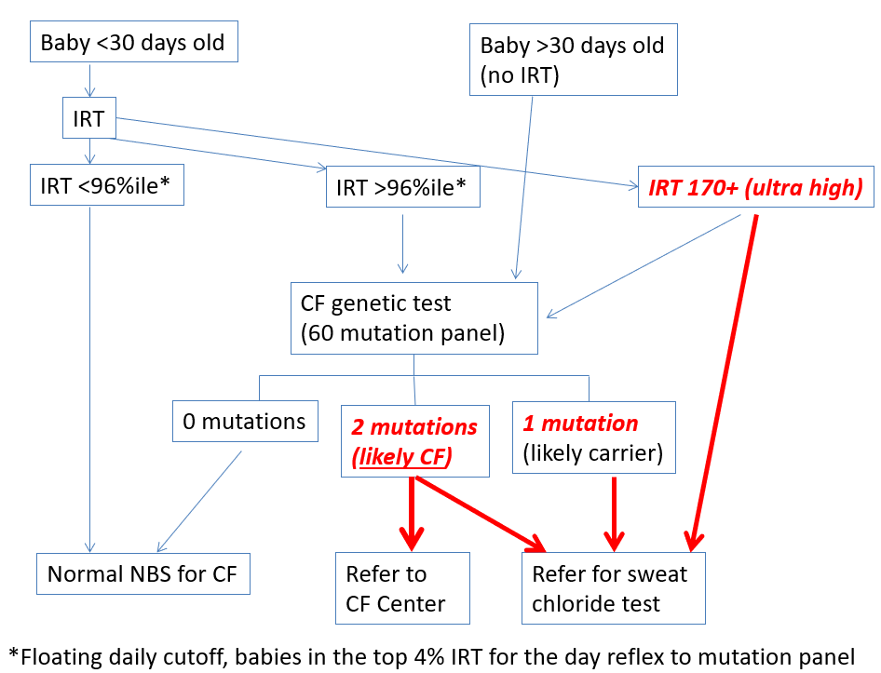
The South Carolina IRT/DNA newborn screening algorithm is depicted. Babies with one or two variants (or super-high IRT) are designated as screen positive and referred to a CF center for sweat chloride testing (SCT). Diagnostic resolution categories include (1) CF, (2) unaffected, where most are carriers of a single variant, and (3) CFTR-related metabolic syndrome (CRMS). Most babies with two variants will have CF, and most with one will be unaffected carriers (i.e., do not have CF; heterozygotes for a single CFTR variant). CRMS applies when the sweat test is equivocal and a diagnosis cannot be confirmed or ruled out without further testing and/or longitudinal follow-up.

Appendix I