S1. The monthly median of NO₂ and SO₂ column concentration for Gilan province in study periods
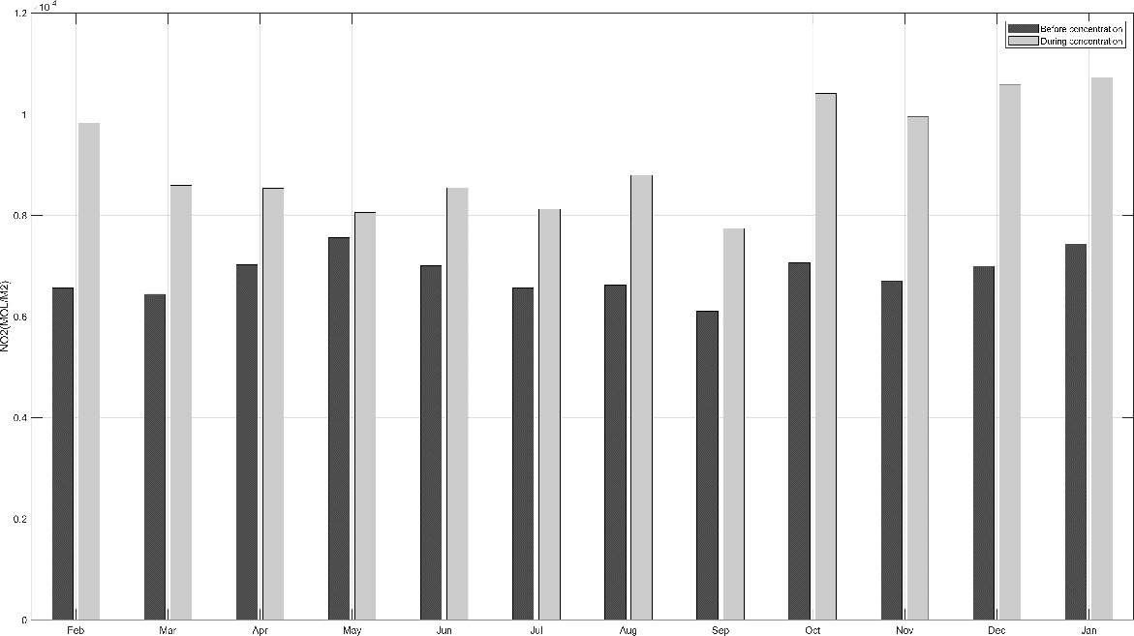
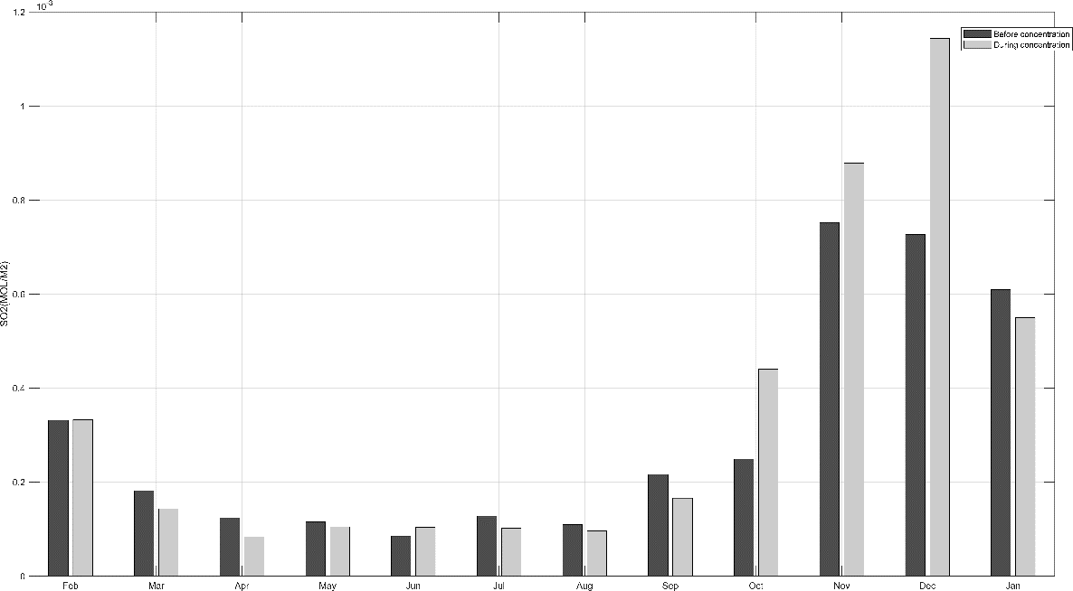

S2. The monthly and seasonal values of standard deviation (noise) of PM_{2.5} levels, extracted by wavelet transform in study periods (µg/m³)
 | Tabriz |  | Isfahan |  | Khuzestan |  | Tehran |  | Khorasan Razavi
 | 1* | 2** | 1 | 2 | 1 | 2 | 1 | 2 | 1 | 2
October | 6.02 | 8.26 | 8.95 | 10.95 | 15.85 | 10.51 | 9.62 | 7.86 | 13.46 | 8.35
November | 3.18 | 7.63 | 6.16 | 7.05 | 7.83 | 13.02 | 4.09 | 5.60 | 7.35 | 4.74
December | 2.96 | 4.72 | 6.85 | 4.13 | 4.91 | 8.18 | 3.38 | 3.27 | 6.31 | 7.14
January | 1.94 | 3.77 | 6.00 | 2.47 | 10.90 | 22.02 | 4.87 | 5.63 | 5.57 | 4.11
February | 2.42 | 3.37 | 14.25 | 3.69 | 9.32 | 31.18 | 4.95 | 3.81 | 6.45 | 5.54
March | 2.26 | 1.87 | 4.95 | 9.35 | 3.59 | 7.23 | 5.04 | 4.32 | 2.73 | 7.09
April | 2.64 | 4.77 | 4.63 | 4.63 | 6.61 | 17.18 | 4.06 | 3.63 | 15.54 | 5.80
May | 3.69 | 4.26 | 2.74 | 3.98 | 18.02 | 12.19 | 2.31 | 3.85 | 19.74 | 4.14
June | 2.65 | 4.75 | 11.16 | 5.11 | 8.72 | 11.24 | 4.38 | 8.91 | 22.02 | 8.08
July | 6.28 | 6.40 | 6.38 | 11.12 | 28.15 | 22.20 | 7.68 | 5.74 | 8.87 | 13.03
August | 6.57 | 9.10 | 10.18 | 15.05 | 7.20 | 9.51 | 12.03 | 10.54 | 10.93 | 13.11
September | 5.85 | 14.30 | 6.46 | 14.83 | 14.30 | 11.72 | 10.44 | 18.86 | 9.85 | 11.14
Spring | 5.51 | 7.10 | 7.75 | 8.83 | 12.31 | 12.03 | 8.17 | 6.79 | 11.01 | 8.13
Summer | 3.24 | 3.15 | 9.75 | 6.95 | 8.87 | 27.49 | 7.88 | 5.41 | 5.43 | 7.29
Fall | 4.25 | 4.98 | 7.61 | 5.18 | 13.40 | 13.91 | 4.28 | 6.34 | 23.13 | 7.82
Winter | 6.44 | 11.22 | 8.76 | 15.35 | 18.83 | 18.19 | 10.55 | 17.10 | 11.61 | 12.64

