Supporting Information

Breaking Solvation Dominance of EC via Electron Engineering Enables Battery Operation Below -100℃
Yuqing Chen¹, Qiu He², Yun Zhao³, Wang Zhou¹, Peitao Xiao⁴, Peng Gao¹, Naser Tavajohi⁵, Jian Tu⁶, Baohua Li³, Xiangming He⁷, Lidan Xing⁸, Xiulin Fan⁹, Jilei Liu^{1∗}
¹College of Materials Science and Engineering, Hunan Joint International Laboratory of Advanced Materials and Technology of Clean Energy, Hunan Province Key Laboratory for Advanced Carbon Materials and Applied Technology, Hunan University, Changsha 410082, People’s Republic of China
²College of Materials Science and Engineering, Sichuan University, Chengdu 610065, P. R. China.
³Shenzhen Key Laboratory on Power Battery Safety and Shenzhen Geim Graphene Center, Tsinghua Shenzhen International Graduate School (SIGS), Shenzhen 518055, China
⁴ College of Aerospace Science and Engineering, National University of Defense Technology, Changsha 410073, China
⁵ Department of Chemistry, Umeå University, Umeå, 90187, Sweden
⁶LI-FUN Technology Corporation Limited, Zhuzhou, 412000, Hunan, China
⁷Institute of Nuclear and New Energy Technology, Tsinghua University, Beijing 100084, China
⁸Engineering Research Center of MTEES (Ministry of Education), Research Center of BMET (Guangdong Province), Engineering Lab. of OFMHEB (Guangdong Province), Key Lab. of ETESPG (GHEI), And Innovative Platform for ITBMD (Guangzhou Municipality), School of Chemistry, South China Normal University, Guangzhou, 510006, China
⁹State Key Laboratory of Silicon Materials, School of Materials Science and Engineering, Zhejiang University, Hangzhou 310027, China
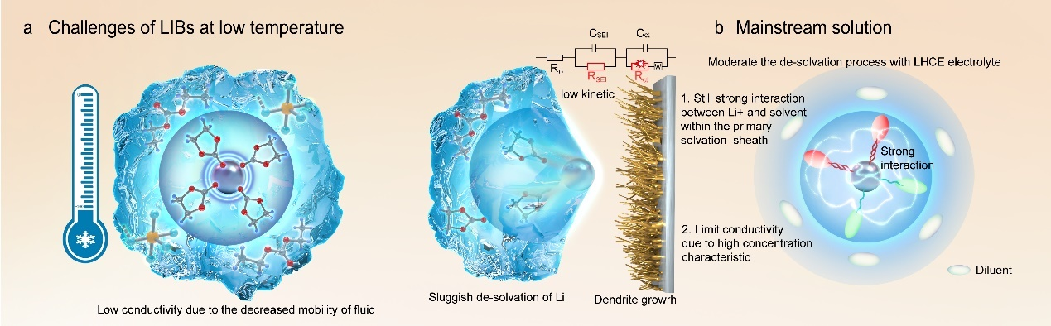
Fig. S1ǀ a, Challenges of lithium-ion batteries operating at low temperature. b, The main strategy of LHCE electrolyte towards low temperature performance.
Fig. S2ǀ The melting point and boiling point of various solvents, including carbonates, linear carboxylates, sulfones, nitriles, and ethers.
Fig. S3ǀ a The molecular structures of the liquid solvents used in this work. b Optimized structures of Li⁺ with different solvents, the purple ball represents Li⁺.

Fig. S4ǀ Electrostatic potential (ESP) of EC, PC, EMC, DEC, EB, ETFB, EHFB, and TFEB molecules (a) and corresponding Li⁺ coordinated structure (b).

Abbreviation List
Abbreviation | Full Name
EC | Ethylene carbonate
PC | Propylene carbonate
DMC | Dimethyl Carbonate
DEC | Diethyl carbonate
EMC | Ethyl Methyl Carbonate
EF | Ethyl Formate
EA | Ethyl Acetate
MP | Methyl Propanoate
EP | Ethyl Propionate
PP | Propyl Propanoate
MB | Methyl Butyrate
EB | Ethyl Butyrate
ETFB | 4,4,4-Ethyl trifluorobutyrate
EHFB | Ethyl heptafluorobutyrate
TFEB | 2,2,2-trifluoroethyl butyrate
THF | Tetrahydrofuran
DME | 1,2-dimethoxyethane
DG | Dimethyl Glycol

Table S1: Carbonyl oxygen charge of various solvents.
Solvent | EC | PC | DEC | EMC | EB | ETFB | EHFB | TFEB
Charge of oxygen | -0.33 | -0.331 | -0.302 | -0.308 | -0.288 | -0.281 | -0.207 | -0.27

Table S2: Frontier molecular orbital energy and electron energy of solvent and coordinated solvent, and the corresponding binding energy and Li band length.
Molecular | Uncoordinated |  |  | Coordinated |  |  |  | Binding Energy
Molecular | ElectronEnergy | HOMO (eV) | LUMO (eV) | Electron  Energy | HOMO (eV) | LUMO  (eV) | Li band length(Å) | Binding Energy
EC | -9319 | -8.02 | -0.28 | -9520 | -12.65 | -5.02 | 1.74 | -2.24
PC | -10390 | -8.36 | -0.31 | -10590 | -12.83 | -4.95 | 1.73 | -2.31
DEC | -11493 | -8.05 | 0.07 | -11693 | -12.47 | -5.23 | 1.73 | -2.09
EMC | -10423 | -8.13 | 0.07 | -10623 | -12.67 | -5.30 | 1.73 | -2.02
EB | -10515 | -8.14 | -0.33 | -10716 | -13.05 | -5.11 | 1.74 | -2.18
ETFB | -18619 | -8.31 | -0.38 | -18819 | -13.13 | -5.37 | 1.79 | -2.86
EHFB | -29422 | -8.82 | -1.54 | -29622 | -13.48 | -6.11 | 1.84 | -1.72
TFEB | -18618 | -8.47 | -0.53 | -18818 | -13.47 | -5.32 | 1.80 | -1.83

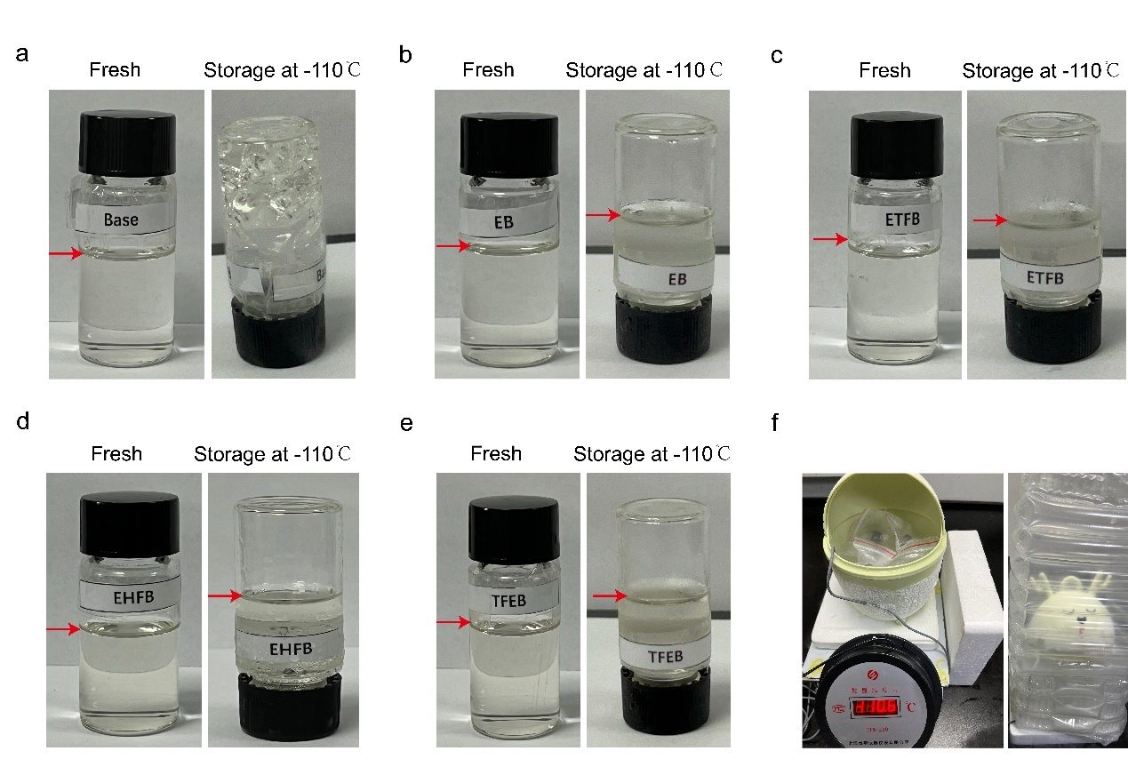
Fig. S5ǀ a-e Digital images of different electrolytes before and after keeping at -50 ℃ for 30 min. f, Cold trap device for electrolyte low temperature storage test as well as the conductivity.

Fig. S6ǀ a-e, The fitting results for the four different electrolytes: (a) Base, (b) EB, (c) ETFB, (d) EHFB, (e) TFEB. For the Base electrolyte, the data were fitted by the Arrhenius equation (Eq.1), because of the solidification of the electrolyte under -50 °C. The other three electrolytes were fitted by the Vogel-Tamman-Fulcher (VTF) empirical equation (Eq.2). f, the optical image of conductivity test of electrolytes.
$σ=σ_{0}$exp($\frac{-E_{a}}{RT}$) (Eq.1)
$σ=σ_{0}T^{-1/2}$exp($\frac{-Ea}{R(T-T_{0})}$) (Eq.2)
where Ea is the activation energy, σ0 is the pre-exponential factor, T0 is the ideal glass transition temperature, and R is the gas constant.
Table S3: Carbonyl oxygen charge of various solvents.
Electrolyte | σ at 25 ℃  (mS/cm) | σ at -80 ℃  (mS/cm) | σ at -90 ℃  (mS/cm) | E_{a}  (eV)
Base | 10.03 | 0.00676 | 0.00107 | 19.19
EB | 11 | 0.191 | 0.0399 | 2.98
ETFB | 10.65 | 0.83 | 0.264 | 1.40
EHFB | 8.922 | 1.675 | 1.462 | 0.98
TFEB | 9.525 | 1.083 | 0.564 | 1.41
1.28 M LiFSI FEMC/FEC- D2¹ | 2.3 | 0.011 | - | 0.034

Stokes-Einstein Eqation: $q=\frac{{\left|ZiZj\right|e}^{2}}{8πε_{0}εK_{B}T}$ (eq.1)
Where, q is the charge of solute, Z is the valence of ion, e is charge of an electron, 1.602 × 10⁻¹⁹ C, ε₀ is the relative permittivity (F/m), ε is permittivity, K_{B} is Boltzmann constant, T is temperature.

Diffusion in liquid: $D=\frac{K_{B}T}{6πηr}$ (eq.2)
Where, D is the diffusivity of solute, r is the inter-particle distance, η is viscosity.

Diffusivity vs. ionic conductivity: $σ=\frac{q^{2}CD}{K_{B}T}$ (eq.3)
Where, σ is ion conductivity, C is the concentration.

Fig. S7ǀ Snapshots of Base (a-b), EB (e), ETFB (f), EHFB (c-d) and TFEB (g) electrolytes obtained by MD simulation at 298 K (a, c, e, f, g) and 203 K (b, d). The Li⁺ and their primary coordinated shells (within 2.6 Å of Li⁺ ions) are presented by ball and stick models, while the wireframes stand for free solvents.
Table S4: Moles of different solvents in the five electrolyte systems.
solvent | density | Volume | Relative molecular mass | moles
EC | 1.3214 | 2 | 88.06 | 0.030011356
PC | 1.198 | 1 | 103.09 | 0.011620914
DEC(Base) | 0.975 | 3 | 118.1 | 0.024767146
DEC(Exp) | 0.975 | 1.5 | 118.1 | 0.012383573
EMC | 1.007 | 4 | 104.1 | 0.038693564
EB | 0.9 | 1.5 | 116.158 | 0.011622101
ETFB | 1.16 | 1.5 | 170.13 | 0.010227473
EHFB | 1.396 | 1.5 | 242.092 | 0.008649604
TFEB | 1.127 | 1.5 | 170.13 | 0.009936519

Table S5: The numbers of different molecules in the five systems.
 | Category | LiPF₆ | EC | PC | DEC | EMC | Co-solvent | Co-efficient | Total Number | Optimized  Volume(Å³)
Base | Moles | 0.01 | 0.03 | 0.01 | 0.02 | 0.04 | — | 1000 | — | —
Base | Number | 50 | 150 | 58 | 124 | 193 | — | — | 575 | 86348.5
Base | Density(ρ) | 5.79e⁻⁴ | 1.73e⁻³ | 6.73 e⁻⁴ | 1.43e⁻³ | 2.24 e⁻³ | — | — | 6.66e⁻³ | —
EB | Moles | 0.01 | 0.03 | 0.01 | 0.012 | 0.04 | 0.012 | 1000 | — | —
EB | Number | 50 | 150 | 58 | 62 | 193 | 58 | — | 572 | 84444.7
EB | Density(ρ) | 5.92e⁻⁴ | 1.18e⁻³ | 6.88 e⁻⁴ | 7.33e⁻⁴ | 2.29e⁻³ | 6.88e⁻⁴ | — | 6.77e⁻³ | —
ETFB | Moles | 0.01 | 0.03 | 0.01 | 0.012 | 0.04 | 0.01 | 1000 | — | —
ETFB | Number | 50 | 150 | 58 | 62 | 193 | 51 | — | 565 | 85312.6
ETFB | Density(ρ) | 5.86e⁻⁴ | 1.76e⁻³ | 6.81 e⁻⁴ | 7.26e⁻⁴ | 2.27e⁻³ | 5.99e⁻⁴ | — | 6.62e⁻³ | —
EHFB | Moles | 0.01 | 0.03 | 0.01 | 0.012 | 0.04 | 0.012 | 1000 | — | —
EHFB | Number | 50 | 150 | 58 | 62 | 193 | 58 | — | 557 | 83505.9
EHFB | Density(ρ) | 5.99e⁻⁴ | 1.80e⁻³ | 6.96 e⁻⁴ | 7.41e⁻⁴ | 2.32e⁻³ | 5.18e⁻⁴ | — | 6.67e⁻³ | —
TFEB | Moles | 0.01 | 0.03 | 0.01 | 0.012 | 0.04 | 0.012 | 1000 | — | —
TFEB | Number(N) | 50 | 150 | 58 | 62 | 193 | 58 | — | 563 | 84828.3
TFEB | Density(ρ) | 5.89e⁻⁴ | 1.77e⁻³ | 6.85e⁻⁴ | 7.30e⁻⁴ | 2.28e⁻³ | 5.86e⁻⁴ | — | 6.64e⁻³ | —

$n\left(r´\right)=4πρ\int_{0}^{r´}{g\left(r\right)r^{2}dr}$ (Eq 3)
Coordination number is calculated from Eq 3 based on the radial distribution function (RDF) according to molecular dynamic simulation. Where, r´ is the first solvation radius, ρ is the number density which equals the number (N) divided by the volume (V), g(r) is the radial distribution function.

Fig. S8ǀ Radial distribution functions ((g(r)), solid lines) and coordination numbers ((n(r)), dash lines) for Base electrolyte (a), EB electrolyte (b), ETFB electrolyte (c), EHFB electrolyte (d) and TFEB electrolyte (e), The summarized coordinated number of Li⁺ with various solvents (EC, PC, DEC, EMC, EB, ETFB, EHFB, and TFEB) in the formula.
Fig. S9ǀ Radial distribution functions (g(r)) and coordination numbers (n(r)) for Base electrolyte (a-b) and EHFB electrolyte (c-d) under 298K (a, c) and 203K (b. d) respectively.

Table S6: Maxima (r_{max}) of the first solvation shell, radial distribution functions g(r_{max}), and the coordination number N(r_{min}) of different electrolytes.
Electrolyte | Pair | T/K | r_{max} / Å | g(max) | N(r_{min})
Base | Li-O_{EC} | 298K | 2.62 | 67.02 | 1.34
Base | Li-O_{PC} | 298K | 2.60 | 7.13 | 0.24
Base | Li-O_{DEC} | 298K | 2.45 | 54.30 | 1.13
Base | Li-O_{EMC} | 298K | 2.61 | 42.90 | 0.94
Base | Li-P | 298K | 4.20 | 22.42 | 0.86
Base | Li-O_{EC} | 203K | 2.52 | 84.76 | 1.76
Base | Li-O_{PC} | 203K | 2.62 | 58.07 | 0.94
Base | Li-O_{DEC} | 203K | 2.60 | 31.56 | 0.74
Base | Li-O_{EMC} | 203K | 2.62 | 26.43 | 0.63
Base | Li-P | 203K | 4.35 | 21.97 | 0.86
EB | Li-O_{EC} | 298K | 2.65 | 49.99 | 0.92
EB | Li-O_{PC} | 298K | 2.63 | 6.20 | 0.2
EB | Li-O_{DEC} | 298K | 2.52 | 66.02 | 1.27
EB | Li-O_{EMC} | 298K | 2.53 | 49.23 | 0.85
EB | Li- O_{EB} | 298K | 2.62 | 72.48 | 1.3
EB | Li-P | 298K | 4.15 | 20.64 | 0.86
ETFB | Li-O_{EC} | 298K | 2.65 | 30.00 | 0.66
ETFB | Li-O_{PC} | 298K | 2.62 | 8.09 | 0.25
ETFB | Li-O_{DEC} | 298K | 2.57 | 88.98 | 1.34
ETFB | Li-O_{EMC} | 298K | 2.57 | 49.53 | 0.94
ETFB | Li- O_{ETFB} | 298K | 2.55 | 41.69 | 0.85
ETFB | Li-P | 298K | 4.15 | 21.33 | 0.91
EHFB | Li-O_{EC} | 298K | 2.69 | 30.31 | 0.61
EHFB | Li-O_{PC} | 298K | 2.65 | 7.72 | 0.25
EHFB | Li-O_{DEC} | 298K | 2.57 | 88.32 | 1.46
EHFB | Li-O_{EMC} | 298K | 2.57 | 55.89 | 1.23
EHFB | Li- O_{EHFB} | 298K | 2.60 | 1.63 | 0.06
EHFB | Li-P | 298K | 4.15 | 23.43 | 1.08
EHFB | Li-O_{EC} | 203K | 2.62 | 14.49 | 0.33
EHFB | Li-O_{PC} | 203K | 2.65 | 25.33 | 0.58
EHFB | Li-O_{DEC} | 203K | 2.57 | 96.77 | 1.71
EHFB | Li-O_{EMC} | 203K | 2.57 | 54.92 | 0.99
EHFB | Li- O_{EHFB} | 203K | 2.70 | 21.49 | 0.56
EHFB | Li-P | 203K | 4.10 | 28.20 | 1.06
TFEB | Li-O_{EC} | 298K | 2.62 | 31.34 | 0.63
TFEB | Li-O_{PC} | 298K | 2.65 | 8.60 | 0.26
TFEB | Li-O_{DEC} | 298K | 2.57 | 83.38 | 1.46
TFEB | Li-O_{EMC} | 298K | 2.57 | 53.79 | 1
TFEB | Li- O_{TFEB} | 298K | 2.60 | 36.02 | 0.74
TFEB | Li-P | 298K | 4.12 | 22.39 | 0.98

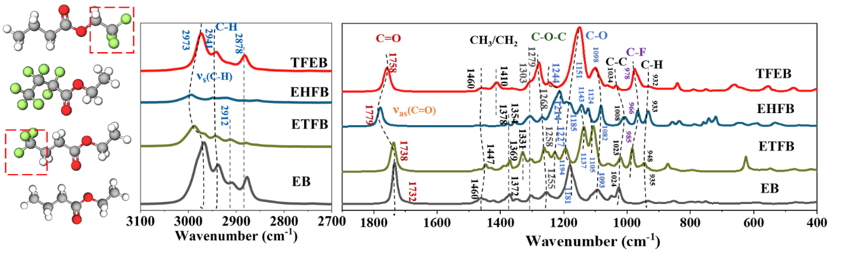
Fig. S10ǀ FTIR spectra of co-solvent molecular EB, ETFB, EHFB, and TFEB, the peak assignment has been presented in Table S7.

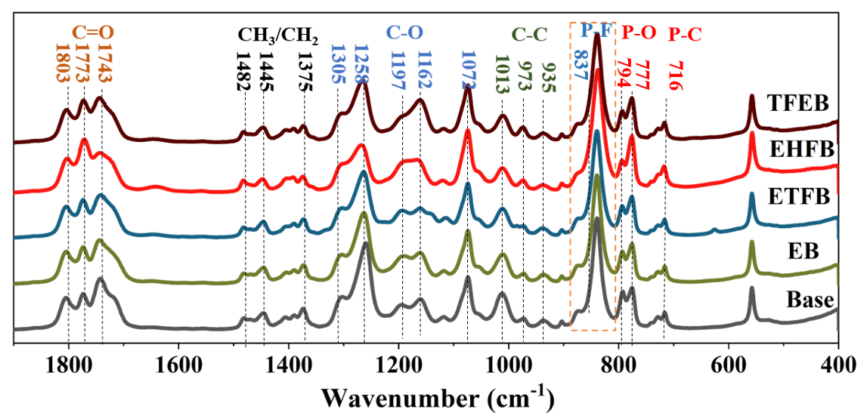
Fig. S11ǀ FTIR spectra of different electrolytes, the peak assignment has been presented in Table S7.

The relative abundance of free and solvated EC and DEC in different electrolyte solutions can be estimated from the stretching frequencies of their IR-active C=O groups, which occur in the region of 1660-1870 cm⁻¹ and are sensitive to changes in the Li⁺ solvation structure (Fig 3c). To evaluate the effect of different cosolvents on the solvation structure and quantify the relative abundance of solvated EC and DEC, the free and solvated C=O peaks were fitted using the Voigt functions (Fig 3d, Fig S12-S16). More details about the peaks assignment can be found in Table S7 and Table S8, and two parameters, R1 (the ratios of solvated to free EC) and R2 (solvated EC to solvated DEC), were introduced using eq. 1 and eq. 2 to quantify the relative abundance of solvated EC and DEC as well as the evolution of competence degree for coordination sites between EC and DEC. The FTIR spectrum of the EHFB electrolyte has five main peaks – two centered at approximately 1724 and 1746cm⁻¹ that were assigned to DEC, and three at 1772, 1803, 1836 cm⁻¹ that were assigned to EC. The high-frequency peaks at 1746 and 1803 cm⁻¹ were assigned to the C=O stretching modes of free DEC and EC, respectively, while the low frequency bands at 1724 and 1772 cm⁻¹ were assigned to Li⁺ coordinated DEC and EC^{2, 3, 4}, respectively, peak at 1836 cm⁻¹ was observed only at low temperature and was assigned to the ring lactone vibration of EC. The vibrational and fitting parameters for these spectra are given in Table S7 and Table S8, respectively.
$R_{1}=\frac{A_{solvated EC}}{A_{free EC}}$ (eq.1)
$R_{2}=\frac{A_{solvated EC}}{A_{solvated DEC}}$ (eq.2)
Here, A_{solvated EC}, A_{free EC} and A_{solvated DEC} are the integrated area intensities of the vibrational bands corresponding to solvated and free EC C=O groups and the C=O group of solvated DEC, respectively.
Fig. S12ǀ FTIR spectra of EC and DEC in Base electrolyte. a, Comparison of the C=O vibration modes under different temperature; b-d, Fitting spectra with the Voigt function in 298K, 263K, and 203K, respectively.
Fig. S13ǀ FTIR spectra of EC and DEC in EB electrolyte. a, Comparison of the C=O vibration modes under different temperature; b-d, Fitting spectra with the Voigt function in 298K, 263K, and 203K, respectively.
Fig. S14ǀ FTIR spectra of EC and DEC in ETFB electrolyte. a, Comparison of the C=O vibration modes under different temperature; b-d, Fitting spectra with the Voigt function in 298K, 263K, and 203K, respectively.
Fig. S15ǀ FTIR spectra of EC and DEC in EHFB electrolyte. a, Comparison of the C=O vibration modes under different temperature; b-d, Fitting spectra with the Voigt function in 298K, 263K, and 203K, respectively.
Fig. S16ǀ FTIR spectra of EC and DEC in TFEB electrolyte. a, Comparison of the C=O vibration modes under different temperature; b-d, Fitting spectra with the Voigt function in 298K, 263K, and 203K, respectively.

Table S7 The FT-IR peak information of co-solvent contained electrolyte and co-solvents.
Number | Wavenumber (cm⁻¹) |  |  |  |  | Band Assignment | Description | References
Number | Electrolytes | EB | ETFB | EHFB | TFEB | Band Assignment | Description | References
1 | 2989 | 2967 | 2987 | 2993(weak) | 2973 | V_{s}(C-H) of β site | Moving towards high wavenumber after solvation | ^{5, 6}
2 | 2938 | 2937 | 2941 (weak) | None | 2941 | V_{s}(C-H) of -CH₂- |  | ⁵
3 | 2913(weak) | 2908 | 2912 (weak) | None | None | V(-H) |  | ⁶
4 | 2878 (weak) | 2878 | 2878 (weak) | None | 2881 | V_{s}(C-H) of -CH₃ |  | ^{5, 7}
5 | 1743 | 1732 | 1738 | 1779 | 1758 | V(C=O)/ or V(C=O) of DEC | Affected by the electron-withdrawing group F, the C = O stretching vibration frequency shifts towards higher frequencies due to the inductive effect. | ^{2, 6, 8}
6 | 1773 | — | — | — | — | V(C=O) of solvated EC |  | ^{2, 3, 7, 8}
7 | 1803 | — | — | — | — | V(C=O) of free EC |  | ^{2, 3, 7, 8}
8 | — | 1460(weak) | 1447 | — | 1460 | σ_{as}(CH₃) of solvent |  | ^{3, 6, 8, 9}
9 | 1445 | — | — | — | — | σ_{as}(CH₃) | Moving towards low wavenumber after solvation | ^{3, 8}
10 | 1482 | — | — | — | — | σ (CH₂) |  | ^{2, 9}
11 | — | — | — | — | 1410 | σ (CH₂) |  | ^{2, 3, 8, 9}
12 | 1375 | 1372 | 1369 | 1378(weak) | — | σ (CH₃), characteristic peak |  | ²
13 | — | — | 1331 | — | — | V(O=C-O) of ETFB |  | ^{3, 8}
14 | 1305(shoulder) | 1303 | 1303 | 1306 | 1305 |  |  | ^{2, 8}
15 | 1258 | 1255 | 1258 | 1268 | 1279 | V(C-O) of carboxylic acid | p-π Conjugation Increases the Density of Electron Clouds between C and O | ^{2, 3, 9}
16 | — | — | 1227 | 1214 | 1244 | V_{as}(C-O-C) |  | ²
17 | 1197 | 1181 | 1194\1137 | 1185\1143\  1124 | 1151 | High wavenumber V(C-O) of Co-solvent Low wavenumber V(C-O) of solvated |  | ^{2, 3, 8}
18 | 1162 | — | — | — | — | V(C-O) of free solvent |  | ^{2, 3, 8}
19 | 1072 | 1093 | 1105 | 1082 | 1098 | V(C-O) of free solvent |  | ^{8, 10}
20 | — | 1052(weak) | 1059(weak) | — | — | V(C-O) of co-solvent |  | ²
21 | 1013 | 1024 | 1023 | 1008 | 1034(weak) | V(C-C) of DEC |  | ²
22 | — | — | 985 | 966 | 978 | V(C-C) of co-solvent
23 | 973(weak) | — | — | — | — | V(C-C) of EC |  | ²
24 | 935(weak) | 935(weak) | 948 | 933 | 932(weak) | C-H | External deformation vibration | ⁵
25 | 902 | — | — | — | —
26 | — | 854(weak) | 870 | 857\835 | 841 | Impurity of co-solvent
27 | 837 | — | — | — | — | V(P-F) |  | ^{3, 10}
28 | 873 | — | — | — | — | V(Li⁺-PF₆⁻)/V(Li⁺- PF₆⁻)₂ |  | ¹⁰
29 | — | — | — | 742 | — | σ (COO⁻)
30 | 794 | — | — | — | — | V(P-O)
31 | 777 | — | — | — | — | V(P-O)
32 | 716 | — | — | — | — | V(P-C)
33 | 559 | — | — | — | —
34 | — | — | 626 | 647(weak) | 663 | Impurity of co-solvent
35 | — | — | — | 586 | 555 | Impurity of co-solvent
36 | — | — | — | 531 | 475 | Impurity of co-solvent

Table S8: Fitting parameters of the C=O stretching modes in the experimental FTIR Spectra.
Sample | T(K) | Peak position |  |  |  |  | FWHM |  |  |  |  | Peak Aera |  |  |  |  | Aera Percentage
Sample | T(K) | A₁ | A₂ | A₃ | A₄ | A₅ | A₁ | A₂ | A₃ | A₄ | A₅ | A₁ | A₂ | A₃ | A₄ | A₅ | A₁ | A₂ | A₃ | A₄ | A₅
Base | 298K | 1803.5 | 1774.5 | 1743.2 | 1717.1 |  | 25.3 | 19.77 | 26.43 | 27.9 |  | 5.35 | 4.35 | 7.89 | 5.71 |  | 22.95 | 18.64 | 33.83 | 22.81
Base | 263K | 1804.33 | 1774.21 | 1743.69 | 1718.47 | 1837.32 | 24.79 | 21.65 | 24.42 | 27.58 | 19.36 | 5.3 | 4.5 | 8.11 | 5.61 | 1.26 | 21.2 | 17.95 | 32.38 | 25.05 | 5.42
Base | 203K | 1803.9 | 1773.69 | 1743.71 | 1717.64 | 1837.09 | 23.94 | 19.61 | 23.73 | 25.6 | 20.39 | 4.76 | 4.18 | 7.86 | 4.47 | 1.42 | 21.24 | 18.63 | 35.08 | 19.15 | 5.66
EB | 298K | 1803.79 | 1774.07 | 1745.51 | 1721.22 |  | 24.39 | 18.5 | 23.16 | 31.99 |  | 4.86 | 3.85 | 5.37 | 5.59 |  | 24.71 | 19.57 | 27.31 | 28.42
EB | 263K | 1803.45 | 1775.52 | 1746.46 | 1721.77 | 1836.9 | 25.93 | 20.63 | 24.74 | 37.88 | 19.3 | 5.17 | 3.88 | 5.19 | 6.23 | 1.28 | 21.71 | 17.29 | 23.17 | 32.18 | 5.71
EB | 203K | 1803.61 | 1775.67 | 1744.48 | 1715.87 | 1836.83 | 27.6 | 19.54 | 27.13 | 30.07 | 17.79 | 5.06 | 3.14 | 7.99 | 5.74 | 1.19 | 21.89 | 13.6 | 34.58 | 24.8 | 5.13
ETFB | 298K | 1803.55 | 1774.03 | 1744.79 | 1720.38 |  | 25.49 | 20.4 | 25.77 | 29.28 |  | 5.65 | 5.21 | 7.21 | 5.8 |  | 23.68 | 21.81 | 30.22 | 24.29
ETFB | 263K | 1803.6 | 1775.33 | 1744.32 | 1719.41 | 1837.05 | 26.19 | 20.66 | 26.64 | 29.39 | 20.21 | 4.84 | 3.84 | 6.37 | 4.97 | 1.26 | 22.38 | 17.74 | 31.11 | 22.95 | 5.82
ETFB | 203K | 1804.79 | 1775.65 | 1743.57 | 1716.26 | 1837.01 | 24.93 | 21.87 | 26.59 | 26.43 | 17.82 | 4.61 | 3.43 | 8.2 | 4.82 | 0.97 | 19.1 | 15.92 | 38.08 | 22.39 | 4.5
EHFB | 298K | 1802.57 | 1771.94 | 1746.01 | 1724.07 |  | 25.75 | 22.27 | 23.73 | 27.95 |  | 5.12 | 5.04 | 7.86 | 5.83 |  | 24.43 | 32.94 | 21.15 | 21.48
EHFB | 263K | 1803.73 | 1775.75 | 1746.43 | 1723.68 | 1836.34 | 24.44 | 23.62 | 23.12 | 32.62 | 24.48 | 4.3 | 5.01 | 4.73 | 6.66 | 2.21 | 18.76 | 21.88 | 20.65 | 29.06 | 9.64
EHFB | 203K | 1804.47 | 1776.36 | 1745.33 | 1719.08 | 1837.42 | 25.03 | 22.3 | 24.01 | 28.64 | 21.15 | 3.37 | 3.67 | 6.35 | 5.54 | 1.39 | 16.61 | 18.06 | 31.23 | 27.26 | 6.84
TFEB | 298K | 1803.4 | 1773.22 | 1745.71 | 1722.2 |  | 24.97 | 21.5 | 24.68 | 27.4 |  | 5.02 | 5.99 | 7.04 | 4.93 |  | 23.85 | 25.39 | 29.87 | 20.88
TFEB | 263K | 1804.61 | 1775.59 | 1745.95 | 1721.37 | 1836.2 | 25.54 | 24.99 | 24.38 | 30.38 | 21.12 | 4.47 | 4.68 | 5.85 | 5.75 | 1.47 | 18.64 | 21.46 | 26.79 | 26.37 | 6.74
TFEB | 203K | 1805.3 | 1775.32 | 1744.73 | 1716.95 | 1837.31 | 25.09 | 25.02 | 25.37 | 25.93 | 20.44 | 3.65 | 3.71 | 7.64 | 5.13 | 1.33 | 16.99 | 17.31 | 35.61 | 23.9 | 6.18

Table S9: Principal SEI products formed on graphite electrode
Fragment ion | Corresponding SEI products | Category | Formation/ Origin | Reference
CH/CH₂ | R-CH(CH₂) | Organic SEI | Organic Products contained CH/CH₂ group
CO₃ | ROCO₂Li | Organic SEI | Eq1: 2EC+2e⁻+2Li⁺→(CH₂OCO₂Li)₂ +CH₂=CH₂  Eq2: EC+2e⁻+2Li⁺→LiCH₂CH₂OCO₂Li | ^{11, 12, 13, 14, 15, 16, 17}
CO₃ | ROCO₂Li | Organic SEI | Eq3: EC+e⁻+Li⁺→CH₂CH₂OCO₂Li  Eq4: 2EC+2e⁻+2Li⁺→(CH₂CH₂OCO₂Li)₂  Eq5: 2EC+2e⁻+2Li⁺→LiOCO₂ (CH₂)₄OCO₂Li  Eq6: EC+2e⁻+2Li⁺→Li (CH₂)₂OCO₂Li | ^{14, 18}
C₂H₃O | CH₃COLi | Organic SEI | Eq7:DEC+e⁻+Li⁺→CH₃CH₂O·O + H₂CH-CH₂OLi  Eq8:DEC+e⁻+Li⁺→CH₃CH₂OCO+H₂CH-CH₂OLi | ^{13, 18}
C₂H₃O₂ | CH₃COOLi | Organic SEI | Eq9: r-BL+Li→·CH₂CH₂ CH₂-COOLi  Eq10: HCOOCH₃+e⁻→HCOOCH₃  HCOOCH₃→HCOO⁻+ ·CH₃  HCOO⁻+ Li⁺→HCOOLi  ·CH₃→CH₄ or C₂H₆  Eq11 (Analogically obtained):  C₃F₇COOC₂H₅+2Li→RCOOLi+2CH₂+LiF | ^{11, 13, 18, 19}
LiF₂⁻/Li₂F₃⁻/ Li₃F₄⁻/ Li₄F₅⁻/ | LiF | Inorganic SEI | Eq12: LiPF₆=PF₅+LiF  Eq13: LiPF₆+H₂O=POF₃+2HF+LiF  Eq14: POF₃+ne⁻+nLi⁺= LiF+Li_{x}PF_{y}  Eq15: Li₂CO₃+2HF→2LiF+ CO₂+ H₂O | ^{20, 21, 22, 23}
PO₃⁻/POF₂⁻/LiPFO₂⁻/LiPFO₃⁻ | Fluorophosphate and Its decomposition Products | Inorganic SEI | Eq16: POF₃ + nH₂O + xLi⁺ →Li_{x}PO_{1-n}F_{1-2n}+2nHF  Eq17: POF₃+H₂O=HF+HPO₂F₂  Eq18: HPO₂F₂+H₂O=HF+H₂PO₃F  Eq19: H₂PO₃F+H₂O=H₃PO₄+HF  Eq20: HPO₂F₂+Li=LiPFO₂+HF  Eq21: H₂PO₃F+Li⁺=LiPFO₃+H⁺ | ^{16, 24, 25, 26, 27, 28, 29, 30}
LiCO₃⁻ | Li₂CO₃ | Inorganic SEI | - Two electrons reduction of EC, PC, DMC,EMC  Eq22: EC+2e-+2Li+→Li₂CO₃+CH₂=CH₂  - Reaction of ROCO₂Li with H₂O or HF  Eq23: H₂O +(CH₂OCO₂Li)₂→Li₂CO₃+CO₂+(CH₂OH)₂  Eq24: 2CO₂+2e⁻+2Li⁺→Li₂CO₃+CO  Eq25: 2RCO₃Li+H₂O→Li₂CO₃+2ROH+ CO₂ | ^{11, 12, 13, 14, 15, 18}
LiOH | LiOH | Inorganic SEI | Produced by reaction of other products with water  contamination  Eq26: Trace H₂O +e⁻+Li⁺→LiOH +1/2H₂ | ¹⁸
Li₂O | Li₂O | Inorganic SEI | Eq27: LiOH+ e⁻+Li⁺→Li₂O+1/2H₂  Reduction of Li₂CO₃, degradation of SEI products  Eq28: Li₂CO₃= Li₂O + CO₂ | ¹⁸

Fig. S17ǀ FTIR spectra of C=O waveband (a-e) and P-F waveband (f-j)
It shows that the higher fluorinated cosolvent decreases the EC coordination and promotes DEC solvation to the most, as well as reduces the PF₆⁻ to the most.
Fig. S18ǀ Raman spectra for symmetric ring deformation of EC and stretching vibration band of C-O single bond in those five electrolytes
When introducing F in electrolyte, the blueshift will be inhibited under low T.
Fig. S19ǀ Temperature-dependent electrochemical impedance spectra (EIS) in the range of 80 ℃ to -60 ℃ for 4.5V LCO/Gr pouch cells.
The EIS of the LCO/Gr pouch cells at 50% of SOC were measured across a temperature range from 80℃ to -60℃ (Figure S19). The EIS plot of LCO/Gr pouch cells consists of two plump semicircles and a line at high temperature. The high-frequency semicircle represents the impedance of Li transport in SEI and the middle-frequency semicircle is attributed to the charge transfer reaction. While, under low temperature, the EIS plot consists of an oblate semicircle and the line.
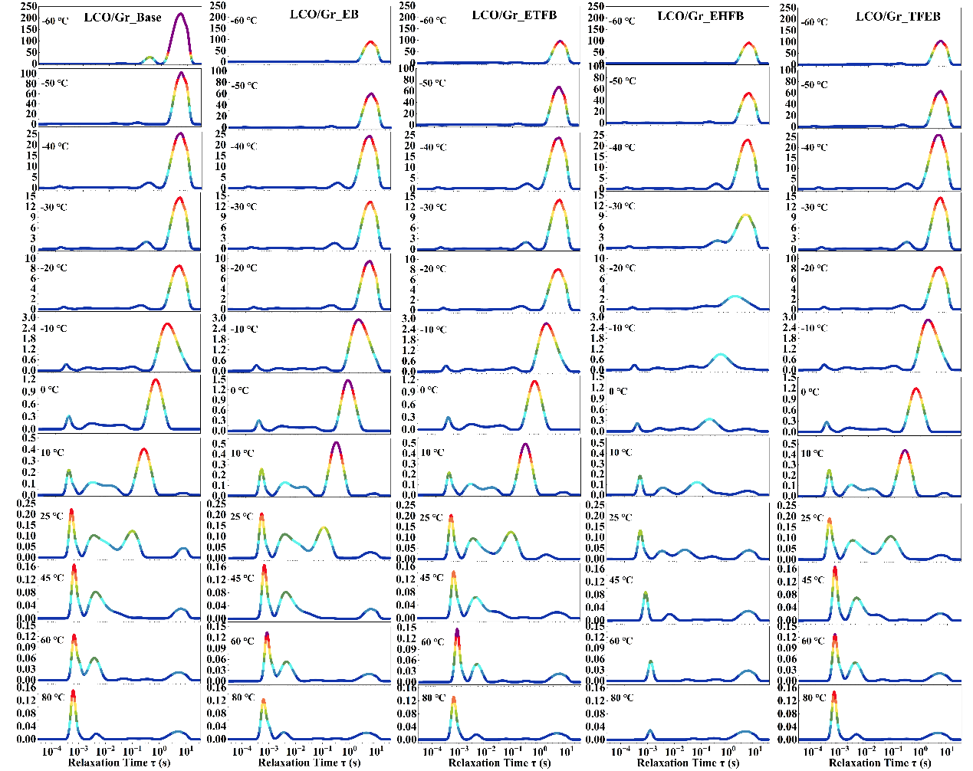
Fig. S20ǀ DRT results at different temperature in the range of 80 ℃ to -60 ℃ for 4.5V LCO/Gr pouch cells obtained from the data in Fig S18.
Equivalent circuit models (ECM) are often used to analyze the EIS data. However, as put forward in Refs, ECM is not suitable for mechanistic analysis, as it has the polysemy problem, that is, countless ECMs can fit the same piece of EIS data, and it does not link electric elements of the ECM with physicochemical parameters of the battery. To avoid these problems associated with ECMs, distribution of relaxation times (DRT) method has been employed to quantify the contribution of each part of the resistance without artificial fitting error. Intrinsically, it is a purely mathematical transformation that translates the frequency domain Nyquist plots into the time domain DRT profile via eq 4^{31, 32, 33}.
$Z_{DRT}=R_{∞}+\int_{-∞}^{∞}{\frac{γ(lnτ)}{1+i2πfτ}dlnτ}$ (eq 4)
In which each physical process is represented as a local maximum in a continuous distribution function³³. And the area under the peak represents the impedance value³⁴. To avoid the inductance characteristics in the high frequency area (above 1KHz) derived from the effect of current collectors, therefore, EIS at the area above 1KHz cannot be calculated using the DRT method due to the long measurement time and then fitted³⁵. We assigned the peak at low frequency (the τ in the range of 10¹ to 10⁻¹) as charge transfer resistance (R_{ct}), and the peak at medium frequency (the τ in the range of 10⁻¹ to 10⁻³) as the resistance of lithium-ion transport through the SEI (R_{SEI}), and the high frequency peak (10⁻³ to 10⁻⁴ s) is identified as contact resistance (R₀) which is in good agreement with the literature³⁶. The EIS was conducted at temperature ranging from 80 ℃ to -60 ℃ at 50% SOC. R₀ is much less sensitive to the temperature, and R_{ct} and R_{SEI} regimes are all temperature-dependent, and the corresponding R_{ct} resistances increase significantly with decreasing temperature, when fluorinated co-solvent added, the resistance increment is much less.
Fig. S21ǀ EIS comparison of Base electrolyte and EHFB electrolyte under different temperature.
Fig. S22ǀ EIS spectra of the LCO/Li half-cell and Gr/Li half-cell with Base electrolyte at 298K (a) and 253K (b), and with EHFB electrolyte at 298K (c) and 253K (d). The corresponding EIS spectra of LCO/Gr pouch cell is inserted.

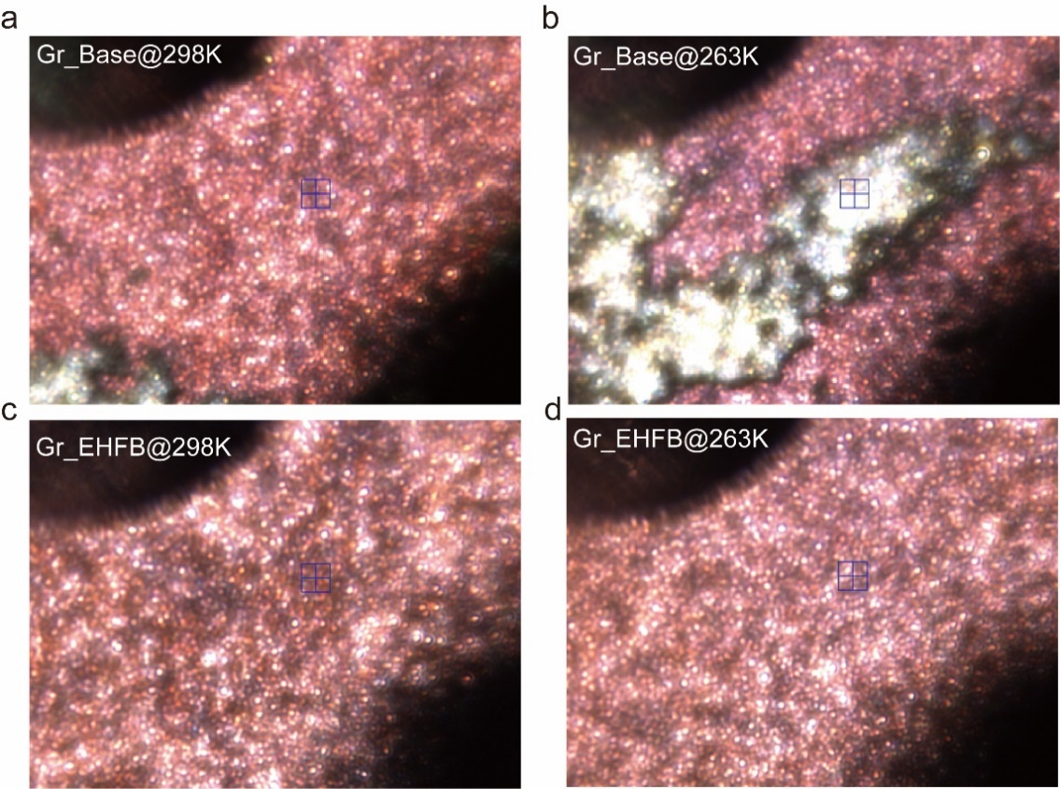
Fig. S23ǀ Optical images seen from the TOF-SIMS camera of graphite anode cycled in Base electrolyte (a-b) and EHFB electrolyte (c-d) at 298K and 263K, respectively.

After cycling at 263K in Base electrolyte compared with it cycled at 298K, the unevenly distributed metallic deposit (the bright area) on the graphite surface was obviously observed, which is the notorious “lithium dendrite”, while for the EHFB, there were the evenly distributed and smooth graphite intercalation compounds LiC_{x} even cycled at 263K. And the selected test area is located at the center of blue cursor.

Fig. S24ǀThe mass spectrum collected at the surface in negative ion mode of graphite electrodes cycled with the (a-b) Base electrolyte and (c-d) EHFB electrolyte after the 200th cycle at 298K and 263K.

Fig. S25ǀThe mass spectrum collected at the surface in positive ion mode of graphite electrodes cycled with the (a-b) Base electrolyte and (c-d) EHFB electrolyte after the 200th cycle at 298K and 263K.
Fig. S26ǀThe mass spectrum collected at the area after sputter in negative ion mode of graphite electrodes cycled with the (a-b) Base electrolyte and (c-d) EHFB electrolyte after the 200th cycle at 298K and 263K.
Fig. S27ǀThe TOF-SIMS depth profiles of functional groups in inorganic SEI (In-SEI) after long cycling for Base electrolyte (a-b) and EHFB electrolyte (c-d) at 298K and 263K.
The inorganic SEI contains LiF, LiP_{x}F_{y}O_{z}, Li₂O, and LiOH, Li₂CO₃ in all the samples. The LiF component derived from Base electrolyte (Fig. S27a-b) is much smaller than it derived from EHFB electrolyte (Fig. S27a-b), which is only 1/6 of that in EHFB electrolyte at low temperature (LT). Table S7 list the origin of the main SEI products formed on graphite electrode and the possible reactions according to literatures, therefore, the less LiF means less anion to participate the solvation process and LiF has been reported repeatedly to be a good SEI component to enhance the conductive of SEI, and the LiF and LiOH component increases with the increase of depth except cycled in Base electrolyte at room temperature (RT), which is well consistent with those reported literatures that the inner layer of SEI is main consist of inorganic components, and the LiF and LiOH component produced in EHFB electrolyte at LT is enhanced compared with it at RT, which indicates that more anions participate solvation process in EHFB contained cells when temperature lowered. While, for other inorganic component Li₂CO₃, Li₂O and LiP_{x}F_{y}O_{z} which properly originated from the two electrons reaction and the lithium salt decomposition, respectively, showed a downward trend with the depth decreases.
Fig. S28ǀThe TOF-SIMS depth profiles of functional groups in organic SEI (O-SEI) after long cycling for Base electrolyte (a-b) and EHFB electrolyte (c-d) at 298K and 263K.
For the organic components C-H and C-O-H, they all showed the downward trend in all the samples (Fig. S28), and the general organic component originated from the decomposition of solvent in EHFB cells is smaller than in Base cells. To enlarge the difference of the three typical organic components which is covered in Fig. S28, CO₃⁻, C₂H₃O⁻ and C₂H₃O₂⁻ are separated to compare between Base cells and EHFB cells under LT and RT (Fig. S29). The ion fragments CO₃⁻ which represent the ROCO₂Li originated from the decomposition of EC molecule (Table S7), generally showed increases with the temperature lowered in Base cells but inversely in EHFB cells, indicating that EC is promoted to solvated with Li⁺ with Base electrolyte but weakened with EHFB electrolyte when temperature lowered. While for the component of C₂H₃O⁻ which is ascribed as the CH₃COLi that derived from the decomposition of DEC (Table S7), is totally increased and decreased when temperature is lowered in Base cells and EHFB cells, respectively, which also certificate that more DEC participates the solvation process in EHFB electrolyte than in Base electrolyte when temperature deceases. These trends of EC and DEC decomposition are rightly agreeing with the calculation result and spatial spectrum analyses.
Fig. S29ǀThe TOF-SIMS depth profiles of the three typical organic components on graphite anode cycled in Base and EHFB electrolyte at different temperature. (a) ROCO₂Li, (b) CH₃COLi, and (c) CH₃COOLi.
Fig. S30ǀThe mapping of Co⁺ (a-d) and Li⁺ (f-i) distributed at the surface of the graphite anode (FOV: 20μm x 20μm, Scale Bar: 10μm)
There detected a serious Co⁺ dissolution on the graphite anode cycled in Base electrolyte due to the high voltage electrochemical window, which is supposed to be inhibited when cycled in EHFB electrolyte because introducing fluorine can enhance the HOMO energies and thus improve the oxidation stability. The Li⁺ distribution of cycled in Base electrolyte at LT shows much more than that in EHFB, which also manifests that the lithium dendrite is likely to growth at the graphite anode with Base electrolyte during LT operations.
Fig. S31ǀThe mapping of Co⁺ and Li⁺ distributed at the surface of the graphite anode.
For the organic component C-H-O, it shows more in the outer of the SEI layer, and it deceases in EHFB cells but increases in Base cells when the temperature jumps from RT to LT. For the inorganic component, it shows much more P-F-O and residue PF₆⁻ and less Li₂O in EHFB cells at LT. And it was found that the lithium salt was evenly distributed at the outer SEI layer.
Fig. S32ǀFormation data of the pouch cells for NCM811/Gr (a-b) and LCO/Gr (c-d). The gas production amount (a,c) and the capacity during formation process (b,d).

Fig. S33ǀ Cycling behavior of LCO/Li half-cells with the electrochemical window of 3-4.5V. (a) and NCM811/Li half-cells (b) under -10 ℃.
Fig. S34ǀ Cycling behavior of pouch cells under room temperature. a, 4.5V LCO/Gr. b, 4.5V NCM811/Gr. c, Gr/Li half-cell.

Fig. S35ǀ Cycling behavior of pouch cells under high temperature of 60 ℃. a, 4.5V LCO/Gr. b, 4.5V NCM811/Gr. c, Gr/Li half-cell.
Fig. S36ǀ Temperature dependent discharge profiles of NCM811/Gr pouch cells. a, Base. b, EHFB.

Fig. S37ǀ Electrochemical behavior of graphite cells. a, Rate performance of Gr/Li cells. b, 50th charge and discharge profiles of Gr/Li cells during 60℃ cycles. c, Cycling performance of Gr/Li cell under -10 ℃ with different electrolytes.

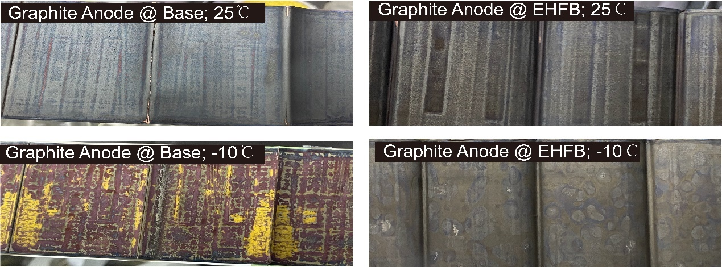
Fig. S38ǀ Disassembled graphite anode after long cycling at 25℃ and -10℃ with Base and EHFB electrolyte.

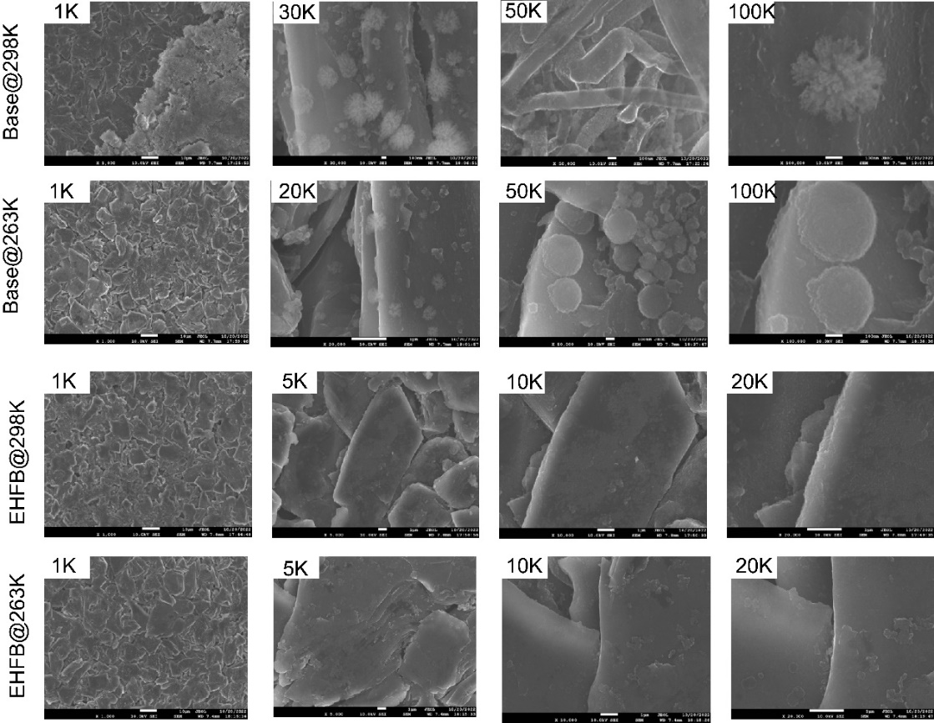
Fig. S39ǀ SEM images of graphite anode dismantled from LCO/Gr pouch cell after long cycling at Base and EHFB electrolyte under different temperature.

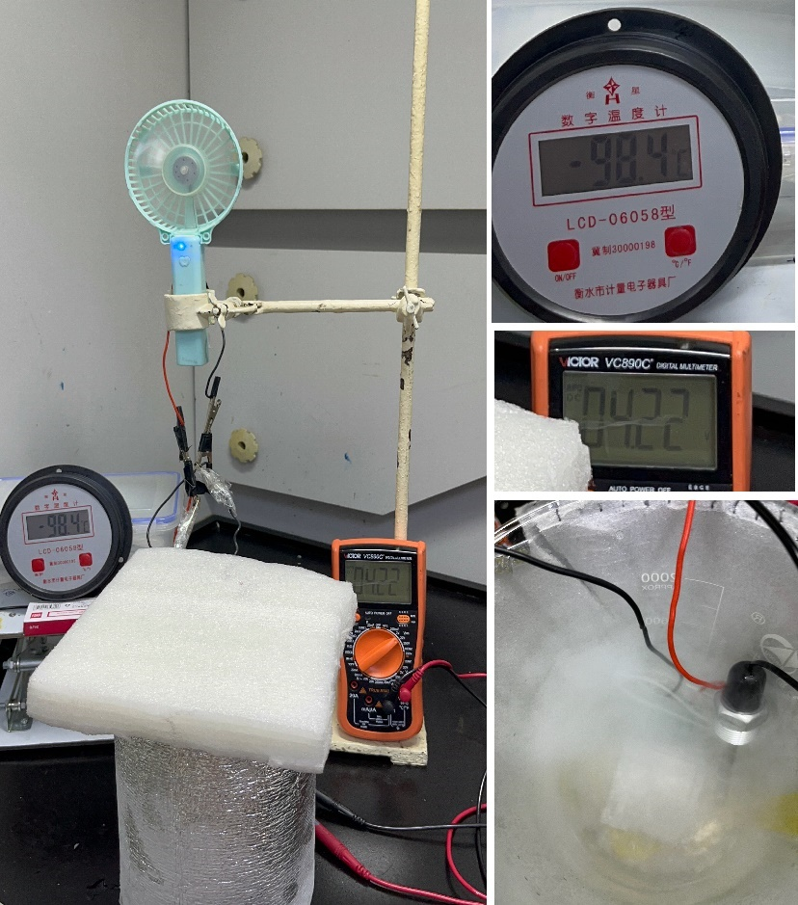
Fig. S40ǀ Photos of an electric fan powered by the 4.5V LCO/Gr pouch cell using EHFB electrolyte at superior low temperature -98.4℃
Fig. S41ǀ LSV of the electrolyte with a scan rate of 0.2mV/s with base electrolyte, EB, ETFB, EHFB, and TFEB contained electrolyte.

Video
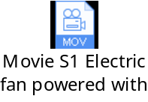
Movie S1: Electric fan powered by the 4.5V LCO/Gr pouch cell using EHFB electrolyte at almost -100 ℃
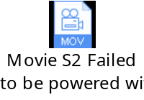
Movie S2: Electric fan failed to be powered by the 4.5V LCO/Gr pouch cell using Base electrolyte at -86 ℃

Reference
1. Fan X, et al. All-temperature batteries enabled by fluorinated electrolytes with non-polar solvents. Nature Energy 4, 882-890 (2019).

2. Akita Y, Segawa M, Munakata H, Kanamura K. In-situ Fourier transform infrared spectroscopic analysis on dynamic behavior of electrolyte solution on LiFePO4 cathode. Journal of Power Sources 239, 175-180 (2013).

3. Marino C, et al. Solvation and Dynamics of Lithium Ions in Carbonate-Based Electrolytes during Cycling Followed by Operando Infrared Spectroscopy: The Example of NiSb2, a Typical Negative Conversion-Type Electrode Material for Lithium Batteries. The Journal of Physical Chemistry C 121, 26598-26606 (2017).

4. Wu Y, et al. Significance of Antisolvents on Solvation Structures Enhancing Interfacial Chemistry in Localized High-Concentration Electrolytes. ACS Central Science 8, 1290-1298 (2022).

5. Lu W, Xie K, Chen Zx, Pan Y, Zheng Cm. Preparation and characterization of trifluoroethyl aliphatic carboxylates as co-solvents for the carbonate-based electrolyte of lithium-ion batteries. Journal of Fluorine Chemistry 161, 110-119 (2014).

6. Wang Z, Huang X, Chen L. Performance Improvement of Surface-Modified LiCoO2 Cathode Materials: An Infrared Absorption and X-Ray Photoelectron Spectroscopic Investigation. Journal of The Electrochemical Society 150, A199 (2003).

7. Yang CR, Wang YY, Wan CC. Composition analysis of the passive film on the carbon electrode of a lithium-ion battery with an EC-based electrolyte. Journal of Power Sources 72, 66-70 (1998).

8. Li J-T, Chen S-R, Ke F-S, Wei G-Z, Huang L, Sun S-G. In situ microscope FTIR spectroscopic studies of interfacial reactions of Sn–Co alloy film anode of lithium ion battery. Journal of Electroanalytical Chemistry 649, 171-176 (2010).

9. Ikezawa Y, Nishi H. In situ FTIR study of the Cu electrode/ethylene carbonate+dimethyl carbonate solution interface. Electrochimica Acta 53, 3663-3669 (2008).

10. Lu W, Xie K, Pan Y, Chen Z-x, Zheng C-m. Effects of carbon-chain length of trifluoroacetate co-solvents for lithium-ion battery electrolytes using at low temperature. Journal of Fluorine Chemistry 156, 136-143 (2013).

11. Aurbach D, Daroux ML, Faguy PW, Yeager E. Identification of Surface Films Formed on Lithium in Propylene Carbonate Solutions. Journal of The Electrochemical Society 134, 1611 (1987).

12. Li G, Li H, Mo Y, Chen L, Huang X. Further identification to the SEI film on Ag electrode in lithium batteries by surface enhanced Raman scattering (SERS). Journal of Power Sources 104, 190-194 (2002).

13. Perla B. Balbuena YW. Lithium-ion batteries: solid-electrolyte interphase.). Imperial College Press (2004).

14. Song W, et al. Electronic structure influences on the formation of the solid electrolyte interphase. Energy & Environmental Science 13, 4977-4989 (2020).

15. Wang Y, Nakamura S, Ue M, Balbuena PB. Theoretical Studies To Understand Surface Chemistry on Carbon Anodes for Lithium-Ion Batteries: Reduction Mechanisms of Ethylene Carbonate. Journal of the American Chemical Society 123, 11708-11718 (2001).

16. Xu M, Hao L, Liu Y, Li W, Xing L, Li B. Experimental and Theoretical Investigations of Dimethylacetamide (DMAc) as Electrolyte Stabilizing Additive for Lithium Ion Batteries. The Journal of Physical Chemistry C 115, 6085-6094 (2011).

17. Zhuang GV, Xu K, Yang H, Jow TR, Ross PN. Lithium Ethylene Dicarbonate Identified as the Primary Product of Chemical and Electrochemical Reduction of EC in 1.2 M LiPF6/EC:EMC Electrolyte. The Journal of Physical Chemistry B 109, 17567-17573 (2005).

18. Gauthier M, et al. Electrode–Electrolyte Interface in Li-Ion Batteries: Current Understanding and New Insights. The Journal of Physical Chemistry Letters 6, 4653-4672 (2015).

19. Lu W, Xie K, Chen Z, Xiong S, Pan Y, Zheng C. A new co-solvent for wide temperature lithium ion battery electrolytes: 2,2,2-Trifluoroethyl n-caproate. Journal of Power Sources 274, 676-684 (2015).

20. Campion CL, Li W, Lucht BL. Thermal Decomposition of LiPF6-Based Electrolytes for Lithium-Ion Batteries. Journal of The Electrochemical Society 152, A2327 (2005).

21. Kim K, et al. Cyclic Aminosilane-Based Additive Ensuring Stable Electrode–Electrolyte Interfaces in Li-Ion Batteries. Advanced Energy Materials 10, 2000012 (2020).

22. Plakhotnyk AV, Ernst L, Schmutzler R. Hydrolysis in the system LiPF6—propylene carbonate—dimethyl carbonate—H2O. Journal of Fluorine Chemistry 126, 27-31 (2005).

23. Yang H, Zhuang GV, Ross PN. Thermal stability of LiPF6 salt and Li-ion battery electrolytes containing LiPF6. Journal of Power Sources 161, 573-579 (2006).

24. Heider U, Oesten R, Jungnitz M. Challenge in manufacturing electrolyte solutions for lithium and lithium ion batteries quality control and minimizing contamination level. Journal of Power Sources 81-82, 119-122 (1999).

25. Henschel J, Peschel C, Klein S, Horsthemke F, Winter M, Nowak S. Clarification of Decomposition Pathways in a State-of-the-Art Lithium Ion Battery Electrolyte through 13C-Labeling of Electrolyte Components. Angewandte Chemie International Edition 59, 6128-6137 (2020).

26. Murakami M, Yamashige H, Arai H, Uchimoto Y, Ogumi Z. Association of paramagnetic species with formation of LiF at the surface of LiCoO2. Electrochimica Acta 78, 49-54 (2012).

27. Wang A, Kadam S, Li H, Shi S, Qi Y. Review on modeling of the anode solid electrolyte interphase (SEI) for lithium-ion batteries. npj Computational Materials 4, 15 (2018).

28. Wilken S, Treskow M, Scheers J, Johansson P, Jacobsson P. Initial stages of thermal decomposition of LiPF6-based lithium ion battery electrolytes by detailed Raman and NMR spectroscopy. RSC Advances 3, 16359-16364 (2013).

29. Xu G, Liu Z, Zhang C, Cui G, Chen L. Strategies for improving the cyclability and thermo-stability of LiMn2O4-based batteries at elevated temperatures. Journal of Materials Chemistry A 3, 4092-4123 (2015).

30. Ye C, et al. Converting detrimental HF in electrolytes into a highly fluorinated interphase on cathodes. Journal of Materials Chemistry A 6, 17642-17652 (2018).

31. Illig J, Ender M, Weber A, Ivers-Tiffée E. Modeling graphite anodes with serial and transmission line models. Journal of Power Sources 282, 335-347 (2015).

32. Illig J, Schmidt JP, Weiss M, Weber A, Ivers-Tiffée E. Understanding the impedance spectrum of 18650 LiFePO4-cells. Journal of Power Sources 239, 670-679 (2013).

33. Schmidt JP, Berg P, Schönleber M, Weber A, Ivers-Tiffée E. The distribution of relaxation times as basis for generalized time-domain models for Li-ion batteries. Journal of Power Sources 221, 70-77 (2013).

34. Lu Y, et al. The carrier transition from Li atoms to Li vacancies in solid-state lithium alloy anodes. Science Advances 7, eabi5520 (2021).

35. Chen X, Li L, Liu M, Huang T, Yu A. Detection of lithium plating in lithium-ion batteries by distribution of relaxation times. Journal of Power Sources 496, 229867 (2021).

36. Zhou X, Huang J, Pan Z, Ouyang M. Impedance characterization of lithium-ion batteries aging under high-temperature cycling: Importance of electrolyte-phase diffusion. Journal of Power Sources 426, 216-222 (2019).

