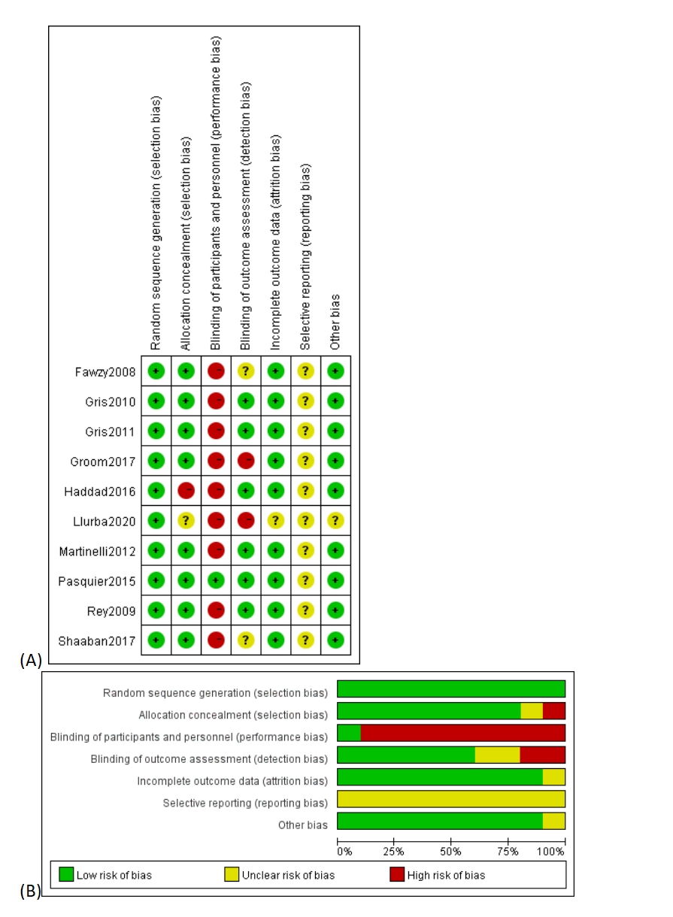
S.Figure 1. Assessment of risk of bias. (A) Summary of risk of bias for each trial; plus sign: low risk of bias; minus sign: high risk of bias; question mark: unclear risk of bias. (B) Risk of bias graph for each risk of bias item presented as percentages across all included studies.

