Supplementary material
People Who Keep Me Strong (Stay Strong app)
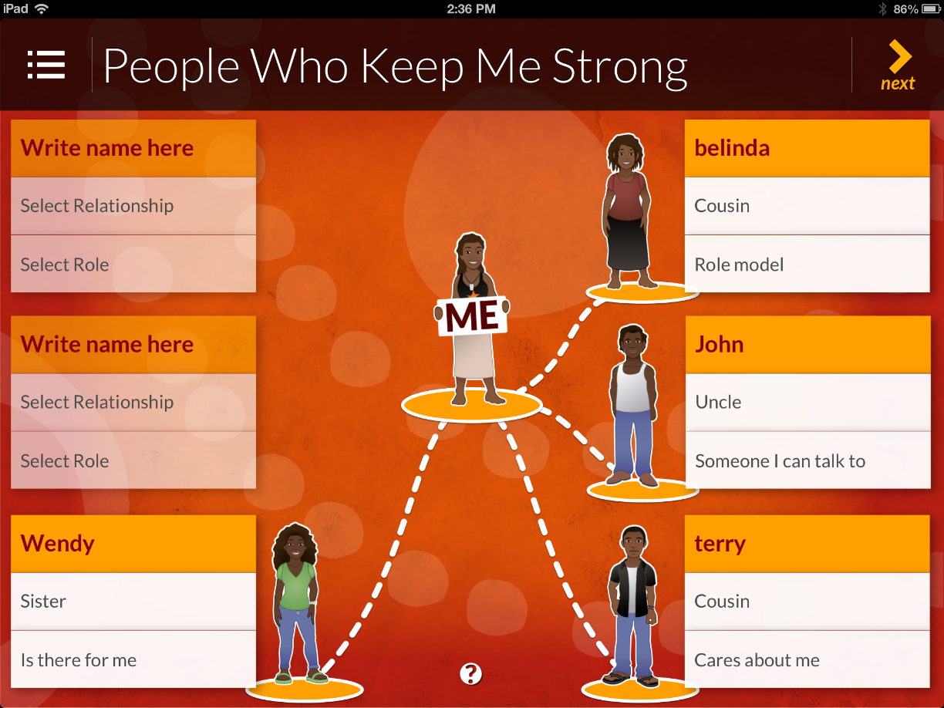

People Who Keep Me Well (Weathering Well app)
Things That Keep Me Strong (Stay Strong app) 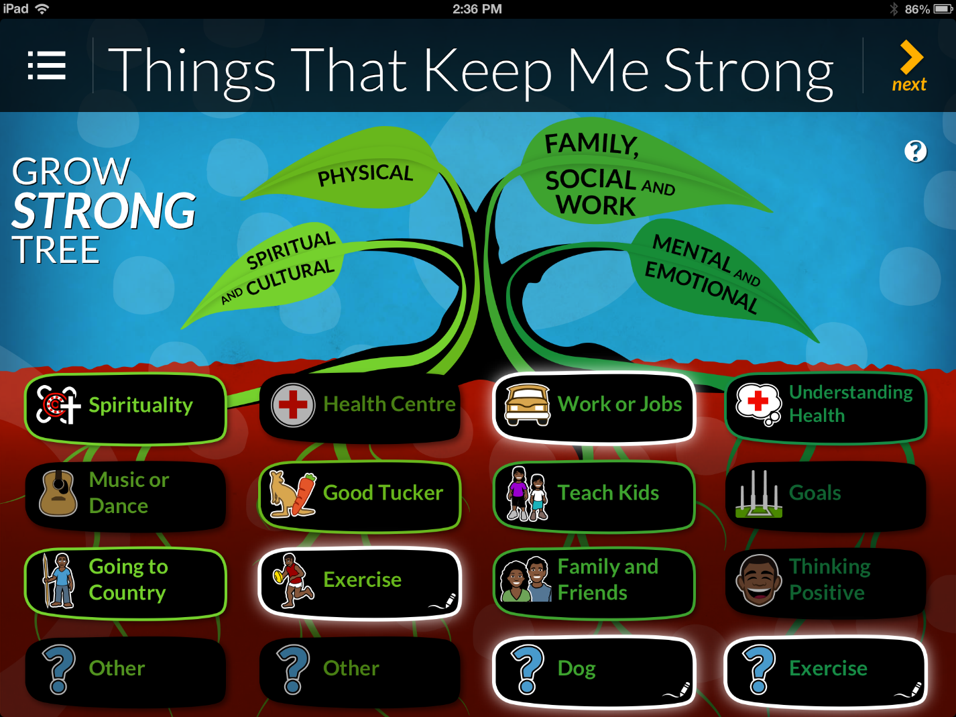
Things That Keep Me Well (Weathering Well app)

My Worries (Stay Strong app)
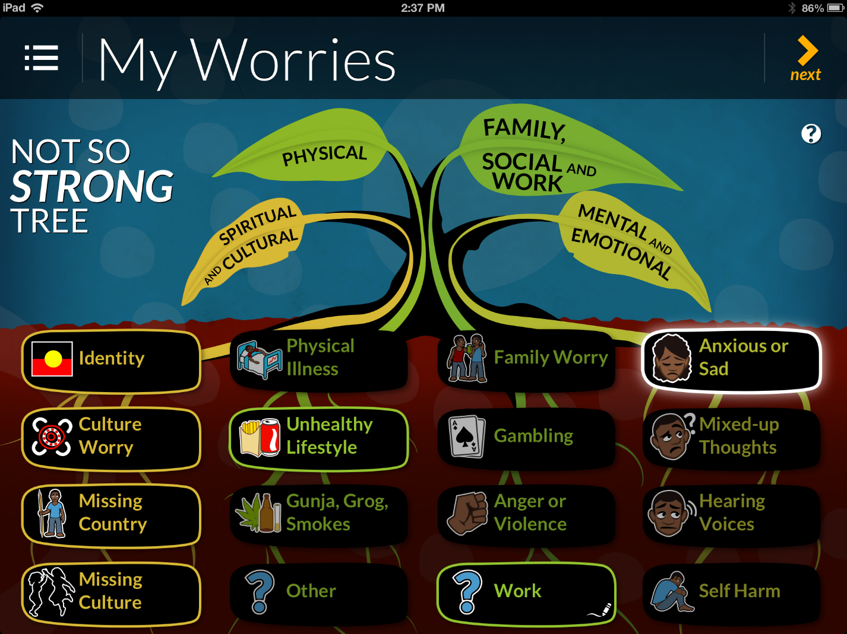

My Goals (Stay Strong app) 