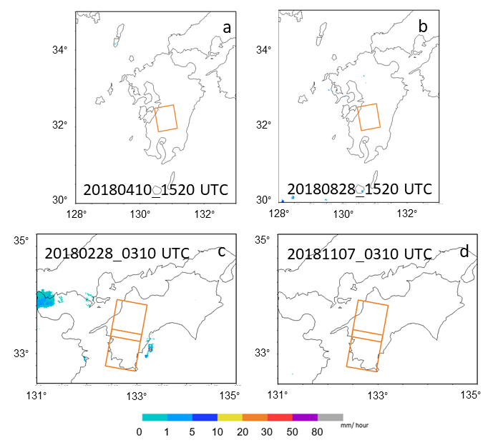
Figure S1. JMA weather radar observation; on Kyushu at (a) 20180410_1520 UTC, (b) 20180828_1520UTC and Shikoku at (c) 20180228_0310UTC, (d) 20181107_0310UTC. Orange square denote the SAR imaging area taken by ALOS-2/PALSAR-2 SM-1 mode.
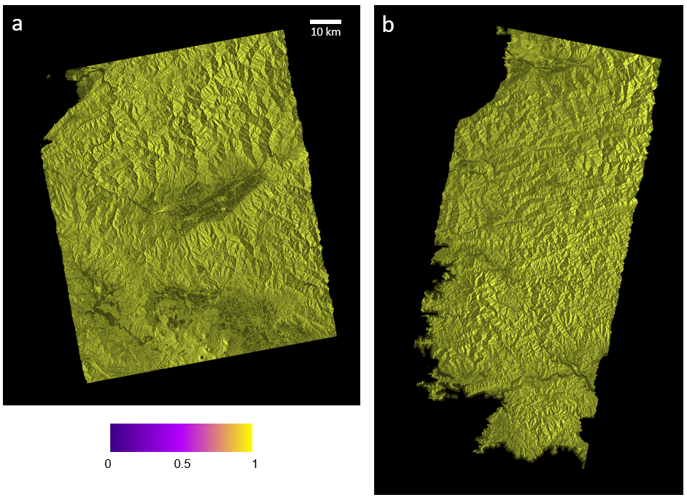
Figure S2. Coherence map of original bandwidth differential interferogram of heavy rain pairs; (a) Kyushu on 20180731_20180828, and (b) Shikoku 20180815_20181107.
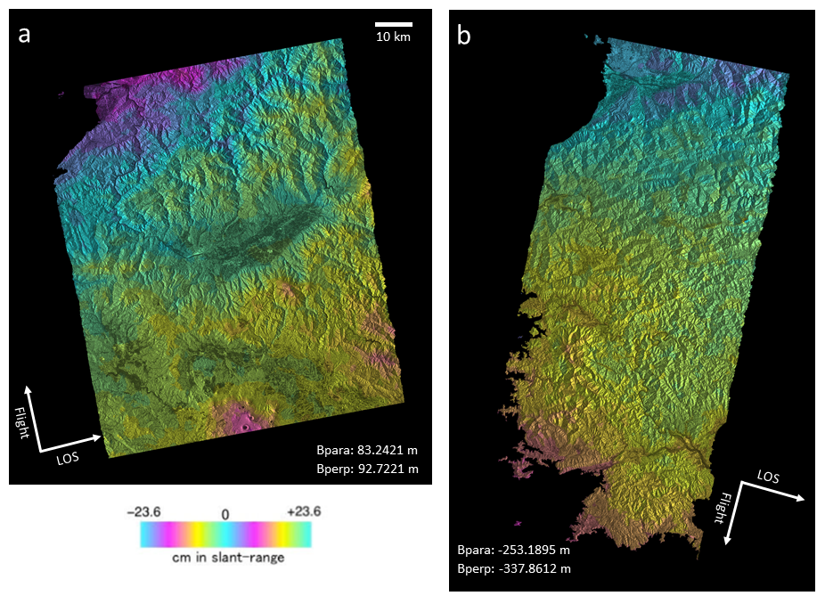
Figure S3. Original bandwidth differential interferogram of fair-weather pairs; (a) Kyushu on 20180410_20180828, and (b) Shikoku 20180228_20181107.
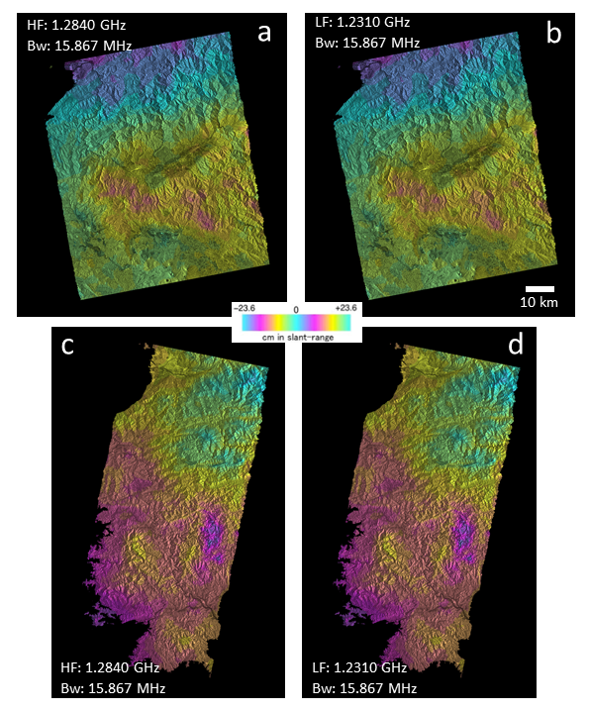
Figure S4. Unwrapped differential interferogram for heavy rain pairs. Kyushu 20180731_20180828 with (a) high frequency, (b) low frequency and Shikoku 20180815_20181107 with (c) high frequency, (d) low frequency.
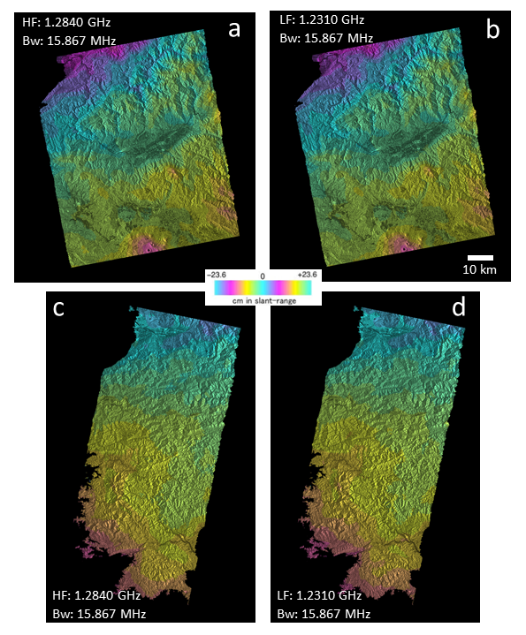
Figure S5. Unwrapped differential interferogram for fair-weather pairs. Kyushu 20180731_20180828 with (a) high frequency, (b) low frequency and Shikoku 20180815_20181107 with (c) high frequency, (d) low frequency.
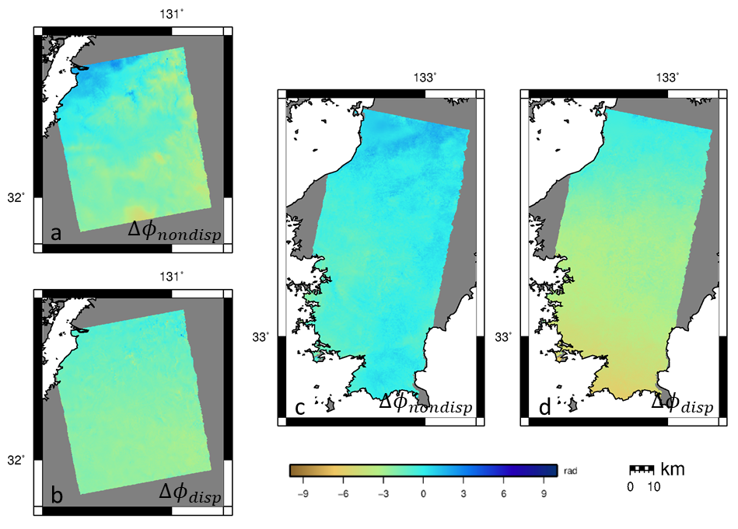
Figure S6. The retrieval of standard SSM on Kyushu 20180731_20180828; (a) ${∆ϕ}_{non-dispersive}$, and (b) ${∆ϕ}_{dispersive}$; and Shikoku 20180228_20181107 (c) ${∆ϕ}_{non-dispersive}$, and (d) ${∆ϕ}_{dispersive}$.
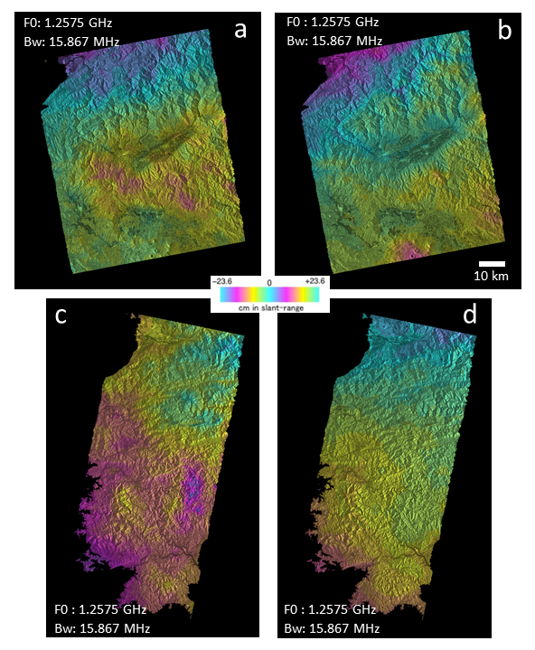
Figure S7. Unwrapped differential interferogram of F0; (a) Kyushu 20180731_20180828 (b) Kyushu 20180410_20180828, (c) Shikoku 20180815_20181107, (d) Shikoku 20180228_20181107.

