Supplementary Information
In-silico studies on hydration in EcoRI-cognate DNA complex
Sasthi Charan Mandal¹, Jaydeb Chakrabarti^{1,2, *}
¹Department of Physics of Complex Systems, S.N. Bose National Centre for Basic Sciences, Block JD, Sector III, Salt Lake, Kolkata 700106, India.
²Also at: The Thematic Unit of Excellence on Computational Materials Science, and Technical Research Centre, S. N. Bose National Centre for Basic Sciences, Block JD, Sector III, Salt Lake, Kolkata 700106, India.

*Corresponding author: jaydeb@bose.res.in

Contents of SI

- Fig. S1: Histograms of the base pair step parameters of DNA in free state and in complexes.
- Fig. S2. Displacements of nucleotides of DNA in EcoRI-DNA, Mg²⁺-EcoRI-DNA, Ca²⁺-EcoRI-DNA and Mg²⁺-EcoRI-mtDNA.

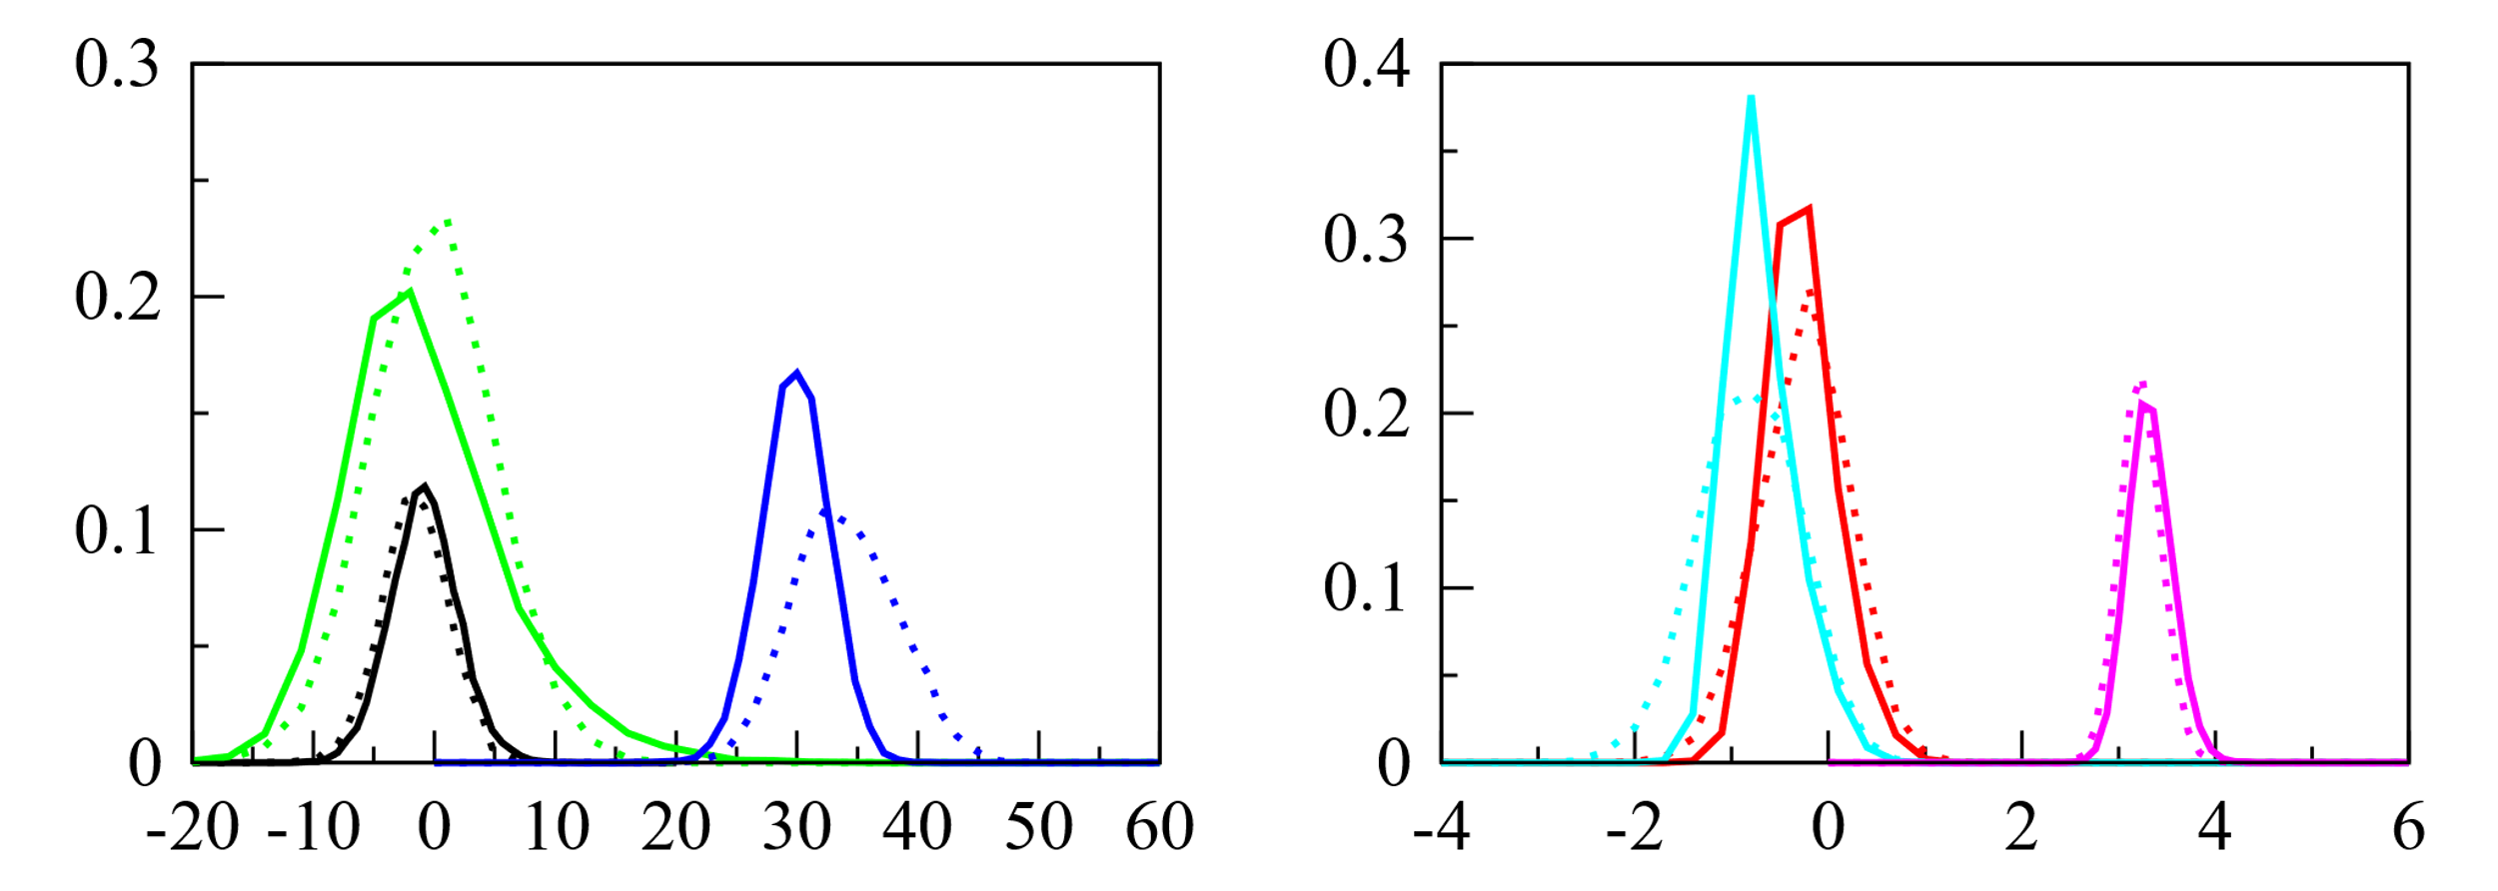
(b)
(a)
$H_{5,6}^{0}$(b), $H_{5,6}^{f}$(b)

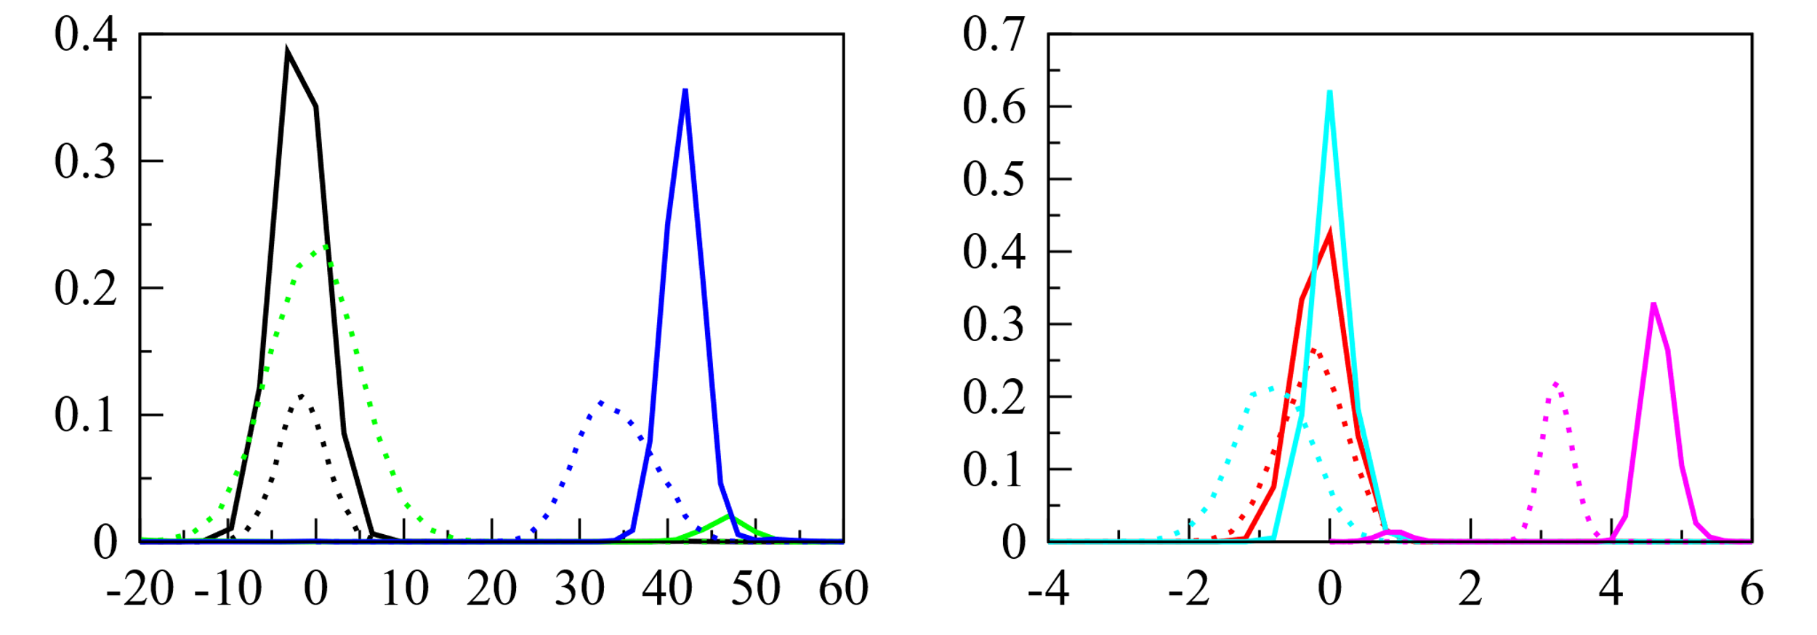
$H_{5,6}^{0}$(b), $H_{5,6}^{Mg}$(b)
(d)
(c)

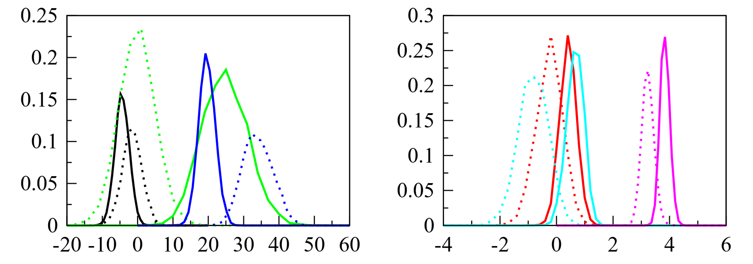
$H_{5,6}^{0}$(b), $H_{5,6}^{Ca}$(b)
(f)
(e)

b
b

Fig. S1. $H_{i, i+1}^{0}$(b), $H_{i, i+1}^{f}$(b), $H_{i, i+1}^{Mg}$(b) and $H_{i, i+1}^{Ca}$(b) of base pair step parameters of DNA in free state, EcoRI-DNA, Mg²⁺-EcoRI-DNA and Ca²⁺-EcoRI-DNA complex. Distributions of (a) τ(black), ρ(green) and ω(blue), and (b) Dx(red), Dy(cyan) and Dz(magenta) of (A₅:T₂₀, A₆:T₁₉) for free DNA (dotted line) and DNA in EcoRI-DNA (solid line), (c) and (d) are same as (a) and (b) respectively, but for free DNA (dotted line) and DNA in Mg²⁺-EcoRI-DNA (solid line). Similarly, (e) and (f) are same as (a) and (b) respectively, but for free DNA (dotted line) and DNA in Ca²⁺-EcoRI-DNA (solid line).

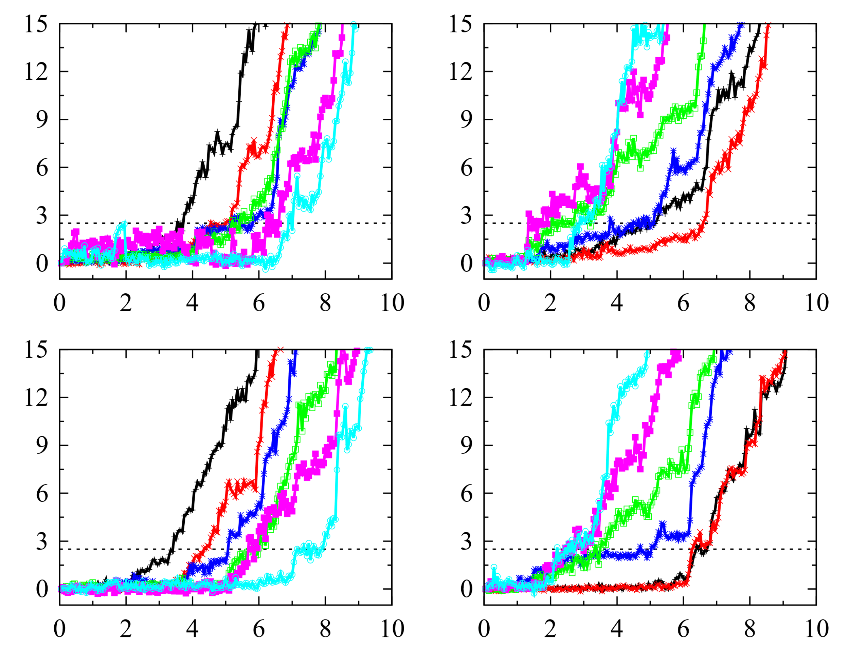
(b)
(a)
$D_{S1}^{Mf}$(Å)
$D_{S2}^{Mf}$(Å)

(d)
(c)
$D_{S2}^{Mg}$(Å)
$D_{S1}^{Mg}$(Å)

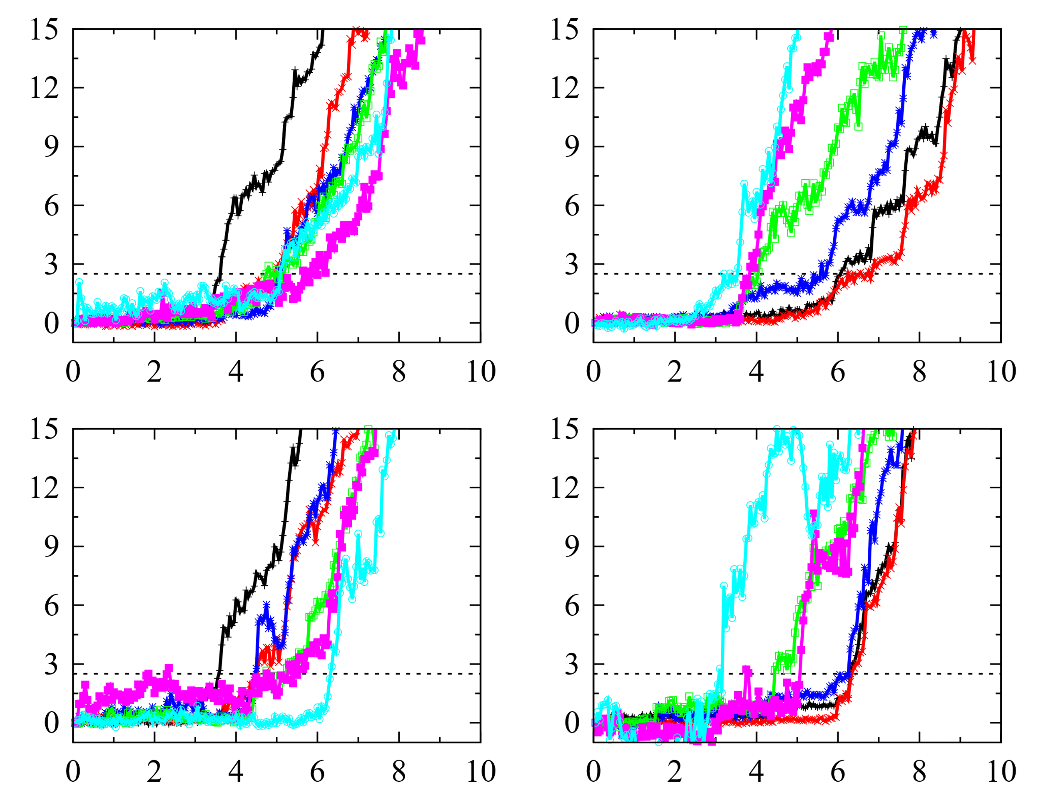
(f)
(e)

$D_{S2}^{Ca}$(Å)
$D_{S1}^{Ca}$(Å)

(h)
(g)
$D_{S1}^{Mut}$(Å)
$D_{S2}^{Mut}$(Å)

0 2 4 6 8 10
0 2 4 6 8 10
Time (ns)
Time (ns)

Fig. S2. Displacements of nucleotides in (a) first and (b) second strands of EcoRI-DNA, (c) first and (d) second strands of Mg²⁺-EcoRI-DNA, (e) first and (f) second strands of Ca²⁺-EcoRI-DNA, and (g) first and (h) second strands of Mg²⁺-EcoRI-mtDNA.

