Supplementary Information
Table S1. Information concerning the experience of each expert.
Role | Years of experience
Clinical neurophysiologist | over 20
Clinical neurophysiologist | 18
Clinical neurophysiologist | over 20
Neurologist | 3
Technical Physician | 9
Neurology resident | 1
Neurology resident | 1

Simulation protocol to determine the necessary sample size
Determining the necessary sample size for this type of study is far from trivial. On one hand, the IEDs from a single patient are not fully independent but the level of correlation is variable intra- and inter-patients. In addition, the biological variability between subjects and its representativity of the overall population is also hard to estimate. Here, we opted to present two simulation studies showing 50 EEGs to be sufficient to assess significant differences between the algorithm and experts. The first simulation is more general, derived from theoretical statistics, and the second one is an adaptation of a paradigm that has been used in radiology and pathology studies.
Simulation 1
For this simulation, we first generate data (1,000,000 data observations; in this case number of IEDs per EEG) from a population (i.e., possible observed values) from a Zero-Inflated Poisson Distribution (a distribution used for count data). This distribution takes into account EEGs without IEDs (Zero-inflation), as well as the EEGs with IEDs (counts).
Poisson Distributions have one parameter, λ, which stands for the mean and the variance of the distribution. In the given case we use λ=10, that serves to approximate the average number of IEDs per EEG across experts for the non-zero instances. Further, since the dataset contains roughly 50% of EEGs with IEDs and without IEDs, we used a zero inflation of 50%, resulting in an overall mean of the distribution equal to λ/2 = 5.
However, this value could have been set to any arbitrary value, as we only want to show that 50 observations are more than enough to obtain an accurate estimate of the true λ, which translates to the notion that 50 observations are, at the very worst, enough to showcase that the deep networks are on par with the experts.
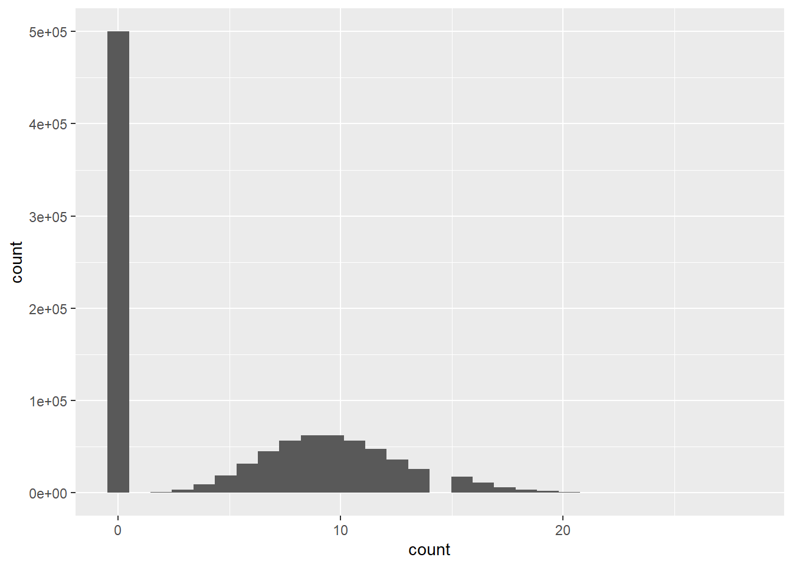
Figure S1 – A particular representation of the zero-Inflated Poisson distribution for the generated data, with λ=10 and mean value λ/2=5. The absence of counts at count=14 results from statistical variation that happened to occur for this simulation.
We draw 10,000 random samples of size 1 through 200 (i.e., 10,000 samples of size 1; 10,000 samples of size 2; etc..) from our previously generated population. For each sample in each sample size we compute the mean count. Once the 10,000 samples of a given sample size are computed, we again compute the mean and standard deviation across these 10,000 samples. Running through the simulation results in a dataset with 200 mean values and standard deviations, 1 for each specified sample size.
To showcase the results regarding the Poisson distribution parameter, we plot the mean values together with the 95% Confidence Interval (CI) of the sampling distribution, as shown in Figure S2. This clearly shows that even when tripling or quadrupling the sample size, no large changes in the confidence interval are observed. Indeed, the CI for 50 EEGs ranges from 4.4 to 5.6, while the CI for 100 EEGs the range is 4.6-5.4 and for 200 EEGs it is 4.7-5.3.
To know whether the CI for 50 EEGs is acceptable in the context of this study, we should compare it to the variance that exists between the experts. Calculating the standard deviation to the mean from the experts in our study, we see that it ranges from 0 to 6.8 for the different EEGs, with an average of 2.3. The width of the CI for 50 EEGs is 1.2, meaning that the detections of the network would theoretically fall within human variance.

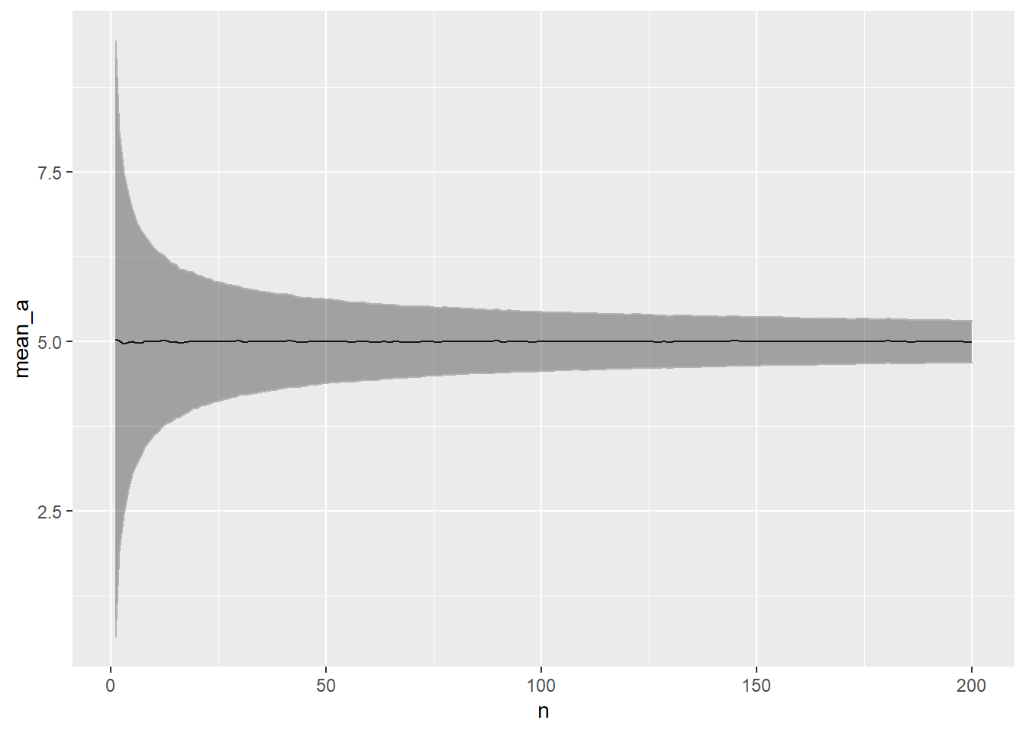
Figure S2 – Mean values of the estimated value of λ/2 and the associated 95% Confidence Interval of the sampling distribution, assuming a Poisson distribution. The sample size (n) is shown on the x axis, ranging from 0 to 200 samples (i.e. EEGs).

Simulation 2
There has been extensive research in the field of reader study assessment for image analysis in the medical field, mostly in radiology and pathology [1-4]. McKinney et al. [3] have created an open-source library that allows assessment of statistical significance for medical machine learning. We adapted the author’s approach to our dataset size (23 ‘positives’ and 27 ‘negatives’) and we assumed a difference of 0.1 in AUCs between the experts (AUC = 0.9) and the network (AUC = 0.8). These values were arbitrary, as we were only interested in the difference between the two groups. Further, we extended the author’s algorithm using a Markov Chain Monte Carlo (MCMC) simulation approach with 1000 iterations. The outcome of this simulation was a distribution of p values, which we used to compute statistical power. Using the threshold of 0.05, power is 0.62 and using a threshold of 0.1, power is 0.8. This shows that a difference between the experts and the network would likely be detected at this level. As the network performed on the higher end of the experts included in the study, we believe this is enough to show non-inferiority of the network. Further, our study includes several IEDs per EEG recording, which differs from the image data used in the referenced studies. Although these are not uncorrelated, the actual dataset is larger than the conservative estimate used for this study.
References
1. Kazemzadeh, S., et al., Deep learning for detecting pulmonary tuberculosis via chest radiography: an international study across 10 countries. arXiv preprint arXiv:2105.07540, 2021.
2. Liu, X., et al., Deep Learning to Detect OCT-derived Diabetic Macular Edema from Color Retinal Photographs: A Multicenter Validation Study. Ophthalmology Retina, 2022. 6(5): p. 398-410.
3. McKinney, S.M., Comparing human and AI performance in medical machine learning: An open-source Python library for the statistical analysis of reader study data. medRxiv, 2022.
4. Steiner, D.F., et al., Evaluation of the use of combined artificial intelligence and pathologist assessment to review and grade prostate biopsies. JAMA network open, 2020. 3(11): p. e2023267-e2023267.

