Table 1. Molecular structures of polymers
Polymer name | Molecular structure | Molecular structure(3D)
Cellulose acetate (CA) | 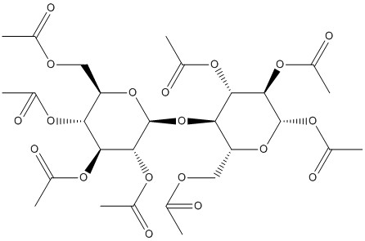 | 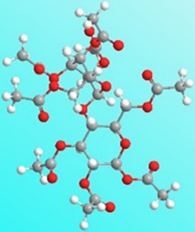
Thermoplastic polyurethanes (TPU) | 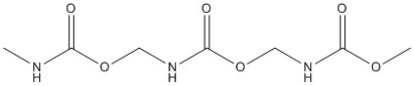 | 